Who we are

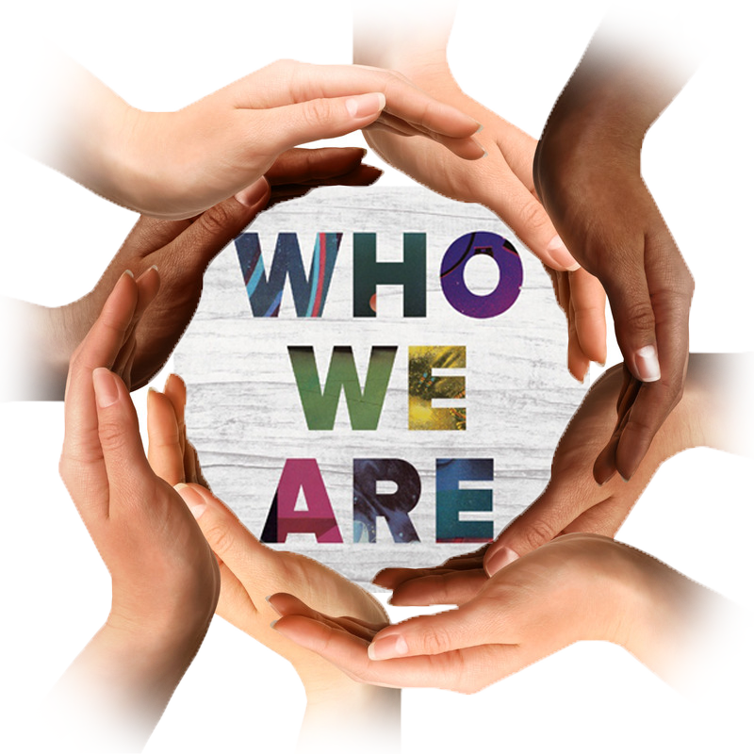

Path to success

Team composition

Global presence

