**Cardioprotective Efficacy of IL-13 following Hypoxia**

**Matt Borrelli**

**Introduction:** Cardiovascular disease is a burden on the healthcare system, costing **$351.2** **Billion** and causing **17.6 million** global deaths each year1. Heart disease, characterized by irreparable damage resulting in fibrosis and lost tissue function, accounts for **43%** of cardiovascular disease deaths1. Suffering an acute myocardial infarction (MI – AKA heart attack) leads to rapid progression of heart disease due to early tissue injury and later pathologic tissue remodeling2. Existing treatments for MI aim to reduce heart damage (statins, ACE inhibitors) or address the subsequent pathologic remodeling (fibrinolytics, ventricular assist devices). These approaches are ineffective and indiscriminately target symptoms rather than precisely correct the dysregulated cellular processes (inflammation, apoptosis) that cause these symptoms. **Localized therapies that target the underlying signaling cascades responsible for heart remodeling could change the way this disease is treated.**

Following acute MI, cardiomyocytes (CM) lost to inflammation and ischemia are replaced by activated myofibroblasts that deposit collagen to stabilize the damaged heart. Deposited collagen becomes cross-linked and causes the tissue to stiffen, diminishing contractility and heart function. Cross-linked collagen cannot be cleared by natural processes and CMs do not regenerate; thus lost tissue function is permanent2. Myofibroblasts are activated through cellular signaling (Inflammation, CM apoptosis) and increased mechanical stress. *Inflammatory signaling reduction, CM apoptosis reduction, and interruption of tissue stiffening are key therapeutic targets to treat the underlying causes of this disease*. Recent studies have identified IL-133 and IL-334 as factors that can reduce CM loss and regulate immune responses following MI. **The described work intends to determine if IL-13 and IL-33 can confer the same degree of protection in an in vitro model of MI.**

**Methods:** *Cell culture:* H9C2 rat heart myoblasts (Sigma #88092904-1VL) were cultured at 37°C & 5% CO2 in DMEM/F12 complete media with 2 mM L-glutamate and 10% FBS (Sigma #SLM-243-B), and supplemented with 100 mM Gibco antibiotic-antimycotic (ThermoFisher #15240062). Cells were passaged 7 times, reaching 70-80% confluency, and then seeded in a 96 well plate at a density of 5e4 cells/well. *Simulated Hypoxia:* Seeded cells were incubated for 72 hours before subjecting to simulated hypoxia. Seeded cells were placed inside a hypoxic chamber (37°C, 1% O2) and the wells were aspirated and 200 $μL$ of hypoxic media (DMEM/F12 media equilibrated inside the hypoxic chamber for 12 hours) was transferred to each well. Cells were subjected to simulated hypoxia for 3 hours, after which the wells were aspirated and 200 $μL$ of DMEM/F12 media supplemented with 100 mM IncuCyte® Caspase-3/7 Green Apoptosis Assay Reagent (Sartorius #4440) and test factors. Test factors include 20 ng/mL TNF (Apoptosis Control), 100 ng/mL IL-13 (Apoptosis Protection), 100 ng/mL IL-33 (Apoptosis Protection), Factor Control (No factors), and hypoxia control (Double Control). The hypoxia control group followed the same cell culturing and seeding procedure, but these cells were neither subjected to hypoxia nor exposed to any factors. *Apoptosis Assay:* Apoptosis rate was tracked for each well seeded with cells in the 96 well plate using IncuCyte® Live-Cell Analyzer, which tracked the total count of green labeled (apoptotic) cells at 2-hour intervals. Experimental groups (N=6) were compared at the 24-hour time point. *Statistical Analysis:* Comparisons between multiple treatment groups were performed using one-way ANOVA, followed by Holm correction for multiple comparisons, and p < 0.05 was considered statistically significant. Statistical tests were performed using R Statistical Software (Foundation for Statistical Computing, Vienna, Austria).

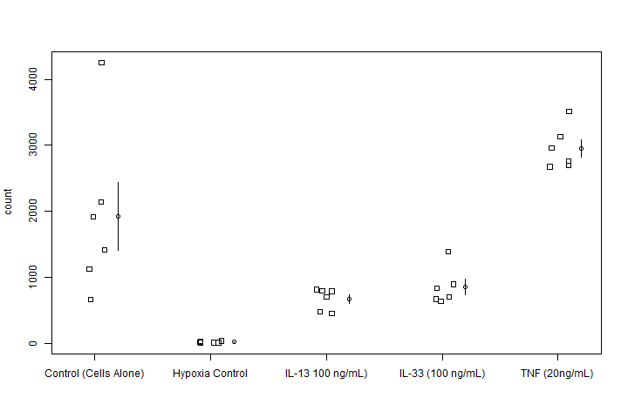**Results:** Count of apoptotic cells data was generated as described in the methods for each factor and Figure 1 displays the distribution and average +/- standard error the mean (SEM). This data is composed of two variables – a discrete, numeric response and a categorical explanatory with 5 levels – One-way ANOVA is the appropriate statistical test to be performed. One-way ANOVA failed to reject the null that all experimental group means are equal, indicating that there may be a difference between groups **(p=6.085e-08)**. Following this result, post-hoc pairwise t-tests were performed to compare every experimental group (10 tests total) in which the null hypothesis is no difference between compared groups and the . The Holm method was used to adjust the p-values to prevent type-1 errors while maintaining (p < 0.05) significance. **Table 1** summarizes the p-values obtained from the pairwise t-tests.

**Figure 1: Test Factor Apoptotic Cell Count**

Groups (Control, Hypoxia Control, IL-13, IL-33, and TNF) were produced as described in the methods. Mean +/- SEM is displayed to the right side of the column as an open circle (mean) connected to a solid line (SEM bounds). One-way ANOVA indicated at least one group was statistically different from the others **(p = 6.085e-08)**. Pairwise t tests with Holm correction indicated reduced apoptotic cells compared to control for IL-13 treated **(p=0.0084)** and IL-33 **(p=0.0257)**. There was not a significant difference between IL-13 and IL-33 treated groups **(p=0.6035)**.

**Table 1: Pairwise t-test p-values for group comparisons**

|  |  |  |  |  |
| --- | --- | --- | --- | --- |
|  | Control | Hypoxia Control | IL-13 | IL-33 |
| Hypoxia Control | 7.5e-05 | -- | -- | -- |
| IL-13 | 0.0084 | 0.1410 | -- | -- |
| IL-33 | 0.0257 | 0.0701 | 0.6035 | -- |
| TNF | 0.0257 | 8.0e-08 | 6.0e-06 | 2.0e-05 |

**Discussion:** Within biological experimental systems, controls are employed to facilitate comparisons and ensure the test model is responding as expected. For this application, the hypoxia control group, comprised of healthy cells not subjected to hypoxia, represents maximum apoptosis reduction while the control group represents the disease baseline. Further, negative and positive controls indicate if our system is responding in a predictable manner – TNF is known to exacerbate apoptosis5 while IL-33 has previously been reported to reduce apoptosis4. Finally, comparing the apoptotic cell count of IL-13 treated wells to these controls facilitate characterization of its therapeutic efficacy.

The p-values listed in **Table 1** for IL-13 indicate that IL-13 and IL-33 perform equally in this system because the null could not be rejected **(p=0.6035)**. Both IL-13 and IL-33 were found to be protective (reduced apoptosis) following MI; however, only IL-13 was not statistically different between the hypoxia control group. This indicates that IL-13 is very effective as an anti-apoptotic agent – equal to IL-33. One of the key assumptions to utilize a parametric test is that the variances of groups are equivalent; yet **Figure 1** indicates that the control group variance may actually be much larger than the other groups. Thus, a test should be conducted to determine if this data violates the equal variance assumption, and if so a non-parametric test should be conducted. Switching to a non-parametric test will reduce the power of the study potentially translating to reduced significance in post-hoc testing.

**References:** [1]Benjamin, E., et al. (2018) Circulation. [2]Konstarn, M., et al. (2011) JACC Cardiovasc. Imaging. [3] Wodsedalek, D., et al. (2019) Am. J. Physiol. Heart Circ. Physiol. [4]Veeraveedu, P. T., et al. (2019) Biochem. Pharmacol. [5] Carlson, D. L., et al. (2002) Am. J. Physiol. Heart. Circ. Physiol.