Alphonse BIZIRAREMYE

REG | kigali, nyarugenge

**Industrial attachment report**

220011657

**DECLARATION**

I hereby declare this industrial attachment is prepared and submitted by me as partial fulfillment of the requirements for the industrial attachment program at Rwanda Energy Group (REG) where make internship activities.

I further declare that the information presented in this report is based on my personal experience and observations during the internship period, along with relevant information obtained from credible resources. Any reference, quotation, or materials user from other sources have been duly acknowledged and cited.

I acknowledge that the internship work and its outcomes presented in this report are the result of my own efforts, under the guidance and my supervisor. The internship was carried out from 30th January 2023 at headquarter of Rwanda Energy Group(REG), located nyarugenge.

I affirm that I have adhered to the ethical standards and guidelines set by the institution and the organization throughout the internship duration. I take full responsibility for the authenticity, accuracy, and originality of the content presented in this report.

I understand that any act of plagiarism or misrepresentation in this report is considered as serious offence may result in disciplinary action, including the rejection of this report and any related academic consequences.

Also I acknowledge and appreciate the support, guidance and cooperation extended by all individuals who contribute to the successful completion of this internship and preparation of this report. Their assistance has been invaluable in enriching my learning experience.

I affirm that all the information provided in this declaration is true and correct to the best of my acknowledge and belief.

I grant permission to the institution and the organization to use this report for academic and research purpose, while maintaining the confidentiality of any proprietary or sensitive information contained herein.

**DEDICATION**

I dedicate this industrial attachment report to my family, friends, and loved ones who have supported and encouraged me throughout my academic journey. Their unwavering belief in my abilities has been a constant source of motivation and strength.

I am grateful for the understanding and patience they have shown during the demanding and challenging moments of this internship. Their love, encouragement and moral support nave been instrumental in helping me overcome obstacles and achieve success.

I would also like to extend my heartfelt gratitude to the faculty and staff of Rwanda Energy Group(REG) for providing me with the opportunity to pursue this internship. Their guidance, knowledge and expertise have played a significant role on shaping my understanding of software development and fostering my professional growth.

Additionally, I want to express my appreciation to my internship supervisor MANISHIMWE EMMANUEL, for their valuable guidance, support, and mentorship throughout the internship period. Their expertise, feedback, and encouragement have been instrumental in enhancing my technical skills and expanding my knowledge in the field of software development.

Finally, I would like to dedicate this report to all individuals within the organization where I completed my internship. Their willingness to share their knowledge and expertise, and their collaborative spirit have contributed immensely to my learning experience. I am grateful for the opportunities they provided me to work on real world project and gain practical insights into the software development industry.

This report is a testament to the collective efforts and support of all who have played a significant role in my internship journey. I am truly grateful for their contributions, and this dedication is a token of my appreciation and gratitude.

**ACKNOWLEDGMENT**

In this report I can express my sincere gratitude for the opportunity to undertake an internship in the field of software development at Rwanda Energy Group. I am thrilled to accept the offer extended to me and eagerly look forward to contributing my skills and knowledge to the company project.

I am fully aware of the significance of this internship in shaping my professional career, and I am committed to making the most of this valuable experience. I am confident that working with the talented team at Rwanda energy group will provide me with the necessary exposure to enhance my technical skills and gain practical industry experience.

I would like to express my appreciation to Rwanda energy group team for giving me this opportunity. I am eager to learn from the experienced professionals at your organization and contribute to the development of innovative software solutions. I am excited about the chance to collaborate on challenging projects and apply the theoretical knowledge I have acquired during studies.

I understand that the internship will commence on 30th January 2023 and conclude on 7th April 2023. I assure you that I will dedicate myself to the tasks assigned to me and actively participate in all relevant training and development programs offered by Rwanda energy group.

Once again, I would like to express my sincere appreciation for granting me this internship opportunity. I am excited about the learning and growth that lies ahead during my tenure at REG. please feel free reach out to me via email or phone if you require any further information or have any specific instructions to me.

[Biziyaremyealphonse@gmail.com](mailto:Biziyaremyealphonse@gmail.com)

0783857284

**ABSTRACT**

This internship focused on software development, providing an opportunity to gain practical experience in a professional setting. The objective was to enhance technical skills and knowledge while working on real world software project. Throughout the internship, the primary responsibilities included collaborating with team of experienced developers, participating in the software development life cycle, and contributing to the design, coding, testing, and debugging of various software applications.

The internship provided a valuable learning experience in multiple aspects of software development, including understanding the project requirement, implementing software solution, and employing best coding practices. It involved utilizing industry standard programming language, frameworks, and tools to develop software application that addressed specific needs and requirements. The experience helped to improve proficiency in areas such as programming logic, algorithm design, and troubleshooting software issues.

Furthermore, the internship fostered an understanding of the importance of effective teamwork, communication, and time management in a professional software development environment. Regular meeting and code reviews with the development team facilitated knowledge sharing, constructive feedback, and continuous improvement. The opportunities to collaborate on team projects also enhanced shills in version control, collaborative coding, and agile development methodologies.

Overall, the internship in software development provided a comprehensive introduction to the practical aspects of building software applications. It equipped the intern with valuable technical skills, industry knowledge, and an understanding of the software development life cycle. The experience gained during this internship will serve as a foundation for future endeavors in the field of software development and contribute to the intern’s professional growth and career aspiration

Table of Contents

CHAP1. INTODUCTION 0

1.1 Background and necessity of the training 0

1.2 Training objectives 1

1.3 Training pre-requisites 1

1.4 Site selection 2

1.4 Training benefit and motivation 3

CHAP2. LITERATURE REVIEW 3

2.1 Class theories related to site training 3

2.2 Description of the training activities 15

CHAP3. MATERIALS AND METHODS 31

3.1 Site description 31

3.1.1 Site localization 31

3.1.2 Brief description of the company 32

3.2 Brief description of the site tools and equipment 33

3.3 Exposure of the used methodology 34

3.3.1 Site visit 35

3.3.2 Required training information and data collection 36

3.3.3 Questionnaire and interview 37

3.3.4 Site illustration 38

3.3.5 Site works 39

3.3.6 Books and e-documentation 40

CHAP4: TRAINING OUTCOMES 41

4.1 Survey map 41

4.2 Description of training activities 41

4.3 Discussions and analysis of the training work 41

4.4 Environmental aspect of the training 41

4.5 Benefit/ cost analysis of the training 41

CHAP 5: CONCLUSION AND RECOMMENDATION 41

5.1 Conclusion 41

5.2 Recommendations 41

5.2.1 Useful remarks 41

5.2.2 Suggestion to the organization 41

5.2.3 Recommendation towards the future trainings 41

REFERENCES 41

APPENDICES 41

**List of tables**

**Table 1 User personal information fields 22**

**Table 2 Department details fieds 22**

**Table 3 Structure of table users 23**

**Table 4 Structure of table department 23**

**Table 5 Structure of tale documents 24**

**Table 6 System users table 26**

**List of figures**

**Figure 1 System architecture 20**

**Figure 2 Conceptual model entity relationship 22**

**Figure 3 Student use case diagram 25**

**Figure 4 Department and student use case diagram 26**

**Figure 5 System homepag 27**

**Figure 6 Admin dashboard 27**

**Figure 8 Admin assign the role to the users 28**

**Figure 9 Assign the department to the user 28**

**Figure 10 Assign the role to user complete 28**

**Figure 11 Assign user to the corresponding department 29**

**Figure 12 Select the department you want to assign to the user 29**

**Figure 13 Assign department to the user complete 29**

**Figure 14 View the available department in the system 30**

**Figure 15 Adding new department to the existing department 30**

**Figure 16 Login form for existing user 30**

**Figure 17 Logout after finish responsibilities in the system 31**

**Figure 18 Registration form for a new users of the system 31**

**Figure 19 Tracking the application progress 31**

**List of symbols and abbreviations**

|  |  |
| --- | --- |
| **API:** | Application Programming Interface |
| **CSS:** | Cascading style sheet |
| **HR:** | Human Resources |
| **HTML:** | Hypertext markup language |
| **IAMS:** | Internship Application Management System |
| **IDEs:** | Integrated Development Environments |
| **JS:** | Java Script |
| **OOP:** | Object Oriented Programming |
| **QA:** | Quality Assurance |
| **REG:** | Rwanda Energy Group |
| **SDLC:** | Software Development Life Cycle |
| **SQL:** | Structured Query Language |
| **TDD:** | Test Driven Development |
| **UI:** | User Interface |
| **VCS:** | Version Control System |
| **VM:** | Virtual Machine |
| **VS:** | Visual studio |

# CHAP1. INTODUCTION

## Background and necessity of the training

During my internship, I had the opportunity to work with an Internship application management system(IAMS) at Rwanda energy group. REG is a learning software development firm specializing in creating innovative solution for various industries. The internship program at REG aims to provide valuable hands on experience to aspiring software developers like myself.

Rwanda energy group has been in operation as a trusted provider of software solutions. The company focuses on developing cutting edge applications and system that cater to the specific needs of their clients.

Within REG, I was assigned to the software development team. Which is responsible for designing, developing and maintaining various software applications. The team consists of experienced software engineers and developers who works collaboratively to deliver high quality solutions to clients. The team follows agile software development methodologies, ensuring efficient project management and timely to delivery of software products.

During my internship I worked on the development and enhancement of Internship Application Management System(IAMS). The IAMS is an internal tool used by REG to streamline and automate the entire internship application process, it allows potential inters to submit their application, provide a centralized platform for HR personnel to manage and review applications, and facilitates communication between the HR team and application.\

Prior to the internship, I had a solid foundation in programming language such as java and web development technologies like HTML.CSS and java script. I also had experience with database and SQL. This knowledge provided a strong base for me to contribute to the development of the IAMS. Throughout the internship, I aimed to further enhance my skills in front-end development, backend programming and database management.

## Training objectives

My primary learning objectives for the internship were to gain practical experience in developing web based application, improve my understanding of software development best practices, and enhance my skills in teamwork and collaboration, I was particularly interested in learning about the software development lifecycle, version control system, and agile methodologies.

Other hand this internship provides to me experience in a specific field or industry. I have the opportunity to apply the knowledge and skills they have acquired though academic studies in real world situation.

Opportunity to assess whether a particular career path or industry is the right fit for them .by gaining exposure to the work environment and tasks associated with a specific fob, this help me to evaluate it aligns with my interest, skills .and long term career goals.

## Training pre-requisites

Training help me to have a basic understanding of the organization internship program, its objectives and the overall application process. This can include knowledge about the types of internship available, eligibility criteria and the desired outcomes of the program.

Clear understanding of the various component of an internship application. This can include knowing what information and documents are typically required, such as resumes, letter, transcripts or reference.

The general of how internship applications are typically reviewed and evaluated. this can include knowledge of criteria used of assessing applications such as relevant skills, qualifications, academic achievements or previous experience.

## 1.4 Site selection

Look for internship opportunities that align with career goals and fields of interest. By consider the industry, sector or specific job function that are interested in pursuing. To choose an internship site that offers relevant experiences and exposure to the skills and knowledge I want to develop.

The company culture and values determine if they align with my own beliefs and work style. By considering factor such as work environment, employee satisfaction, diversity and inclusion initiatives and corporate social responsibility. A positive company culture can enhance my internship experience.

Evaluate the learning and development opportunities provided by the internship site. Consider if the organization offers structured training programs, and workshops or other professional development activities. The presence of such opportunities indicates a commitment to the growth and skills development of inters.

## Training benefit and motivation

Training offer the opportunity to apply academic knowledge in real world scenarios. They provide hand on experience in a specific field or industry allow inters to develop practical skills and learn how to navigate professional environment.

Training enable individual to develop a wide range of skills relevant to chosen fields. Whether its technical skills, such as programming or data analysis or soft skills like communication and teamwork internship provide and avenue for honing and expanding one’s skills set.

Training allow interns to build professional networks and establish connections with industry professionals. These connections can be instrumental in sevuring future job opportunities obtaining references and gaining mentorship or guidance from experienced professionals.

# CHAP2. LITERATURE REVIEW

## 2.1 Class theories related to site training

When it comes to internship in software development, several class theories and concept are relevant for understanding and enhancing the internship experience. Here there are a few theories that can be applied.

Software development life cycle(SDLC): the software development life cycle is a process framework that guides the development of software applications. Understanding different phases of the software development life cycle. Such as requirement gathering, design, development, test and deployment, can help interns grasp the overall the development process.

It provides a structured approach for managing software development project, ensuring efficiency quality and adherence to timelines.

Agile methodologies: agile methodologies, such as scrum or Kanban, focus on iterative and incremental development allows interns to experience working in cross functional teams, participate in daily stand-up meetings, and engage in collaborative problem solving.

It also fosters a mindset of flexibility, continuous learning, and adapting to changing project requirement.

Object oriented programming(OOP): object oriented programming paradigm that organize software design around object that interact with each other, interns in software development often encounter object oriented programming concept, such as class, objects, inheritance and polymorphism.

Understanding object oriented programming principle help interns to grasp the fundamental concepts of software design and development and enable them to write modular and reusable code.

Test –Driven development(TDD): Test driven development approach that emphasizes writing test before writing the actual code, this practice help to ensure the reliability and correctness of software applications.

Introducing interns to TDD principle allow them to understand the importance of testing and how to create test cases, write code to pass the test, and iteratively improve code quality.

Version control system(VCS): Version control system, such as Git, are tools that track and manage change to source code, inters should be familiar with VCS principle and practice, including creating branches, committing code, merging change, and resolving conflict.

Understanding VCS helps interns collaborate efficiently, maintain code integrity, and contribute to a shared codebase.

Software documentation: documentation is an essential aspect of software development. Interns should learn how to create and maintain technical documentation, such as design document, API documentation, and user manual.

Understanding documentation practices enable interns to communicate effectively with team members, ensure code maintainability, and support future development effort.

Quality assurance(QA) and Testing: quality assurance and testing ensures software quality and identify and fix defects. Interns should be familiar with QA principle, including creating test plan, executing test cases, and reporting and making tracking bugs.

Gaining experience in quality assurance and testing helps interns develop a quality mindset and contribute to delivering reliable software product.

## 2.2 Description of the training activities

INTRODUCTION

Nowadays, finding internship or summer to enhance competitiveness before the graduation has become in increasing tendency. For university students, doing internship is a way to have a great chance to find the career in the future, but for elementary school and high school students, internship is the way to understand the different divisions of social labor so that the student can find their own interest in different areas.

That is they will establish their goals of future and not completely be in dark when choosing a major after graduation. For university students, it will not easy to find a job via social recruitment because a large number of company will require experience before a candidate apply for a job student will face the same obstacles if the lack of real world experience.

The student in many universities need to attain industrial attachments at the end of their studies where their universities request them to find the company or organization help them in these internships in other to attain the working experience.

In the process of searching where they make the internship take a long time for a student in a way of transport going to the company/organization to bring a document needed by the company before allow anyone to make an internship in the organization, the introduced internship management system is the system come for helping the students to make application in the organization easily where the students must sent their request for internship on organization with full requirement via the system and make the response via emails it the applicant must be allowed or request is rejected.

This system is used by students need to make request for internship with fill their personal information and education information in other to express their proof of education background and the receptionist of the organization must be accept the request from the students and assign the request with providing the response to the student or clients.

The purpose of the internship application management system is to help the students to request the internship on the organization and make the response without the more cost of transport and saving their time. Because the student must upload the required document for internship and make the response about their request via internship application management system.

REQUIREMENT

FUNCTIONAL REQUIREMENT

There is requirement needed by the all user of the system where the system request the user to enter same credential in other to assign the responsibilities of the user came to use the system.

When the user sign in the system after entering the email and password in the system. The system must assign their responsibilities based on roles in the system like the following roles for each user of the system.

STUDENTS

The students must have requested by the system to enter the personal information like: First name, Last name, Age, Email, Phone numbers and the education information like University name, College, Department and the kind of internship request in the organization like software development or networking and others based on the available internship in the organization.

RECEPTIONIST OF ORGANIZATION

All request from the student must be seen by the receptionist of the organization and the receptionist must be check for the request have full information needed and must be sent to the department have the responsibilities to provide that king of internship.

HEAD OF DEPARTMENT

The all request for internship requested by students must be sent in their related department and the head of department must to accept or reject the request internship based on the reasons that are available in the department.

HUMAN RESOURCES

The application that are accepted to start internship in the department their request is sent to human resources department to confirm the accepted starting for the internship in the organization.

AUTHENTICATION

Each user must be entering in the system after providing login credentials where the system put user on the dashboard based on the role of the user in the system then the user must logout his or her account after performing the required responsibilities in the system.

NONFUNCTIONAL REQUIREMENT

This system of internship application management system contains the form or registration or signup where the student requested to enter their information and upload the recommendation letter from the department.

Web server is the another requirement for the system used to serve the request font the Mysql database used to keep the information from the client and keep the information of student when the student make any request.

All user must reach to the homepage means that the homepage is the page viewed by everyone on the system and new user of the system must have button to make registration and the existing users have the login form used to come back into the system.

After login for users the system redirects the user to the corresponding page base on the role of the user in the system.

DESIGN

This project, internship application management system, implement web system to provide an environment for student and organization to successfully complete the internship application. Thus the component needed to implement internship application management system are database server.

Web server, graphic user interface component and database interface application programming interface(API) to programmatically access to the database.

ARCHTECTURE DESIGN

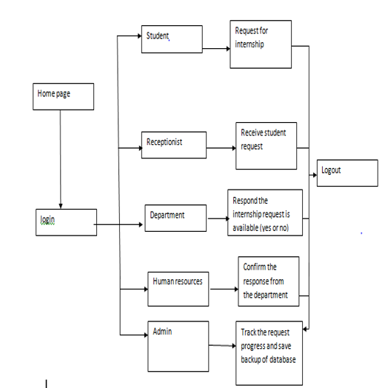

Figure 1 System architecture

DATABASE DESIGN

DATA ANALYSIS

The data for designing and implementing the schema of the database depend on the properties of the pages and users.

The page data needed by the internship application management system are title, header, body and several tabs to move around the web pages. The user data needed by the system are the user social security or student id, username, password, first name, last name and email address. The role of user is automatically redirect to the appropriate page. All the user data will have checked on the server side when the user is created.

All information entered by the user will be checked and appropriate error message will be checked flagged include password mismatch and missing required field. A unique number identifies every record stored in the database and that serves as a parameter to check integrity constraints and maintain true in the database.

DATA SCHEMA CONCEPTUAL MODEL ENTETY RELATIONSHIP

In designing the schema for the internship application management system database, two distinct parts have been identified. The first includes entities having relationship between them. The second include a description of the entities and their attributes.

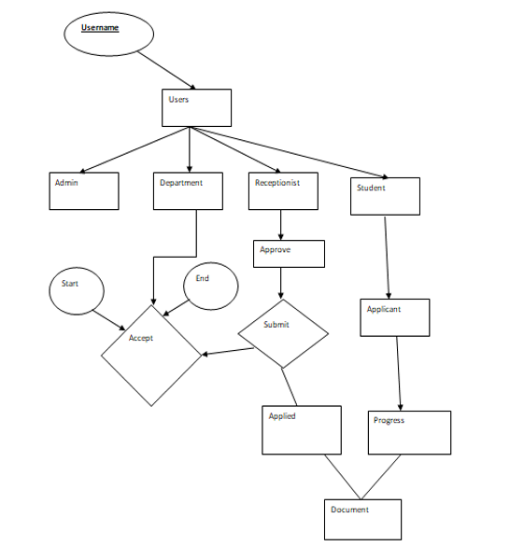

Figure 2 Conceptual model entity relationship

DATABASE SCHEMA LOGICAL MODEL-RELATIONAL SCHEMA

The conceptual model entity relational diagram maps into the following table design, in the following tables, fields with key indicate the primary.

Table 1 User personal information fields

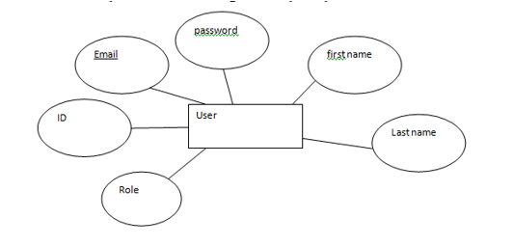

Table 2 Department details fieds

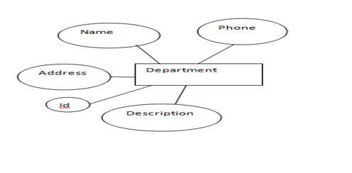

DATA TYPE AND DETAILS

The logical model establishes the following detailed design in MySQL database. The detailed following table describe data type, length, primary key, null or non-null key, and extra information in database in encrypted and it is shown in the web page as some special character repeated as many times as the length of the actual password.

STUCTURE OF TABLE USERS

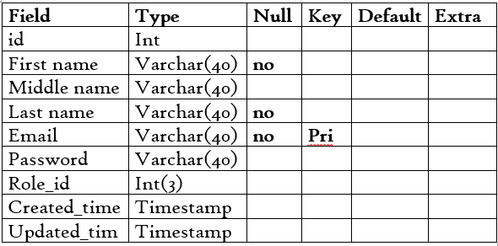

Table 3 Structure of table users

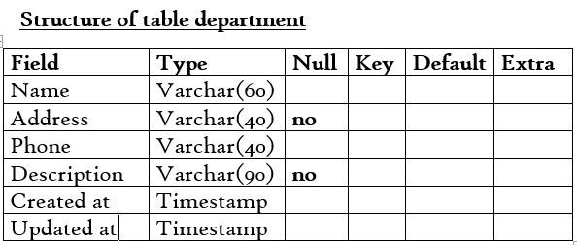

Table 4 Structure of table department

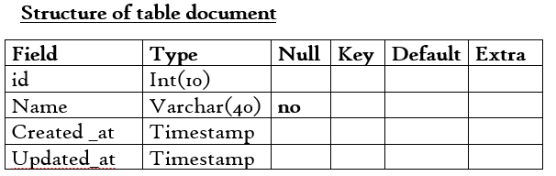

Table 5 Structure of tale documents

USE CASE DIAGRAM

Internship application management system is designed to perform several different function for different users

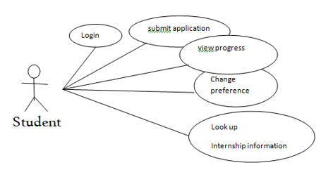

Figure 3 Student use case diagram

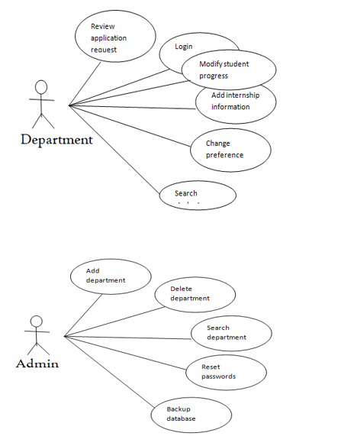

Figure 4 Department and student use case diagram

User interface design

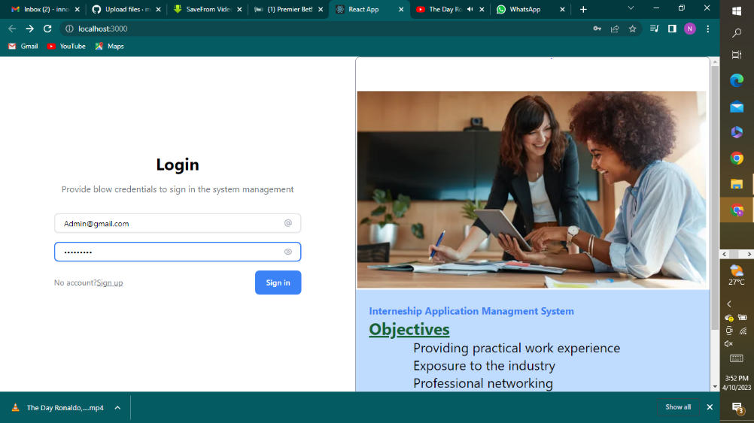

Figure 5 System homepage

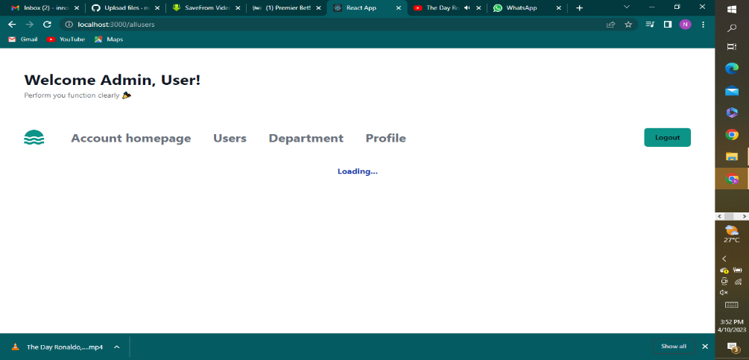

Figure 6 Admin dashboard

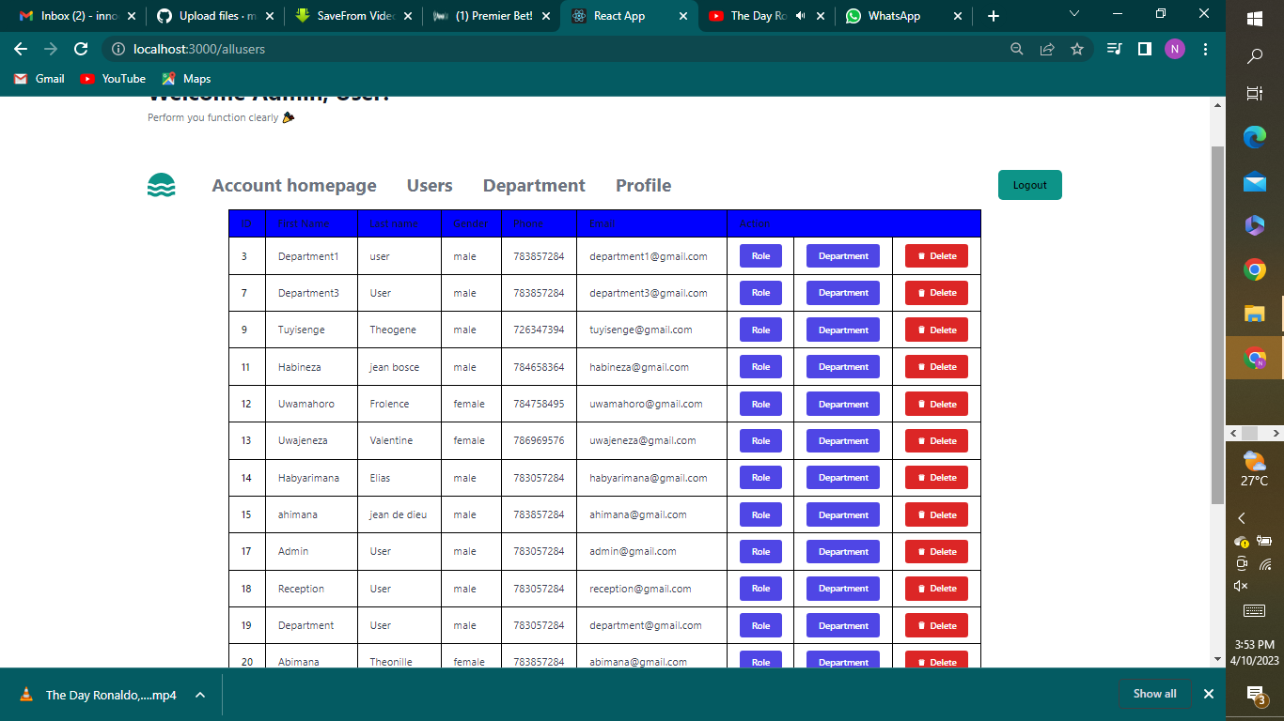

Table 6 System users table

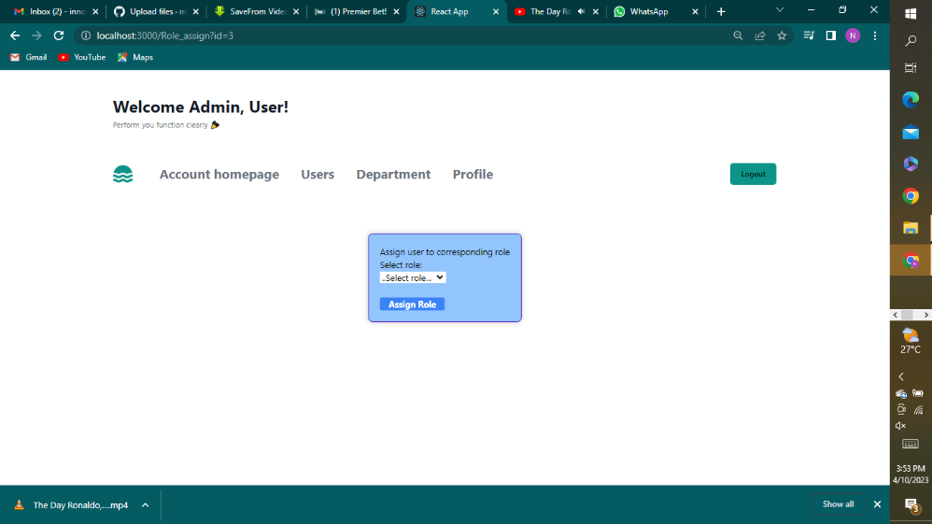

Figure 8 Admin assign the role to the users

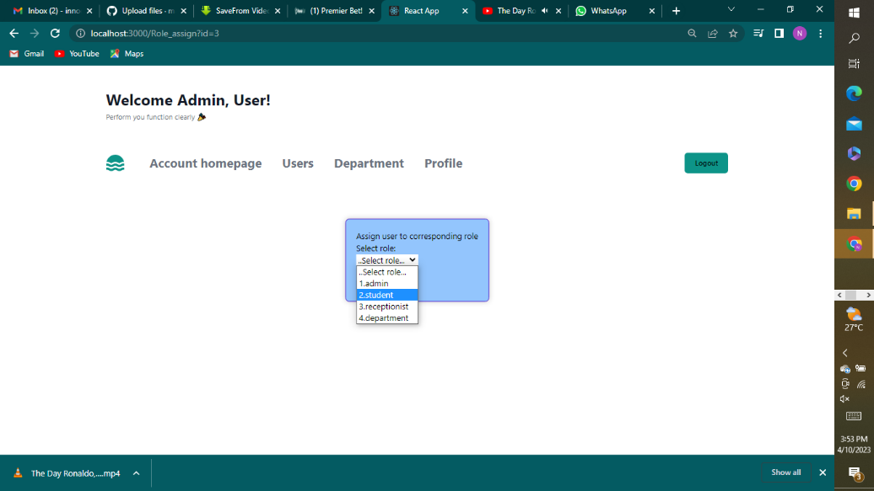

Figure 9 Assign the department to the user

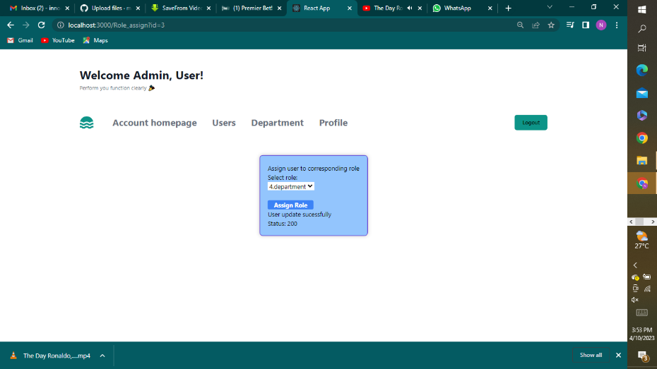

Figure 10 Assign the role to user complete

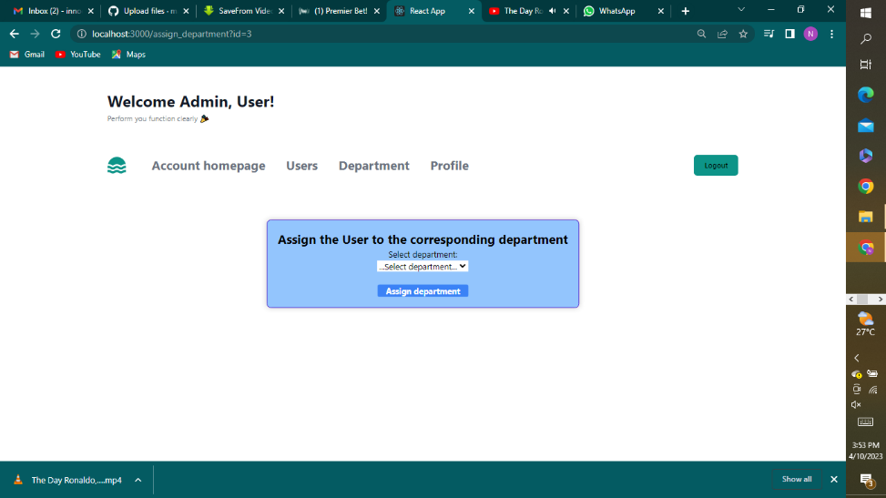

Figure 11 Assign user to the corresponding department

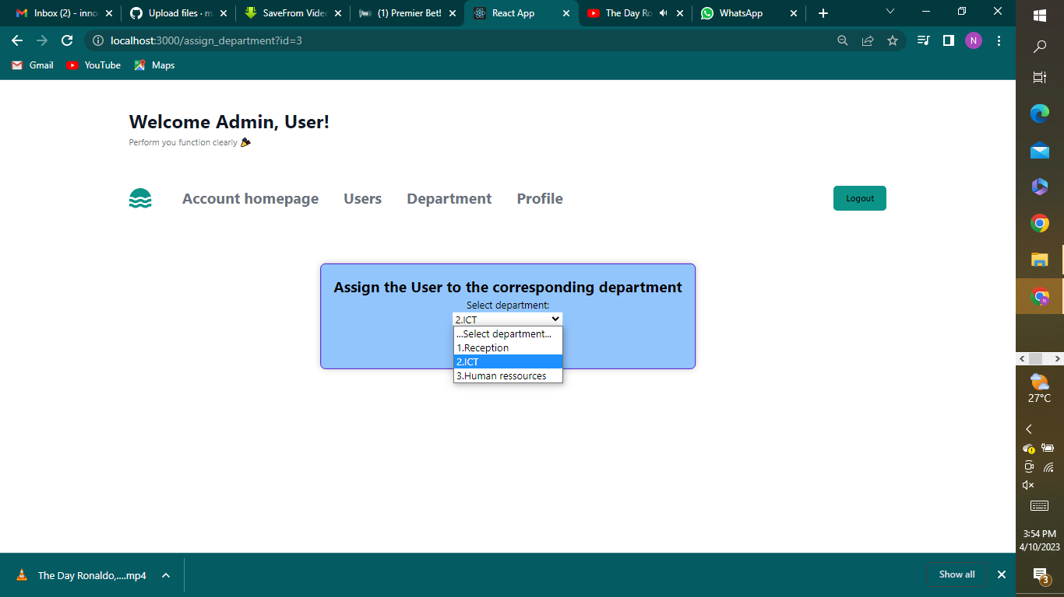

Figure 12 Select the department you want to assign to the user

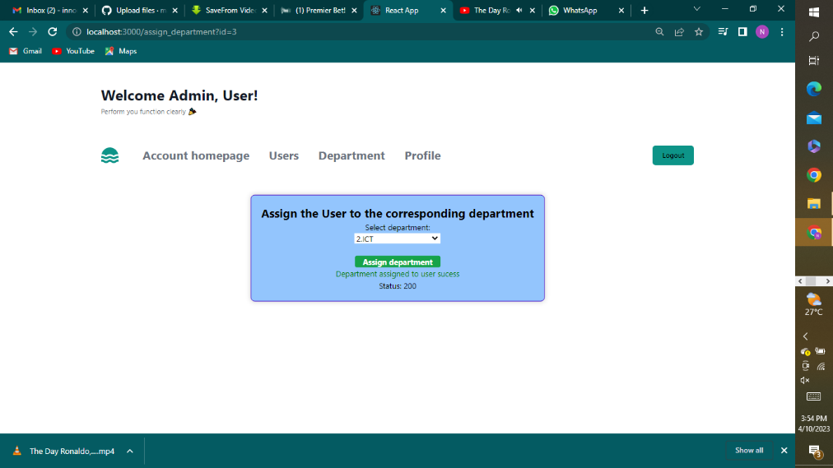

Figure 13 Assign department to the user complete

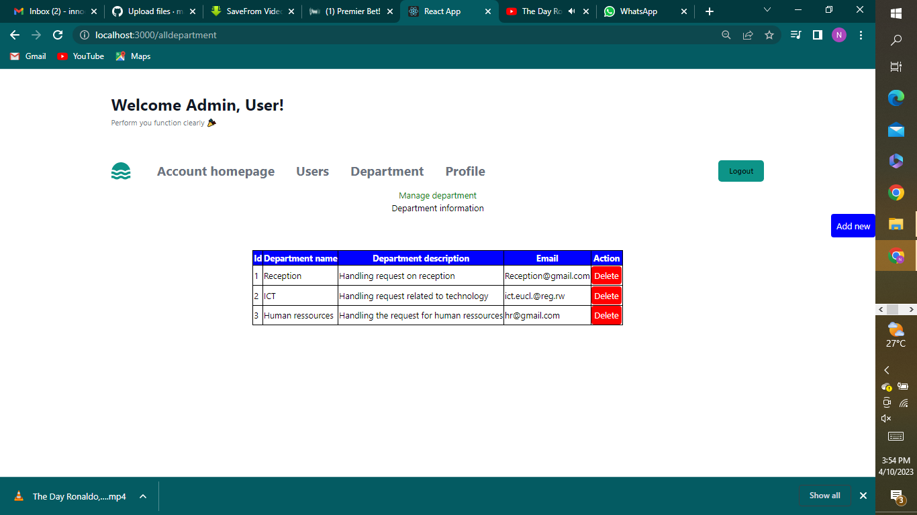

Figure 14 View the available department in the system

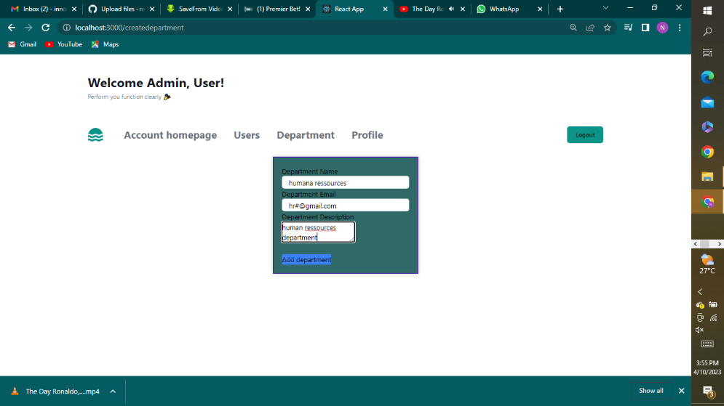

Figure 15 Adding new department to the existing department

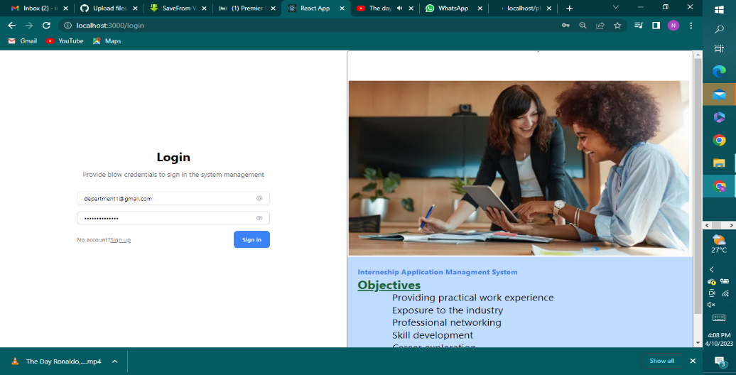

Figure 16 Login form for existing user

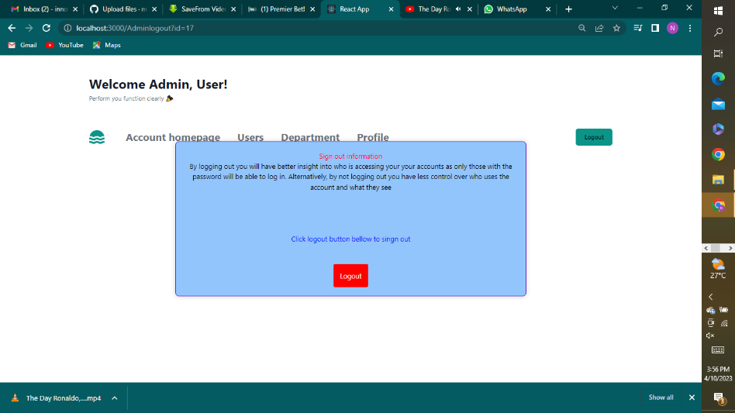

Figure 17 Logout after finish responsibilities in the system

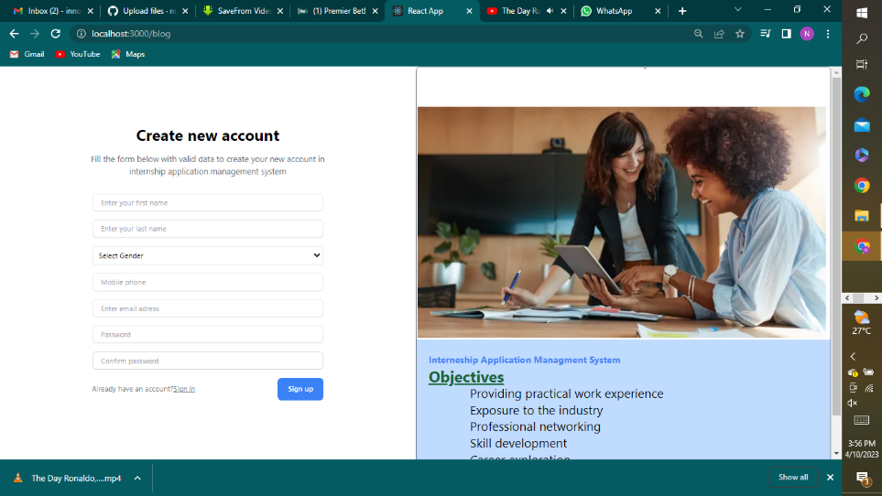

Figure 18 Registration form for a new users of the system

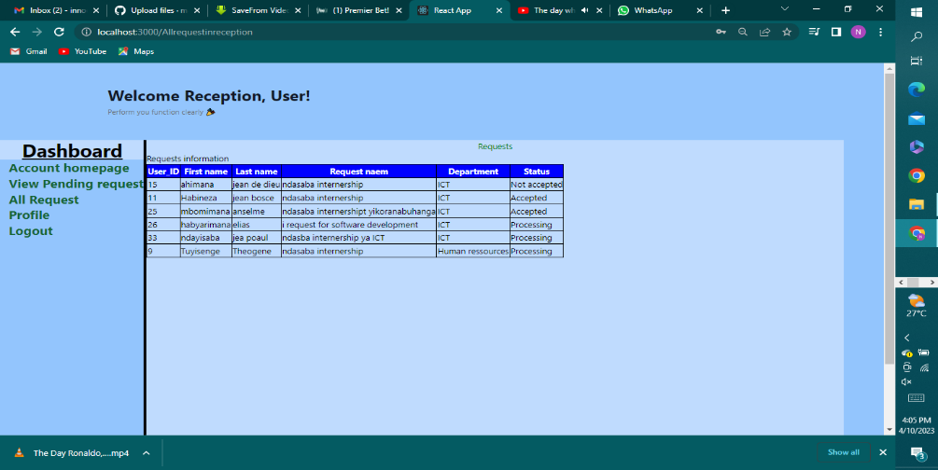

Figure 19 Tracking the application progress

# CHAP3. MATERIALS AND METHODS

## 3.1 Site description

### 3.1.1 Site localization

I am thrilled to share my software development internship journey with you. Throughout my internship at Rwanda energy group, I had the privilege of working in a multicultural and diverse environment. As a result, I understand the importance of catering to different language and cultures, which is why I have localized my website.

You can select your preferred language from the drop down menu at the top of right corner of the page and the entire website will be translated accordingly. This way, I want to ensure that everyone regardless of their language or cultural background can fully comprehend and engage with the content.

During my internship, I had the opportunity to collaborate with talented professionals and work on a variety of software development projects I gained hands on experience in the different phases of the software development life cycle, employing agile methodologies to adapt to changing requirements and foster effective teamwork.

I am excited to share my experience showcase the projects I contributed to and highlight the technologies and programming languages I worked with by providing localization option, I aim to create an inclusive and accessible platform for visitors from all over the world.

### 3.1.2 Brief description of the company

During my internship, I had the privilege of working at Rwanda energy group.a leading software development company in the industry. This organization is known for its innovative solutions and cutting edge technologies that drive digital transformation across various sectors. As an intern I had the opportunity to collaborate with a talented team of software engineers and developers, working on challenging project that pushed the boundaries of what is possible. The company’s commitment to excellence, emphasis on continuous learning and supportive work environment made it an ideal place for me to gain practical experience and enhance my skills in software development.

I had the incredible opportunity to inter at company. A dynamic startup specializing in software development. At company, the culture of innovation and entrepreneurial spirit were palpable, creating an exciting and fast pace work environment. I was fortunate to be part of a small but highly skilled team where I contributed to the development of innovative software solutions. The company focus on agility, creativity, and customer centricity allowed me to hone my problem solving skills collaborate closely with cross functional teams, and make a meaningful impact on product we delivered.

In the field if software development th tools and equipment used during an internship typically revolve around software and hardware resources rather than physical tools. Here a brief description of some common site tools and equipment used during a software development.

Development software. Inters have access to a range of development software tools including integrated development environment like visual studio code, eclipse or intellij IDEA. These IDEs provide a robust set of features for coding, debugging, version control, and project management. making them essential for efficient software development.

## 3.2 Brief description of the site tools and equipment

In my field of software development, the tools and equipment used during an internship typically revolve around software and hardware resources rather than physical tools.

Development software: interns have access to range of development software tools, including integrated development environments (IDEs) like visual studio code, eclipse. These IDEs provide a robust set of features for coding, debugging, version control, and project management, making them essential foe efficient software development.

Source code management system: source code management systems like git or subversion are fundamental tools for version control and collaboration. Inters utilize these tools to trach changes, manage code repositories, collaborate with team members, and handle branching and merging of code.

Project management tools: Project management tools such as Jira, and asana are commonly used during software development internships. These tools on site help to organize and tracks set priorities. Manage workflows and facilitate communication and collaboration among the team members.

Testing and debugging tools: inters are use a variety of testing and debugging tools to ensure the quality and functionality of software applications. Tools like selenium, Junit, Postman features provided by IDEs assist in writing and executing test cases, identifying and fixing bugs and validating software performance.

Virtual machine and cloud platform: Virtual machines and cloud platforms like Amazon Web Service(AWS) enable to create and deploy software applications in scalable and virtualized environment. These platforms offer resources and service for hosting, testing, and deploying software, enhancing the practical experience in cloud-based development.

Hardware: while software development primarily rlies on computers, inters may access hardware resources such as laptops or desktop computers with sufficient processing power and memory. Additionally, access to peripheral device like monitors, keyboards, mice and headphones is essential for comfortable and productive work.

## 3.3 Exposure of the used methodology

During my internship, I gained exposure to various methodologies that are commonly used in the industry.

Agile methodology: agile methodology is widely adopted in software development due to its iterative and collaborative approach. I had the opportunity to work in an agile environment, where development task was divided into sprits or shorts iteration.

The team held daily stand-up meeting to discuss the progress, challenge and plan for the day. Agile methodologies such as Scrum of Kanban were utilized to manage project backlogs, prioritize tasks, and track progress on a visual broad. This methodology emphasize flexibility, adaptability to changing requirement and close collaboration between team members and stakeholders.

Test driven development(TTD): test driven development is a development approach that focuses on writing test before writing the actual code. During my internship. I was introduced to TTD and had a chance to apply it in practice. I learn how to write unit test that defined the expected behavior of the code and then implemented the code to made the tests pass. This methodology helped ensure code quality, identify issues early in the development process, and foster a test-first mindset,

Waterfall methodology: while agile methodologies were more prevalent during my internship I also gained exposure to the waterfall methodology. Waterfall is a sequential approach where each phase of the software development life cycle follows a linear flow, with one phase starting only after the previous phase is completed. I observed how requirement gathering, design, development, testing, and deployment were carried out in structured and sequential manner. Although less flexible compare to agile methodologies, waterfall allow for comprehensive planning and documentation at each stage, ensuring a well-defined and predictable development process.

### 3.3.1 Site visit

Development area: this is where magic happens! The development area is buzzing space filled with developers working diligently on their computers. You will see rows of workstation equipped with powerful computers, multiple monitors, and comfortable ergonomic setups. Developers collaborate, write code, and test their application in this workspace.

Collaborative space: software development thrives on collaboration and you will find dedicated collaboration space in the office. These areas are designed for team meeting, brainstorming sessions, and code reviews. Teams gather here to discuss ideas, share knowledge, and collaborative on solving complex problems.

Scrum board: agile development methodologies like scrum are widely adopted in the industry. You will find scum board prominently displays representing ongoing projects. These boards visualize the follow, with sticky notes or digital cards representing tasks in different stage such as to Do in progress and completed. This helps a team to track the progress and maintain the transparency.

Testing lab: quality assurance is critical aspect of software development and you will have the opportunity to visit the testing lab. This dedicate areas is equipped with various device, operating system, and testing tools, testers perform manual and automated testing, ensuring that software applications meet the required standards and functionality.

Project management area: effective project management is essential for successful software development. In the project management area, you will find project managers and coordinators overseeing the progress of multiple project. They utilize project management tools and software to plan, allocate resources, monitor timelines, and ensure smooth execution.

Breakout spaces: in between coding and problem solving, software developers need a breather. Breakout space are design for relaxation and informal discussion. You find couches, bean bags, or game areas where developers can unwind, recharge or engage in friendly discussion to foster a positive and collaborative environment.

### 3.3.2 Required training information and data collection

Goals and objectives: clearly define goals and objectives of the internship program. Specify the desired learning outcomes, technical skills to be acquired, and professional development areas to focus on during the internship.

Curriculum and learning plan: develop a structured curriculum or learning plan the outlines the topic, technologies, and programming language to be covered during the internship. This plan can include a breakdown of learning module, practical exercises, coding assignments, and hand on project to provide a compressive learning experience.

Resources and tools: ensure have the necessary resources and tools or the training. This include software development platforms, programming tools, documentation, and online resources for self study and exploration.

Collaboration and teamwork: emphasize the importance to collaboration and teamwork in software development. Encourage interns to work on group project, participate in the code review, engage in pair programming and foster effective communication skills within the development team

Data collection

Project assessment: evaluate the performance and progress by assessing the work on individuals or group project, this include reviewing coding practice, code quality, adherence to coding standard and ability to meet project requirement. Provide constructive feedback to help them improve the development skills.

Code review: conduct regular code reviews to access interns code quality, adherence to the best practice, and understanding the software development principle, code review can be performed by mentor, supervisor or peers to identify areas for improvement and provide recommendation.

Performance evaluation: conduct periodic performance evaluation to access intern’s overall performance and growth during the internship. This evaluation can include a review of technical skills collaboration and contribution to the development team.

### 3.3.3 Questionnaire and interview

Certainly! Here are some samples questions for questionnaire and interview for software development internship

Questionnaire:

1. What motivated to apply for a software development internship?
2. What specific programming language or technologies are you familiar with?
3. Have you worked on any software development project in the past? If yes, please provide a brief description of your role and contributions?
4. What are your career goals in software development and how do you think this internship will help you achieve them?
5. How comfortable are you with working in a team and collaborating with other developers?
6. Are you familiar with an software development methodologies such as agile, scrum, or waterfall? If yes, please describe your experience them.
7. How do you approach problem solving and debugging in software development?

Interview:

1. Tell us about your experience with software development and any relevant project you have worked on
2. Which programming language are you most comfortable with? Can you provide examples of project you have completed using those languages?
3. How do you handle challenges or obstacles that arise during the software development process?
4. Have you worked in a team setting before? if so, describe your experience collaboration with others and contributing to a team project.
5. Can you explain the difference between front-end and back-end development? Which area are you more interested in.
6. have you worked with any software development frameworks or libraries? If yes, please provide examples and discuss your experience with them.

### 3.3.4 Site illustration

Development environment: an illustration showcasing developers working at their desks, surrounded by computers, multiple monitors and various programming tools. This can depict the typical workspace of a software development team.

Collaboration space: show an illustration of a designated collaboration area with team members brainstorming, discussing code, and working together on digital collaboration tools. This emphasizes the importance of teamwork and collaboration in software development.

Agile methodology: create an illustrations representing an agile environment featuring in scrum board with sticky notes representing user stories, tasks, and progress. This visually represent the iterative and collaborative nature of agile software development.

Testing lab: depict an illustration of a testing lab, showing testers using different device and too to perform software testing, including manual testing and automated testing. This highlight the importance of quality assurance in software development.

Code review: show an illustration of a code session, with developers sharing their code on screen or using code review tools. This emphasizes the importance of code quality and collaborative code review in improving software development practice.

Learning and training: illustrate a scene where interns engaged in training sessions or workshops, with a mentor or trainer guiding them through various software development concept and technologies. This represent the learning and growth opportunities provided during the internship.

Project collaboration: create illustration showcasing developers working together on a software development project, collaborating on code, discussing solution, and sharing knowledge, this demonstrate the collaborative nature of software development projects.

### 3.3.5 Site works

Assigned me in specific development tasks such as coding features or fixing bugs, under the guidance of experienced developers. These task may involve programming in various language, writing clean and efficient code and following coding standards and best practices.

Involved in software development testing activities, including manual tasting, test case creation, and test script execution. They may assist in identifying and reporting bugs, analyzing test result and contributing to the overall quality assurance process.

Contribute to the documentation process by creating or updating technical documentation, user manuals or API documentation. This include documenting code, APIs project requirement and software design.

Participate in collaborative projects within a development team. This could involve working on specific modules or features of a large software project, collaborating with team members and using version control system to manage code changed and contributions.

Often encouraged to explore new technologies, programming languages or framework. They may be assigned research tasks to evaluate new tool, libraries or methodologies and provide recommendation on their potential use in software development project.

Participate in code reviews sessions both as reviewers and receivers of feedback. The can learn from experienced developers code reviews and gain insight into code quality, best practices and effectives programming technique.

Provide technical support to end users or assist in troubleshooting issues related to software application. This involves understanding user requirement reproducing reporting issues, and providing solution or escalation the to the appropriate team members.

### 3.3.6 Books and e-documentation

Agile software development: principles, pattern and practices by Robert C. Martin- this book provides an in depth understanding of agile principles and patterns along with practical advice for applying agile method in software development

Scrum: The art of doing twice the work in half the time by Jeff Sutherland- this book introduces the scrum framework and shares insights on how to implement scrum effectively improve productivity and deliver high quality software.

Agile estimating and planning by Mike Cohn- this book offers guidance on writing and refining user stories an essential technique for capturing requirements in agile development projects.

Succeeding with agile: software development using scrum by Mike Cohn this comprehensive guide covers scrum practices including sprint planning, daily stand ups, backlog grooming and retrospectives to help teams succeed in agile software development.

Agile alliance (<https://www.agilealliance.org/resources/)-> the agile alliance websites offers a wide range of resources including articles, whitepapers, and case studies covering various agile methodologies, practices and tools.

Scrm.org [(https://www.scrum.org/resources)](https://www.scrum.org/resources) –scrum.org provide a collection or resources including guides assessments and case studies for individuals and teams looking to learn and apply scrum.

Agile manifesto [(https://agilemanifesto.org/)](https://agilemanifesto.org/)-- the agile manifesto is a foundational document that outlines the values and principle of agile software development, it is serves as a guiding reference for understanding the agile mindset.

Agile coach’s toolbox (<https://agilecoachingtoolbox.com/> ) – this is online resources offers a curated collection of tools, techniques, and templates for agile coaches and practitioners, providing practical guidance for implementing agile methodologies.

# CHAP4: TRAINING OUTCOMES

## 4.1 Survey map

## 4.2 Description of training activities

## 4.3 Discussions and analysis of the training work

## 4.4 Environmental aspect of the training

## 4.5 Benefit/ cost analysis of the training

# CHAP 5: CONCLUSION AND RECOMMENDATION

## 5.1 Conclusion

## 5.2 Recommendations

### 5.2.1 Useful remarks

### 5.2.2 Suggestion to the organization

### 5.2.3 Recommendation towards the future trainings

# REFERENCES

# APPENDICES