Name: Deepa Kumari

Roll No.: 1814019

Batch: A1

CODE:

* Encryption:

def encrypt(plaintext, key):

key_len = len(key)

#ord is to give the unicode for the particular letter encountered in the string.

key_as_int = [ord(i) for i in key]

plaintext_int = [ord(i) for i in plaintext]

ciphertext = ''

#applying the formula for encryption

for i in range(0,len(plaintext_int)):

value = (plaintext_int[i] + key_as_int[i % key_len]) % 26

ciphertext += chr(value + 65)

return ciphertext

OUTPUT:

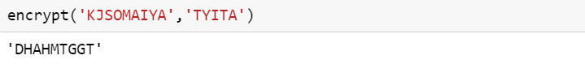

* Decryption:

def decrypt(ciphertext,key):

key_len=len(key)

key_as_int=[ord(i) for i in key]

ciphertext_int = [ord(i) for i in ciphertext]

plaintext = ''

#applying the formula for decryption

for i in range(0,len(ciphertext_int)):

value = (ciphertext_int[i] - key_as_int[i % key_len]) % 26

plaintext += chr(value + 65)

return plaintext

OUTPUT:

