**Ecological character displacement can destabilize food-web dynamics**

Matthew A. Barboura,1, Seth Rudmana, and Sarah Ottoa

aDepartment of Zoology, University of British Columbia, #4200-6270 University Blvd., Vancouver, B.C., V6T 1Z4, Canada.

**1Corresponding author:** Matthew A. Barbour, Department of Zoology, University of British Columbia, #4200-6270 University Blvd., Vancouver, B.C., V6T 1Z4, Canada. Telephone: (604) 446-8576, Email: barbour@zoology.ubc.ca.

**Keywords:** competition; eco-evolutionary dynamics; ecological speciation; three-spine stickleback; zooplankton

**Abstract**

Ecological character displacement is a key driver of diversification and adaptive radiation; however, there has been little work examining the consequences of character displacement on the dynamics of ecological communities. Given the growing recognition for the role of evolution in structuring ecological communities, understanding how major evolutionary processes impact ecological dynamics is increasingly important. Here, we build a mathematical model to predict how exploitative competition between two consumers for two resources affects the evolution of consumer attack rates, and, in turn, consumer-resource population dynamics. We then compared these predictions to results from a natural system, where a fish consumer (three-spine stickleback) has become locally adapted to different aquatic habitats with different resources (benthic vs. limnetic zones). Our model suggested that increasing ecological character displacement decreases the equilibrium density of resources, and with sufficient divergence, results in more oscillatory (destabilizing) consumer-resource dynamics. In support of this prediction, we found that the biomass density of zooplankton (resource) in lakes with two species of stickleback was only a fraction of that found in lakes with one species, varying from 4 to 41%. Moreover, we found that the biomass density of zooplankton was 2-fold more variable (CV) in lakes with two vs. one species of stickleback. These results suggest that ecological character displacement can eventually have a negative feedback on food-web persistence in the absence of other processes.

**Introduction**

Ecological character displacement (ECD) is thought to be a key evolutionary process in the diversification of species and consequently the generation of biodiversity [(Schluter 2000; Pfennig and Pfennig 2010; Stuart and Losos 2013)](https://paperpile.com/c/NgFwQk/VXBF+CRq1+MmDu). ECD describes the “process of phenotypic evolution in a species generated or maintained by [exploitative] resource competition with one or more coexisting species” (Schluter 2000). Over the past 40 years, a large body of theoretical [(e.g. Lawlor and Smith 1976; Abrams 1986; Doebeli 1996; Taper and Chase 1985)](https://paperpile.com/c/NgFwQk/8Qx2+J8fi+x4Bf+Nss9) and empirical [(reviewed in: Schluter 2000; Dayan and Simberloff 2005; Stuart and Losos 2013)](https://paperpile.com/c/NgFwQk/VXBF+MvGc+MmDu) work has been generated to understand the scenarios under which exploitative competition for resources leads to the divergence of consumer foraging traits. Yet, although the process of ecological character displacement is driven by the interplay between competition and trait change, and hence is strongly dependent on resource availability, little of the work to date has explicitly considered how character displacement impacts other species within the community. Similarly, research on food-web dynamics has largely ignored the potential role of evolution in altering interactions and stability [(Fussmann et al. 2007)](https://paperpile.com/c/NgFwQk/aaJj). Given the emerging evidence that evolutionary processes can drive ecological dynamics (Hairston et al. 2005, Post et al. 2008, Harmon et al. 2009, Schoener 2011, Rudman et al. 2015), understanding the ecological consequences of character displacement is a natural first step in investigating how evolutionary processes affect food-web dynamics.

Ecological character displacement has typically been considered to be a stabilizing factor in communities [(Lawlor and Smith 1976)](https://paperpile.com/c/NgFwQk/8Qx2). This is because divergence in foraging traits is thought to reduce the strength of interspecific competition between consumers. Reducing the strength of interspecific competition relative to intraspecific competition is a stabilizing force in consumer-resource systems. Consumer specialization on distinct resources suggests that there are niche differences between consumers. Mathematically, this is also often assumed to be the case, because using techniques such as evolutionary invasion analysis describe the ability for a consumer with a mutant allele to increase in abundance when rare, a demographic signature of niche differentiation. Therefore, if both consumers are able to invade when rare, then this suggests that they can coexist. On the other hand, relatively specialized consumers have also been shown to be a strongly stabilizing force in food webs (McCann et al. 2005). This is because these more specialized consumers may generate asynchrony in the dynamics of patchily distributed resources. This asynchrony in resources then permits consumers to move to habitat patches with higher resource densities after they have depleted the resources in a different patch. If, for example, the consumers were not specialized, then the resources would exhibit the same dynamics, so when the resources at low densities, consumers would be unable to switch to alternative resources, which would cause the consumer populations to crash, and oscillate more with their resources (McCann et al. 2005). Consequently, whether ecological character displacement will tend to stabilize (via asynchronous resource dynamics) or destabilize (via increased interaction strength) food webs is unclear.

On the other hand, ecological character displacement often results in the evolution of characters that enhance a consumer’s ability to capture resources, which tends to destabilize consumer-resource interactions [(Murdoch et al. 2003; McCann 2011)](https://paperpile.com/c/NgFwQk/xmGa+oJBV).

This occurs because increases in a consumer’s attack rate results in the resource being suppressed well below its carrying capacity, which if sufficient enough, can generate oscillations, and hence less stable, consumer-resource dynamics (Rosenzweig 1971; Murdoch et al. 2003). Experimental decreases in interaction strength between consumers and resources has been shown to promote coexistence between consumers and resources (Luckinbill 1973). Moreover, there is broad support that specialized consumers, since they are tightly coupled to their resources, tend to exhibit consumer-resource cycles, whereas this is not the case for generalists (Murdoch et al. 2002). Therefore, although evolutionary responses to exploitative competition may reduce the strength of interactions between consumers, they ultimately increase the strength of interactions with their resources which can destabilize the direct consumer-resource interaction (rather than the indirect consumer-consumer interaction). While prior models of character displacement have included more realistic functional responses and spatial relationships between consumers and resources, they have focused more on whether these factors alter patterns of character displacement rather than the effects of character displacement on the stability of the ecological community. As a consequence, it is currently unclear whether ecological character displacement has a net stabilizing or destabilizing effect on ecological communities.

Here, we address this knowledge gap by building a mathematical model to examine how ecological character displacement affects consumer-resource dynamics. We then compared the predictions from our model to field data from one of the most well-studied examples of ecological character displacement in a natural system, threespine stickleback in lakes of southern British Columbia. We specifically sought to address two questions: (1) How does exploitative competition between two consumers for two resources affect the evolution of consumer attack rates? (2) How does the evolution of consumer attack rates affect community stability?

**Methods & Results**

**Model and Analytical Methods**

**Food-Web Dynamics**

We modelled the dynamics of two consumers indirectly competing through the consumption of two, patchily distributed resources using the following general equations:

$$\frac{dR_{1}}{dt}=r_{1}R_{1}(1-\frac{R_{1}}{K_{1}})-F_{11}(R_{1},R_{2})C_{1}-F_{21}(R_{1},R_{2})C_{2}$$

$$\frac{dR_{2}}{dt}=r_{2}R_{2}(1-\frac{R_{2}}{K_{2}})-F_{12}(R_{1},R_{2})C_{1}-F_{22}(R_{1},R_{2})C_{2}$$

$$\frac{dC_{1}}{dt}={C_{1}(e_{11}F}_{11}(R_{1},R_{2})+{e_{12}F}_{12}(R_{1},R_{2})-m_{1})$$

$$\frac{dC_{2}}{dt}={C_{2}(e_{21}F}_{21}(R_{1},R_{2})+{e_{22}F}_{22}(R_{1},R_{2})-m_{2})$$

We assumed resource *i* exhibits logistic growth, where $r_{i}$ represents its population growth rate in the absence of consumers and $K_{i}$ is its carrying capacity. We assumed consumer *i* experiences density-independent mortality at rate $m_{i}$ and converts resource *j* into new consumers at a rate $e_{ij}$.

To model the multispecies functional response of each consumer, $$F_{ij}(R_{1},R_{2})$$, we used a spatially-implicit functional response developed by [McCann et al. (2005)](https://paperpile.com/c/NgFwQk/iAft). This spatially-implicit functional response assumes that each resource is restricted to a separate habitat patch of equal size. This functional response also assumes that consumers are mobile and rapidly switch between habitat patches depending on the relative densities of the resources. Here, a ‘rapid switch’ is relative to a consumer’s population growth rate, which enables the spatially-implicit model to approximate a spatially-explicit model [(McCann et al. 2005)](https://paperpile.com/c/NgFwQk/iAft). In addition, this spatially-implicit model assumes that a consumer only perceives resources as well mixed at the scale of the habitat patch, resulting in the following functional response equations:

$$F_{11}(R_{1},R_{2})=\frac{W_{11}(R_{1},R_{1})a_{11}R_{1}}{1+W_{11}(R_{1},R_{2})a_{11}h_{11}R_{1}+W_{12}(R_{1},R_{2})a_{12}h_{12}R_{2}}$$

$$F_{12}(R_{1},R_{2})=\frac{W_{12}(R_{1},R_{1})a_{12}R_{2}}{1+{W_{11}(R_{1},R_{2})a_{11}h_{11}R_{1}+W}_{12}(R_{1},R_{2})a_{12}h_{12}R_{2}}$$

$$F_{21}(R_{1},R_{2})=\frac{W_{21}(R_{1},R_{1})a_{21}R_{1}}{1+{W_{22}(R_{1},R_{2})a_{22}h_{22}R_{2}+W}_{21}(R_{1},R_{2})a_{21}h_{21}R_{1}}$$

$$F_{22}(R_{1},R_{2})=\frac{W_{22}(R_{1},R_{1})a_{22}R_{2}}{1+W_{22}(R_{1},R_{2})a_{22}h_{22}R_{2}+W_{21}(R_{1},R_{2})a_{21}h_{21}R_{1}}$$

We assumed that consumer *i* feeding on resource *j* has a handling time $h_{ij}$, attack rate $$a_{ij}$$, and habitat preference $$W_{ij}(R_{1},R_{2})$$. The consumer’s habitat preference function takes the form:

$$W_{11}(R_{1},R_{2})=\frac{{w_{11}R}_{1}}{w_{11}R_{1}+w_{12}R_{2}}$$

$$W_{12}(R_{1},R_{2})=\frac{{w_{12}R}_{2}}{w_{11}R_{1}+w_{12}R_{2}}$$

$$W_{21}(R_{1},R_{2})=\frac{w_{21}R_{1}}{w_{22}R_{2}+w_{21}R_{1}}$$

$$W_{22}(R_{1},R_{2})=\frac{{w_{22}R}_{2}}{w_{22}R_{2}+w_{21}R_{1}}$$

where $$w_{ij}$$ is the relative preference for consumer *i* to feed in the habitat where resource *j* is found when resources *i* and *j* are at equal densities. All parameters in our model were constrained to be positive. Note that wij = 1 - wii

Similar models of exploitative competition that explicitly model resource dynamics have shown that character displacement in foraging traits is an inevitable consequence [(Lawlor and Smith 1976; Abrams 1986)](https://paperpile.com/c/NgFwQk/8Qx2+J8fi), unless there is some other form of density dependence acting on consumers ([Abrams 1986)](https://paperpile.com/c/NgFwQk/J8fi).

*How does exploitative competition affect the coevolution of consumer attack rates?*

Analytical Solution -- To answer this question, we conducted an evolutionary invasion analysis on consumer attack rates following the methodology of [Otto and Day (2007)](https://paperpile.com/c/NgFwQk/ySGZ). Specifically, we augmented the above model to track the dynamics of a mutant attack-rate allele for a given consumer (e.g. for $C_{1}$: $a_{11, m}, a_{12, m})$ that appears in a population fixed for the resident allele (e.g. for $C_{1}$: $a_{11}, a_{12})$. We then identified the conditions that would enable a consumer with the mutant attack-rate allele to have a positive population growth rate, and subsequently invade the system. We assumed that the mutant allele had no effect on resource population dynamics because the mutant is at low density. We also assumed that the mutant allele had only a small effect on attack rate and can be written as $a_{ij, m}=a_{ij}+δ_{ij}$. Furthermore, we impose a linear trade-off so that $δ_{ij}$ = $-δ_{ii}$. By taking the partial derivative of the mutant allele’s dynamics with respect to its abundance, a mutant attack-rate allele will invade the system when the following condition is positive:

$δ_{ii}R_{i}^{2}w_{ii}(e_{ii}({R_{i}w_{ii}+}^{}R_{j}w_{ij})+a_{ij}R_{j}^{2}w_{ij}(e_{ii}h_{ij}-e_{ij}h_{ii}))+$

$δ_{ij}R_{j}^{2}w_{ij}(e_{ij}({R_{i}w_{ii}+}^{}R_{j}w_{ij})+a_{ii}R_{i}^{2}w_{ii}(e_{ij}h_{ii}-e_{ii}h_{ij}))$

This criteria confirms our intuition that, if resources are equally abundant ${(R}_{1}^{}=$ $R_{2}^{})$, consumer attack rates will evolve toward the resource for which the consumer has a greater preference, higher conversion efficiency, and lower handling time. However, if the alternative resource is relatively more abundant, this can cause evolution to favor the more abundant resource. This does present a bit of a paradox though. Indeed, we would expect that as consumers evolve an increased capacity to exploit a resource, this will cause the resource to decrease in abundance, thereby reducing the benefits to the consumer. Given a competing consumer that is also evolving, this may eventually cause resources to become equally abundant, at which point, this would then favor the evolution of consumers to evolve an increased capacity to exploit the resource that they have an advantage on. This effectively is ecological character displacement and recapitulates this result in our model.

*Numerical Solution* -- We used latin hypercube sampling to identify a set of parameters resulting in stable coexistence for both a three-species (C1, R1, & R2) and four-species food web (C1, C2, R1, & R2). We used the following range of initial state variables: (R1: ; R2: ; C1: ; C2: ) and parameter values (eij: ; hij: ; aij: ; mi: ; wii: 0.05 - 0.95). In this simulation. For the 3-species system, we set the initial value for C2 = 0 and all foraging parameters related to C2 equal to zero. After identifying a parameter set resulting in stable coexistence, we simulated the evolutionary dynamics of the system. Specifically, we randomly chose a consumer (probability = 0.5) and modified its attack rate by either -0.1 or +0.1 ($δ_{ij}$). We then determined whether the mutant could invade the system. If so, we updated the attack rate of the resident consumer to the mutant attack rate and allowed the system to reach a steady-state. We then repeated the simulation X times to determine the coevolutionary trajectory of competing consumers. If both consumers evolved toward being more generalists, we classified this as convergent character displacement. If both consumers evolved toward being more specialists on different resources, we classified this as divergent character displacement. If one consumer evolved toward specialization, while the other consumer evolved toward generalism, we classified this as parallel character displacement.

We found that …

*How does coevolution of consumer attack rates affect food-web stability?*

Analytical Solution -- To analyze the dynamics of the model, we identified the equilibrium conditions and examined their local stability using standard techniques (Otto and Day 2007). In the supplementary material, we give a detailed analysis of all model equilibria; however, we focus our results in the main text on the equilibria where at least one consumer and both resources are present. We did this because these are the only equilibria that enable us to study how specialization affects consumer-resource dynamics. For equilibria that contained only one consumer, we determined invasibility criteria to study coexistence between competitors. Invasibility criteria are commonly used to study coexistence in competitive systems (Chesson 2000). Invasibility criteria identify the conditions under which an invader, in this case a second competitor, is able to increase from low density in the presence of the rest of the community. To calculate this criteria, we assumed that the resident species are unaffected by the invader because the invader is at low density. For the two-consumer, two-resource equilibrium, we used Routh-Hurwitz criteria to examine its local stability properties (Otto and Day 2007). The Routh-Hurwitz criteria specify when equilibria are locally stable without requiring explicit solving of the eigenvalues of the stability matrix, and are therefore useful for complicated stability matrices.

We were unable to find an analytical solution for the local stability of the general model; so we explored a simplified scenario. In this situation, we considered the scenario where consumers were mirror images of each other (i.e. aij = aji; eij = eji; hij = hji; m1 = m2; w11 = w22). and that resources were equivalent. When we do this, we find

Results for the 3-species model: I haven’t done this, but I need to.

*One-Consumer, Two-Resource System*

Setting $$C_{2}=0$$ and solving equations (ref) = 0, we determined that $$R_{1}$$, $$R_{2}$$, and $$C_{1}$$ will reach a steady-state equilibrium under the following conditions:

$${R_{1}}^{*}=\frac{w_{ij}a_{ij}K{R_{2}}^{*} }{w_{ii}a_{ii} (K-{R_{2}}^{*})+w_{ij}a_{ij}{R_{2}}^{*}}$$

$${C_{1}}^{*}=\frac{r(K-{R_{2}}^{*})(w_{ii}{R_{1}}^{*}+w_{ij}{R_{2}}^{*}+h(w_{ii}a_{ii}{{R_{1}}^{*}}^{2}+w_{ij}a_{ij}{{R_{2}}^{*}}^{2})}{w_{ij}a_{ij}K{R_{2}}^{*}}$$

$$m=\frac{e(w_{ii}a_{ii}{{R_{1}}^{*}}^{2}+w_{ij}a_{ij}{{R_{2}}^{*}}^{2})}{w_{ii}{R_{1}}^{*}+w_{ij}{R_{2}}^{*}+h(w_{ii}a_{ii}{{R_{1}}^{*}}^{2}+w_{ij}a_{ij}{{R_{2}}^{*}}^{2})}$$

We did not solve for $${R_{2}}^{*}$$ explicitly because the expression is a complicated quadratic (see Appendix 1). In order for this equilibrium to be valid, all species must have positive densities, which requires $$K>{R_{2}}^{*}$$ and $$K>{R_{1}}^{*}$$ (shown in Appendix 1), otherwise $${C_{1}}^{*}$$ is absent. From these equations, it is not immediately clear how specialization in attack rates and/or preferences will affect the equilibrium densities of the consumer and resources. However, we expected that a consumer with a higher effective attack rate on one resource would suppress this resource to a lower relative density than the alternative resource. To verify this, we specified $$R_{1}$$ as the resource subject to a higher effective attack rate and examined the conditions under which $${R_{2}}^{*}/{R_{1}}^{*}$$ > 1. We found that $${R_{2}}^{*}/{R_{1}}^{*}$$ > 1 when:

$$\frac{(K{{-R}_{2}}^{*})(w_{ii}a_{ii}-w_{ij}a_{ij}) }{w_{ij}a_{ij}K}>0$$

This condition will be positive whenever the effective attack rate of $$C_{1}$$ on $$R_{1}$$ ($$w_{ii}a_{ii}$$) is greater than on $$R_{2}{(w}_{ij}a_{ij})$$. When $$w_{ii}a_{ii}=w_{ij}a_{ij}$$, this condition goes to zero, indicating that $$R_{1}$$ and $$R_{2}$$ are at the same equilibrium densities.

In Appendix 1, we show that $$C_{2}$$ will be able to invade whenever its growth rate is greater than $$C_{1}$$ in Appendix 1 that coexistence occurs whenever the resident and invading consumers have higher relative attack rates and preferences for different resources (when $$a_{ii}$$ > $$a_{ij}$$, $$w_{ii}$$ > $$w_{ij}$$ or $$a_{ij}$$ > $$a_{ii}$$, $$w_{ij}$$ > $$w_{ii}$$) (Fig. 1). This occurs because the resident consumer will suppress the resource it has a higher effective attack rate on to a lower equilibrium density than the alternative resource. The higher relative density of the alternative resource ensures that the invading consumer, which has a relatively higher attack rate and preference for this abundant resource, will always have a positive growth rate, and therefore invade the system (Fig. 1). This occurs regardless of the shape of the trade-off for attack rates and preferences for the two resources (Appendix 1). However, if the attack rates and preferences of the resident consumer are negatively correlated for the same resource ( $$a_{ii}$$ > $$a_{ij}$$, $$w_{ij}$$ > $$w_{ii}$$ or $$a_{ij}$$ > $$a_{ii}$$, $$w_{ii}$$ > $$w_{ij}$$), coexistence is still possible, albeit over a restricted region of parameter space (Fig. 1, Appendix 1).

Results for the 4-species model: I have done this, but I need to synthesize.

*Two-Consumer, Two-Resource System*

We show in Appendix 1 that the equilibrium densities of both consumers and both resources are equivalent to each other (i.e. $${C_{1}}^{*}={C_{2}}^{*}$$ and $${R_{1}}^{*}={R_{2}}^{*}$$) whenever there is matched specialization (when $$a_{ii}$$ > $$a_{ij}$$, $$w_{ii}$$ > $$w_{ij}$$ or $$a_{ij}$$ > $$a_{ii}$$, $$w_{ij}$$ > $$w_{ii}$$). Since their dynamics are equivalent, we can rewrite the equations describing their equilibrium densities as:

$$R^{*}=\frac{m(w_{ii}+w_{ij})}{(w_{ii}a_{ii}+w_{ij}a_{ij})(e-mh)}$$

$$C^{*}=\frac{r(K-R^{*})(w_{ii}a_{ii}+w_{ij}a_{ij}+hR^{*}(w_{ii}a_{ii}+w_{ij}a_{ij}))}{K(w_{ii}a_{ii}+w_{ij}a_{ij})}$$

From these equations, it is straightforward to see that $$R^{*}$$ will decrease when the effective attack rate of the consumer, $$w_{ii}a_{ii}+w_{ij}a_{ij}$$, increases. This increase will occur, regardless of the trade-off function, in the matched specialization scenario where $$a_{ii}$$ > $$a_{ij}$$, $$w_{ii}$$ > $$w_{ij}$$ or $$a_{ij}$$ > $$a_{ii}$$, $$w_{ij}$$ > $$w_{ii}$$. For $$C^{*}$$, increasing specialization from relatively low values will increase the equilibrium density of the consumer; however, when specialization is relatively high, increasing specialization will result in lower equilibrium density of the consumer.

In terms of local stability, we found that the consumer-resource dynamics switch from a steady-state equilibrium to a limit cycle when:

$$\frac{w_{ii}a_{ii}+w_{ij}a_{ij}}{w_{ii}+w_{ij}}> \frac{e+hm}{hK(e-hm)}$$.

Biologically, this means that increasing the effective attack rates of the consumers, while holding the right side of the equation constant, will push the system toward its boundary of stability. Figure 1 illustrates graphically the effect of increasing $$a_{ii}$$ on local stability. If we hold the other parameters constant, increasing $$a_{ii}$$ shifts the consumers’ zero net growth isocline to the left relative to the position of the resources’ isocline. Biologically, this means that increasing specialization increases the capacity of the consumers to exhibit a positive growth rate even when resources are at low densities. This results in the consumer suppressing the resources well below their carrying capacity. If this suppression is large enough, this causes the consumers and resources to exhibit a limit cycle (Fig. 1).

Numerical Solution -- We used the previously described simulation to determine two things: (1) does coevolution of consumer attack rates result in qualitative changes in food-web stability? To determine this, we determined the proportion of simulations, that were initially at a stable coexistence equilibrium, resulted in an unsteady-state or in the functional exclusion of one of the competitors (Ci < 1 x 10^-3).

(2) does coevolution of consumer attack rates result in quantitative changes in food-web stability? To determine this, we examined the simulations where stable coexistence persisted but there was a quantitative change in the maximum, real eigenvalue of the system, which is what determines local stability.

Field Evidence -- Effectively, this spatially implicit food-web model is a simplification of the common empirical finding that consumers tend to be more mobile than their resources and that consumer movement between habitats couples the dynamics of these habitats (McCann *et al.* 2005). Moreover, this spatially implicit food-web model is likely a reasonable approximation of the foraging behaviour of threespine stickleback, one of the most well studied examples of ecological character displacement (Schluter & McPhail 1992; Rundle *et al.* 2003). Stickleback species pairs (found in lakes in Southwest British Columbia, Canada) consist of two relative specialists, benthic and limnetic ecotypes, that each feed preferentially on two fairly discrete resources (benthic invertebrates and zooplankton). Previous work has demonstrated that ecotypes are locally adapted to their respective habitats and prey (Schluter 1996). In contrast, the vast majority of other lakes in the region contain a single generalist form of stickleback, that feeds on both zooplankton and benthic invertebrates (Schluter & McPhail 1992).

To study the effects of resource specialization in stickleback on food-web dynamics, we quantified the seasonal dynamics of zooplankton, the preferred resource of the limnetic ecotype (and alternative resource of the benthic ecotype). To do this, we collected zooplankton samples from three lakes containing independently evolved species pairs of stickleback and three nearby lakes containing generalist populations of stickleback. Lakes containing generalist populations of stickleback were chosen based on proximity and physical similarity to lakes containing species pairs of stickleback. We collected zooplankton monthly May-August 2012, in October 2012, and February 2013. For each sample period in each lake we collected two five-meter and one ten-meter vertical zooplankton sample using a 30cm diameter zooplankton tow constructed from 80um mesh with a Cod end. All zooplankton samples were subsampled to 1/16th volume, stained with Rose bengal, then counted with at least the first 20 individuals of each taxon measured to obtain average sizes for each taxon. **[SETH, PLEASE INSERT HOW WE CONVERTED LENGTH ESTIMATES TO BIOMASS].**

*Empirical Results*

Based on our model results, we predicted that resource specialization in threespine stickleback would result in lower biomass density of zooplankton, and if sufficient enough, more seasonal variability as well. In support of this prediction, we found that the biomass density of zooplankton (seasonal average) in species-pair lakes was 11-times lower than solitary lakes (Fig. 3A,B). Moreover, we found that the biomass density of zooplankton was 2-times more variable in species-pair lakes compared to solitary lakes (Fig. 3A,C).

**Discussion**

Our results suggest that specialization can destabilize competitive systems. On the one hand, specialization is necessary for coexistence between competing consumers; however, if specialization is sufficient enough, this can destabilize consumer-resource dynamics. *Discussion of in general how this work synthesizes competition and consume-resource theory. Notably, by taking a mechanistic approach to consumer-resource modeling (extension of MacArthur and Rosenzweig-MacArthur models).*

P2: Corroborating results from previous competition models and discuss how we extended other models.

P3: Corroborating results from previous consumer-resource models, although our results are somewhat at odds with McCann 2005’s work on habitat preference.

Conclusion:

**Acknowledgements**

**References**  
1.  
Abrams, P. (1986). Character displacement and niche shift analyzed using consumer-resource models of competition. *Theoretical Population Biology*, 29, 107160.

2.  
Dayan, T. & Simberloff, D. (2005). Ecological and community‐wide character displacement: the next generation. *Ecol Lett*, 8, 875–894.

3.  
Doebeli, M. (1996). An explicit genetic model for ecological character displacement. *Ecology*, 77, 510–520.

4.  
McCann, K.S., Rasmussen, J.B. & Umbanhowar, J. (2005). The dynamics of spatially coupled food webs. *Ecology letters*, 8, 513–23.

5.  
Pfennig, D. & Pfennig, K. (2010). Character displacement and the origins of diversity. *Am Nat*, 176 Suppl 1, S26–44.

6.  
Rundle, H., Vamosi, S. & Schluter, D. (2003). Experimental test of predation’s effect on divergent selection during character displacement in sticklebacks. *Proc Natl Acad Sci*, 100, 14943–14948.

7.  
Schluter, D. (2000). Ecological Character Displacement in Adaptive Radiation. *Am Nat*, 156, S4–S16.

8.  
Schluter, D. & McPhail, J.D. (1992). Ecological character displacement and speciation in sticklebacks. *Am. Nat.*, 140, 85–108.

9.  
Stuart, Y. & Losos, J. (2013). Ecological character displacement: glass half full or half empty? *Trends Ecol Evol*, 28, 402–408.

10.  
Taper, M.L. & Case, T.J. (1992). Models of character displacement and the theoretical robustness of taxon cycles. *Evolution*, 46, 317–333.

*many more to add*

Tables

**Figures**

**Figure 1: Plot the eigenvalues as a function of the parameters w and ap for a given parameter set to show how specialization (i.e. character differences in allopatry) promotes invasion by a second consumer (left column), but destabilizes the competive system (right column). Do this for all of the different trade-off curves.**

**Figure 2: Plot the real densities and abundances and show how higher specialization promotes invasion, but at the same time destabilizes the 2C-2R system. Consider showing the geometric effects on the system as well.**

**Figure 3: stickleback system dynamics**

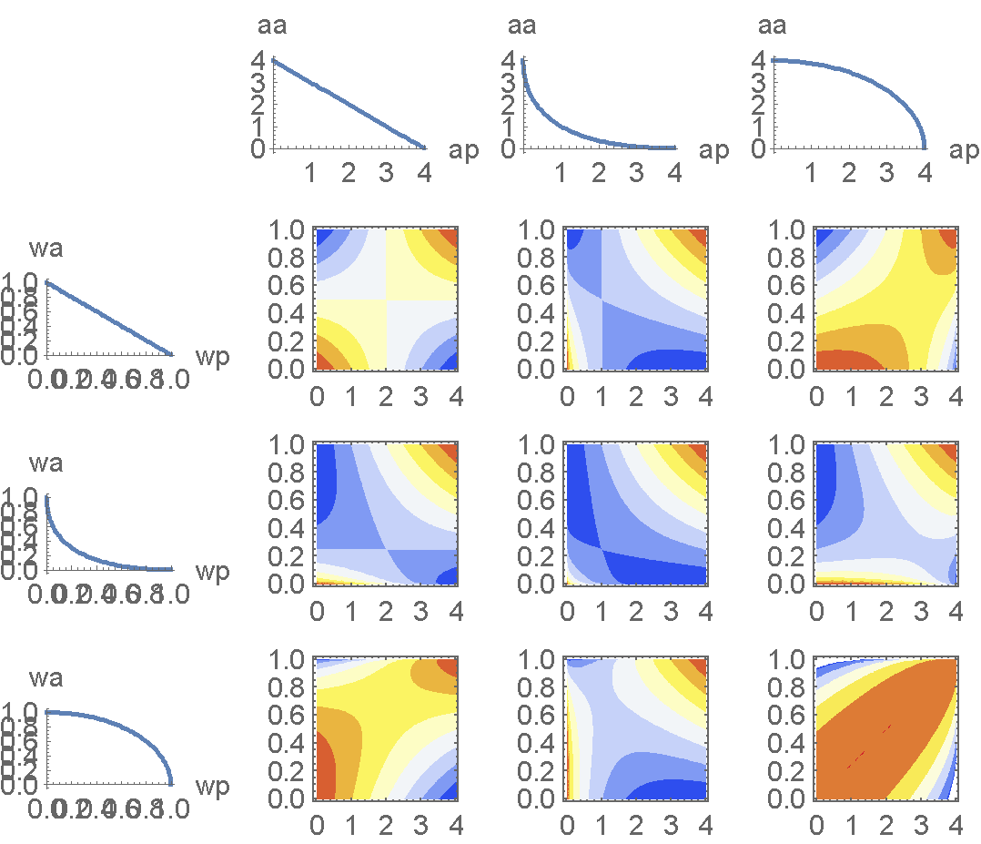

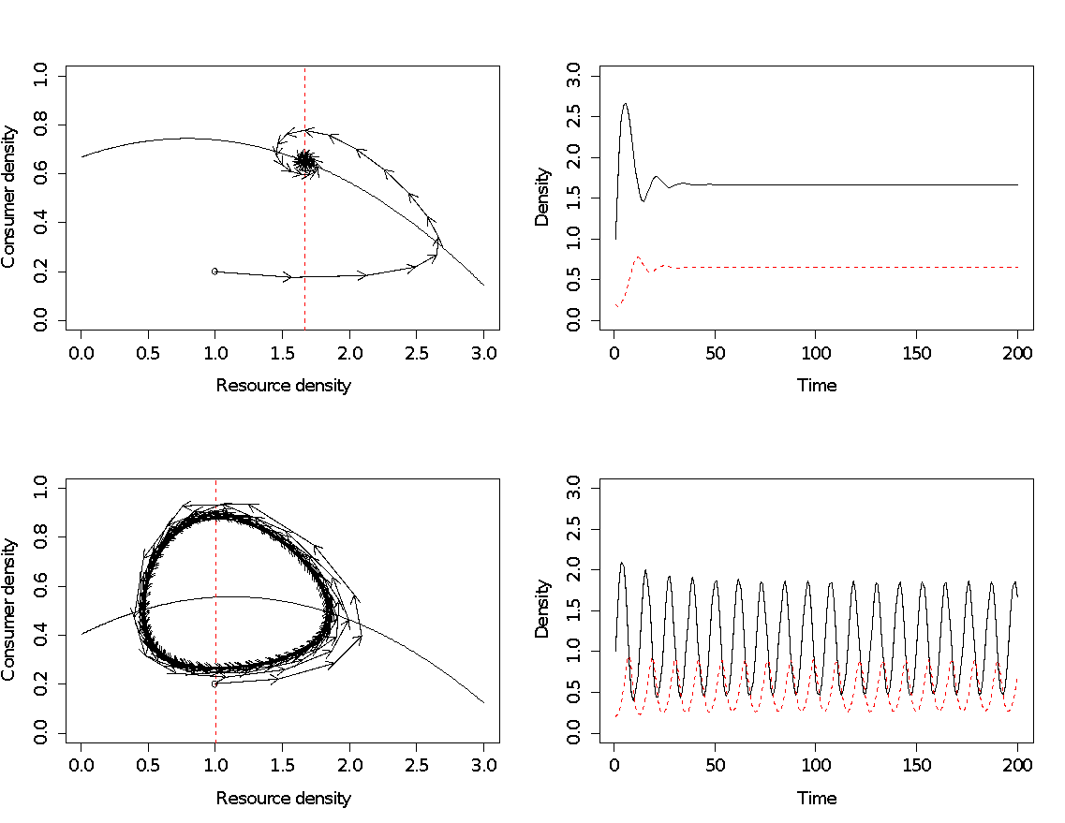 **Figure 1**. Dynamics of the reduced consumer-resource model under ecological character displacement (i.e. increasing $$a_{ECD}$$). All of these plots represent the dynamics of consumer and resource densities over time, but the ones on the left illustrate this in phase-space. Solid black lines correspond to the resource isocline (phase-space plot) and density over time, while dashed red lines correspond to the consumer isocline (phase-space plot) and density over time. The directions of the arrows in the phase-space plots illustrate the trajectory of consumer and resource densities over time. The top-plots represent a scenario with little ecological character displacement ($$a_{ECD}=1.5$$), whereas the bottom-plots represent a scenario with relatively greater ecological character displacement ($$a_{ECD}=2.5$$). Increasing $$a_{ECD}$$ shifts the consumer isocline to the left relative to the position of the resource isocline, which increases the capacity of the consumer to suppress the resource below its carrying capacity. For these simulations, we set initial resource and consumer densities to 1.0 and 0.2, respectively, and held the following parameter values constant: *r* = 1.0; *K* = 3.25; *e* = 0.8; *m* = 1.0; *h* = 0.4). Note that for this reduced model, the qualitative conclusions still hold for different initial resource and consumer densities as well as other sets of parameters.

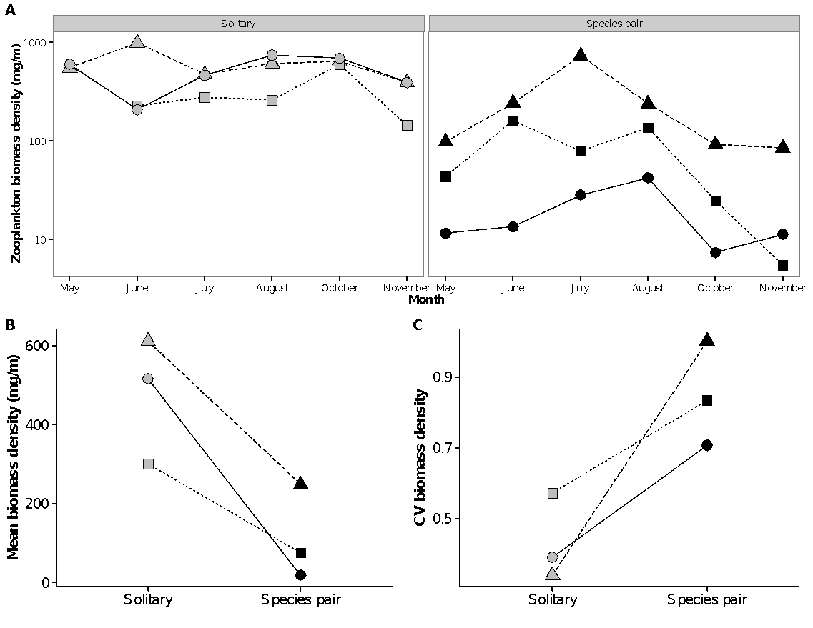

**Figure 3**. Ecological character displacement in threespine stickleback drive variation in the biomass density of zooplankton in small lakes of southwestern British Columbia. (A) Seasonal variation in biomass density of zooplankton in lakes with a single species of stickleback (Solitary) vs. lakes with two species of stickleback (Species pair). (B) Seasonal mean biomass density of zooplankton is 11-times lower, on average, in lakes with a two vs. a single species of stickleback. (C) Seasonal variability (coefficient of variation, CV) in biomass density of zooplankton in lakes with two vs. a single species of stickleback. Grey and black symbols correspond to lakes with a single vs. pair of stickleback species, respectively. Symbol shape and line type correspond to lakes that have been paired based on proximity and lake characteristics.