Testing whether a system is at equilibrium or not

2025-01-09

By definition, a system is at equilibrium when there is no net change in its state variable(s) (e.g. population abundance) over time. Mathematically, this is when the first derivative of the state variable(s) with respect to time is equal to zero. Here, we describe how to use generalized additive mixed models (GAMMs) to statistically determine whether a system is outside equilibrium or not. GAMMs provide a flexible framework for modeling timeseries data: different types of variables can be modeled (e.g. counts, presence/absence, biomass, etc.); complex experimental designs (i.e. crossed/nested random effects), residual temporal autocorrelation, as well as irregularly spaced timeseries (Pedersen et al. 2019). In addition, they are well suited for detecting periods of change in timeseries data (Simpson 2018; Pedersen et al. 2020).

To illustrate this approach, we used a GAMM to analyze the population dynamics of flour beetles (Tribolium castaneum) sampled weekly over a period of 11 weeks from three independent populations experiencing the same environmental conditions. The variable of interest is the natural log abundance (lnN) of beetles over time. The first derivative of this variable with respect to time corresponds to the per-capita population growth rate (dlnN(t)/dt). When dlnN(t)/dt = 0, the beetle population is at equilibrium. We first fit our GAMM with the following code:

GAMM <- gam(log(Abundance) ~ s(Week) + s(ID, bs="re") + s(Week, ID, bs="re"), data = test_df, method = "REML")

Here, we have modeled the natural log abundance of the beetle population over time (s(Week)) and allowed each independent population to have a different intercept (s(ID, bs=”re”) and slope (s(ID, Week, bs=”re”) (i.e. random intercept and slope). This model fit the data well (Fig. X), outperformed other potential models (e.g. random intercept only, random smooths), and there was no evidence of residual autocorrelation (see code online). (Pedersen et al. 2019) provide an excellent introduction to fitting and comparing GAMMs.

From this GAMM, we calculated the mean and 95% confidence interval of the first derivative of the model’s fit throughout the entire experiment. This allowed us to determine the time periods of the experiment where the beetle population was at equilibrium (thicker lines in Fig. X). Specifically, we can say that there is no clear change in the beetle population over these time periods, because the 95% confidence interval overlaps with zero (dashed line in Fig. X). From this figure, it can be seen that there are multiple transient periods of zero detectable change. Knowing whether the study system is potentially in a transient state requires domain knowledge and careful reflection. For the flour beetles, we conclude that the population has reached an equilibrium by week 11, because the model indicates that there was no net change for two consecutive time points, whereas previous transients always occurred between sampling periods. Also, the flower beetles have had close to 3 generations by this time point… We recommend that decisions regarding equilibrium be made after the population has been documented to be at equilibrium for at least one generation. Given the generation time of the flour beetle is about 30 days, we recommend documenting that the population is at equilibrium for at least 5 consecutive weeks of sampling (i.e. 35 days).

One challenge with our approach is that the equilibrium state is the null model. In other words, we default to concluding the system is at equilibrium if the confidence intervals of the estimate of the first derivative overlap with zero. This makes our approach susceptible to concluding a system is at equilibrium at low sample sizes due to greater uncertainty widening the confidence intervals. Therefore, we always recommend plotting the model and inferred change in the system (Fig. X) and using domain expertise to conclude whether there is sufficient data to make an assessment of whether the system is at equilibrium or not. Mixed models are helpful in this regard because they efficiently pool information from multiple replicates. Analysis of individual timeseries, in contrast, need more sampling points to determine whether they are at equilibrium or not.

pred_deriv_plot

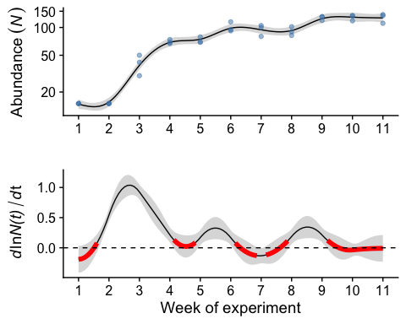

deriv_2_plot

