Insect food web structure depends on host-plant genotype

Matthew A. Barbour1*, Jordi Bascompte2, Joshua R. Nicholson1, Riitta Julkunen-Tiitto3, Erik S. Jules4, and Gregory M. Crutsinger1

1Department of Zoology, University of British Columbia, #4200-6270 University Blvd., Vancouver, B.C., V6T 1Z4, Canada

2Estación Biológica de Doñana, CSIC, C/ Américo Vespucio s/n, 41092 Sevilla. España

3Department of Biology, University of Eastern Finland, PO Box 111, FI-80101, Joensuu, Finland

4Department of Biological Sciences, Humboldt State University, 1 Harpst St., Arcata, California, 95521, USA

*Author for correspondence, email: barbour@zoology.ubc.ca

Abstract

Interactions between individual organisms give rise to the arrangement and strength of feeding interactions among species within a community (i.e., food web structure). While we know that food web structure can have a profound influence on community dynamics, we have a limited understanding of how different genotypes and phenotypes of individual organisms contribute to overall food web structure. We address this knowledge gap by using a common garden experiment to examine how genetic and phenotypic variation within a dominant host-plant species influences insect food web structure. We found that plant genotypes differentially contributed to the composition of herbivore-parasitoid interactions. These differential contributions led to the formation of distinct genotype-herbivore-parasitoid associations. In particular, we found that heritable variation in plant traits mediated resistance to herbivores (e.g., herbivore density and size). Moreover, we found that variation in both herbivore density and size affected attack rates from parasitoids. Taken together, our results indicate that host-plant genetic variation can play a key role in the assembly of insect food webs. Moreover, our results highlight the potential for microevolutionary processes at the plant-population level to shape insect food web structure and dynamics.

Introduction

A major goal of food web research in ecology is to understand how the arrangement and strength of feeding interactions among species (i.e. food web structure) influences community dynamics (cite). Network theory has emerged as a novel framework for quantifying the structure of food webs, using species as nodes and their interactions as links, and has led to clearer predictions for how network assembly should influence the persistence of species and, ultimately, the stability of food web. For example, food webs that exhibit a modular structure, when there are groups of species that frequently interact with one another more so than other species, promotes the persistence of food webs by buffering species extinctions from propagating throughout the entire community (Stouffer & Bascompte, 2011). To date, empirical tests of network theory have focused almost exclusively on species and interspecific variation, assuming that all individuals are equal (). However, there can be considerable variation among individuals that can influence interactions within and between species, as well as the diversity and composition of communities (Cite). Therefore, intraspecific variation has the potential to play an important role in structuring food webs but remains poorly explored in a network context (or whatever you want to say here)

Intraspecific genetic variation is a key driver of individual differences that occur within food webs () and has been shown to have numerous direct and indirect effects throughout communities in a variety of focal species, from the base of food webs to top trophic levels (). For example, plants and phenotypes (insert examples from community genetics). Similarly, predators and phenotypes (insert examples from eco-evo). While food web studies have failed to incorporate genetic variation, a mechanistic understanding of the genetic basis to food web structure can be built by estimating the heritability of phenotypic variation and understanding the effects on species interactions within a network context.

Here, we test the hypothesis that genetic variation within a species influences food web structure due to heritable phenotypic variation that directly and indirectly affects feeding interactions among associated species using the insect gall-parasitoid food web (5 gall species, 8 parasitoid speice) associated with the coastal willow Salix hookeriana (hereafter ‘willow’). This willow-gall-parasitoid system was ideal for testing our hypothesis for the following three reasons. First, S. hookeriana, displays considerable genetic and phenotypic variation that corresponds to variation in the susceptibility to galling insects (Barbour et al. in press). Second, the sedentary nature of herbivorous galling insects make them amenable to building quantitative food webs due to the fact that galls can be collected and reared in the lab to determine survival and the extent of parasitism from different species (van Veen et al. 2006). Finally, prior studies in other willow species have shown that genetic variation can influence the strength of pairwise trophic interactions between galls and their parasitoids (Craig, Itami, & Price, 1990; Fritz, 1995), though have not examined this in the framework of food webs.

If genetic variation within species influences food web structure, we would predict that the willow-gall-parasitoid food web would exhibit a modular structure, due to variation in the frequency of particular gall-parasitoid interactions among willow genotypes. We predicted that heritable variation in plant traits would be associated with variation in gall density and gall size (indexes of resistance to galling insects), which in turn, would mediate the strength of gall-parasitoid interactions. Taken together, our study seeks to incorporate the role of individual variation in community assembled, to ascertain the the genetic basis of ecological networks, as well as develop a better understanding about the potential effects of evolution on food web dynamics. Play around with this, but you need to end your intro putting everything into a big concluding idea.

Materials & Methods

### Study System & Common Garden

We tested our hypothesis using a subset of the insect food web associated with the coastal willow Salix hookeriana. The herbivores of this food web all induce closed-galls on the leaves, buds, or shoots of S. hookeriana and consisted of four species of gall midges (Family: Cecidomyiidae) and a leaf galling sawfly Pontania californica (Family: Tenthredinidae)(Plate 1, supplement; for details on their biology, see Caltagirone, 1964; Gagné, 1989; Russo, 2006). The closed morphology of these gall species restricts the natural enemy community to eight species of insects that include seven parasitoid wasps (Chalcidoidea = 5 sp.; Platygastroidea = 1 sp.; Ichneumonoidea = 1 sp.) and one predatory Cecidomyiid midge (Lestodiplosis septemmaculata). Our study represents the first description of this gall-parasitoid food web, for which we give more quantitative details in the supplementary materials. The host-plant to this food web, S. hookeriana, displays considerable genetic and phenotypic variation, which corresponds to variation in susceptibility to a broader community of herbivorous insects (Barbour et al. in press). Moreover, prior studies in other willow species have also shown that genetic variation can influence the strength of pairwise trophic interactions between herbivores and their natural enemies (Craig, Itami, & Price, 1990; Fritz, 1995). Therefore, S. hookeriana (hereafter ‘willow’) represents an ideal system for studying the effects of host-plant genetics on insect food webs.

To isolate the effects of willow genetic variation on gall-parasitoid food webs, we used a common garden experiment consisting of 26 different genotypes of S. hookeriana (13 males; 13 females), located at Humboldt Bay National Wildlife Refuge (HBNWR) (40°40'53"N, 124°12'4"W) near Loleta, California, USA. Willow genotypes were collected from a single population of willows growing around Humboldt Bay. This common garden was planted in February 2009 with 25 clonal replicates (i.e., stem cuttings) of each willow genotype in a completely randomized design in two hectares of a former cattle pasture at HBNWR. Willows in our garden begin flowering in February and reach their peak growth in early August. During this study, willows had reached 2-4 m in height. Further details on the genotyping and planting of the common garden are available in Barbour et al. (2014, in press).

Willow genotypes are associated with particular gall-parasitoid interactions

To build a quantitative gall-parasitoid food web for each willow genotype, we collected all galls occurring on one haphazardly selected basal branch from about 5 randomly chosen replicates of each genotype (N = 146 trees, range = 4-9 trees per genotype). To control for differences in branch size, we estimated the number of shoots on each branch based on an allometric equation using the stem diameter of the sampled basal branch (mean shoot count = 280, SD = 124; details in supplementary materials). We collected all galls in September 2012 when gall larva were in late instars of their development or had already spun cocoons within the gall. All galls were placed into 30 mL plastic transport vials (loosely capped at the end) and maintained at room temperature in the lab for four months. We then opened galls under a dissecting scope and determined gall survival or parasitoid species identity. We omitted galls for which we could not reliably determine the cause of mortality from further analysis (43% of galls).

We used a null model analysis to test our prediction that certain willow genotypes would be associated with particular gall-parasitoid interactions. To do this, we first pooled all observed gall-parasitoid interactions for each willow genotype. This resulted in a weighted, bipartite (i.e., two sets of nodes) network, where each willow genotype and each unique gall-parasitoid interaction comprised the two sets of nodes, respectively. The weights between nodes corresponded to the frequency of each link (willow genotype-gall-parasitoid interaction). To identify different willow genotype-gall-parasitoid associations, we used an algorithm (QuaBiMo) that seeks to find the optimal partition of the network into groups, or modules, of nodes that frequently interact with each other compared to other nodes (Dorman and Strauss 2014). This module-finding algorithm seeks to maximize the modularity value Q, which is calculated as,



where m is half of the total number of observed links in the network, Aij is the weighted, bipartite network and Kij is the network of expected weights (Dormann and Strauss 2013). The module to which a node i or j is assigned is ci,cj. The indicator function δ(ci,cj) = 1 if ci = cj and 0 if ci ≠ cj. Q ranges from 0, which means the community has no more links within modules than expected by random chance, to a maximum value of 1, which indicates increasing support for the division of a network into modules. Since Q is determined by an optimality function and is susceptible to being trapped at local optima, we repeated this calculation 100 times and used the iteration with the highest Q value to identify the modules within our network. Importantly, the magnitude of Q will be influenced by the number of nodes, the number of links between nodes, and the total number of links observed (Dormann & Strauss, 2013; Thébault, 2012). Therefore, we used a conservative null model to examine whether the degree of modularity (Q) we observed was significantly different from what we would expect by chance. Specifically, we used a swapping algorithm that randomized the observed weights in the bipartite network while preserving both the total weights for each genotype and each gall-parasitoid interaction, as well as the number of unique links from the original network. Both the modularity and null model analysis were conducted with the bipartite package in R (Dormann R citation; R Development Core Team 2014).

Heritable variation in plant traits mediates resistance to galling insects

To identify the plant traits mediating the resistance of willow genotypes to herbivory from galling insects, we measured 40 different traits associated with variation in leaf quality (36 traits) and plant architecture (4 traits). Details on how these willow traits were sampled and quantified are given in Barbour et al. (2014, in press), but we summarize which traits were sampled here. Leaf quality traits included: phenolic chemistry (7 classes of compounds, 31 individual metabolites), trichome density, specific leaf area (SLA), water content, and percent Carbon and Nitrogen (converted to C:N). Plant architecture traits included: plant size, fractal dimension (index of architectural complexity), height, and foliage density. We calculated the broad-sense heritability (H2) of plant traits using the equation: H2 = VG / VP, where VG is the total genotypic variance among clones, and VP is the total phenotypic variance, calculated as the sum of the residual and genetic variance (Lynch & Walsh 1998). Broad-sense heritability values range between 0-1, where values close to zero indicate low heritability (i.e., the trait is strongly influenced by the environment), and values close to 1 indicate high heritability (i.e., the trait is strongly controlled by underlying genetic variation). Each of these traits exhibited significant broad-sense heritable variation among willow genotypes (mean leaf quality H2 = 0.72; mean architecture H2 = 0.27; range of H2 = 0.15 - 0.97; Barbour et al., 2014 in press).

We conducted two types of analyses to test whether heritable variation in plant traits affects resistance to galling insects. We quantified resistance from our gall collections on each replicate willow tree (N = 146) by calculating both the density of each gall species as well as the size of each gall (measured as the maximum diameter perpendicular to plant tissue orientation, to the nearest 0.01 mm). First, we calculated separate restricted maximum likelihood (REML) random-effect models and performed restricted likelihood-ratio tests to examine whether willow genotypes exhibited variation in the density and size of each gall species. Gall density and gall size were transformed as needed to improve normality and reduce heteroscedasticity of model residuals. As with each plant trait, we calculated the broad-sense heritability of gall density and gal size for each species. If we identified heritable variation in gall density or gall size among willow genotypes, we then used multiple regression with forward model selection to identify the key plant traits mediating resistance to galling insects. We mitigated multicollinearity using three different methods: principal components analysis, residual and sequential regression (Graham 2003), and omitting highly correlated traits (details in Barbour et al. 2014, in press). We used the forward model selection approach advocated by Blanchet et al. (2008), which prevents inclusion of spurious variables (i.e., inflated Type 1 error) and overestimation of explained variance (i.e., R2).

Resistance to galling insects affects the strength of gall-parasitoid interactions

To test our prediction that resistance to galling insects would affect the strength of gall-parasitoid interactions, we analyzed generalized linear and additive mixed-effect models (GLMM and GAMM, respectively). We modeled gall density, gall size and their interaction as fixed-effects, and included each replicate willow tree as a random effect. We modeled willow tree was as a random effect because gall density was measured at the scale of the entire willow tree, but gall size was measured for individual galls collected from each willow tree. Since parasitoids often exhibit a non-linear response to variation in gall size (e.g., Hezewijk and Roland, 2003), we first analyzed GAMMs and only switched to simpler GLMMs if the difference in aikaike’s information criteria (AIC) values between the models was less than two (i.e., we went with the most parsimonious model). For GAMMs, we used the chi-squared statistic to test for non-linear effects of gall density, gall size, and their interaction. For GLMMs, we used parametric bootstrapping to test the effect of gall density, gall size, and their interaction. We always started with the most complex model and remove non-significant predictors (P > 0.05) until we identified the most parsimonious model. All GLMMs and GAMMs were analyzed in R using the lme4, gamm4, and pbkrtest packages (R core team 2014).

Results

Willow genotypes are associated with particular gall-parasitoid interactions

In concordance with our prediction, we found that willow genotypes were associated with particular gall-parasitoid interactions, resulting in a modular food web structure (Q = 0.33, Z = 2.41, P = 0.008; Fig. 1). In particular, we detected five distinct modules. Three of these modules (Fig. 1; blue, purple, and red) were primarily determined by variation in the frequency of parasitism from three different parasitoid species on the most abundant gall former Iteomyia salicisverruca (63% of total observed gall-parasitoid interactions). Specifically, the frequency of parasitism from the egg, endoparasitoid Platygaster on Iteomyia varied 34.9-fold among willow genotypes (H2 = 0.31, RLRT = 21.61, P < 0.001), while parasitism from the larval, ectoparasitoids Mesopolobus (H2 = 0.11, RLRT = 3.77, P = 0.024) and Torymus (H2 = 0.25, RLRT = 14.75, P < 0.001) varied 10.5- and 5.7-fold among willow genotypes, respectively. Another gall former, R. salicisbrassicoides experienced a similar shift in its source of parasitism, although the strength of these interactions were weaker than the interactions with Iteomyia. In contrast, the three other gall species in our study system each participated in a single, but not necessarily distinct, compartment. The leaf galling sawfly Pontania had a distinct parasitoid community from the four gall midges. For both gall formers R. salicisbattatus and Cecidomyiid sp. A, we detected only a single associated parasitoid species each (Platygaster sp. and Torymus sp., respectively), but this may simply be a reflection of their relatively low abundances (5% and 4% of total galls, respectively).

Heritable variation in plant traits mediates resistance to galling insects

We found that willows displayed heritable variation in resistance to galling insects in terms of both the density and size of galls. Specifically, density for four of the five gall species varied between 22.8- and 70.2-fold among willow genotypes (Fig. 2A; range of H2 = 0.12 - 0.36), but was the most pronounced for the most common gall former, Iteomyia. Iteomyia was also the only gall species that varied in size (2.3-fold) among willow genotypes (Fig. 2B; H2 = 0.13, RLRT = 3.68, P = 0.022).

We found that variation in both the density and size of galls was explained by both leaf quality and plant architecture traits. For example, the density of Iteomyia galls was higher on shorter willows with higher leaf C:N (R2 = 0.17, F2,119 = 12.14, P < 0.001); however, the size of Iteomyia galls was larger on willows with higher concentrations of salicylates and flavones in their leaves (R2 = 0.14, F2,75 = 5.88, P = 0.004). As with Iteomyia, the density of R. salicisbrassicoides galls was higher on shorter willows and higher leaf C:N (R2 = 0.15, F2,120 = 10.97, P < 0.001). The density of Pontania galls was higher on smaller willows with low leaf trichome density, but higher concentrations of flavones (R2 = 0.17, F3,106 = 7.38, P < 0.001). The density of Cecidomyiid sp. A galls was higher on willows with higher concentrations of flavanones and flavanonols (R2 = 0.10, F1,131 = 15.21, P < 0.001).

Resistance to galling insects affects the strength of gall-parasitoid interactions

We found that the dominant interactions in the gall-parasitoid food web were shaped by an interaction between gall size and gall density. Specifically, the probability of Platygaster parasitizing Iteomyia decreased 18-fold over the range of gall sizes (Fig. 3A). For small-to-intermediate size galls though, the probability of Platygaster parasitizing Iteomyia increased 4.5-fold over the range of gall densities (Fig. 3C; (χ2 = 20.61, P < 0.001). In contrast to Platygaster, the probability of Mesopolobus parasitizing Iteomyia was highest for intermediate sized galls (Fig. 3B) and decreased 2.8-fold over the range of gall densities (Fig. 3D; χ2 = 18.10, P = 0.003). The probability of Torymus parasitizing Iteomyia was not influenced by gall size, but similar to Mesopolobus, parasitism decreased 19-fold over the range of gall densities (Fig. 3E; χ2 = 10.82, P = 0.001).

Discussion

Figure Legends

Figure 1. Quantitative food web of interactions among five species of galling insects, eight species of natural enemies that attack these galls, and 25 different genotypes of the coastal willow, Salix hookeriana. The width of each link is proportional to the observed density of each interaction. Each color corresponds to a different food web module. For clarity, we have only plotted the interactions observed among nodes within each module. Note that each genotype was associated with a different compartment and has been filled in with in the appropriate color. However, galls and parasitoids can participate in multiple modules, so the color of their corresponding node was kept white. Each gall (triangle) and parasitoid (inverted triangle) species was given a corresponding code. Galls included: Iteo. = Iteomyia salicisverruca; Rab-B = Rabdophaga salicisbrassicoides, bud gall; Rab.-S = Rabdophaga salicisbattatus, stem gall; Pont. = Pontania californica; Cec. = Cecidomyiid sp. A. Parasitoids included: Lest = Lestodiplosis septemmaculata; Eulo. = Eulophid; Mym = Mymarid; Platy. = Platygaster sp.; Meso. = Mesopolobus sp.; Tory. = Torymus sp.; Lath. = Lathrostizus euurae; Eury. = Eurytoma sp.

Figure 2. Variation in gall density (A, 4 of 5 species) and gall size (B, Iteomyia only) among different genotypes of the coastal willow, Salix hookeriana, measured in a common garden experiment. (A) Each point corresponds to the mean density, for the corresponding galling insect, observed on each willow genotype. (B) Each dashed line corresponds to the mean size of Iteomyia galls observed on each willow genotype, while each grey circle represents the size of an individual gall.

Figure 3. Probability of three common parasitoid species (Platygaster, Mesopolobus, and Torymus) parasitizing the leaf galling midge Iteomyia as a function of gall density and gall size. (A) The probability of attack from the egg, endoparasitoid Platygaster decreases as gall size increases. (B) The probability of attack from the larval, ectoparasitoid Mesopolobus is highest on intermediate sized galls. (C) Platygaster exhibits density-dependent attack on small galls (< 8 mm). (D) Mesopolobus exhibits inverse density-dependent attack on small galls (< 8 mm). (E) Torymus exhibits inverse density-dependent attack on galls of all sizes.

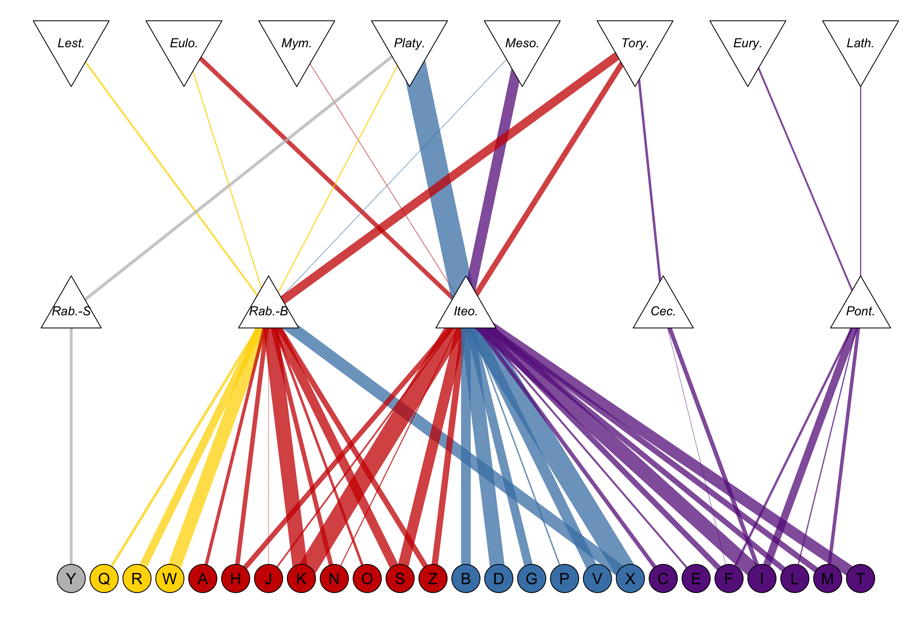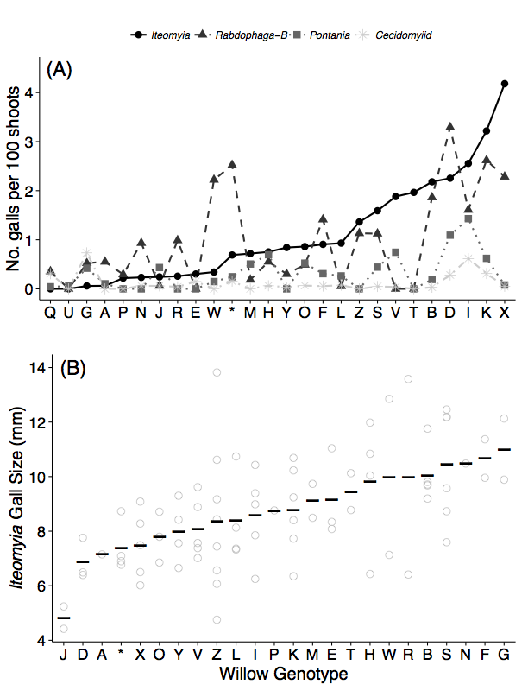

(A)

(C)

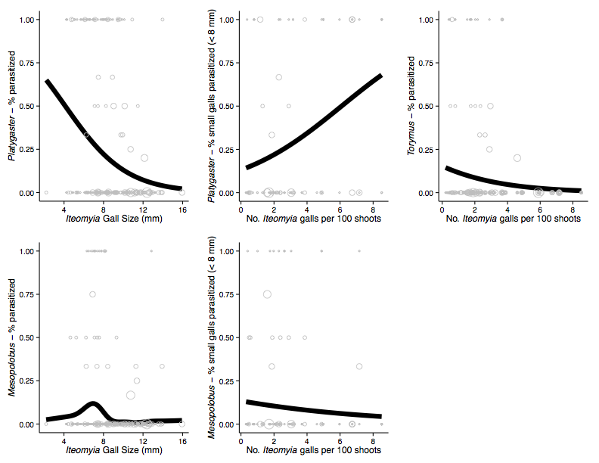

(A)

(B)

(C)

(D)

(E)