Plant genetic variation drives beta-diversity of herbivore-parasitoid interaction networks

Matthew A. Barbour

January 19, 2015

Conceptual outline Figure before this. Perhaps at end of introduction.

### Results

## Network Dissimilarity

## Linking heritable plant traits to herbivore community/traits to network dissimilarity

Genotype and phenotype level. Need to consider removing a couple of the outlying trees...(at least for vLG and rG)

Mantel tests and path analysis? First, do mantel tests for each one. Genotype and phenotype level. Download package for looking at dissimilarity in size-structure of a community.

May be able to perform mantel tests with subset of plant traits that actually influence herbivores. And same thing with herbivores influencing network dissimilarity...

Consider including individual species responses in a supplement. I think these results are important for teasing apart the density-independent, -dependent, and size-dependent parasitoid responses.

This is an R Markdown document. Markdown is a simple formatting syntax for authoring HTML, PDF, and MS Word documents. For more details on using R Markdown see <http://rmarkdown.rstudio.com>.

When you click the **Knit** button a document will be generated that includes both content as well as the output of any embedded R code chunks within the document. You can embed an R code chunk like this:

summary(cars)

## speed dist   
## Min. : 4.0 Min. : 2   
## 1st Qu.:12.0 1st Qu.: 26   
## Median :15.0 Median : 36   
## Mean :15.4 Mean : 43   
## 3rd Qu.:19.0 3rd Qu.: 56   
## Max. :25.0 Max. :120

You can also embed plots, for example:

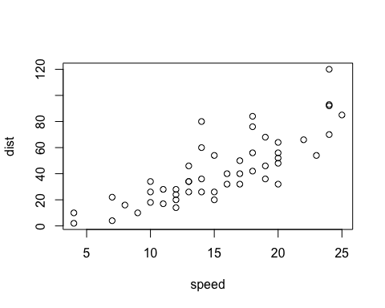

Note that the echo = FALSE parameter was added to the code chunk to prevent printing of the R code that generated the plot.