**Trait plasticity is more important than genetic variation in determining species richness of associated communities**

Matthew A. Barbour1,2,*, Sonya Erlandson3, Kabir Peay3, Brendan Locke4, Erik S. Jules4, Gregory M. Crutsinger5

1University of British Columbia, Department of Zoology, Vancouver, Canada

2University of Zurich, Department of Evolutionary Biology and Environmental Studies, Zurich, Switzerland

3Department of Biology, Stanford University, Stanford, CA, USA.

4Department of Biological Sciences, Humboldt State University, Arcata, CA, USA

5Drone Scholars, San Francisco, CA, USA

*Corresponding author email: matthew.barbour@ieu.uzh.ch

**Abstract**

1. Intraspecific variation can be an important driver of ecological interactions in species-rich communities. Predicting the effects of intraspecific variation in different environments, however, remains a major challenge. This is because we often do not quantify both the effects of functional traits on associated communities and the extent to which trait variation is due to genetics (genotype effects) vs. plasticity (environment effects). As a consequence, the relative importance of trait plasticity vs. genetic variation in structuring associated communities remains unclear.
2. We sought to fill this gap by conducting common garden experiments with the plant *Salix hookeriana* across biotic (ant-aphid interactions) and abiotic (wind exposure) environmental gradients in a coastal dune ecosystem. In each experiment, we simultaneously measured plant traits and species richness of associated above and belowground communities. We then used statistical models to quantify the relative importance of trait plasticity vs. genetic variation in structuring communities.
3. Our major finding was that trait plasticity was more important than genetic variation in determining the number of species in associated communities. This result was consistent across different environmental contexts (experimental manipulations of ant-aphid interactions and wind exposure), multiple years, and for aboveground arthropods and root microbes. This occurred because the traits that had the largest effect on species richness were also the most plastic.
4. *Synthesis*. These results indicate that trait plasticity can be a dominant driver of above and belowground biodiversity.

**Key Words:** Arthropods; community genetics; functional traits; heritability; intraspecific variation; phenotypic plasticity; rhizosphere

**Introduction**

A central goal of ecology is to understand how processes acting at the individual level scale up to structure species-rich communities [(Chave, 2013; Levin, 1992)](https://paperpile.com/c/LrWEsn/nSdY+MMqj). Once assumed to be unimportant for explaining community-level patterns [(Mcgill, Enquist, Weiher, & Westoby, 2006)](https://paperpile.com/c/LrWEsn/a5V9), intraspecific variation is now appreciated as a key component of functional trait diversity [(Siefert et al., 2015)](https://paperpile.com/c/LrWEsn/IR95), with effects on ecological communities often rivalling that of interspecific variation [(Des Roches et al., 2018; Koricheva & Hayes, n.d.)](https://paperpile.com/c/LrWEsn/pllG+w7JW). Despite the likely pervasive effects of intraspecific trait variation [(Bolnick et al., 2011; Violle et al., 2012)](https://paperpile.com/c/LrWEsn/kgod+Vy8T), predicting its community-level effects in different environments remains a major challenge. This is because intraspecific trait variation ultimately results from both genetic (G), environmental (E), and GxE processes. Thus, predicting community-level effects not only requires identifying important functional traits, but also in quantifying sources of intraspecific variation.

In plants, genetic variation can be a key driver of intraspecific trait variation, which in turn can structure species-rich communities of dependent organisms [(Crutsinger et al., 2006; Fritz & Price, 1988; Lamit et al., 2015; Maddox & Root, 1990)](https://paperpile.com/c/LrWEsn/J1Is+ANnE+I282+jbT6). For example, genetic variation in the leaf chemistry of cottonwoods [(Whitham et al., 2006)](https://paperpile.com/c/LrWEsn/j4Uz) and in the plant architecture of coyote bush [(Crutsinger et al., 2014)](https://paperpile.com/c/LrWEsn/6pOV) have been shown to structure diverse communities of foliar arthropods and soil microbes. While community-level effects of genetic variation have been documented in a variety of plant taxa [(Whitham et al., 2012)](https://paperpile.com/c/LrWEsn/UDsw), evidence comes primarily from experiments done in a single common environment. These controlled environments limit the effects of environmental variation on the expression of plant traits (trait plasticity: [(Gratani, 2014)](https://paperpile.com/c/LrWEsn/1F6H), and thus the effects of trait plasticity on associated communities.

Trait plasticity is a major mechanism by which plants cope with changes in the biotic and abiotic environment [(Gratani, 2014)](https://paperpile.com/c/LrWEsn/1F6H), and thus can also be an important driver of community structure [(Miner, Sultan, Morgan, Padilla, & Relyea, 2005; Ohgushi, 2016)](https://paperpile.com/c/LrWEsn/CYBr+ZCcX). For example, herbivory can induce changes in plant traits related to growth and defense with diverse effects on above [(Utsumi & Ohgushi, 2009; Van Zandt & Agrawal, 2004)](https://paperpile.com/c/LrWEsn/Sllr+7va2) and belowground communities [(Johnson et al., 2012)](https://paperpile.com/c/LrWEsn/CMZC). Similarly, changes in abiotic factors (e.g. light, nutrients) can alter above and belowground plant traits, thereby altering resource availability for associated consumers [(Erb & Lu, 2013; Legay et al., 2014; Wardle et al., 2004)](https://paperpile.com/c/LrWEsn/KcRj+Ur64+s7fb). Few studies though have tested whether a plant’s genetic background modifies linkages between environmental variation, traits, and community structure. The rare examples of this have been limited to manipulations of soil nutrients and responses of aboveground growth traits and arthropod communities [(Abdala-Roberts & Mooney, 2013; Barrios-Garcia, Rodriguez-Cabal, Rudgers, & Crutsinger, 2017; Burkle, Souza, Genung, & Crutsinger, 2013; Orians & Fritz, 1996; Rossi & Stiling, 1998)](https://paperpile.com/c/LrWEsn/rIQw+RBrp+3meM+vDrX+Hmk8). In general though, the relative importance of trait plasticity vs. genetic variation in structuring the diverse communities associated with plants remains unclear.

Here we sought to answer the question: what is the relative importance of trait plasticity vs. genetic variation in structuring plant-associated communities? To do this, we conducted common garden experiments with the plant *Salix hookeriana* across different environmental contexts of a coastal dune ecosystem. Prior work in this system has shown that willow genotypes host distinct arthropod communities and that multiple plant traits determine community structure [(Barbour et al., 2015, 2016)](https://paperpile.com/c/LrWEsn/WYvN+9GwL). Importantly, plant traits varied substantially in their degree of genetic variation, suggesting that the environment may influence them in different ways. Preliminary surveys identified two important sources of environmental variation for *S. hookeriana* at our coastal dune site. The first was the mutualistic interaction between the sallow aphid (*Aphis farinosa*) and western thatching ant (*Formica obscuripes*). Sallow aphids were abundant and they excrete carbohydrate-rich honeydew while feeding, which commonly attracted the western thatching ant, a generalist consumer that feeds on the honeydew. Such mutualisms can have strong direct effects on arthropod communities [(Abdala-Roberts, Agrawal, & Mooney, 2012; Johnson, 2008; Mooney & Agrawal, 2008)](https://paperpile.com/c/LrWEsn/bcS4+Gyke+HpZe); however, we focused on quantifying the indirect effects of this mutualism due to induced changes in plant traits. We hypothesized that this mutualism would have its largest effect when aphids were present and in close proximity to ant colonies, since we expected these conditions to favor high aphid densities and thus a greater impact on willows. The second environmental factor we identified was wind exposure. We noticed that willows growing in wind-exposed habitats exhibited reduced growth, especially at their leading edge, appearing to be “swept back” by the wind. We hypothesized that wind exposure would be an important source of intraspecific variation in willow growth and leaf quality traits, with strong indirect effects on associated communities. We conducted separate experiments across each of these environmental gradients. We simultaneously measured intraspecific variation in above and belowground plants traits as well as the species richness of foliar arthropods, root fungi, and root bacteria. This enabled us to first identify the key functional traits affecting community structure. We then used our experimental manipulations to quantify sources of intraspecific variation and, in turn, the relative importance of trait plasticity vs. genetic variation in structuring communities in each experiment.

**Methods**

*Study Site*

We conducted this research at Lanphere Dunes (40°53'29.85''N, 124°8'49.06''W), a restored coastal dune ecosystem managed by US Fish and Wildlife service in Humboldt County, California, USA. While most dunes on the Pacific coast of North America have become degraded due to a combination of development, use of off-road vehicles, and the invasion of non-native plant species, Lanphere Dunes has been restored and managed to be one of the last remaining areas of native dune left in California [(Pickart, 2013)](https://paperpile.com/c/LrWEsn/0V0B). Coastal willow (*Salix hookeriana* ex Barratt ex Hooker) naturally occurs in nearshore dune swales --- seasonal freshwater wetlands that form in depressions between dune ridges [(Pickart & Barbour, 2007)](https://paperpile.com/c/LrWEsn/QTiU). Aside from coastal willow (hereafter willow), the dominant vegetation in these swales consists of beach pine (*Pinus contorta* ssp. *contorta*) and slough sedge (*Carex obnupta*).

*Experimental Design*

Prior to bud break in February 2012, we took shoot cuttings (40 cm length and ~0.5 cm diameter) from one to two replicates of 10 different willow genotypes from a pool of 26 locally collected willow genotypes planted in a large common garden experiment in the same region as the current study site (~24 km down the coastline). Details about the establishment of this common garden and genotyping are given in [(Barbour et al., 2015)](https://paperpile.com/c/LrWEsn/WYvN). These 10 genotypes displayed substantial variation in both plant-growth and leaf-quality traits [(Barbour et al., 2015)](https://paperpile.com/c/LrWEsn/WYvN). Shoot cuttings were soaked in water overnight and then planted in a mixture of 80% perlite, 20% peat moss (dolomite lime added to balance pH) inside “Cone-tainers” (Stuewe & Sons, Inc.). We grew cuttings under ambient weather conditions outside the greenhouse at Humboldt State University until we transplanted willows to our experimental sites at Lanphere Dunes.

To examine how the presence of aphids, proximity to ant mounds, and willow genotype affected associated communities, we established common gardens around 5 different ant mounds (treated as blocks) distributed across a 300 m by 50 m area in late May 2012. Within each block, we randomly planted 20 cuttings (2 replicates of each of 10 genotypes) with 0.5 m spacing in plots that were at a distance of 1, 6, and 12 meters from the edge of the ant mound, for a total of 60 cuttings per ant mound (300 cuttings for entire experiment). Within each plot, we randomly assigned the aphid treatment (aphid presence vs. absence) to one of the two replicates for each genotype. On May 22, we collected aphids (*Aphis farinosa*) from a single willow patch at Lanphere Dunes and placed 5 adult apterate aphids on the tips of willow cuttings in the aphid treatment using a moist paintbrush. We bagged aphids onto the apical shoots of cuttings using organza bags to promote aphid establishment on plants. Similarly, we placed organza bags on all control plants. On May 27, we checked aphid treatments to ensure there were 5 adult aphids and removed bags from all cuttings. If necessary, we added aphids to these treatments until there were 5 adults and we removed any aphid nymphs that were produced since initial establishment. We checked plants for aphids on June 6, June 13, June 24, July 4, July 14, and July 20, 2012. If plants in the aphid treatment had less than 5 aphids, we noted their abundance and added aphids until there were at least 5 individuals. If plants in the control treatment had any aphids, we also noted their abundance, but removed these aphids from the plant. The ant-aphid experiment was restricted to the summer of 2012, because in the summer of 2013 there was high willow mortality induced by drought and *A. farinosa* was too low in abundance on naturally occurring willows to allow us to repeat the experiment. For 2012 though, our experimental design proved effective at creating variation in ant-aphid interactions among willows (Fig. A1).

To examine how wind exposure and willow genotype affected associated communities, we planted 200 willow cuttings across 10 different naturally occurring willow stands (treated as blocks) distributed across a 400 m by 40 m area in late May of 2012. At each willow stand, we established an “exposed” and an “unexposed” common garden with exposed gardens on the windward side of natural willow stands and unexposed plots on the leeward side. Each garden consisted of one replicate cutting of each of 10 genotypes randomly planted in 2 m by 0.5 m grid with 0.5 m spacing between plants. The center of exposed and unexposed gardens within each block were the same distance (2 m) from the edge of the willow stand to control for insect accessibility. To estimate the difference in wind conditions experienced by exposed vs. unexposed plants, we went out on a representative windy afternoon in September 2012. A nearby weather station (Arcata, CA) estimated wind speeds of 22 km/h during this period. We used a hand-held anemometer (Kestrel 1000) to measure wind speed at a height of 37 cm aboveground (approximate height of tallest plants in the garden in 2012) in each plot of our experiment. For each block, we randomly selected the order in which exposed and unexposed plots were measured and took maximum wind speed measurements over a 30 s period. We found that willows growing in wind-exposed plots experienced up to 3.7-fold higher wind speeds compared to unexposed plots (paired t-test, t9=187.32, P<0.001), suggesting that the location of our plots were effective manipulations of wind exposure.

*Measuring Plant Traits*

Prior work in this study system demonstrated that variation in both plant-growth and leaf-quality traits affects the diverse community of herbivorous insects on *S. hookeriana* [(Barbour et al., 2015)](https://paperpile.com/c/LrWEsn/WYvN). To quantify plant-growth traits, we measured plant height, the number of shoots produced, and average shoot length in late July of each year (end of growing season) for both experiments. We quantified plant height as the distance (mm) from the ground to the tip of the tallest shoot. We quantified average shoot length by measuring every shoot on each plant to the nearest millimeter and calculating the average shoot length for each plant. We also measured several traits that could affect leaf quality for herbivores, including trichome density (2012 only), water content (2012 & 2013), specific leaf area (SLA, 2013 only), percent carbon (C) and nitrogen (N), and C:N (2013 only). To measure these traits, we excised fully expanded and undamaged leaves from plants in late July of each year, stored leaf samples with a moist paper towel in separate plastic bags within a cooler and immediately brought them back to the laboratory. We then weighed leaves to obtain fresh mass (g), digitally scanned them to measure leaf area (mm2) using ImageJ [(Abràmoff, Magalhães, & Ram, 2004)](https://paperpile.com/c/LrWEsn/Tl5d), and oven-dried them at 60 °C for 72 h to obtain dry mass (g)[(Cornelissen et al., 2003)](https://paperpile.com/c/LrWEsn/Rbso). We calculated SLA as leaf area divided by dry mass [(Cornelissen et al., 2003)](https://paperpile.com/c/LrWEsn/Rbso). We calculated leaf water content as (fresh mass - dry mass)/(dry mass) [(Munns & Contributors, 2010)](https://paperpile.com/c/LrWEsn/IPjz). To measure trichome density, we counted the number of trichomes along an 11 mm by 1 mm transect in the center of the leaf, halfway between the leaf edge and the mid-vein, under a dissecting scope. To measure percent C and N, we ground oven-dried leaves to a fine powder using a ball mill (Mixer/Mill 8000D, SPEX SamplePrep; Metuchen, NJ, USA). Subsamples of each material were then analyzed for percent C and N on an elemental analyzer (ECS 4010; Costech Analytical Technologies, Valencia, California, USA) using atropine (4.84% N and 70.56% C) as a reference standard. For root-associated communities, we hypothesized that variation in root C:N may affect interactions with root microbes. We measured root C and N (2013 only) by crushing a subsample of oven-dried roots with a razor blade and then analyzing for percent C and N on an elemental analyzer (Carlo-Erba NA 1500) using atropine (4.84% N and 70.56% C) as a reference standard.

We used principal components analysis (PCA) to condense aboveground willow traits into a small number of uncorrelated variables. This step was necessary to eliminate collinearity among traits, which could make it difficult to interpret subsequent analyses of intraspecific effects on associated communities. We conducted PCA for each experiment and year separately, meaning that principal component axes have different interpretations. At times, we lacked data for every trait on a plant. Therefore, we used a regularized iterative PCA algorithm to impute missing values [(Josse & Husson, 2012)](https://paperpile.com/c/LrWEsn/x5Up). For each PCA, we retained principal components with eigenvalues greater than 1.

*Measuring Arthropod Communities*

We visually surveyed plants for arthropods to determine the abundances of different morphospecies. For the ant-aphid experiment, we surveyed arthropods on 5 different occasions between early June and late July 2012. For the wind experiment, we surveyed arthropods once at the end of July 2012 and then once a month in May, June, and July of 2013. So that individuals were not counted twice between sampling dates, we took the maximum abundance for each arthropod morphospecies from each plant across all sampling dates within each year. This approach provides a conservative estimate of the total number of individuals of each morphospecies that occurred on individual plants through the summer. We used these data to calculate arthropod richness on individual plants for each year of the experiments.

*Measuring Root-Microbial Communities*

We dug up the willows from the wind experiment to sample fungi and bacteria communities associated with willow roots in late July of 2013. We were unable to sample belowground communities of plants in the ant-aphid experiment due to the high mortality of plants in 2013. To sample these belowground communities, we removed willows with the surrounding soil intact to preserve root systems, separated shoots and roots, then brushed soil off root systems and stored roots in separate plastic bags. Within 6 hours of excavation, root systems were stored at 4 °C. To process roots, we gently rinsed them in tap water until free of visible soil. In order to randomly select roots for molecular analysis, second order roots were cut into 2 cm lengths, spread out on a grid, and then, using a random number generator, a total of 30 cm of root length was picked from numbered grid cells. These random root subsamples were flash frozen in liquid N, and kept at -80 °C until DNA extraction. To increase efficiency of DNA extraction, roots were physically disrupted with 2 beads per 2 mL tube (3.0 mm Yttria stabilized Zirconia Grinding Media) for 30 seconds at 1500 strokes per minute (SPEX SamplePrep 200 geno/grinder). Total DNA was extracted from the root samples using MoBio PowerSoil 96 sample DNA extraction kits following the manufacturer's instructions.

To identify fungal and bacterial operational taxonomic units (OTUs), we used custom Illumina-compatible barcode primer sets ITS1F/ITS2 [(Smith & Peay, 2014; White, Bruns, Lee, Taylor, & Others, 1990)](https://paperpile.com/c/LrWEsn/YFxu+sQjh) and 515f/806r [(Gregory Caporaso et al., 2012)](https://paperpile.com/c/LrWEsn/asGt) to amplify via PCR the first internal transcribed spacer (ITS1) of the fungal nuclear ribosomal RNA operon and the V4 region of bacterial 16S ribosomal DNA from total root DNA extractions. Product quality was assessed by gel electrophoresis. PCR products were cleaned with house-made magnetic bead solution, quantified with a Qubit fluorometric kit, then sample libraries were pooled at a fungi:bacteria concentration ratio of 2:1. Pooled amplicon libraries were sequenced as single-index (the reverse barcode was uniquely indexed) 300 base pair reads at Stanford Functional Genomics Facility on one lane of an Illumina MiSeq. Quality control of reads consisted of these steps: trimming bases with quality score less than 20 phred; trimming sequenced adaptors; and removing reads with average error rates greater than 0.25 using UPARSE [(Edgar, 2013)](https://paperpile.com/c/LrWEsn/ljRh). Only high quality, paired forward and reverse reads were used for OTU clustering at 97% identity, then OTUs were checked for chimeras against the GOLD 16s rRNA database [(Reddy et al., 2014)](https://paperpile.com/c/LrWEsn/FUxQ) and UNITE fungal ITS database ver6_97_13.05.2014 [(Kõljalg et al., 2005)](https://paperpile.com/c/LrWEsn/0wnG) with UPARSE. Taxonomy was assigned in QIIME [(Gregory Caporaso et al., 2010)](https://paperpile.com/c/LrWEsn/ApYE) using the RDP Classifier for bacteria [(Wang, Garrity, Tiedje, & Cole, 2007)](https://paperpile.com/c/LrWEsn/5Xsy) and BLAST for fungi. To account for differences in each sample's library size (number of reads obtained for each sample), we normalized datasets and calculated rarefied richness [(Gotelli & Colwell, 2001)](https://paperpile.com/c/LrWEsn/1GxA) for root fungi and bacteria separately. We discarded some OTUs and samples based on the following conditions: OTUs with no known taxonomy (any OTU that was not assigned to at least Kingdom Fungi, Bacteria or Archaea); root samples with fewer than 6000 fungal reads and 9000 bacterial reads; and mitochondrial and chloroplast OTUs.

*Statistical Analyses*

To estimate the effect of intraspecific variation on species richness of associated communities, we used linear mixed-effect models. We specified trait principal components (PC) as fixed effects in models of arthropod richness, and root C:N as a fixed effect for models of root fungi and bacteria rarefied richness. In order to compare trait effects and community responses within and between experiments, we centered and scaled these variables (i.e., subtract mean and divide by standard deviation) prior to analyses. To quantify the unique effects of intraspecific trait variation, we included the structure of our experimental design in these statistical models. Willow genotype and microhabitat (experimental block and plot nested within block) were modelled as random intercepts. Experimental manipulations of wind exposure as well as aphid presence, distance from ant mounds, and aphid-by-ant treatment interactions, were modelled as fixed effects. Genotype-by-environment interactions (i.e., G x Wind, G x Aphid, G x Ant, G x Aphid x Ant) were modelled as random slopes.

To quantify the variance explained by different sources of genetic and environmental variation for plant traits, we again used linear mixed-effect models. These models had the same structure as described previously expect that plant traits were now the response variable. We converted fixed-effect coefficients into variance components following the methods of [(Nakagawa & Schielzeth, 2013)](https://paperpile.com/c/LrWEsn/QtDP). We then quantified variance explained by dividing the observed variance component by the sum of variance components for all fixed and random effects as well as residual variation in the model.

To compare the relative importance of trait plasticity vs. genetic variation in determining species richness, we transformed estimates from the linear mixed-effect models described previously. Specifically, we first converted the effect of intraspecific trait variation on species richness into units of standard deviations (SD) following the methods of [(Nakagawa & Schielzeth, 2013)](https://paperpile.com/c/LrWEsn/QtDP). We then converted the variance components for each source of intraspecific variation into SD units by taking the square root of each variance component. To quantify the indirect effects of each source of trait variation on species richness, we multiplied the SDs for each source of trait variation by the SD of each trait effect on species richness (Fig. A2). We calculated the indirect effects of trait plasticity by summing the indirect effects due to each source of environmental variation as well as genotype-by-environment effects. We calculated the indirect effect of genetic variation as simply the indirect effect due to plant genotype. Our standardized measure of indirect effects is analogous to the approach used in structural equation models (SEMs) to calculate the strength of indirect effects. However, we could not use an SEM approach for this analysis since SEMs cannot estimate indirect effects due to random effects.

We used a Bayesian approach to estimate fixed and random effects, combining prior information with a Gaussian likelihood to generate a posterior distribution for each effect. We set a generic, regularizing prior (Gaussian distribution: mean=0, SD=1) for all fixed and random effects. Putting the majority of prior information around zero acts to prevent our statistical models from overfitting. We simulated samples from the posterior using Markov chain Monte Carlo (MCMC) sampling in the probabilistic programming language Stan [(Carpenter et al., 2017)](https://paperpile.com/c/LrWEsn/W6W1). We ran four chains with the No-U-Turn Sampler for 1000 iterations each, discarding the first 500 iterations as burn-in [(Hoffman & Gelman, 2014)](https://paperpile.com/c/LrWEsn/AO4p). Convergence was assessed visually and by verifying that all of the $\hat{R}$ statistics were less than 1.1 [(Brooks & Gelman, 1998)](https://paperpile.com/c/LrWEsn/2gNH). All analyses and visualizations were conducted in R [(Bürkner, 2017; R Core Team, 2017; Wickham, 2009)](https://paperpile.com/c/LrWEsn/anT6+5nyH+T1XM). All data and R-scripts for reproducing the reported results are publicly available and can be found at the GitHub repository https://github.com/mabarbour/Lanphere_Experiments.git.

**Results**

We found that the most important driver of arthropod species richness was trait PC1 -- the major axis of intraspecific trait variation. Trait PC1 had a consistent, positive effect on arthropod richness in both the ant-aphid and wind experiments (Fig. 1). Plant height, shoot count, and shoot length had strong, positive loadings on trait PC1 in each experiment (Fig. 2), indicating that larger willows supported more arthropod species. Interestingly, leaf water content had a large negative loading on trait PC1 in scenarios where it had the largest effect size (Ant-Aphid 2012 and Wind 2013; Fig. 1,2), indicating that willows with lower leaf water content also supported more arthropod species. Compared to trait PC1, trait PC2 had a weak negative effect on arthropod richness in both experiments (Fig. 1). Loadings on trait PC2 were more idiosyncratic than trait PC1, but tended to be driven by traits linked to leaf quality, such as trichome density, water content, and C:N (Fig. 2). Belowground, we found that root C:N was negatively associated with the rarefied richness of root-microbes, with a particularly strong effect on root-fungi (Fig. 1).

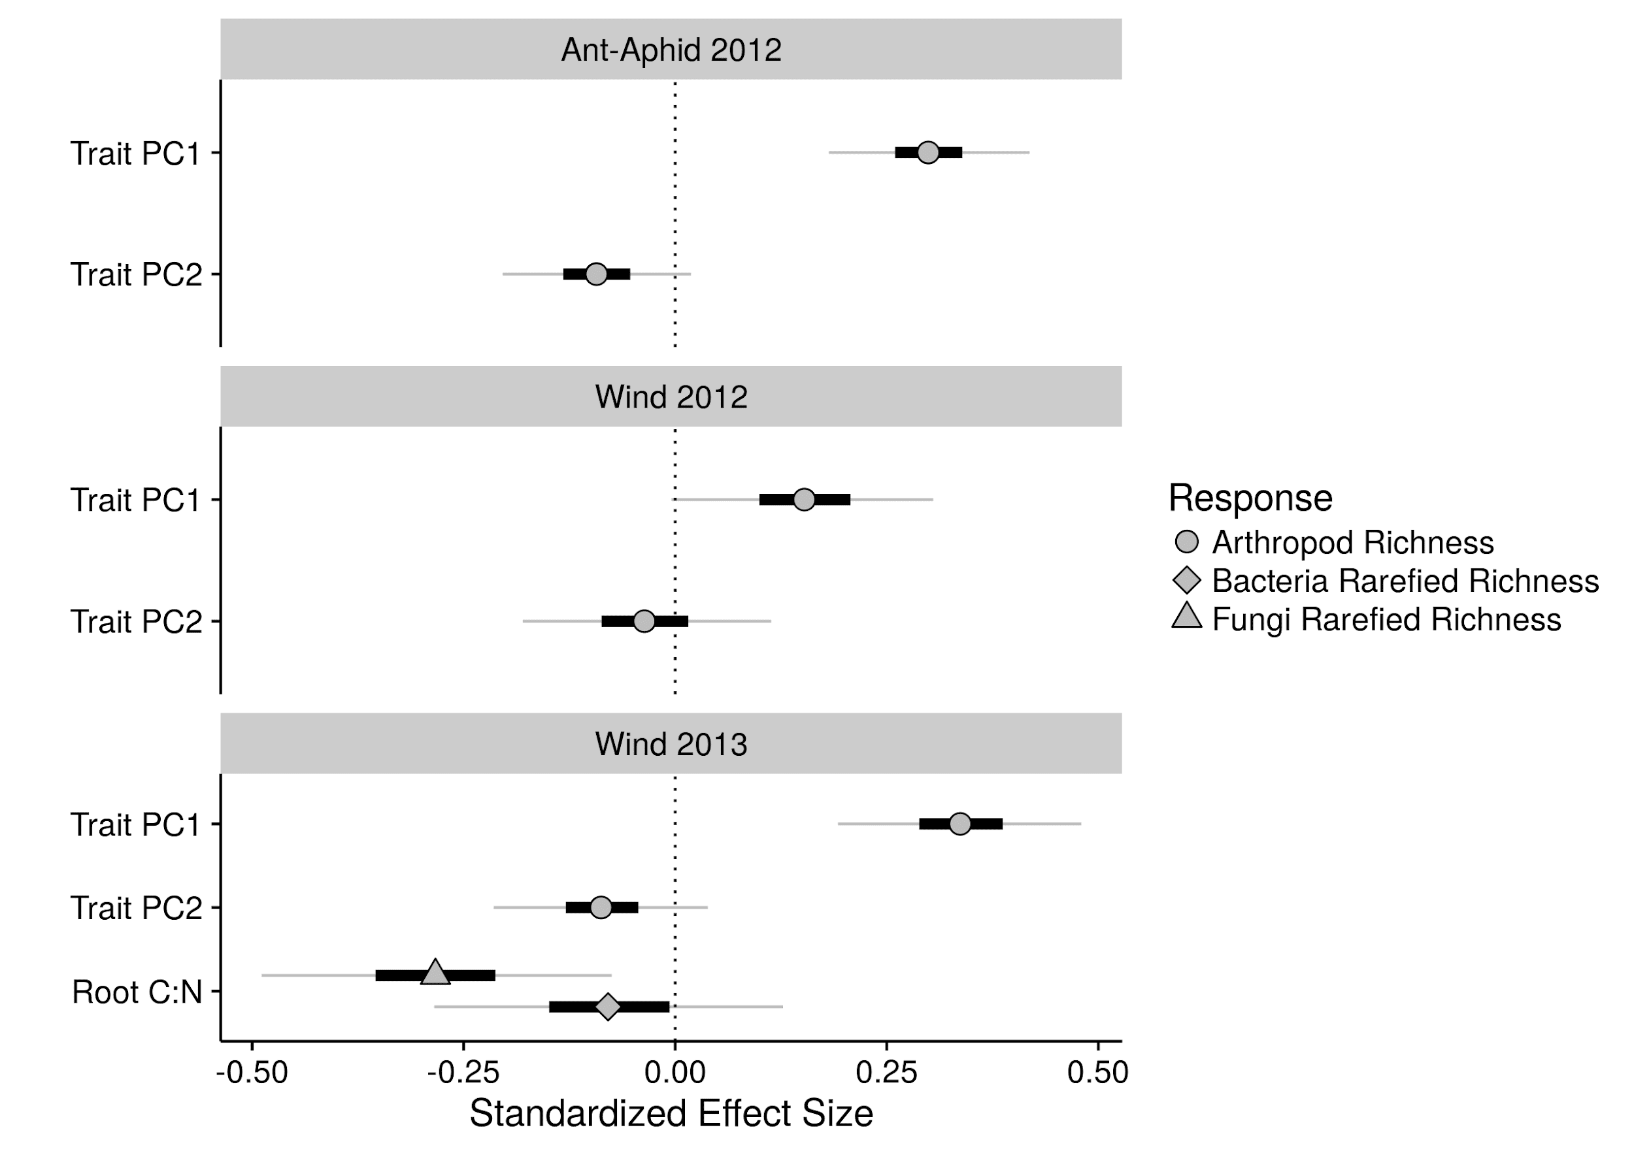

**Figure 1**. Standardized effect sizes of plant traits on the species richness of associated communities in the ant-aphid and wind experiments. Grey points, black bars, and grey lines correspond to the median, 25% - 75% interval, and 2.5% - 97.5% interval of posterior estimates of standardized effects, respectively. Different shapes correspond to different community responses.

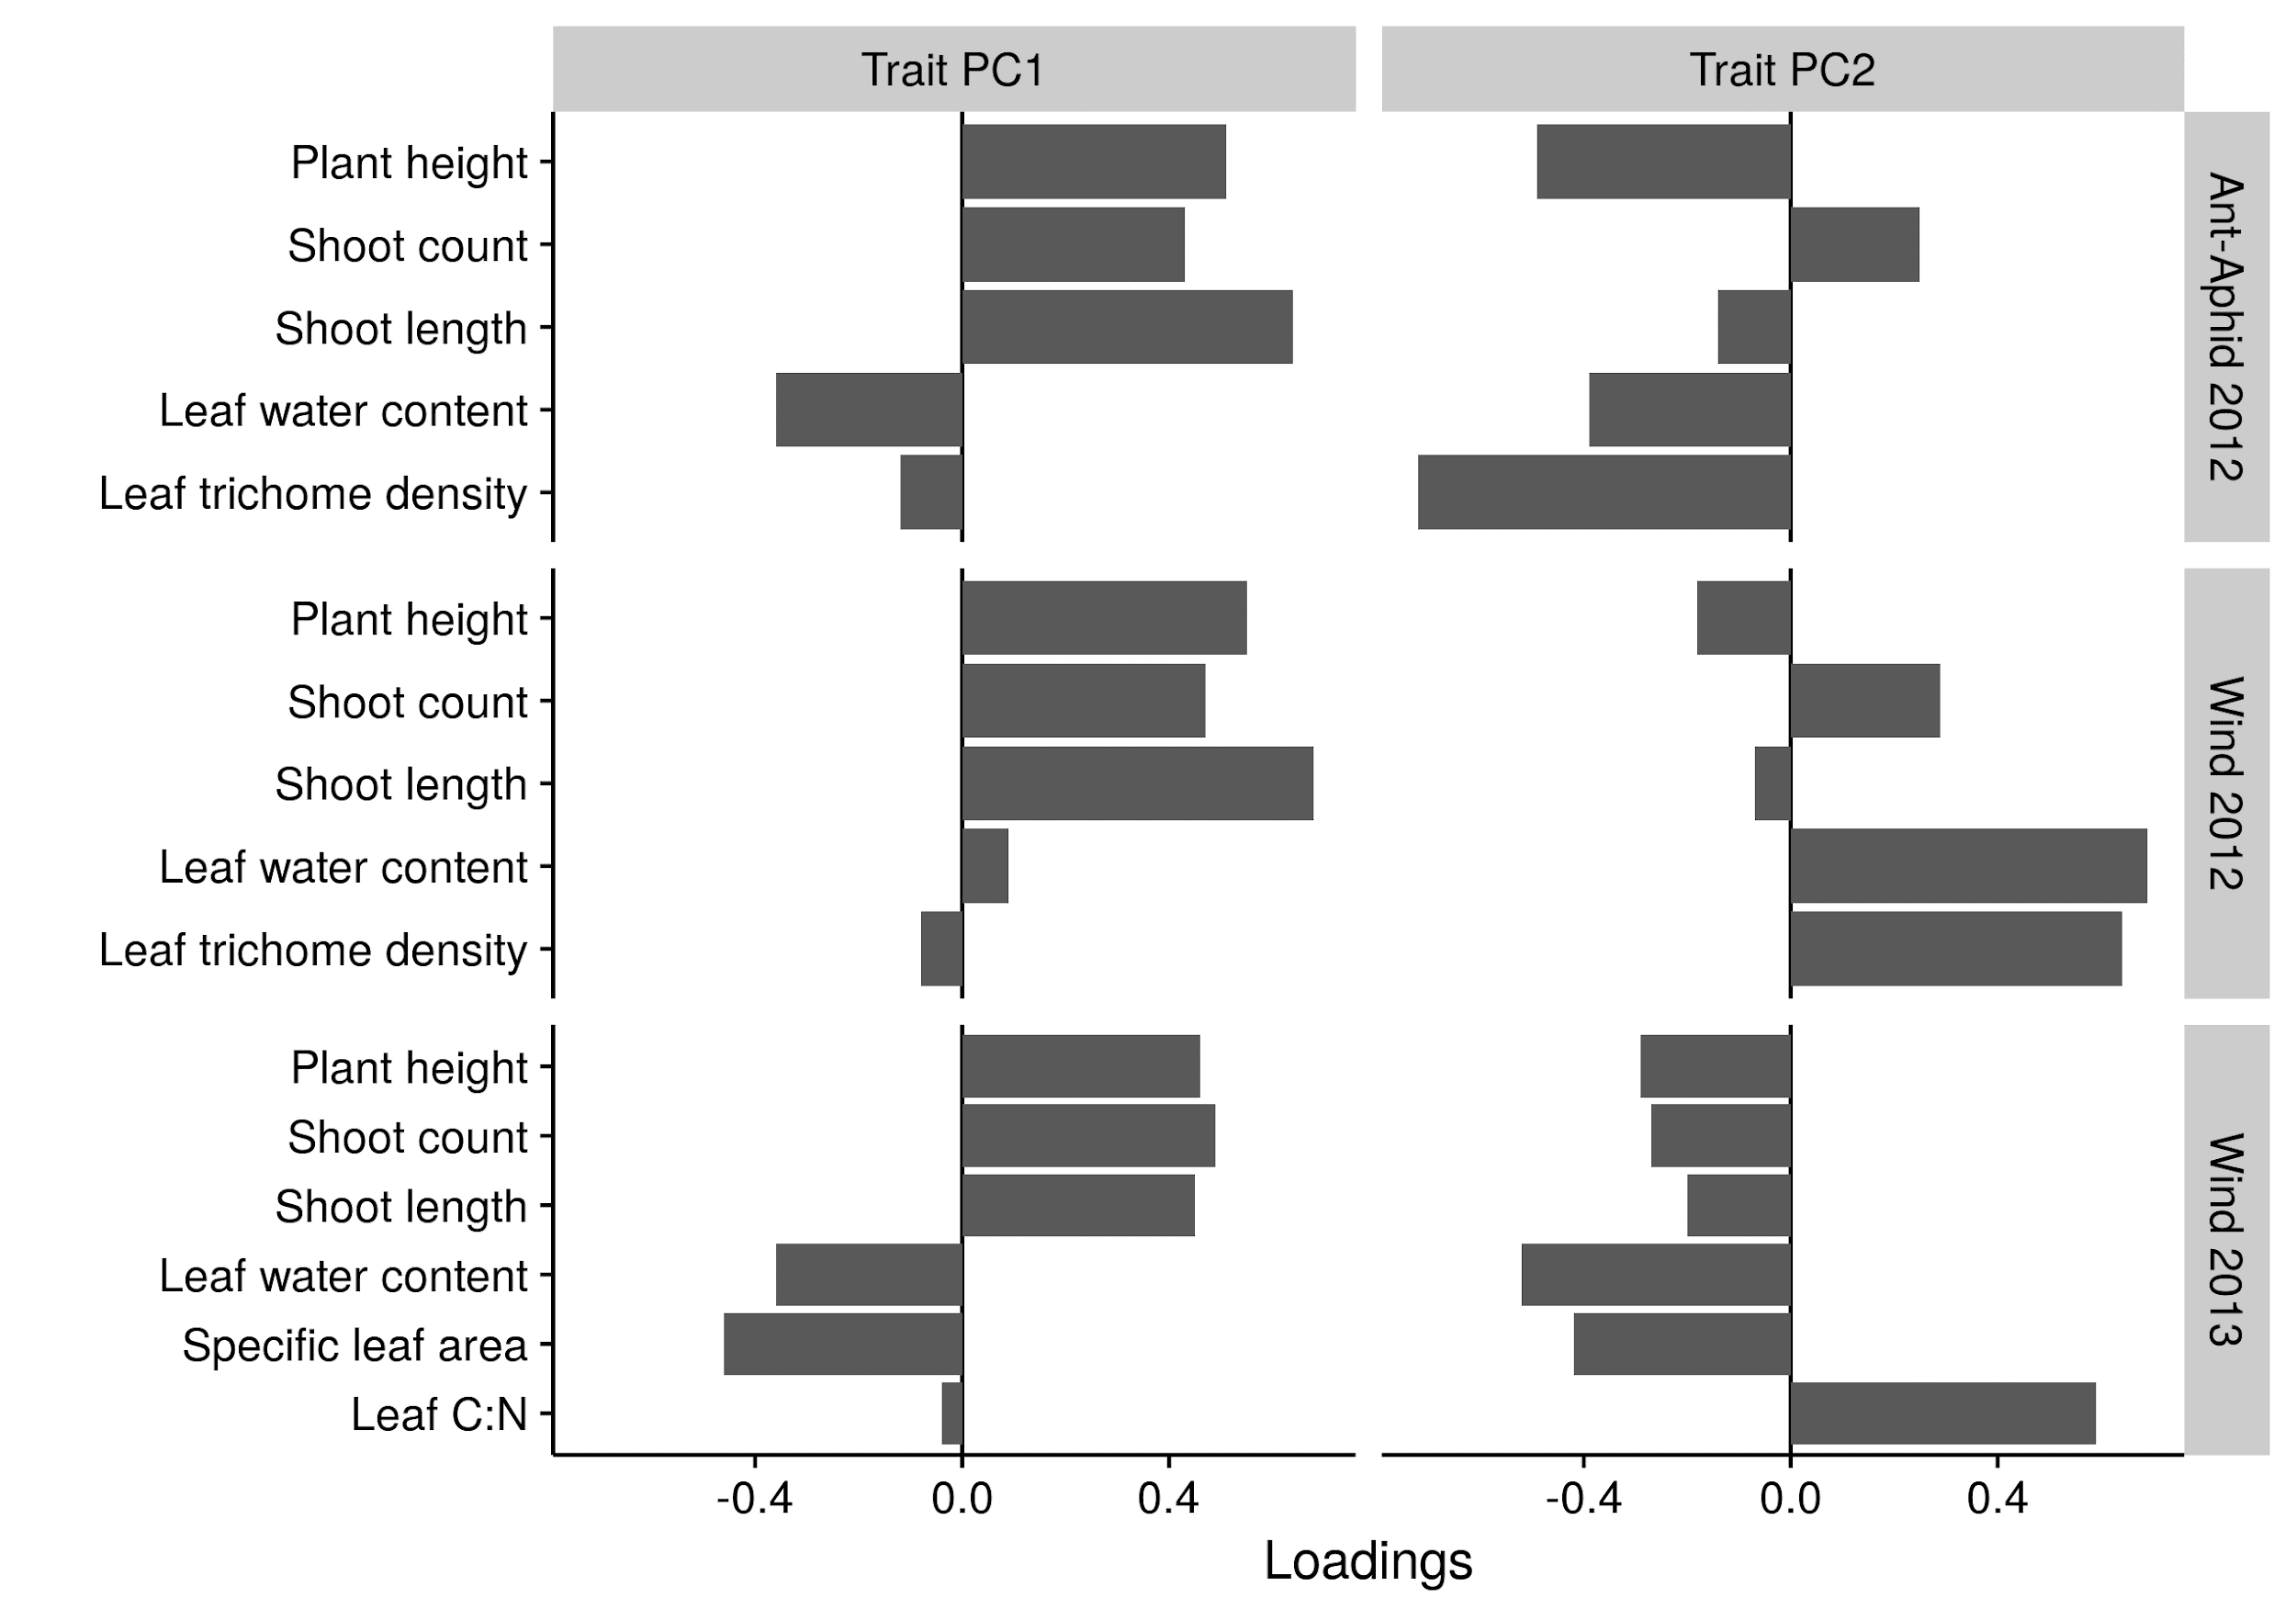

**Figure 2**. Loadings on trait principal components (PC) for the ant-aphid and wind experiments.

Plant genotype was consistently a more important source of intraspecific variation than any of the specific environmental factors we manipulated in our experiments (i.e. ant-aphid interactions and wind exposure; Fig. 3). Plant genotype was a particularly important source of variation for trait PC2, indicating the importance of genetic variation in shaping leaf-quality traits such as trichome density, water content, and C:N (Fig. A3). Of the environmental factors we manipulated, wind exposure was the most important source of trait variation. Wind had a particularly strong effect on trait PC1 (Fig. 3), indicating its negative effect on plant growth traits (Fig. A4). Our manipulations of aphid presence and distance from ant mounds had generally weak effects on functional trait variation (Fig. 3), with the strongest effect being the presence of aphids modifying the effect of willow genotype on trichome density (G x Aphid effect, Fig. A3). Despite the importance of plant genotype, we found that variation in microhabitat (experimental plots and blocks) was often the dominant source of trait variation. This result was particularly true for trait PC1 and root C:N, where environmental variation among plots was just as, or more important, than plant genotype (Fig. 3). Note, however, that experimental plots and blocks capture variation in multiple sources of unmeasured environmental factors.

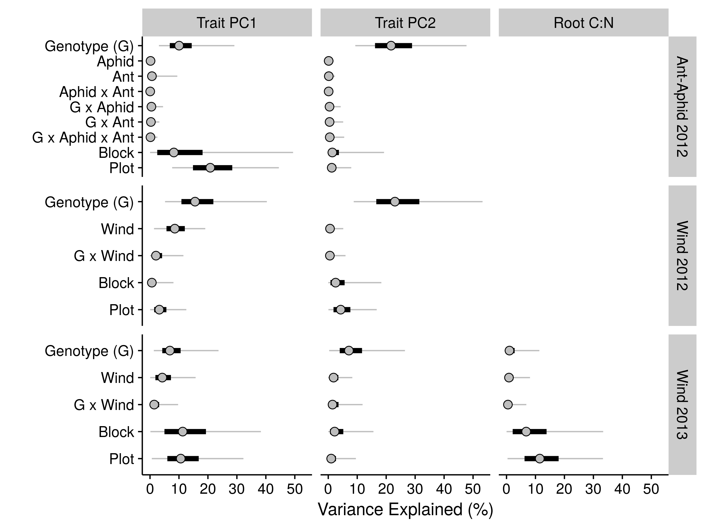

**Figure 3**. Partitioning genetic and environmental sources of intraspecific trait variation in the ant-aphid and wind experiments. Grey points, black bars, and grey lines correspond to the median, 25% - 75% interval, and 2.5% - 97.5% interval of posterior estimates of percent variance explained, respectively.

Taken together, we found that the combined effects of trait plasticity were more important than genetic variation in determining species richness of associated communities. This result was consistent across experiments, years, and community types (Fig. 4). For example, the combined effects of trait plasticity on arthropod richness was 2-fold greater than genetic variation in the ant-aphid experiment (Trait PC1 + Trait PC2, Fig. 4). In the wind experiment, the relative importance of trait plasticity on arthropod richness increased over time, as can be seen by the increase in effect size from 1.5-fold in 2012 to 3.6-fold in 2013 (Trait PC1 + Trait PC2, Fig. 4). Belowground, we found that trait plasticity had a 7-fold larger effect on the rarefied richness of bacteria and fungi compared to genetic variation (effect on root fungi shown in Fig. 4).

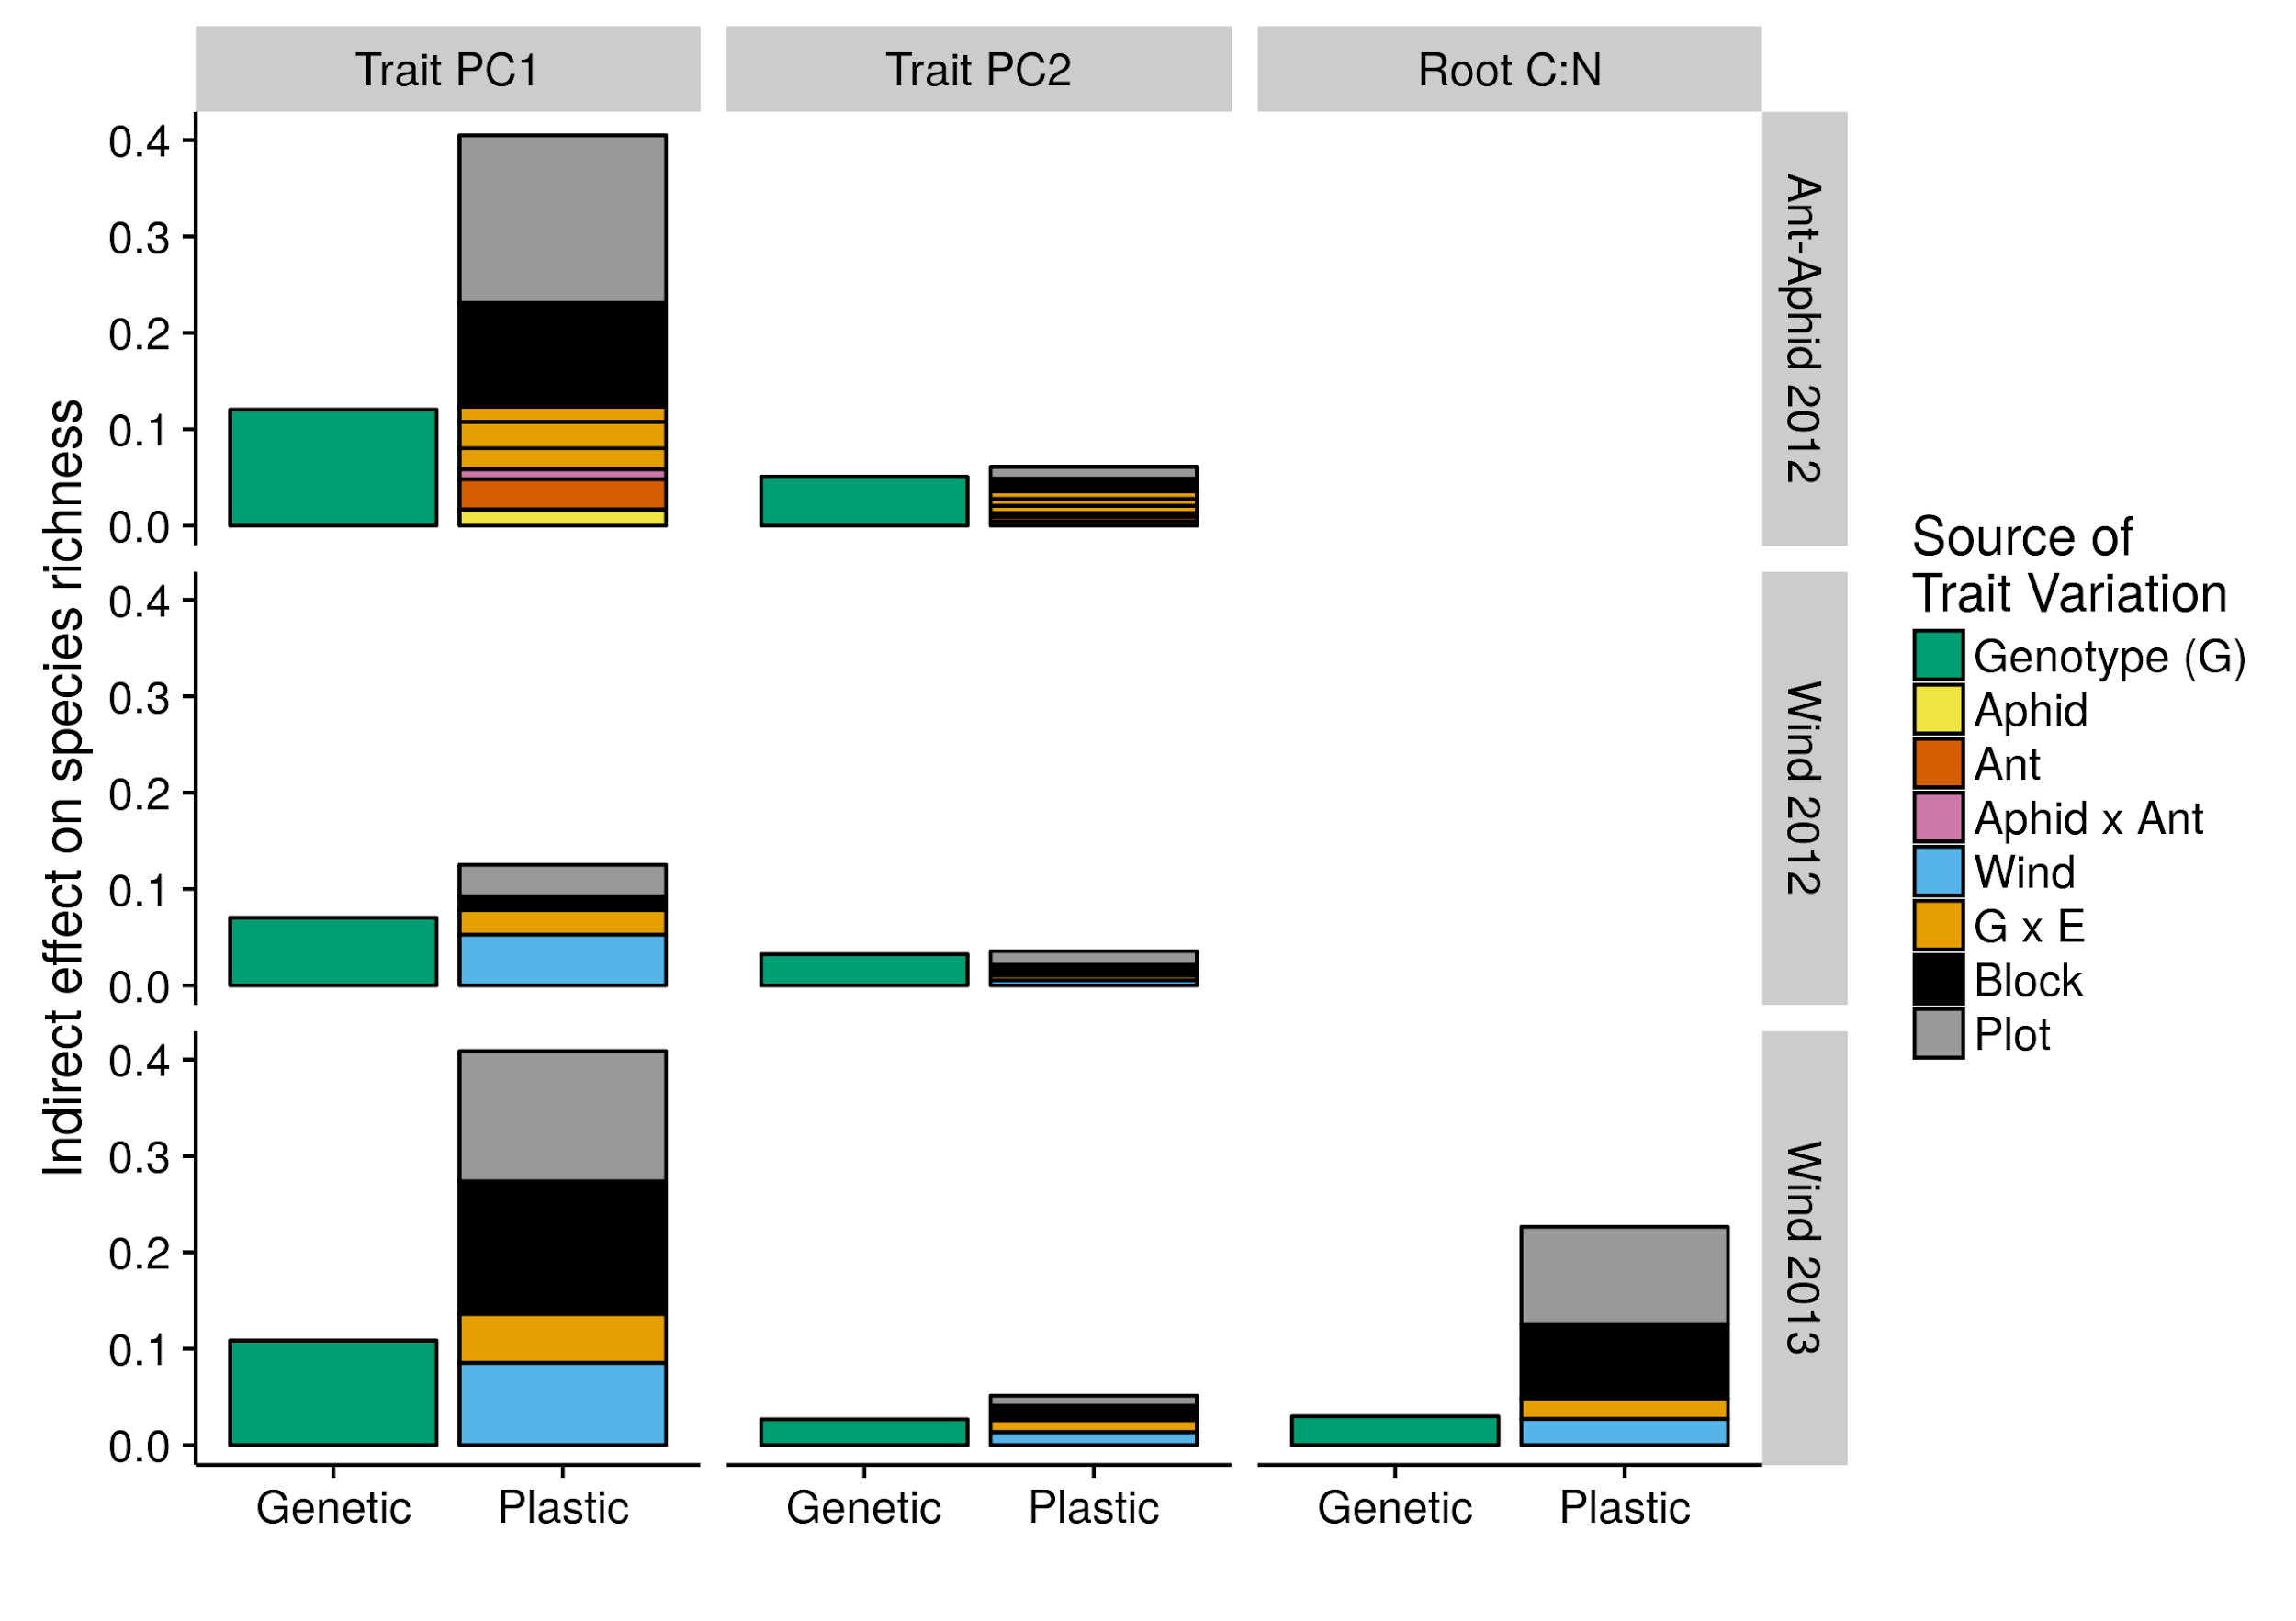

**Figure 4**. Indirect effects of trait plasticity and genetic variation on species richness in the ant-aphid and wind experiments. Colors correspond to different sources of indirect effects. The height of each bar corresponds to the median standard deviation (SD) of each source of trait variation multiplied by the median SD of species richness response to the corresponding trait (see Fig. A2 for illustration). Note that the effect of root C:N displayed in the graph is only for root fungi.

**Discussion**

Our major finding was that trait plasticity was more important than genetic variation in determining species richness of both above and belowground communities. This pattern was consistent across different environmental gradients and over multiple years. This pattern was due to the fact that plant functional traits that had the largest effect on species richness were also the most plastic. It is worth noting that genetic variation was often more important than any single component of environmental variation. Still, the combined indirect effects of the environment resulted in plasticity being the dominant source of trait variation in structuring associated communities.

Intraspecific variation in plant size was the primary driver of arthropod richness in both experiments and years. We found similar results in our prior work with *Salix hookeriana* [(Barbour et al., 2015)](https://paperpile.com/c/LrWEsn/WYvN), although the effects of plant size appeared much more important in this study. This is likely because the absolute size of plants in the current study were small (<60 cm tall), therefore plant biomass could have been a limiting resource for insect herbivores, and in turn, upper trophic levels. Genotype-by-environment experiments with small-statured plants (forbs, herbs, etc.) have similarly found that plant size is a key factor in determining arthropod diversity [(Crutsinger et al., 2014; Johnson & Agrawal, 2005)](https://paperpile.com/c/LrWEsn/Vqdf+6pOV). We speculate that the effects of plant size on arthropod communities may be especially strong for smaller plants, with leaf quality traits becoming more important as plants grow and biomass is no longer a limiting resource. Belowground, we observed a negative relationship between root C:N and microbial diversity, and this was particularly strong for root-fungi. This negative relationship likely reflects the fact that nutrients, such as N, are often limited in the rhizosphere [(Kuzyakov, 2002)](https://paperpile.com/c/LrWEsn/HnlH), thus lower root C:N could promote increased microbial growth and diversity. While species richness of above and belowground communities were decoupled in our study, similar studies have found either coupled [(Crutsinger et al., 2014)](https://paperpile.com/c/LrWEsn/6pOV) or decoupled responses [(Lamit et al., 2015; Wagner et al., 2016)](https://paperpile.com/c/LrWEsn/ANnE+nF59) to intraspecific variation. Predicting when above and belowground communities will be coupled will require studies that explicitly measure (co)variation in multiple above and belowground plant traits in different environmental contexts. A trait-based approach will also be necessary for exploring plant-mediated feedbacks between above and belowground communities.

Intraspecific variation in plant growth was primarily a result of plastic responses to the environment, whereas leaf-quality traits were determined primarily by genetic variation. This result corresponds with the generally high variation among genotypes in leaf quality compared to plant growth traits we observed in our prior work with *Salix hookeriana* [(Barbour et al., 2015)](https://paperpile.com/c/LrWEsn/WYvN) and others have observed in other plant species [(Geber & Griffen, 2003; Johnson, Agrawal, Maron, & Salminen, 2009)](https://paperpile.com/c/LrWEsn/9MA1+OzgO). Interestingly, we found that root C:N, a trait linked to root quality, was more influenced by microhabitat variation (experimental blocks and plots) than genetic variation. This variation in root C:N could reflect differences among microhabitats in available soil N. Alternatively, many fungi form mutualistic associations with plant roots (e.g. mycorrhiza) where in exchange for root C exudates, they make inaccessible soil N available to plants. Thus, pre-existing differences in fungal diversity among microhabitats could have altered root C:N. Either way, this suggests that it may be common for the chemical composition of above and belowground plant tissues to be decoupled as they are influenced by different processes.

There’s been a persistent call over the past decade to measure functional traits in order to identify the mechanisms by which genetic variation affects associated communities [(Crutsinger, 2016; Hersch-Green, Turley, & Johnson, 2011; Hughes, Inouye, Johnson, Underwood, & Vellend, 2008)](https://paperpile.com/c/LrWEsn/0aSW+xMxO+h029). Measuring traits is especially important for identifying mechanisms in genotype-by-environment studies, since environmental variation can affect communities independently of trait variation. By measuring plant functional traits, we showed that trait plasticity was more important than genetic variation in determining species richness of associated communities in a coastal dune ecosystem. Despite the increasing number of genotype-by-environment studies in the past decade [(Abdala-Roberts et al., 2012; Busby, Newcombe, Dirzo, & Whitham, 2014; Johnson, 2008; Johnson & Agrawal, 2005; Mooney & Agrawal, 2008; Tack, Ovaskainen, Pulkkinen, & Roslin, 2010; Wagner et al., 2016)](https://paperpile.com/c/LrWEsn/nF59+BQLZ+mbqs+Vqdf+Gyke+bcS4+HpZe), most studies neglect to measure functional traits, precluding an understanding of the relative importance of trait plasticity vs. genetic variation in structuring communities. The few studies that can give insight to the relative importance of trait plasticity vs. genetic variation have been limited to manipulations of soil nutrients within common gardens and focused on the response of plant-growth traits and aboveground arthropod communities [(Abdala-Roberts & Mooney, 2013; Barrios-Garcia et al., 2017; Burkle et al., 2013; Orians & Fritz, 1996)](https://paperpile.com/c/LrWEsn/Hmk8+vDrX+rIQw+RBrp). This prior work suggests that the community-level effects of trait plasticity range from being weakly independent [(Abdala-Roberts & Mooney, 2013; Barrios-Garcia et al., 2017; Burkle et al., 2013)](https://paperpile.com/c/LrWEsn/Hmk8+vDrX+rIQw) to strongly modified by plant genotype [(Orians & Fritz, 1996)](https://paperpile.com/c/LrWEsn/RBrp). In contrast, we found strong and independent effects of trait plasticity on above and belowground species richness in multiple environmental contexts. If we want to predict the consequences of genetic and environmental variation for species-rich communities, we need further tests across natural environmental gradients and in environmental scenarios that we expect to see in the future.

One important caveat of our study is that we cannot compare the effects of plasticity and genetic variation in unmeasured plant traits. Potentially important traits that we did not measure in this study include phenology [(Johnson & Agrawal, 2005)](https://paperpile.com/c/LrWEsn/Vqdf) and the diverse phenolic compounds produced by *Salix hookeriana* [(Barbour et al., 2015)](https://paperpile.com/c/LrWEsn/WYvN). While trait measurements are necessary to disentangle direct effects of the environment vs. trait plasticity, we can assume that any effects of plant genotype can be attributed to genetic variation in measured and unmeasured plant traits. For example, we found that plant genotype was the dominant driver of arthropod richness in the ant-aphid experiment, indicating the importance of genetic variation in unmeasured plant traits for this experiment (Fig. A5). This result emphasizes the importance of simultaneously conducting detailed trait measurements to disentangle the effects of trait plasticity and genetic variation in structuring communities. This result does not alter our conclusions, however, about the relative importance of trait plasticity vs. genetic variation for the suite of plant traits we measured in this study.

**Conclusions**

Work in willows and similar plant species have long emphasized the importance of genetic variation in functional traits for shaping community structure [(Barbour et al., 2015, 2016; Fritz & Price, 1988; Whitham et al., 2006, 2012)](https://paperpile.com/c/LrWEsn/j4Uz+UDsw+WYvN+9GwL+J1Is), and thus the potential importance of evolutionary processes. While plasticity can have a genetic basis, we observed only weak genotype-by-environment interactions on associated communities. The dominant effects of trait plasticity that we observed suggest that plant evolution is unlikely to play a major role in structuring communities associated with *S. hookeriana*. Interestingly, our study hints at the possibility of the community-level effects of trait plasticity increasing over time (Wind 2012 vs. 2013 in Fig. 4). This could occur if plant traits accumulate the effects of the environment over time and would have an especially strong impact on perennial plants such as *S. hookeriana*. Trait plasticity has been shown to play a key role in shaping the evolutionary ecology of species-rich communities associated with willows [(Ohgushi, 2016; Utsumi, 2015; Utsumi & Ohgushi, 2009)](https://paperpile.com/c/LrWEsn/ZCcX+Sllr+rbRf), and this is likely true for other perennial plants. We need to continue merging trait-based approaches with genotype-by-environment studies if we want to understand how individual-level variation scales up to structure species-rich communities.

**Acknowledgements**

We thank A. Pickart and the staff of Humboldt Bay National Wildlife Refuge (U.S. Fish and Wildlife Service) for permission to work at Lanphere Dunes and for facilitating experiment logistics. L. Mackas-Burns assisted with the fieldwork. M. O'Connor and D. Srivastava gave helpful comments that improved this manuscript. M.A.B. was supported by multiple fellowships from the University of British Columbia (BRITE Fellowship, James Robert Thompson Fellowship, and a Four-Year Fellowship). G.M.C. was supported by the Miller Institute for Basic Research in Science and a NSERC Discovery grant.

**Authors’ contributions**

M.A.B., E.S.J., and G.M.C. conceived the ideas and designed the experiment; M.A.B. and G.M.C. designed and implemented the protocols for measuring the aboveground community, while S.E. and K.P. designed and implemented the protocols for measuring the belowground community; M.A.B., S.E., and B.L. collected the data; M.A.B. analyzed the data and led the writing of the manuscript. All authors contributed critically to the drafts and gave final approval for publication.

**Data accessibility**

All data and R-scripts for reproducing the reported results are publicly available and can be found at the GitHub repository https://github.com/mabarbour/Lanphere_Experiments.git. Data for these analyses will also be deposited on figshare.

**References**

[Abdala-Roberts, L., Agrawal, A. A., & Mooney, K. A. (2012). Ant-aphid interactions on Asclepias syriaca are mediated by plant genotype and caterpillar damage. *Oikos* , *121*(11), 1905–1913.](http://paperpile.com/b/LrWEsn/HpZe)

[Abdala-Roberts, L., & Mooney, K. A. (2013). Environmental and plant genetic effects on tri-trophic interactions. *Oikos* , *122*(8), 1157–1166.](http://paperpile.com/b/LrWEsn/rIQw)

[Abràmoff, M. D., Magalhães, P. J., & Ram, S. J. (2004). Image processing with ImageJ. *Biophotonics International*, *11*(7), 36–42.](http://paperpile.com/b/LrWEsn/Tl5d)

[Barbour, M. A., Fortuna, M. A., Bascompte, J., Nicholson, J. R., Julkunen-Tiitto, R., Jules, E. S., & Crutsinger, G. M. (2016). Genetic specificity of a plant–insect food web: Implications for linking genetic variation to network complexity. *Proceedings of the National Academy of Sciences*, *113*(8), 2128–2133.](http://paperpile.com/b/LrWEsn/9GwL)

[Barbour, M. A., Rodriguez-Cabal, M. A., Wu, E. T., Julkunen-Tiitto, R., Ritland, C. E., Miscampbell, A. E., … Crutsinger, G. M. (2015). Multiple plant traits shape the genetic basis of herbivore community assembly. *Functional Ecology*, *29*(8), 995–1006.](http://paperpile.com/b/LrWEsn/WYvN)

[Barrios-Garcia, M. N., Rodriguez-Cabal, M. A., Rudgers, J. A., & Crutsinger, G. M. (2017). Soil fertilization does not alter plant architectural effects on arthropod communities. *Journal of Plant Ecology*, *10*(5), 800–807.](http://paperpile.com/b/LrWEsn/Hmk8)

[Bolnick, D. I., Amarasekare, P., Araújo, M. S., Bürger, R., Levine, J. M., Novak, M., … Vasseur, D. A. (2011). Why intraspecific trait variation matters in community ecology. *Trends in Ecology & Evolution*, *26*(4), 183–192.](http://paperpile.com/b/LrWEsn/kgod)

[Brooks, S. P., & Gelman, A. (1998). General Methods for Monitoring Convergence of Iterative Simulations. *Journal of Computational and Graphical Statistics: A Joint Publication of American Statistical Association, Institute of Mathematical Statistics, Interface Foundation of North America*, *7*(4), 434–455.](http://paperpile.com/b/LrWEsn/2gNH)

[Burkle, L. A., Souza, L., Genung, M. A., & Crutsinger, G. M. (2013). Plant genotype, nutrients, and G × E interactions structure floral visitor communities. *Ecosphere* , *4*(9), 1–20.](http://paperpile.com/b/LrWEsn/vDrX)

[Bürkner, P.-C. (2017). brms: An R Package for Bayesian Multilevel Models Using Stan. *Journal of Statistical Software*. doi:](http://paperpile.com/b/LrWEsn/5nyH)[10.18637/jss.v080.i01](http://dx.doi.org/10.18637/jss.v080.i01)

[Busby, P. E., Newcombe, G., Dirzo, R., & Whitham, T. G. (2014). Differentiating genetic and environmental drivers of plant–pathogen community interactions. *The Journal of Ecology*, *102*(5), 1300–1309.](http://paperpile.com/b/LrWEsn/BQLZ)

[Carpenter, B., Gelman, A., Hoffman, M., Lee, D., Goodrich, B., Betancourt, M., … Riddell, A. (2017). Stan: A Probabilistic Programming Language. *Journal of Statistical Software, Articles*, *76*(1), 1–32.](http://paperpile.com/b/LrWEsn/W6W1)

[Chave, J. (2013). The problem of pattern and scale in ecology: what have we learned in 20 years? *Ecology Letters*, *16*, 4–16.](http://paperpile.com/b/LrWEsn/MMqj)

[Cornelissen, J. H. C., Lavorel, S., Garnier, E., Díaz, S., Buchmann, N., Gurvich, D. E., … Poorter, H. (2003). A handbook of protocols for standardised and easy measurement of plant functional traits worldwide. *Australian Journal of Botany*, *51*, 335–380.](http://paperpile.com/b/LrWEsn/Rbso)

[Crutsinger, G. M. (2016). A community genetics perspective: opportunities for the coming decade. *The New Phytologist*, *210*(1), 65–70.](http://paperpile.com/b/LrWEsn/h029)

[Crutsinger, G. M., Collins, M. D., Fordyce, J. A., Gompert, Z., Nice, C. C., & Sanders, N. J. (2006). Plant genotypic diversity predicts community structure and governs an ecosystem process. *Science*, *313*(5789), 966–968.](http://paperpile.com/b/LrWEsn/jbT6)

[Crutsinger, G. M., Rodriguez-Cabal, M. A., Roddy, A. B., Peay, K. G., Bastow, J. L., Kidder, A. G., … Rudgers, J. A. (2014). Genetic variation within a dominant shrub structures green and brown community assemblages. *Ecology*, *95*(2), 387–398.](http://paperpile.com/b/LrWEsn/6pOV)

[Des Roches, S., Post, D. M., Turley, N. E., Bailey, J. K., Hendry, A. P., Kinnison, M. T., … Palkovacs, E. P. (2018). The ecological importance of intraspecific variation. *Nature Ecology & Evolution*, *2*(1), 57–64.](http://paperpile.com/b/LrWEsn/pllG)

[Edgar, R. C. (2013). UPARSE: highly accurate OTU sequences from microbial amplicon reads. *Nature Methods*, *10*(10), 996–998.](http://paperpile.com/b/LrWEsn/ljRh)

[Erb, M., & Lu, J. (2013). Soil abiotic factors influence interactions between belowground herbivores and plant roots. *Journal of Experimental Botany*, *64*(5), 1295–1303.](http://paperpile.com/b/LrWEsn/KcRj)

[Fritz, R. S., & Price, P. W. (1988). Genetic Variation Among Plants and Insect Community Structure: Willows and Sawflies. *Ecology*, *69*(3), 845–856.](http://paperpile.com/b/LrWEsn/J1Is)

[Geber, M. A., & Griffen, L. R. (2003). Inheritance and Natural Selection on Functional Traits. *International Journal of Plant Sciences*, *164*(S3), S21–S42.](http://paperpile.com/b/LrWEsn/OzgO)

[Gotelli, N. J., & Colwell, R. K. (2001). Quantifying biodiversity: procedures and pitfalls in the measurement and comparison of species richness. *Ecology Letters*, *4*(4), 379–391.](http://paperpile.com/b/LrWEsn/1GxA)

[Gratani, L. (2014). Plant Phenotypic Plasticity in Response to Environmental Factors. *Advances in Botany*, *2014*. doi:](http://paperpile.com/b/LrWEsn/1F6H)[10.1155/2014/208747](http://dx.doi.org/10.1155/2014/208747)

[Gregory Caporaso, J., Kuczynski, J., Stombaugh, J., Bittinger, K., Bushman, F. D., Costello, E. K., … Knight, R. (2010). QIIME allows analysis of high-throughput community sequencing data. *Nature Publishing Group*, *7*(5), 335–336.](http://paperpile.com/b/LrWEsn/ApYE)

[Gregory Caporaso, J., Lauber, C. L., Walters, W. A., Berg-Lyons, D., Huntley, J., Fierer, N., … Knight, R. (2012). Ultra-high-throughput microbial community analysis on the Illumina HiSeq and MiSeq platforms. *The ISME Journal*, *6*(8), 1621–1624.](http://paperpile.com/b/LrWEsn/asGt)

[Hersch-Green, E. I., Turley, N. E., & Johnson, M. T. J. (2011). Community genetics: what have we accomplished and where should we be going? *Philosophical Transactions of the Royal Society of London. Series B, Biological Sciences*, *366*(1569), 1453–1460.](http://paperpile.com/b/LrWEsn/xMxO)

[Hoffman, M. D., & Gelman, A. (2014). The No-U-turn sampler: adaptively setting path lengths in Hamiltonian Monte Carlo. *Journal of Machine Learning Research: JMLR*, *15*(1), 1593–1623.](http://paperpile.com/b/LrWEsn/AO4p)

[Johnson, M. T. J. (2008). Bottom-up effects of plant genotype on aphids, ants, and predators. *Ecology*, *89*(1), 145–154.](http://paperpile.com/b/LrWEsn/Gyke)

[Johnson, M. T. J., & Agrawal, A. A. (2005). Plant genotype and environment interact to shape a diverse arthropod community on evening primrose (Oenotera biennis). *Ecology*, *86*(4), 874–885.](http://paperpile.com/b/LrWEsn/Vqdf)

[Johnson, M. T. J., Agrawal, A. A., Maron, J. L., & Salminen, J.-P. (2009). Heritability, covariation and natural selection on 24 traits of common evening primrose (Oenothera biennis) from a field experiment. *Journal of Evolutionary Biology*, *22*(6), 1295–1307.](http://paperpile.com/b/LrWEsn/9MA1)

[Johnson, S. N., Clark, K. E., Hartley, S. E., Jones, T. H., McKenzie, S. W., & Koricheva, J. (2012). Aboveground–belowground herbivore interactions: a meta-analysis. *Ecology*, *93*(10), 2208–2215.](http://paperpile.com/b/LrWEsn/CMZC)

[Josse, J., & Husson, F. (2012). Selecting the number of components in principal component analysis using cross-validation approximations. *Computational Statistics & Data Analysis*, *56*(6), 1869–1879.](http://paperpile.com/b/LrWEsn/x5Up)

[Kõljalg, U., Larsson, K.-H., Abarenkov, K., Nilsson, R. H., Alexander, I. J., Eberhardt, U., … Ursing, B. M. (2005). UNITE: a database providing web-based methods for the molecular identification of ectomycorrhizal fungi. *The New Phytologist*, *166*(3), 1063–1068.](http://paperpile.com/b/LrWEsn/0wnG)

[Koricheva, J., & Hayes, D. (n.d.). The relative importance of plant intraspecific diversity in structuring arthropod communities: a meta-analysis. *Functional Ecology*. doi:](http://paperpile.com/b/LrWEsn/w7JW)[10.1111/1365-2435.13062](http://dx.doi.org/10.1111/1365-2435.13062)

[Kuzyakov, Y. (2002). Review: Factors affecting rhizosphere priming effects. *Journal of Plant Nutrition and Soil Science*, *165*, 382–396.](http://paperpile.com/b/LrWEsn/HnlH)

[Lamit, L. J., Busby, P. E., Lau, M. K., Compson, Z. G., Wojtowicz, T., Keith, A. R., … Whitham, T. G. (2015). Tree genotype mediates covariance among communities from microbes to lichens and arthropods. *The Journal of Ecology*, *103*(4), 840–850.](http://paperpile.com/b/LrWEsn/ANnE)

[Legay, N., Baxendale, C., Grigulis, K., Krainer, U., Kastl, E., Schloter, M., … Lavorel, S. (2014). Contribution of above- and below-ground plant traits to the structure and function of grassland soil microbial communities. *Annals of Botany*, *114*(5), 1011–1021.](http://paperpile.com/b/LrWEsn/Ur64)

[Levin, S. A. (1992). The Problem of Pattern and Scale in Ecology: The Robert H. MacArthur Award Lecture. *Ecology*, *73*(6), 1943–1967.](http://paperpile.com/b/LrWEsn/nSdY)

[Maddox, G. D., & Root, R. B. (1990). Structure of the Encounter between Goldenrod (Solidago Altissima) and Its Diverse Insect Fauna. *Ecology*, *71*(6), 2115–2124.](http://paperpile.com/b/LrWEsn/I282)

[Mcgill, B., Enquist, B., Weiher, E., & Westoby, M. (2006). Rebuilding community ecology from functional traits. *Trends in Ecology & Evolution*, *21*(4), 178–185.](http://paperpile.com/b/LrWEsn/a5V9)

[Miner, B. G., Sultan, S. E., Morgan, S. G., Padilla, D. K., & Relyea, R. A. (2005). Ecological consequences of phenotypic plasticity. *Trends in Ecology & Evolution*, *20*(12), 685–692.](http://paperpile.com/b/LrWEsn/CYBr)

[Mooney, K. A., & Agrawal, A. A. (2008). Plant genotype shapes ant-aphid interactions: implications for community structure and indirect plant defense. *The American Naturalist*, *171*(6), E195–205.](http://paperpile.com/b/LrWEsn/bcS4)

[Munns, R., & Contributors, P. (2010). Plant water content and relative water content. Retrieved from](http://paperpile.com/b/LrWEsn/IPjz) /tiki-pagehistory.php?page=Plant water content and relative water content&preview=6

[Nakagawa, S., & Schielzeth, H. (2013). A general and simple method for obtaining R2 from generalized linear mixed-effects models. *Methods in Ecology and Evolution / British Ecological Society*, *4*(2), 133–142.](http://paperpile.com/b/LrWEsn/QtDP)

[Ohgushi, T. (2016). Eco-evolutionary dynamics of plant-herbivore communities: incorporating plant phenotypic plasticity. *Current Opinion in Insect Science*, *14*, 40–45.](http://paperpile.com/b/LrWEsn/ZCcX)

[Orians, C. M., & Fritz, R. S. (1996). Genetic and soil-nutrient effects on the abundance of herbivores on willow. *Oecologia*, *105*(3), 388–396.](http://paperpile.com/b/LrWEsn/RBrp)

[Pickart, A. J. (2013). Dune restoration over two decades at the Lanphere and Ma-le’l Dunes in northern California. In *Restoration of coastal dunes* (pp. 159–171). Springer.](http://paperpile.com/b/LrWEsn/0V0B)

[Pickart, A. J., & Barbour, M. G. (2007). Beach and Dune. In *Terrestrial Vegetation of California, 3rd Edition*. University of California Press.](http://paperpile.com/b/LrWEsn/QTiU)

[Randall Hughes, A., Inouye, B. D., Johnson, M. T. J., Underwood, N., & Vellend, M. (2008). Ecological consequences of genetic diversity. *Ecology Letters*, *11*, 609–623.](http://paperpile.com/b/LrWEsn/0aSW)

[R Core Team. (2017). R: A Language and Environment for Statistical Computing. Vienna, Austria: R Foundation for Statistical Computing. Retrieved from](http://paperpile.com/b/LrWEsn/anT6) [https://www.R-project.org/](https://www.r-project.org/)

[Reddy, T. B. K., Thomas, A. D., Stamatis, D., Bertsch, J., Isbandi, M., Jansson, J., … Kyrpides, N. C. (2014). The Genomes OnLine Database (GOLD) v. 5: a metadata management system based on a four level (meta) genome project classification. *Nucleic Acids Research*, *43*(D1), D1099–D1106.](http://paperpile.com/b/LrWEsn/FUxQ)

[Rossi, A. M., & Stiling, P. (1998). The interactions of plant clone and abiotic factors on a gall-making midge. *Oecologia*, *116*(1-2), 170–176.](http://paperpile.com/b/LrWEsn/3meM)

[Siefert, A., Violle, C., Chalmandrier, L., Albert, C. H., Taudiere, A., Fajardo, A., … Wardle, D. A. (2015). A global meta-analysis of the relative extent of intraspecific trait variation in plant communities. *Ecology Letters*, *18*(12), 1406–1419.](http://paperpile.com/b/LrWEsn/IR95)

[Smith, D. P., & Peay, K. G. (2014). Sequence depth, not PCR replication, improves ecological inference from next generation DNA sequencing. *PloS One*, *9*(2), e90234.](http://paperpile.com/b/LrWEsn/YFxu)

[Tack, A. J. M., Ovaskainen, O., Pulkkinen, P., & Roslin, T. (2010). Spatial location dominates over host plant genotype in structuring an herbivore community. *Ecology*, *91*(9), 2660–2672.](http://paperpile.com/b/LrWEsn/mbqs)

[Utsumi, S. (2015). Feeding evolution of a herbivore influences an arthropod community through plants: implications for plant-mediated eco-evolutionary feedback loop. *The Journal of Ecology*, *103*(4), 829–839.](http://paperpile.com/b/LrWEsn/rbRf)

[Utsumi, S., & Ohgushi, T. (2009). Community-wide impacts of herbivore-induced plant regrowth on arthropods in a multi-willow species system. *Oikos* , *118*(12), 1805–1815.](http://paperpile.com/b/LrWEsn/Sllr)

[Van Zandt, P. A., & Agrawal, A. A. (2004). Community-wide impacts of herbivore-induced plant responses in milkweed (Asclepias syriaca). *Ecology*, *85*(9), 2616–2629.](http://paperpile.com/b/LrWEsn/7va2)

[Violle, C., Enquist, B. J., McGill, B. J., Jiang, L., Albert, C. H., Hulshof, C., … Messier, J. (2012). The return of the variance: intraspecific variability in community ecology. *Trends in Ecology & Evolution*, *27*(4), 244–252.](http://paperpile.com/b/LrWEsn/Vy8T)

[Wagner, M. R., Lundberg, D. S., Del Rio, T. G., Tringe, S. G., Dangl, J. L., & Mitchell-Olds, T. (2016). Host genotype and age shape the leaf and root microbiomes of a wild perennial plant. *Nature Communications*, *7*, 12151.](http://paperpile.com/b/LrWEsn/nF59)

[Wang, Q., Garrity, G. M., Tiedje, J. M., & Cole, J. R. (2007). Naive Bayesian Classifier for Rapid Assignment of rRNA Sequences into the New Bacterial Taxonomy. *Applied and Environmental Microbiology*, *73*(16), 5261–5267.](http://paperpile.com/b/LrWEsn/5Xsy)

[Wardle, D. A., Bardgett, R. D., Klironomos, J. N., Setälä, H., van der Putten, W. H., & Wall, D. H. (2004). Ecological linkages between aboveground and belowground biota. *Science*, *304*(5677), 1629–1633.](http://paperpile.com/b/LrWEsn/s7fb)

[White, T. J., Bruns, T., Lee, S., Taylor, J. L., & Others. (1990). Amplification and direct sequencing of fungal ribosomal RNA genes for phylogenetics. *PCR Protocols: A Guide to Methods and Applications*, *18*(1), 315–322.](http://paperpile.com/b/LrWEsn/sQjh)

[Whitham, T. G., Bailey, J. K., Schweitzer, J. A., Shuster, S. M., Bangert, R. K., LeRoy, C. J., … Wooley, S. C. (2006). A framework for community and ecosystem genetics: from genes to ecosystems. *Nature Reviews Genetics*, *7*(7), 510–523.](http://paperpile.com/b/LrWEsn/j4Uz)

[Whitham, T. G., Gehring, C. A., Lamit, L. J., Wojtowicz, T., Evans, L. M., Keith, A. R., & Smith, D. S. (2012). Community specificity: life and afterlife effects of genes. *Trends in Plant Science*, *17*(5), 271–281.](http://paperpile.com/b/LrWEsn/UDsw)

[Wickham, H. (2009). ggplot2: Elegant Graphics for Data Analysis. Springer-Verlag New York. Retrieved from](http://paperpile.com/b/LrWEsn/T1XM) <http://ggplot2.org>

**Appendix**

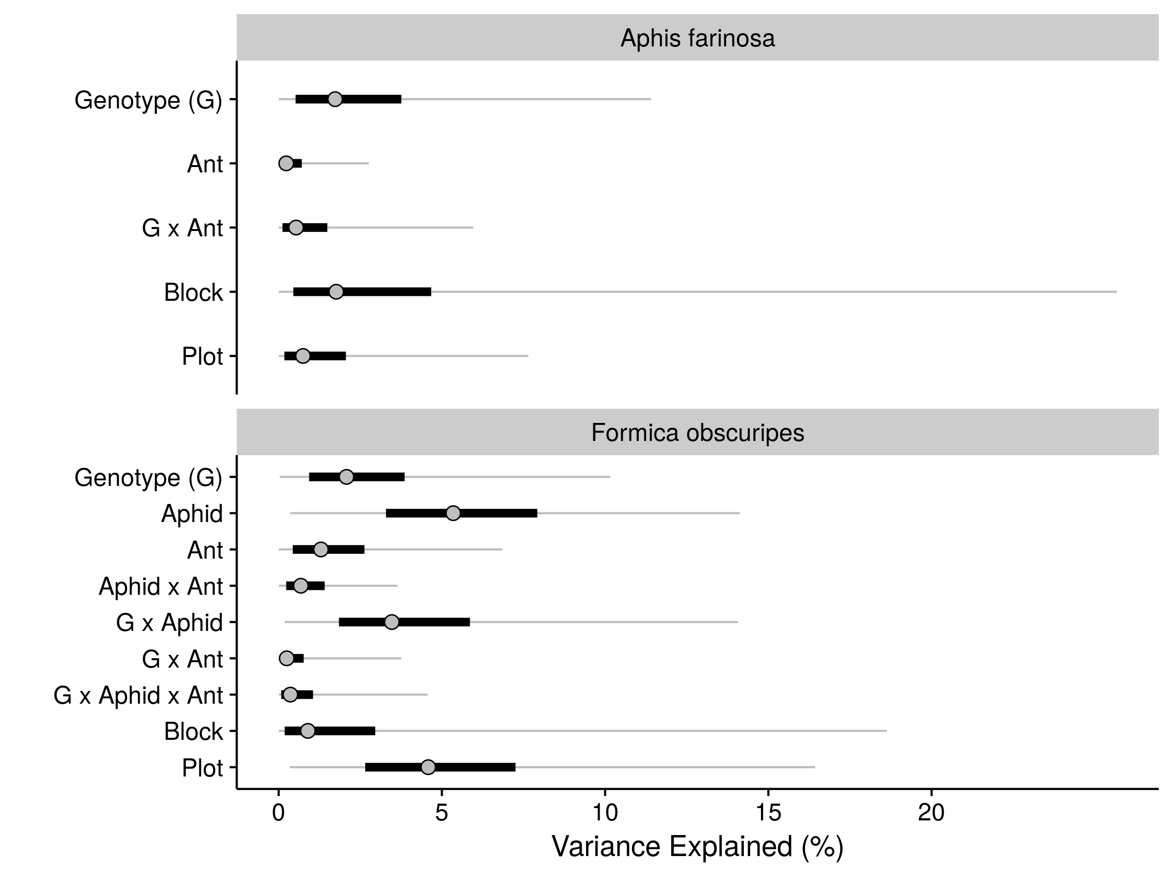

**Figure A1**. Sources of variation in sallow aphid (*Aphis farinosa*) and western thatch ant (*Formica obscuripes*) abundance measured in the ant-aphid and wind experiments. Grey points, black bars, and grey lines correspond to the median, 25% - 75% interval, and 2.5% - 97.5% interval of posterior estimates of percent variance explained, respectively.



**Figure A2**. Illustration of how we calculated the indirect effects of trait plasticity and genetic variation. SD corresponds to the the standard deviation of effects estimated from Bayesian linear mixed-effects model.

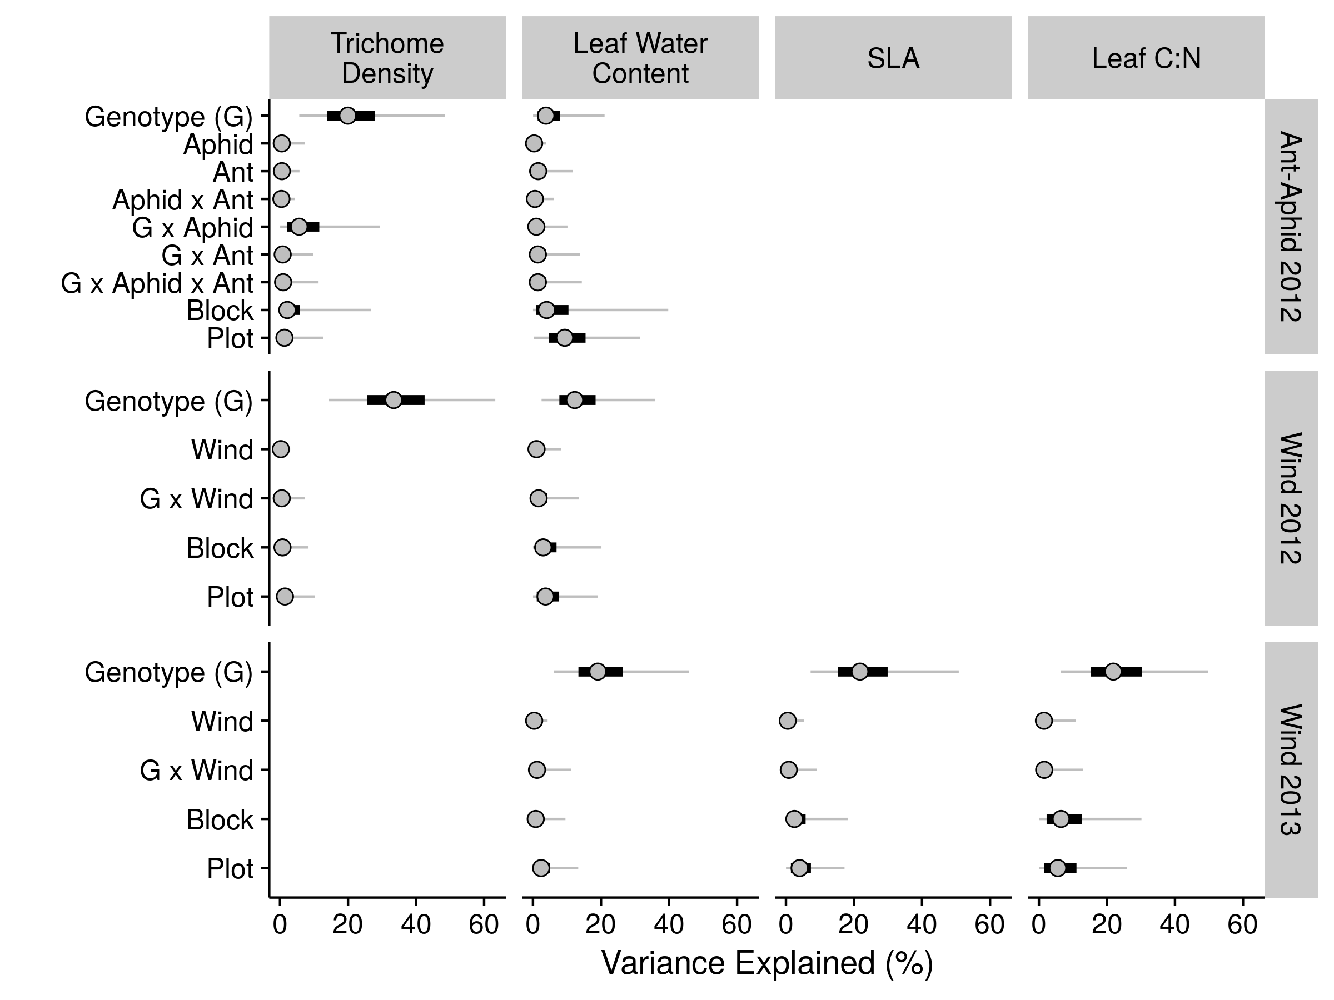

**Figure A3**. Sources of variation in leaf-quality traits measured in the ant-aphid and wind experiments. Grey points, black bars, and grey lines correspond to the median, 25% - 75% interval, and 2.5% - 97.5% interval of posterior estimates of percent variance explained, respectively.

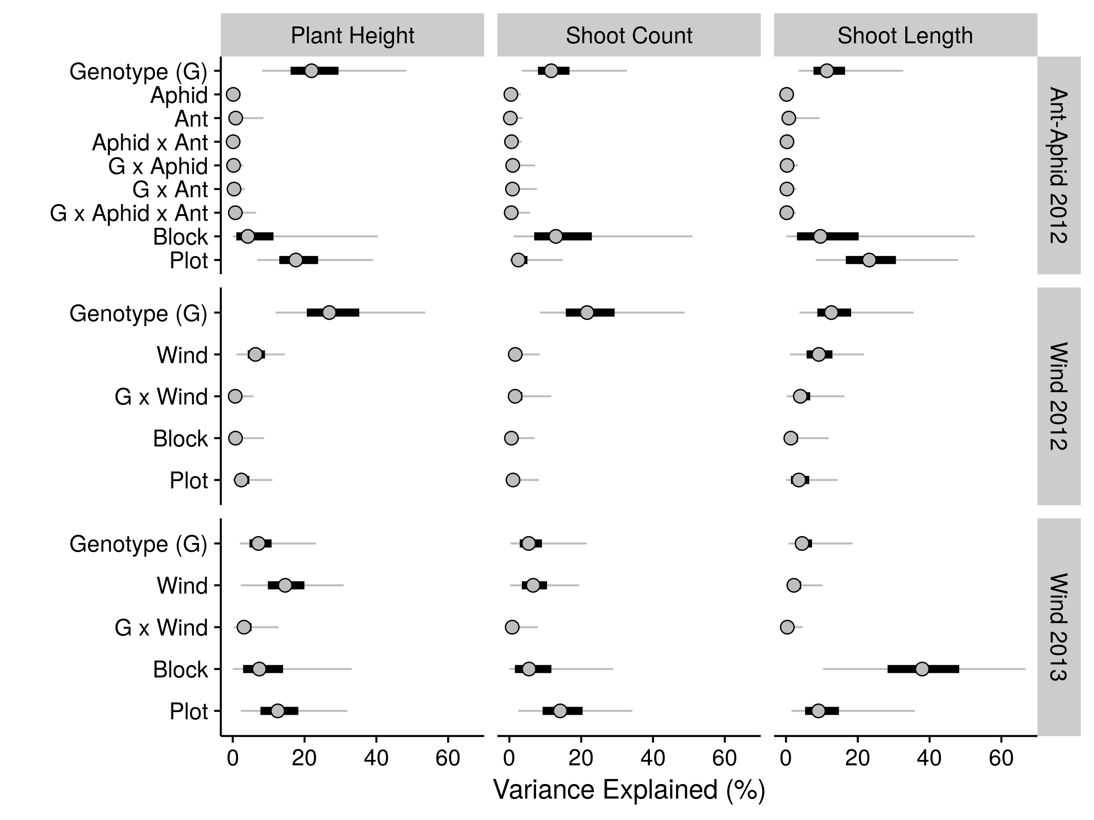

**Figure A4.** Sources of variation in plant-growth traits measured in the ant-aphid and wind experiments. Grey points, black bars, and grey lines correspond to the median, 25% - 75% interval, and 2.5% - 97.5% interval of posterior estimates of percent variance explained, respectively.

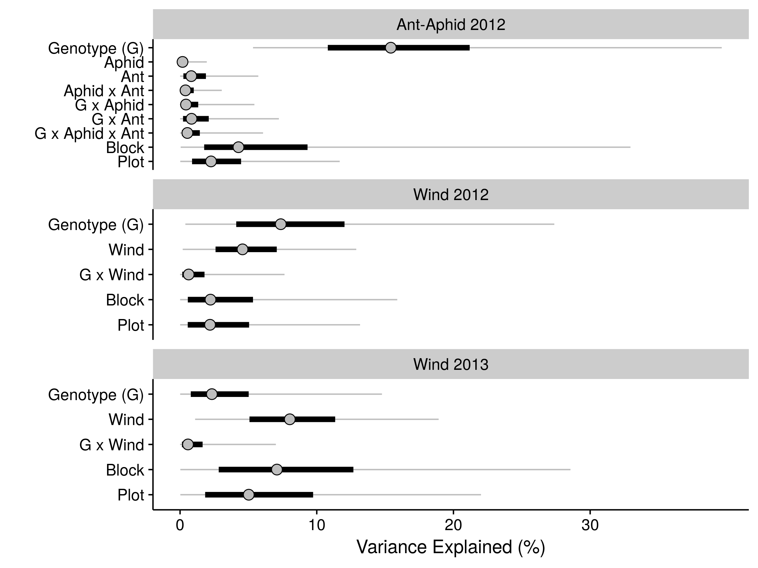

**Figure A5**. Sources of variation in arthropod species richness measured in the ant-aphid and wind experiments. Grey points, black bars, and grey lines correspond to the median, 25% - 75% interval, and 2.5% - 97.5% interval of posterior estimates of percent variance explained, respectively.