**Host-plant genetic and environmental variation structure above and belowground communities in a coastal dune ecosystem**

Matthew A. Barboura, Sonya Erlandsonb, Kabir Peayb, Brendan Lockec, Erik S. Julesc, Gregory M. Crutsingerd

aDepartment of Zoology, University of British Columbia, Vancouver, Canada; bDepartment of Biology, Stanford University, Palo Alto, California, USA;

cDepartment of Biological Sciences, Humboldt State University, Arcata, USA;

d3D Robotics, Berkeley, California, USA

Corresponding Author: barbour@zoology.ubc.ca

**Abstract**

Over the past several decades, the role of host-plant genetic variation has received a growing appreciation for its effects on the diversity and composition of associated above and belowground communities. To date, however, the vast majority of studies have occurred within a single common garden, thereby minimizing the array of biotic and abiotic environmental conditions that might directly or indirectly (via host plant phenotypes) affect communities. Therefore, whether abiotic and biotic environments nullify or modify host-plant genetic effects on the communities they support remains poorly understood. We addressed this knowledge gap by planting a series of common gardens consisting of 10 different clones (genotypes) of the willow *Salix hookeriana* in a coastal dune ecosystem and manipulating natural variation in ant-aphid mutualisms (biotic) and wind exposure (abiotic). We then quantified variation in associated foliar arthropods, root-associated ectomycorrhiza and bacteria, and plant traits across all willow individuals to tease apart the processes by which willow genotype and the environment influenced associated communities. In the ant-aphid experiment, we found that willow genotype what the strongest predictor of variation in foliar arthropod communities compared to aphid additions and proximity to aphid-tending ant mounds. Still, we observed that aphid additions modified the effect of willow genotype on arthropod community composition by attracting other aphid species on certain willow genotypes, supporting that both host-plant genotype and herbivores were key factors. In the wind experiment, we found that wind exposure was the main predictor of variation in communities of foliar arthropods and root bacteria. Still, willow genotype had strong effect sizes on several community properties of arthropods and ectomycorrhiza, indicating that host-plant genetic variation remains important despite wind being a key environmental factor in coastal dune ecosystems. In both experiments, plant-growth traits were the primary determinants of arthropod community structure with leaf quality traits playing a lesser role; however, we failed to identify which root traits were mediating belowground community responses. Taken together, our results suggest that host-plant genetic and phenotypic variation can play a key role in shaping associated communities, despite natural variation in the biotic and abiotic environment. However, considering the role of both genotype and the surrounding environment will lead to a better understanding of how host-plant communities are assembled.

**Introduction**

Intraspecific genetic variation is a key driver of phenotypic variation within host plants, which in turn can have cascading effects on associated species and entire communities of organisms (Fritz & Price 1988; Maddox & Root 1990; Antonovics 1992; Lamit *et al.* 2015)For example, genetic variation in the leaf chemistry of cottonwoods (Whitham *et al.* 2006)and the plant architecture of coyote bush (Crutsinger *et al.* 2014)has been shown to structure diverse assemblages of species, from foliar arthropods aboveground to soil microbes below. While the community-level consequences of genetic variation (commonly referred to as ‘community genetics’, *sensu* (Antonovics 1992), have been documented in a variety of host-plant taxa (Whitham *et al.* 2012)case studies come primarily from common garden experiments where environmental variation is minimized. Yet, decades of ecological studies have shown that variability in the environment has a fundamental influence on trait variation in host plants (Gratani 2014); however, the relative importance of host-plant genotypic vs. environmental effects on ecological communities remains an open question for the vast majority of systems (Hersch-Green *et al.* 2011; Tack *et al.* 2012; Crutsinger 2015)

A key challenge for advancing community genetics beyond the common garden is to: (i) identify important sources of environmental variation that host-plants are exposed to within a given ecosystem; and (ii) distinguish whether environmental effects are independent (E) or modified by host-plant genotype (G x E). For example, a series of experiments in common milkweed (*Asclepias syriaca*) have shown that a diversity of biotic and abiotic factors, such as light competition from neighboring plants (Agrawal & Zandt 2003), caterpillar herbivory (Abdala‐Roberts *et al.* 2012), and aphid-tending ants (Mooney & Agrawal 2008; Abdala‐Roberts *et al.* 2012) can act independently or interact with milkweed genotype to shape its associated community of foliar arthropods.

For the majority of host-plant systems, however, we have a poor understanding of the relevant sources of environmental variation and whether they act independently or modify the effects of host-plant genetic variation on associated communities.

Although host plants provide essential resources for a diverse array of taxa both above- and belowground, the majority of community genetics studies have focused on aboveground assemblages (Whitham *et al.* 2012). Studies that have simultaneously examined above- and belowground communities have found variable results, with host-plant genetic effects on aboveground communities being stronger (Crutsinger *et al.* 2008; Bailey *et al.* 2009) or comparable (Crutsinger *et al.* 2014) to those belowground. Communities that are only weakly coupled to host-plant genotypes may be more sensitive to variation in the environment; however, there are no studies, to our knowledge, that have simultaneously examined above- and belowground community responses to host-plant genetic and environmental variation. Since above- and belowground linkages can have important consequences for both plant fitness (Whitham *et al.* 2006) and terrestrial ecosystem processes (Wardle *et al.* 2004), a rising challenge for community genetics is to understand the linkages between these above- and belowground communities (Crutsinger *et al.* 2014; Lamit *et al.* 2015) and whether these linkages are modified by environmental variation.

Finally, identifying the underlying mechanisms of community assembly requires a detailed survey of the specific plant traits that shape interactions with associated species. Identifying these key traits can be challenging. Plant traits are often highly correlated, making it difficult to determine which trait (or suite of traits) associated community members are cueing in on (Barbour et al. 2015). Different traits can also vary in their heritability (proportion of variance in a trait explained by genotype, (Lynch & Walsh 1998)which may coincide with their response to environmental variation. Because many genotype-by-environment studies do not conduct detailed trait screenings, the processes generating community responses often remain unclear (Hersch-Green *et al.* 2011; Crutsinger 2015).

Here, we use common garden experiments to examine how host-plant genotypic variation as well as the abiotic and biotic environment structure communities associated with the willow *Salix hookeriana* in a coastal dune ecosystem. Prior work in this system has shown that willow genotypes host distinct arthropod communities and that multiple plant phenotypes are important in determining community assembly (Barbour *et al.* 2015, 2016)Importantly, these phenotypes varied substantially in their degree of heritability (plant growth, mean *H*2 = 0.26; leaf quality, mean *H*2 = 0.72), suggesting that the environment may influence them in different ways. We sought to address the following questions: (1) what is the relative importance of willow genotype vs. the abiotic and biotic environment in determining willow phenotypes and associated communities? (2) What are the mechanisms by which willow genetic and environmental variation affects community responses? (3) Do above- and belowground communities differ in their responses to willow genetic and environmental variation?

**Methods**

*Study Site*

We conducted this research at Lanphere Dunes (40**°** 53’29.85”N, 124**°** 8’49.06”W), a pristine coastal dune ecosystem managed by US Fish and Wildlife service in Humboldt County, California. Coastal willow (*Salix hookeriana* ex Barratt ex Hooker) naturally occurs in nearshore dune swales – seasonal freshwater wetlands that form in depressions between dune ridges (Pickart 2009). Aside from coastal willow (hereafter willow), the dominant vegetation in these swales consists of beach pine (*Pinus contorta* ssp. *Contorta*) and slough sedge (*Carex obnupta*).

During preliminary surveys, we qualitatively identified two important sources of environmental variation for willows in the dunes – one abiotic (wind exposure) and one biotic (the presence of ant-aphid mutualisms). Willows growing in wind-exposed habitats often exhibit reduced growth, especially at the their leading edge, appearing to be “swept back” by the wind. We also observed that the aphid *Aphis farinosa* was an abundant herbivore at Lanphere Dunes. *Aphis farinosa* is usually found at the tips of new shoot growth where they feed on willow phloem. As with many other aphid species, *A. farinosa* excretes carbohydrate-rich honeydew while feeding, which attracts ants that tend the aphids and feed on the honeydew. This ant-aphid interaction is often mutualistic, because the ants will defend aphids from predatory arthropods and also eat other herbivores that may be competing with the aphids (Floate & Whitham 1994; Mooney & Agrawal 2008). The ant species we observed most frequently tending *A. farinosa* was the western thatching ant, *Formica obscuripes*. Western thatching ants create distinct dome-shaped mounds from nearby plant-material and are known to influence *S. hookeriana*’s arthropod community at our study site (Crutsinger & Sanders 2005). Therefore, we hypothesized that the presence of aphids and the proximity to ant mounds were important biotic factors that would affect ant-aphid interactions, and in turn other members of the arthropod community.

*Experimental Design*

Prior to bud burst in February 2012, we took shoot cuttings (40 cm length & ~0.5 cm diameter) from one to two replicates of 10 different willow genotypes from a pool of 26 locally collected willow genotypes planted in a large common garden experiment. Details about the establishment of this common garden are given in (Barbour *et al.* 2015)These 10 genotypes displayed substantial variation in both plant-growth and leaf quality traits ( (Barbour *et al.* 2015)Shoot cuttings were soaked in water overnight and then planted in a mixture of 80% perlite, 20% peat moss (dolomite lime added to balance pH) inside ‘cone-tainers’. We grew cuttings under ambient weather conditions outside the greenhouse at Humboldt State University until we transplanted willows into multiple common gardens at Lanphere Dunes.

Ant-aphid experiment – To examine how the presence of ant-aphid mutualisms affected willow associated communities, we established common gardens around 5 different ant mounds (treated as blocks) in late May 2012. Within each block, we randomly planted 20 cuttings (2 replicates of each of 10 genotypes) with 0.5 m spacing in plots that were at a distance of 1, 6, and 12 meters from the edge of the ant mound, for a total of 60 cuttings per ant mound (300 cuttings for entire experiment). Within each plot, we randomly assigned the aphid treatment (aphid presence vs. absence) to one of the two replicates for each genotype. On May 22, we collected aphids (*Aphis farinosa*) from a single willow patch at Lanphere Dunes and placed 5 adult apterate aphids on the tips of willow cuttings in the aphid treatment using a moist paintbrush. We bagged aphids onto the apical shoots of cuttings using organza bags to promote aphid establishment on plants. Similarly, we placed organza bags on all control plants. On May 27, we checked aphid treatments to ensure there were 5 adult aphids and removed bags from all cuttings. If necessary, we added aphids to these treatments until there were 5 adults and we removed any aphid nymphs that were produced since initial establishment. We checked plants for aphids on June 6, June 13, June 24, July 4, July 14, and July 20, 2012. If plants in the aphid treatment had less than 5 apterate aphids, we noted their abundance and added aphids until there were at least 5 individuals. The ant-aphid experiment was restricted to the summer of 2012, because in the summer of 2013 there was high drought induced willow mortality and *A. farinosa* was in too low of abundance on naturally occurring willows to allow us to repeat the experiment.

Wind experiment – To examine how wind exposure affected willow associated communities in the coastal dunes, we planted 200 willow cuttings in a split-plot experimental design in late May of 2012. At 10 different willow patches (treated as blocks), we established an ‘exposed’ and ‘unexposed’ common garden with exposed gardens facing prevailing winds during the growing season. Each garden consisted of one replicate cutting of each of 10 genotypes randomly planted in 2 m by 0.5 m grid with 0.5 m spacing between plants. The center of exposed and unexposed gardens within each block were the same distance (2 m) from the edge of the willow patch to control for insect accessibility. To estimate the difference in wind conditions experienced by exposed vs. unexposed plants, we went out on a representative windy afternoon in September 2012. A nearby weather station estimated wind speeds of 22 km/h during this period (Arcata, CA). We used a hand-held anemometer (Kestrel 1000) to measure wind speed at a height of 37 cm aboveground (approximate height of tallest plants in the garden in 2012) in each plot of our experiment. Maximum wind speed measurements were taken over a 30 s period and collected on either an exposed or unexposed site first. We found that willows growing in wind-exposed plots experienced up to 3.7-fold higher wind speeds compared to unexposed plots (F1,9 = 187.32, P < 0.001), suggesting that the location of our plots were effective manipulations of wind exposure.

*Community Responses*

Arthropod community – We visually surveyed plants for arthropods to determine the abundances of different (morpho)species. For the ant-aphid experiment, we surveyed arthropods on 5 different occasions between early June and late July 2012. For the wind experiment, we surveyed arthropods once at the end of July 2012 and then once a month in May, June, and July of 2013. So that individuals were not counted twice between sampling dates, we took the maximum abundance for each arthropod (morpho)species from each plant across all sampling dates within each year. This approach provides a conservative estimate of the total number of individuals of each (morpho)species that occurred on individual plants through the summer. Given the relatively low abundances of individual morphospecies, we grouped arthropods at the Family-level for insects and at the Order-level for all other arthropods prior to analyzing community composition (details in *Statistical Analyses* section below).

Ectomycorrhiza and bacteria communities – In late July of 2013, we dug up the willows from the wind experiment in order to sample the ectomychorriza and bacteria communities associated with the willow roots. We did not sample the belowground communities of plants in the ant-aphid experiment due to the high mortality of plants in 2013. To sample these belowground communities, we removed willows with the surrounding soil intact to preserve root systems, separated shoots and roots, then brushed soil off root systems and stored roots in separate plastic bags. Within 6 hours of excavation, root systems were stored at 4°C. To process roots, we gently rinsed them in tap water until free of visible soil. In order to randomly select roots for molecular analysis, second order roots were cut up into 2 cm lengths; spread out on a grid; and using a random number generator, a total of 30 cm of root length was picked from numbered grid cells. These random root subsamples were flash frozen in liquid N, and kept at -80°C until DNA extraction. To extract DNA, flash frozen root samples were physically disrupted with 2 beads per 2 mL tube (3.0 mm Yttria stabilized Zirconidea Grinding Media) for 30 seconds at 1500 strokes per minute (SPEX SamplePrep 200 geno/grinder). Total DNA was extracted from frozen root samples using MoBio PowerSoil 96 sample DNA extraction kits following the manufacture’s instructions.

To sequence and identify ectomycorrhiza and bacteria OTUs, we used custom barcode primer sets ITS1f/ITS4 and 515f/806r (Caporaso et al. 2012) to PCR amplify the fungal ITS1, 5.8S, and ITS2 region of ribosomal DNA and the V4 region of bacterial 16S ribosomal DNA from total root DNA extractions. Product quality was assessed by gel electrophoresis. PCR products were cleaned with magnetic beads, quantified with Qubit fluorometric kit, and all samples were pooled at a bacteria:fungal concentration ratio of 2:1. Pooled amplicon libraries were sequenced as single-index (the reverse barcode was uniquely indexed) 300 base pair reads at Stanford Functional Genomics Facility on one lane of an Illumina MiSeq. Reads were quality controlled by trimming low quality bases and sequenced adaptors and removing reads with average error rates greater than 0.25 using UPARSE (Edgar 2013). Only high quality, paired forward and reverse reads were used for OTU clustering at 97% identity and then checked for chimeras against the GOLD 16s rRNA database (Reddy et al.) and UNITE fungal ITS database ver6_97_13.05.2014 (Kõljalg et al.) with UPARSE. Taxonomy was assigned using the RDP Classifer (Wang et al.) and UNITE (ver6_97_13.05.2014) in QIIME (Caporaso et al. 2010). We then normalized datasets and discarded some OTUs and samples based on the following conditions: OTUs with no known taxonomy (any OTU that did not blast to at least Kingdom Fungi, Bacteria or Archaea); root samples with fewer than 6000 fungal reads; mitochondrial and chloroplast OTUs with samples with less than 9000 bacterial reads.

Statistical analyses – To examine how willow genotype, the environment, and their interaction influenced richness, abundance, and rarefied richness of aboveground arthropods as well as ectomycorrhiza and root bacteria, we used separate generalized linear mixed-effect models (GLMMs, (Bolker *et al.* 2009). For the ant-aphid experiment, we omitted *A. farinosa* and *F. obscuripes* from our calculations of arthropod community properties because we expected our treatments to manipulate their abundances. We specified block (ant mound) and plots nested within block (3 different distances from ant mound) as random effects. We specified willow genotype, aphid treatment, distance from ant mound, and their 3-way interaction as fixed effects in the model. For the wind experiment, we specified block (willow patch) and plots nested within block (2 wind exposure treatments) as random effects. We specified willow genotype, wind treatment, sampling year, and their 3-way interaction as fixed effects in the model. Plant mortality in each experiment resulted in unbalanced designs, so we used Type II sum-of-squares to test the significance of fixed effects. For continuous responses (rarefied richness, normalized abundances of ectomycorrhiza and bacteria) we specified Gaussian error distributions in our models and tested the significance of fixed effects using F-tests with Kenward-Roger approximated degrees of freedom. For count responses (richness and arthropod abundances), we specified Poisson error distributions in our models and tested the significance of fixed effects using likelihood-ratio tests. If necessary, we modeled overdispersion in these Poisson models by specifying an individual-level random effect.

To examine whether community composition depended on willow genotype, the environment, or their interaction, we applied a Hellinger transformation to our community data (square root of proportional abundance of species found on each willow; (Legendre & Gallagher 2001) and conducted separate permutational multivariate analysis of variance (PERMANOVA, 1000 permutations on Euclidean distances) for the arthropod, ectomycorrhiza, and bacteria communities. We incorporated the same fixed effects structured as we used to analyze the univariate community responses for each experiment. To test the significance of each effect, we used Type II sum-of-squares and compared the observed community dissimilarities to the dissimilarities we would expect by random chance with a permutation test that controls for the blocked design of our experiment. To test the significance of treatments that varied at the plot-level (wind exposure and distance from ant mound), we first calculated the community’s centroid in multivariate space for each plot. We then included block as a covariate and ran the same permutation test as previously described. This ensured that our significance tests of treatments that varied at the plot-level were based on the appropriate residual degrees of freedom (wind exposure residual *df* = 9; distance from ant mound residual *df* = 4).

*Mechanisms of community assembly*

Plant traits – Prior work in this study system has found that variation in both plant growth and leaf quality traits affect the likelihood of willows being colonized by foliar arthropods (Barbour et al. 2015). To quantify plant-growth traits, we measured plant height, the number of shoots produced, and average shoot length in late July of each year (end of growing season) for both experiments. We quantified plant height as the distance (mm) from the ground to the tip of the tallest shoot. We quantified average shoot length by measuring every shoot on each plant to the nearest millimeter and calculating the average shoot length for each plant. We also measured several traits that could shape leaf quality for herbivores, including water content, trichome density, specific leaf area (SLA), percentage carbon (C) and nitrogen (N), and C:N. To measure these traits, we excised fully expanded and undamaged leaves from plants in late July of each year, stored leaf samples with a moist paper towel in separate plastic bags within a cooler and immediately brought them back to the laboratory. We then weighed leaves to obtain fresh mass (g), digitally scanned them to measure leaf area (mm2) using ImageJ (Abrámoff, Magalhães, and Ram 2004), and oven-dried them at 60 °C for 72 h to obtain dry weight (g) (Cornelissen et al. 2003). We calculated SLA as (Cornelissen et al. 2003). We calculated leaf water content as the (Munns & PrometheusWiki Contributors 2010). To measure trichome density, we counted the number of trichomes along an 11 mm by 1 mm transect in the center of the leaf, halfway between the leaf edge and the mid-vein, under a dissecting scope. To measure percentage C and N, we ground oven-dried leaves to a fine powder using a ball mill (Mixer/Mill 8000D, SPEX SamplePrep; Metuchen, NJ, USA). Subsamples of each material were then analyzed for percentage C and N on an elemental analyzer (ECS 4010; Costech Analytical Technologies, Valencia, California, USA) using atropine (4.84% N and 70.56% C) as a reference standard. For root-associated communities, we hypothesized that variation in root C:N may affect community assembly. A small subsample of roots from each plant was oven-dried, crushed with a razor blade and approximately 4 mg were flash combusted on a Carlo-Erba 1500 elemental analyzer to measure percentage C and N.

To analyze how willow genotype, the environment, and their interaction influenced willow phenotypes, we used separate GLMMs with the same structure described in the *Community responses* section. For the wind experiment, we lacked multiple years of data on leaf trichome density (2012 only), SLA (2013 only), leaf C:N (2013 only), and root C:N (2013 only); therefore, we removed sampling year, and its interactions, from the fixed effects structures of these GLMMs.

Soil characteristics – Soil nutrients, total organic matter, and moisture may all influence plant phenotypes and the assembly of ectomychorizzal and bacterial communities on plant roots (Erlandson *et al.* 2015). Moreover, we expected that wind exposure to affect these soil characteristics (LORTIE & CUSHMAN 2007); therefore, we measured soil nutrients, percent organic matter, and moisture within each plot of the wind experiment (one exposed and one unexposed plot per block).

To estimate soil nutrient uptake by willows, we installed Plant Root Simulator (PRS) Probes (Western Ag Innovations, Saskatchewan, Canada) at three randomly selected locations within each plot for 11 days in September 2012. PRS Probes estimate nutrient supply rates to roots by continuously adsorbing charged ionic elements over the burial period. For our study, we estimated potential root uptake of NO3+, NH4-, Ca, Mg, K, P, Fe, Mn, Cu, Zn, B, S, Pb, Al, and Cd. From this nutrient data, we calculated total N as NO3+ + NH4-, and then used principal components analysis to condense these nutrients into a single axis (nutrients PC1) that explained 34% of the variation. Nutrients PC1 described the negative correlation between nitrogen compounds (NO3+, NH4-) and the rest of the ionic elements, with positive values indicating high supply rates of all ionic elements except for the nitrogen compounds. To measure percent organic matter content (%OM), we used a trowel to collect soil (depth = 0 – 15 cm) adjacent to the randomly positioned PRS probes in September 2012. Soils were transported back to the lab in plastic bags, sieved into fragments less than 2 mm, randomly subsampled using a soil splitter, and dried at 105 **°**C for 72 hours. We then weighed a subsample of the oven dried soil into an oven dried crucible and placed the crucible and soil into a furnace to be combusted at 375 **°**C for 16 hours. We then weighed the combusted samples, placed them in a desiccator for 20 minutes, and weighed them again. We calculated percent organic matter as . To measure soil moisture (volumetric water content, m3/m3), we used a 5TE soil sensor coupled to an EM50 Digital/Analog Data Logger (Decagon Devices, Pullman, Washington, USA). In September 2012, while PRS probes were in the ground, we measured soil moisture at a depth of 5 cm in three random locations within each plot on three different days between 1100 – 1500 hours. We repeated this same sampling scheme in early July 2013. Plot levels measurements of soil moisture were highly correlated between years (Pearson’s *r* = 0.93, *t*18 = 10.91, P < 0.001), so we averaged these soil moisture estimates to determine a single soil moisture value per plot.

To examine the effect of wind exposure on soil characteristics (total N, nutrients PC1, %OM, and soil moisture), we used separate mixed effect models with wind treatment as a fixed effect and block (willow patch) as a random effect. Since all soil characteristics were continuous responses, we specified Gaussian error distributions in our models and tested the significance of fixed effects using F-tests with Kenward-Roger approximated degrees of freedom.

Direct and indirect effects – Ultimately, we wanted to examine how willow phenotypes and soil properties mediated the direct and indirect effects of willow genotype and the environment on community responses. To quantify these effects, we used piecewise structural equation models (SEMs, (Lefcheck 2015). An advantage of piecewise SEMs is that they are flexible, allowing users to account for correlated structure (i.e. random effects) in their experimental design. However, as with any technique that relies on multiple regression, structural equation models can give misleading results if there is collinearity among predictor variables. To mitigate the effects of collinearity, we used principal components analysis (PCA) to condense aboveground willow phenotypes as well as soil properties into a small number of uncorrelated variables. For aboveground willow phenotypes in the wind experiment, we analyzed separate PCAs for 2012 and 2013 since we did not always have data on the same traits in each year. At times, we lacked data for all traits on each plant or all soil properties measured in each plot. Therefore, we used a regularized iterative PCA algorithm to impute missing values (Josse & Husson 2013). For each PCA, we retained principal components with eigenvalues greater than 1.

To calculate standardized coefficients in our piecewise SEM, we scaled all predictor and response variables to mean = 0 and SD = 1 prior to analyzing them with GLMMs (error distribution = Gaussian). For willow genotype, we specified the average effect for the 10 genotypes as the reference level (i.e. deviation contrasts) and calculated the standard deviation of the coefficients to determine its standardized coefficient. To evaluate the explanatory power of our separate GLMMs, we report marginal *R*2 (Nakagawa & Schielzeth 2013). Marginal *R*2 do not adjust for the variance explained by our random effects; therefore, they give us a truer sense of the explanatory power of our models. To evaluate the fit of the full structural equation model, we used a test of directed separation (Shipley 2000). This test identifies missing paths in the model, calculates the *P*-value for each missing pathway, and then calculates a test statistic, Fisher’s *C*, using the following equation: *C* = -2, where is the *P*-value of the *i*th missing pathway and *k* is the total number of missing pathways. Fisher’s *C* can then be compared to a chi-square distribution with 2*k* degrees of freedom.Note that if there are many missing pathways with low *P*-values, this will result in a lower *P*-value for the structural equation model. Therefore, a *P*-value < 0.05 indicates a poor fit for the structural equation model, whereas a *P*-value > 0.05 indicates a good fit.

All analyses were conducted in R version 3.2.4 (R Core Team 2016).

**Results: Ant-aphid experiment**

*Community responses*

Willow genotype and the biotic environment had both independent and interactive effects on the arthropod community (Table 1). Specifically, we found that arthropod richness varied from 1.2 to 3.2 species among genotypes (Fig. 1A), while arthropod abundance varied 4-fold among the different clones (Fig. 1B). The effect of willow genotype on arthropod richness appeared to be due to correlated responses in arthropod abundance, as there was no difference in rarefied richness among genotypes (Table 1). Aphid treatment was the only factor that affected rarefied richness (Table 1), leading to a 16% decrease in rarefied richness when aphids were added to willows (Fig. 1D); however, this effect of aphid treatment did not translate into an effect on total richness (Table 1). Willows in the aphid treatment also had 2-fold more arthropods, but only at the furthest distance from ant mounds (EaphidEant, Table 1, Fig. 1C). Proximity to ant mounds did not influence any other aspect of the arthropod community (Table 1). In terms of community composition, we found that the arthropod community was influenced by an interaction between willow genotype and the aphid treatment (Table 1, Fig. 1E)*.* This GEaphid effect was primarily due to the differential response of other aphids to a single willow genotype (Table S1, Fig. 1F). If we remove this genotype from the analysis, we still find strong, but independent effects of willow genotype (F8,156 = 1.66, P = 0.007)and the addition of aphids (F1,156 = 2.93, P = 0.017)on community composition.

*Mechanisms of community assembly*

Ant-aphid interactions – We hypothesized that the effect of willow genetic variation and the biotic environment on arthropod communities would be mediated, in part, by variation in the abundance of *A. farinosa* and *F. obscuripes*, so we first tested for these intermediate effects. While distance from ant mounds had little effect on *A. farinosa*, willow genotype had a strong effect, with the average number of aphids ranging from 0.05 to 7 among the most disparate willow genotypes in the aphid treatment (Fig. 2A, Table 1). This strong effect of willow genotype on *A. farinosa* in the aphid treatment resulted in a GEaphid effect on the abundance of *F. obscuripes* (Table 1), with ant abundance varying from 0 to ~0.5 individuals (on average) among clones in the aphid treatment, whereas they were virtually absent in the absence of aphids (Fig. 2B). Proximity to ant mounds had no effect on the abundance of *F. obscuripes* (Table 1).

Plant traits – In addition to ant-aphid interactions, we hypothesized that the effect of willow genetic variation and the biotic environment on arthropod communities would be mediated by plant traits. We observed both direct and interactive effects of willow genotype and the biotic environment on plant traits (Table 1). For example, all of the plant-growth traits we measured varied approximately 2-fold among the most disparate willow genotypes (Table 1, Fig. 2C). Willows did appear to produce 28% more shoots in the absence of aphids, but only at the furthest distance from ant mounds (EaphidEant effect, Table 1). While there was little apparent effect of willow genotype and the biotic environment on leaf water content (Table 1), we found that the addition of aphids modified the effect of certain willow genotypes on leaf trichome density (GEaphid effect, Table 1). Specifically, two clones (S and T) produced ~4-fold more trichomes when aphids were absent, whereas genotype L produced 3-fold more trichomes when aphids were present (solid lines in Fig. 1F).

Direct and indirect effects – We used structural equation models (for richness, abundance, and rarefied richness) and redundancy analysis (for community composition) to tease apart the direct and indirect effects of willow genetic variation and the biotic environment on the arthropod community. For the traits we measured, we found that the indirect effect of willow genotype on arthropod richness and abundance was mediated primarily by plant trait PC1 (Fig. 3A,B). Plant height, shoot count, and shoot length all had strong, positive loadings on trait PC1 (Table S3), indicating that larger willows hosted more arthropod species and individuals. Arthropod abundance was also positively influenced by the addition of aphids, primarily because *A. farinosa* also attracted other ant species (Pearson’s *r* = 0.42, t282 = 7.74, P < 0.001; Fig. 3D) and these other ants were the second most abundant taxonomic group in the community. In contrast to total abundance, the addition of aphids negatively affected rarefied richness. This negative effect was due in part to aphid additions attracting more *F. obscuripes*, an active generalist predator that likely consumed or inhibited the colonization of other arthropods. In terms of composition, we found that the abundance of *A. farinosa* was the only factor (of the mechanisms we modeled) influencing the arthropod community. Specifically, higher abundance of *A. farinosa* resulted in an increase in the proportional abundance of other ant species in the community (Fig. 3D).

Despite our detailed analysis of potential mechanisms, our structural equation models revealed multiple missing paths (dotted lines, Fig. 3A,B,C), resulting in rather poor fits for most of the models (richness: C2 = 8.49, P = 0.014; abundance: C32 = 37.66, P = 0.226; rarefied richness: C4=11.10, P = 0.025). For example, after accounting for the traits we measured, willow genotype still had a strong effect on arthropod richness (Fig. 3A) and *A. farinosa* abundance (Fig. 3B), indicating that we failed to identify key pathways (likely unmeasured traits) by which genetic variation influenced these responses. Similarly, we failed to fully identify the EaphidEant effect on arthropod abundance (Fig. 3B) as well as how the addition of aphids negatively affected rarefied richness (Fig. 3C). For our redundancy analysis of community composition, we found that *A. farinosa* abundance explained the effect of the aphid treatment (F1,173 = 0.90, P = 0.447), but we still failed to detect the effect of both willow genotype (F9,173 = 1.53, P = 0.014) and the GEaphid effect (F9,164 = 1.71, P = 0.004), suggesting that we failed to measure important constitutive and inducible plant traits.

**Results: Wind experiment**

*Community Responses*

Arthropod community – We found that wind exposure and willow genotype had strong, but independent effects on the arthropod community (Table 2). In particular, willows growing in wind-exposed plots hosted 51% fewer species, 47% fewer individuals, and 60% fewer rarefied species compared to unexposed willows (Fig. 4A,C,E). In spite of the effects of wind exposure, willow genotype had a strong effect on both the richness (~3-fold differences, Fig. 4B) and abundance (~5-fold differences, Fig. 4D) of arthropods, but only a marginal effect on rarefied richness (Fig. 4F). Arthropod communities on willows had both more species and more individuals in the second year of the experiment compared to the first (Table 2); however, we also conducted more arthropod surveys for the wind experiment in 2013 vs. 2012. In terms of community composition, we observed strong effects of wind exposure by the end of experiment (Table 2, Fig 5A). These compositional differences were due to several key arthropod taxa (gall midges, leaf-mining moths, and spiders) being less abundant on wind-exposed willows, whereas leaf-tiering moths were insensitive to wind exposure (and therefore relatively more abundant; Table S2). Although several arthropod taxa varied in abundance among willow genotypes (Table S1), we did not detect an effect of genotype on community composition in either year of the experiment (Table 2).

Ectomycorrhiza and Bacteria communities – Root-associated ectomycorrhiza and bacteria communities responded differently to willow genotype and wind exposure compared to foliar arthropods. For example, neither wind exposure nor willow genotype influenced the richness, abundance, or rarefied richness of ectomycorrhiza OTUs (Table 2). However, willow genotype explained 7% of the variation in the composition of the ectomycorrhizal community (Fig. 5B) with no detectable effect of wind-exposure (Table 2). In contrast to the ectomycorrhizal community, wind exposure slightly influenced multiple indices of the bacteria community (Table 2), but in the opposite direction of foliar arthropods. For example, the roots of wind-exposed plants tended to host more bacteria OTUs than unexposed plants (10% increase, Table 2). The effect of wind-exposure on bacteria richness was likely a result of the significant increase in rarefied richness on wind-exposed plants (Table 2), but the effect size for rarefied richness was very small (wind-exposed mean = 0.9993, unexposed mean = 0.9992). While wind exposure did not affect the total abundance of bacteria OTUs (Table 2), it had a marginal effect on the composition of the bacteria community (Fig. 5C). There was no detectable effect of willow genotype on any aspect of the bacteria community.

*Mechanisms of community assembly*

Soil characteristics – One of the mechanisms by which wind exposure could influence willow-associated communities is through accumulated effects on soil properties; however, we observed only modest effects of wind exposure on soil properties (Table 2). Specifically, soil in wind-exposed plots was marginally drier (Fig. 6A) with higher amounts of total Nitrogen (Fig. 6B) than in unexposed plots, but there was no clear difference in either percent organic matter or nutrient composition (Table 2).

Plant traits – As with the ant-aphid experiment, we hypothesized that the effects of wind exposure and willow genotype on associated communities would be mediated by plant traits. Interestingly, we found that plant-growth and leaf quality traits responded differently to wind exposure and willow genetic variation (Table 2). For example, wind exposure negatively affected all plant-growth traits (Table 1). Moreover, the negative effects of wind exposure were magnified by the end of the experiment for both plant height (Fig. 6C) and the number of shoots produced (Table 2).Still, willow genotype had a pronounced effect on all plant-growth traits, resulting in willows that varied over 2-fold in height (Fig. 6D), number of shoots, and shoot length among the most disparate genotypes. While the effect of willow genotype on shoot length changed by the end of the experiment (Table 2), this GEyear effect was relatively small (*R2* = 0.05) compared to the effect of genotype alone (*R2* = 0.13). In contrast to plant-growth traits, willow genotype was the primary factor in determining leaf traits across both years of the experiment (Table 2). The leaves of willow genotypes varied 46-fold in trichome density, 1.5-fold in SLA, and 1.6-fold in C:N (Fig. 6E). We had data available on leaf water content for 2012 and 2013, and we found that the amount of variation explained by willow genotype depended on the sampling year (2012, *R2* = 0.11; 2013, *R2* = 0.16). Unlike aboveground plant traits, root C:N did not appear to be influenced by either wind exposure or willow genotype (Table 2, Fig. 6F).

Direct and indirect effects – In contrast to the ant-aphid experiment, our structural equation models provided good fits to our data (i.e., P > 0.05), indicating that we identified the key processes affecting the richness (Fig. 7A; C38 = 28.83, P = 0.858), abundance (C38 = 32.8, P = 0.709), and rarefied richness (C38 = 21.63, P = 0.985) of willow-associated communities.

Aboveground, we found that wind exposure had a direct, negative effect on arthropod richness (Fig. 7A), abundance (std. coef. = -0.08), and rarefied richness (std. coef. = -0.26). In addition, we found that both trait PC1 and PC2 mediated the indirect effects of wind exposure (negative) and willow genetic variation on the arthropod community (Fig. 7A). Trait PC1 had a strong, positive effect on arthropod richness (Fig. 7A), abundance (std. coef. = 0.28), and rarefied richness (std. coef = 0.37). Similar to the ant-aphid experiment, trait PC1 had strong, positive associations with plant height, shoot count, and shoot length (Table S3), indicating that larger willows hosted more arthropod species. Trait PC2 had a smaller, but negative effect on arthropod richness (Fig. 7A), abundance (-0.15), and rarefied richness (-0.12). Trait PC2 had a strong positive correlation with leaf C:N, but strong negative correlations with leaf water content and SLA (Table S3), indicating that willows with poorer quality leaf tissue hosted fewer arthropod species. These qualitative patterns held for the richness, abundance, and rarefied richness of foliar arthropods in the first year of the experiment as well (C22 = 26.02, P = 0.251), except that trait PC2 was determined by different traits (Table S3) and did not appear to affect any aspect of the arthropod community (richness, P = 0.657; abundance, P = 0.104; rarefied richness, P = 0.850). For community composition, we only analyzed the data from the second year of the experiment because this was the only year we detected a significant effect of wind exposure (Table 2). We found that the effects of wind exposure on community composition were primarily mediated by plant trait PC1. Positive values of trait PC1 (i.e. larger plants) had greater proportional abundance of gall midges, leaf-mining moths, and spiders, whereas leaf-tiering moths were insensitive to plant size (Fig. 7B).

Belowground, we found that different processes determined the structure of root-associated ectomycorrhiza and bacteria communities. For example, soil PC1, and to a lesser extent root C:N, negatively affected ectomycorrhiza richness (Fig. 7A), abundance (std. coefs: soil PC1 = -0.28; root C:N = -0.15), and rarefied richness (std. coefs: soil PC1 = -0.28; root C:N = -0.22). Soil PC1 had strong positive correlations with soil moisture and organic matter, but negative correlations with NO3- and NH4+, indicating that ectomycorrhiza communities were more diverse in drier environments with more available nitrogen. In contrast, soil PC2 was the primary factor in determining bacteria richness (Fig. 7A), abundance (std. coef. = 0.23), and rarefied richness (std. coef. = 0.28). Micronutrients such as Ca2+, Mg2+, and Cd2+ had strong positive loadings on soil PC2, indicating that bacteria richness was greater in environments with more of these micronutrients. Although we detected clear effects of soil properties and root C:N on richness, abundance, and rarefied richness of root-associated communities, none of these characteristics were strong predictors of their compositions (Table 3). Indeed, although we detected a significant effect of willow genetic variation on ectomycorrhizal composition (Table 2), we failed to identify the process mediating the effect of willow genotype (F9,106 = 1.03, P = 0.002). Our failure to identify this process is not surprising though, given that we measured one belowground plant trait (root C:N) and it was not strongly influenced by willow genotype (Table 2).

**Discussion**

The overarching goal of this study was to compare the relative effects of host-plant genetic variation as well as abiotic and biotic environments on associated communities. Our key finding was that genetic effects on associated communities were often dependent on the environmental context in which a host-plant is growing. In the ant-aphid experiment, willow genetic variation tended to have a stronger effect on arthropod community structure compared to aphid additions and proximity to ant mounds. Still, we did find that aphid additions modified the effect of willow genotype on the composition of the arthropod community, suggesting that both factors play an important role in understanding community assembly. In the wind experiment, we found that wind exposure trumped willow genotype in the strength of its effect on foliar arthropods and root-associated bacteria; however, willow genotype was the only factor that influenced the composition of root-associated ectomycorrhiza. Moreover, despite the importance of wind exposure in shaping arthropod composition, willow genotype still had predictable effects on individual arthropod guilds. Taken together, our study suggests that future experiments should consider both host-plant genetic variation and the amount of wind exposition in structuring associated communities in coastal dunes ecosystems.

*Ant-aphid experiment*

Our study supports an emerging trend that host-plant genetic variation has strong bottom-up effects on ant-aphid interactions (Johnson 2008; Mooney & Agrawal 2008; Abdala‐Roberts *et al.* 2012). As with other studies, we found that ant abundances were strongly mediated by genetic variation in aphid densities (Johnson 2008; Mooney & Agrawal 2008). Johnson (2008) found that heritable variation in leaf water content and trichome density were important determinants of the densities of *Aphis oestlundi* on evening primrose (*Oenothera biennis*); however, leaf water content and trichome density did not appear to be important for *A. farinosa* in our study, suggesting the traits mediating plant-aphid interactions are highly species specific (Züst & Agrawal 2016).

In contrast to previous work though (Johnson 2008; Mooney & Agrawal 2008), we found that the effects of host-plant genotype on the richness and abundance of other arthropods were mediated, in part, by heritable variation in plant size rather than ant abundance. One possible reason for this discrepancy is that the absolute variation in *F. obscuripes* abundance was quite low in our experiment (max. genotype average = ~0.5 individuals) compared to other studies (max. genotype average = ~3 individuals), which was likely due to the rather low abundance of aphids we observed (max. genotype average = 7 individuals). While we failed to fully identify the mechanisms (likely unmeasured plant traits) explaining arthropod community responses in this experiment, our results do suggest that host-plant evolution can have strong effects on arthropod community structure, despite variability in this biotic factor.

*Wind experiment*

Our study supports the notion that wind is a key environmental factor in structuring communities associated with host plants in coastal dune ecosystems (Miller and Weis 1999; Crutsinger et al. 2010, 2014). We found that the negative effects of wind exposure on arthropod richness and abundance resulted from a combination of direct effects on colonization as well as indirect effects mediated by wind pruning and, to a lesser extent, reductions in leaf quality. Similarly, Crutsinger *et al.* (2014) found that there were more arthropod species and individuals on prostrate vs. erect morphs of coyote bush (*Baccharis piluaris*), due to their low-lying growth form which enabled them to be more productive than erect morphs at their windy coastal dunes site.

Surprisingly, there is a paucity of studies that have examined community-level responses to natural variability in the abiotic environment and host-plant genetic variation, making it difficult to draw other useful comparisons. The majority of genotype-by-abiotic environment studies to date have used fertilizers to manipulate soil nutrient availability (Abdala-Roberts and Mooney 2013, Orians and Fritz 1996, Stiling and Rossi 1996), but it is unclear whether these manipulations reflect natural variation in soil nutrients. This may explain why the effects of variation in soil nutrients range from being independent and weak (Abdala-Roberts 2013) to being strong modifiers (Orians and Fritz 1996) of host-plant genotype on arthropod communities. The one other genotype-by-abiotic environment study we are aware of manipulated sun exposure to sea daisy (*Borrichia frutescens*,Ross and Stiling 1998) and, similar to our study, they observed strong, independent effects of shade on densities of the gall midge, *Asphondylia borrichiae*, presumably through changes in carbon-based secondary metabolites. If we are to make progress on understanding the relative importance of willow genotype vs. environment for associated communities, future experimental work should focus on manipulating natural variation in specific abiotic factors, or at the very least, measuring variability in abiotic factors to begin to identify putative causal factors.

*Above vs. belowground community responses*

Although diverse assemblages of above and belowground taxa colonize host plants, there are no genotype-by-environment studies, to our knowledge, that have simultaneously measured the responses of above and belowground assemblages. We found that foliar arthropods, ectomycorrhiza, and root microbes all responded differently to willow genetic and environmental variation, suggesting that these communities are responding to different plant traits and environmental correlates of wind exposure. Similarly, Lamit *et al.* (2015) found that communities of foliar arthropods and ectomycorrhiza did not covary across genotypes of narrowleaf cottonwood (*Populus angustifolia*). The lack of covariation between these communities is likely because these assemblages are responding to different plant traits, although we did not fully identify the root traits mediating ectomycorrhiza and bacteria colonization. While we have made substantial progress in the past decade understanding plant-arthropod interactions, it is time that community genetics research turns its attention belowground to understand the plant traits influencing these diverse assemblages. This will have the added benefit of understanding associations between above and belowground traits which will be important for predicting when we would expect linkages between above and belowground communities.

*Conclusions*

Overall, our study reinforces the importance of host-plant genetic variation in shaping associated communities. At the same time though, our findings suggest that predicting community responses to genetic and environmental variation is a complex task that may depend on historical processes that have shaped the genetic architecture for the populations of interest (i.e. sensitivity to specific environmental factors). Still, the effects of willow genetic variation were clear at both the level of plant traits and the community structure of foliar arthropods and ectomycorrhiza. Importantly, this suggests that host-plant evolution can have a strong influence on these communities. Future studies should work toward understanding how these diverse communities on host plants impose selection pressures as well as mutually influence each other. In doing so, we will be able to work toward a more synthetic understanding of the evolutionary ecology of host plants and their diverse associated communities.

**Acknowledgements**

We thank A. Pickart and the staff of Humboldt Bay National Wildlife Refuge (U.S. Fish and Wildlife Service) for permission to work at Lanphere Dunes and for facilitating experimental logistics. L. Mackas-Burns assisted with the fieldwork. M.A. Barbour was supported by a BRITE Fellowship and a Four-Year Fellowship from the University of British Columbia. G.M. Crutsinger was supported by the Miller Institute for Basic Research in Science, as well as a NSERC Discovery grant.

**References**

1.  
Abdala‐Roberts, L., Agrawal, A. & Mooney, K. (2012). Ant–aphid interactions on Asclepias syriaca are mediated by plant genotype and caterpillar damage. *Oikos*, 1905–1913.

2.  
Agrawal, A.A. & Zandt, P.A. (2003). Ecological play in the coevolutionary theatre: genetic and environmental determinants of attack by a specialist weevil on milkweed. *Journal of Ecology*, 91, 1049–1059.

3.  
Antonovics, J. (1992). Toward community genetics. *Plant resistance to herbivores and pathogens: ecology, evolution, and genetics*, 426–449.

4.  
Bailey, Schweitzer, Ubeda, Koricheva, LeRoy, Madritch, *et al.* (2009). From genes to ecosystems: a synthesis of the effects of plant genetic factors across levels of organization. *Philosophical Transactions of the Royal Society B: Biological Sciences*, 1607–1616.

5.  
Barbour, M., Fortuna, M., Bascompte, J., Nicholson, J., Julkunen-Tiitto, R., Jules, E., *et al.* (2016). Genetic specificity of a plant–insect food web: Implications for linking genetic variation to network complexity. *Proceedings of the National Academy of Sciences*, 2128–2133.

6.  
Barbour, M.A., Rodriguez-Cabal, M.A., Wu, E.T., Julkunen-Tiitto, R., Ritland, C.E., Miscampbell, A.E., *et al.* (2015). Multiple plant traits shape the genetic basis of herbivore community assembly. *Functional Ecology*, 29, 995–1006.

7.  
Bolker, B., Brooks, M., Clark, C., Geange, S., Poulsen, J., Stevens, H., *et al.* (2009). Generalized linear mixed models: a practical guide for ecology and evolution. *Trends in Ecology & Evolution*, 24.

8.  
Crutsinger, G. (2015). A community genetics perspective: opportunities for the coming decade. *The New phytologist*, 65–70.

9.  
Crutsinger, G.M., Reynolds, W., Classen, A.T. & Sanders, N.J. (2008). Disparate effects of plant genotypic diversity on foliage and litter arthropod communities. *Oecologia*.

10.  
Crutsinger, G.M., Rodriguez-Cabal, M.A. & Roddy, A.B. (2014). Genetic variation within a dominant shrub structures green and brown community assemblages. *Ecology*.

11.  
Crutsinger, G.M. & Sanders, N.J. (2005). Aphid-tending ants affect secondary users in leaf shelters and rates of herbivory on Salix hookeriana in a coastal dune habitat. *American Midland Naturalist*, 154, 296–304.

12.  
Erlandson, S., Savage, J., Cavender-Bares, J. & Peay, K. (2015). Soil moisture and chemistry influence diversity of ectomycorrhizal fungal communities associating with willow along an hydrologic gradient. *Fems Microbiol Ecol*, 92, fiv148.

13.  
Floate, K. & Whitham, T. (1994). Aphid-ant interaction reduces chrysomelid herbivory in a cottonwood hybrid zone. *Oecologia*, 215–221.

14.  
Fritz, R.S. & Price, P.W. (1988). Genetic variation among plants and insect community structure: willows and sawflies. *Ecology*, 69, 845–856.

15.  
Gratani, L. (2014). Plant Phenotypic Plasticity in Response to Environmental Factors. *Advances in Botany*, 2014, 1–17.

16.  
Hersch-Green, E.I., Turley, N.E. & Johnson, M.T.J. (2011). Community genetics: what have we accomplished and where should we be going? *Phil Trans R Soc B*, 366, 1453–1460.

17.  
Johnson, M. (2008). BOTTOM‐UP EFFECTS OF PLANT GENOTYPE ON APHIDS, ANTS, AND PREDATORS. *Ecology*, 89, 145–154.

18.  
Josse, J. & Husson, F. (2013). Handling missing values in exploratory multivariate data analysis. *Journal de la SFdS*, 153, 79–99.

19.  
Lamit, L., Busby, P., Lau, M., Compson, Z., Wojtowicz, T., Keith, A., *et al.* (2015). Tree genotype mediates covariance among communities from microbes to lichens and arthropods. *Journal of Ecology*, 103, 840–850.

20.  
Lefcheck, J. (2015). piecewiseSEM: Piecewise structural equation modelling in r for ecology, evolution, and systematics. *Methods in Ecology and Evolution*.

21.  
Legendre, P. & Gallagher, E. (2001). Ecologically meaningful transformations for ordination of species data. *Oecologia*, 271–280.

22.  
LORTIE, C. & CUSHMAN, H. (2007). Effects of a directional abiotic gradient on plant community dynamics and invasion in a coastal dune system. *J Ecol*, 95, 468–481.

23.  
Lynch, M. & Walsh, B. (1998). *Genetics and analysis of quantitative traits*. Sinauer Associates, Sunderland, MA, USA.

24.  
Maddox, G. David & Root, R.B. (1990). Structure of the encounter between goldenrod (Solidago altissima) and its diverse insect fauna. *Ecology*, 71, 2115–2124.

25.  
Mooney, K. & Agrawal, A. (2008). Plant genotype shapes ant-aphid interactions: implications for community structure and indirect plant defense. *Am Nat*, 171, E195–205.

26.  
Nakagawa, S. & Schielzeth, H. (2013). A general and simple method for obtaining R2 from generalized linear mixed‐effects models. *Methods in Ecology and Evolution*, 4, 133–142.

27.  
Tack, A., Johnson, M. & Roslin, T. (2012). Sizing up community genetics: it’s a matter of scale. *Oikos*, 121, 481–488.

28.  
Wardle, D.A., Bardgett, R.D., Klironomos, J.N., Setälä, H., van der Putten, W.H. & Wall, D.H. (2004). Ecological linkages between aboveground and belowground biota. *Science*, 304, 1629–1633.

29.  
Whitham, T.G., Bailey, J.K. & Jennifer, J.A. (2006). A framework for community and ecosystem genetics: from genes to ecosystems. *Nature Genetics*.

30.  
Whitham, T.G., Gehring, C.A., Lamit, L.J., Wojtowicz, T., Evans, L.M., Keith, A.R., *et al.* (2012). Community specificity: life and afterlife effects of genes. *Trends Plant Sci*, 17, 271–281.

31.  
Züst, T. & Agrawal, A. (2016). Mechanisms and evolution of plant resistance to aphids. *Nature Plants*, 2, 15206.

**Figures**

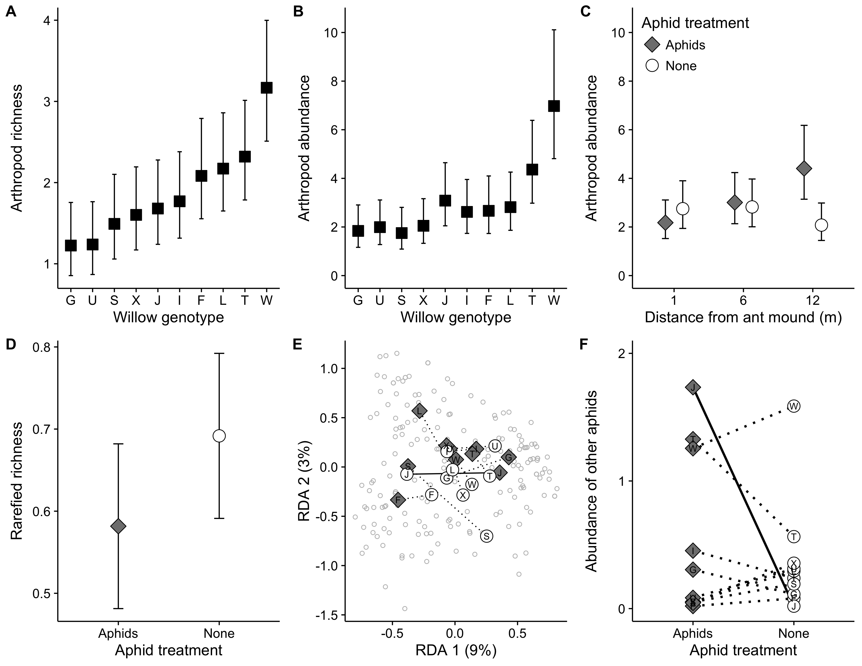

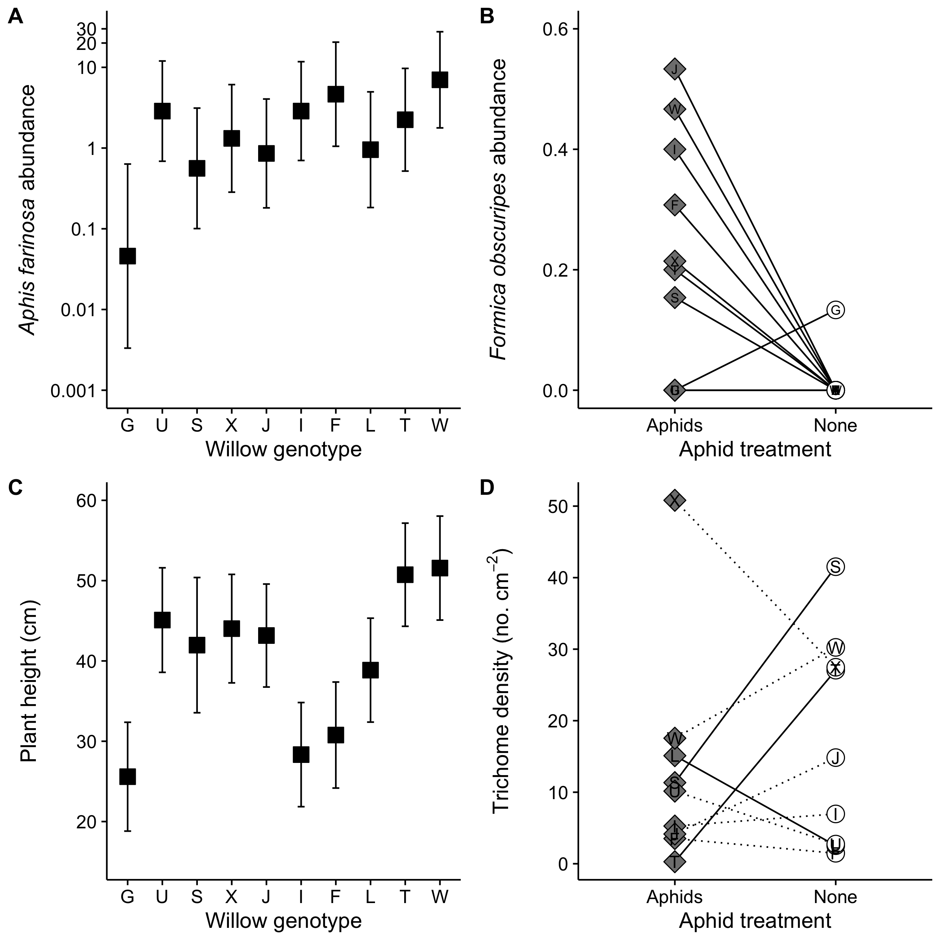

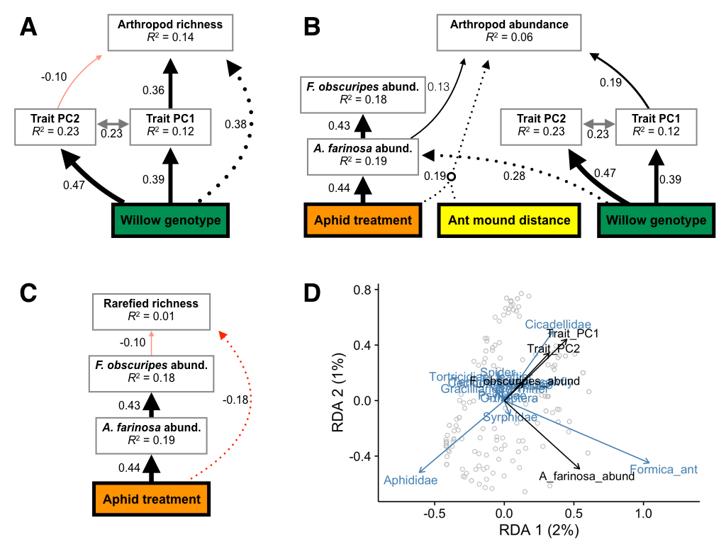

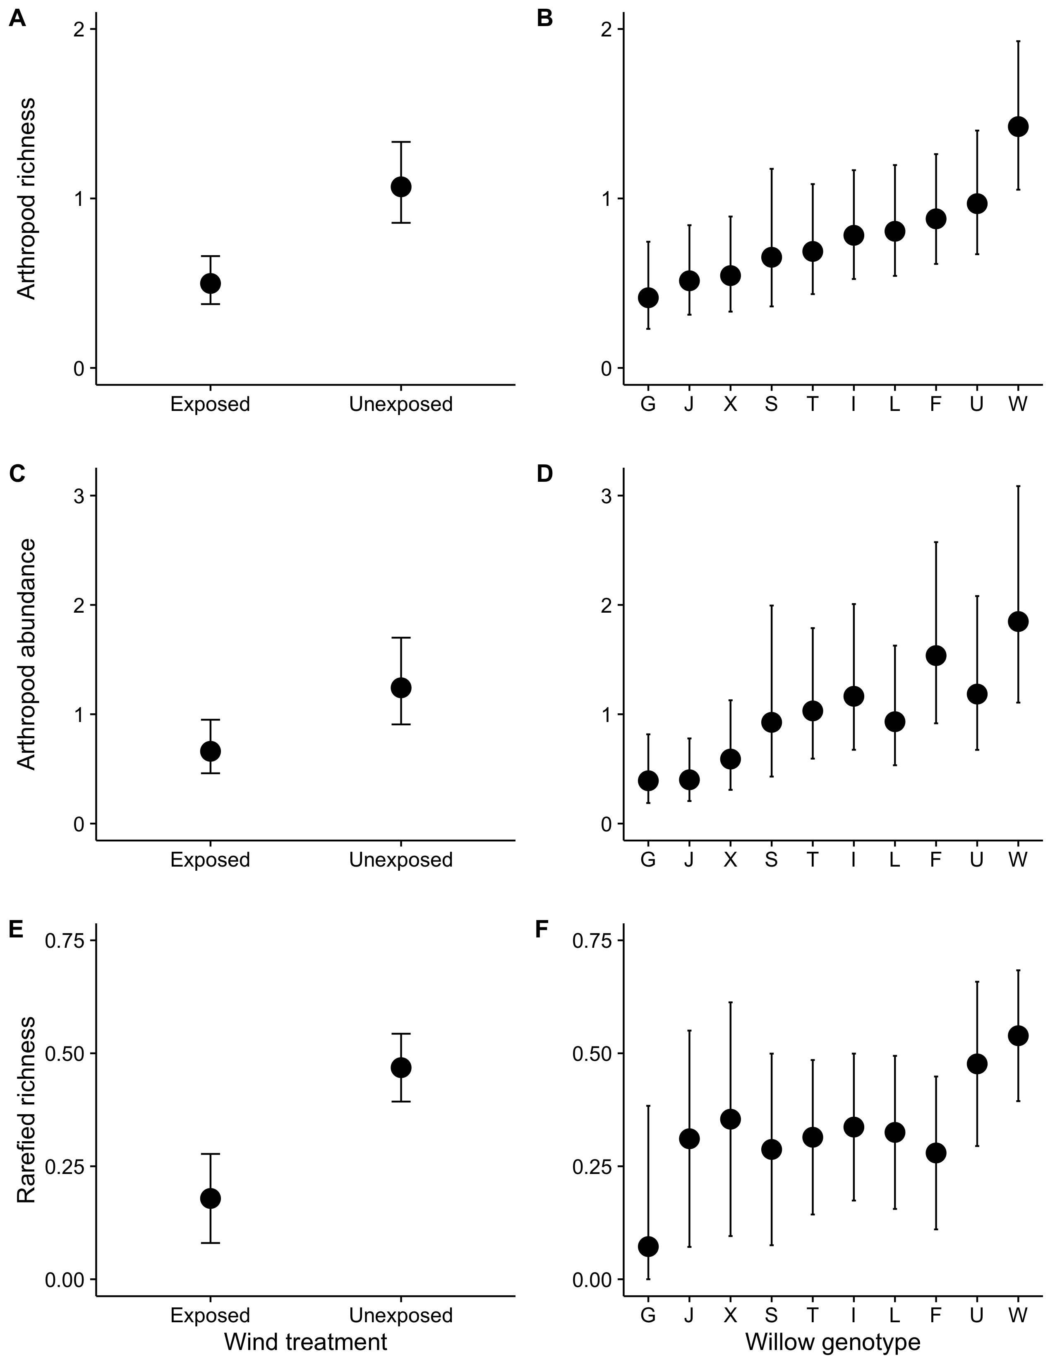

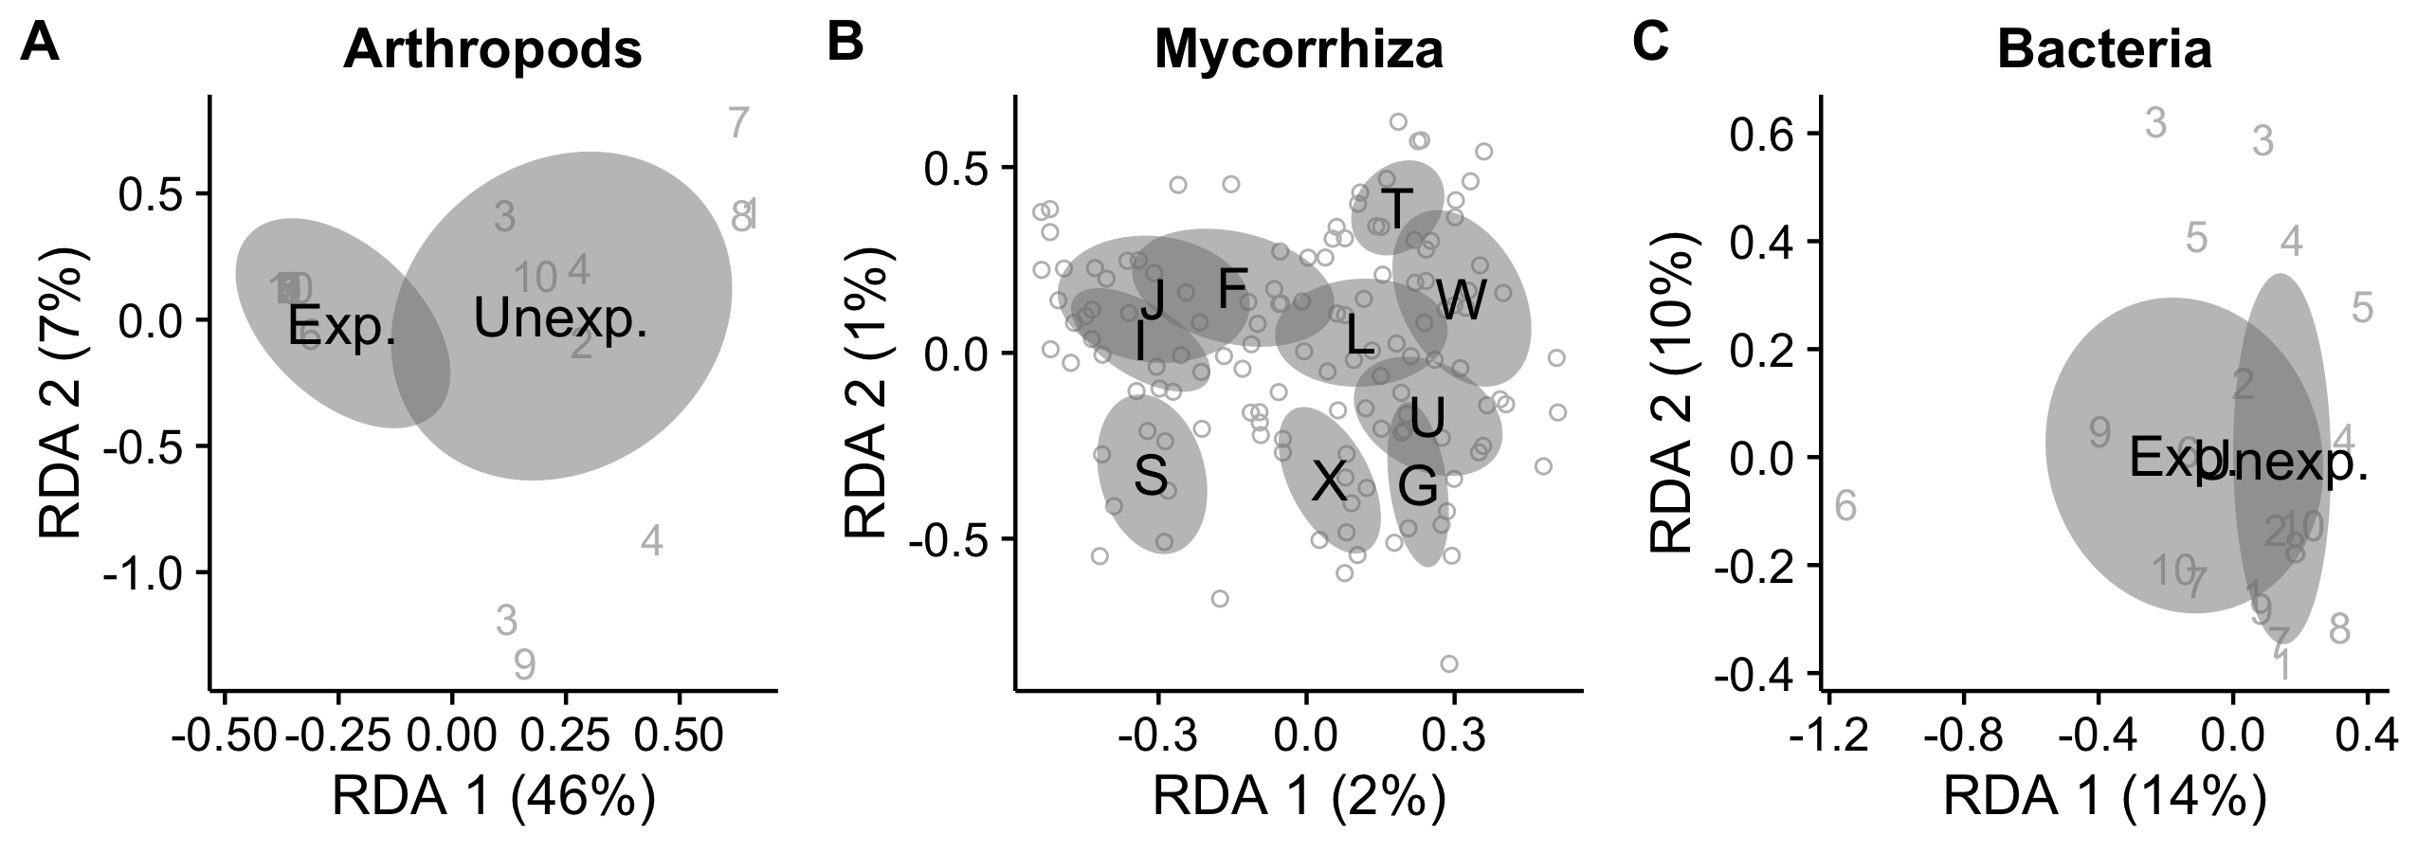

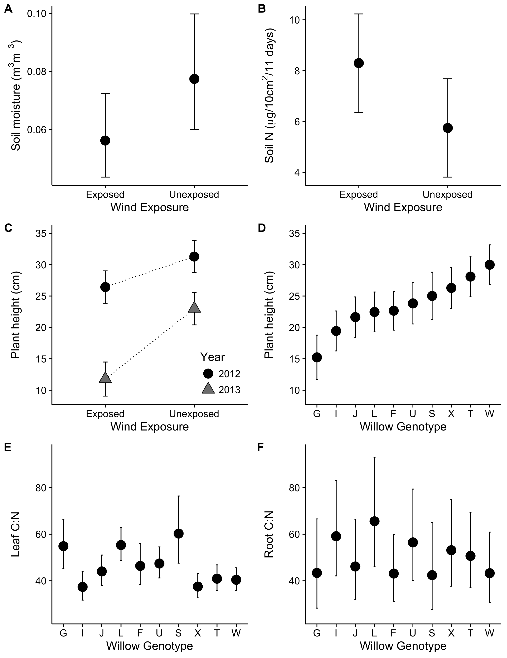

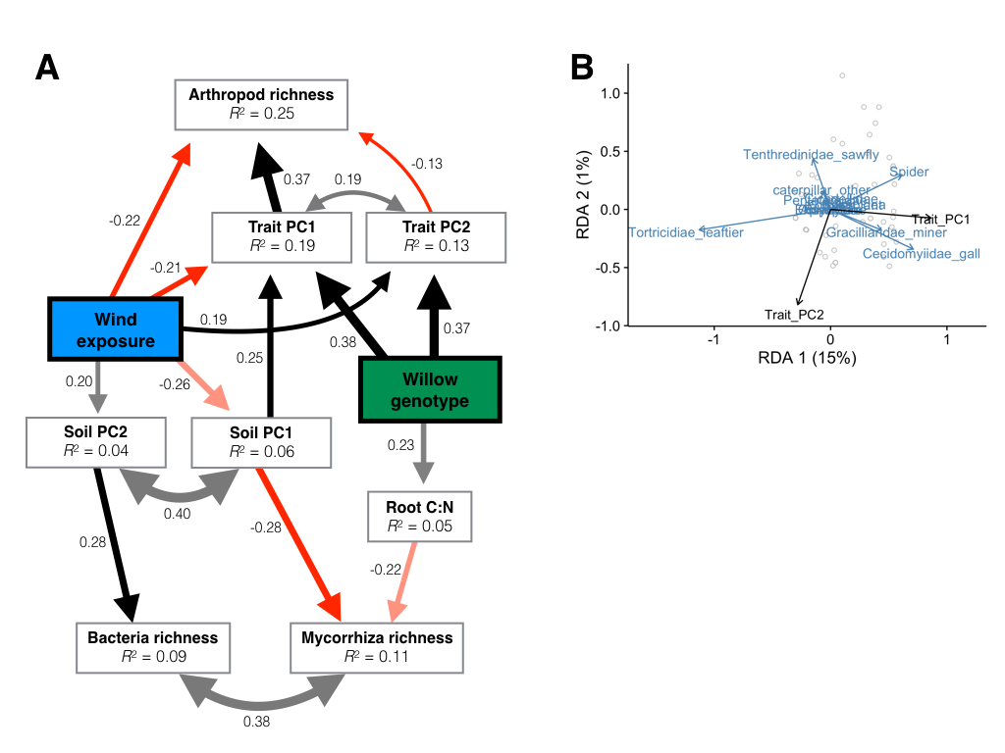

**Figure Legends**

**Figure 1**. Responses of the arthropod community to genetic variation within the willow *Salix hookeriana*, the addition of the aphid *Aphis farinosa*, and proximity to mounds of the ant *Formica obscuripes*. We found that willow genotype influenced both the total richness (A) and abundance (B) of arthropods. Arthropod abundance was also influenced by the addition of aphids, but only at the furthest distances from ant mounds (C). The addition of aphids reduced the probability of encountering a different arthropod species (rarefied richness) by 16% across all treatments (D). We also found that the addition of aphids modified the effect of willow genotype on the composition of the arthropod community (E). This interaction between willow genotype and aphid treatment was solely due to the differential effect of genotype J on the abundance of non-*A. farinosa* aphids in the aphid treatment (F). Symbols and error bars correspond to the response variable’s mean ± 95% confidence interval. We calculated mean and confidence intervals based on the full models (Table 1) using the ‘*effects*’ package in R. Black squares correspond to the effect of willow genotype after controlling for other treatments, while grey diamonds and white circles represent the aphid treatment and control, respectively.

**Figure 2**. Variability in ant-aphid interactions and plant traits explained by genetic variation within the willow *Salix hookeriana*, the addition of the aphid *Aphis farinosa*, and distance from mounds of the ant *Formica obscuripes*. In the aphid treatment, we found that willow genotype influenced the abundance of the aphid *Aphis farinosa* (A). The effect of willow genotype on *A. farinosa* resulted in willow genotype determining the abundance of the ant *Formica obscuripes*, but only in the aphid treatment (B). Plant height was solely determined by willow genetic variation (C). In contrast, the aphid treatment modified the effect of willow genotype on leaf trichome density (D). Symbols and error bars correspond to the response variable’s mean ± 95% confidence interval. We calculated mean and confidence intervals based on the full models (Table 1) using the ‘*effects*’ package in R. Black squares correspond to the effect of willow genotype after controlling for other treatments, while grey diamonds and white circles represent the aphid treatment and control, respectively.

**Figure 3**. Statistical models of the processes mediating arthropod community assembly in the ant-aphid experiment. Piecewise structural equation models of arthropod richness (A), abundance (B), and rarefied richness (C). Colored and white boxes represent exogenous and endogenous variables, respectively. Solid, single-headed arrows correspond to modeled pathways between predictor and response variables, and may be either positive (black) or negative (red). Grey, double-headed arrows denote variables with no direct relationship and that we assumed to be driven by the same underlying factor. For clarity, we only plotted paths with standardized coefficients > 0.10. Numbers next to all arrows represent the standardized path coefficient, which also corresponds to the thickness of arrows. (B) Redundancy analysis illustrating the effect of plant traits (Trait PC1 & PC2) on arthropod community composition (Hellinger-transformed = square root of proportional abundances of species found on each willow). Black and blue arrows correspond to plant traits and species, respectively, while grey dots represent the position of individual willow communities.

**Figure 4**. Arthropod community responses to wind exposure and genetic variation within the willow *Salix hookeriana*. We found that both wind exposure and willow genotype had strong, but independent effects on the arthropod community. Specifically, arthropod communities on wind-exposed willows had lower richness (A), abundance (C), and rarefied richness (E) compared to unexposed willows. Willow genotype had a strong effect on the richness (B) and abundance (D) of arthropods, but only a marginal effect on rarefied richness (F). Points and error bars correspond to the response variable’s mean ± 95% confidence interval. We calculated mean and confidence intervals based on the full models (Table 2) using the ‘*effects*’ package in R.

**Figure 5.** Community dissimilarity of foliar arthropods (A) as well as root-associated ectomycorrhiza (B) and bacteria (C) in response to wind exposure and genetic variation within the willow *Salix hookeriana*. Black text and grey ellipses correspond to the community centroid ± 95% confidence interval. Grey numbers denote blocks and each unique number is the community centroid for the plot within each block. Grey circles mark the location of individual willow communities in multivariate space. We calculated the locations of centroids ± 95% confidence interval and individual samples using redundancy analysis on Hellinger-transformed community data.

**Figure 6.** Variability in soil characteristics and plant traits explained by wind exposure and genetic variation within the willow *Salix hookeriana*. Wind exposure had marginal effects on both soil moisture (A) and Nitrogen availability (B). The negative effect of wind exposure on plant height was magnified in the second year of the experiment (C); however, plant height still varied ~2-fold among the most disparate willow genotypes (D). Willow genotype was a good predictor of leaf C:N (E), but a poor predictor of root C:N (F). Symbols and error bars correspond to the response variable’s mean ± 95% confidence interval. We calculated mean and confidence intervals based on the full models (Table 2) using the ‘*effects*’ package in R.

**Figure 7.** Statistical models of the processes mediating community assembly in the wind experiment. (A) Piecewise structural equation model of the richness of foliar arthropods as well as root-associated ectomycorrhiza and bacteria. Colored and white boxes represent exogenous and endogenous variables, respectively. Solid, single-headed arrows correspond to modeled pathways between predictor and response variables, and may be either positive (black) or negative (red). Grey, double-headed arrows denote variables with no direct relationship and that we assumed to be driven by the same underlying factor. For clarity, we only plotted paths with standardized coefficients > 0.10. Numbers next to all arrows represent the standardized path coefficient, which also corresponds to the thickness of arrows. (D) Redundancy analysis illustrating the effect of plant traits (Trait PC1 & PC2) on arthropod community composition (Hellinger-transformed = square root of proportional abundances of species found on each willow). Black and blue arrows correspond to plant traits and species, respectively, while grey dots represent the position of individual willow communities.

**Tables**

|  |  |  |  |  |  |  |  |
| --- | --- | --- | --- | --- | --- | --- | --- |
| **Table 1**: Summary of statistical models that analyze the effects of willow genotype, aphid treatment, and distance from ant mounds on the arthropod community, ant-aphid interactions, and plant traits. We report the test statistic and include the degrees of freedom for each test in parentheses. Font type denotes statistical significance (**bold P < 0.05**, *italic P < 0.10*, normal P > 0.10). | | | | | | | |
| **Responses** | **Genotype (G)** | **Eaphid** | **Eant** | **GEaphid** | **GEant** | **EaphidEant** | **GEaphidEant** |
| *Foliar arthropods* |  |  |  |  |  |  |  |
| Total richnessa | **41.35**(9) | 0.45(1) | 1.12(1) | 7.66(9) | 7.84(9) | 1.15(1) | 6.17(9) |
| Total abundancea | **34.86**(9) | 1.79(1) | 1.42(1) | 14.61(9) | 9.00(9) | **8.12**(1) | 9.18(9) |
| Rarefied richnessb | 0.83(9,138.8) | **5.34**(1,139.2) | 0.46(1,8.2) | *1.81*(9,139.7) | 0.94(9,139.7) | 0.41(1,140.6) | 0.70(9,139.4) |
| Community compositionc | **1.52**(9,176) | *2.04*(1,176) | 1.01(1,9) | **1.45**(9,157) | 0.97(9,157) | 0.69(1,157) | 0.93(9,148) |
| *Ant-aphid interactions* |  |  |  |  |  |  |  |
| *A. farinosa* abund.a | **20.83**(9) | - | 0.55(1) | - | 10.25(9) | - | - |
| *F. obscuripes* abund.a | 2.42(1*) | **9.77**(1) | 1.68(1) | **6.26**(2*) | - | - | - |
| *Plant traits* |  |  |  |  |  |  |  |
| Heightb | **15.83**(9,204.2) | 0.63(1,204.3) | 0.31(1,9.1) | 0.93(9,204.5) | 0.98(9,204.4) | 0.07(1,204.3) | 1.62(9,204.7) |
| Shoot countb | **65.84**(9) | *2.76*(1) | 0.21(1) | 12.11(9) | 8.80(9) | **4.20**(1) | 9.21(9) |
| Shoot lengthb | **7.27**(9,204.2) | 2.39(1,204.2) | 0.10(1,9.1) | 1.05(9,204.5) | 0.70(9,204.3) | 1.24(1,204.3) | 0.56(9,204.6) |
| Leaf trichome densitya | 38.17(9) | 0.44(1) | 0.81(1) | **23.17**(8) | 8.41(9) | 0.84(1) | - |
| log(Leaf water content)b | 1.33(9,69.6) | 0.01(1,69.4) | 1.02(1,7.1) | 0.48(8,70.4) | 0.79(9,69.5) | 0.36(1,70.6) | 1.02(7,72.0) |

Notes: aLikelihood-ratio test and degrees of freedom calculated using a generalized linear mixed-effect model (error distribution = Poisson, link function = log); b*F*-test and Kenward-Roger approximated degrees of freedom calculated using a linear mixed-effect model; c*F*-test calculated using redundancy analysis on Hellinger-transformed community data; *indicates that predictor was modeled as a random effect and its significance was determined using a likelihood ratio test.

|  |  |  |  |  |  |  |  |
| --- | --- | --- | --- | --- | --- | --- | --- |
| **Table 2**: Summary of statistical models that analyze the effects of willow genotype and wind exposure on associated communities, soil characteristics, and plant traits. We report the test statistic and include the degrees of freedom for each test in parentheses. Font type denotes statistical significance (**bold P < 0.05**, *italic P < 0.10*, normal P > 0.10). | | | | | | | |
| **Responses** | **Genotype (G)** | **Ewind** | **Eyear** | **GEwind** | **GEyear** | **EwindEyear** | **GEwindEyear** |
| *Foliar arthropods* |  |  |  |  |  |  |  |
| Richnessa | **28.01**(9) | **10.33**(1) | **13.55**(1) | 3.74(9) | 9.85(9) | 0.92(1) | 7.04(9) |
| Abundancea | **25.25**(9) | **5.48**(1) | **6.72**(1) | 7.33(9) | 8.22(9) | 1.65(1) | 11.85(9) |
| Rarefied richnessb | **1.96**(9,71.1) | **22.82**(1,7.8) | 1.13(1,82.7) | 0.66(9,80.9) | - | 0.67(1,81.9) | - |
| Community composition2012 | 0.96(9,51) | 1.26(1,7) |  | 0.91(9,42) |  |  |  |
| Community composition2013 | 1.17(9,68) | **5.70**(1,9) |  | 0.69(6,62) |  |  |  |
| *Root-associated Mycorrhiza* |  |  |  |  |  |  |  |
| Richness2013b | 1.28(9,95.0) | 1.01(1,8.8) | - | 1.23(9,95.8) | - | - | - |
| Abundance2013b | 0.80(9,95.5) | 0.36(1,8.7) | - | 1.03(9,96.4) | - | - | - |
| Rarefied richness2013b | 0.87(9,95.1) | 0.88(1,8.8) | - | 0.93(9,95.9) | - | - | - |
| Community composition2013 | **1.01**(9,117) | 1.18(1,9) | - | 0.87(9,108) | - | - | - |
| *Root-associated Bacteria* |  |  |  |  | - | - | - |
| Richness2013b | 1.35(9,100.8) | *4.53*(1,7.9) | - | 0.87(9,101.5) | - | - | - |
| Abundance2013b | 1.39(9,102.3) | 2.00(1,8.0) | - | 0.64(9,103.2) | - | - | - |
| Rarefied richness2013b | 1.48(9,99.9) | **6.03**(1,7.8) | - | 1.35(9,100.5) | - | - | - |
| Community composition2013 | 0.93(9,120) | *1.38*(1,9) | - | 0.87(9,111) | - | - | - |
| *Soil characteristics* |  |  |  |  |  |  |  |
| Total Nb | - | *5.08*(1,9) | - | - | - | - | - |
| Soil moistureb | - | *3.52*(1,9) | - | - | - | - | - |
| Percent organic matterb | - | 0.68(1,8.4) | - | - | - | - | - |
| Nutrient PC1b | - | 1.31(1,9) | - | - | - | - | - |
| *Plant traits* |  |  |  |  |  |  |  |
| Heightb | **9.13**(9,145.3) | **29.10**(1,9.0) | **210.09**(1,156.3) | 0.71(9,147.9) | 0.80(9,157.8) | **16.69**(1,158.4) | *1.84*(9,160.9) |
| Shoot counta | **47.42**(9) | **9.91**(1) | **5.68**(1) | 10.70(9) | **18.26**(9) | **12.53**(1) | 5.76(9) |
| Shoot lengthb | **4.97**(9,144.2) | **10.44**(1,9.0) | **75.36**(1,158.5) | 0.84(9,146.9) | 1.61(9,160.1) | 0.05(1,160.7) | 0.70(9,163.2) |
| Leaf water contentb | **4.90**(9,129.0) | 0.97(1,8.7) | *2.93*(1,139.7) | 0.47(9,132.0) | **2.80**(9,141.6) | 2.03(1,141.5) | 1.56(9,144.1) |
| Leaf trichome density2012b | **67.31**(9) | 0.02(1) | - | 10.45(9) | - | - | - |
| SLA2013b | **4.21**(9,122.5) | 0.34(1,8.9) | - | 1.19(9,123.4) | - | - | - |
| Leaf C:N2013b | **4.88**(9,70.48) | 1.54(1,7.8) | - | 1.31(9,71.6) | - | - | - |
| Root C:N2013b | 0.85(9,107.0) | 0.31(1,8.7) | - | 0.33(9,107.5) | - | - | - |

Notes: aLikelihood-ratio test and degrees of freedom calculated using a generalized linear mixed-effect model (error distribution = Poisson, link function = log); b*F*-test and Kenward-Roger approximated degrees of freedom calculated using a linear mixed-effect model; c*F*-test calculated using redundancy analysis on Hellinger-transformed community data; *indicates that predictor was modeled as a random effect and its significance was determined using a likelihood ratio test.

|  |  |  |  |  |  |  |
| --- | --- | --- | --- | --- | --- | --- |
| **Table 3**: Redundancy analyses of foliar arthropods and root-associated ectomycorrhiza and bacteria. We report F-statistics and degrees of freedom in parenthesis. Font type denotes statistical significance (**bold P < 0.05**, *italic P < 0.10*, normal P > 0.10). | | | | | | |
| **Community composition** | **Ewind** | **Trait PC1** | **Trait PC2** | **Root C:N** | **Soil PC1** | **Soil PC2** |
| Arthropods | 0.83(1,9) | **12.05**(1,76) | 0.65(1,76) | - | - | - |
| Mycorrhiza | - | - | - | 1.17(1,115) | 1.89(1,8) | 0.85(1,8) |
| Bacteria | - | - | - | *1.31*(1,116) | 1.90(1,8) | 0.81(1,8) |