**Host-plant genotype predicts individual and community phenotypes across diverse environments**

Matthew A. Barboura, Sonya Erlandsonb, Kabir Peayb, Brendan Lockec, Erik S. Julesc, Gregory M. Crutsingerd

aDepartment of Zoology, University of British Columbia, Vancouver, Canada; bDepartment of ____, Stanford University, Palo Alto, California, USA;

cDepartment of Biological Sciences, Humboldt State University, Arcata, USA;

d3D Robotics, Berkeley, California, USA

Corresponding Author: barbour@zoology.ubc.ca

**Abstract**

**Introduction**

Plant genes determine individual phenotypes, which can have cascading effects on associated species and entire communities of organisms (Fritz & Price 1988; Maddox & Root 1990; Antonovics 1992; Lamit *et al.* 2015) . While the importance of plant genes for associated communities is well established in common gardens where environmental variation is minimized, the relative importance of plant genotype vs. the environment still remains an open question (Hersch-Green *et al.* 2011; Tack *et al.* 2012; Crutsinger 2015) . Addressing this question is critical for understanding the dynamic interplay between ecological and evolutionary processes in shaping communities (Johnson & Stinchcombe 2007; Hughes *et al.* 2008; Hersch-Green *et al.* 2011) .

In genotype-by-environment studies, “environment” is often a catch-all term that encompasses a diversity of abiotic and biotic factors. For example, many studies manipulate the environment by planting common gardens in distant locations that likely differ in both abiotic (e.g. soil properties) and biotic (e.g. species pool) factors. This work has provided invaluable insight to the importance of spatial scale (Johnson & Agrawal 2005; Tack *et al.* 2010; Silfver *et al.* 2015); however, it is difficult to tease apart the effects of the many abiotic and biotic factors that could affect community assembly. Studies conducted at smaller spatial scales are advantageous in that they can focus on a single abiotic or biotic factor (Johnson 2008; Abdala‐Roberts *et al.* 2012; Abdala‐Roberts & Mooney 2013); still though, we have a limited understanding of the relative importance of local abiotic and biotic factors in shaping communities associated with host-plants.

Host-plants are usually colonized by a diverse group of organisms, including arthropods, fungi, and bacteria; however, most studies examine the associations between host-plant genotype and a particular taxonomic group (reviewed in Whitham *et al.* 2012; but see Crutsinger 2014; Lamit *et al.* 2015). In particular, the majority of studies have been conducted on aboveground arthropods, with comparatively little attention given to belowground mycorrhizal and bacteria communities. As a consequence, it is unclear whether these diverse communities exhibit similar or different responses to genetic and environmental variation. A recent meta-analysis of the well-studied introgression between *Populus fremontii* and *Populus angustifolia* suggests that aboveground arthropods are more tightly coupled to host-plant genotype than belowground microbes/fungi (Bailey *et al.* 2009). However, there has been little work that has simultaneously examined above- and belowground community responses within genotype-by-environment studies.

While there have been several studies examining the joint contribution of the environment and host-plant genotype to associated communities, the processes generating community responses often remain unclear (Hersch-Green *et al.* 2011; Crutsinger 2015). This is because many studies do not measure the plant phenotypes mediating the interactions between plant genotype and the associated community. Identifying these key phenotypes is also crucial for teasing apart the direct and indirect (via plant traits) effects of the environment on community assembly. Indeed, we should be able to predict which phenotypes are more likely to be influenced by the environment based on prior estimates of heritability. Heritability measures the proportion of variance in a phenotype explained by genotype (Lynch & Walsh 1998); therefore, we expect that traits with low heritability are more likely to be altered by the environment compared to traits that are highly heritable. This can have important consequences for predicting community assembly depending on whether species are cueing in on traits that are weakly or strongly heritable.

Here, we use common garden experiments to examine how host-plant genetics as well as the abiotic and biotic environment structure communities associated with the willow *Salix hookeriana* in a coastal dune ecosystem. Prior work in this system has shown that willow genotypes host distinct arthropod communities and that multiple plant phenotypes are important in determining community assembly (Barbour *et al.* 2015, 2016). Importantly, these phenotypes varied substantially in the degree of heritability (plant growth, mean *H*2 = 0.26; leaf quality, mean *H*2 = 0.72), suggesting that the environment may differentially influence them. We sought to address the following questions: (1) what is the relative importance of willow genotype vs. the abiotic and biotic environment in determining willow phenotypes and associated communities? (2) What are the mechanisms by which willow genetic and environmental variation affects community responses? (3) Do host-associated arthropods, fungi, and bacteria exhibit similar or contrasting responses to willow genetic and environmental variation?

Methods

*Study Site*

We conducted this research at Lanphere Dunes (40**°** 53’29.85”N, 124**°** 8’49.06”W), a pristine coastal dune ecosystem managed by US Fish and Wildlife service in Humboldt County, California. Coastal willow (*Salix hookeriana* ex Barratt ex Hooker) naturally occurs in nearshore dune swales – seasonal freshwater wetlands that form in depressions between dune ridges (Pickart 2009). Aside from coastal willow (hereafter willow), the dominant vegetation in these swales consists of beach pine (*Pinus contorta* ssp. *Contorta*) and slough sedge (*Carex obnupta*).

During preliminary surveys, we qualitatively identified two important sources of environmental variation for willows in the dunes – wind exposure and ant-aphid mutualisms. Willows growing in wind-exposed habitats often exhibit reduced growth, especially at the their leading edge, appearing to be “swept back” by the wind (Fig. 1a). We also observed that the aphid *Aphis farinosa* was an abundant herbivore at Lanphere Dunes in 2012. *Aphis farinosa* is usually found at the tips of new shoot growth where they feed on willow phloem. Phloem is high in sugars, but low in proteins, so aphids have to ingest large volumes of phloem to get a balanced diet (cite). As a result, aphids excrete carbohydrate-rich honeydew, which attracts ants that tend the aphids and feed on the honeydew (citation). This ant-aphid interaction is often mutualistic, because the ants will defend aphids from predatory arthropods and also eat other herbivores that may be competing with the aphids (Floate & Whitham 1994; Mooney & Agrawal 2008). The ant species we observed most frequently tending *A. farinosa* was the western thatching ant, *Formica obscuripes* (Fig. 1b). Thatch ant colonies create distinct dome-shaped mounds from nearby plant-material. The strength of this mutualistic interaction may also decrease at further distances from ant colonies (Wimp & Whitham 2001).

*Experimental Design*

Prior to bud burst in February 2012, we took shoot cuttings (40 cm length & ~0.5 cm diameter) from one to two replicates of 10 different willow genotypes from a pool of 26 locally collected willow genotypes planted in a large common garden experiment. Details about the establishment of this common garden are given in Barbour et al. (2015). These 10 genotypes displayed substantial variation in both plant-growth and leaf traits (Barbour et al. 2015). Shoot cuttings were soaked in water overnight and then planted in a mixture of 80% perlite, 20% peat moss (dolomite lime added to balance pH) inside ‘cone-tainers’. We grew cuttings under ambient weather conditions outside the greenhouse at Humboldt State University until we transplanted willows into multiple common gardens at Lanphere Dunes.

Ant-aphid experiment – We established common gardens around 5 different ant mounds (blocks) in late May 2012. Within each block, we randomly planted 20 cuttings (2 replicates of each of 10 genotypes) with 0.5 m spacing in plots that were at a distance of 1, 6, and 12 meters from the edge of the ant mound, for a total of 60 cuttings per ant mound (300 cuttings for entire experiment). Within each plot, we randomly assigned the aphid treatment (aphid presence vs. absence) to one of the two replicates for each genotype. On May 22, we collected aphids (*Aphis farinosa*) and placed 5 adult apterate aphids on willow cuttings in the aphid treatment. We bagged aphids onto the apical shoots of cuttings using organza bags to promote aphid establishment in spite of oncoming inclement weather (wind and rain). We also placed organza bags on all control plants as well. On May 27, we checked aphid treatments to ensure there were 5 adult aphids and removed bags from all cuttings. If necessary, we added aphids to these treatments until there were 5 adults and we removed any aphid nymphs that were produced since initial establishment. We checked plants for aphids on June 6, June 13, June 24, July 4, July 14, and July 20, 2012. The ant-aphid experiment was restricted to the summer of 2012, because in the summer of 2013 there was high willow mortality (_% of plants died by DATE) and *Aphis farinosa* was not in high enough abundance on naturally occurring willows to repeat the aphid treatment.

Wind experiment – In late May 2012, we planted 200 willow cuttings in a split-plot experimental design at Lanphere Dunes. At 10 different willow patches (blocks), we established an ‘exposed’ and ‘unexposed’ common garden. Each garden consisted of one replicate cutting of each of 10 genotypes randomly planted in 2 m by 0.5 m grid with 0.5 m spacing between plants. The center of exposed and unexposed gardens within each block were the same distance (2 m) from the edge of the willow patch to control for insect accessibility; however, exposed gardens faced prevailing winds during the growing season. To estimate the maximum amount of wind speed (km/h) experienced by exposed vs. unexposed plants, we went out on a windy afternoon in September 2012 (weather station estimated wind speeds of 22 km/h during this period) and use a hand-held anemometer (Kestrel 1000) to measure wind speed at a height of 37 cm aboveground (approximate height of tallest plants in the garden in 2012) in each plot of our experiment. Maximum wind speed measurements were taken over a 30 s period and haphazardly collected on either an exposed or unexposed site first. Willows growing in wind-exposed plots experienced up to 3.7-fold higher wind speeds compared to unexposed plots (F1,9 = 187.32, P < 0.001).

*Community Responses*

Arthropod community – We visually surveyed plants for arthropods to determine the abundances of different (morpho)species. For the wind experiment, we surveyed arthropods once at the end of July 2012 and then once a month in May, June, and July of 2013. For the ant-aphid experiment, we surveyed arthropods on 5 different occasions between early June and late July 2012. So that individuals were not counted twice between sampling dates, we took the maximum abundance for each arthropod (morpho)species from each plant across all sampling dates within each year. This approach provides a conservative estimate of the total number of individuals of each (morpho)species that occurred on individual plants through the summer. Given the relatively low abundances of individual morphospecies, we grouped arthropods at the Family-level for insects and at the Order-level for other arthropods.

Mycorrhizal and Bacterial communities – In late July of 2013, we dug up the willows from the wind experiment in order to sample the mychorrizal and bacterial communities associated with the willow roots. We did not sample the belowground communities of plants in the ant-aphid experiment due to the high mortality of plants in 2013. To sample these belowground communities, we carefully removed dirt until we found all of the living root tissue. We then stored the root tissue of each plant in separate plastic bags within a cooler which were immediately transported back to the lab and kept in a freezer at _°C until further processing. *(need further details on quantifying the belowground communities from Sonya).*

Statistical analyses – To examine how willow genotype, the environment, and their interaction influenced richness, abundance, and rarefied richness of aboveground arthropods as well as root-associated mycorrhiza and bacteria, we used separate generalized linear mixed-effect models (GLMMs, Bolker *et al.* 2009). For the wind experiment, we specified block (willow patch) and plots nested within block (2 wind exposure treatments) as random effects. We specified willow genotype, wind treatment, sampling year, and their 3-way interaction as fixed effects in the model. For the ant-aphid experiment, we specified block (ant mound) and plots nested within block (3 different distances from ant mound) as random effects. We specified willow genotype, aphid treatment, distance from ant mound, and their 3-way interaction as fixed effects in the model. Plant mortality in each experiment resulted in unbalanced designs, so we used Type II sum-of-squares to test the significance of fixed effects. For continuous responses (rarefied richness, normalized mycorrhiza and bacteria abundances) we specified Gaussian error distributions in our models and tested the significance of fixed effects using F-tests with Kenward-Roger approximated degrees of freedom. For count responses (richness and arthropod abundances), we specified Poisson error distributions in our models and tested the significance of fixed effects using likelihood-ratio tests. If necessary, we modeled overdispersion in these Poisson models by specifying an individual-level random effect.

To examine how community composition depended on willow genotype, the environment, and their interaction, we applied a Hellinger transformation to our community data (square root of proportional abundance of species found on each willow; Legendre & Gallagher 2001) and conducted separate permutational multivariate analysis of variance (PERMANOVA, 1000 permutations on Euclidean distances) for the arthropod, mycorrhiza, and bacteria communities. We incorporated the same fixed effects structured as we used to analyze the univariate community responses for each experiment. To test the significance of each effect, we used Type II sum-of-squares and compared the observed community dissimilarities to the dissimilarities we would expect by random chance with a permutation test that controls for the blocked design of our experiment. To test the significance of treatments that varied at the plot-level (wind exposure and distance from ant mound), we first calculated the community’s centroid in multivariate space for each plot. We then included block as a covariate and ran the same permutation test as previously described. This ensured that our significance tests of treatments that varied at the plot-level were based on the appropriate residual degrees of freedom (wind exposure residual *df* = 9; distance from ant mound residual *df* = 4).

*Mechanisms of community assembly*

Plant traits – Host plants provide both food and shelter for the diverse group of organisms that colonize them. Ultimately, the availability and suitability of food and shelter for these organisms is determined by host-plant traits; therefore, we hypothesized that one of the major pathways by which willow genotype and the environment could shape community responses is via plant traits.

For foliar arthropods, variation in both plant growth and leaf quality may affect their likelihood of colonizing plants. To quantify plant-growth traits, we measured plant height, the number of shoots produced, and average shoot length in late July of each year (end of growing season) for both experiments. We quantified plant height as the distance (mm) from the ground to the tip of the tallest shoot. We quantified average shoot length by measuring every shoot on each plant to the nearest millimeter and calculating the average shoot length for each plant. We also measured several traits that could shape leaf quality for herbivores, including water content, trichome density, specific leaf area (SLA), percentage carbon (C) and nitrogen (N), and C:N. To measure these traits, we excised fully expanded and undamaged leaves from plants in late July of each year, stored leaf samples with a moist paper towel in separate plastic bags within a cooler and immediately brought them back to the laboratory. We then weighed leaves to obtain fresh mass (g), digitally scanned them to measure leaf area (mm2) using ImageJ (Abrámoff, Magalhães, and Ram 2004), and oven-dried them at 60 °C for 72 h to obtain dry weight (g) (Cornelissen et al. 2003). We calculated SLA as (Cornelissen et al. 2003). We calculated leaf water content as the (Munns & PrometheusWiki Contributors 2010). To measure trichome density, we counted the number of trichomes along an 11 mm by 1 mm transect in the center of the leaf, halfway between the leaf edge and the mid-vein, under a dissecting scope. To measure percentage C and N, we ground oven-dried leaves to a fine powder using a ball mill (Mixer/Mill 8000D, SPEX SamplePrep; Metuchen, NJ, USA). Subsamples of each material were then analyzed for percentage C and N on an elemental analyzer (ECS 4010; Costech Analytical Technologies, Valencia, California, USA) using atropine (4.84% N and 70.56% C) as a reference standard.

For root-associated communities, …

To analyze how willow genotype, the environment, and their interaction influenced willow phenotypes, we used separate GLMMs with the same structure described in the *Community responses* section. For the wind experiment, we lacked multiple years of data on leaf trichome density (2012 only), SLA (2013 only), leaf C:N (2013 only), and root C:N (2013 only); therefore, we removed sampling year, and its interactions, from the fixed effects structures of these GLMMs.

Soil characteristics – Soil nutrients, total organic matter, and moisture may all influence plant phenotypes and the assembly of mychorizzal and bacterial communities on plant roots (Erlandson *et al.* 2015). Moreover, we expected that wind exposure to affect these soil characteristics (LORTIE & CUSHMAN 2007); therefore, we measured soil nutrients, percent organic matter, and moisture within each plot of the wind experiment (one exposed and one unexposed plot per block).

To estimate soil nutrient uptake by willows, we installed Plant Root Simulator (PRS) Probes (Western Ag Innovations, Saskatchewan, Canada) at three randomly selected locations within each plot for 11 days in September 2012. PRS Probes estimate nutrient supply rates to roots by continuously adsorbing charged ionic elements over the burial period. For our study, we estimated potential root uptake of NO3+, NH4-, Ca, Mg, K, P, Fe, Mn, Cu, Zn, B, S, Pb, Al, and Cd. From this nutrient data, we calculated total N as NO3+ + NH4-, and then used principal components analysis to condense these nutrients into a single axis (nutrients PC1) that explained 34% of the variation. Nutrients PC1 described the negative correlation between nitrogen compounds (NO3+, NH4-) and the rest of the ionic elements, with positive values indicating high supply rates of all ionic elements except for the nitrogen compounds. To measure percent organic matter content (%OM), we used a trowel to collect soil (depth = 0 – 15 cm) adjacent to the randomly positioned PRS probes in September 2012. Soils were transported back to the lab in plastic bags, sieved into fragments less than 2 mm, randomly subsampled using a soil splitter, and dried at 105 **°**C for 72 hours. We then weighed a subsample of the oven dried soil into an oven dried crucible and placed the crucible and soil into a furnace to be combusted at 375 **°**C for 16 hours. We then weighed the combusted samples, placed them in a desiccator for 20 minutes, and weighed them again. We calculated percent organic matter as . To measure soil moisture (volumetric water content, m3/m3), we used a 5TE soil sensor coupled to an EM50 Digital/Analog Data Logger (Decagon Devices, Pullman, Washington, USA). In September 2012, while PRS probes were in the ground, we measured soil moisture at a depth of 5 cm in three random locations within each plot on three different days between 1100 – 1500 hours. We repeated this same sampling scheme in early July 2013. Plot levels measurements of soil moisture were highly correlated between years (Pearson’s *r* = 0.93, *t*18 = 10.91, P < 0.001), so we averaged these soil moisture estimates to determine a single soil moisture value per plot.

To examine the effect of wind exposure on soil characteristics (total N, nutrients PC1, %OM, and soil moisture), we used separate mixed effect models with wind treatment as a fixed effect and block (willow patch) as a random effect. Since all soil characteristics were continuous responses, we specified Gaussian error distributions in our models and tested the significance of fixed effects using F-tests with Kenward-Roger approximated degrees of freedom.

Direct and indirect effects – Ultimately, we wanted to examine how willow phenotypes and soil properties mediated the direct and indirect effects of willow genotype and the environment on community responses. To quantify these effects, we used piecewise structural equation models (SEMs cite Lefcheck MEE 2015). An advantage of piecewise SEMs is that they are flexible, allowing users to account for correlated structure (i.e. random effects) in their experimental design. However, as with any technique that relies on multiple regression, structural equation models can give misleading results if there is collinearity among predictor variables. To mitigate the effects of collinearity, we used principal components analysis (PCA) to condense aboveground willow phenotypes as well as soil properties into a small number of uncorrelated variables. For aboveground willow phenotypes in the wind experiment, we analyzed separate PCAs for 2012 and 2013 since we did not always have data on the same traits in each year. At times, we lacked data for all traits on each plant or all soil properties measured in each plot. Therefore, we used REGULARIZED …, a technique that uses correlations among variables to impute missing values. For each PCA, we retained principal components with eigenvalues greater than 1 (cite reference ).

To calculate standardized coefficients in our piecewise SEM, we scaled all predictor and response variables to mean = 0 and SD = 1 prior to analyzing them with GLMMs (error distribution = Gaussian). For willow genotype, we specified the average effect for the 10 genotypes as the reference level (i.e. deviation contrasts) and calculated the standard deviation of the coefficients to determine its standardized coefficient. To evaluate the explanatory power of our separate GLMMs, we report marginal *R*2 (Nakagawa & Schielzeth 2013). Marginal *R*2 do not adjust for the variance explained by our random effects; therefore, they give us a truer sense of the explanatory power of our models. To evaluate the fit of the full structural equation model, we used a test of directed separation (cite Shipley 2000). This test identifies missing paths in the model, calculates the *P*-value for each missing pathway, and then calculates a test statistic, Fisher’s *C*, using the following equation: *C* = -2, where is the *P*-value of the *i*th missing pathway and *k* is the total number of missing pathways. Fisher’s *C* can then be compared to a chi-square distribution with 2*k* degrees of freedom.Note that if there are many missing pathways with low *P*-values, this will result in a lower *P*-value for the structural equation model. Therefore, a *P*-value < 0.05 indicates a poor fit for the structural equation model, whereas a *P*-value > 0.05 indicates a good fit.

To examine the direct and indirect effects of willow genotype and the environment on community composition, we used PERMANOVA. For the arthropod community in the wind experiment, we

All analyses were conducted in R version 3.2.4 (R Core Team 2016).All code and data to replicate these analyses has been deposited in Zenodo (DOI: ___).

**Results**

*Community Responses*

Arthropod community – In the ant-aphid experiment, we found that willow genotype, the biotic environment, and their interaction influenced arthropod community responses (Table 1). We found that the richness and abundance of arthropods varied 2.6- and 4-fold, respectively, among the most disparate willow genotypes. The effect of willow genotype on arthropod richness appeared to be due to correlated responses in arthropod abundance, as willow genotype had no effect on rarefied richness. We also detected a significant EaphidEant effect on arthropod abundance (Table 2). Arthropods were 1.8-fold more abundant on aphid-treated willows at 12 m vs. 2 m from ant mounds. In contrast to the independent effects of willow genotype and biotic factors on aggregate community responses, we detected a significant willow GEaphid effect on arthropod community composition (Table 1, Fig. 1E). This GEaphid effect was primarily due to non-*A. farinosa* aphids that varied from being positively to negatively affected by the aphid treatment, depending on willow genotype (Fig. S1).

In the wind experiment, we found that wind exposure and willow genotype had strong, but independent effects on the arthropod community (Table 1). In particular, willows growing in wind-exposed plots hosted 51% fewer species, 47% fewer individuals, and 60% fewer rarefied species compared to unexposed willows. In spite of the effects of wind exposure, willow genotype had a strong effect on both the richness (3.1-fold differences) and abundance (4.7-fold differences) of arthropods, but only a marginal effect on rarefied richness. Arthropod communities on willows had both more species and more individuals in the second year of the experiment compared to the first (Table 1); however, this effect could simply be an artifact of us conducting more arthropod surveys for the wind experiment in 2013 vs. 2012. In terms of community composition, we observed strong effects of wind exposure by the end of experiment (Table 1, Fig. 1F). These compositional differences were due to several key arthropod taxa (gall midges, leaf-mining moths, and spiders) being less abundant on wind-exposed willows, whereas leaf-tiering moths were insensitive to wind exposure (and therefore relatively more abundant; Table S1, Fig. S2). Although several arthropod taxa varied in abundance among willow genotypes (Table S2, Fig. S2), we did not detect an effect of genotype on community composition in either year of the experiment (Table 1).

Mycorrhizal and Bacterial communities – Root-associated mycorrhizal and microbial communities responded differently to willow genotype and wind exposure compared to foliar arthropods. For example, neither wind exposure nor willow genotype influenced the richness, abundance, or rarefied richness of the mycorrhiza (Table 1, Fig. 1C). However, willow genotype explained 7% of the variation in the composition of the mycorrhizal community (Fig. 1G), whereas wind-exposure had no detectable effect (Table 1). In contrast to the mycorrhizal community, wind exposure appeared to influence multiple indices of the bacteria community, but in the opposite direction of the aboveground arthropods (Table 1). For example, the roots of wind-exposed plants tended to host more bacteria OTUs (10% increase) than unexposed plants (Fig. 1D). Wind-exposed plants also had higher rarefied richness of bacteria OTUs (Table 1), but the effect size was very small (wind-exposed PIE = 0.9993, unexposed PIE = 0.9992). While wind exposure did not affect the total abundance of bacteria OTUs, it had a marginal effect on the composition of the bacteria community (Table 1, Fig. 1H). There was no detectable effect of willow genotype on any responses of the bacteria community.

*Mechanisms of community assembly*

Plant traits – In the ant-aphid experiment, willow genotype was the primary determinant of variation in plant traits (Table S2). For example, all of the plant-growth traits we measured varied approximately 2-fold among the most disparate willow genotypes. Willows also appeared to produce slightly more shoots in the absence of aphids and at further distances from ant mounds (Table 2), but this effect was weak (*R*2 = 0.01) compared to willow genotype (*R*2 = 0.15). Leaf trichome density varied 30-fold among willow genotypes, but there was little apparent effect of willow genotype on leaf water content in the ant-aphid experiment (Table 2).

In contrast to the ant-aphid experiment, we found that plant-growth and leaf quality traits responded differently to willow genotype and wind exposure (Table 2). For example, wind exposure negatively affected all plant-growth traits. Moreover, the negative effects of wind were magnified by the end of the experiment for both plant height and the number of shoots produced (Table 1).Still, willow genotype had a pronounced effect on all plant-growth traits, resulting in willows that varied over 2-fold in height, number of shoots, and shoot length among the most disparate genotypes. While the effect of willow genotype on shoot length changed by the end of the experiment (Table 1), this GEyear effect was relatively small (*R2* = 0.05) compared to the effect of genotype alone (*R2* = 0.13). In contrast to plant-growth traits, willow genotype was the primary factor in determining leaf traits across both years of the experiment (Table 1). The leaves of willow genotypes varied 46-fold in trichome density, 1.5-fold in SLA, and 1.6-fold in C:N. We had data available on leaf water content for 2012 and 2013, and we found that the amount of variation explained by willow genotype depended on the sampling year (2012, *R2* = 0.11; 2013, *R2* = 0.16). Unlike aboveground plant traits, root C:N did not appear to be influenced by either wind exposure or willow genotype.

Ant-aphid interactions – Willow genotype had a strong effect on *Aphis farinosa* abundance ( = 20.83, P = 0.013), whereas mound distance did not influence aphid abundance ( = 0.55, P = 0.460). Both aphid treatment and mound distance independently affected the probability of finding *F. obscuripes* tending *Aphis farinosa.* The probability of finding *F. obscuripes* on willowsincreased from < 1% to 10% in the aphid treatment ( = 28.10, P < 0.001) and decreased from 4% at to < 1% at 12 m from the ant mound ( = 4.02, P = 0.045). Genotype did not appear to have a strong effect on the probability of finding *F. obscuripes* ( = 0.98, P = 0.322).

Soil characteristics – We observed only modest effects of wind exposure on soil properties. Specifically, soil in wind-exposed plots tended to be drier (F1,9 = 3.52, P = 0.093) with higher amounts of total Nitrogen (F1,9 = 5.08, P = 0.051). There was no difference in percent organic matter (F1,8.4 = 0.68, P = 0.434) or nutrient composition (PC1: F1,9 = 1.31, P = 0.282) between soils in wind-exposed and unexposed plots.

Direct and indirect effects – For the ant-aphid experiment, our structural equation models for both arthropod richness (*stats* Fig. 2A) and abundance (*stats create supplement Fig.*) provided a good fit to our data, suggesting that we identified the key drivers of these community responses. For arthropod richness, we found that the effect of willow genotype was primarily mediated by plant trait PC1. Plant height, shoot count, and shoot length all had strong, positive loadings on trait PC1 (*create supplement table*), indicating that larger willows hosted more arthropod species and individuals. Aphid treatment also positively influenced arthropod richness and abundance via increases in abundance of Aphis farinosa, although the total effect on richness was small (std. coef. = 0.08) compared to willow genotype (std. coef. = 0.14). Still, when we investigated the potential for missing paths, we found that their was a path willow genotype affected by Aphis farinosa and arthropod richness, suggesting that the plant traits we measured failed to capture these other effects of plant genotype. Surprisingly, we found that neither trait PC1 (F1,183 = 2.09, P = 0.231), trait PC2 (F1,183 = 1.02, P = 0.394), nor F. obscuripes (F1,183 = 0.656, P = 0.671) influenced community composition, with the only detectable effect being from the abundance of *Aphis farinosa* (F1,183 = 2.86, P = 0.018). When we added the GEaphid effect in the model, we still found that it had a significant effect (F9,164 = 1.71, P = 0.002), suggesting that we did not fully identify the processes driving community composition in this experiment.

As with the ant-aphid experiment, our structural equation models for arthropod richness (*stats* Fig. 2A), abundance (*stats create supplement Fig.*), and rarefied richness provided a good fit to our data (*stats create supplement Fig.*), suggesting that we identified the key drivers of the above- and belowground communities. For aboveground arthropods, the effect of willow genotype was primarily mediated by plant trait PC1. As in the ant-aphid experiment, all of the plant-growth traits had strong, positive loadings on trait PC1 (*create supplement table*), indicating that larger willows hosted more arthropod species and individuals. However, wind exposure appeared to be the main driver of community responses. These negative effects of wind were mediated by both an indirect effect via plant trait PC1 as well as a direct effect.

**Discussion**

Willow genotype had predictable effects on individual phenotypes and the arthropod community across variation in both the abiotic and biotic environment (FIG or TABLE). These predictable effects occurred despite the abiotic environment often explaining as much or more of the variation in plant-growth traits and arthropod responses.

- Aboveground, we found that wind exposure dominated both plant genotype and ant-aphid interactions in explaining arthropod community responses.

- Belowground, mycorrhizal and microbial communities responded differently than aboveground arthropods to willow genotype and wind exposure.

- Despite the fact that the environment sometimes dominated plant genotype in explaining community responses, the effects of plant genotype were predictable across variation in both the abiotic and biotic environment (Fig. genetic correlations).

*Genotype vs. abiotic and biotic environment*

Knowing the relative importance of genetics vs. the environment in shaping associated communities is critical for determining whether a community genetics approach is warranted (cite Hersch-Green et al. 2012). We found that willow genotype ranged from being the least important was often of intermediate importance in determining community responses, being trumped by wind exposure but more important than ant-aphid interactions. the relative importance of genotype vs. the environment depended on both the environmental factor and the organisms being studied. For example, the diversity of arthropods and bacteria both arthropod and microbial diversity, wind exposure trumped willow genotype in explained the diversity of both arthropods and bacteria. , which trumped ant-aphid interactions. This hierarchy was maintained for community composition, , with wind exposure trumping willow genotype At Lanphere Dunes, we found that the relative importance of willow genotype vs. the environment in determining community responses went in the following order: wind exposure > genotype

*Above- vs. belowground community responses*

Communities

Updated Key Findings:

- Arthropod community responses: Abiotic > Genotype > Biotic

- Mycorrhizal community responses: Genotype > Abiotic

- Microbial community responses: Abiotic > Genotype

- Plant-growth traits: Abiotic = Genotype > Biotic

- Leaf-quality traits: Genotype > Abiotic = Biotic

- Host-plant associated communities responded differently to variation in host-plant genotype and the environment.

- Measuring the plant traits enabled us to tease apart the direct and indirect effects of genotype and the environment in determining community responses. Most everything was determined by plant height, with a secondary contribution from other plant traits.

Key Findings:

- Biotic interactions had little effect on willow phenotypes, but directly affected the willow’s associated arthropod community. Still, genotype was the primary determinant of variation in its phenotype and its associated community.

- Abiotic interactions had strong effect on willow growth traits, which had strong indirect effects on the richness, abundance, and composition of the arthropod community. However, genotype was still comparable in its effects on willow growth traits and its associated arthropod community. However, the traits we measured were insufficient to explain the effect of willow genotype on the arthropod community. This result has repeated itself in previous work in this system (Barbour et al. 2015). To date, the functional trait approach (quantifying easy to measure traits) is failing in its ability to predict arthropod community responses. How do we improve this? I think it will involve careful consideration of which plant traits arthropods are responding too. We also, don’t really have a good sense for how much of the variation we should expect traits to explain. Is it all of it? Perhaps we need to start incorporating stochasticity into arthropod community ecology. This may give us a more realistic benchmark for how much variation we expect to be explained by plant traits.

- Genotypes still had predictive power on individual and community phenotypes across both experiments.

**Acknowledgements**

**References**

**Figures**

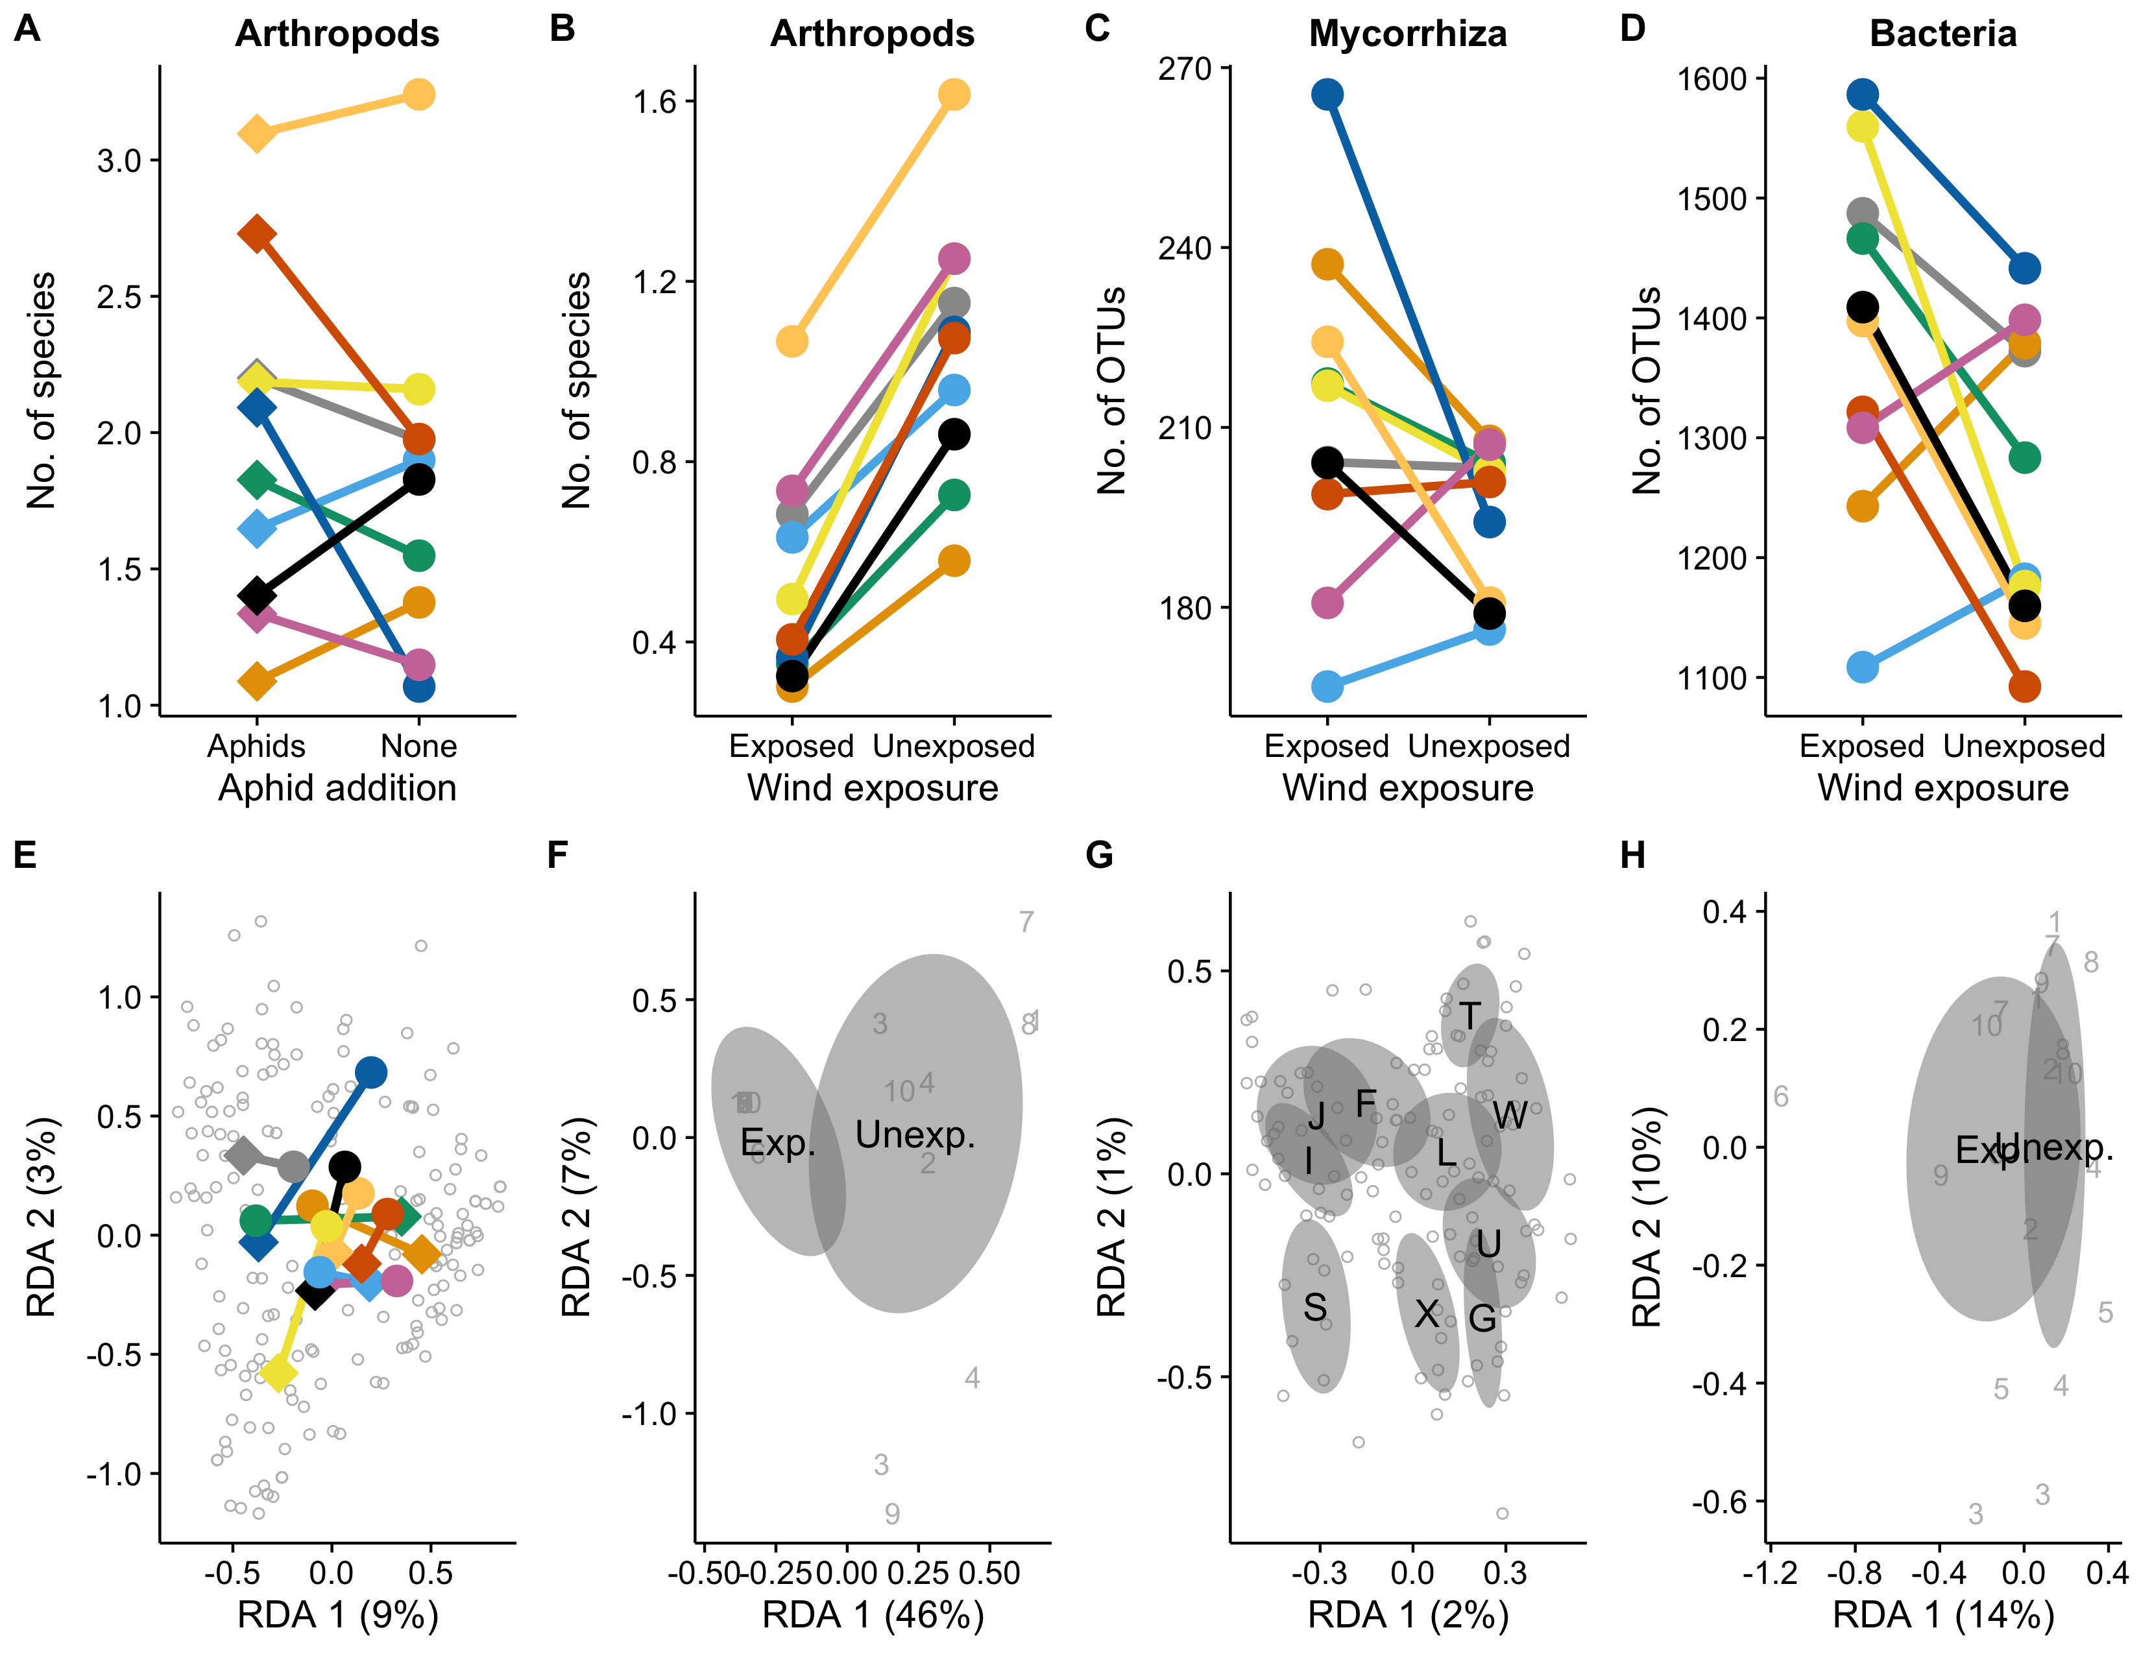

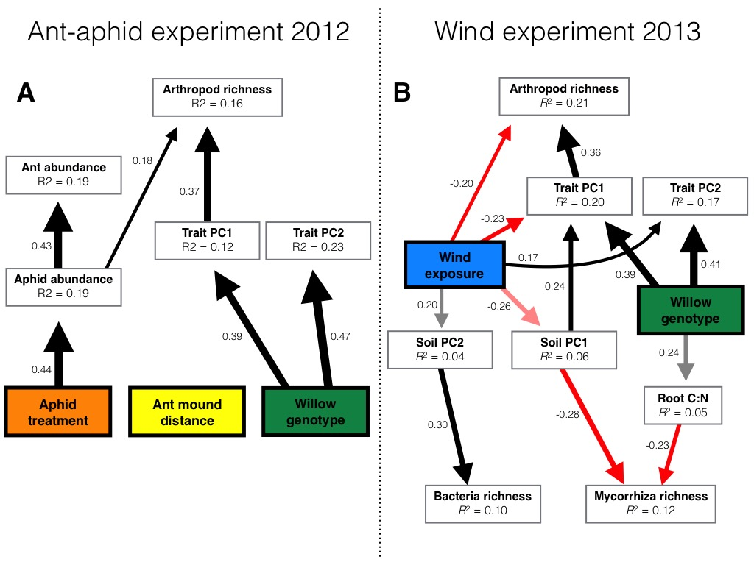

**Figure Legends**

**Tables**

**Table 1:**

|  |  |  |  |  |  |
| --- | --- | --- | --- | --- | --- |
| **Factor** | **Richness** | **Abundance** | **Rarefied richness** | **Composition2012** | **Composition2013** |
| **Ant-aphid experiment** |  |  |  |  |  |
| **Arthropods** |  |  |  |  |  |
| **Genotype (G)** | **43.36** | **37.34** | 0.69 | **1.62** | **-** |
| **Eaphid** | 2.34 | *3.45* | *3.15* | **2.90** | **-** |
| **Eant** | 0.51 | 0.98 | 0.04 | 1.05 | **-** |
| **GEaphid** | 7.24 | *16.22* | *1.78* | **1.42** | **-** |
| **GEant** | 8.38 | 9.63 | 1.09 | 1.01 | **-** |
| **EaphidEant** | 0.42 | **7.07** | 1.16 | 0.91 | **-** |
| **GEaphidEant** | 6.69 | 9.82 | 0.57 | 0.88 | **-** |
| **Wind experiment** |  |  |  |  |  |
| **Arthropods** |  |  |  |  |  |
| Genotype (G) | **23.63** | **25.25** | *15.79* | 0.95 | 1.14 |
| Ewind | **13.16** | **5.48** | **18.81** | 1.26 | **5.70** |
| GEwind | 3.43 | 7.33 | 6.66 | 0.91 | 0.69 |
| Eyear | **6.77** | **6.72** | 0.34 | **-** | **-** |
| GEyear | 8.72 | 8.22 | - | **-** | **-** |
| EwindEyear | 0.20 | 1.65 | 0.16 | **-** | **-** |
| GEwindEyear | 7.84 | 11.85 | **-** | **-** | **-** |
| **Mycorrhiza** |  |  |  |  |  |
| Genotype (G) | 1.28 | 0.80 | 0.87 | - | **1.00** |
| Ewind | 1.01 | 0.40 | 0.88 | - | 1.15 |
| GEwind | 1.23 | 1.03 | 0.93 | - | 0.87 |
| **Bacteria** |  |  |  |  |  |
| Genotype (G) | 1.35 | 1.39 | 1.48 | - | 0.93 |
| Ewind | *4.53* | 2.00 | **6.03** | - | *1.38* |
| GEwind | 0.87 | 0.64 | 1.35 | - | 0.87 |

|  |  |  |  |  |  |  |  |  |
| --- | --- | --- | --- | --- | --- | --- | --- | --- |
| **Factor** | **Height** | **Shoot**  **count** | **Shoot**  **length** | **Water**  **content** | **Trichome density** | **SLA** | **Leaf C:N** | **Root C:N** |
| **Ant-aphid experiment** |  |  |  |  |  |  |  |  |
| **Genotype (G)** |  |  |  |  |  |  |  |  |
| **Eaphid** |  |  |  |  |  |  |  |  |
| **Eant** |  |  |  |  |  |  |  |  |
| **GEaphid** |  |  |  |  |  |  |  |  |
| **GEant** |  |  |  |  |  |  |  |  |
| **EaphidEant** |  |  |  |  |  |  |  |  |
| **GEaphidEant** |  |  |  |  |  |  |  |  |
| **Wind experiment** |  |  |  |  |  |  |  |  |
| Genotype (G) |  |  |  |  |  |  |  |  |
| Ewind |  |  |  |  |  |  |  |  |
| GEwind |  |  |  |  |  |  |  |  |
| Eyear |  |  |  |  |  |  |  |  |
| GEyear |  |  |  |  |  |  |  |  |
| EwindEyear |  |  |  |  |  |  |  |  |
| GEwindEyear |  |  |  |  |  |  |  |  |