**Host-plant genetic and environmental variation structure above and belowground communities in a coastal dune ecosystem**

Matthew A. Barboura, Sonya Erlandsonb, Kabir Peayb, Brendan Lockec, Erik S. Julesc, Gregory M. Crutsingerd

aDepartment of Zoology, University of British Columbia, Vancouver, Canada; bDepartment of Biology, Stanford University, Palo Alto, California, USA;

cDepartment of Biological Sciences, Humboldt State University, Arcata, USA;

d3D Robotics, Berkeley, California, USA

Corresponding Author: barbour@zoology.ubc.ca

**Abstract**

Over the past thirty years, common garden experiments have clearly shown that host-plant genetic variation can affect the structure of the above and belowground communities that colonize them. In natural ecosystems though, host plants are exposed to a diverse array of biotic and abiotic environments, even over small spatial scales. Currently, we have a poor understanding of the relative importance of host-plant genetic variation vs. natural variability in the environment in structuring communities associated with host plants. We addressed this knowledge gap by planting multiple common gardens with 10 different clones (genotypes) of the willow *Salix hookeriana* in a coastal dune ecosystem and manipulating natural variation in ant-aphid mutualisms (biotic) and wind exposure (abiotic). We then examined how willow genotype interacts with natural variation in the environment to affect the structure of foliar arthropods and root-associated ectomycorrhiza and bacteria. Furthermore, we measured plant traits to tease apart the processes by which willow genotype and the environment structure associated communities. In the ant-aphid experiment, we found that willow genotype trumped both aphid additions and proximity to ant mounds in predicting most properties of the arthropod community. Still, we observed that aphid additions modified the effect of willow genotype (GEaphid) on arthropod community composition, indicating that neither factor was more important. In the wind experiment, we found that wind exposure trumped willow genotype in structuring communities of foliar arthropods and root microbes. Still, we observed that willow genotype had strong effect sizes on several community properties of arthropods and ectomycorrhiza, indicating that it would be unwise to ignore the importance of host-plant genetic variation. In both experiments, plant-growth traits were the primary determinants of arthropod community structure with leaf quality traits playing a lesser role; however, we failed to identify which root traits were mediating belowground community responses. Taken together, our results suggests that host-plant genetic and phenotypic variation can play a key role in shaping associated communities, despite natural variation in the biotic and abiotic environment.

**Introduction**

Intraspecific genetic variation can drive trait variation within host plants, which in turn can have cascading effects on associated species and entire communities of organisms (Fritz & Price 1988; Maddox & Root 1990; Antonovics 1992; Lamit *et al.* 2015). For example, genetic variation in the leaf chemistry of cottonwoods (Whitham *et al.* 2006) and the plant architecture of coyote bush (Crutsinger *et al.* 2014) has been shown to structure diverse assemblages of foliar arthropods and soil microbes. While the community level consequences of host-plant genetic variation have been documented in a variety of taxa (Whitham *et al.* 2012), these case studies primarily come from common garden experiments where environmental variation is minimized. Variability in the environment has a fundamental influence on trait variation in host plants, but the relative importance of host-plant genotypic vs. environmental effects on ecological communities remains an open question (Hersch-Green *et al.* 2011; Tack *et al.* 2012; Crutsinger 2015). Addressing this question is critical for understanding the dynamic interplay between ecological and evolutionary processes in shaping communities (Johnson & Stinchcombe 2007; Hughes *et al.* 2008; Hersch-Green *et al.* 2011) .

A key challenge for moving community genetics beyond the common garden is to identify the key sources of environmental variation that host-plants are exposed to and tease apart their relative importance. Abiotic factors, such as soil nutrients (Orians 1996; Abdala‐Roberts & Mooney 2013) and shade (Rossi & Stiling 1998), as well as biotic factors, such as competition from neighboring plants (Agrawal and Van Zandt 2003), herbivory (Hochwender *et al.* 2005; McGuire & Johnson 2006; Abdala‐Roberts *et al.* 2012), and ant activity (Johnson 2008; Mooney & Agrawal 2008), have all been shown to either independently or interactively shape insect assemblages on host-plant genotypes. To date though, we have a poor understanding of how natural variation in both the biotic and abiotic environment within a single ecosystem affects host-plant communities. Understanding the relative importance of different environmental factors will give insight as to how eco-evolutionary dynamics are likely to unfold for a host-plant and its associated community.

Another challenge for community genetics is that host plants are often colonized by a diverse array of phylogenetically distant taxa (Whitham *et al.* 2012; Lamit *et al.* 2015) whose interactions with each other can determine their abundances and distributions ( Tack *et al.* 2012; Busby *et al.* 2015). However, virtually all studies that examine community-level responses of genetic and environmental variation are focused on a single community type, with a particular bias toward arthropods. A necessary first step is to examine whether these diverse assemblages respond concordantly or independently to host-plant genetic and environmental variation. If there responses are independent of each other, then perhaps they can be studied separately; however, if there responses are coordinated, then there is potential for diffuse coevolution and it will be necessary to further explore how these different assemblages interact.

Finally, understanding the eco-evolutionary dynamics of host plants and their associated communities requires knowing which plant traits are mediating community assembly. Identifying these key traits is crucial for teasing apart the direct and indirect (via plant traits) effects of the environment on community assembly. Moreover, plant traits often exhibit substantial variation in their heritability (proportion of variance in a trait explained by genotype, Lynch & Walsh 1998), indicating that traits vary in their response to environmental variation. This can have important consequences for predicting community assembly in genotype-by-environment studies depending on whether associated community members are cueing in on traits that are weakly or strongly heritable. However, many genotype-by-environment studies do not conduct detailed trait screenings, the processes generating community responses often remain unclear (Hersch-Green *et al.* 2011; Crutsinger 2015).

Here, we use common garden experiments to examine how host-plant genotypic variation as well as the abiotic and biotic environment structure communities associated with the willow *Salix hookeriana* in a coastal dune ecosystem. Prior work in this system has shown that willow genotypes host distinct arthropod communities and that multiple plant phenotypes are important in determining community assembly (Barbour *et al.* 2015, 2016). Importantly, these phenotypes varied substantially in the degree of heritability (plant growth, mean *H*2 = 0.26; leaf quality, mean *H*2 = 0.72), suggesting that the environment may differentially influence them. We sought to address the following questions: (1) what is the relative importance of willow genotype vs. the abiotic and biotic environment in determining willow phenotypes and associated communities? (2) What are the mechanisms by which willow genetic and environmental variation affects community responses? (3) Do host-associated arthropods, fungi, and bacteria exhibit similar or contrasting responses to willow genetic and environmental variation?

Methods

*Study Site*

We conducted this research at Lanphere Dunes (40**°** 53’29.85”N, 124**°** 8’49.06”W), a pristine coastal dune ecosystem managed by US Fish and Wildlife service in Humboldt County, California. Coastal willow (*Salix hookeriana* ex Barratt ex Hooker) naturally occurs in nearshore dune swales – seasonal freshwater wetlands that form in depressions between dune ridges (Pickart 2009). Aside from coastal willow (hereafter willow), the dominant vegetation in these swales consists of beach pine (*Pinus contorta* ssp. *Contorta*) and slough sedge (*Carex obnupta*).

During preliminary surveys, we qualitatively identified two important sources of environmental variation for willows in the dunes – wind exposure and ant-aphid mutualisms. Willows growing in wind-exposed habitats often exhibit reduced growth, especially at the their leading edge, appearing to be “swept back” by the wind. We also observed that the aphid *Aphis farinosa* was an abundant herbivore at Lanphere Dunes in 2012. *Aphis farinosa* is usually found at the tips of new shoot growth where they feed on willow phloem. As with many other aphid species, *A. farinosa* excretes carbohydrate-rich honeydew while feeding, which attracts ants that tend the aphids and feed on the honeydew. This ant-aphid interaction is often mutualistic, because the ants will defend aphids from predatory arthropods and also eat other herbivores that may be competing with the aphids (Floate & Whitham 1994; Mooney & Agrawal 2008). The ant species we observed most frequently tending *A. farinosa* was the western thatching ant, *Formica obscuripes*. Thatch ant colonies create distinct dome-shaped mounds from nearby plant-material. The strength of this mutualistic interaction may also decrease at further distances from ant colonies (Wimp & Whitham 2001).

*Experimental Design*

Prior to bud burst in February 2012, we took shoot cuttings (40 cm length & ~0.5 cm diameter) from one to two replicates of 10 different willow genotypes from a pool of 26 locally collected willow genotypes planted in a large common garden experiment. Details about the establishment of this common garden are given in Barbour et al. (2015). These 10 genotypes displayed substantial variation in both plant-growth and leaf traits (Barbour et al. 2015). Shoot cuttings were soaked in water overnight and then planted in a mixture of 80% perlite, 20% peat moss (dolomite lime added to balance pH) inside ‘cone-tainers’. We grew cuttings under ambient weather conditions outside the greenhouse at Humboldt State University until we transplanted willows into multiple common gardens at Lanphere Dunes.

Ant-aphid experiment – We established common gardens around 5 different ant mounds (blocks) in late May 2012. Within each block, we randomly planted 20 cuttings (2 replicates of each of 10 genotypes) with 0.5 m spacing in plots that were at a distance of 1, 6, and 12 meters from the edge of the ant mound, for a total of 60 cuttings per ant mound (300 cuttings for entire experiment). Within each plot, we randomly assigned the aphid treatment (aphid presence vs. absence) to one of the two replicates for each genotype. On May 22, we collected aphids (*Aphis farinosa*) and placed 5 adult apterate aphids on willow cuttings in the aphid treatment. We bagged aphids onto the apical shoots of cuttings using organza bags to promote aphid establishment in spite of oncoming inclement weather (wind and rain). We also placed organza bags on all control plants as well. On May 27, we checked aphid treatments to ensure there were 5 adult aphids and removed bags from all cuttings. If necessary, we added aphids to these treatments until there were 5 adults and we removed any aphid nymphs that were produced since initial establishment. We checked plants for aphids on June 6, June 13, June 24, July 4, July 14, and July 20, 2012. The ant-aphid experiment was restricted to the summer of 2012, because in the summer of 2013 there was high willow mortality and *Aphis farinosa* was not in high enough abundance on naturally occurring willows to repeat the aphid treatment.

Wind experiment – In late May 2012, we planted 200 willow cuttings in a split-plot experimental design at Lanphere Dunes. At 10 different willow patches (blocks), we established an ‘exposed’ and ‘unexposed’ common garden. Each garden consisted of one replicate cutting of each of 10 genotypes randomly planted in 2 m by 0.5 m grid with 0.5 m spacing between plants. The center of exposed and unexposed gardens within each block were the same distance (2 m) from the edge of the willow patch to control for insect accessibility; however, exposed gardens faced prevailing winds during the growing season. To estimate the maximum amount of wind speed (km/h) experienced by exposed vs. unexposed plants, we went out on a windy afternoon in September 2012 (weather station estimated wind speeds of 22 km/h during this period) and use a hand-held anemometer (Kestrel 1000) to measure wind speed at a height of 37 cm aboveground (approximate height of tallest plants in the garden in 2012) in each plot of our experiment. Maximum wind speed measurements were taken over a 30 s period and haphazardly collected on either an exposed or unexposed site first. Willows growing in wind-exposed plots experienced up to 3.7-fold higher wind speeds compared to unexposed plots (F1,9 = 187.32, P < 0.001).

*Community Responses*

Arthropod community – We visually surveyed plants for arthropods to determine the abundances of different (morpho)species. For the wind experiment, we surveyed arthropods once at the end of July 2012 and then once a month in May, June, and July of 2013. For the ant-aphid experiment, we surveyed arthropods on 5 different occasions between early June and late July 2012. So that individuals were not counted twice between sampling dates, we took the maximum abundance for each arthropod (morpho)species from each plant across all sampling dates within each year. This approach provides a conservative estimate of the total number of individuals of each (morpho)species that occurred on individual plants through the summer. Given the relatively low abundances of individual morphospecies, we grouped arthropods at the Family-level for insects and at the Order-level for other arthropods.

Mycorrhizal and Bacterial communities – In late July of 2013, we dug up the willows from the wind experiment in order to sample the mychorrizal and bacterial communities associated with the willow roots. We did not sample the belowground communities of plants in the ant-aphid experiment due to the high mortality of plants in 2013. To sample these belowground communities, we removed willows with the surrounding soil intact to preserve root systems, separated shoots and roots, then brushed soil off root systems and stored them in separate plastic bags. Within 6 hours of excavation roots systems were stored at 4°C. To process roots, we gently rinsed them in tap water until free of visible soil. In order to randomly select roots for molecular analysis, second order roots were cut up into 2 cm lengths; spread out on a grid; and using a random number generator, a total of 30 cm of root length was picked from numbered grid cells. These random root subsamples were flash frozen in liquid N, and kept at -80°C until DNA extraction. To extract DNA, flash frozen root samples were physically disrupted with 2 beads per 2 mL tube (3.o mm Yttria stabilized Zirconidea Grinding Media) for 30 seconds at 1500 strokes per minute (SPEX SamplePrep 200 geno/grinder). Total DNA was extracted from frozen root samples using MoBio PowerSoil 96 sample DNA extraction kits following manufacture’s instructions.

PCR, sequencing and data analysis:

To sequence and identify mycorrhiza and bacteria OTUs, we used custom barcode primer sets ITS1f/ITS4 and 515f/806r (Caporaso et al. 2012) to PCR amplify the fungal ITS1, 5.8S, and ITS2 region of ribosomal DNA and the V4 region of bacterial 16S ribosomal DNA from total root DNA extractions. Product quality was assessed by gel electrophoresis. PCR products were cleaned with magnetic beads, quantified with Qubit fluorometric kit, and all samples were pooled at a bacteria:fungal concentration ratio of 2:1. Pooled amplicon libraries were sequenced as single-index (the reverse barcode was uniquely indexed) 300 base pair reads at Standford Functional Genomics Facility on one lane of an Illumina MiSeq. Reads were quality controlled by trimming low quality bases and sequenced adaptors and removing reads with average error rates greater than 0.25 using UPARSE (Edgar 2013). Only high quality, paired forward and reverse reads were used for OTU clustering at 97% identity and then checked for chimeras against the GOLD 16s rRNA database (Reddy et al.) and UNITE fungal ITS database ver6_97_13.05.2014 (Kõljalg et al.) with UPARSE. Taxonomy was assigned using the RDP Classifer (Wang et al.) and UNITE (ver6_97_13.05.2014) in QIIME (Caporaso et al. 2010). We then normalized datasets and discarded some OTUs and samples based on the following conditions: OTUs with no known taxonomy (any OTU that did not blast to at least Kingdom Fungi, Bacteria or Archaea); root samples with fewer than 6000 fungal reads; mitochondrial and chloroplast OTUs with samples with less than 9000 bacterial reads.

Statistical analyses – To examine how willow genotype, the environment, and their interaction influenced richness, abundance, and rarefied richness of aboveground arthropods as well as root-associated mycorrhiza and bacteria, we used separate generalized linear mixed-effect models (GLMMs, Bolker *et al.* 2009). For the wind experiment, we specified block (willow patch) and plots nested within block (2 wind exposure treatments) as random effects. We specified willow genotype, wind treatment, sampling year, and their 3-way interaction as fixed effects in the model. For the ant-aphid experiment, we specified block (ant mound) and plots nested within block (3 different distances from ant mound) as random effects. We specified willow genotype, aphid treatment, distance from ant mound, and their 3-way interaction as fixed effects in the model. Plant mortality in each experiment resulted in unbalanced designs, so we used Type II sum-of-squares to test the significance of fixed effects. For continuous responses (rarefied richness, normalized abundances of mycorrhiza and bacteria) we specified Gaussian error distributions in our models and tested the significance of fixed effects using F-tests with Kenward-Roger approximated degrees of freedom. For count responses (richness and arthropod abundances), we specified Poisson error distributions in our models and tested the significance of fixed effects using likelihood-ratio tests. If necessary, we modeled overdispersion in these Poisson models by specifying an individual-level random effect.

To examine how community composition depended on willow genotype, the environment, and their interaction, we applied a Hellinger transformation to our community data (square root of proportional abundance of species found on each willow; Legendre & Gallagher 2001) and conducted separate permutational multivariate analysis of variance (PERMANOVA, 1000 permutations on Euclidean distances) for the arthropod, mycorrhiza, and bacteria communities. We incorporated the same fixed effects structured as we used to analyze the univariate community responses for each experiment. To test the significance of each effect, we used Type II sum-of-squares and compared the observed community dissimilarities to the dissimilarities we would expect by random chance with a permutation test that controls for the blocked design of our experiment. To test the significance of treatments that varied at the plot-level (wind exposure and distance from ant mound), we first calculated the community’s centroid in multivariate space for each plot. We then included block as a covariate and ran the same permutation test as previously described. This ensured that our significance tests of treatments that varied at the plot-level were based on the appropriate residual degrees of freedom (wind exposure residual *df* = 9; distance from ant mound residual *df* = 4).

*Mechanisms of community assembly*

Plant traits – Host plants provide both food and shelter for the diverse group of organisms that colonize them. Ultimately, the availability and suitability of food and shelter for these organisms is determined by host-plant traits; therefore, we hypothesized that one of the major pathways by which willow genotype and the environment could shape community responses is via plant traits.

For foliar arthropods, variation in both plant growth and leaf quality may affect their likelihood of colonizing plants. To quantify plant-growth traits, we measured plant height, the number of shoots produced, and average shoot length in late July of each year (end of growing season) for both experiments. We quantified plant height as the distance (mm) from the ground to the tip of the tallest shoot. We quantified average shoot length by measuring every shoot on each plant to the nearest millimeter and calculating the average shoot length for each plant. We also measured several traits that could shape leaf quality for herbivores, including water content, trichome density, specific leaf area (SLA), percentage carbon (C) and nitrogen (N), and C:N. To measure these traits, we excised fully expanded and undamaged leaves from plants in late July of each year, stored leaf samples with a moist paper towel in separate plastic bags within a cooler and immediately brought them back to the laboratory. We then weighed leaves to obtain fresh mass (g), digitally scanned them to measure leaf area (mm2) using ImageJ (Abrámoff, Magalhães, and Ram 2004), and oven-dried them at 60 °C for 72 h to obtain dry weight (g) (Cornelissen et al. 2003). We calculated SLA as (Cornelissen et al. 2003). We calculated leaf water content as the (Munns & PrometheusWiki Contributors 2010). To measure trichome density, we counted the number of trichomes along an 11 mm by 1 mm transect in the center of the leaf, halfway between the leaf edge and the mid-vein, under a dissecting scope. To measure percentage C and N, we ground oven-dried leaves to a fine powder using a ball mill (Mixer/Mill 8000D, SPEX SamplePrep; Metuchen, NJ, USA). Subsamples of each material were then analyzed for percentage C and N on an elemental analyzer (ECS 4010; Costech Analytical Technologies, Valencia, California, USA) using atropine (4.84% N and 70.56% C) as a reference standard. For root-associated communities, we hypothesized that variation in root C:N may affect community assembly. A small subsample of roots was oven-dried for percentage C and N analysis. The dried root samples were crushed with a razor blade and approximately 4 mg were flash combusted on a Carlo-Erba 1500 elemental analyzer.

To analyze how willow genotype, the environment, and their interaction influenced willow phenotypes, we used separate GLMMs with the same structure described in the *Community responses* section. For the wind experiment, we lacked multiple years of data on leaf trichome density (2012 only), SLA (2013 only), leaf C:N (2013 only), and root C:N (2013 only); therefore, we removed sampling year, and its interactions, from the fixed effects structures of these GLMMs.

Soil characteristics – Soil nutrients, total organic matter, and moisture may all influence plant phenotypes and the assembly of mychorizzal and bacterial communities on plant roots (Erlandson *et al.* 2015). Moreover, we expected that wind exposure to affect these soil characteristics (LORTIE & CUSHMAN 2007); therefore, we measured soil nutrients, percent organic matter, and moisture within each plot of the wind experiment (one exposed and one unexposed plot per block).

To estimate soil nutrient uptake by willows, we installed Plant Root Simulator (PRS) Probes (Western Ag Innovations, Saskatchewan, Canada) at three randomly selected locations within each plot for 11 days in September 2012. PRS Probes estimate nutrient supply rates to roots by continuously adsorbing charged ionic elements over the burial period. For our study, we estimated potential root uptake of NO3+, NH4-, Ca, Mg, K, P, Fe, Mn, Cu, Zn, B, S, Pb, Al, and Cd. From this nutrient data, we calculated total N as NO3+ + NH4-, and then used principal components analysis to condense these nutrients into a single axis (nutrients PC1) that explained 34% of the variation. Nutrients PC1 described the negative correlation between nitrogen compounds (NO3+, NH4-) and the rest of the ionic elements, with positive values indicating high supply rates of all ionic elements except for the nitrogen compounds. To measure percent organic matter content (%OM), we used a trowel to collect soil (depth = 0 – 15 cm) adjacent to the randomly positioned PRS probes in September 2012. Soils were transported back to the lab in plastic bags, sieved into fragments less than 2 mm, randomly subsampled using a soil splitter, and dried at 105 **°**C for 72 hours. We then weighed a subsample of the oven dried soil into an oven dried crucible and placed the crucible and soil into a furnace to be combusted at 375 **°**C for 16 hours. We then weighed the combusted samples, placed them in a desiccator for 20 minutes, and weighed them again. We calculated percent organic matter as . To measure soil moisture (volumetric water content, m3/m3), we used a 5TE soil sensor coupled to an EM50 Digital/Analog Data Logger (Decagon Devices, Pullman, Washington, USA). In September 2012, while PRS probes were in the ground, we measured soil moisture at a depth of 5 cm in three random locations within each plot on three different days between 1100 – 1500 hours. We repeated this same sampling scheme in early July 2013. Plot levels measurements of soil moisture were highly correlated between years (Pearson’s *r* = 0.93, *t*18 = 10.91, P < 0.001), so we averaged these soil moisture estimates to determine a single soil moisture value per plot.

To examine the effect of wind exposure on soil characteristics (total N, nutrients PC1, %OM, and soil moisture), we used separate mixed effect models with wind treatment as a fixed effect and block (willow patch) as a random effect. Since all soil characteristics were continuous responses, we specified Gaussian error distributions in our models and tested the significance of fixed effects using F-tests with Kenward-Roger approximated degrees of freedom.

Direct and indirect effects – Ultimately, we wanted to examine how willow phenotypes and soil properties mediated the direct and indirect effects of willow genotype and the environment on community responses. To quantify these effects, we used piecewise structural equation models (SEMs, Lefcheck 2015). An advantage of piecewise SEMs is that they are flexible, allowing users to account for correlated structure (i.e. random effects) in their experimental design. However, as with any technique that relies on multiple regression, structural equation models can give misleading results if there is collinearity among predictor variables. To mitigate the effects of collinearity, we used principal components analysis (PCA) to condense aboveground willow phenotypes as well as soil properties into a small number of uncorrelated variables. For aboveground willow phenotypes in the wind experiment, we analyzed separate PCAs for 2012 and 2013 since we did not always have data on the same traits in each year. At times, we lacked data for all traits on each plant or all soil properties measured in each plot. Therefore, we used a regularized iterative PCA algorithm to impute missing values (Josse & Husson 2013). For each PCA, we retained principal components with eigenvalues greater than 1.

To calculate standardized coefficients in our piecewise SEM, we scaled all predictor and response variables to mean = 0 and SD = 1 prior to analyzing them with GLMMs (error distribution = Gaussian). For willow genotype, we specified the average effect for the 10 genotypes as the reference level (i.e. deviation contrasts) and calculated the standard deviation of the coefficients to determine its standardized coefficient. To evaluate the explanatory power of our separate GLMMs, we report marginal *R*2 (Nakagawa & Schielzeth 2013). Marginal *R*2 do not adjust for the variance explained by our random effects; therefore, they give us a truer sense of the explanatory power of our models. To evaluate the fit of the full structural equation model, we used a test of directed separation (Shipley 2000). This test identifies missing paths in the model, calculates the *P*-value for each missing pathway, and then calculates a test statistic, Fisher’s *C*, using the following equation: *C* = -2, where is the *P*-value of the *i*th missing pathway and *k* is the total number of missing pathways. Fisher’s *C* can then be compared to a chi-square distribution with 2*k* degrees of freedom.Note that if there are many missing pathways with low *P*-values, this will result in a lower *P*-value for the structural equation model. Therefore, a *P*-value < 0.05 indicates a poor fit for the structural equation model, whereas a *P*-value > 0.05 indicates a good fit.

All analyses were conducted in R version 3.2.4 (R Core Team 2016).

**Results: Ant-aphid experiment**

*Community responses*

Willow genotype and the biotic environment shaped different aspects of the arthropod community (Table 1). For example, arthropod richness was determined solely by willow genotype, with the average number of species varying from 1.2 to 3.2 among genotypes (Fig. 1A). Similarly, we found that arthropod abundance varied 4-fold among willow genotypes (Fig. 1B). The effect of willow genotype on arthropod richness appeared to be due to correlated responses in arthropod abundance, as willow genotype had no effect on rarefied richness (Table 1). Arthropod abundance, but not richness, was also shaped by an interaction between the aphid treatment and distance from the ant mound (EaphidEant, Table 1). Specifically, arthropods were 2-fold more abundant on willows in the aphid treatment, but only at the furthest distance from ant mounds (Fig. 1C). Aphid treatment was the only factor that affected rarefied richness (Table 1), leading to a 16% decrease in rarefied richness when aphids were added to willows (Fig. 1D). However, the effect of aphid treatment on rarefied richness did not translate into an effect on total richness. In terms of community composition, we found that the arthropod community was influenced by an interaction between willow genotype and the aphid treatment (Table 1, Fig. 1E)*.* This GEaphid effect was primarily due to the differential response of other aphids to a single willow genotype (Fig. 1F). If we remove this genotype from the analysis, we will find strong, but independent effects of willow genotype (F8,156 = 1.66, P = 0.007)and the addition of aphids (F1,156 = 2.93, P = 0.017)on community composition.

*Mechanisms of community assembly*

Ant-aphid interactions – We hypothesized that the effect of willow genetic variation and the biotic environment on arthropod communities would be mediated, in part, by variation in the abundance of *A. farinosa* and *F. obscuripes*, so we first tested for these intermediate effects. While distance from ant mounds had little effect on *A. farinosa*, willow genotype had a strong effect, with the average number of aphids ranging from 0.05 to 7 among the most disparate willow genotypes in the aphid treatment (Fig. 2A, Table 1). This strong effect of willow genotype on *A. farinosa* in the aphid treatment resulted in a GEaphid effect on the abundance of *Formica obscuripes* (Fig. 2B), an effect that explained 22% of the variation in this ant’s distribution (Table 1).

Plant traits – In addition to ant-aphid interactions, we hypothesized that the effect of willow genetic variation and the biotic environment on arthropod communities would be mediated by plant traits. We observed both additive and non-additive effects of willow genotype and the biotic environment on plant traits (Table 1). For example, all of the plant-growth traits we measured varied approximately 2-fold among the most disparate willow genotypes (Table 1, Fig. 2C). Willows did appear to produce 28% more shoots in the absence of aphids, but only at the furthest distance from ant mounds (EaphidEant effect, Table 1). While there was little apparent effect of willow genotype and the biotic environment on leaf water content (Table 1), we found that the addition of aphids modified the effect of willow genotype on leaf trichome density (GEaphid effect, Table 1). Interestingly, of the three genotypes driving this effect (solid lines in Fig. 1F), two of them produced less trichomes in the aphid treatment, which is opposite of what we would expect if this was an induced-defense response.

Direct and indirect effects – We used structural equation models (richness, abundance, and rarefied richness) and redundancy analysis (community composition) to tease apart the direct and indirect effects of willow genetic variation and the biotic environment on the arthropod community. For the traits we measured, we found that the indirect effect of willow genotype on arthropod richness and abundance was mediated primarily by plant trait PC1 (Fig. 3A,B). Plant height, shoot count, and shoot length all had strong, positive loadings on trait PC1 (Table S3), indicating that larger willows hosted more arthropod species and individuals. Arthropod abundance was also positively influenced by the addition of aphids, primarily because *A. farinosa* also attracted other ant species (Pearson’s *r* = 0.42, t282 = 7.74, P < 0.001; Fig. 3D) and these other ants were the second most abundant taxonomic group in the community. In contrast to total abundance, the addition of aphids negatively affected rarefied richness. This negative effect was due in part to aphid additions attracting more *F. obscuripes*, an active generalist predator that likely consumed or inhibited the colonization of multiple arthropod species. In terms of composition, we found that the abundance of *A. farinosa* was the only factor (of the mechanisms we modeled) influencing the arthropod community. Specifically, higher abundance of *A. farinosa* resulted in an increase in the proportional abundance of other ant species in the community (Fig. 3D).

Despite our detailed analysis of potential mechanisms, our structural equation models revealed multiple missing paths (dotted lines, Fig. 3A,B,C), resulting in rather poor fits for most of the models (richness: C2 = 8.49, P = 0.014; abundance: C32 = 37.66, P = 0.226; rarefied richness: C4=11.10, P = 0.025). For example, after accounting for the traits we measured, willow genotype still had a strong effect on arthropod richness (Fig. 3A) and *A. farinosa* abundance (Fig. 3B), indicating that we failed to identify key pathways by which genetic variation influenced these responses. Similarly, we failed to fully identify the EaphidEant effect on arthropod abundance (Fig. 3B) as well as how the addition of aphids negatively affected rarefied richness (Fig. 3C). For our redundancy analysis of community composition, we found that *A. farinosa* abundance explained the effect of the aphid treatment (F1,173 = 0.90, P = 0.447), but we still failed to detect the effect of both willow genotype (F9,173 = 1.53, P = 0.014) and the GEaphid effect (F9,164 = 1.71, P = 0.004), suggesting that we failed to measure important constitutive and inducible plant traits.

**Results: Wind experiment**

*Community Responses*

Arthropod community – We found that wind exposure and willow genotype had strong, but independent effects on the arthropod community (Table 2). In particular, willows growing in wind-exposed plots hosted 51% fewer species, 47% fewer individuals, and 60% fewer rarefied species compared to unexposed willows (Fig. 4A,C,E). In spite of the effects of wind exposure, willow genotype had a strong effect on both the richness (~3-fold differences, Fig. 4B) and abundance (~5-fold differences, Fig. 4D) of arthropods, but only a marginal effect on rarefied richness (Fig. 4F). Arthropod communities on willows had both more species and more individuals in the second year of the experiment compared to the first (Table 2); however, this effect could simply be an artifact of us conducting more arthropod surveys for the wind experiment in 2013 vs. 2012. In terms of community composition, we observed strong effects of wind exposure by the end of experiment (Table 2, Fig 5A). These compositional differences were due to several key arthropod taxa (gall midges, leaf-mining moths, and spiders) being less abundant on wind-exposed willows, whereas leaf-tiering moths were insensitive to wind exposure (and therefore relatively more abundant; Table S_, Fig. S_ ). Although several arthropod taxa varied in abundance among willow genotypes (Table S_, Fig. S_), we did not detect an effect of genotype on community composition in either year of the experiment (Table 2).

Mycorrhizal and Bacterial communities – Root-associated mycorrhizal and microbial communities responded differently to willow genotype and wind exposure compared to foliar arthropods. For example, neither wind exposure nor willow genotype influenced the richness, abundance, or rarefied richness of mycorrhiza OTUs (Table 2). However, willow genotype explained 7% of the variation in the composition of the mycorrhizal community (Fig. 5B) with no detectable effect of wind-exposure (Table 2). In contrast to the mycorrhizal community, wind exposure slightly influenced multiple indices of the bacteria community (Table 2), but in the opposite direction of foliar arthropods. For example, the roots of wind-exposed plants tended to host more bacteria OTUs than unexposed plants (10% increase, Table 2). The effect of wind-exposure on bacteria richness was likely a result of the significant increase in rarefied richness on wind-exposed plants (Table 2), but the effect size for rarefied richness was very small (wind-exposed mean = 0.9993, unexposed mean = 0.9992). While wind exposure did not affect the total abundance of bacteria OTUs (Table 2), it had a marginal effect on the composition of the bacteria community (Fig. 5C). There was no detectable effect of willow genotype on any aspect of the bacteria community.

*Mechanisms of community assembly*

Soil characteristics – One of the mechanisms by which wind exposure could influence willow-associated communities is through accumulated effects on soil properties; however, we observed only modest effects of wind exposure on soil properties (Table 2). Specifically, soil in wind-exposed plots was marginally drier (Fig. 6A) with higher amounts of total Nitrogen (Fig. 6B) than in unexposed plots, but there was no clear difference in either percent organic matter or nutrient composition (Table 2).

Plant traits – As with the ant-aphid experiment, we hypothesized that the effects of wind exposure and willow genotype on associated communities would be mediated by plant traits. Interestingly, we found that plant-growth and leaf quality traits responded differently to wind exposure and willow genetic variation (Table 2). For example, wind exposure negatively affected all plant-growth traits (Table 1). Moreover, the negative effects of wind exposure were magnified by the end of the experiment for both plant height (Fig. 6C) and the number of shoots produced (Table 2).Still, willow genotype had a pronounced effect on all plant-growth traits, resulting in willows that varied over 2-fold in height (Fig. 6D), number of shoots, and shoot length among the most disparate genotypes. While the effect of willow genotype on shoot length changed by the end of the experiment (Table 2), this GEyear effect was relatively small (*R2* = 0.05) compared to the effect of genotype alone (*R2* = 0.13). In contrast to plant-growth traits, willow genotype was the primary factor in determining leaf traits across both years of the experiment (Table 2). The leaves of willow genotypes varied 46-fold in trichome density, 1.5-fold in SLA, and 1.6-fold in C:N (Fig. 6E). We had data available on leaf water content for 2012 and 2013, and we found that the amount of variation explained by willow genotype depended on the sampling year (2012, *R2* = 0.11; 2013, *R2* = 0.16). Unlike aboveground plant traits, root C:N did not appear to be influenced by either wind exposure or willow genotype (Table 2, Fig. 6F).

Direct and indirect effects – In contrast to the ant-aphid experiment, our structural equation models provided good fits to our data (i.e., P > 0.05), indicating that we identified the key processes affecting the richness (Fig. 7A; C38 = 28.83, P = 0.858), abundance (C38 = 32.8, P = 0.709), and rarefied richness (C38 = 21.63, P = 0.985) of willow-associated communities.

Aboveground, we found that wind exposure had a direct, negative effect on arthropod richness (Fig. 7A), abundance (std. coef. = -0.08), and rarefied richness (std. coef. = -0.26). In addition, we found that both trait PC1 and PC2 mediated the indirect effects of wind exposure (negative) and willow genetic variation on the arthropod community (Fig. 7A). Trait PC1 had a strong, positive effect on arthropod richness (Fig. 7A), abundance (std. coef. = 0.28), and rarefied richness (std. coef = 0.37). Similar to the ant-aphid experiment, trait PC1 had strong, positive associations with plant height, shoot count, and shoot length (Table S3), indicating that larger willows hosted more arthropod species. Trait PC2 had a smaller, but negative effect on arthropod richness (Fig. 7A), abundance (-0.15), and rarefied richness (-0.12). Trait PC2 has a strong positive correlation with leaf C:N, but strong negative correlations with leaf water content and SLA (Table S3), indicating that willows with poorer quality leaf tissue hosted fewer arthropod species. These qualitative patterns held for the richness, abundance, and rarefied richness of foliar arthropods in the first year of the experiment as well (C22 = 26.02, P = 0.251), except that trait PC2 was determined by different traits (Table S3) and did not appear to affect any aspect of the arthropod community (richness, P = 0.657; abundance, P = 0.104; rarefied richness, P = 0.850). For community composition, we only analyzed the data from the second year of the experiment because this was the only year we detected a significant effect of wind exposure (Table 2). We found that the effects of wind exposure on community composition were primarily mediated by plant trait PC1. Positive values of trait PC1 (i.e. larger plants) had greater proportional abundance of gall midges, leaf-mining moths, and spiders, whereas leaf-tiering moths were insensitive to plant size (Fig. 7B).

Belowground, we found that different processes determined the structure of root-associated mycorrhiza and bacteria communities. For example, soil PC1, and to a lesser extent root C:N, negatively affected mycorrhiza richness (Fig. 7A), abundance (std. coefs: soil PC1 = -0.28; root C:N = -0.15), and rarefied richness (std. coefs: soil PC1 = -0.28; root C:N = -0.22). Soil PC1 had strong positive correlations with soil moisture and organic matter, but negative correlations with NO3- and NH4+, indicating that mycorrhiza communities were more diverse in drier environments with more available nitrogen. In contrast, soil PC2 was the primary factor in determining bacteria richness (Fig. 7A), abundance (std. coef. = 0.23), and rarefied richness (std. coef. = 0.28). Micronutrients such as Ca2+, Mg2+, and Cd2+ had strong positive loadings on soil PC2, indicating that bacteria richness was greater in environments with more of these micronutrients. Although we detected clear effects of soil properties and root C:N on richness, abundance, and rarefied richness of root-associated communities, none of these characteristics were strong predictors of their compositions (Table 3). Indeed, although we detected a significant effect of willow genetic variation on mycorrhizal composition (Table 2), we failed to identify the process mediating the effect of willow genotype (F9,106 = 1.03, P = 0.002). Our failure to identify this process is not surprising though, seeing as how we only measured one belowground plant trait (root C:N) and it was not strongly influenced by willow genotype (Table 2).

**Discussion**

Knowing the relative importance of genetic variation vs. the environment in shaping associated communities is crucial for determining whether a community genetics approach is warranted (cite Hughes et al. 2008; Hersch-Green et al. 2012). Our key finding was that the relative importance of host-plant genotype vs. small-scale variation in the environment in structuring communities was context dependent. In the ant-aphid experiment, willow genetic variation tended to have a stronger effect on arthropod community structure compared to aphid additions and distance from ant mounds. Therefore, our study supports an emerging trend that host-plant genetic variation is often more important than the small-scale biotic variation in structuring associated communities of arthropods (McGuire and Johnson 2006, Johnson 2008, Mooney and Agrawal 2008, Hochwender et al. 2005). Still, we did find that aphid additions modified the effect of willow genotype on the composition of the arthropod community, suggesting that we cannot simply compare the relative importance of host-plant genotype vs. the environment in shaping this community.

In the wind experiment, we found that wind exposure trumped willow genotype in the strength of its effect on foliar arthropods and root-associated bacteria; however, willow genotype was the only factor that influenced the composition of root-associated mycorrhiza. Despite the importance of wind exposure in shaping arthropod composition, willow genotype had predictable effects on individual arthropod guilds. Taken together, our study suggests that it would be unwise for future experiments to ignore the importance of host-plant genetic variation in structuring associated communities.

*Genetic vs. biotic and abiotic environmental variation*

In terms of small-scale biotic variation, prior work has conducted common garden experiments that also manipulated herbivory from insects (reviewed in McGuire and Johnson 2006), large mammals (Hochwender et al. 2005), access from ants (Mooney and Agrawal 2008), or a combination of these factors (Johnson 2008, Abdala-Roberts 2012). Our study supports an emerging trend that host-plant genetic variation is often more important than the small-scale biotic variation in structuring associated communities of arthropods (McGuire and Johnson 2006, Johnson 2008, Mooney and Agrawal 2008, Hochwender et al. 2005). However, we also found evidence of a genotype-by-environment interaction on the composition of the arthropod community, suggesting that comparing the relative importance of these factors will be misleading because of their interdependence.

In terms of small-scale abiotic variation, there is a paucity of studies that have explicitly manipulated natural variation in the abiotic environment. The majority of other community G x E(abiotic) have manipulated the availability of soil Nitrogen (Abdala-Roberts 2013 Oikos, Orians and Fritz 1996, Stiling and Ross 1996), but it is unclear whether these manipulations reflect natural variation in this essential soil nutrient. The one other community G x Eabiotic study we are aware of that has manipulated natural variation in the abiotic environment is through a shade manipulation (Stiling and Ross 1996) and they found that …. If we are to make progress on understanding the relative importance of willow genotype vs. environment for a community genetics research approach, future experimental work should focus on manipulating natural variation in specific abiotic factors, or at the very least, measuring variability in abiotic factors to begin to identify putative causal factors.

*Above vs. belowground community responses*

Our work has two important implications for research on above-belowground linkages for community genetics. First, although it has recently been suggested that aboveground communities are more sensitive to host-plant genetic variation than belowground communities (Bailey et al. 2009), in contrast, we found that the composition of the ectomycorrhizal community was the only community composition affected by host-plant genotype, despite variation in wind exposure. This contrasting result suggests that the verdict is still out on this assembly rule in community genetics. Furthermore, we have no idea which heritable plant traits are mediating this response to willow genotype. We have made substantial progress in the past decade understanding the mechanisms mediating the genetic basis of arthropod community assembly on host plants. It is time that community genetic research turns its attention belowground to understand the plant traits influencing these belowground communities. This will have the added benefit of understanding phenotypic and genetic correlations between above and belowground traits which will be important for predicting when, or when we would not expect above and belowground linkages.

Although host plants are colonized by a diverse group of organisms, there are no GxE studies, to our knowledge, that have simultaneously measured the responses of multiple community types. Interestingly, we found that communities responded differently to willow genetic and environmental variation, suggesting that these communities are interacting with the host-plant independently of each other. If this is true, then this suggests that studying these communities separately from one another, as has been typically done, may be appropriate. Still, other recent work has shown diverse communities exhibit-correlated responses among genotypes of *Populus angustifolia* (Lamit et al. 2015). At present, it is too early to tell whether diverse communities interact strongly with each other, but future work should address this.

*Mechanisms of community assembly*

Herbivores often respond to a suite of host-plant traits, so if those traits vary in their degree of heritability, we may expect certain herbivores to be more influenced by environmental variation because the plant traits they are responding to are influenced by the environment. Based on prior work (Barbour et al. 2015), we hypothesized that leaf quality traits would be less influenced by environmental variation than plant-growth traits. Concordantly, we found that wind exposure had consistent, negative effects on plant growth (trait PC1) and comparatively little effects on leaf quality (trait PC2). In contrast, we found that willow genotype was the primary determinant of plant growth variation in the ant-aphid experiment. Therefore, while variation in plant-growth traits was the primary mechanism affecting arthropods in both experiments, we observed a clear effect of wind exposure on community responses due to its strong effect on trait PC1.

While this picture was clear for the wind experiment, we observed an interesting pattern in the ant-aphid experiment. Mainly, it appeared that trichome density, and perhaps an unmeasured induced response was also at play as determined by an interaction between willow genotype and the environment. This suggests that leaf quality traits still exhibit substantial heritable variation, as predicted from a prior common garden experiment (Barbour et al. 2015). However, the values of these traits were highly plastic, depending on the additions of aphids. Furthermore, these induced responses were not necessarily associated with increased defense, as two of the 3 genotypes actually grew fewer trichomes in the aphid treatment, and one genotype was much more susceptible to other aphids in aphid treatment. This suggests that we should take a more nuanced perspective of plant induced traits and not immediately assume that they are adaptive (increased defense). Indeed, we may be ignoring an important “offensive” role (Agrawal paper??) that herbivores may play. Indeed, there is substantial evidence that galling insects are capable of manipulating leaf secondary metabolites in consistent ways that appear to be to their benefit (Nyman and Julkenen-Tiitto 200?). Given that herbivores may impose highly heterogeneous selection pressures in space and time (Lewinsohn et al. 2005), it may not be surprising that a trait that was once adaptive may no longer be adaptive. A broader perspective that doesn’t simply shoehorn plant traits into “defense” traits and includes the dynamic interplay between plants and herbivores may be necessary for understanding the coevolutionary dyanmics of plants and insects as has been done for host-parasite systems in general (cite).

*Conclusions*

The context dependency of the results in this experiment suggest that it is too early to find generalities in community GxE studies. To us, this seems to reinforce a community genetics approach, as this context dependency may be a result of historical processes that have shaped the genetic architecture of willows. At the same time though, it does suggest that predicting community GxE is a complex task that may depend on historical processes that have shaped the genetic architecture for the populations of interest. Still, the effects of willow genetic variation were clear at both the level of plant traits and the community structure of foliar arthropods and ectomycorrhiza. Importantly, this suggests that host-plant evolution can have a strong influence on these communities. Future work needs to begin to work toward understanding how these diverse communities on host plants impose selection pressures as well as mutually influence each other. In doing so, we’ll be able to work toward a more synthetic understanding of the evolutionary ecology of host plants and their associated communities.

**Acknowledgements**

We thank A. Pickart and the staff of Humboldt Bay National Wildlife Refuge (U.S. Fish and Wildlife Service) for permission to work at Lanphere Dunes and for facilitating experimental logistics. L. Mackas-Burns assisted with the fieldwork. M.A. Barbour was supported by a BRITE Fellowship and a Four-Year Fellowship from the University of British Columbia. G.M. Crutsinger was supported by the Miller Institute for Basic Research in Science, as well as a NSERC Discovery grant.

**References**

1.  
 Tack, A.M., Gripenberg, S. & Roslin, T. (2012). Cross-kingdom interactions matter: fungal-mediated interactions structure an insect community on oak. *Ecology Letters*.

2.  
Abdala‐Roberts, L., Agrawal, A. & Mooney, K. (2012). Ant–aphid interactions on Asclepias syriaca are mediated by plant genotype and caterpillar damage. *Oikos*, 1905–1913.

3.  
Abdala‐Roberts, L. & Mooney, K.A. (2013). Environmental and plant genetic effects on tri‐trophic interactions. *Oikos*, 122, 1157–1166.

4.  
Antonovics, J. (1992). Toward community genetics. *Plant resistance to herbivores and pathogens: ecology, evolution, and genetics*, 426–449.

5.  
Barbour, M., Fortuna, M., Bascompte, J., Nicholson, J., Julkunen-Tiitto, R., Jules, E., *et al.* (2016). Genetic specificity of a plant–insect food web: Implications for linking genetic variation to network complexity. *Proceedings of the National Academy of Sciences*, 2128–2133.

6.  
Barbour, M.A., Rodriguez-Cabal, M.A., Wu, E.T., Julkunen-Tiitto, R., Ritland, C.E., Miscampbell, A.E., *et al.* (2015). Multiple plant traits shape the genetic basis of herbivore community assembly. *Functional Ecology*, 29, 995–1006.

7.  
Bolker, B., Brooks, M., Clark, C., Geange, S., Poulsen, J., Stevens, H., *et al.* (2009). Generalized linear mixed models: a practical guide for ecology and evolution. *Trends in Ecology & Evolution*, 24.

8.  
Busby, P.E., Lamit, L.J., Keith, A.R., Newcombe, G., Gehring, C.A., Whitham, T.G., *et al.* (2015). Genetics-based interactions among plants, pathogens, and herbivores define arthropod community structure. *Ecology*, 96, 1974–1984.

9.  
Crutsinger, G. (2015). A community genetics perspective: opportunities for the coming decade. *The New phytologist*, 65–70.

10.  
Crutsinger, G.M., Rodriguez-Cabal, M.A. & Roddy, A.B. (2014). Genetic variation within a dominant shrub structures green and brown community assemblages. *Ecology*.

11.  
Erlandson, S., Savage, J., Cavender-Bares, J. & Peay, K. (2015). Soil moisture and chemistry influence diversity of ectomycorrhizal fungal communities associating with willow along an hydrologic gradient. *Fems Microbiol Ecol*, 92, fiv148.

12.  
Floate, K. & Whitham, T. (1994). Aphid-ant interaction reduces chrysomelid herbivory in a cottonwood hybrid zone. *Oecologia*, 215–221.

13.  
Fritz, R.S. & Price, P.W. (1988). Genetic variation among plants and insect community structure: willows and sawflies. *Ecology*, 69, 845–856.

14.  
Hersch-Green, E.I., Turley, N.E. & Johnson, M.T.J. (2011). Community genetics: what have we accomplished and where should we be going? *Phil Trans R Soc B*, 366, 1453–1460.

15.  
Hochwender, C., Janson, E., Cha, D. & Fritz, R. (2005). Community structure of insect herbivores in a hybrid system: examining the effects of browsing damage and plant genetic variation. *Ecol Entomol*, 30, 170–175.

16.  
Hughes, A.R., Inouye, B.D., Johnson, M.T.J., Underwood, N. & Vellend, M. (2008). Ecological consequences of genetic diversity. *Ecol Lett*, 11, 609–623.

17.  
Johnson, M. (2008). BOTTOM‐UP EFFECTS OF PLANT GENOTYPE ON APHIDS, ANTS, AND PREDATORS. *Ecology*, 89, 145–154.

18.  
Johnson, M. & Stinchcombe, J. (2007). An emerging synthesis between community ecology and evolutionary biology. *Trends Ecol Evol*, 22, 250–257.

19.  
Josse, J. & Husson, F. (2013). Handling missing values in exploratory multivariate data analysis. *Journal de la SFdS*, 153, 79–99.

20.  
Lamit, L., Busby, P., Lau, M., Compson, Z., Wojtowicz, T., Keith, A., *et al.* (2015). Tree genotype mediates covariance among communities from microbes to lichens and arthropods. *Journal of Ecology*, 103, 840–850.

21.  
Lefcheck, J. (2015). piecewiseSEM: Piecewise structural equation modelling in r for ecology, evolution, and systematics. *Methods in Ecology and Evolution*.

22.  
Legendre, P. & Gallagher, E. (2001). Ecologically meaningful transformations for ordination of species data. *Oecologia*, 271–280.

23.  
LORTIE, C. & CUSHMAN, H. (2007). Effects of a directional abiotic gradient on plant community dynamics and invasion in a coastal dune system. *J Ecol*, 95, 468–481.

24.  
Lynch, M. & Walsh, B. (1998). *Genetics and analysis of quantitative traits*. Sinauer Associates, Sunderland, MA, USA.

25.  
Maddox, G. David & Root, R.B. (1990). Structure of the encounter between goldenrod (Solidago altissima) and its diverse insect fauna. *Ecology*, 71, 2115–2124.

26.  
McGuire, R.J. & Johnson, M.T.J. (2006). Plant genotype and induced responses affect resistance to herbivores on evening primrose (Oenothera biennis). *Ecological Entomology*, 31, 20–31.

27.  
Mooney, K. & Agrawal, A. (2008). Plant genotype shapes ant-aphid interactions: implications for community structure and indirect plant defense. *Am Nat*, 171, E195–205.

28.  
Nakagawa, S. & Schielzeth, H. (2013). A general and simple method for obtaining R2 from generalized linear mixed‐effects models. *Methods in Ecology and Evolution*, 4, 133–142.

29.  
Orians, C. & Fritz, R. (1996). Genetic and soil-nutrient effects on the abundance of herbivores on willow. *Oecologia*, 105, 388–396.

30.  
Rossi, A. & Stiling. (1998). The interactions of plant clone and abiotic factors on a gall-making midge. *Oecologia*, 116, 170–176.

31.  
Tack, A., Johnson, M. & Roslin, T. (2012). Sizing up community genetics: it’s a matter of scale. *Oikos*, 121, 481–488.

32.  
Whitham, T.G., Bailey, J.K. & Jennifer, J.A. (2006). A framework for community and ecosystem genetics: from genes to ecosystems. *Nature Genetics*.

33.  
Whitham, T.G., Gehring, C.A., Lamit, L.J., Wojtowicz, T., Evans, L.M., Keith, A.R., *et al.* (2012). Community specificity: life and afterlife effects of genes. *Trends Plant Sci*, 17, 271–281.

34.  
Wimp, G. & Whitham, T. (2001). BIODIVERSITY CONSEQUENCES OF PREDATION AND HOST PLANT HYBRIDIZATION ON AN APHID–ANT MUTUALISM. *Ecology*, 440–452.

**Figures**

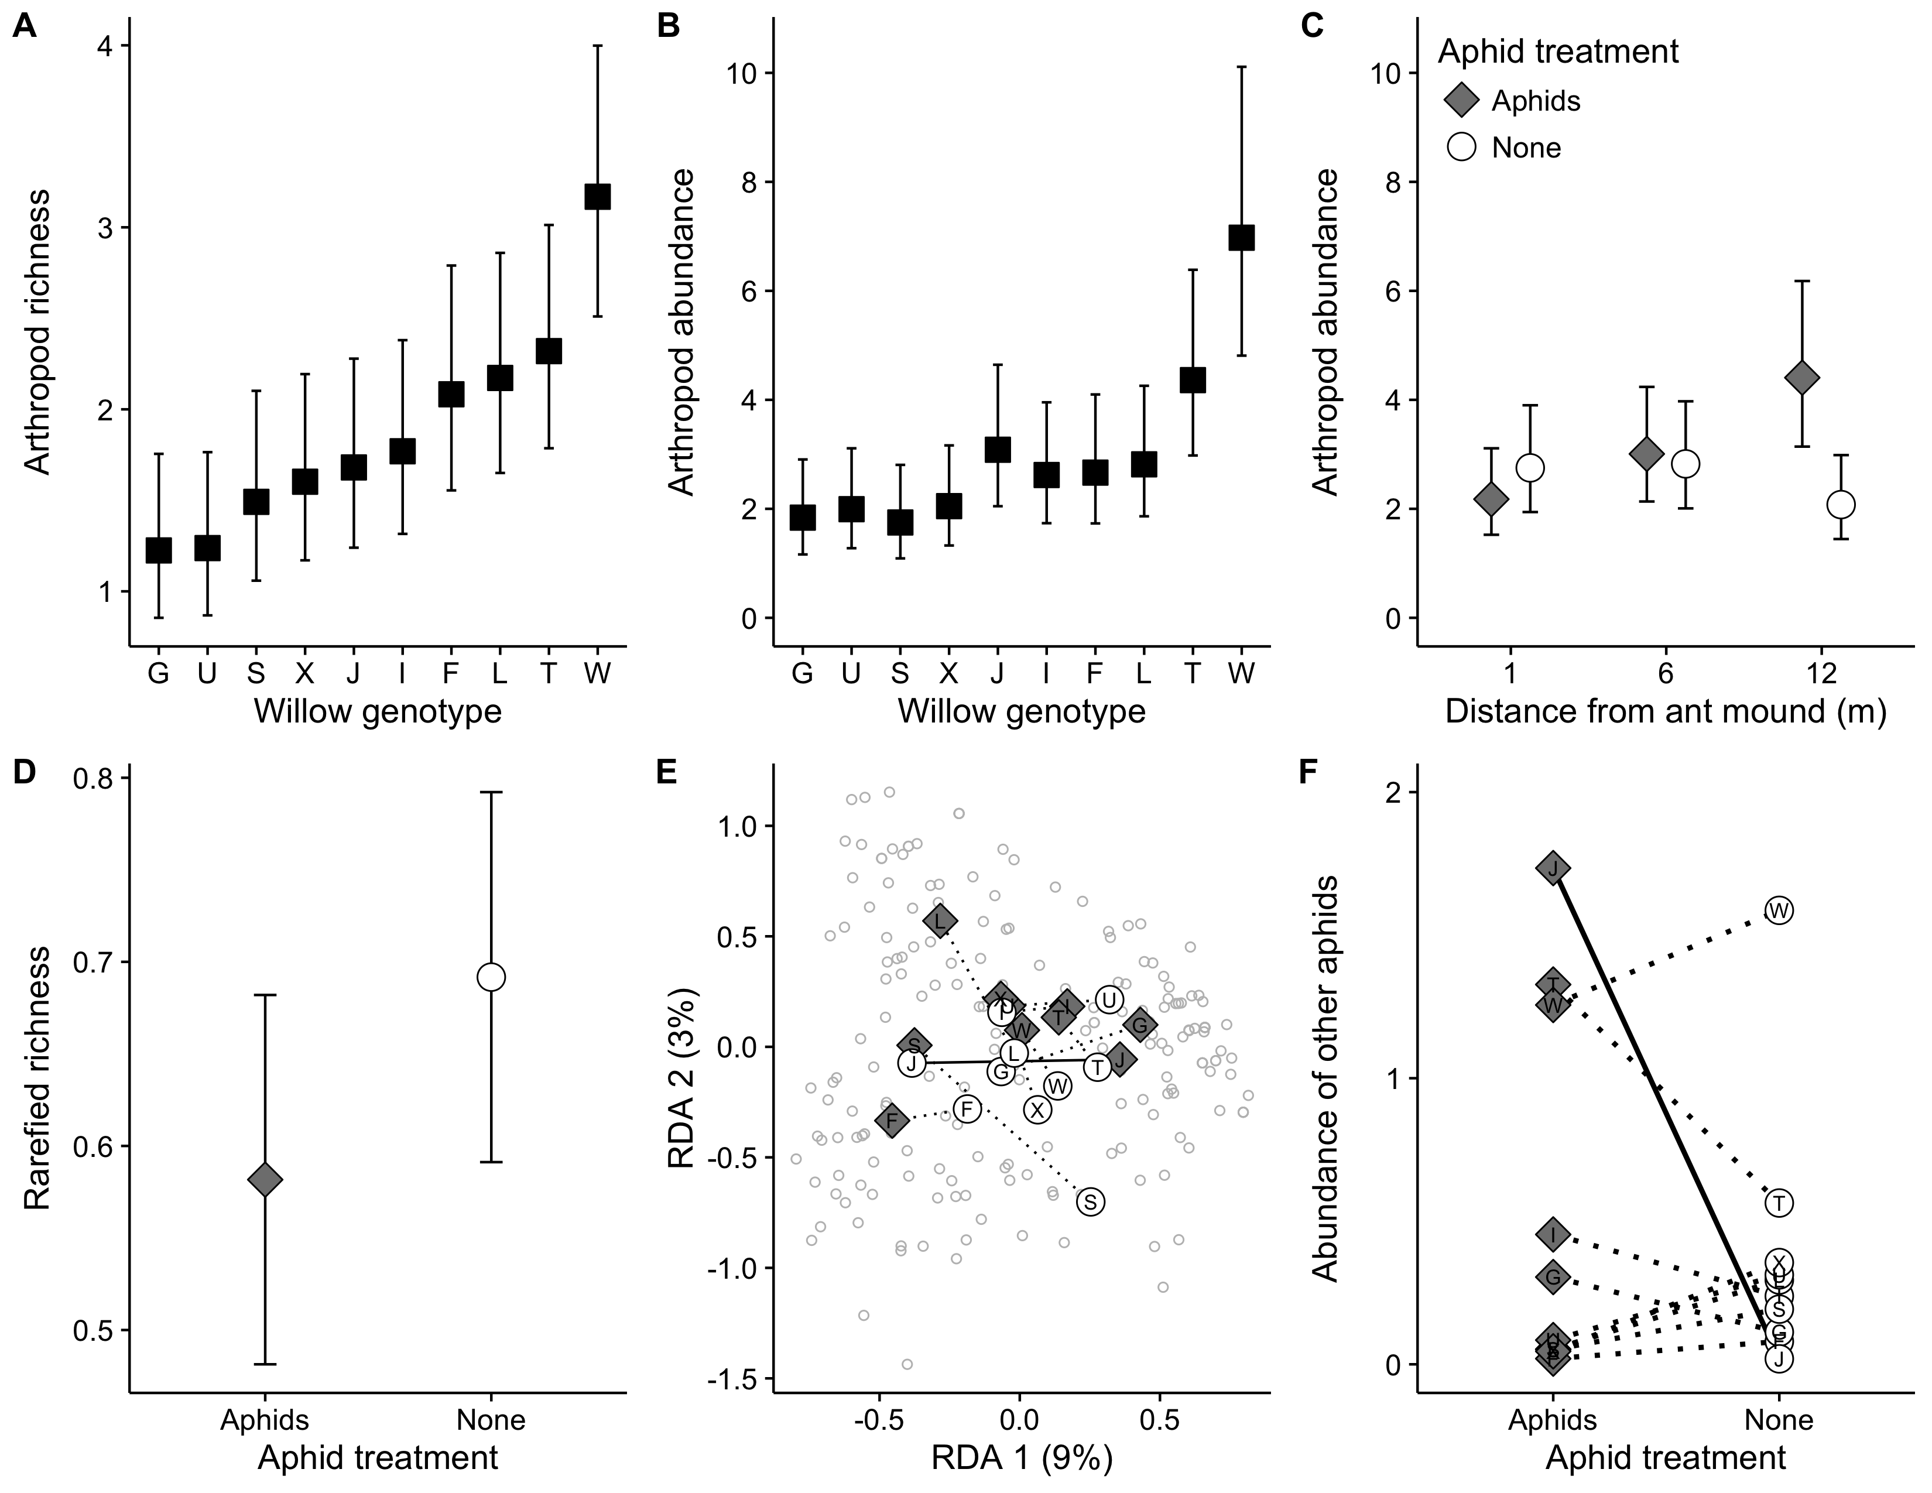

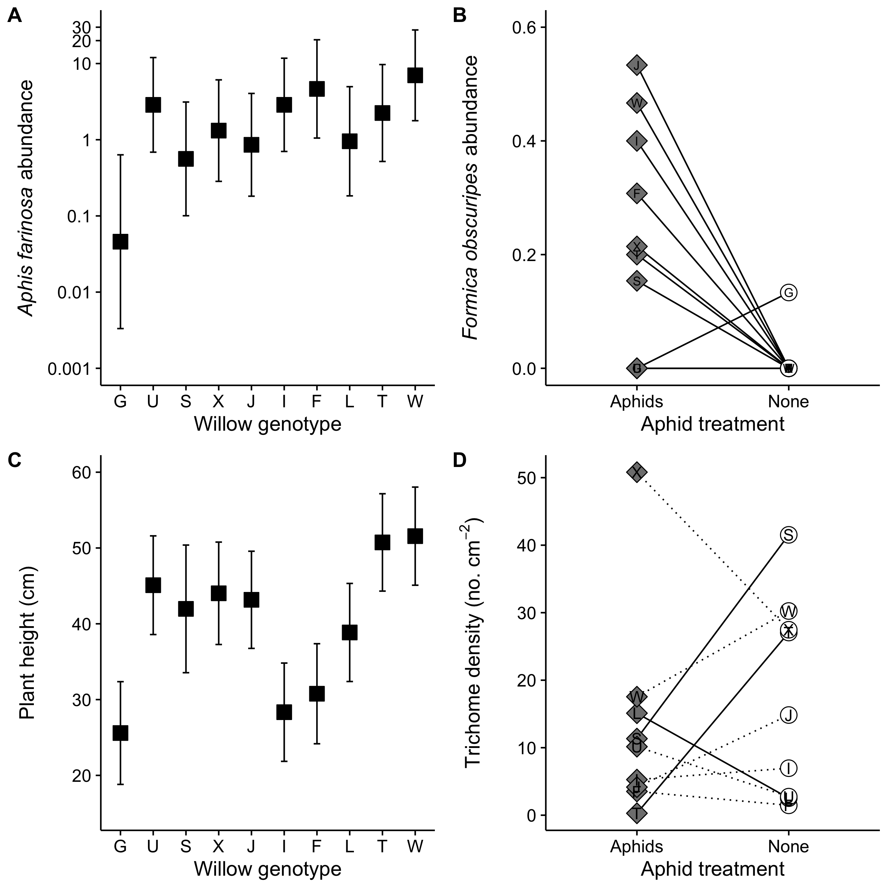

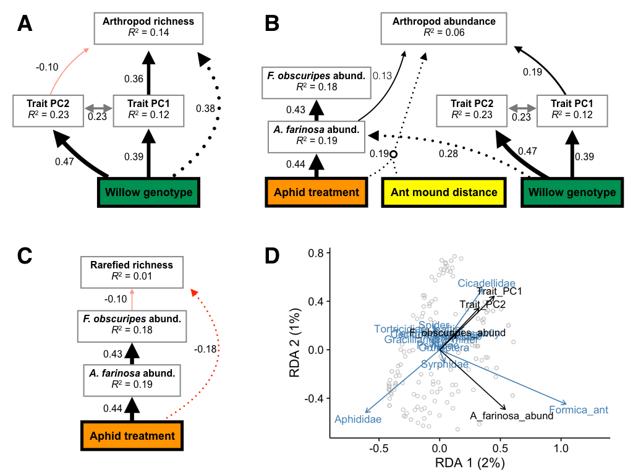

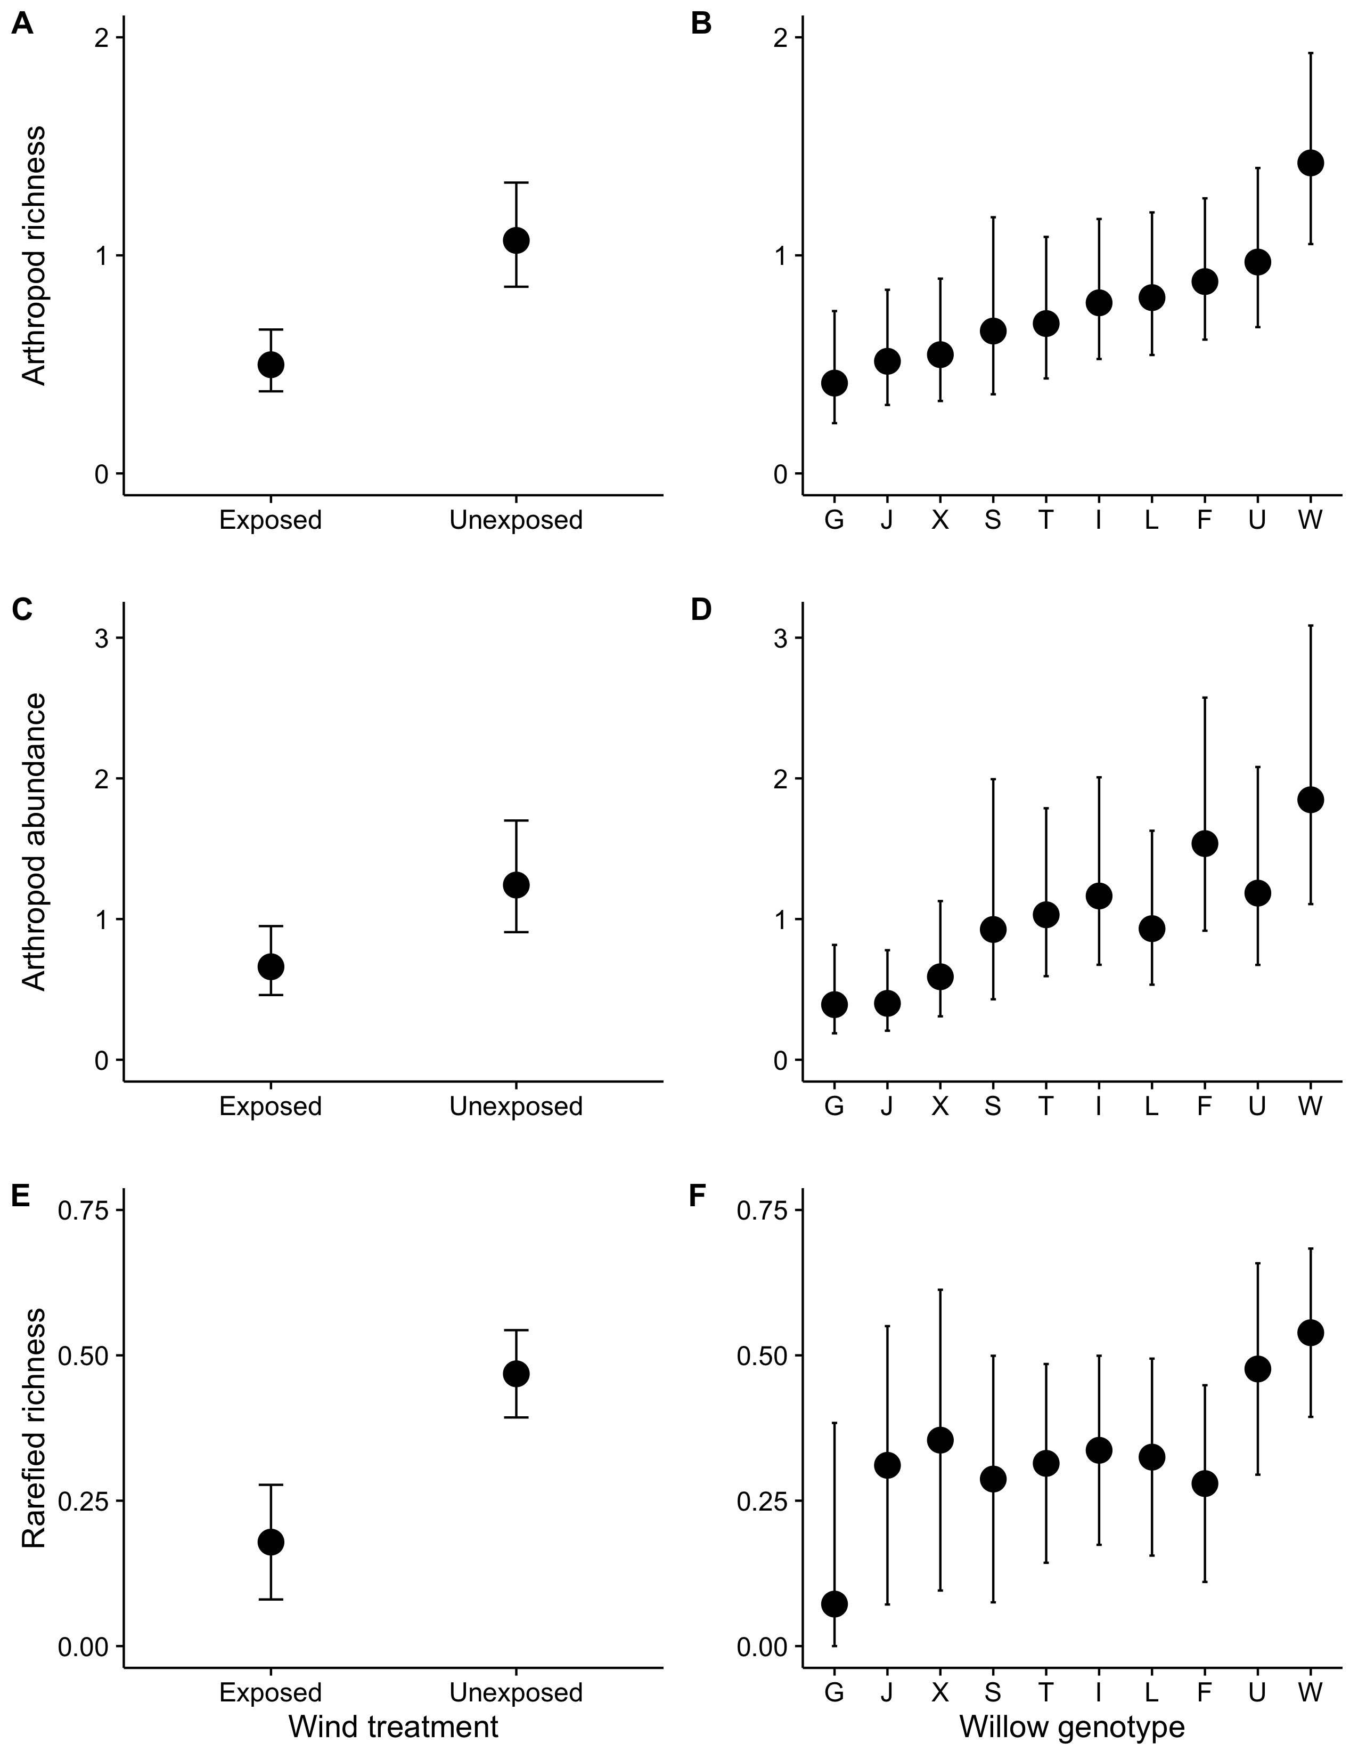

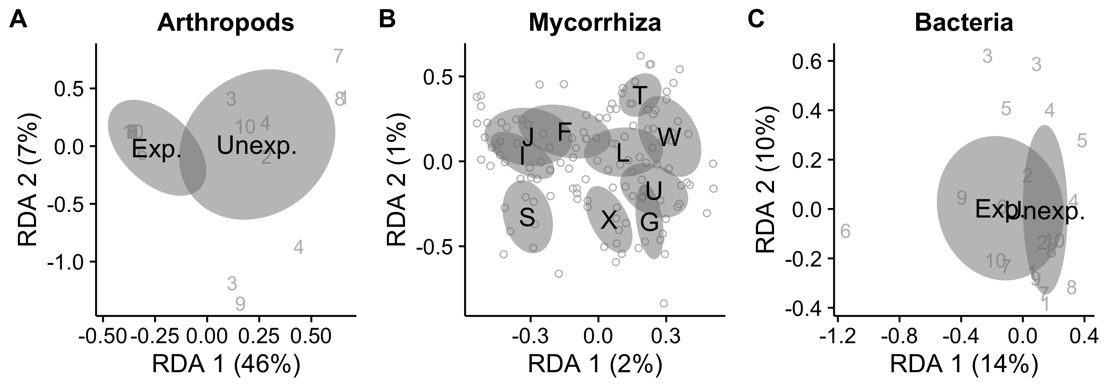

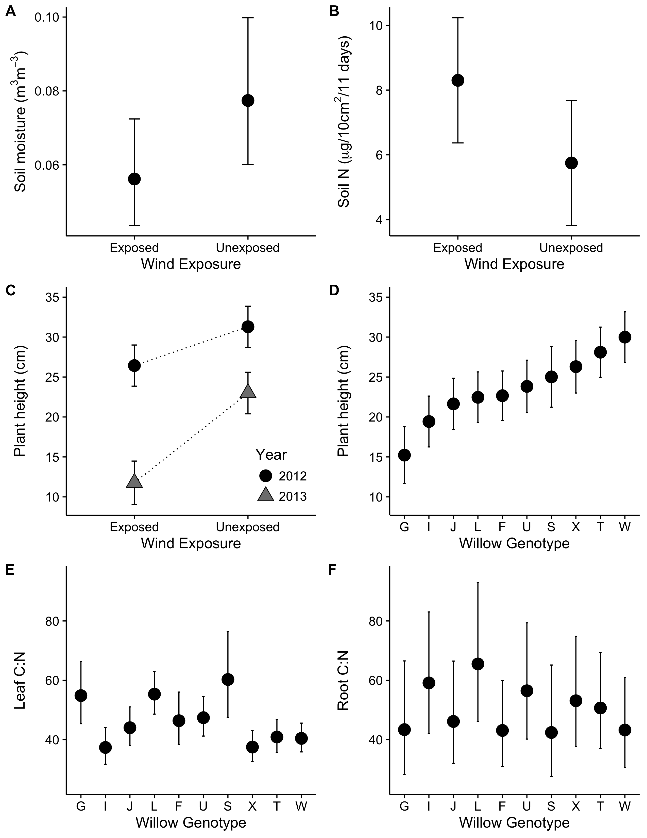

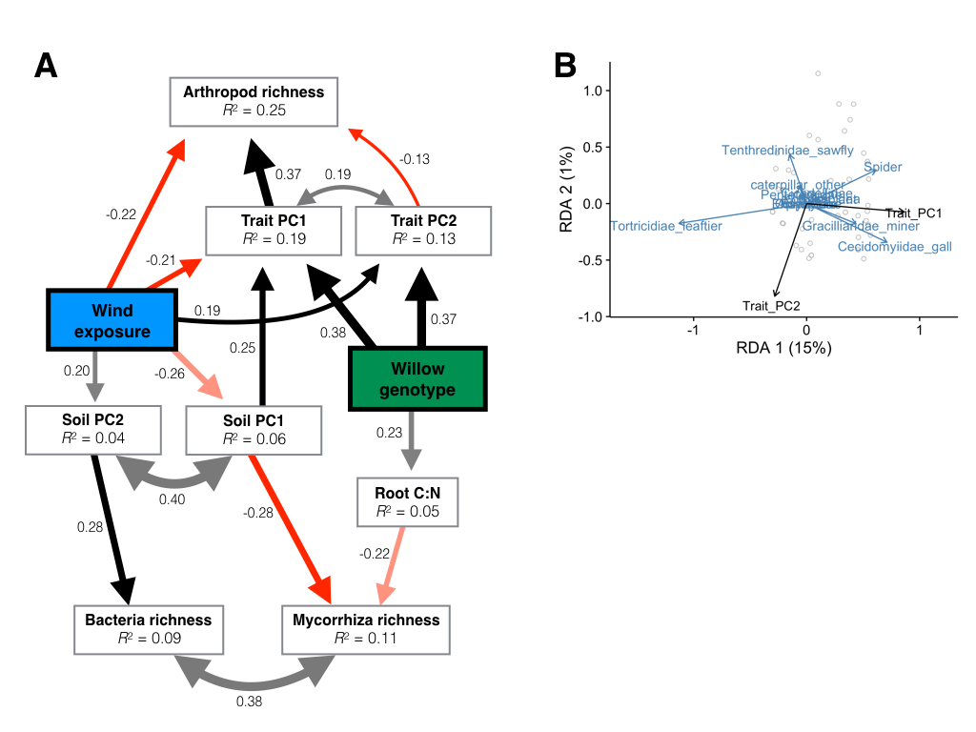

**Figure Legends**

**Figure 1**. Responses of the arthropod community to genetic variation within the willow *Salix hookeriana*, the addition of the aphid *Aphis farinosa*, and distance from mounds of the ant *Formica obscuripes*. We found that willow genotype influenced both the total richness (A) and abundance (B) of arthropods. Arthropod abundance was also influenced by the addition of aphids, but only at the furthest distances from ant mounds (C). The addition of aphids reduced the probability of encountering a different arthropod species (rarefied richness) by 16% across all treatments (D). We also found that the addition of aphids modified the effect of willow genotype on the composition of the arthropod community (E). This interaction between willow genotype and aphid treatment was solely due to the differential effect of genotype J on the abundance of non-*A. farinosa* aphids in the aphid treatment (F). Symbols and error bars correspond to the response variable’s mean ± 95% confidence interval. We calculated mean and confidence intervals based on the full models (Table 1) using the ‘*effects*’ package in R. Black squares correspond to the effect of willow genotype after controlling for other treatments, while grey diamonds and white circles represent the aphid treatment and control, respectively.

**Figure 2**. Variability in ant-aphid interactions and plant traits explained by genetic variation within the willow *Salix hookeriana*, the addition of the aphid *Aphis farinosa*, and distance from mounds of the ant *Formica obscuripes*. In the aphid treatment, we found that willow genotype influenced the abundance of the aphid *Aphis farinosa* (A). The effect of willow genotype on *A. farinosa* resulted in willow genotype determining the abundance of the ant *Formica obscuripes*, but only in the aphid treatment (B). Plant height was solely determined by willow genetic variation (C). In contrast, the aphid treatment modified the effect of willow genotype on leaf trichome density (D). Symbols and error bars correspond to the response variable’s mean ± 95% confidence interval. We calculated mean and confidence intervals based on the full models (Table 1) using the ‘*effects*’ package in R. Black squares correspond to the effect of willow genotype after controlling for other treatments, while grey diamonds and white circles represent the aphid treatment and control, respectively.

**Figure 3**. Statistical models of the processes mediating arthropod community assembly in the ant-aphid experiment. Piecewise structural equation models of arthropod richness (A), abundance (B), and rarefied richness (C). Colored and white boxes represent exogenous and endogenous variables, respectively. Solid, single-headed arrows correspond to modeled pathways between predictor and response variables, and may be either positive (black) or negative (red). Grey, double-headed arrows denote variables with no direct relationship and that we assumed to be driven by the same underlying factor. For clarity, we only plotted paths with standardized coefficients > 0.10. Numbers next to all arrows represent the standardized path coefficient, which also corresponds to the thickness of arrows. (B) Redundancy analysis illustrating the effect of plant traits (Trait PC1 & PC2) on arthropod community composition (Hellinger-transformed = square root of proportional abundances of species found on each willow). Black and blue arrows correspond to plant traits and species, respectively, while grey dots represent the position of individual willow communities.

**Figure 4**. Arthropod community responses to wind exposure and genetic variation within the willow *Salix hookeriana*. We found that both wind exposure and willow genotype had strong, but independent effects on the arthropod community. Specifically, arthropod communities on wind-exposed willows had lower richness (A), abundance (C), and rarefied richness (E) compared to unexposed willows. Willow genotype had a strong effect on the richness (B) and abundance (D) of arthropods, but only a marginal effect on rarefied richness (F). Points and error bars correspond to the response variable’s mean ± 95% confidence interval. We calculated mean and confidence intervals based on the full models (Table 2) using the ‘*effects*’ package in R.

**Figure 5.** Community dissimilarity of foliar arthropods (A) as well as root-associated mycorrhiza (B) and bacteria (C) in response to wind exposure and genetic variation within the willow *Salix hookeriana*. Black text and grey ellipses correspond to the community centroid ± 95% confidence interval. Grey numbers denote blocks and each unique number is the community centroid for the plot within each block. Grey circles mark the location of individual willow communities in multivariate space. We calculated the locations of centroids ± 95% confidence interval and individual samples using redundancy analysis on Hellinger-transformed community data.

**Figure 6.** Variability in soil characteristics and plant traits explained by wind exposure and genetic variation within the willow *Salix hookeriana*. Wind exposure had marginal effects on both soil moisture (A) and Nitrogen availability (B). The negative effect of wind exposure on plant height was magnified in the second year of the experiment (C); however, plant height still varied ~2-fold among the most disparate willow genotypes (D). Willow genotype was a good predictor of leaf C:N (E), but a poor predictor of root C:N (F). Symbols and error bars correspond to the response variable’s mean ± 95% confidence interval. We calculated mean and confidence intervals based on the full models (Table 2) using the ‘*effects*’ package in R.

**Figure 7.** Statistical models of the processes mediating community assembly in the wind experiment. (A) Piecewise structural equation model of the richness of foliar arthropods as well as root-associated mycorrhiza and bacteria. Colored and white boxes represent exogenous and endogenous variables, respectively. Solid, single-headed arrows correspond to modeled pathways between predictor and response variables, and may be either positive (black) or negative (red). Grey, double-headed arrows denote variables with no direct relationship and that we assumed to be driven by the same underlying factor. For clarity, we only plotted paths with standardized coefficients > 0.10. Numbers next to all arrows represent the standardized path coefficient, which also corresponds to the thickness of arrows. (D) Redundancy analysis illustrating the effect of plant traits (Trait PC1 & PC2) on arthropod community composition (Hellinger-transformed = square root of proportional abundances of species found on each willow). Black and blue arrows correspond to plant traits and species, respectively, while grey dots represent the position of individual willow communities.

**Tables**

|  |  |  |  |  |  |  |  |
| --- | --- | --- | --- | --- | --- | --- | --- |
| **Table 1**: Summary of statistical models that analyze the effects of willow genotype, aphid treatment, and distance from ant mounds on the arthropod community, ant-aphid interactions, and plant traits. We report the test statistic and include the degrees of freedom for each test in parentheses. Font type denotes statistical significance (**bold P < 0.05**, *italic P < 0.10*, normal P > 0.10). | | | | | | | |
| **Responses** | **Genotype (G)** | **Eaphid** | **Eant** | **GEaphid** | **GEant** | **EaphidEant** | **GEaphidEant** |
| *Foliar arthropods* |  |  |  |  |  |  |  |
| Total richnessa | **41.35**(9) | 0.45(1) | 1.12(1) | 7.66(9) | 7.84(9) | 1.15(1) | 6.17(9) |
| Total abundancea | **34.86**(9) | 1.79(1) | 1.42(1) | 14.61(9) | 9.00(9) | **8.12**(1) | 9.18(9) |
| Rarefied richnessb | 0.83(9,138.8) | **5.34**(1,139.2) | 0.46(1,8.2) | *1.81*(9,139.7) | 0.94(9,139.7) | 0.41(1,140.6) | 0.70(9,139.4) |
| Community compositionc | **1.52**(9,176) | *2.04*(1,176) | 1.01(1,9) | **1.45**(9,157) | 0.97(9,157) | 0.69(1,157) | 0.93(9,148) |
| *Ant-aphid interactions* |  |  |  |  |  |  |  |
| *A. farinosa* abund.a | **20.83**(9) | - | 0.55(1) | - | 10.25(9) | - | - |
| *F. obscuripes* abund.a | 2.42(1*) | **9.77**(1) | 1.68(1) | **6.26**(2*) | - | - | - |
| *Plant traits* |  |  |  |  |  |  |  |
| Heightb | **15.83**(9,204.2) | 0.63(1,204.3) | 0.31(1,9.1) | 0.93(9,204.5) | 0.98(9,204.4) | 0.07(1,204.3) | 1.62(9,204.7) |
| Shoot countb | **65.84**(9) | *2.76*(1) | 0.21(1) | 12.11(9) | 8.80(9) | **4.20**(1) | 9.21(9) |
| Shoot lengthb | **7.27**(9,204.2) | 2.39(1,204.2) | 0.10(1,9.1) | 1.05(9,204.5) | 0.70(9,204.3) | 1.24(1,204.3) | 0.56(9,204.6) |
| Leaf trichome densitya | 38.17(9) | 0.44(1) | 0.81(1) | **23.17**(8) | 8.41(9) | 0.84(1) | - |
| log(Leaf water content)b | 1.33(9,69.6) | 0.01(1,69.4) | 1.02(1,7.1) | 0.48(8,70.4) | 0.79(9,69.5) | 0.36(1,70.6) | 1.02(7,72.0) |

Notes: aLikelihood-ratio test and degrees of freedom calculated using a generalized linear mixed-effect model (error distribution = Poisson, link function = log); b*F*-test and Kenward-Roger approximated degrees of freedom calculated using a linear mixed-effect model; c*F*-test calculated using redundancy analysis on Hellinger-transformed community data; *indicates that predictor was modeled as a random effect and its significance was determined using a likelihood ratio test.

|  |  |  |  |  |  |  |  |
| --- | --- | --- | --- | --- | --- | --- | --- |
| **Table 2**: Summary of statistical models that analyze the effects of willow genotype and wind exposure on associated communities, soil characteristics, and plant traits. We report the test statistic and include the degrees of freedom for each test in parentheses. Font type denotes statistical significance (**bold P < 0.05**, *italic P < 0.10*, normal P > 0.10). | | | | | | | |
| **Responses** | **Genotype (G)** | **Ewind** | **Eyear** | **GEwind** | **GEyear** | **EwindEyear** | **GEwindEyear** |
| *Foliar arthropods* |  |  |  |  |  |  |  |
| Richnessa | **28.01**(9) | **10.33**(1) | **13.55**(1) | 3.74(9) | 9.85(9) | 0.92(1) | 7.04(9) |
| Abundancea | **25.25**(9) | **5.48**(1) | **6.72**(1) | 7.33(9) | 8.22(9) | 1.65(1) | 11.85(9) |
| Rarefied richnessb | **1.96**(9,71.1) | **22.82**(1,7.8) | 1.13(1,82.7) | 0.66(9,80.9) | - | 0.67(1,81.9) | - |
| Community composition2012 | 0.96(9,51) | 1.26(1,7) |  | 0.91(9,42) |  |  |  |
| Community composition2013 | 1.17(9,68) | **5.70**(1,9) |  | 0.69(6,62) |  |  |  |
| *Root-associated Mycorrhiza* |  |  |  |  |  |  |  |
| Richness2013b | 1.28(9,95.0) | 1.01(1,8.8) | - | 1.23(9,95.8) | - | - | - |
| Abundance2013b | 0.80(9,95.5) | 0.36(1,8.7) | - | 1.03(9,96.4) | - | - | - |
| Rarefied richness2013b | 0.87(9,95.1) | 0.88(1,8.8) | - | 0.93(9,95.9) | - | - | - |
| Community composition2013 | **1.01**(9,117) | 1.18(1,9) | - | 0.87(9,108) | - | - | - |
| *Root-associated Bacteria* |  |  |  |  | - | - | - |
| Richness2013b | 1.35(9,100.8) | *4.53*(1,7.9) | - | 0.87(9,101.5) | - | - | - |
| Abundance2013b | 1.39(9,102.3) | 2.00(1,8.0) | - | 0.64(9,103.2) | - | - | - |
| Rarefied richness2013b | 1.48(9,99.9) | **6.03**(1,7.8) | - | 1.35(9,100.5) | - | - | - |
| Community composition2013 | 0.93(9,120) | *1.38*(1,9) | - | 0.87(9,111) | - | - | - |
| *Soil characteristics* |  |  |  |  |  |  |  |
| Total Nb | - | *5.08*(1,9) | - | - | - | - | - |
| Soil moistureb | - | *3.52*(1,9) | - | - | - | - | - |
| Percent organic matterb | - | 0.68(1,8.4) | - | - | - | - | - |
| Nutrient PC1b | - | 1.31(1,9) | - | - | - | - | - |
| *Plant traits* |  |  |  |  |  |  |  |
| Heightb | **9.13**(9,145.3) | **29.10**(1,9.0) | **210.09**(1,156.3) | 0.71(9,147.9) | 0.80(9,157.8) | **16.69**(1,158.4) | *1.84*(9,160.9) |
| Shoot counta | **47.42**(9) | **9.91**(1) | **5.68**(1) | 10.70(9) | **18.26**(9) | **12.53**(1) | 5.76(9) |
| Shoot lengthb | **4.97**(9,144.2) | **10.44**(1,9.0) | **75.36**(1,158.5) | 0.84(9,146.9) | 1.61(9,160.1) | 0.05(1,160.7) | 0.70(9,163.2) |
| Leaf water contentb | **4.90**(9,129.0) | 0.97(1,8.7) | *2.93*(1,139.7) | 0.47(9,132.0) | **2.80**(9,141.6) | 2.03(1,141.5) | 1.56(9,144.1) |
| Leaf trichome density2012b | **67.31**(9) | 0.02(1) | - | 10.45(9) | - | - | - |
| SLA2013b | **4.21**(9,122.5) | 0.34(1,8.9) | - | 1.19(9,123.4) | - | - | - |
| Leaf C:N2013b | **4.88**(9,70.48) | 1.54(1,7.8) | - | 1.31(9,71.6) | - | - | - |
| Root C:N2013b | 0.85(9,107.0) | 0.31(1,8.7) | - | 0.33(9,107.5) | - | - | - |

Notes: aLikelihood-ratio test and degrees of freedom calculated using a generalized linear mixed-effect model (error distribution = Poisson, link function = log); b*F*-test and Kenward-Roger approximated degrees of freedom calculated using a linear mixed-effect model; c*F*-test calculated using redundancy analysis on Hellinger-transformed community data; *indicates that predictor was modeled as a random effect and its significance was determined using a likelihood ratio test.

|  |  |  |  |  |  |  |
| --- | --- | --- | --- | --- | --- | --- |
| **Table 3**: Redundancy analyses of foliar arthropods and root-associated mycorrhiza and bacteria. We report F-statistics and degrees of freedom in parenthesis. Font type denotes statistical significance (**bold P < 0.05**, *italic P < 0.10*, normal P > 0.10). | | | | | | |
| **Community composition** | **Ewind** | **Trait PC1** | **Trait PC2** | **Root C:N** | **Soil PC1** | **Soil PC2** |
| Arthropods | 0.83(1,9) | **12.05**(1,76) | 0.65(1,76) | - | - | - |
| Mycorrhiza | - | - | - | 1.17(1,115) | 1.89(1,8) | 0.85(1,8) |
| Bacteria | - | - | - | *1.31*(1,116) | 1.90(1,8) | 0.81(1,8) |