. University of Zurich, Department of Evolutionary Biology and Environmental Studies, Zurich, 8057 ZH, Switzerland;

Corresponding author; e-mail: [matthew.barbour@ieu.uzh.ch](mailto:matthew.barbour@ieu.uzh.ch)

*Short Running Title*: MS Template

*Keywords*: food webs; eco-evolutionary dynamics.

*Total Word Count*: 693

*Another Title Page Requirement*: You could include a statement of authorship for the manuscript for example.

# Abstract

You’ll see that I use a combination of LaTeX and R Markdown here. I try to use R Markdown whenever possible because it is cleaner and will knit more consistently across different formats (e.g., html or docx). LaTeX can give finer control though, and is necessary to use if you’re trying to format something within a LaTeX command.

# Introduction

It’s easy to cite multiple articles and include other text within the citation (e.g., Barbour and Clark 2012a, 2012b). It also takes care of papers with many authors easily according to the appropriate style file (Barbour et al. 2016).

# Material and methods

## Common formatting for R Markdown (like this Subsection)

Check out this [Cheat Sheet for R Markdown](https://rstudio.com/wp-content/uploads/2015/02/rmarkdown-cheatsheet.pdf)[1] for how to deal with many common formatting issues, but I’ve also include some formatting details that are common for manuscripts below:

*Italics*; **Bold**; Subscript; Superscript

## Equations

You’ll have to write equations with Latex code. Below is an example of a continuous-time model of two consumers competing for two resources.

# Results

It is easy to reproduce summary statistics and analyses, rather than having to copy and paste them from a spreadsheet. For example, the mean SD of *Iris* petal length corresponds to: 3.76 1.77. Similarly, we include more specific statistical analyses. For example, I found that species identity had a strong effect on *Iris* petal length (*F*2,147 = 1180.2, *P* < 0.001).

Although you can’t see it, I have “cached” the results from the above analysis. This isn’t necessary for such a small analysis, but if you have larger simulations or analyses setting “cache=TRUE” in the chunk option will save you a lot of time.

It is also easy to include figures and link the figures to the main text. For example, click on the number 3 to go to a figure I made for one of the papers from my PhD (Fig. ). This figure was a simple image file (.jpg), but I can also make figures with R code inside this document (e.g., Fig. )

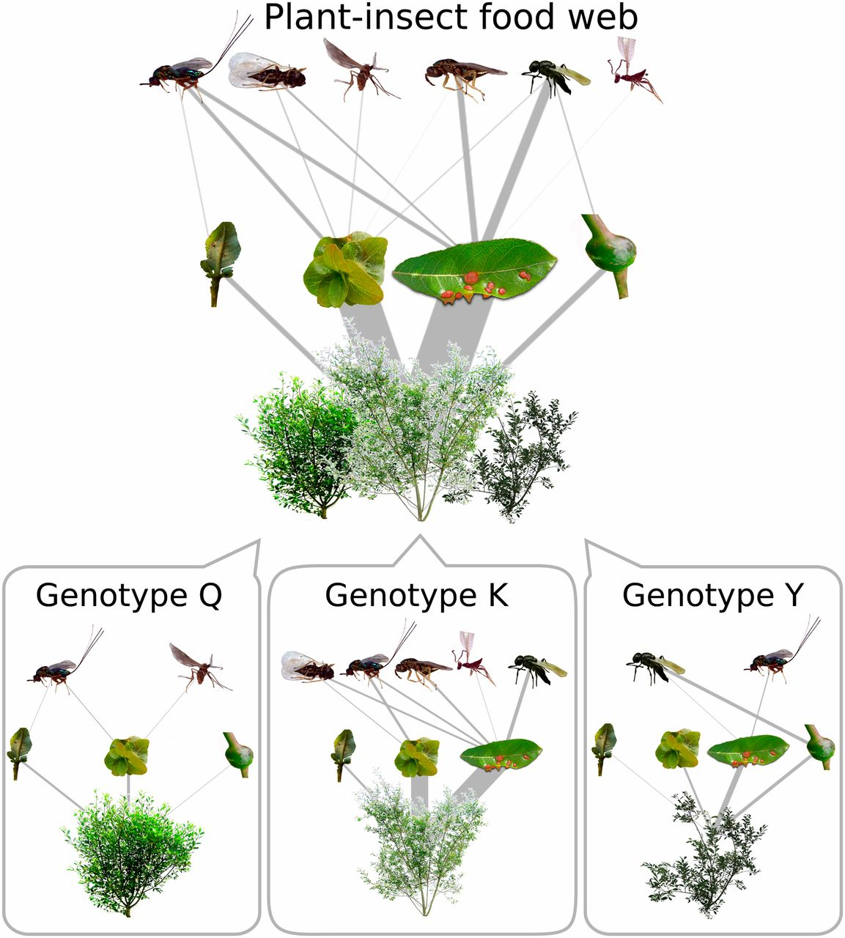

Here is a figure from one of my papers. You can use chunk options for resizing and aligning the figure. Apparently, *R Markdown* formatting doesn’t work (at least for me right now) inside figure legends, so you’ll have to use . Remember though that you’ll have to precede any LaTeX command with an extra backslash.

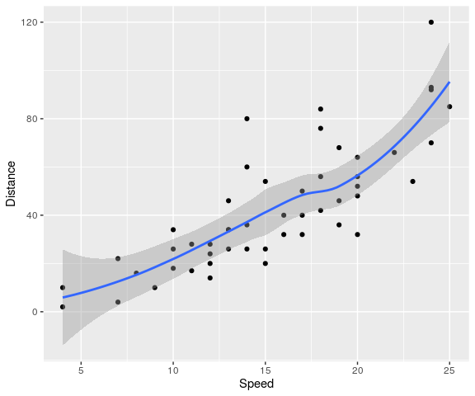

Here is a figure generated directly from R code. I like to use the R package for figures, because the default looks nice and ready for a publication. Note that you have to use different chunk options to adjust this type of figure. This figure will be automatically saved as a pdf file that is used for this manuscript.

You can do the same for tables, like this table of *Iris* floral characters (Table ).

A caption.

|  |  |  |  |  |
| --- | --- | --- | --- | --- |
| Sepal.Length | Sepal.Width | Petal.Length | Petal.Width | Species |
| 5.1 | 3.5 | 1.4 | 0.2 | setosa |
| 4.9 | 3.0 | 1.4 | 0.2 | setosa |
| 4.7 | 3.2 | 1.3 | 0.2 | setosa |
| 4.6 | 3.1 | 1.5 | 0.2 | setosa |
| 5.0 | 3.6 | 1.4 | 0.2 | setosa |

# Discussion

This is by no means a definitive guide to writing reproducible manuscripts in R Markdown.

I have tried to cover simple solutions to common problems I have encountered, especially when knitting to a pdf_document. This simple style, which was inspired by *The American Naturalist*’s [LaTeX template](https://www.journals.uchicago.edu/pb-assets/docs/journals/AmNat_MS_template-1515709536857.tex), and should be compatible for an initial submission to any journal in ecology or evolutionary biology (with minimal tweaks).

Below, I’ve included some links to resources that may help you address issues more detailed issues that I have not covered here.

* Book on [“R Markdown: The Definitive Guide”](https://bookdown.org/yihui/rmarkdown/)
* Slide presentation on [“Writing reports and manuscripts in R Markdown”](http://rstudio-pubs-static.s3.amazonaws.com/368020_865af4d4afaa4c5cbdb95a7b2670c812.html#1)
* Blogpost on [“Tips and tricks for working with images and figures in R Markdown documents”](http://zevross.com/blog/2017/06/19/tips-and-tricks-for-working-with-images-and-figures-in-r-markdown-documents/)

# Acknowledgements

A lot of different resources have been useful to me over the past year in learning how to write reproducible manuscripts in R that I’m probably forgetting. I apologize for not including them here.

# References

Barbour, Matthew A, and Rulon W Clark. 2012a. “Diel Cycles in Chemosensory Behaviors of Free-Ranging Rattlesnakes Lying in Wait for Prey.” *Ethology* 118 (5): 480–88.

———. 2012b. “Ground Squirrel Tail-Flag Displays Alter Both Predatory Strike and Ambush Site Selection Behaviours of Rattlesnakes.” *Proceedings of the Royal Society B: Biological Sciences* 279 (1743): 3827–33.

Barbour, Matthew A, Miguel A Fortuna, Jordi Bascompte, Joshua R Nicholson, Riitta Julkunen-Tiitto, Erik S Jules, and Gregory M Crutsinger. 2016. “Genetic Specificity of a Plant–Insect Food Web: Implications for Linking Genetic Variation to Network Complexity.” *Proceedings of the National Academy of Sciences* 113 (8): 2128–33.

1. You can set ‘linkcolor: black’ in the YAML header for an actual manuscript. I’ve used a blue color here to make it clear that it’s a hyperlink. Also, you’ll probably never need a footnote for a manuscript, but this is how you would do it in R Markdown.