**Mohammad Abbas**

**Senior Full Stack Java Developer** 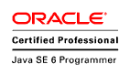 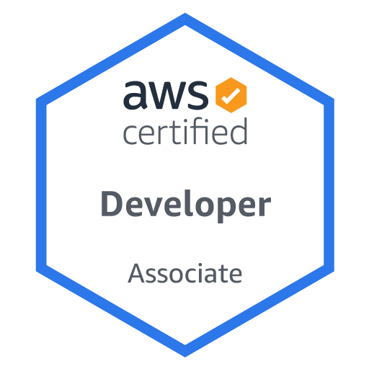[**mabbas.java@gmail.com**](mailto:mabbas.java@gmail.com)

**+91 7007726311**

**Summary of Experience**

* Around **7**.**1** years of IT experience with **Full Stack Development**, all phases of Analysis, Design, Development, Customization, Implementation, Integration, Maintenance and Support of Java, J2EE Enterprise Application, in Banking, and Insurance domain.
* Requirement Gathering, Analysis, Scope documentation, Development & Implementation-Solution Designing, Coding, end-to-end Testing, Production Support Interfacing.
* Possess comprehensive command over Spring Framework including modules such as **Spring Boot**, **Eureka Discovery Server and Client**, **spring-data, JPA**, **Spring MVC, Spring AOP, Spring Transaction, Spring Security, and JMS.**
* Worked on various cache mechanism such as **Couche in memory DB, Redis, JPA Second level cache etc. to improve application performance.**
* Worked on integration of **AWS cloud with application such as S3 to application integration, Lambda functions, API Gateway etc.**
* Working on complete Agile environmentwith **Test Driven Development using JUNIT** and Test coverage tool **JACOCO.**
* Worked on frontend UI development using **Angular** and integrated it through rest services in **Spring** and **Spring boot**
* Hands on experience on Integration of Spring with **Hibernate (JPA)** integration with **Restful services** and with **SOAP Web Services**.
* Work in an **AGILE** environment geared towards delivering development framework.
* Highly proficient in implementing requirements using Gang of four Design patterns including **Singleton, Factory, Abstract Factory, Decorator, Adapter, Flyweight, Template Method**), JEE (**Intercepting Filters, Front Controller, Application Context, Session Façade, Service Locator**).
* Experience in Creating, Managing and Securing and Socializing the full ecosystem of APIs on **IBM API Connect.**
* Thorough knowledge of algorithms Excellent in customizing internal frameworks using Tools like **Log4J, Junit.**
* Hands on Experience in developing applications using core java concept like **Collection**, **Multithreading**, **OOPs**, **Exception Handling** and **Generic**.
* Experience in Performance Testing and API Testing using **JMETER**.
* Expertized in automating operations such as **Jenkins CI/CD**.
* Continuous interaction with various Product Owner for requirement gathering and Product Delivery.
* Good **Team player** and have ability to achieve team goals.
* Has Exceptional Interest in adopting new Technologies and doing R&D on new concepts.

**Qualifications:**

* MCA in 2014 from Dr.R.M.L. Avadh University Faizabad U.P. with 75%
* B.Sc. in 2011 from Dr.R.M.L. Avadh University Faizabad U.P. with 51%
* Intermediate in 2008 from Ramdev Janta Inter College Katehri, U.P. with 51%
* High School in 2006 from Ramdev Janta Inter College Katehri, U.P. with 60%
* Certification Java Programmer
* DevOps certification Simplilearn
* AWS Certified Developer

**Organization:**

* Working as Senior Full Stack Developer **with Deloitte USA INC. (12th April 2021 till present)**.
* Worked as a Full Stack Developer in NTT DATA (Formerly known as DELL Services), Noida from **11th July 2018 to 9th April 2021.**
* Working as a Product Developer in DXC Technologies **(Formerly known as CSC), Noida from 20th March 2017 to 6 July 2018.**
* Worked as a Java Software Engineer in DENAVE India PVT. ltd. **from 3rd February 2016 to 10th March 2017.**

**Project Details:**

|  |  |
| --- | --- |
| **Title # 1** | **Origami Risk** |
| **Company Name** | **Deloitte** |
| **Client Name** | **Mission** |
| **Role &**  **Responsibilities** | * Providing technical expertise for every phase of the project lifecycle—from concept development to solution design, implementation, optimization and support. * Interact with a set of clients (client senior developers and architects) to create technology specifications from business requirements for one of the modules within the project * Prepare the technical design of the more complex technology components within the module (one or more of client/web presentation tier, server tier, data access and data model, integration component, package function customization) * Work with and assist the architect in articulating the pros and cons of using a certain technology stack or component or design pattern versus another to the clients and project team and drives selection of technologies, designs to come up with the optimal architecture * Drive the performance tuning, re-design and re-factoring for a module. * Involve in Performance testing and APIs testing * Handled code reviews and unit test creation. * Extensive use of Angular framework for developing the SPAs (Single Page Applications) * Worked Extensively with Angular CLI for creating components, Services, pipes, Directives. * Involve in Multithreading implementation for performance improvement. * Converted a monolithic app to microservices architecture using Spring Boot using 12-factor app methodology. Deployed, Scaled, Configured, wrote manifest file for various Microservices in PCF. * Implemented REST Microservices using spring boot. Generated Metrics with method level granularity and Persistence using Spring AOP and Spring Actuator. * Implemented Zipkins for distributed Micro Service Monitoring. Integrated Swagger UI and wrote integration test along with REST document. * Implemented Hysterix a Latency and Fault Tolerance system for Distributed Systems. Wrote Controller, Services and directive code using Angular JS. |
| **Project Description** | Origami Risk is a leading provider of integrated SaaS solutions for the risk and insurance industry—from insured corporate and public entities to brokers and risk consultants, insurers, third party claims administrators (TPAs), and risk pools. Highly configurable and completely scalable, Origami Risk delivers a full suite of risk management and insurance core system solutions from a single secure, cloud-based platform accessible via web browser and mobile app. |

|  |  |
| --- | --- |
| **Title # 2** | **AEP Web** |
| **Company Name** | **NTT DATA** |
| **Client Name** | **US BANK** |
| **Role & Responsibilities** | * As an offshore developer was responsible for requirements analysis, interacting with client /onsite team to validate the understanding and actively involved in the development of the module. * Integration of code quality plugins like Sonar, HP Fortify in the development environment to ensure team always delivers with high quality and all issues are identified in the early stages of the application development process. * Extensive use of Angular framework for developing the SPAs (Single Page Applications) * Worked Extensively with Angular CLI for creating components, Services, pipes, Directives. * Prepare the technical design of the more complex technology components within the module (one or more of client/web presentation tier, server tier, data access and data model, integration component, package function customization) * Developed server-side application to interact with database using Spring Boot and Hibernate. * Implemented Log4j and I18N technology for a broader perspective of the project. * Developed test classes in JUnit for unit testing. * Used Postman to test the RESTful API for HTTP requests such as GET, POST, and PUT. * Used GIT for version control tool for merging branches and used Source tree to solve conflicts. * Worked with Threads, Multithreading, Synchronization and Collection API. * Worked on server-side validation using various web forms through annotation-based approach. * Integrated Spring Security to validate the users. |
| **Project Description** | AEP-Web is a web-based application, provides support to their customers. AEP-Web is used to board North America merchants for their credit card processing with Elavon. This application used in NA and Canada regions.  This application provides the ability to access internal boarding users, Tele sales users and external MSP users to board new merchants and to board applications from different sales tools.  A process to create a new merchant in AEP-Web application is a Boarding process. In this process, users are responsible to board customer in application by gathering customer data. This customer data flows in different status like verify, credit and Review etc. for processing. |

**Personal Details:**

Gender : Male

Date of Birth : 05-june-1991

Nationality/Region : Indian

Marital Status : Married

Languages Known : English, Hindi

Permanent Address : Village – Rajepur Dhavan, Post- Akbarpur Dist. - Ambedkar Nagar, Pin -224122, U.P.

**Declaration:**

I hereby declare that all information furnished by me is true to best of my knowledge.

**Date: Mohammad Abbas**