**Mohammad Abbas**

[**https://mabbas-java.github.io/**](https://mabbas-java.github.io/)

**Senior Full Stack Java Developer** 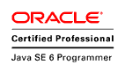 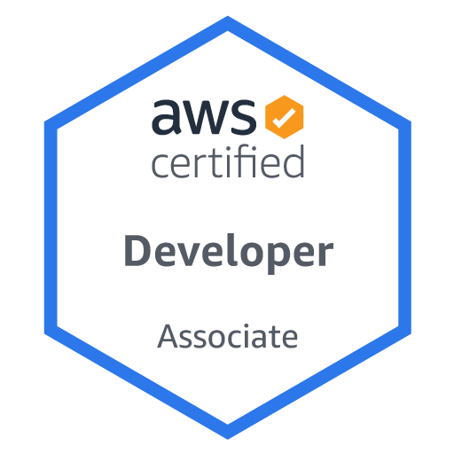[**mabbas.java@gmail.com**](mailto:mabbas.java@gmail.com)

**+971526242163**

**Summary:**

* I am an experienced full stack developer with 8.1 years of experience in IT. My expertise spans across all phases of the software development life cycle, from requirements gathering and analysis to deployment and support. I have a proven track record in delivering end-to-end solutions for Java and J2EE enterprise applications in the banking, immigration, and insurance domains. I am highly proficient in the Spring Framework and have experience in cloud integration, API development, Agile software development, and modern software development paradigms, such as microservices and event-driven architecture.

**Skills:**

* Full stack development
* Java and J2EE enterprise applications
* Spring Framework (Spring Boot, Spring Kafka, Spring JPA, Spring MVC, Spring AOP, Spring Transaction, Spring Security, JMS)
* Cloud integration (AWS S3, Lambda, API Gateway)
* Docker and Kubernetes
* Frontend development (Angular)
* Agile software development (Scrum, Kanban)
* Gang of Four design patterns
* Microservices and event-driven architecture
* Redis
* Apache Kafka
* IBM API Connect
* Core Java concepts (Collections, Multithreading, OOPs, Exception Handling, Generics)
* Performance testing and API testing (JMETER)
* Jenkins CI/CD
* Collaboration and communication with product owners and stakeholders
* Research and development

**Qualifications:**

* MCA in 2014 from Dr.R.M.L. Avadh University Faizabad U.P. with 75%

**Experience:**

* Senior Full Stack Java Developer with Emaratech Dubai. (17th April 2022 till present)
* Consultant with Deloitte USA INC Gurgaon. (12th April 2021 to 15th April 2022).
* Full Stack Developer in NTT DATA (Formerly known as DELL Services), Noida from 11th July 2018 to 9th April 2021.
* Product Developer in DXC Technologies (Formerly known as CSC), Noida from 20th March 2017 to 6 July 2018.
* Java Software Engineer in DENAVE India PVT. ltd. from 3rd February 2016 to 10th March 2017.

**Personal Details:**

Date of Birth : 05-june-1991

Nationality/Region : Indian

Marital Status : Married

Languages Known : English, Hindi