MAP524A
Assignment 2
Prof. John Selmys
April 10, 2015
Mahboubeh Abbasi
054421136

Executive summary
I built this Android app to make it easier for all type of user to look up the data related to the number of International students, who came to Canada, in both 2013 and 2014 in different provinces. This data can be easily accessible through the Government of Canada; however accessing to this information would be much easier through this app. These information has been stored on the phone and will be updated frequently to provide updated information to users. The user interface of this app is so friendly and easy to work. I have built this project as an Android app because Android is very popular among people and also is the world's most popular mobile platform; so was able to make satisfied all its customers.

Description of the final app
The final project is very close the proposal I had provided. It almost has all the features that I mentioned in Assignment 1. It is very simple app that direct the user to the main page that contain some buttons. Each button takes the user to the specific page. The main purpose of this app is to connect to the database that contains some basic information about the number of intentional students in recent years.
In addition, I tried to add some feature to this app to make it more useful. For example, I provided a list of top universities that can help new students to get the idea which university is the best option for them. Also, there are some organized information about how international students can apply for the university or how to work and study at the same time and etc…
Also, each page has the Help option that guide users how each page works that make the job easier for them.

A list of completed and uncompleted features
In this app I stored the data inside the mobile to decline the risk of disconnection. However, it might have some disadvantages like database might not get updated frequently, and updating should be done manually.
This app is very easy to use. The user doesn’t need to even type a single word; everything is there and only needs to be selected. This app is good for people who have difficulty working with technology.
Moreover, The extra information that has been provided can help the user to decide which university is the best option for them, how they can work or stay in Canada. This information can be more important than anything else for the international students because they need go through the long process to be able pursue their education in Canada.

Snapshots
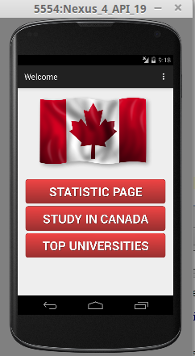

This is the main page of this app that contain three buttons that takes user to three different pages. In the following I will explain the purpose of each page.

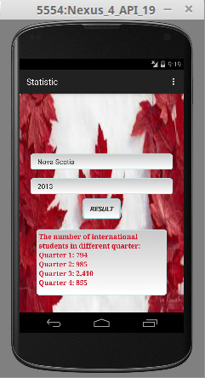

When user click on the Static Page in main page, this page appears on the screen. In this page user only needs to select a province and year; by clicking on result, he/she can see the number of international students in different quarter in selected province and year. Also, in the meantime user can enjoy listening to music.

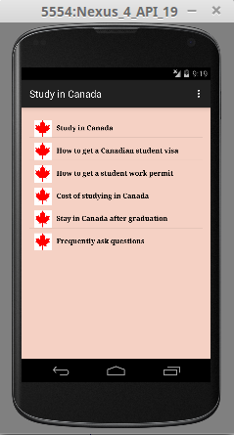

This page is shown when Study in Canada button is selected. This page provides extra information about how to apply for a university, how to work and study at the same time, or how to stay in Canada after graduation. This page can be useful for users who are interested in living in Canada

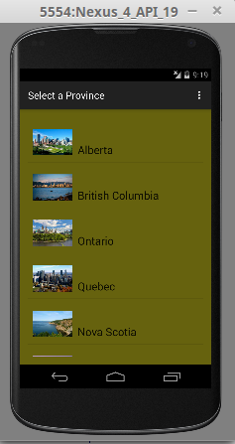

This page comes up by selecting the Top Universities button. In this page there is a list of top university in different provinces in Canada. By clicking on each province user will be able to see a list of top university in the selected province (is shown below).

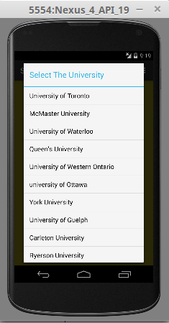

This page shows a list of top university in Ontario. After clicking on each university user will be guided to the website of the university to help user to get all the information about that university.

Conclusion
I almost added all the features that I decided to use in this app. Because the information that I have access was not enough, I was not able to make the app that I had in my mind. Thus, I decided to work more on the layout. This app could be a better one if I had access to more data; however, this app could be improved in the future to add extra features. I liked to make it possible for users to choose their favorite language while they are using this app; but, I couldn't finish this part due to time limit. Overall, since this is my first app, I can consider it as a good app; maybe in the future I can improve it to make a more professional and useful app.

