**Introduction to Ansible**

A System Administrator (SysAdmin) manages and maintains computer systems and servers to ensure reliable operation and performance.

* To check OS is up to date
* Package versions are up to date
* Application depends
* Mantaences

This work is done by the application system administrator and **manually** by using a **shell scripting**

* Shell scripting primarily works on **Linux** (and other UNIX-like systems) because it relies on the **UNIX shell** environment, which is designed to interpret **commands** specific to these operating systems

To resolve this problem we use ansible

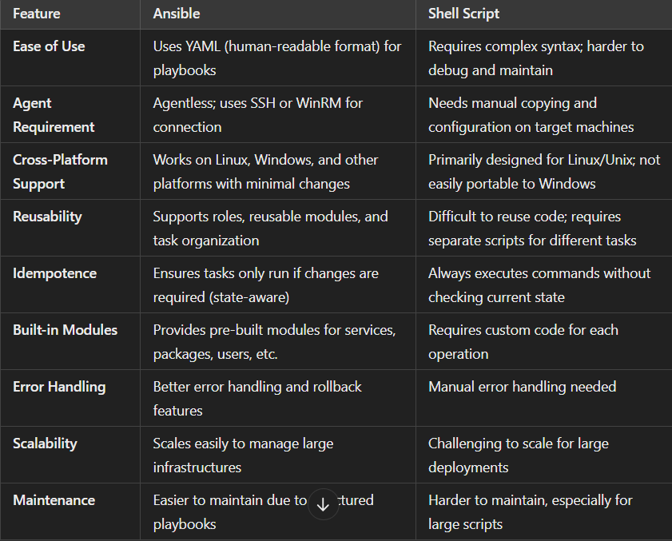

Ansible is mostly written in a yam file that the user can easily read and write

* Ansible we do not need to install agents it has two node

1. Control node can be installing any one VM machine
2. Manage the node controlled by the control node

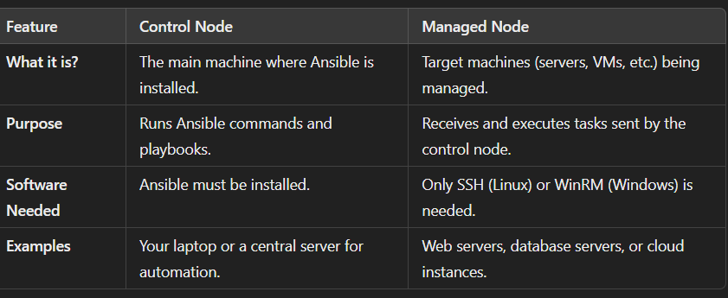

**what are different tasks that can be done by Ansible**

**• Configuration Management**

**• Application Deployment**

**• Orchestration of Complex Workflows**

**• Infrastructure Provisioning**

**• Continuous Integration and Delivery (CI/CD)**