**Network**

**What is computer networking?**

computer network is a collection of computing devices that are logically connected together to communicate and share resources

**node** refers to any devices on the network

**host**

is a node that has a unique function. Other devices connect to nodes so they can access data or other services. (Example: server)

**OSI Model**

Open systems interconnection model

It show how the date flow done in the computer

**Data Starts at the Source**: The source computer prepares to send data to the target computer.

**Application Layer (Layer 7)**: This is where applications interact with the network (e.g., a web browser sending data).

**Presentation Layer (Layer 6)**: The data is formatted, encrypted, or decrypted here to make it usable for the next step.

**Session Layer (Layer 5)**: Manages the connection and keeps data from different applications separate.

**Transport Layer (Layer 4)**: Sets up a logical link between the source and target, specifying protocols like TCP for transmission.

**Network Layer (Layer 3)**: Determines the physical path the data will travel (routing).

**Data Link Layer (Layer 2)**: Defines the data format and manages the physical network.

**Physical Layer (Layer 1)**: Sends the raw bits (0s and 1s) over the network cable or wireless signal.

**Data Travels to the Target**: The data, now packaged for network transmission, moves across the network.

**Reverse Unpacking at Target**: The target computer unpacks the data, moving from Layer 1 back up to Layer 7, so it can understand and use the data.

In essence:

* **Layer 7 to 1**: Data is packed and transformed.
* **Layer 1 to 7 at Target**: Data is unpacked and understood.
* **Layer 2 (Data Link Layer)**:
  + Data is called a **frame**.
  + Frames use **MAC addresses** (physical addresses) to identify devices on the same network.
* **Layer 3 (Network Layer)**:
  + Data is called a **packet**.
  + Packets use **IP addresses** to identify devices across different networks.

Think of it as:

* **Frames + MAC addresses** at Layer 2 (Data Link)
* **Packets + IP addresses** at Layer 3 (Network)

**Switch**:

* Operates at **Layer 2 (Data Link Layer)** of the OSI model.
* Connects devices within the same network (like computers in an office).
* Uses **MAC addresses** to forward data to the correct device on the local network.

**Router**:

* Operates at **Layer 3 (Network Layer)** of the OSI model.
* Connects different networks (like your home network to the internet).
* Uses **IP addresses** to route data between networks.

**networking components:**

•Client

•Server

•NIC

•Network cables

•Switch

•Router

**Server**

A server responds to a request from a client computer over a network

The server responds to the client’s request with the requested content

The server has a specific job to respond to a request. When the client sends a request, the server will respond with the appropriate content the client is requesting

**Network Interface Card**

* A **Network Interface Card (NIC)**, also called a **network adapter**, connects your computer to the network.
* Each NIC has its own **MAC address**, which is a unique identifier (like a "name tag") for that device.
* **MAC addresses** are used in **Layer 2 (Data Link Layer)** of the OSI model to identify the sender and receiver of data on the same network.

In short:

* **NIC = Network Connection**
* **MAC address = Device Identifier at Layer 2**

**2**

**Networking Fundamentals**

**Types of computer networks**

* Local area network (LAN) limited geographical
* Wide -area network (WAN) large geographical area
* Lan versus WAN(LAN) within the same building or fioor

Network topologies

A topology is a pattern that shows how node connect to each other

**They two topologies are** :

Physical topology: Refers to the physical layout of wires in the network

Logica topology: refers to how data moves through the network

• **Bus Topology**:

* All devices are connected along a single cable (line).
* Only one device can send data at a time, which can cause collisions and slow down the network.
* Also known as **line topology** or **backbone topology**.

• **Star Topology**:

* Every device connects to a central switch using cables.
* Commonly used and easy to set up.
* Uses **coaxial**, **twisted-pair**, or **fiber-optic cables**.

**Mesh Topology**:

* Devices are interconnected.
* **Partial Mesh**: Each device is connected to at least two others.
* **Full Mesh**: Every device is connected to all others, providing full redundancy (usually found in larger networks like WANs but is costly).

**Hybrid Topology**:

* Combines two or more different topologies.
* Often used in large organizations where different departments may use different network structures.
* **Star-Bus** is a popular hybrid topology today

**Logical Topology**

* Refers to **how data flows** through a network, regardless of physical connections.

**Examples of Logical Topologies**

1. **Bus Topology**:
   * Data flows in **one direction** along a single path.
   * Only one device can send data at a time, which can cause collisions and slow down the network.
2. **Star Topology**:
   * All data passes through a **central switch** to reach its destination.
   * The central switch can also **boost signals** to prevent data loss.
3. **Mesh Topology**:
   * Devices are interconnected in a **peer-to-peer** style.
   * **Partial Mesh**: Each device connects to at least two others.
   * **Full Mesh**: Every device is connected to all others, providing full redundancy (common in large networks like WANs but costly).
4. **Hybrid Topology**:
   * Combines two or more topology types.
   * Commonly found in large organizations with different network needs.
   * **Star-Bus** is a popular hybrid example today.
5. **VPC (Virtual Private Cloud)**:
   * A **virtual network** provided by Amazon AWS.
   * Works like a typical network within a data center, but uses AWS for **scalability** and flexibility.

What is Amazon VPC?

Amazon VPC (Virtual Private Cloud) is a virtual network in AWS where you can launch resources (like servers, databases, etc.) that you define.

It works like a regular network in a data center but offers the added benefits of AWS, like **scalability** and **no maintenance** requirements.

Comparison of Traditional Networking vs. AWS Services

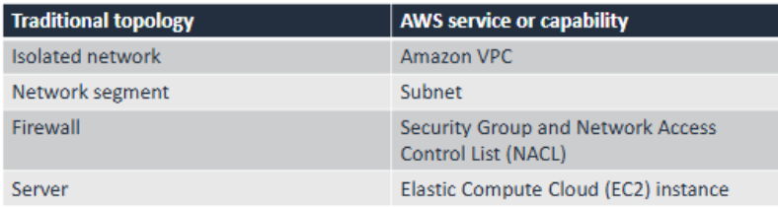

### Key Points

**Amazon VPC**: Like an isolated network, providing a private environment within AWS where you can create your own virtual architecture.

**Subnet**: A network segment within a VPC, helping separate different parts of a network.

**Security Groups and NACLs**: These act like firewalls. Security Groups control traffic to individual instances, while NACLs control traffic for entire subnets.

**EC2 Instance**: Similar to servers in a data center; used to run applications and services within your VPC.

Comparing LAN/WAN and Amazon VPC

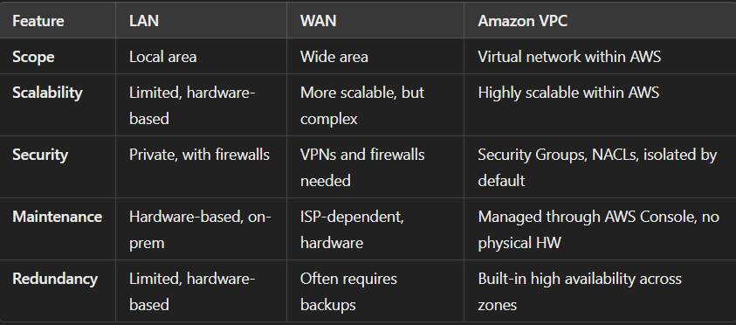

Network management

A network management model is a representation of how data is managed and how applications are hosted in a network

The two most common models for LAN are:

* Client -server
* Peer to peer

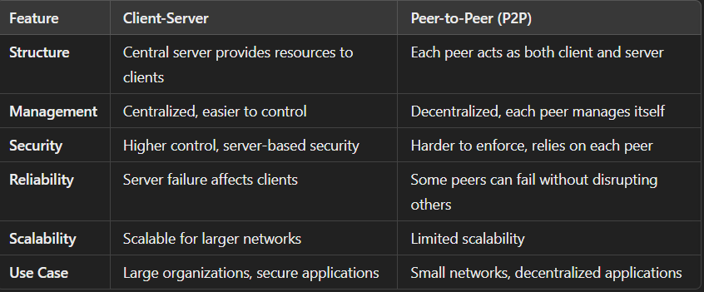

**Network protocols**

* **Tcp (Transmission Control Protocol)**
* **Udp (User Datagram Protocol)**

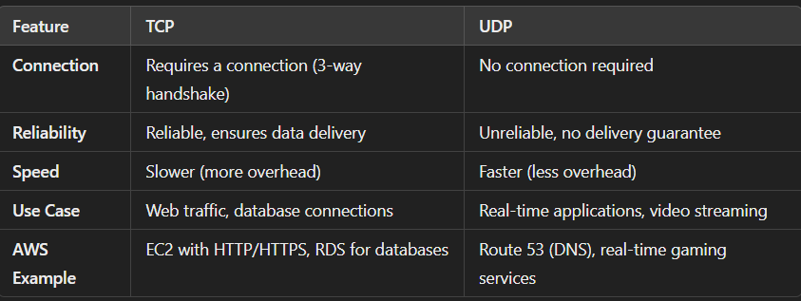

* Uses IP addresses to identify devices.
* Uses port numbers to identify endpoints.
* Supports subnetting to subdivide a network**.**

**IP addresses**:

Ip addresses will work on the 3 layers in the OSI model and are used to identify a host and network

* It can be assigned in a dynamic and static way
* Can be made in public and private
* Public can be accessed over the internet
* Private IP address can not accessed on the internet

**Private and public IP addresses -OSI model**

Issues that can happen with IP addresses (layer 3)