**CS424 Compiler Construction**

Assignment 1

2020256

Muhammad Abdullah

**Design and Implement a Scanner for “MiniLang”**

First of all, the following rules were defined in the **minilang.l** lex file according to the MiniLang’s language specifications:

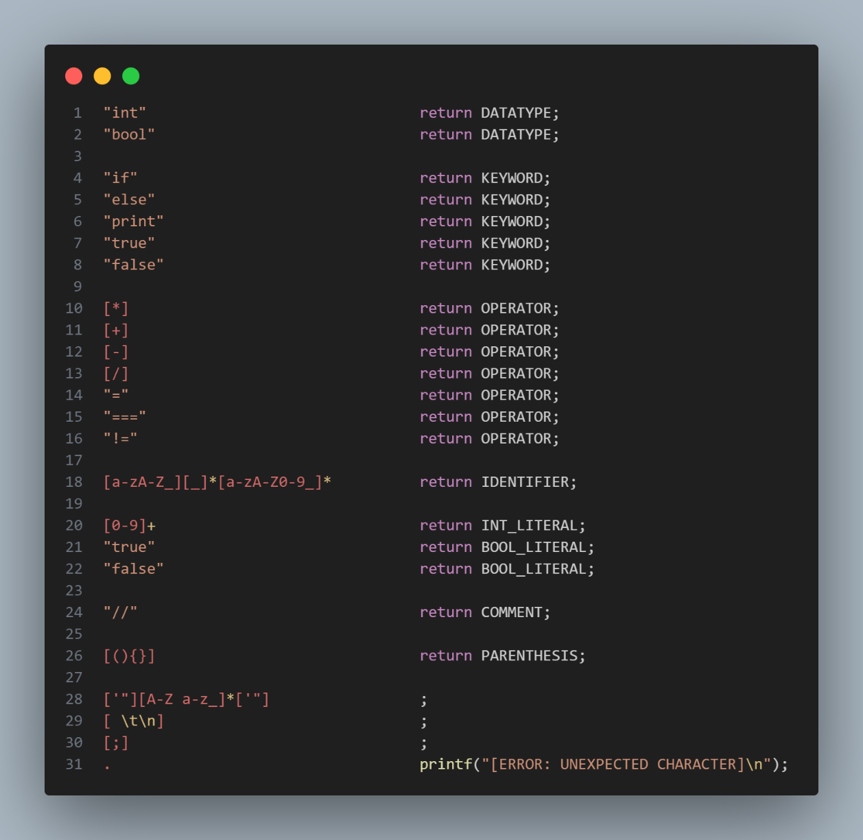

In case of a match, a specifier indicating the token type is returned while in the case of a lexical error, an error message is printed to the console.

**Finite State Machine**

The finite state machine was implemented in **minilang.c** file using C, it keeps reading the tokens from the input file according to the rules of MiniLang.

The finite state machine checks what token type was returned and prints its name along with the token.

All token types are stored in a separate header file called **minilang.h**.

**Sample input provided:**

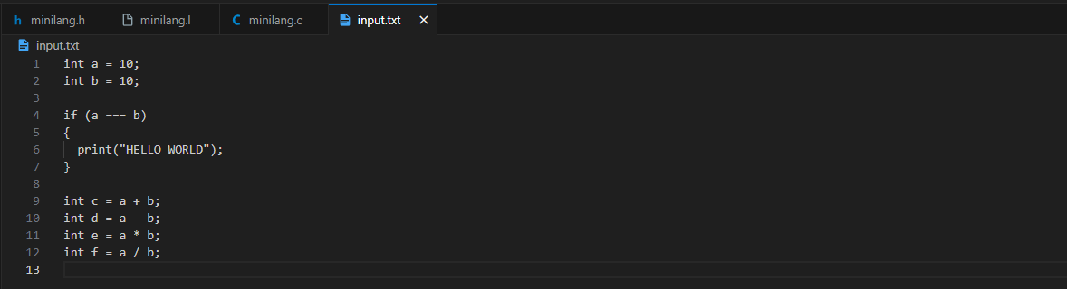

**Output corresponding to the above input:**

