Superstore Sales Analysis – Executive Report

  - Prepared by
M. Abdullah Khalil

- Linkedin Profile: Abdullah Khalil
- Github Repo: github.com
- Date: 07-07-2026
- Dataset: Tableau Superstore Sample Dataset

Executive Summary
This report analyzes sales and profitability trends using Pivot Tables in Excel. Key findings include:
- West Region is the best performing region.
- Several states are underperforming.
- Technology category generates the highest revenue and profit.
- 301 products are loss-making, creating a total loss of $77,068.
- Consumer Segment is the most valuable.
- Peak sales occur in November and December.
- Discounts above 30% reduce profitability.
- Future investment should focus on West Region, Technology products, and Consumer Segment.

Business Questions, Findings & Recommendations
1. Which region is performing best?
- Finding: West Region generates the highest sales.
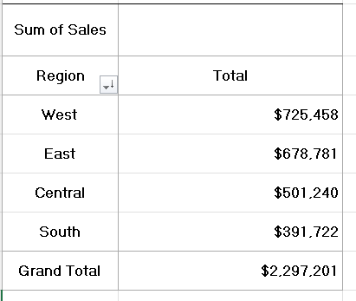
- Recommendation: Increase marketing investment in the West Region.

2. Which state is Best performing?
- Finding: States like California and New York show highest revenue.
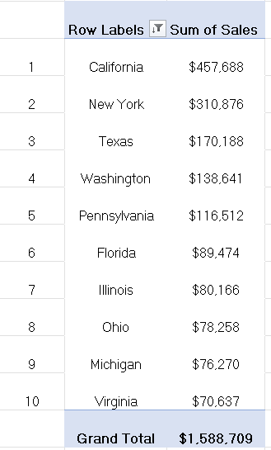
- Recommendation: These states should be more focused for increasing sales.

3. Which category generates the highest revenue?
- Finding: Technology category.
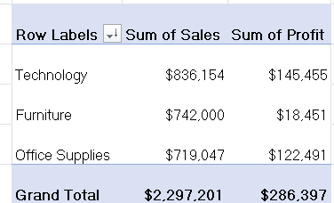
- Recommendation: Focus product strategy on Technology for growth.

4. Which category generates the highest profit?
- Finding: Technology category.

- Recommendation: Continue investing in Technology products to maximize margins.

5. Which products should be discontinued due to losses?
- Finding: 301 products with negative profit, total loss $77,068.
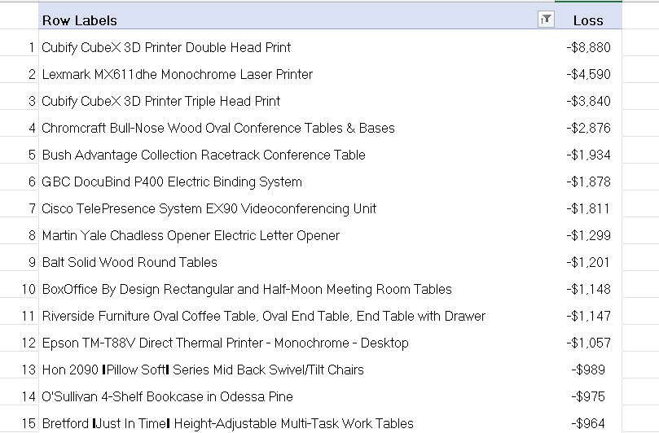
Top 15 products with highest loss

- Recommendation: Discontinue or re-price loss-making products.

6. Which customer segment is the most valuable?
- Finding: Consumer Segment generates the highest revenue and Profit.
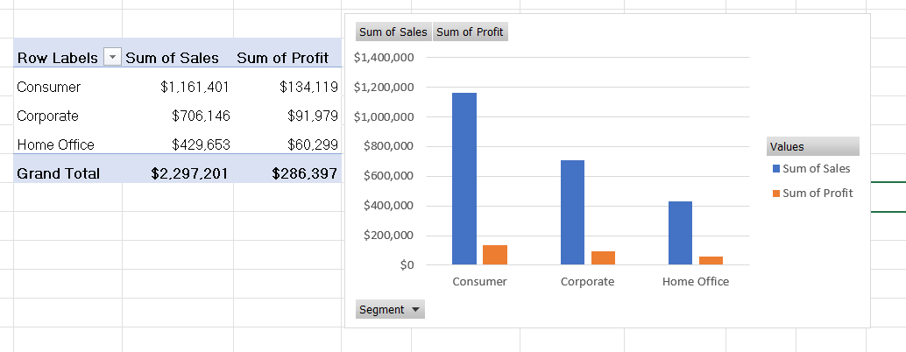
- Recommendation: Target Consumer Segment with marketing campaigns.

7. Which months have peak sales?
- Finding: November and December.
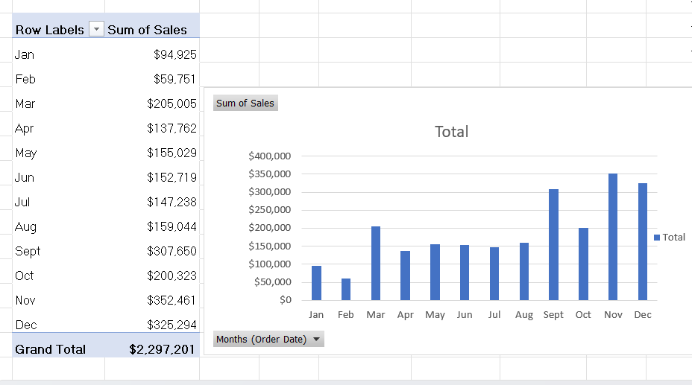
- Recommendation: Plan inventory and promotions around peak months.

8. Should the company continue offering large discounts?
- Finding: Discounts >30% reduce profitability.
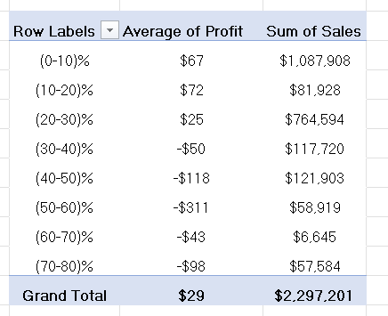
- Recommendation: Limit discounts to below 30%.

9. Where should the company focus future investment?
- Finding: West Region, Technology products, Consumer Segment.
- Recommendation: Allocate resources to these areas for sustainable growth.

Executive Dashboard
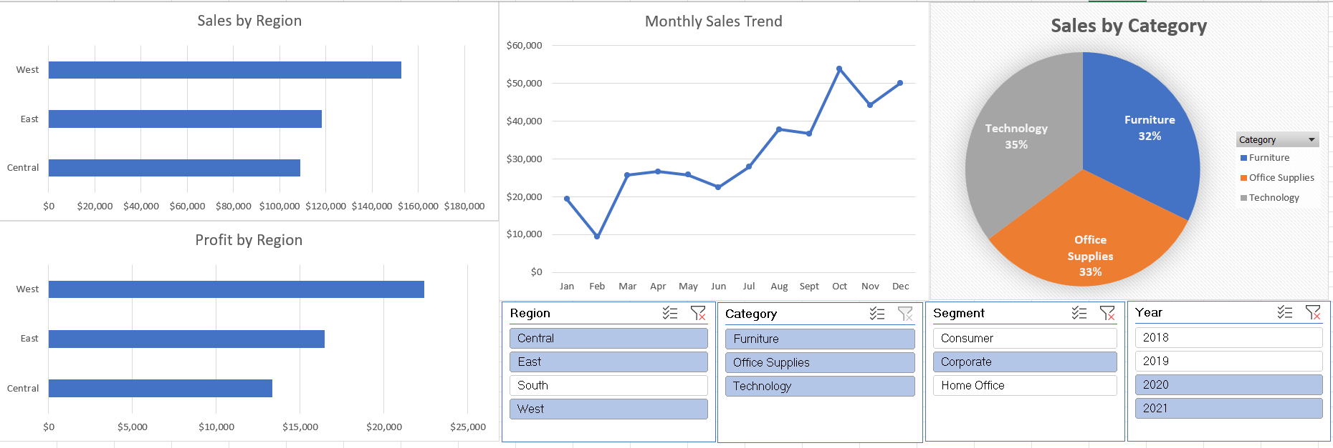
This interactive dashboard integrates multiple Pivot Tables and Charts with slicers for Region, Category, Segment, and Year. It provides interactive insights for management.

Conclusion
This analysis demonstrates how Pivot Tables can answer real business questions. Recommendations:
- Invest in West Region and Technology products.
- Reduce high discounts.
- Discontinue loss-making products.
- Focus marketing on Consumer Segment.
- Align promotions with peak months.

Skills Demonstrated
- Pivot Tables & Pivot Charts
- Sorting, Filtering, Top/Bottom analysis
- Date grouping (Month, Quarter, Year)
- Slicers & interactive dashboards
- Business storytelling with data

