Executive Retail Sales Analysis Using Excel Charts

  - Prepared by
M. Abdullah Khalil
Aspiring eCommerce Data Analyst

- Linkedin Profile: Abdullah Khalil
- Github Repo: github.com
- Tool: Microsoft Excel
- Analysis Type: Sales Performance & Business Intelligence Dashboard
- Dataset: Tableau Superstore Sample Dataset (USA Retail Sample)
- Date: 31-07-2026

1. Executive Summary
This report analyzes the sales performance of a US retail business using Microsoft Excel. Interactive charts were developed to evaluate regional performance, product categories, customer segments, customer value, shipping efficiency, seasonal sales trends, and the relationship between discounts and profitability.
The analysis identified the West region as the strongest-performing market and Technology as the highest-performing product category. Sales increased significantly during November and December, suggesting strong seasonal demand. The Consumer customer segment contributed the highest revenue, while several high-discount orders produced negative profits.
Based on these findings, the company should strengthen investment in high-performing markets, optimize discount policies, and expand customer retention initiatives for its highest-value customers.

2. Project Objective
The objective of this project was to transform raw retail transaction data into business insights through professional Excel charts and dashboards. The analysis aims to support management in making informed decisions regarding sales growth, profitability, customer strategy, and operational efficiency.

3. Dataset Overview
Item | Details
Dataset | Tableau Sample Superstore
Market | United States
Records | 9,994 Orders
Tool | Microsoft Excel
Analysis | Charts & Dashboard

4. Key Findings

A. Regional Performance
Which region generates the highest sales?

Finding

West Region generated highest sales.

B. Category Performance
Which product category performs best?

Finding

The Technology category generated both the highest sales and the highest profit.

C. Monthly Sales Trend
Which months produce the highest revenue?

Finding

Sales peaked during last four months, indicating strong seasonal demand.

D. Customer Analysis
Which customers generate the highest sales?

Finding

E. Customer Segment
Which customer segment contributes the most revenue?

Finding

The Consumer segment contributed the highest 50% of overall revenue.

F. Discount Analysis
Do higher discounts reduce profitability?

Finding

Orders with discounts above 30% frequently generated lower or negative profits.

G. Shipping Performance
How efficient is the shipping process?

Finding

Most orders were delivered within the expected shipping period, with only a limited number of delayed shipments.

5. Executive Dashboard
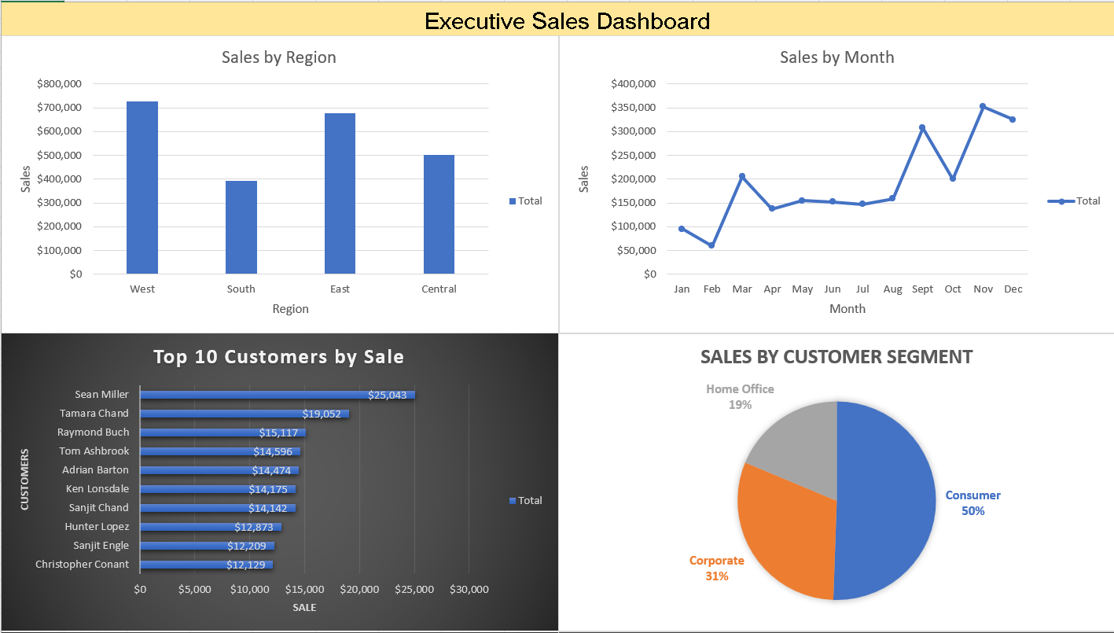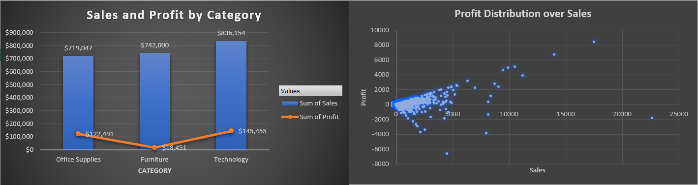

6. Business Recommendations
- Increase investment in the West region and continue expanding the Technology product category, as both consistently deliver strong sales and profits.
- Review and optimize discount policies, particularly for discounts exceeding 30%, to improve profitability while maintaining customer competitiveness.
- Develop customer loyalty initiatives targeting the highest-value customers to encourage repeat purchases and long-term retention.
- Prepare inventory and promotional campaigns ahead of last four months to capitalize on seasonal demand.
- Monitor shipping delays through operational dashboards and investigate orders that exceed the expected delivery timeframe.

7. Business Value
This analysis demonstrates how Excel can transform raw transactional data into actionable business insights. The dashboard enables executives to identify growth opportunities, monitor profitability, evaluate customer behavior, and support strategic decision-making through clear visual reporting.

8. Conclusion
This project highlights the use of Microsoft Excel as a business intelligence tool for retail analytics. By combining data visualization with business interpretation, the analysis provides meaningful insights into sales performance, customer behavior, operational efficiency, and profitability. The resulting dashboard offers decision-makers a concise view of key performance indicators and supports data-driven strategic planning.

