Retail Sales Analysis with Excel Conditional Formatting

  - Prepared by
M. Abdullah Khalil
BS Data Science Student (Air University Multan)

- Linkedin Profile: Abdullah Khalil
- Github Repo: github.com
- Date: 27-07-2026
- Dataset: Tableau Superstore Sample Dataset (USA Retail Sample)

Executive Summary
This report demonstrates how Microsoft Excel's Conditional Formatting can be used to transform raw retail sales data into an interactive and decision-oriented reporting system. Using the Tableau Sample Superstore dataset, I developed fifteen business scenarios that simulate real-world analytical tasks performed by retail data analysts.
The project applies visual formatting techniques to identify high-value sales, financial risks, operational delays, customer performance, regional trends, and data quality issues. Rather than manually scanning thousands of transactions, Conditional Formatting enables managers to identify critical insights instantly through automated visual indicators.
The final deliverable includes an executive dashboard that combines multiple Conditional Formatting techniques into a single management report, illustrating how Excel can support faster business decisions without requiring advanced BI tools.

Business Context
Retail organizations generate thousands of sales transactions every year. Identifying profitable products, risky discounts, operational delays, duplicate records, and high-performing customers through manual inspection is time-consuming and prone to error.
Business leaders require reporting tools that immediately highlight important information, allowing them to focus on opportunities and risks rather than searching through raw data.
This project demonstrates how Excel's Conditional Formatting can convert raw transactional data into an intuitive visual reporting system that supports faster and more informed decision-making.

Business Objectives
- Highlight high-value sales transactions.
- Detect loss-making orders.
- Identify pricing risks caused by excessive discounts.
- Compare regional sales performance.
- Monitor monthly sales trends.
- Classify products based on profitability.
- Detect duplicate records.
- Identify missing customer information.
- Monitor shipping performance.
- Recognize high-value customers.
- Compare sales and profit against business benchmarks.
- Build dynamic reports using formula-based formatting.
- Develop an executive dashboard for management reporting.

Methodology
- Imported the Tableau Sample Superstore dataset into Microsoft Excel.
- Reviewed the dataset for data quality issues.
- Applied Conditional Formatting rules to solve business-specific problems.
- Used formula-based formatting where standard rules were insufficient.
- Built summary tables for sales, customers, and regional performance.
- Combined multiple formatting techniques into an executive dashboard designed for business users.

5. Business Problems Solved

Sales Performance
High-value orders contribute significantly to total revenue and should receive priority attention for customer retention and premium service.

Which orders generated the highest sales?

Answer

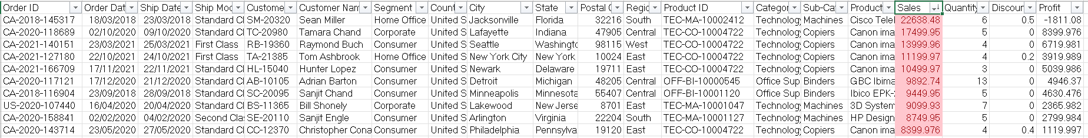

Financial Risk Monitoring
Conditional Formatting enables rapid identification of transactions that reduce profitability, allowing management to review pricing strategies and promotional activities.

Which orders are losing money?
Answer
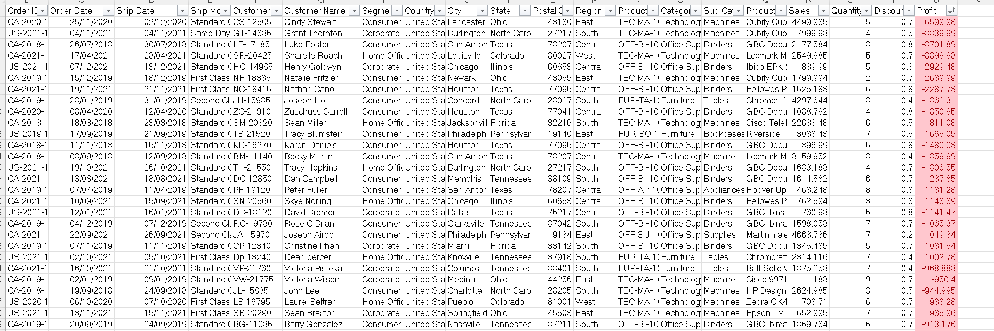
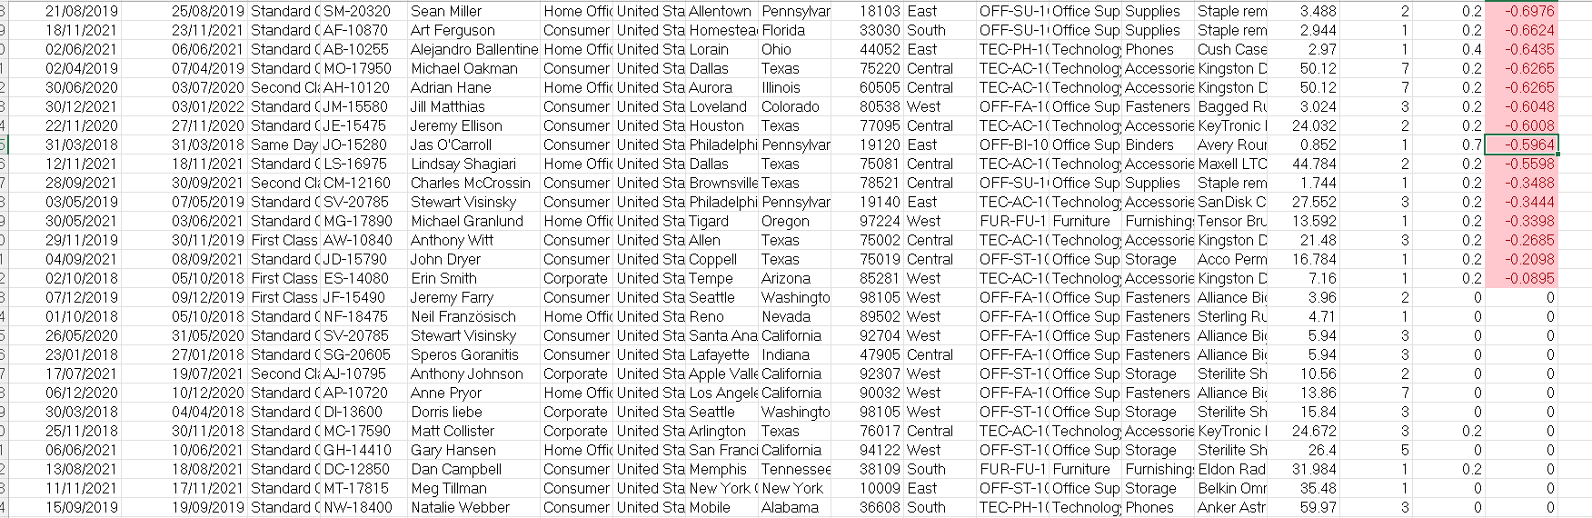

Which orders have unusually high discounts greater than 30%?
Answer
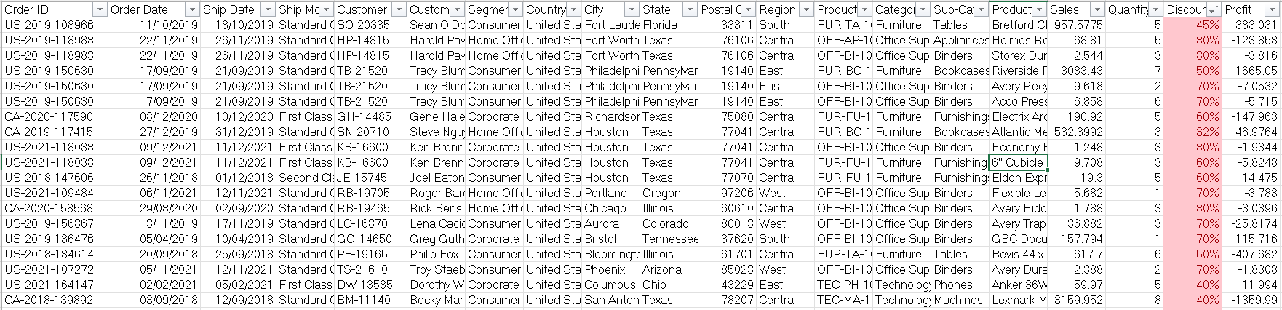
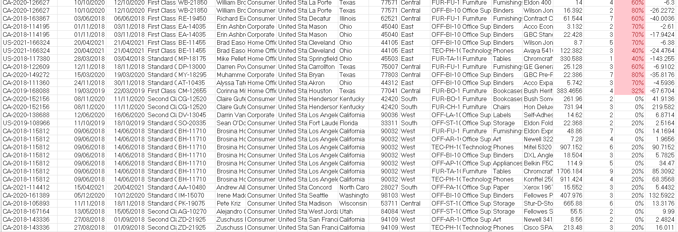

Regional Performance
West and East regions generated the strongest sales performance, making them potential candidates for future investment and expansion.
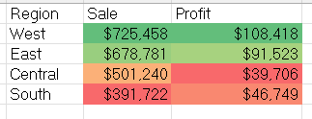

Sales Trend Analysis
Sales activity peaks during November and December, suggesting strong seasonal demand during the holiday period.
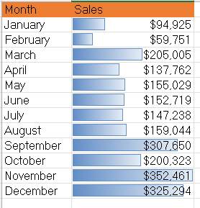

Product Profitability
Visual categorization enables managers to quickly distinguish between profitable, average-performing, and loss-making products.
- Profit > 500 → Green
- 0–500 → Yellow
- <0 → Red
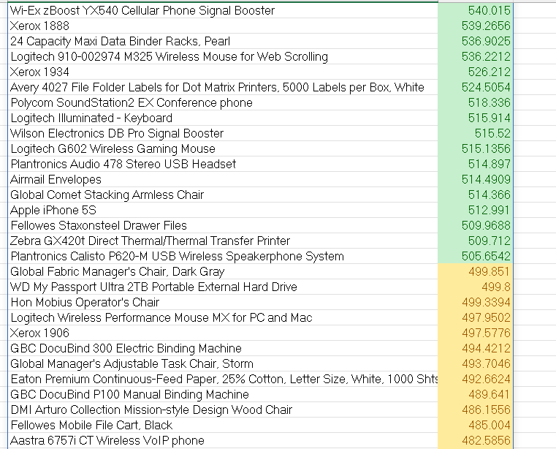

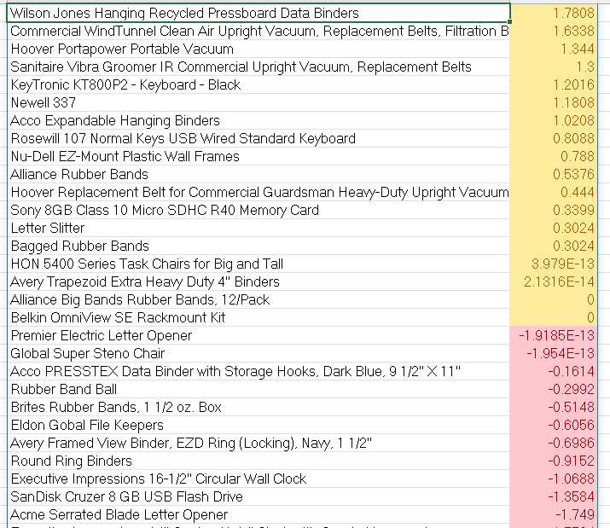

F. Data Quality Assessment
Data quality validation is essential for producing reliable business reports. Duplicate records and missing values should be investigated before analysis.

Are there duplicate Order IDs?
Answer
Yes, there are many duplicate Order IDs.
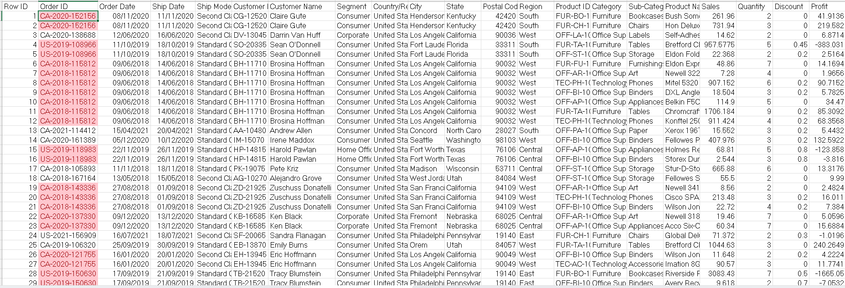

ii. Are any important fields blank of Customer’s Information?
Answer
Not an important, but one order's postal code is missing.
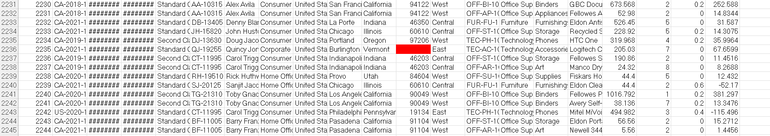

G. Operational Performance
Shipping delays can negatively impact customer satisfaction and should be monitored continuously to improve operational efficiency.
- Orders requiring more than five days for delivery were highlighted.
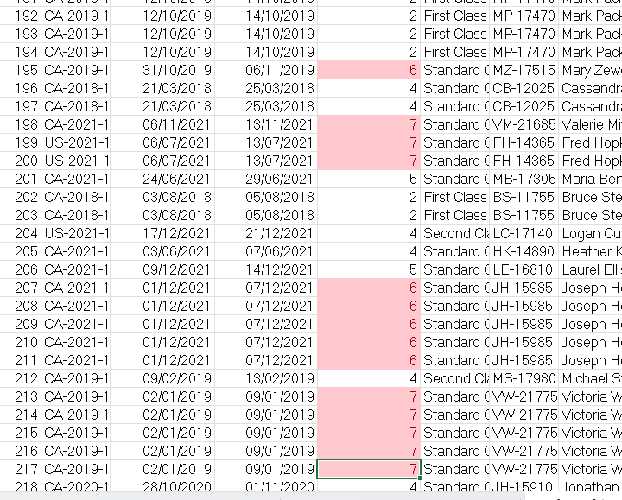

H. Customer Analysis
Identifying high-value customers enables businesses to develop targeted retention strategies and personalized marketing campaigns.
- Top 20 customers according to sale are indentified.
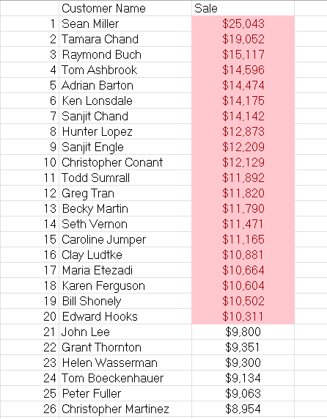

I. Dynamic Reporting
- Formula-based Conditional Formatting was used to create an interactive regional filter and highlight weekend orders.
- Dynamic reports improve user experience by allowing managers to focus on specific regions or operational scenarios without modifying the underlying dataset.

i. Highlight all rows for a selected region.
Answer
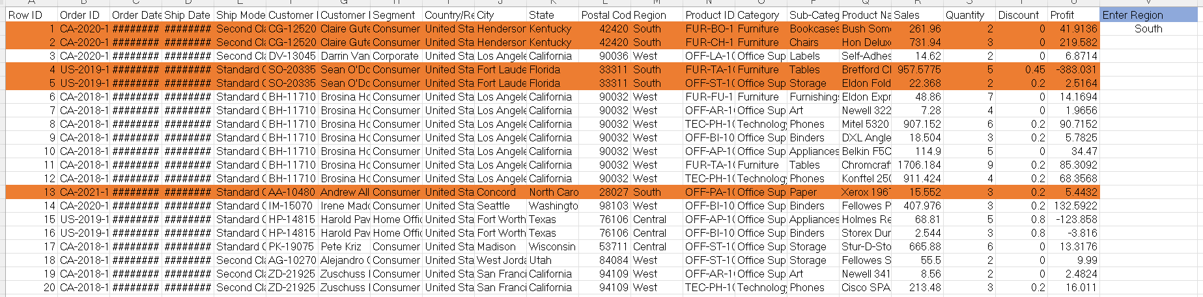
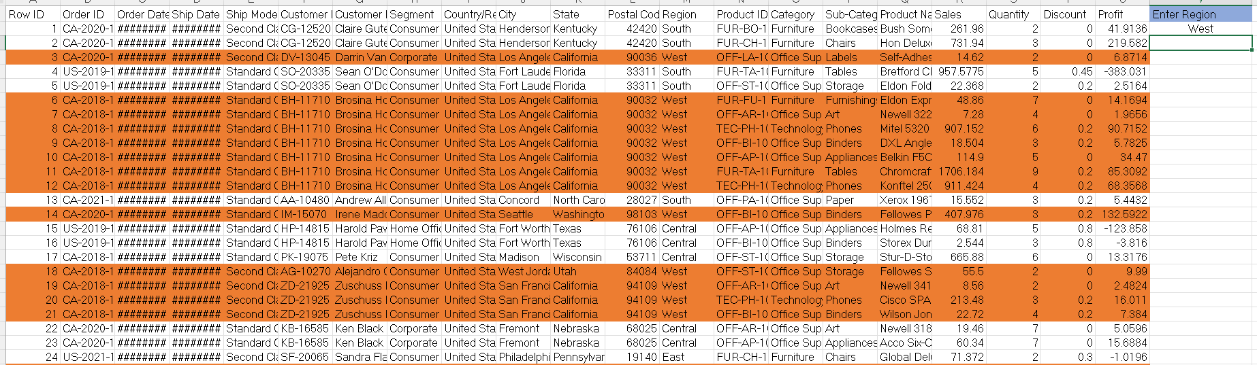

ii. Were any orders placed on weekends?
- Highlight rows where the Order Date falls on Saturday or Sunday.
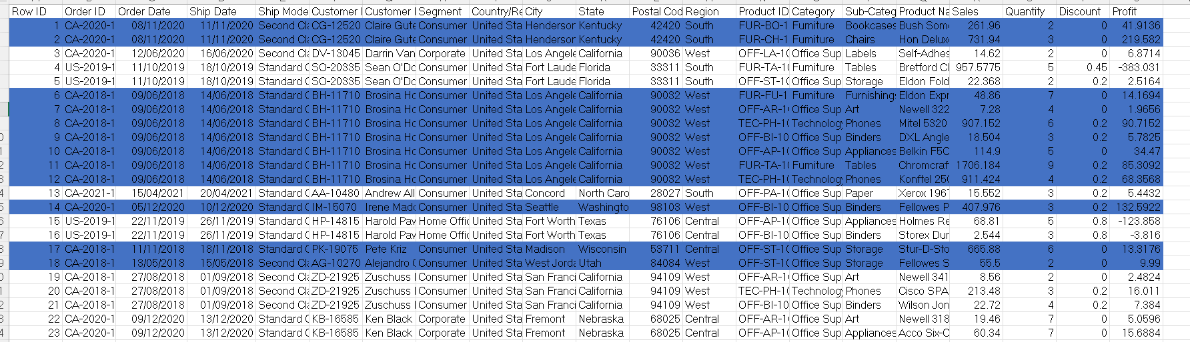

J. Executive Dashboard
The dashboard provides management with an immediate overview of business performance, highlighting opportunities, risks, and operational issues through visual indicators rather than complex reports.
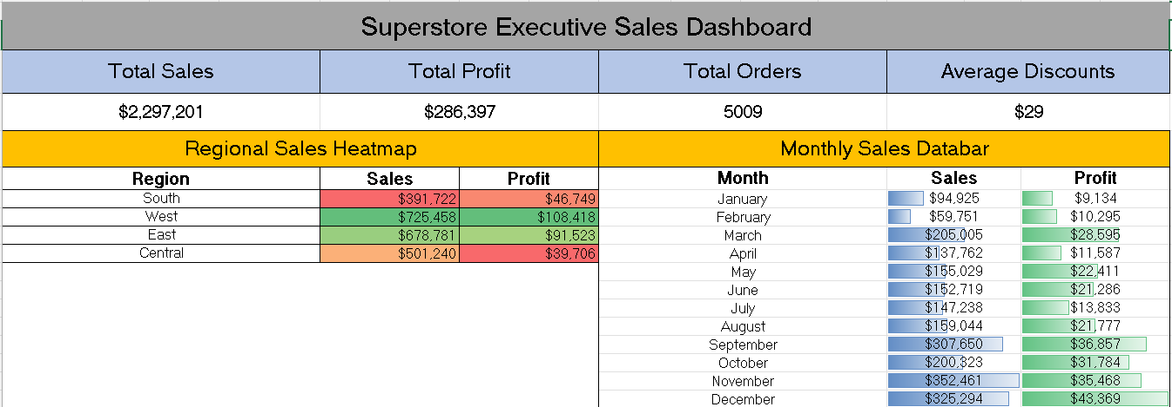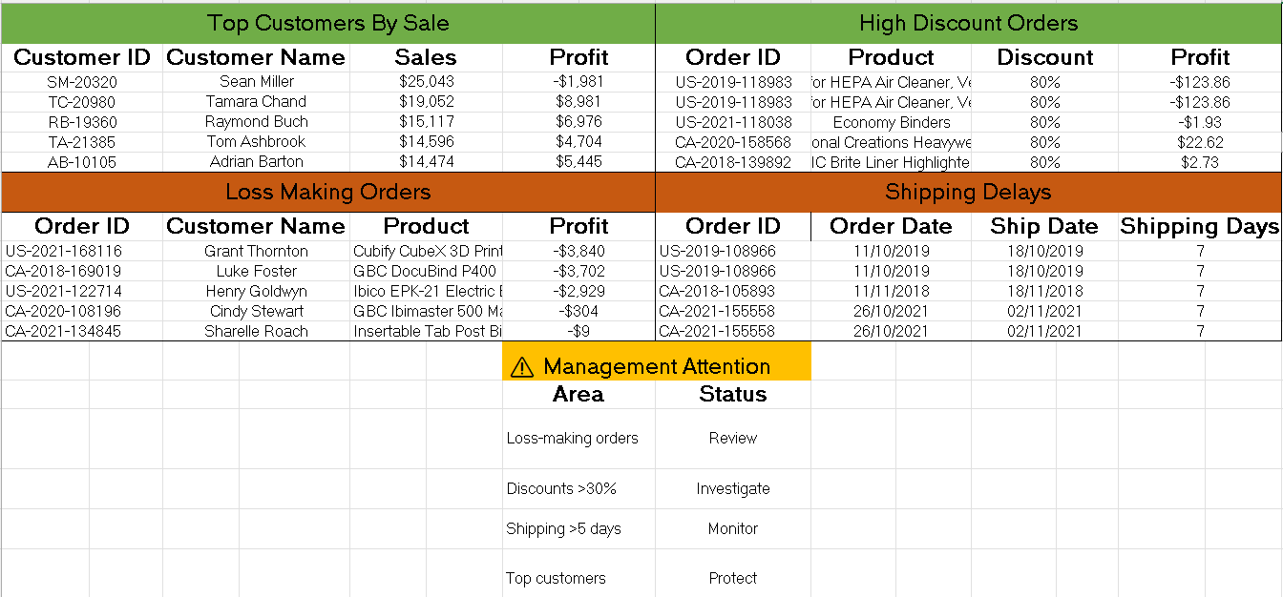

6. Key Findings
- West and East regions achieved the highest sales performance.
- November and December recorded the strongest monthly sales.
- Several orders generated financial losses despite completed sales.
- High discounts require careful monitoring to protect profit margins.
- Duplicate Order IDs emphasize the importance of understanding the dataset structure and validating data before analysis.
- Only one record contained missing postal code information, indicating generally good data quality.
- Formula-based Conditional Formatting can significantly improve report interactivity and usability.
- Executive dashboards become more effective when visual alerts direct attention to exceptions rather than displaying every transaction equally.

7. Skills Demonstrated
Business Skill | Excel Feature
Sales Performance Monitoring | Top/Bottom Rules
Financial Risk Detection | Formula-Based Rules
Regional Comparison | Color Scales
Trend Analysis | Data Bars
Customer Segmentation | Top Rules
Data Quality Validation | Duplicate & Blank Detection
Operational Monitoring | Date-Based Rules
Dynamic Reporting | Formula-Based Conditional Formatting
Executive Reporting | Dashboard Design

8. Business Recommendations
• Monitor high-discount transactions to ensure promotional activities remain profitable.
• Investigate recurring loss-making orders to identify pricing or operational issues.
• Continue investing in high-performing regions while evaluating strategies to improve weaker markets.
• Strengthen shipping performance monitoring to reduce delivery delays.
• Maintain regular data quality checks before reporting.
• Expand the use of Conditional Formatting to automate operational reporting and highlight business exceptions.

9. Conclusion
This project demonstrates how Microsoft Excel's Conditional Formatting can be used as a practical business intelligence technique rather than simply a formatting tool. By applying visual rules to realistic retail business scenarios, the analysis transformed raw sales data into an interactive reporting system capable of highlighting opportunities, risks, and operational performance. The resulting executive dashboard illustrates how effective visual reporting can support faster and more informed business decisions.

