Solving Retail Business Problems Using Excel XLOOKUP
  - Using Microsoft Excel to Build Dynamic Lookup Systems for Retail Business Analysis

  - Prepared by
M. Abdullah Khalil
BS Data Science Student (Air University Multan)

- Linkedin Profile: Abdullah Khalil
- Github Repo: github.com
- Date: 21-07-2026
- Dataset: Tableau Superstore Sample Dataset (USA Retail Sample)

Executive Summary
This report demonstrates how Microsoft Excel's XLOOKUP function can be applied to solve common business problems using the Tableau Sample Superstore retail dataset. Rather than treating XLOOKUP as a standalone Excel function, the project focuses on practical scenarios that analysts encounter when working with customer, product, regional, and sales data.
The analysis covers customer information retrieval, product classification, regional performance tracking, sales target comparison, customer profiling, price lookup, and dynamic reporting. Additional reference tables were created where necessary to simulate realistic business environments in which transactional sales data is combined with master data such as regional managers, pricing lists, and sales targets.
Through these business scenarios, the project demonstrates how XLOOKUP can automate data retrieval, reduce manual effort, improve reporting accuracy, and support faster decision-making. The exercises also compare XLOOKUP with VLOOKUP to highlight the advantages of modern Excel functions when building scalable business reports and dashboards.

Business Context
A retail company manages thousands of customer orders across multiple U.S. regions. Different departments—including Sales, Customer Service, HR, Finance, and Operations—require quick access to customer, product, and regional information. Manually searching these records is inefficient and prone to errors. This project demonstrates how XLOOKUP can automate these business processes.

Business Objectives
- Retrieve customer information instantly.
- Classify products automatically.
- Build customer profiles.
- Compare regional sales with targets.
- Monitor regional performance.
- Retrieve management information.
- Build dynamic lookup reports.
- Compare traditional and modern lookup methods.

Methodology
Step | Description
Data Source | Tableau Sample Superstore
Data Preparation | Created supporting lookup tables where needed
Lookup Engine | XLOOKUP
Conditional Analysis | SUMIF / SUMIFS
Validation | Exact Match
Dynamic Reporting | Nested XLOOKUP

Note: The Tableau Sample Superstore dataset was used as the primary transactional dataset. To simulate real-world business environments, additional reference tables (Regional Targets, Product Price List, Customer Master, and Regional Managers) were created with sample data to demonstrate advanced XLOOKUP scenarios commonly used in business reporting.

Business Problems Solved

Customer Information Management
Customer information can be retrieved instantly using a single Customer ID or Order ID, reducing manual searching and improving customer support efficiency.

Find the customer’s name for a given Order ID.
Answer
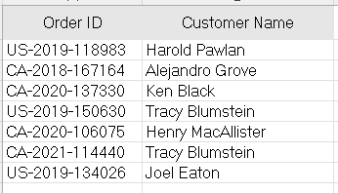

HR wants to know the customer's Segment and Region using Customer ID.
Return:
- Customer Name
- Segment
- Region
Answer
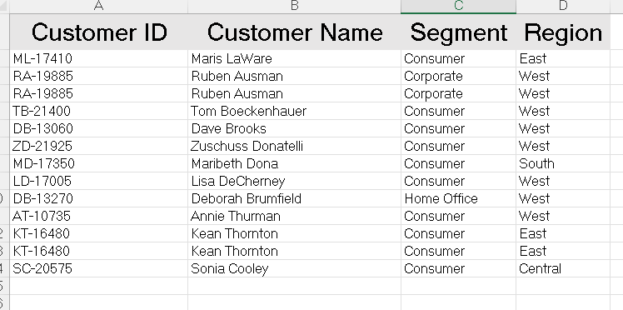

Retrive Customer Contact Details
Create a customer table:
| Customer ID | Name |Phone | Email |
Return:
- Customer Name
- Phone
- Email
- using Customer ID.
Answer
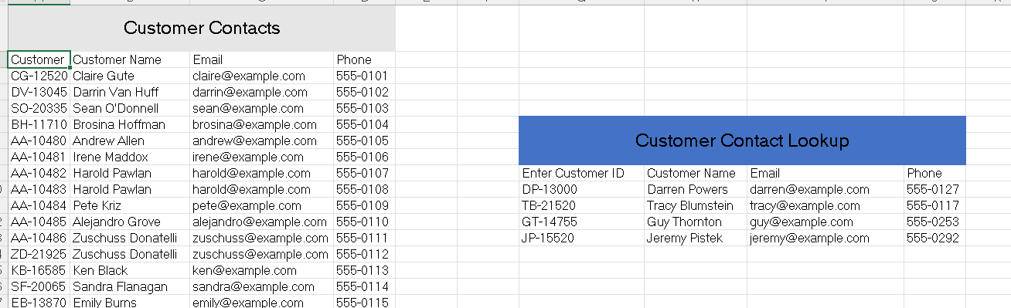

Find Total Sale for a Selected Customer
The CEO wants total sales for a selected customer.
If a customer has multiple orders, use a lookup to identify the customer or category and then aggregate the relevant sales (or use XLOOKUP to retrieve criteria from a helper table and combine it with SUMIF/SUMIFS).

Answer
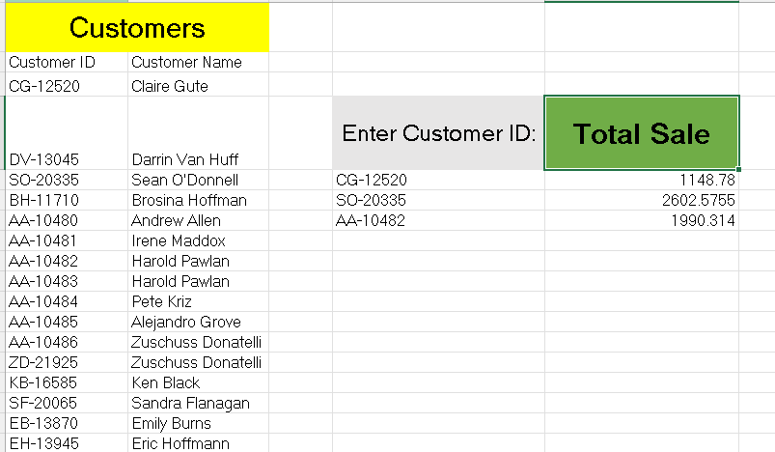

Product Information Management
Product categories and pricing can be retrieved dynamically from centralized reference tables, reducing inconsistencies and manual errors.

Return Product Category and Sub-Category by it’s name
Answer
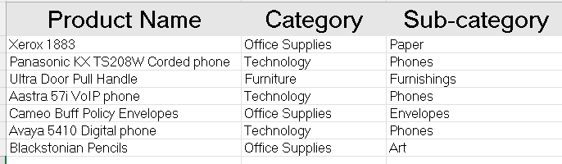

Return Product Price from List
Create:
| Product | Standard Price |
Return product price from the price list.

Answer
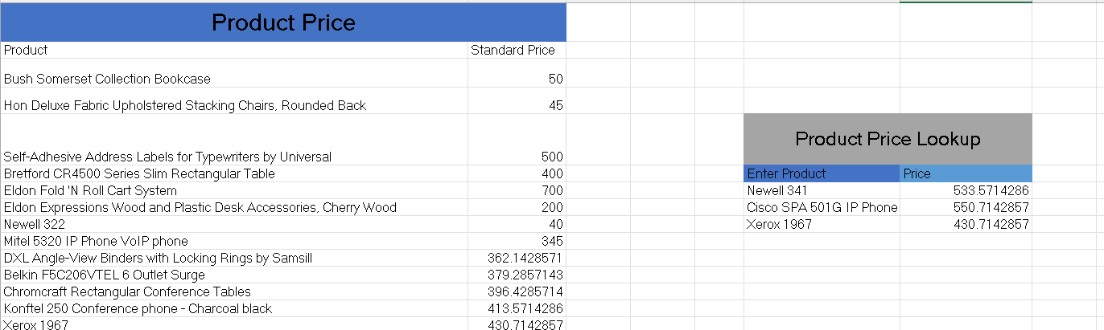

Sales Performance Monitoring
XLOOKUP was combined with aggregation formulas to compare actual sales against targets, calculate variances, and summarize customer sales.

Return the target for a selected region
Managers have regional sales targets. Use XLOOKUP to return the target for a selected region.
Answer
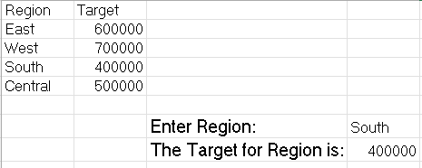

Find Regional Performance
Compare:
Actual Sales vs Target Sales
Calculate:
Variance = Actual – Target
Answer
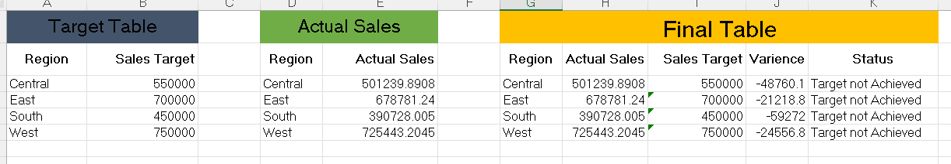

Find Sales + Target for selected Region
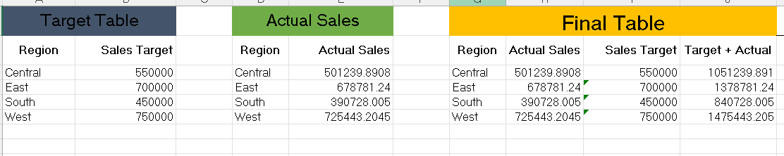

Find Total Sale for a Selected Customer
The CEO wants total sales for a selected customer.
If a customer has multiple orders, use a lookup to identify the customer or category and then aggregate the relevant sales (or use XLOOKUP to retrieve criteria from a helper table and combine it with SUMIF/SUMIFS).

Answer


Lookup Accuracy
Exact-match lookups reduce reporting errors caused by incorrect inputs. The comparison with VLOOKUP demonstrates why XLOOKUP provides greater flexibility for modern business reporting.

Find Exact Match
A manager accidentally types:
Californi instead of California
Your formula should not return an incorrect value.
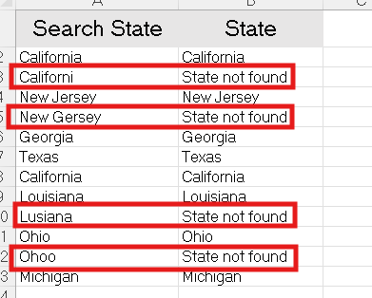

XLOOKUP vs VLOOKUP
Find the Customer Name using Customer ID.
Solve it with:
- XLOOKUP
- VLOOKUP
Answer
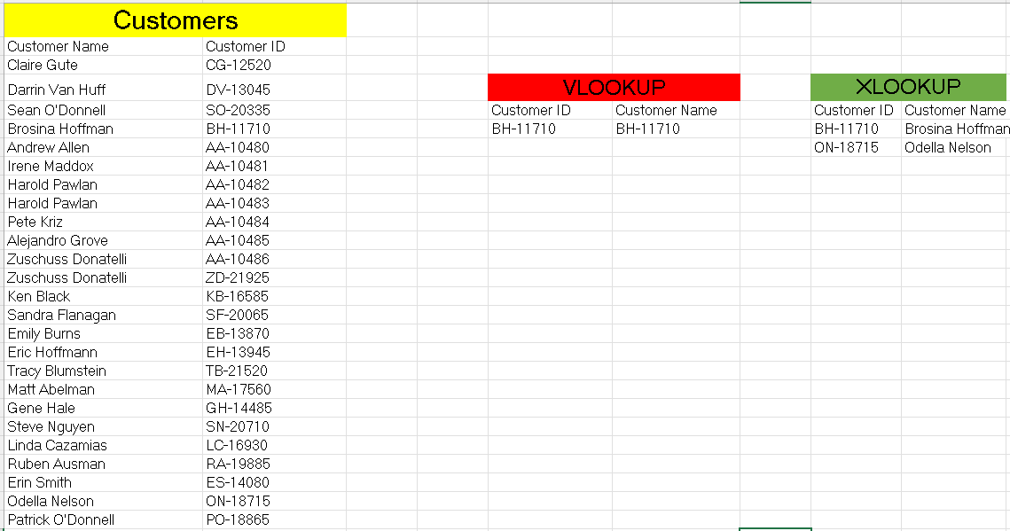

Time-Based Reporting
Search-order and horizontal lookup capabilities enable analysts to retrieve first or latest transactions and access KPI values stored across columns.

Find Latest Order Details
One customer has placed many orders.
Management wants to know:
What was the customer's most recent order?
Answer
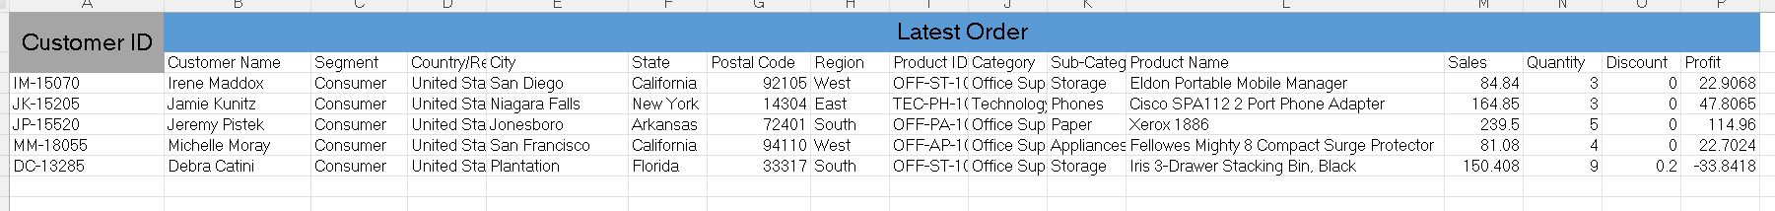

Find First Order Details
One customer has placed many orders.
Management wants to know:
What was the customer's most first order?
Answer
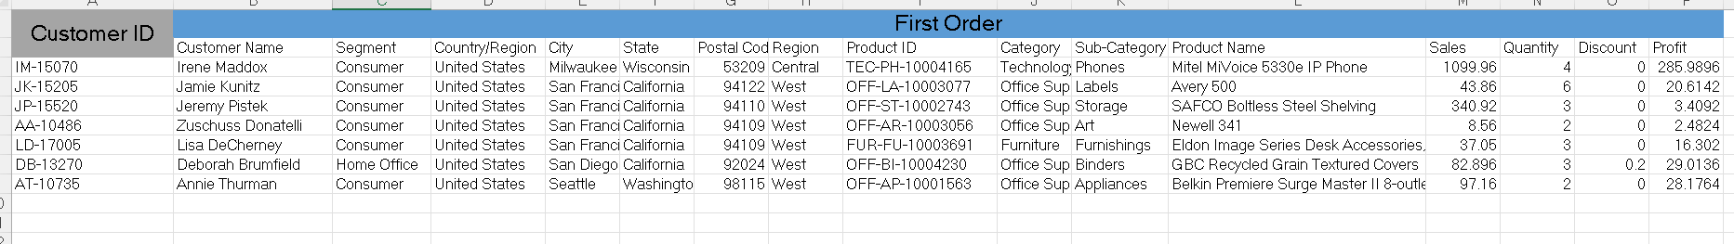

Find Sales for all Months in a Row
Answer
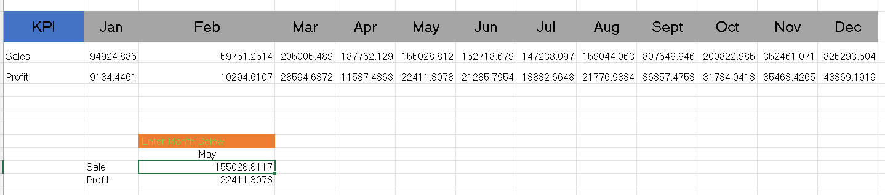

Key Business Outcomes
- Automated customer lookup.
- Automated product classification.
- Built reusable lookup tables.
- Created regional performance reports.
- Compared sales with targets.
- Reduced manual search effort.
- Improved reporting accuracy.

Skills Demonstrated
Business Skill | Excel Technique
Data Retrieval | XLOOKUP
Multiple Field Lookup | XLOOKUP
Lookup Validation | Exact Match
Horizontal Reporting | Horizontal XLOOKUP
Performance Reporting | XLOOKUP + SUMIFS
Business Analysis | Variance Calculation
Master Data Integration | Reference Tables
Legacy Comparison | VLOOKUP vs XLOOKUP

Business Recommendations
- Maintain centralized reference tables for products, customers, and regional managers.
- Replace repetitive manual searches with XLOOKUP-based reports.
- Use lookup-driven dashboards for operational reporting.
- Standardize master data to improve reporting accuracy.
- Adopt XLOOKUP instead of VLOOKUP in new Excel solutions.

Conclusion
This project demonstrates how Excel can be used not only as a spreadsheet application but also as a business analysis tool. By applying XLOOKUP to realistic retail scenarios, the analysis shows how analysts can automate data retrieval, integrate multiple datasets, improve reporting efficiency, and support business decision-making.

