Retail Sales Analysis Using Microsoft Excel Formulas

  - Prepared by
M. Abdullah Khalil
BS Data Science Student (Air University Multan)

- Linkedin Profile: Abdullah Khalil
- Github Repo: github.com
- Date: 16-07-2026
- Dataset: Tableau Superstore Sample Dataset (USA Retail Sample)

1. Executive Summary
This report presents a business analysis of the Tableau Sample Superstore dataset using Microsoft Excel to demonstrate how spreadsheet functions can support data-driven decision-making in a retail business. The objective was to answer common business questions related to sales performance, profitability, customer behavior, regional performance, and operational efficiency by applying Excel formulas to real-world sales data.
The analysis focused on identifying key business metrics such as the highest and lowest sales orders, total company profit, regional and category revenue, customer segment performance, order volumes, and shipping efficiency. Data preparation techniques were also applied to standardize text, clean customer information, extract meaningful identifiers, and format dates for reporting purposes.
The analysis found that the West region generated $725,458 in total sales, making it the strongest-performing region. The Technology category produced $836,154 in revenue, highlighting it as the company's highest-revenue product category. The company generated an overall profit of $286,397 across 9,994 orders, while California recorded the highest number of customer orders with 2,001 transactions. Multi-condition analysis further showed that Technology products in the West region generated $251,992 in sales, demonstrating the value of combining multiple business dimensions when evaluating performance.
Beyond calculating business metrics, this project demonstrates how Microsoft Excel can be used to clean, organize, analyze, and summarize operational data into meaningful business insights. The techniques presented in this report can support managers in monitoring performance, identifying growth opportunities, improving reporting quality, and making informed business decisions based on reliable data.

2. Business Context
Superstore is a nationwide retailer operating across multiple U.S. regions. Management wants to evaluate sales performance, identify profitable areas, monitor logistics, and improve operational efficiency using Excel-based analysis.

3. Business Objectives
- Identify highest and lowest sales.
- Classify profitable and loss-making orders.
- Measure regional revenue.
- Evaluate technology sales.
- Analyze customer segments.
- Measure shipping performance.
- Monitor business days between order and shipment.

4. Methodology
Business Need | Excel Function
Find highest sale | MAX
Classify profits | IF
Segment sales | IFS
Extract codes | LEFT / RIGHT
Clean names | TRIM
Standardize names | SUBSTITUTE
Regional sales | SUMIF
Multi-condition sales | SUMIFS
Count orders | COUNTIFS
Shipping time | DAYS
Working days | NETWORKDAYS

5. Analysis & Findings

Highest & Lowest Sales
Business Question: Which orders generated the highest and lowest sales? Finding:
- Highest sale: $22,638.48 (Order ID CA-2018-145317)
- Lowest sale: $0.44 (Order ID US-2021-102288)
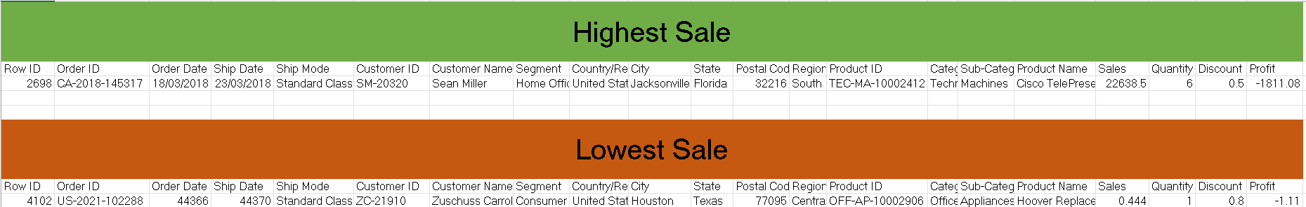
Business Insight: Identifying extreme values helps detect anomalies and highlight best-selling products.
Recommendation: Investigate extremely low-value orders for potential errors and promote high-value products.

Profit Classification
Business Question: How profitable are our orders?
Finding: Orders classified into Profit, Loss, Break Even categories.
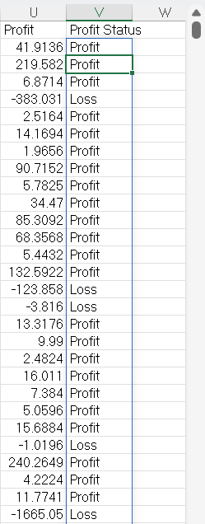
Business Insight: Quick classification enables management to monitor profitability at the transaction level.
Recommendation: Reduce loss-making orders by reviewing pricing and discount strategies.

Regional Revenue
Business Question: What is the total revenue generated in the West region?
Finding: West Region generated $725,458 in sales.

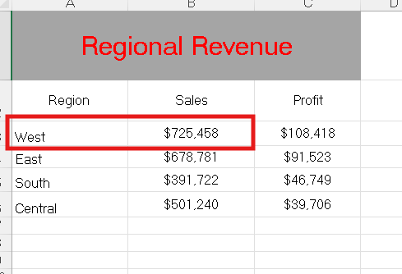
Business Insight: The West region is a strong revenue contributor.
Recommendation: Continue investing in marketing and operations in the West.

Technology Category Revenue
Business Question: How much revenue comes from Technology products?
Finding: Technology category generated $836,154 in sales.
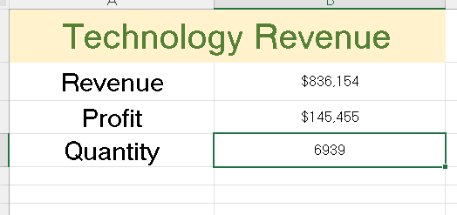
Business Insight: Technology is the highest-performing product line.
Recommendation: Expand Technology offerings and prioritize inventory for it.

Multi-Condition Sales
Business Question: What is the revenue for Technology products in the West region?
Finding: Combined sales = $251,992.
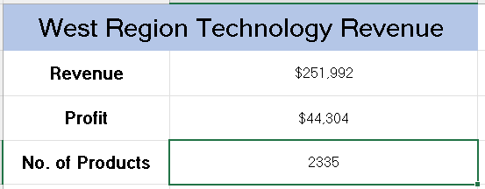
Business Insight: Targeted analysis shows strong demand for Technology in the West.
Recommendation: Launch region-specific promotions for Technology products.

California Orders
Business Question: How many orders came from California?
Finding: California generated 2,001 orders.
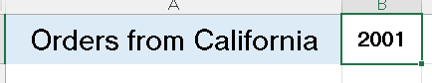
Business Insight: California is a high-volume state, critical for overall sales.
Recommendation: Strengthen logistics and customer engagement strategies in California.

Consumer Orders in West Region
Business Question: How many consumer segment orders were placed in the West region?
Finding: 1,672 orders.
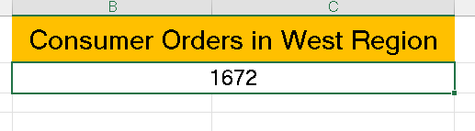
Business Insight: Consumer segment dominates demand in the West.
Recommendation: Focus marketing campaigns on consumer customers in this region.

Shipping Duration
Business Question: How long does shipping take?
Finding: Calculated shipping days and business days between order and delivery.
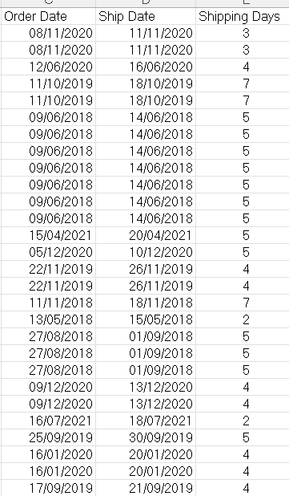
Business Insight: Shipping duration is a key metric for customer satisfaction and SLA monitoring.
Recommendation: Optimize logistics to reduce delivery times and improve efficiency.

Summary of Findings
- Highest order value reached $22,638.
- West region generated $725K in revenue.
- Technology category contributed $836K.
- Company profit totaled $286K.
- California produced 2,001 orders.
- Consumer customers dominated the West region.
- Shipping metrics provide visibility into delivery performance.

6. Business Recommendations
- Increase investment in high-performing regions.
- Expand Technology product line.
- Investigate extremely low-value orders.
- Monitor delivery performance with shipping metrics.
- Standardize product names before reporting.
- Build automated KPI dashboards for management.

7. Skills Demonstrated
- Data Preparation: TRIM, SUBSTITUTE, LEFT, RIGHT, LEN
- Business Logic: IF, IFS
- KPI Calculation: MAX, MIN, SUM, SUMIF, SUMIFS
- Reporting: COUNT, COUNTIF, COUNTIFS
- Logistics: DAYS, NETWORKDAYS

8. Conclusion
This project demonstrates how Microsoft Excel formulas can transform raw retail sales data into meaningful business insights. Beyond learning individual functions, the analysis focused on solving practical business problems related to revenue, profitability, customer behavior, and operations. The project reflects an analytical approach that can support data-driven decision-making in retail organizations.

