Shopify Orders Data Cleaning

  - Prepared by
M. Abdullah Khalil
Aspiring eCommerce Data Analyst

- Linkedin Profile: Abdullah Khalil
- Github Repo: github.com
- Tool: Microsoft Excel
- Analysis Type: Data Quality Audit & Cleaning
- Dataset: Shopify Orders Dataset
- Date: 19-08-2026

Executive Summary
This project focused on cleaning and validating a Shopify orders dataset before using it for business analysis. A structured, repeatable workflow was applied to audit, standardize, and correct the data so it could support reliable e-commerce reporting.
The cleaning process identified and resolved the following issues:
- 35 duplicate orders
- 121 missing customer emails
- Inconsistent country names and discount codes
- Non-standard order dates
- Currency values stored as text
- Negative quantities
- 10 incorrect order totals
- SKU inconsistency
- Statistical sales outliers

The final dataset was standardized, validated, and exported for further analysis.
Key Lesson
Data cleaning is not only about fixing errors; analysts must understand the business context before deciding whether a value is actually incorrect.

1. Project Objective

Goal
Prepare a Shopify orders dataset for reliable e-commerce reporting and analysis.

Objectives
- Identify data-quality problems
- Standardize inconsistent fields
- Validate financial calculations
- Remove duplicate and invalid records
- Investigate outliers
- Produce a clean, analysis-ready dataset

2. Dataset Overview
Item | Details
Dataset | Shopify Orders Dataset
Source | Kaggle
Data Type | E-commerce transaction data
Main Use | Sales & customer analysis
Tool | Microsoft Excel
Output | Cleaned dataset

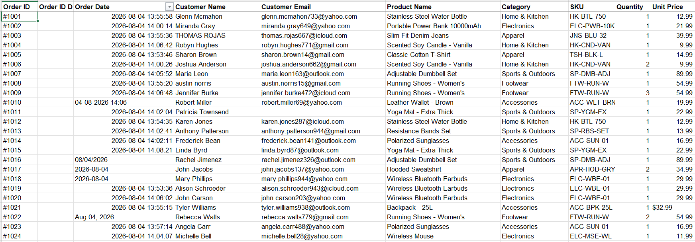

Figure 1 — Sample of the raw Shopify orders dataset.

3. Initial Data Quality Assessment
Before cleaning, the dataset was audited for:
- Missing values
- Duplicates
- Inconsistent text
- Invalid quantities
- Incorrect calculations
- Formatting problems
- SKU inconsistencies
- Outliers

Major Findings
Issue | Finding
Duplicate orders | 35
Missing emails | 121
Incorrect totals | 10
Unique discount codes | 5
SKU inconsistency | 1 product
Test orders | None identified

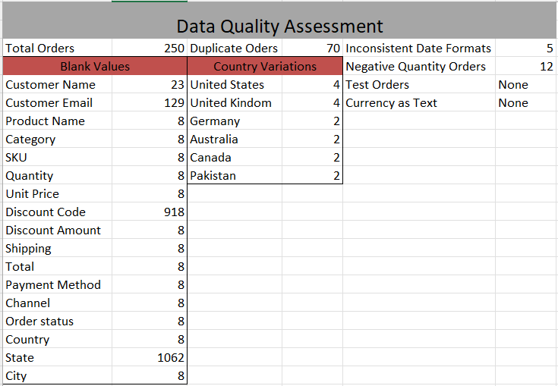

Figure 2 — Initial data-quality assessment of the Shopify dataset.

4. Cleaning Methodology
The cleaning workflow followed this sequence: Audit → Standardize → Validate → Correct → Remove → Investigate → Export

Main Cleaning Operations
- Standardized country names
- Evaluated missing state values
- Standardized order dates
- Identified missing customer emails
- Standardized discount codes
- Converted currency text to numbers
- Checked for test orders
- Removed duplicate orders
- Validated quantities
- Recalculated order totals
- Investigated outliers
- Validated SKUs

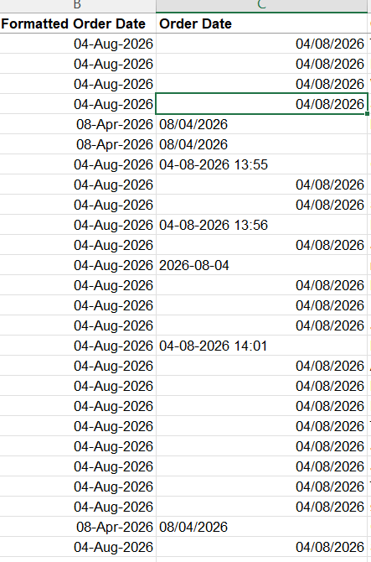

Figure 3 — Order dates standardized for time-based analysis.

5. Issues Identified and Resolved
Problem | Result
Duplicate orders | 35 removed
Missing emails | 121 identified
Country inconsistencies | Standardized
Date inconsistencies | Standardized
Currency stored as text | Converted
Negative quantities | Corrected
Incorrect order totals | 10 corrected
SKU inconsistency | 1 corrected
Test orders | None found

Important Cleaning Decisions
Missing States
Blank states were evaluated based on country context instead of being blindly filled.

Outliers
The IQR method flagged order totals above approximately $81.36, but high-value orders were investigated rather than automatically deleted.

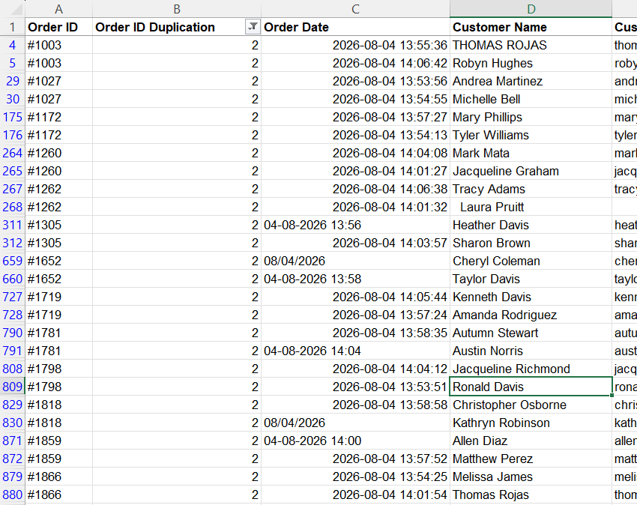
Before Cleaning Duplicate Orders

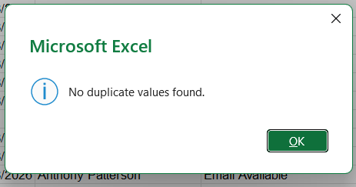
After Cleaning Duplicate Orders

Figure 4 — Duplicate orders identified and removed.

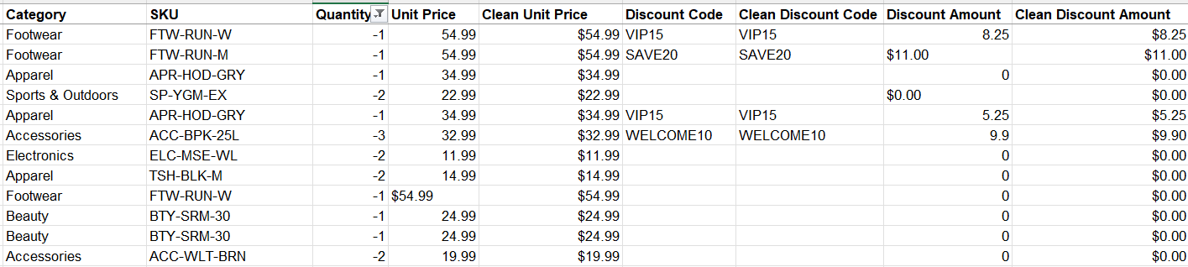
Before Removing Negative Quantities

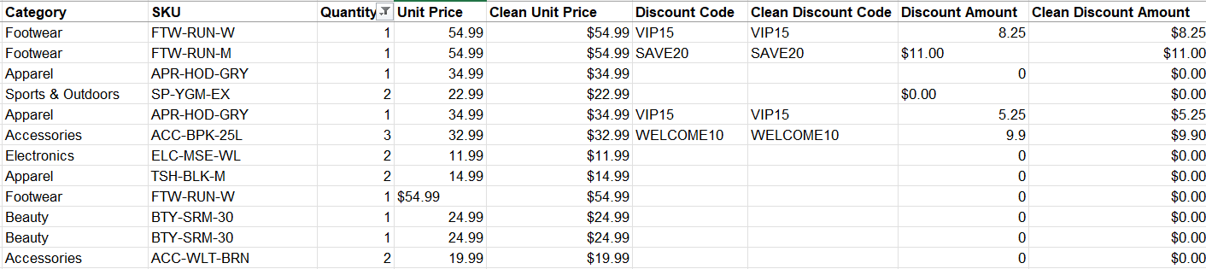
After Cleaning Negative Quantities

Figure 5 — Invalid negative quantities identified and corrected.

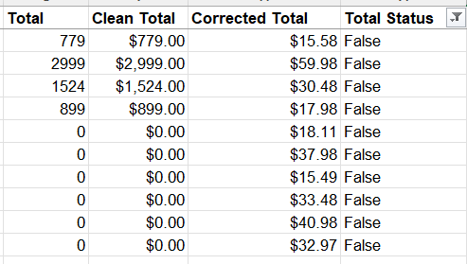

Figure 6 — Order totals validated and incorrect calculations corrected.

6. Before vs. After Data Quality
Quality Area | Before → After
Duplicate orders | 35 → Removed
Missing emails | 121 → Identified
Country names | Inconsistent → Standardized
Order dates | Mixed format → Standardized
Discount codes | Inconsistent → Standardized
Currency | Text → Numeric
Negative quantities | Present → Corrected
Incorrect totals | 10 → Corrected
SKU | 1 inconsistency → Corrected
Test orders | None → No action required

This is the main visual of the report — the final dashboard should summarize the full before/after picture at a glance.
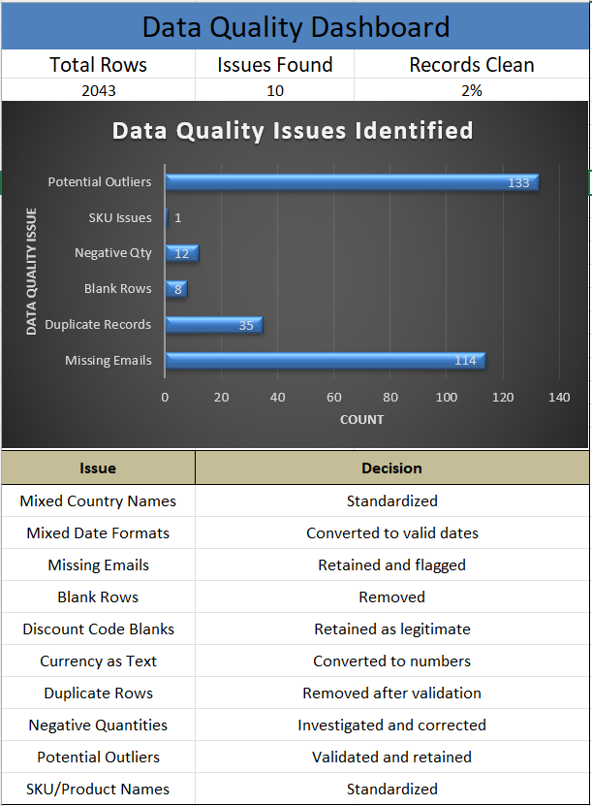

Figure 7 — Final data-quality dashboard showing the condition of the cleaned dataset.

7. Business Impact
The cleaning process improves the reliability of future e-commerce analysis.

Revenue
Removing duplicates and correcting incorrect totals reduces the risk of inaccurate revenue reporting.

Customer Marketing
The 121 missing emails highlight a limitation in customer data that can affect email marketing.

Geographic Analysis
Standardized country names prevent markets from being split into multiple categories.

Product Analysis
SKU validation improves product-level reporting.

Time Analysis
Standardized dates enable accurate monthly and yearly sales analysis.

8. Recommendations
- Add validation rules for quantities and financial fields.
- Standardize country, SKU, and discount-code values at data entry.
- Monitor missing customer emails.
- Introduce regular duplicate checks.
- Automate order-total validation.
- Investigate outliers instead of automatically deleting them.
- Maintain a recurring data-quality dashboard.
- Keep the raw dataset separate from the cleaned dataset.

9. Conclusion
The Shopify orders dataset was successfully cleaned and prepared for further e-commerce analysis.
The project identified 35 duplicate orders, 121 missing emails, and 10 incorrect order totals, while also resolving formatting, quantity, SKU, and consistency issues.
Main Takeaway
Good data cleaning combines technical validation with business judgment.

The final cleaned dataset is now suitable for downstream reporting, dashboards, and e-commerce analysis.

