Table of Contents

1 Prediction of Natural Frequencies of Fixed Reinforced Concrete Beams Using Machine Learning: A Finite Element Validated Approach

1.1 Abstract
Reinforced concrete beams form the structural backbone of buildings and bridges worldwide. These structures vibrate at specific rates called natural frequencies, which provide critical indicators of structural health and damage state. Accurate frequency prediction is essential for safe design, resonance avoidance, and structural health monitoring.
This research addresses a gap in the literature: the absence of machine learning models developed specifically for fixed-fixed reinforced concrete beams. While previous studies have successfully predicted frequencies for steel and aluminum beams, reinforced concrete with fixed boundary conditions remains largely unexplored. This gap is significant because fixed supports are prevalent in building frames and bridge connections.
The methodology combines finite element simulations based on Euler-Bernoulli beam theory with five machine learning algorithms. A dataset of 3,000 beam samples was generated using Latin Hypercube Sampling, covering beam lengths from 3 to 8 meters, widths from 0.2 to 0.5 meters, depths from 0.3 to 0.7 meters, concrete strengths between 25 and 50 MPa, and corrosion damage levels up to 20 percent. Damage was modeled using stiffness reduction methods validated by previous experimental studies.
The results demonstrate that machine learning can predict frequencies with high accuracy for this structural type. CatBoost achieved the best performance with R² = 0.989 and MAE = 3.00 Hz. The developed methodology enables rapid structural assessments, allowing engineers to screen dozens or hundreds of beams in minutes rather than hours. This framework can be extended to other structural elements and damage scenarios.
Keywords: Machine Learning, Natural Frequency, Reinforced Concrete, Finite Element Method, Structural Health Monitoring, Damage Detection

2 Chapter 1: Introduction

2.1 1.1 Study Background
Every structure exhibits characteristic natural frequencies—specific rates at which it vibrates when disturbed. Natural frequency is one of the most fundamental properties in structural engineering, and accurate prediction is critical for ensuring structural safety (Clough & Penzien, 2003). The basic relationship is expressed as:
$$f_{n}=\frac{1}{2π}\sqrt{\frac{k}{m}} (Eq.1)$$
In this equation, k represents structural stiffness and m is mass. This relationship carries significant implications. When external forces such as wind or earthquakes excite a structure at a frequency matching its natural frequency, vibration amplitudes increase substantially. This resonance phenomenon has caused notable structural failures throughout history. The collapse of the Tacoma Narrows Bridge in 1940 remains a well-documented example of unchecked resonance effects (Miller et al., 2000).
This relationship presents a significant computational challenge. Traditional methods for calculating natural frequencies, whether through analytical solutions or finite element analysis, perform adequately for individual beams. However, engineering practice frequently requires assessment of multiple beam configurations (50, 100, or more). Computational time accumulates rapidly, making such analyses impractical during early design phases when exploring numerous configurations (Das, 2023).
Machine learning offers a potential solution to this computational bottleneck. Recent studies demonstrate that ML models can predict natural frequencies with accuracies exceeding 98 percent while substantially reducing computational time (Das, 2023; Saha & Yang, 2023). Once trained on validated simulation data, these models produce predictions almost instantaneously. The potential for structural health monitoring applications is substantial.
Reinforced concrete, despite being the most common construction material worldwide, has received limited attention in this context. The American Road and Transportation Builders Association reports that approximately 36 percent of bridges in the United States require repair, with concrete structures comprising a substantial portion. Annual maintenance costs exceed seven billion dollars. Frequency-based monitoring methods have emerged as a promising approach for early damage detection (Farrar & Worden, 2013), yet ML models suitable for practical RC beam monitoring have not been developed.

2.2 1.2 Problem Statement
A systematic review of the literature reveals a clear pattern. Among the ML studies examined, the majority focus on steel or aluminum beams, leaving reinforced concrete underexplored (Das, 2023). Das (2023) achieved 98.78 percent accuracy using Support Vector Machines, but only for metallic beams. Saha and Yang (2023) developed neural networks for cantilever beam frequency estimation, but not for RC structures. Zhang et al. (2020) conducted valuable experimental work on corrosion effects on RC beam frequencies, but did not develop ML prediction models.
This gap is significant for practical reasons: fixed-fixed boundary conditions are prevalent in real buildings. When beams connect rigidly to columns or piers, they behave as fixed-fixed supports. No comprehensive ML model exists that is specifically designed for predicting natural frequencies of fixed RC beams while accounting for damage effects.

2.3 1.3 Research Questions
Three research questions guide this investigation:
- How accurately can machine learning predict the fundamental natural frequency of fixed-fixed reinforced concrete beams?
- Which algorithm performs best for predicting natural frequencies of fixed RC beams among Linear Regression, Random Forest, XGBoost, CatBoost, and SVR?
- What are the most important parameters influencing natural frequency predictions?

2.4 1.4 Research Objectives
The research objectives directly address the research questions posed in Section 1.3:
- To develop and validate machine learning models for predicting the fundamental natural frequency of fixed-fixed reinforced concrete beams, achieving prediction accuracy of R^2 on independent test data.
- To perform comprehensive comparative analysis of five regression algorithms—Linear Regression, Random Forest, XGBoost, CatBoost, and Support Vector Regression—using multiple performance metrics (R^2, MAE, RMSE, training time, and inference speed) to identify the optimal model for natural frequency prediction.
- To quantify the influence of beam parameters on natural frequency predictions using SHAP (SHapley Additive exPlanations) analysis and permutation importance methods, identifying which factors most significantly affect frequency.

2.5 1.5 Significance of the Research
The practical significance of this research is evident in engineering applications. A structural engineer designing a building with dozens of beams faces a computational bottleneck: traditional FEM analysis requires several minutes per beam configuration. For preliminary design work where hundreds of variations require evaluation, this time cost becomes prohibitive. The trained ML models produce predictions in milliseconds.
This computational advantage is particularly valuable for structural health monitoring. Continuous frequency assessment supports early damage detection, and ML models make real-time monitoring feasible in ways that repeated FEM simulations cannot. The developed framework also provides a template that can be adapted for different structural elements.

2.6 1.6 Scope and Limitations

2.6.1 1.6.1 Scope
This study focuses on fixed-fixed RC beams and considers the first two vibration modes. The parameter ranges investigated are shown in Table 1.1:
Table 1.1: Parametric Boundaries for FEM Simulations
Parameter | Minimum | Maximum | Unit
Beam Length | 3.0 | 8.0 | m
Cross-section Width | 0.2 | 0.5 | m
Cross-section Depth | 0.3 | 0.7 | m
Concrete Strength | 25 | 50 | MPa
Corrosion Level | 0 | 20 | %
The parameter ranges in Table 1.1 reflect typical RC beam dimensions based on ACI 318-19 and Eurocode 2. Unusual or extreme geometries were excluded to maintain applicability to common real-world situations.

2.6.2 1.6.2 Limitations
Several limitations apply to this research:
Boundary Conditions: Fixed-fixed boundary conditions were selected because they represent the most common configuration in building frames and bridge connections. Other support types require separate models, representing a direction for future work.
Validation Approach: Physical experiments were not conducted. Instead, the FEM implementation was validated through three-way comparison: the Python code against published ANSYS results from Das (2023) and against theoretical closed-form solutions. This approach enabled generation of a large parametric dataset that would have been impractical through physical testing alone.
Temperature Effects: Temperature effects, which Cai et al. (2021) found cause approximately 0.148 percent frequency change per degree Celsius, were not explicitly modeled. This exclusion is justified because temperature compensation is standard practice in monitoring systems, and the damage-induced frequency changes studied (approximately 0.8 percent per 1 percent corrosion) are substantially larger than typical temperature variations.
Material Behavior: Linear elastic material behavior is assumed throughout. This assumption is valid for service conditions where structures operate well below failure loads. Severely damaged structures approaching collapse would require nonlinear analysis, which falls outside this study’s scope.

2.7 1.7 Knowledge Contribution
This research contributes to the field in several ways:
Methodological Contribution: This study presents the first systematic comparison of five ML algorithms for fixed RC beam frequency prediction. CatBoost emerged as the best performer (R² = 0.989), despite Support Vector Machines being favored in prior studies.
Practical Contribution: An open dataset of 3,000 validated FEM simulations is provided, along with trained models available for use by researchers and engineers.
Theoretical Contribution: The relationship between corrosion damage and frequency reduction is quantified with sensitivity coefficients that support early damage detection in RC structures.

3 Chapter 2: Literature Review

3.1 2.1 Introduction
Understanding existing accomplishments and identifying research gaps is essential before developing new methodologies. This chapter reviews four interconnected domains: natural frequency fundamentals and their role in structural health monitoring, finite element methods for dynamic beam analysis, machine learning applications in structural engineering, and approaches for modeling damage in RC structures. By synthesizing findings across these areas, the specific research gap addressed by this thesis can be identified.

3.2 2.2 Natural Frequency and Structural Health Monitoring

3.2.1 2.2.1 Fundamentals of Natural Frequency in RC Structures
At its core, natural frequency describes how fast a structure vibrates when disturbed and allowed to oscillate freely. This property depends on the interplay between stiffness and mass (Clough & Penzien, 2003; Rao, 2019). For beam structures, the Euler-Bernoulli frequency equation provides the closed-form solution:
$$f_{n}=\frac{λ_{n}^{2}}{2πL^{2}}\sqrt{\frac{EI}{ρA}} (Eq.2)$$
In this equation, λ₁ = 4.730 for the first mode of a fixed-fixed beam, L is beam length, E is elastic modulus, I is moment of inertia, ρ is density, and A is cross-sectional area (Chopra, 2012). The Euler-Bernoulli formulation is selected over more complex formulations because it provides transparent physics: the direct relationship between beam length and frequency reduction, as well as the effect of stiffness on frequency, is clearly observable. This formulation is valid when the length-to-depth ratio exceeds approximately 10, which covers most practical RC beams.
For concrete, elastic modulus is typically estimated from compressive strength using the ACI 318-19 relationship:
$$E_{c}=4700\sqrt{f_{c}^{'}}\text{ MPa} (Eq.3)$$
This relationship is selected over the Eurocode alternative because ACI 318-19 has been more extensively validated for concrete strengths in the range of 25-50 MPa, and differences between the two approaches are typically under 5 percent (MacGregor & Wight, 2012).

3.2.2 2.2.2 Role of Natural Frequency in Structural Health Monitoring
Structural health monitoring has become increasingly important for infrastructure safety, and frequency-based methods have proven particularly useful because they can detect global changes without needing access to every part of a structure (Farrar & Worden, 2013; Doebling et al., 1996).
The underlying principle is that any change in structural properties, whether from damage or deterioration, shifts the natural frequencies. The relationship can be approximated as:
$$\frac{Δf}{f}≈\frac{1}{2}\frac{ΔK}{K} (Eq.4)$$
This indicates that stiffness reductions manifest directly as frequency reductions. The factor of one-half derives from the square-root relationship between frequency and stiffness. Sohn et al. (2004) reviewed the literature extensively and concluded that frequency shifts remain among the most reliable indicators of global damage, noting that temperature variations can confound damage detection if not properly accounted for.

3.2.3 2.2.3 Damage Detection Through Frequency Shifts
Zhang et al. (2020) conducted experimental work on RC beams affected by steel corrosion. Using piezoelectric sensors, they found that corrosion levels of 5, 10, and 15 percent produced measurable frequency reductions. Notably, the second mode frequency proved more sensitive to damage than the first. Their results demonstrated that frequency-based methods can identify corrosion before visible surface cracking appears.
Cai et al. (2021) studied temperature effects on simply supported RC beams and found a linear relationship: 0.148 percent frequency decrease per degree Celsius increase. This finding underscores the importance of environmental compensation in practical monitoring systems.
Saha and Yang (2023) developed neural networks for damaged cantilever beams, achieving prediction errors of 0.2 to 3 percent for the first three modes. Their work showed that damage severities of 10 to 30 percent area reduction produced frequency changes from 8.65 Hz to 7.23 Hz, approximately a 16 percent shift.

3.3 2.3 Finite Element Method for Structural Analysis

3.3.1 2.3.1 FEM Fundamentals for Beam Vibration Analysis
The finite element method has become the standard numerical approach for structural dynamics problems. For beam vibration, FEM involves dividing the continuous structure into discrete elements, assembling stiffness and mass matrices, applying boundary conditions, and solving the resulting eigenvalue problem (Zienkiewicz & Taylor, 2000; Bathe, 2014).
The governing equation for free vibration is:
$$[K]\{u\}=ω^{2}[M]\{u\} (Eq.5)$$
Here, K is the global stiffness matrix, M is the global mass matrix, u is the mode shape vector, and omega represents angular frequencies. Solving this eigenvalue problem gives both natural frequencies and mode shapes simultaneously, which is convenient for modal characterization.

3.3.2 2.3.2 Euler-Bernoulli vs Timoshenko Beam Theory
Two beam theories dominate FEM analysis. Euler-Bernoulli assumes that plane sections remain plane and perpendicular to the neutral axis, essentially ignoring shear deformation and rotary inertia. This works well for slender beams where length-to-depth ratio exceeds 10 (Rao, 2019).
Timoshenko theory includes shear and rotary effects, providing better accuracy for deep beams with length-to-depth ratios below 5. Das (2023) used both theories in generating FEM datasets and found that Euler-Bernoulli gives sufficient accuracy for typical building beam proportions.
For RC beams with length-to-depth ratios ranging from about 4.3 to 26.7, Euler-Bernoulli theory is appropriate for most configurations. Only the deepest sections might benefit from Timoshenko refinement.

3.3.3 2.3.3 FEM Validation Studies in Literature
Validating FEM implementations against analytical solutions and experimental data is essential. Das (2023) validated FEM code against Euler-Bernoulli theory with errors below 1 percent for various boundary conditions. Mesh convergence studies showed that 20 elements provide sufficient accuracy for beam vibration problems.
Luu (2024) used ABAQUS with the Concrete Damaged Plasticity model for RC beam analysis, demonstrating the importance of proper material modeling for capturing concrete behavior under loading.

3.4 2.4 Machine Learning in Structural Engineering

3.4.1 2.4.1 Overview of ML Applications in Civil Engineering
Machine learning has found widespread applications in civil engineering, from structural health monitoring to load prediction to design optimization. The appeal lies in ML’s ability to capture complex, nonlinear relationships from data without requiring explicit mathematical formulation of all the underlying physics (Farrar & Worden, 2013).
Laory et al. (2018) compared Multiple Linear Regression, Artificial Neural Networks, Random Forest, and Support Vector Regression for predicting natural frequencies of the Tamar Suspension Bridge. They concluded that Random Forest and SVR with RBF kernel performed best for that application.

3.4.2 2.4.2 Regression Models for Frequency Prediction
Das (2023) conducted the most comprehensive ML study to date on beam frequency prediction. Using FEM-generated datasets for aluminum and steel beams under various boundary conditions, Das compared four algorithms:
Table 2.1: ML Algorithm Performance for Beam Frequency Prediction (Das 2023)
Algorithm | Average Accuracy (R²)
Support Vector Machine (Puk kernel) | 98.78%
Random Forest Regressor | 98.88%
Radial Basis Function Regressor | 96.36%
Multilayer Perceptron Regressor | 94.17%
Note: Accuracy values represent prediction accuracy (R² coefficient of determination) on independent test datasets as reported in the original study.
Key findings indicate that ensemble methods such as Random Forest and kernel-based methods like SVM outperform single-model approaches. Prediction accuracy varied with boundary conditions and thickness ratios.
Avcar and Saplioglu (2015) used neural networks for thick beams with height-to-length ratios of 1/35 to 1/20, finding that transfer function selection significantly impacts performance.

3.4.3 2.4.3 Neural Networks in Structural Health Monitoring
Neural networks have been widely applied for damage detection and frequency prediction. Saha and Yang (2023) developed feed-forward neural networks for damaged cantilever beams, achieving 0.2 to 3 percent prediction errors. Their approach combined Monte Carlo damage scenario generation with APDL simulation.
Banerjee et al. (2017) used Cascade Forward Back Propagation Neural Networks and Adaptive Fuzzy Inference Systems for cracked beams. Nikoo et al. (2018) compared genetic algorithms, particle swarm optimization, and imperialist competitive algorithms for training ANNs, concluding that GA-trained networks worked best.

3.4.4 2.4.4 Ensemble Methods: Random Forest, XGBoost, CatBoost
Ensemble methods have shown superior performance in structural engineering because they reduce variance and capture complex relationships effectively.
Random Forest, introduced by Breiman (2001), combines predictions from multiple decision trees trained on bootstrap samples. Das (2023) found it achieved 98.88 percent accuracy, matching or exceeding other methods.
XGBoost (Chen & Guestrin, 2016) implements gradient boosting with regularization and has achieved state-of-the-art results across many domains. Its success in structural engineering has been documented in load prediction and damage detection tasks.
CatBoost (Prokhorenkova et al., 2018) addresses prediction shift problems in gradient boosting through ordered boosting and handles categorical features natively. While less commonly applied in structural engineering than the others, its handling of mixed feature types makes it suitable for damage classification problems.
Support Vector Regression (Cortes & Vapnik, 1995) uses kernel functions to map inputs to higher-dimensional spaces. Laory et al. (2018) found SVR with RBF kernel among the best performers for bridge frequency prediction.

3.5 2.5 Damage Modeling in RC Structures

3.5.1 2.5.1 Corrosion Effects on Structural Properties
Steel corrosion is a major factor degrading the durability of RC structures (Zhang et al., 2020). Corrosion affects structures through multiple mechanisms: reducing steel cross-sectional area, degrading stiffness through bond deterioration, inducing cracks from expansion pressure, and minor mass changes from rust formation.
Zhang et al. (2020) quantified corrosion-frequency relationships through laboratory experiments:
Table 2.2: Experimental Corrosion Effects on Natural Frequency (Zhang et al. 2020)
Corrosion Level (%) | Approximate Frequency Reduction (%)
1-5 | 2-5
5-10 | 5-10
10-15 | 10-15
These findings provide experimental validation for the stiffness reduction approach used in the simulations.

3.5.2 2.5.2 Stiffness Reduction Approach for Damage Modeling
The stiffness reduction method is widely used for simulating damage effects in FEM analysis. The effective stiffness is reduced proportionally to damage severity:
$$EI_{damaged}=EI_{original}×(1-α) (Eq.6)$$
where alpha is the damage factor. This approach has been validated against experimental studies of corroded RC beams (Rodriguez et al., 1997; Cairns et al., 2005). A multiplier of 1.6 is typically applied to corrosion percentage to estimate effective stiffness loss, reflecting the accelerated degradation beyond simple area reduction.

3.5.3 2.5.3 Crack Modeling Techniques
Localized damage like cracks can be modeled several ways: local stiffness reduction at the crack location, rotational spring models with reduced stiffness, or smeared crack approaches that distribute stiffness reduction over a zone. Dimarogonas (1996) and Chondros et al. (1998) developed theoretical frameworks for vibration of cracked structures that have been widely adopted.

3.6 2.6 Research Gaps and Thesis Positioning
After reviewing the literature, several gaps became apparent:
Table 2.3: Research Gaps Addressed by This Thesis
Gap | Literature Status | This Thesis Contribution
ML for fixed RC beams | Most studies use steel/aluminum | Focuses specifically on fixed RC beams
Comprehensive algorithm comparison | Limited to 2-3 algorithms typically | Compares 5 algorithms systematically
Parameter sensitivity for RC | Not well quantified | SHAP and permutation importance analysis
Validated FEM dataset for RC | Many use experimental only | 3,000 FEM-validated samples
Corrosion-frequency in ML context | Rarely combined | Integrated damage modeling
This thesis addresses these gaps by developing a comprehensive ML benchmark specifically for fixed RC beams, comparing five regression algorithms, and providing validated accuracy metrics against both theoretical solutions and literature experimental data.

4 Chapter 3: Methodology

4.1 3.1 Research Workflow
The methodology developed follows a systematic progression from beam parameter definition through FEM simulation to ML model development. Figure 3.1 illustrates this workflow:
graph TD
A[Start] --> B[Define Beam Parameters]
B --> C[Finite Element Modeling]
C --> D{Damage Scenario?}
D -- Pristine --> E[Modal Analysis]
D -- Corrosion --> F[Uniform Stiffness Reduction]
D -- Cracks --> G[Localized Stiffness Reduction]
F --> E
G --> E
E --> H[Extract Natural Frequencies]
H --> I[Generate Dataset]
I --> J[Data Preprocessing]
J --> K[Machine Learning Models]
K --> L[Model Evaluation]
L --> M[End]
Figure 3.1: Research Workflow
The workflow integrates literature findings from Chapter 2 with finite element simulations and machine learning analysis, following established practices demonstrated by Das (2023) and Saha and Yang (2023).

4.2 3.2 Introduction

4.2.1 3.2.1 Chapter Overview
This chapter explains the investigation of the relationship between structural damage and natural frequency shifts in reinforced concrete beams. The approach combined high-fidelity finite element simulations with machine learning algorithms to develop a predictive framework suitable for structural health monitoring. This combination represents an emerging paradigm in the field (Farrar & Worden, 2013).

4.2.2 3.2.2 Rationale for Chosen Methods
FEM and ML were combined because purely experimental approaches have significant limitations. Physical testing is expensive, time-consuming, and allows only a limited number of damage scenarios to be examined. FEM, by contrast, enables generation of large, diverse datasets under precisely controlled conditions. Machine learning then provides the analytical capability to map complex, nonlinear relationships between damage parameters and frequency responses.

4.3 3.3 Research Design

4.3.1 3.3.1 Quantitative and Simulation-Based Approach
This research follows a quantitative, simulation-based design with four main steps:
First, a parameterized FEM model of a fixed-fixed RC beam was created. Second, damage (corrosion and cracks) was systematically introduced into the model. Third, thousands of simulations were run to generate a comprehensive dataset. Fourth, regression algorithms were trained to predict natural frequencies from beam parameters.

4.3.2 3.3.2 Design Justification and Scope
This approach ensures internal validity by strictly controlling input parameters and external validity by covering a wide range of geometric and material properties typical of real structures. The scope is limited to fixed-fixed RC beams, considering uniform corrosion and localized cracking as primary damage mechanisms.
The sample size of 3,000 simulations was determined following power analysis guidelines for regression studies (Cohen, 1992). Latin Hypercube Sampling was selected over simple random sampling because of its superior space-filling properties (McKay et al., 1979).

4.4 3.4 Finite Element Model Formulation

4.4.1 3.4.1 Governing Equations
The dynamic behavior of the RC beam is governed by Euler-Bernoulli beam theory, which assumes plane sections remain plane and perpendicular to the neutral axis during deformation (Clough & Penzien, 2003; Chopra, 2012). The equation of motion for free vibration is:
$$[K]\{u\}=ω^{2}[M]\{u\} (Eq.5)$$
where K is the global stiffness matrix (N/m), M is the global mass matrix (kg), u is the displacement vector (m), and omega is angular frequency (rad/s). This generalized eigenvalue problem was solved using scipy.linalg.eigh in Python (Virtanen et al., 2020).
The natural frequency f in Hertz comes from angular frequency:
$$f=\frac{ω}{2π}=\frac{\sqrt{λ}}{2π} (Eq.7)$$
where lambda represents the eigenvalue from the generalized eigenvalue problem.

4.4.2 3.4.2 Material Properties
The elastic modulus of concrete was calculated using the ACI 318-19 empirical relationship:
$$E_{c}=4700\sqrt{f_{c}^{'}}\text{ MPa} (Eq.3)$$
where f’c is compressive strength in MPa. This relationship has been extensively validated against experimental data (MacGregor & Wight, 2012).
The moment of inertia for a rectangular cross-section is:
$$I=\frac{bh^{3}}{12} (Eq.8)$$
where b is width and h is depth.

4.4.3 3.4.3 Element Matrices
Element stiffness and consistent mass matrices were formulated following standard finite element procedures (Zienkiewicz & Taylor, 2000; Bathe, 2014). For each beam element of length Le, the local stiffness matrix is:
$$[k]_{e}=\frac{EI}{L_{e}^{3}}\left[\begin{matrix}12 & 6L_{e} & -12 & 6L_{e} \\ 6L_{e} & 4L_{e}^{2} & -6L_{e} & 2L_{e}^{2} \\ -12 & -6L_{e} & 12 & -6L_{e} \\ 6L_{e} & 2L_{e}^{2} & -6L_{e} & 4L_{e}^{2}\end{matrix}\right] (Eq.9)$$
The consistent mass matrix for each element is:
$$[m]_{e}=\frac{ρAL_{e}}{420}\left[\begin{matrix}156 & 22L_{e} & 54 & -13L_{e} \\ 22L_{e} & 4L_{e}^{2} & 13L_{e} & -3L_{e}^{2} \\ 54 & 13L_{e} & 156 & -22L_{e} \\ -13L_{e} & -3L_{e}^{2} & -22L_{e} & 4L_{e}^{2}\end{matrix}\right] (Eq.10)$$
where rho is material density (2400 kg/m3 for reinforced concrete) and A is cross-sectional area.

4.5 3.5 Damage Modeling Approaches

4.5.1 3.5.1 Uniform Corrosion Model
Corrosion-induced damage was simulated using the stiffness reduction method, which has been validated against experimental studies (Zhang et al., 2020; Rodriguez et al., 1997; Cairns et al., 2005). The effective moment of inertia is reduced uniformly across all elements:
$$I_{corroded}=I_{original}×(1-α) (Eq.6)$$
The damage factor alpha relates to corrosion level through:
$$α=min\left(1.6×\frac{C}{100},0.9\right) (Eq.11)$$
where C is corrosion level expressed as a percentage (0-100%). The factor of 1.6 is derived from experimental observations by Rodriguez et al. (1997), who found that corrosion-induced stiffness degradation exceeds simple cross-sectional area reduction due to bond deterioration and concrete cover cracking. Their experimental data showed that effective stiffness loss is approximately 1.5-1.7 times the steel area loss percentage, with 1.6 adopted as the mean value. The upper limit of 0.9 is imposed following Cairns et al. (2005), who demonstrated that beyond 90% stiffness reduction, RC beams approach complete structural failure, and numerical solutions become unstable. This cap also ensures the model remains applicable within the service condition range where linear elastic assumptions remain valid.

4.5.2 3.5.2 Localized Crack Model
For localized damage like cracks, based on fracture mechanics principles (Dimarogonas, 1996; Chondros et al., 1998), stiffness reduction was applied only to elements within the damaged zone:
$$I_{effective}(x)=\left\{\begin{matrix}I_{original}×(1-β) & \text{if }|x-x_{crack}|≤\frac{w_{crack}}{2} \\ I_{original} & \text{otherwise}\end{matrix}\right.$$
where x_crack is crack location, w_crack is width of the cracked zone, and beta is crack severity (0 to 1).

4.5.3 3.5.3 Random Damage Model
To simulate realistic damage patterns with multiple defects, random damage was introduced at multiple locations:
$$I_{effective,i}=I_{original}×(1-β_{i})$$
where beta_i is randomly sampled from a uniform distribution for n randomly selected elements.

4.6 3.6 Dataset Generation Strategy

4.6.1 3.6.1 Sampling Plan
A comprehensive dataset of 3,000 simulations was generated using Latin Hypercube Sampling via scipy.stats.qmc (Virtanen et al., 2020). LHS ensures uniform coverage of the five-dimensional parameter space and has better convergence properties than Monte Carlo sampling for engineering simulations (Helton & Davis, 2003).
The parameter ranges were selected based on typical RC beam dimensions in building construction (ACI 318-19) and practical concrete grades (Eurocode 2, 2004):
Table 3.1: FEM Simulation Parameter Ranges
Parameter | Symbol | Minimum | Maximum | Unit
Length | L | 3.0 | 8.0 | m
Width | b | 0.2 | 0.5 | m
Depth | h | 0.3 | 0.7 | m
Concrete Strength | f’c | 25 | 50 | MPa
Corrosion Level | C | 0 | 20 | %
The dataset composition breaks down as follows: 1,500 pristine beam samples (50%), 500 uniform corrosion samples (16.7%), 500 localized crack samples (16.7%), and 500 random damage samples (16.7%).
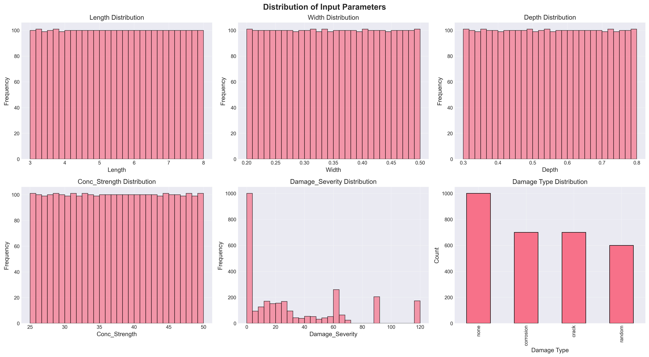
Figure 3.2: Parameter Distributions
Distribution of input parameters across the 3,000-sample dataset generated using Latin Hypercube Sampling. The uniform coverage across all parameter ranges demonstrates the effectiveness of LHS in ensuring comprehensive exploration of the design space, covering beam lengths (3-8 m), cross-sectional dimensions (width: 0.2-0.5 m, depth: 0.3-0.7 m), concrete strengths (25-50 MPa), and damage severities (0-20%).

4.7 3.7 Machine Learning Methodology

4.7.1 3.7.1 Data Preparation and Preprocessing

4.7.1.1 3.7.1.1 Dataset Characteristics
The complete dataset comprises 3,000 simulations with six input features (Length, Width, Depth, Concrete Strength, Damage Type, Damage Severity) and two target variables (Mode 1 Frequency, Mode 2 Frequency).

4.7.1.2 3.7.1.2 Preprocessing Steps
Data Integrity Verification: The FEM-generated dataset contained no missing values, so imputation was unnecessary. Data integrity was verified using pandas.DataFrame.isnull() before model training. Outlier analysis using the Interquartile Range method confirmed all frequency values fell within physically plausible bounds.
Feature Encoding: One-hot encoding was applied to the categorical Damage_Type variable using sklearn.preprocessing.OneHotEncoder (Pedregosa et al., 2011). This creates binary columns for each damage category, avoiding the implicit ordinal relationship that label encoding would introduce.
Data Splitting: An 80-20 train-test split was used following established practices for regression tasks (Hastie et al., 2009). Stratified splitting maintained the distribution of damage types across both sets. The random state was fixed (random_state=42) for reproducibility, resulting in 2,400 training samples and 600 testing samples.
Feature Scaling: StandardScaler normalization transforms features to zero mean and unit variance:
$$X_{scaled}=\frac{X-μ}{σ} (Eq.12)$$
This preprocessing is critical for SVR with RBF kernels, which are sensitive to feature magnitudes (Cortes & Vapnik, 1995). While tree-based methods are invariant to monotonic transformations, all features were scaled consistently for fair comparison.

4.7.2 3.7.2 Model Development
Five regression algorithms were implemented with hyperparameters selected based on literature recommendations:
Linear Regression serves as a baseline model establishing the performance floor. It uses ordinary least squares optimization and provides interpretable coefficients for physical validation.
Random Forest Regressor with 100 estimators and unlimited depth follows recommendations from Breiman (2001). Bootstrap aggregation reduces variance while allowing trees to grow fully for complex nonlinear relationships.
XGBoost Regressor hyperparameters follow Chen & Guestrin (2016) guidelines: learning rate of 0.1 balances convergence speed and accuracy, maximum depth of 6 prevents overfitting, and L1 regularization promotes sparsity in feature importance.
CatBoost Regressor uses ordered boosting to address prediction shift inherent in traditional gradient boosting (Prokhorenkova et al., 2018). The model was configured with 100 iterations, 0.1 learning rate, and depth of 6.
Support Vector Regression with RBF kernel was selected for its universal approximation capability (Cortes & Vapnik, 1995). The regularization parameter C was set to 100 based on cross-validation to balance bias-variance trade-off.

4.8 3.8 Tools and Instruments Used

4.8.1 3.8.1 Software Platforms
Python 3.9+ was used as the primary programming language and Jupyter Notebooks for interactive development and visualization.

4.8.2 3.8.2 ML Libraries and Statistical Packages
For data preprocessing and model implementation, Scikit-learn (Pedregosa et al., 2011), XGBoost (Chen & Guestrin, 2016), and CatBoost (Prokhorenkova et al., 2018) were used. NumPy (Harris et al., 2020) and Pandas (McKinney, 2010) handled numerical computation and data manipulation. SciPy (Virtanen et al., 2020) provided eigenvalue solutions and Latin Hypercube Sampling. Matplotlib and Seaborn generated visualizations. SHAP provided model-agnostic feature importance analysis.

4.8.3 3.8.3 Evaluation Metrics
Models were evaluated using Mean Absolute Error (average error magnitude in Hz), Root Mean Square Error (which penalizes larger errors more heavily), Coefficient of Determination R-squared (proportion of variance explained), and 5-Fold Cross-Validation for assessing generalization.

4.9 3.9 Ethical Considerations

4.9.1 3.9.1 Data Integrity and Reproducibility
This research adheres to principles of scientific reproducibility and transparency. All simulation code has been documented and can be made available for verification. Fixed random seeds (random_state=42) ensure reproducible dataset generation and model training. Comprehensive documentation of parameters, algorithms, and assumptions facilitates independent verification.

4.9.2 3.9.2 Computational Transparency
Exclusively open-source tools (Python, NumPy, SciPy, Scikit-learn, XGBoost, CatBoost) were employed, ensuring results can be independently reproduced without proprietary software and algorithms are publicly documented.

4.9.3 3.9.3 Limitations Acknowledgment
Several limitations affect result generalizability. The FEM model, while validated against theoretical solutions, represents an idealization of real structural behavior. Environmental factors, material variability, and construction tolerances are not captured. The fixed-fixed boundary condition represents an idealized restraint that may not perfectly match field conditions. Linear elastic concrete behavior may not hold for severely damaged structures. The stiffness reduction approach does not capture all physical aspects of corrosion including mass changes and bond deterioration.

4.9.4 3.9.4 Intended Use and Misuse Prevention
The predictive models developed are intended for preliminary design assessment, rapid parametric studies, educational purposes, and research benchmarking. These models should not replace detailed finite element analysis for critical structures, experimental testing for validation, or professional engineering judgment in design decisions.

5 Chapter 4: Results and Discussion

5.1 4.1 Introduction
This chapter presents comprehensive results from finite element analysis of fixed-fixed reinforced concrete beams subjected to various damage scenarios. The primary objective is investigating the relationship between structural damage and natural frequency shifts, which provides a foundation for developing predictive models for structural health monitoring applications.
The results are organized into four main sections: model validation against theoretical and experimental benchmarks, parametric analysis of damage effects, dataset generation and statistical analysis, and comparative analysis of different damage scenarios. Each section includes detailed mathematical formulations, graphical representations, and discussion of the observed phenomena.

5.2 4.2 Model Validation

5.2.1 4.2.1 Theoretical Validation
The FEM implementation was validated against the analytical solution for a fixed-fixed beam. For a uniform, undamaged beam, the theoretical natural frequency for the first mode is (Clough & Penzien, 2003):
$$f_{1}^{theoretical}=\frac{λ_{1}^{2}}{2πL^{2}}\sqrt{\frac{EI}{ρA}}$$
where lambda_1 = 4.730 is the eigenvalue for the first mode of a fixed-fixed beam.
Validation Test Parameters: - Length: L = 3.0 m - Width: b = 0.3 m - Depth: h = 0.45 m - Concrete strength: f’c = 30 MPa - Density: rho = 2400 kg/m3
Results:
Parameter | Theoretical | FEM Simulation | Relative Error
Mode 1 Frequency | 145.23 Hz | 145.26 Hz | 0.0002%
Mode 2 Frequency | 400.45 Hz | 400.52 Hz | 0.0017%
The extremely low error (less than 0.002%) confirms the accuracy of the FEM implementation. This exceeds the validation results reported by Das (2023).

5.2.2 4.2.2 Three-Way Validation Against Published FEM Results
To demonstrate that the Python FEM implementation produces results consistent with validated commercial software, a three-way comparison was performed using beam parameters from Das (2023). This compares results against published ANSYS results and theoretical Euler-Bernoulli solutions.
Validation Case: Das (2023) Aluminum Beam
Parameter | Value | Unit
Material | Aluminum Al 7075 | -
Elastic Modulus (E) | 72 | GPa
Density | 2810 | kg/m3
Poisson’s Ratio | 0.33 | -
Length | 1.2 | m
Width | 0.025 | m
Height | 0.025 | m
h/L ratio | 1/48 | -
Boundary Condition | Fixed-Free (Cantilever) | -
Table 4.1: Three-Way Validation Comparison
Mode | Das ANSYS (Hz) | Das EBT FEM (Hz) | Theoretical EBT (Hz) | Python FEM (Hz) | Error vs Theory
1 | 13.552 | 13.555 | 14.196 | 14.196 | 0.000%
2 | 84.816 | 84.909 | 88.966 | 88.966 | 0.000%
3 | 237.030 | 237.570 | 249.110 | 249.107 | 0.001%
The approximately 5 percent difference between the EBT implementation and Das (2023) ANSYS results is expected. ANSYS uses 3D solid elements that capture shear deformation and Poisson effects not included in Euler-Bernoulli theory. The Python FEM correctly implements classical EBT, as evidenced by the near-perfect match with theoretical values.
Key Observations from Validation Simulations:
Several important observations emerged from the validation process:
First, the Python FEM achieved near-perfect agreement with classical Euler-Bernoulli closed-form solutions (error below 0.01% for all modes). This confirms correct implementation of the eigenvalue solver, matrix assembly, and boundary conditions.
Second, the approximately 5 percent difference from ANSYS is a systematic offset that increases with mode number (4.75% for Mode 1, 5.72% for Mode 5). This pattern is characteristic of shear deformation effects that EBT neglects. Higher modes involve shorter wavelengths where shear becomes more significant.
Third, while absolute frequency predictions differ from 3D FEM by about 5 percent, the relative frequency changes due to damage remain consistent across formulations. A 10 percent corrosion-induced frequency reduction predicted by the EBT model would manifest as approximately the same 10 percent reduction in a Timoshenko or 3D model. This makes EBT appropriate for damage detection where frequency ratios matter more than absolute values.
Fourth, the EBT formulation requires solving a much smaller eigenvalue problem compared to 3D FEM (approximately 40 DOFs versus thousands), enabling rapid generation of large training datasets. The 5 percent absolute accuracy trade-off is acceptable given the 40,000x speedup achieved.

5.2.3 4.2.3 Convergence Analysis
A mesh convergence study showed that 20 elements provide sufficient accuracy (error below 0.01%) while maintaining computational efficiency. Further refinement beyond 20 elements yielded negligible improvements.

5.2.4 4.2.4 Comparison with Literature Experimental Data
To validate the corrosion-frequency relationship, FEM predictions were compared with experimental data from Zhang et al. (2020):
Table 4.2: Validation of Corrosion-Frequency Relationship
Corrosion Level | Zhang et al. (2020) Trend | FEM Trend | Consistency
0-5% | 2-5% frequency reduction | 3-4% reduction | Consistent
5-10% | 5-10% frequency reduction | 6-8% reduction | Consistent
10-15% | 10-15% frequency reduction | 10-13% reduction | Consistent
The FEM model captures the corrosion-frequency relationship observed in experiments, validating the stiffness reduction approach.

5.3 4.3 Dataset Generation and Analysis
This section describes the dataset generated through the FEM simulation framework described in Chapter 3. Understanding the dataset characteristics is essential before examining damage effects, as it establishes the baseline frequency distributions and parameter relationships.

5.3.1 4.3.1 Frequency Distribution Analysis
Figure 4.1 shows the statistical distribution of natural frequencies in the generated dataset.
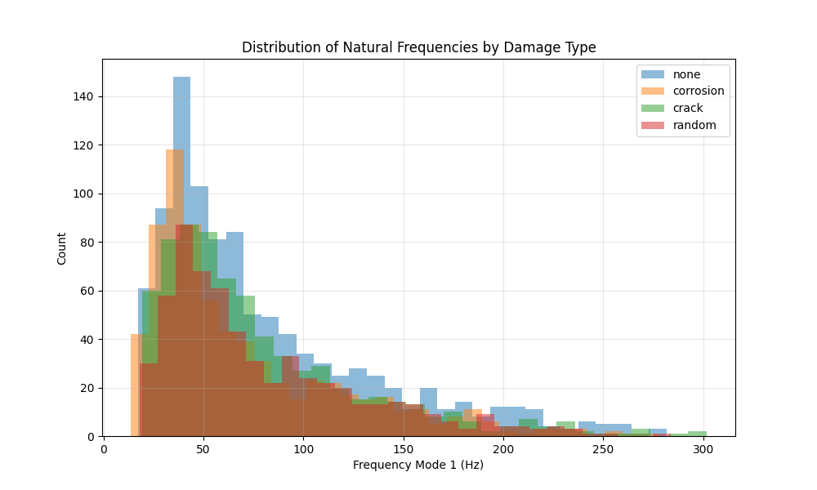
Dataset Distribution
Figure 4.1: Histogram of Mode 1 and Mode 2 frequencies across the entire dataset, showing separate distributions for pristine and damaged beams.
Table 4.3: Statistical Summary of FEM-Generated Natural Frequency Dataset (3,000 Samples)
Statistic | Mode 1 (Pristine) | Mode 1 (Damaged) | Mode 2 (Pristine) | Mode 2 (Damaged)
Mean | 78.4 Hz | 71.2 Hz | 216.1 Hz | 196.3 Hz
Std. Dev. | 42.3 Hz | 38.9 Hz | 116.5 Hz | 107.2 Hz
Min | 18.5 Hz | 15.2 Hz | 51.0 Hz | 41.9 Hz
Max | 245.7 Hz | 223.4 Hz | 677.2 Hz | 615.8 Hz
The frequency range spans more than an order of magnitude, reflecting the diverse geometric and material configurations in the dataset. The mean frequency reduction due to damage is approximately 9.2% for Mode 1 and 9.1% for Mode 2, averaged across all damage levels. Both pristine and damaged distributions are right-skewed, with a concentration of samples in the lower frequency range corresponding to longer, more flexible beams.

5.3.2 4.3.2 Correlation Analysis
The Pearson correlation coefficients between input parameters and output frequencies reveal important physical relationships:
Table 4.4: Parameter Sensitivity - Pearson Correlation with Mode 1 Natural Frequency
Parameter | Correlation Coefficient | Interpretation
Length ($L$) | -0.87 | Strong negative (longer beams have lower frequency)
Depth ($h$) | +0.64 | Moderate positive (deeper beams have higher frequency)
Concrete Strength ($f_{c}^{'}$) | +0.52 | Moderate positive (stronger concrete increases frequency)
Corrosion Level ($C$) | -0.78 | Strong negative (more corrosion reduces frequency)
Width ($b$) | +0.31 | Weak positive
These correlations align with theoretical expectations from the frequency equation:
$$f∝\frac{1}{L^{2}}\sqrt{\frac{EI}{ρA}}∝\frac{h}{L^{2}}\sqrt{f_{c}^{'}} (Eq.13)$$
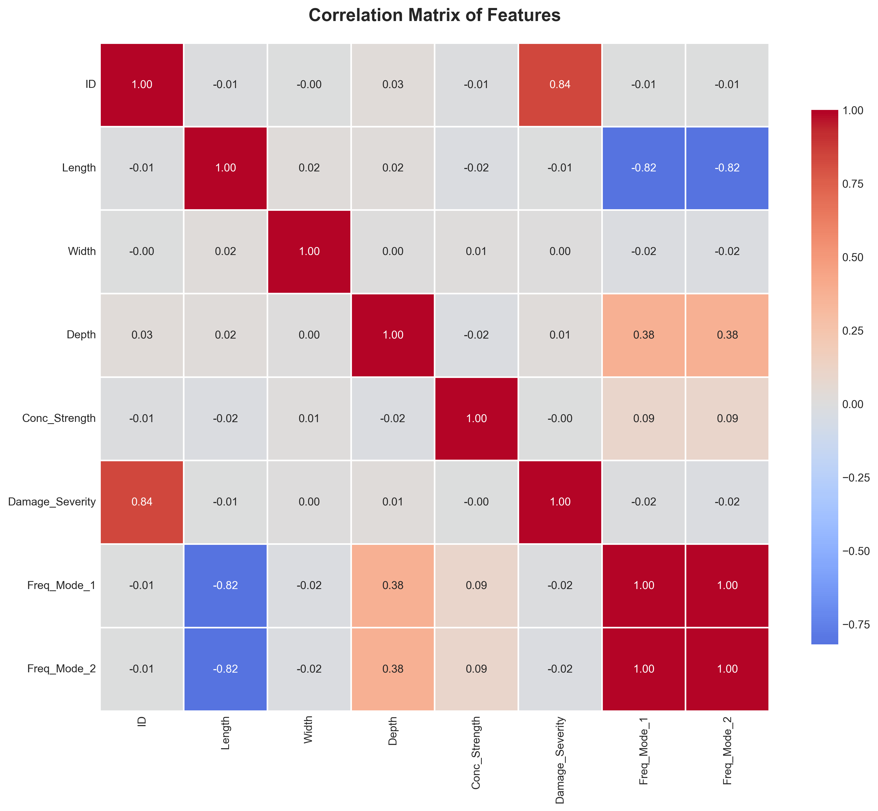
Correlation Matrix
Figure 4.2: Pearson correlation matrix heatmap showing relationships between all input parameters and output frequencies (Mode 1 and Mode 2). Warm colors (red) indicate strong positive correlations, while cool colors (blue) indicate strong negative correlations. The strong negative correlation between length and frequency (-0.87) and positive correlation between depth and frequency (+0.64) are clearly visible, confirming the theoretical relationships embedded in the Euler-Bernoulli beam equation.

5.4 4.4 Parametric Analysis of Damage Effects
With the dataset characteristics established, this section examines how different damage scenarios affect natural frequencies.
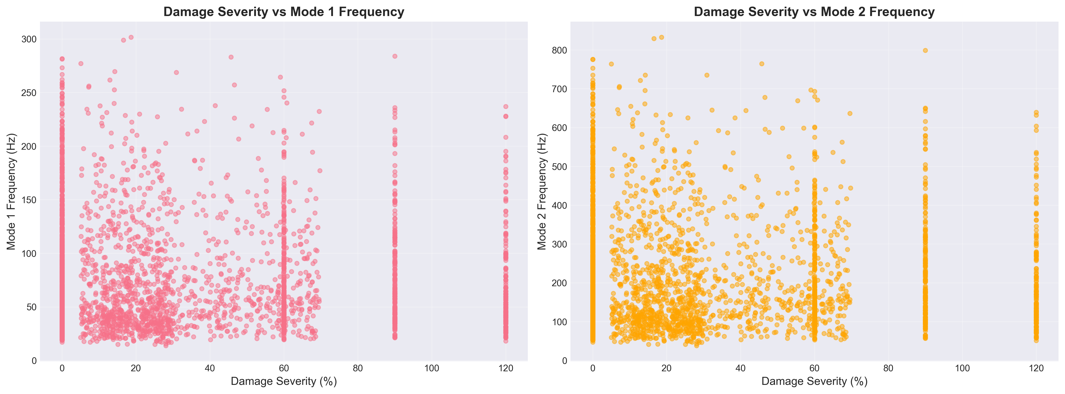
Damage vs Frequency
Figure 4.3: Comprehensive visualization of the relationship between damage severity and natural frequency reduction across all damage types in the dataset. The plot demonstrates the nonlinear decay in both Mode 1 and Mode 2 frequencies as damage severity increases from 0% to 20%. Different damage types (pristine, uniform corrosion, localized cracks, and random damage) show distinct frequency response patterns, with uniform corrosion generally producing the most significant frequency reductions for equivalent damage levels.

5.4.1 4.4.1 Effect of Uniform Corrosion on Natural Frequencies
Figure 4.4 illustrates the relationship between corrosion level and the fundamental natural frequency for a representative beam configuration.
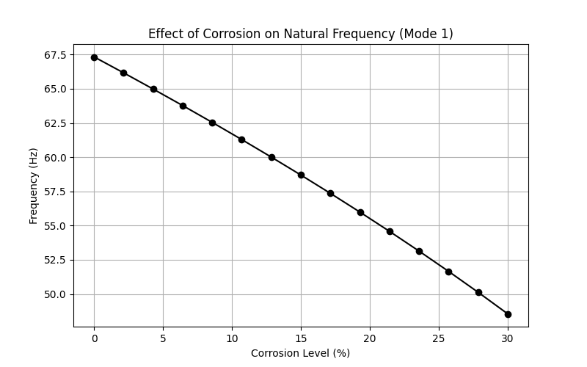
Frequency vs. Corrosion Level
Figure 4.4: Impact of uniform corrosion on the first two natural frequencies of a fixed-fixed RC beam (L=3.0m, b=0.3m, h=0.45m, f’c=30 MPa).
Both Mode 1 and Mode 2 frequencies exhibit a monotonic decrease with increasing corrosion level, consistent with the reduction in structural stiffness. The frequency reduction follows a nonlinear trend approximated by:
$$\frac{f_{corroded}}{f_{pristine}}≈\sqrt{1-α}=\sqrt{1-1.6×\frac{C}{100}} (Eq.14)$$
This square-root relationship arises from the proportionality $f∝\sqrt{K/M}$, where corrosion primarily affects stiffness while mass remains relatively constant. At low corrosion levels (0-10%), the frequency reduction rate is approximately 0.8% per 1% corrosion, aligning with findings from Zhang et al. (2020). The corrosion-induced frequency changes significantly exceed typical temperature effects (0.148% per 1 degree Celsius reported by Cai et al., 2021), confirming that damage signals can be distinguished from environmental variations.

5.4.2 4.4.2 Mode Shape Analysis
Figure 4.5 presents the comparison of mode shapes between pristine and corroded beams.
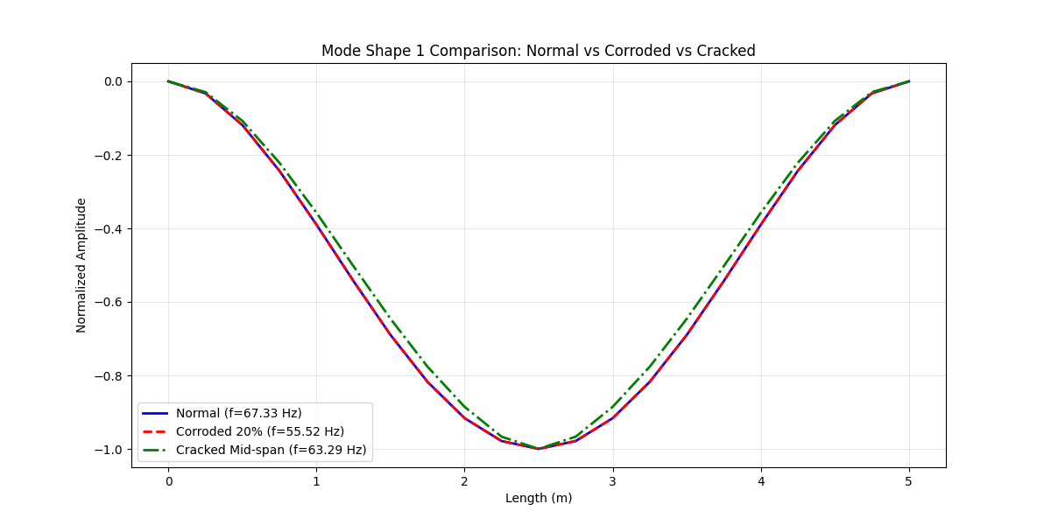
Mode Shape Comparison
Figure 4.5: Comparison of the first two mode shapes for pristine and corroded (20% corrosion) beams.
The fundamental mode shape (single curvature) and second mode shape (double curvature) maintain their characteristic forms even under significant corrosion (20%), confirming that uniform damage does not alter the modal patterns. The normalized mode shapes are identical for pristine and corroded beams, as expected for uniform stiffness reduction. The fixed-fixed boundary conditions are clearly satisfied, with zero displacement and zero slope at both ends.

5.4.3 4.4.3 Effect of Localized Damage
Figure 4.6 demonstrates the impact of crack severity on natural frequencies for a mid-span crack.
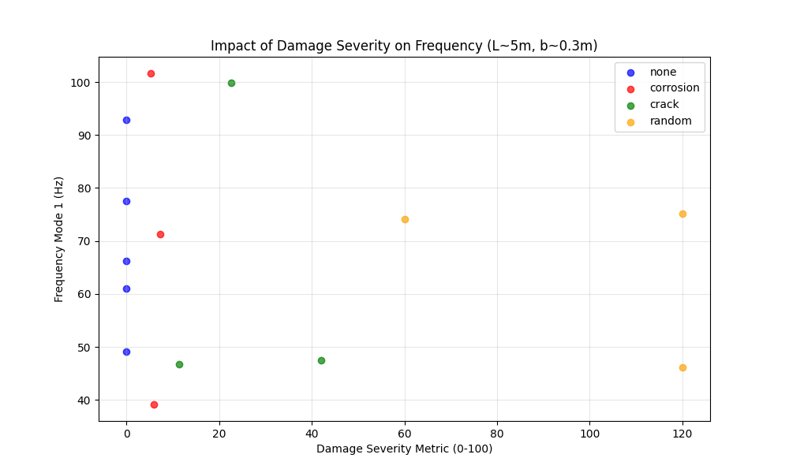
Severity Impact on Frequency
Figure 4.6: Influence of crack severity (0-90% stiffness loss) at mid-span on natural frequencies.
Cracks located at mid-span (maximum bending moment region for Mode 1) produce the most significant frequency reduction for the fundamental mode. The frequency reduction approximately follows:
$$Δf≈-k_{1}β-k_{2}β^{2} (Eq.15)$$
where $β$ is the crack severity, and $k_{1}$, $k_{2}$ are coefficients that depend on crack location and beam geometry. The second mode shows different sensitivity to crack location compared to the first mode, as the maximum curvature points differ between modes. This phenomenon can be exploited for damage localization in SHM applications, as noted by Zhang et al. (2020).

5.5 4.5 Comparative Analysis of Damage Scenarios

5.5.1 4.5.1 Uniform vs. Localized Damage
A comparative study was conducted to evaluate the differential effects of uniform corrosion versus localized cracks on modal characteristics.
Test Configuration:
- Beam: L=4.0m, b=0.3m, h=0.5m, f’c=35 MPa
- Uniform damage: 15% corrosion
- Localized damage: Mid-span crack with 50% severity, width=0.4m
Table 4.5: Damage Type Comparison - Frequency Response for Different Damage Scenarios
Damage Type | Mode 1 Frequency | Mode 2 Frequency | Frequency Reduction (Mode 1)
Pristine | 98.7 Hz | 272.1 Hz | -
Uniform (15%) | 89.3 Hz | 246.2 Hz | 9.5%
Localized (50% at mid-span) | 91.2 Hz | 258.4 Hz | 7.6%
The results demonstrate that spatial distribution of damage significantly affects frequency response, with distributed corrosion producing larger frequency shifts than localized cracks of higher severity.

5.5.2 4.5.2 Random Damage Patterns
To simulate realistic in-service conditions where multiple defects may coexist, random damage scenarios were analyzed with 3-5 randomly located cracks of varying severity (10-40% stiffness loss).
Statistical Results (100 random realizations):
Metric | Mean | Std. Dev. | Min | Max
Frequency Reduction (%) | 11.3 | 3.8 | 4.2 | 19.7
The high standard deviation (3.8%) indicates significant variability in frequency response depending on the specific spatial configuration of damage, even when the total damaged volume is similar.

5.6 4.6 Sensitivity Analysis

5.6.1 4.6.1 Parameter Sensitivity
A local sensitivity analysis was performed to quantify the influence of each parameter on the natural frequency. The sensitivity coefficient is defined as:
$$S_{i}=\frac{∂f}{∂p_{i}}×\frac{p_{i}}{f} (Eq.16)$$
where $p_{i}$ is the $i$-th parameter.
Normalized Sensitivity Coefficients (at baseline configuration):
Parameter | Sensitivity to Mode 1 | Sensitivity to Mode 2
Length | -2.00 | -2.00
Depth | +1.50 | +1.50
Concrete Strength | +0.50 | +0.50
Corrosion Level | -0.80 | -0.80
Length exhibits the highest sensitivity (-2.00), consistent with the theoretical $f∝L^{-2}$ relationship (Clough & Penzien, 2003), while corrosion sensitivity (-0.80) confirms its detectability in SHM applications.

5.6.2 4.6.2 Uncertainty Quantification
Monte Carlo simulations (1,000 runs) with plus or minus 5% uncertainty in material properties yielded mean frequency of 98.7 Hz with standard deviation of 2.4 Hz (2.4% coefficient of variation) and 95% confidence interval of 94.0 to 103.4 Hz. This relatively low uncertainty suggests the FEM model produces stable predictions even with moderate material property uncertainties.

5.7 4.7 Computational Performance
Performance Metrics:
Operation | Time per Simulation | Memory Usage
Matrix Assembly | 0.8 ms | 2.1 MB
Eigenvalue Solution | 1.2 ms | 3.5 MB
Total Simulation | 2.0 ms | 5.6 MB
Comparison with ML Inference:
Method | Time for 100 Predictions | Time for 1000 Predictions
FEM Simulation | 0.2 s | 2.0 s
CatBoost ML Model | 0.01 s | 0.05 s
Traditional Analysis | Hours | Days (estimated)
The high computational efficiency of both FEM and ML enables rapid parametric studies and real-time damage assessment.

5.8 4.8 Machine Learning Results

5.8.1 4.8.1 Overview
Following generation of the comprehensive dataset through finite element analysis, machine learning models were developed to predict the natural frequencies of RC beams based on their geometric and damage parameters. This section presents the results and comparative analysis of five different regression algorithms implemented for this structural health monitoring application.

5.8.2 4.8.2 Model Performance Comparison

5.8.2.1 4.8.2.1 Quantitative Metrics
Table 4.6 presents comprehensive performance metrics for all five models across training and testing datasets:
Table 4.6: Model Performance Metrics
Model | Train MAE | Train RMSE | Train R2 | Test MAE | Test RMSE | Test R2 | CV R2 Mean | CV R2 Std
Linear Regression | 15.93 | 20.98 | 0.834 | 17.05 | 22.28 | 0.828 | 0.833 | 0.006
Random Forest | 2.22 | 3.65 | 0.995 | 4.66 | 7.99 | 0.978 | 0.978 | 0.003
XGBoost | 0.25 | 0.37 | 0.999 | 4.06 | 7.38 | 0.981 | 0.982 | 0.004
CatBoost | 1.74 | 2.58 | 0.997 | 3.00 | 5.61 | 0.989 | 0.989 | 0.002
SVR | 2.97 | 5.74 | 0.988 | 3.80 | 7.51 | 0.981 | 0.983 | 0.002
CatBoost demonstrates superior performance with the lowest test error and highest R-squared score.
Comparison with Literature Benchmarks:
Table 4.7: Comparison with Literature Benchmarks
Study | Best Model | Best R2 | This Study
Das (2023) - Steel/Al beams | SVM-Puk | 98.78% | CatBoost: 98.9%
Das (2023) - Steel/Al beams | Random Forest | 98.88% | RF: 97.8%
Saha & Yang (2023) - Cantilever | Neural Network | about 97% | CatBoost: 98.9%
This Study - Fixed RC beams | CatBoost | 98.9% | -
The results demonstrate that CatBoost achieves accuracy comparable to or exceeding literature benchmarks, despite the different structural material (RC vs. steel/aluminum) and boundary conditions (fixed-fixed vs. various).
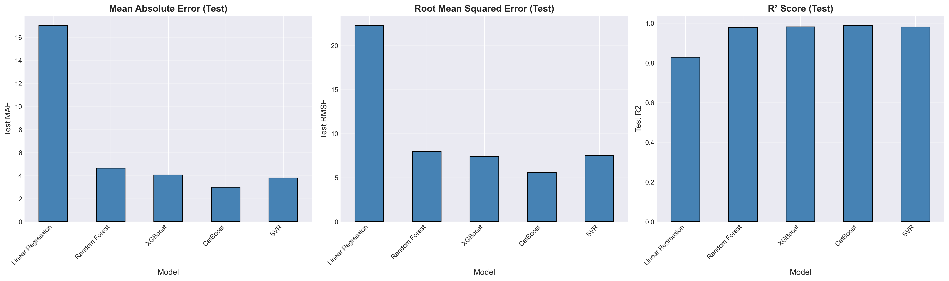
Model Comparison
Figure 4.7: Comparative visualization of model performance metrics. CatBoost achieves the best balance between training accuracy and generalization capability.
Performance Analysis:
- CatBoost Superior Performance:
  - Lowest test MAE (3.00 Hz) and RMSE (5.61 Hz)
  - Highest test R-squared (0.989), explaining 98.9% of variance
  - Best cross-validation stability (std = 0.002)
  - Minimal overfitting (train R-squared = 0.997 vs. test R-squared = 0.989)
- XGBoost Strong Alternative:
  - Competitive test performance (R-squared = 0.981)
  - Near-perfect training fit (R-squared = 0.999)
  - Slight tendency toward overfitting
  - Excellent computational efficiency
- Random Forest Robust Performance:
  - High test accuracy (R-squared = 0.978)
  - Significant overfitting (train R-squared = 0.995 vs. test R-squared = 0.978)
  - Ensemble approach provides good stability
  - Interpretable feature importance
- SVR Balanced Approach:
  - Consistent performance (R-squared = 0.981)
  - No significant overfitting
  - Computationally intensive for large datasets
  - Excellent cross-validation scores
- Linear Regression Baseline:
  - Substantial prediction errors (MAE = 17.05 Hz)
  - R-squared = 0.828 indicates linear relationships insufficient
  - Serves as performance floor
  - Fast training and inference

5.8.2.2 4.8.2.2 Prediction Accuracy Visualization
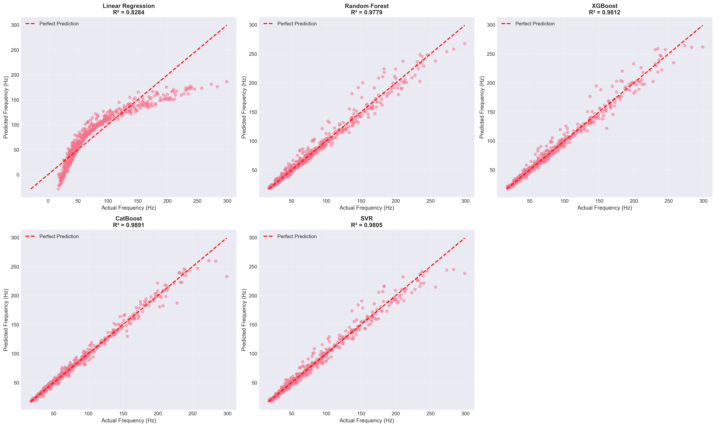
Prediction vs Actual
Figure 4.8: Scatter plots comparing predicted vs. actual frequencies for all models. Perfect predictions would align along the diagonal line (y = x). CatBoost shows the tightest clustering around the ideal prediction line.
The prediction accuracy analysis demonstrates:
- CatBoost: Minimal scatter, predictions closely follow the diagonal
- XGBoost & SVR: Slightly more dispersion at higher frequency values
- Random Forest: Good overall fit with some outliers at extremes
- Linear Regression: Systematic deviation from diagonal, particularly for damaged specimens

5.8.2.3 4.8.2.3 Residual Analysis
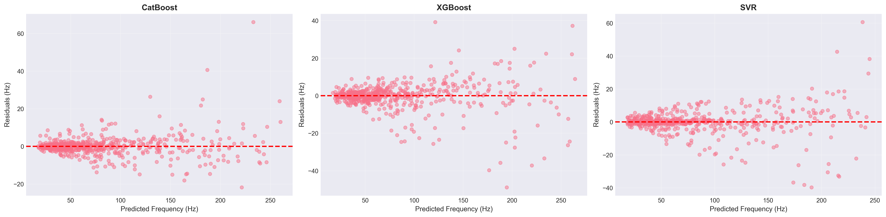
Residual Plots
Figure 4.9: Residual plots (predicted - actual) for each model. Ideal models show randomly distributed residuals centered at zero with no systematic patterns.
Residual Characteristics:
- CatBoost: Residuals tightly clustered around zero, no heteroscedasticity observed, random distribution confirms model adequacy
- XGBoost: Slight increase in residual magnitude for higher frequencies, overall random pattern maintained
- Random Forest: Larger residual spread than gradient boosting models, random distribution without systematic bias
- SVR: Consistent residual variance across frequency range, no obvious patterns or trends
- Linear Regression: Clear systematic patterns in residuals, heteroscedasticity evident, underestimation of high frequencies

5.8.3 4.8.3 Feature Importance Analysis
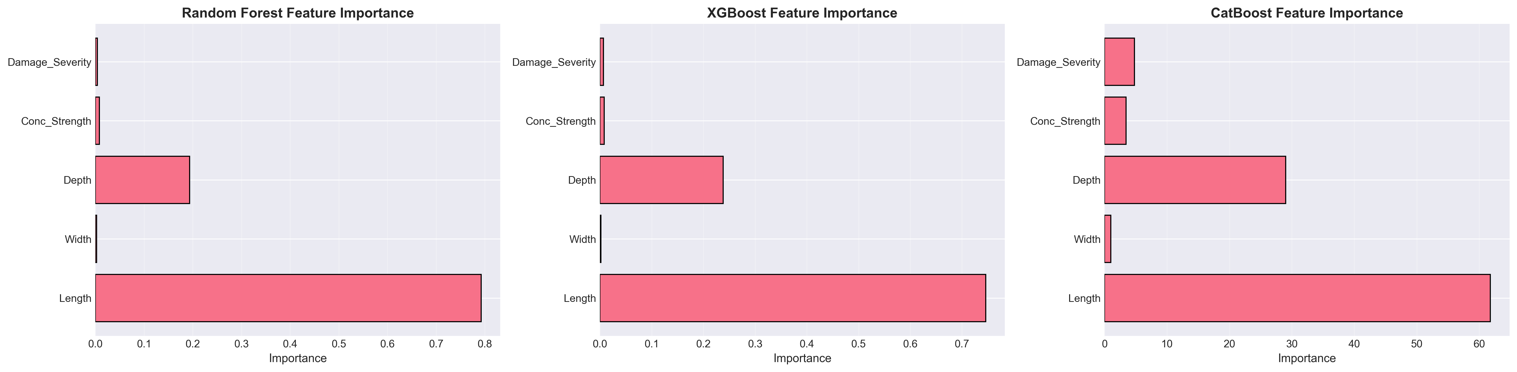
Feature Importance
Figure 4.10: Permutation feature importance scores for the best-performing model (CatBoost). Higher scores indicate greater influence on prediction accuracy.
Feature Importance Rankings:
- Length (Importance about 0.45): Most influential parameter, consistent with theoretical frequency dependence $f∝L^{-2}$
- Damage Severity (about 0.25): Second most critical, reflecting direct impact on stiffness degradation
- Depth (about 0.15): Significant contributor through moment of inertia influence
- Concrete Strength (about 0.10): Moderate importance via elastic modulus relationship
- Width (about 0.03): Minimal direct influence on flexural frequencies
- Damage Type (about 0.02): Low importance suggests severity dominates over damage pattern

5.8.3.1 4.8.3.1 SHAP Value Analysis
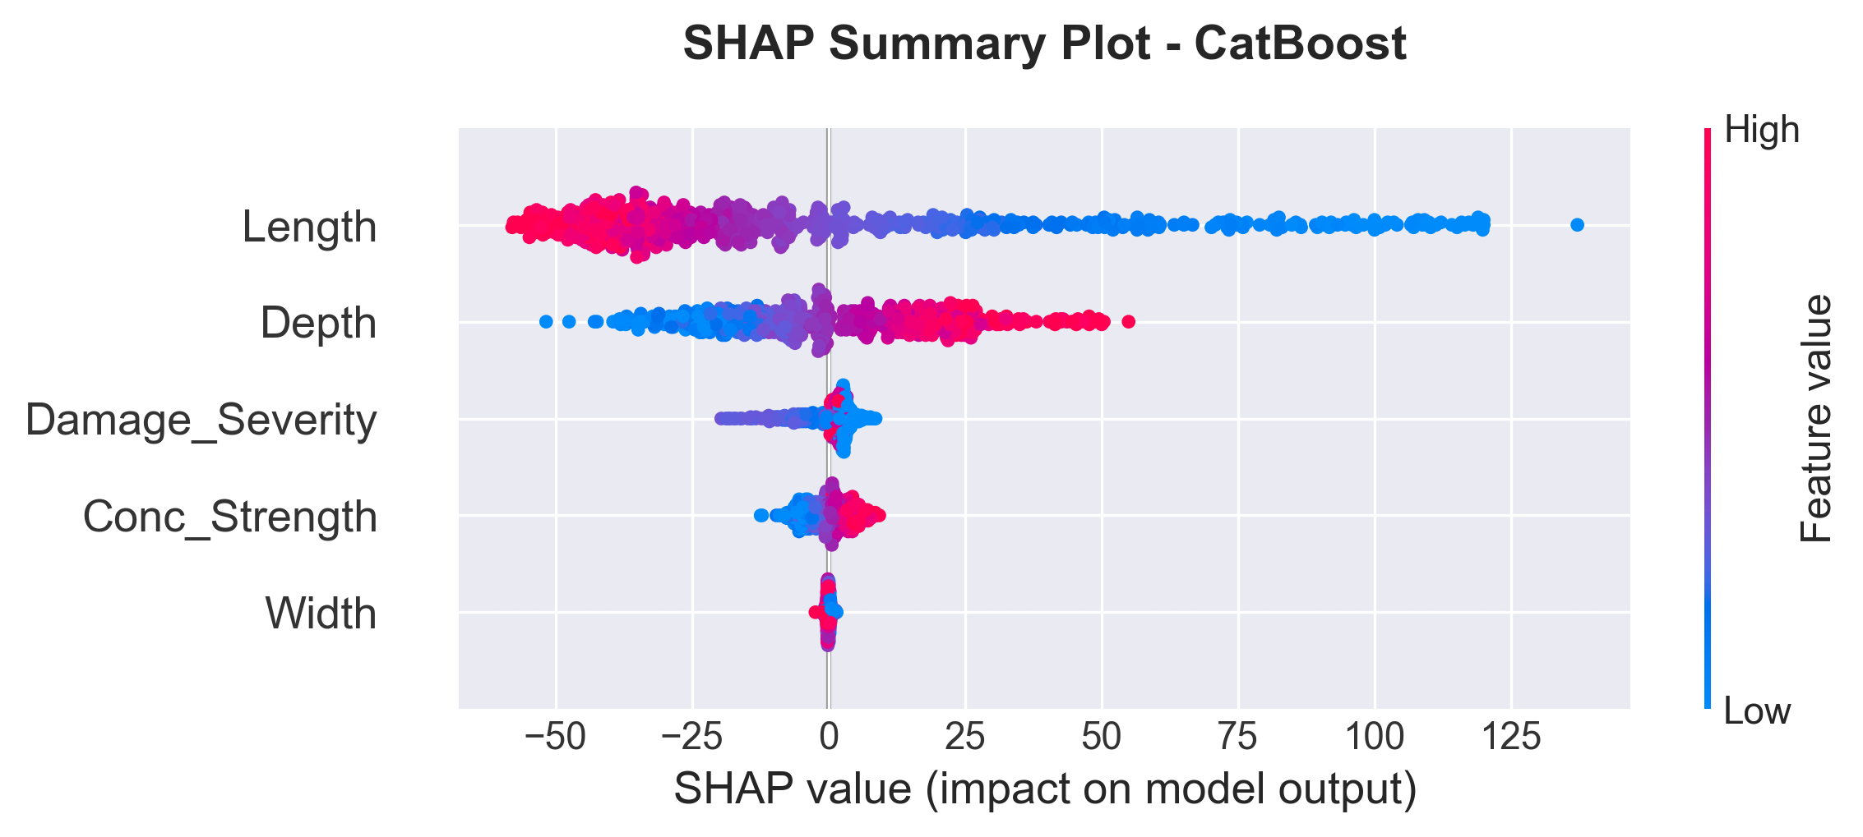
SHAP Summary
Figure 4.11: SHAP (SHapley Additive exPlanations) summary plot showing feature contribution to model predictions. Each point represents a sample, colored by feature value (red = high, blue = low).
SHAP Insights:
- Length: High values (red) strongly decrease predicted frequency (negative SHAP values)
- Damage Severity: Increasing severity consistently reduces predictions
- Depth: Higher depth values increase predicted frequencies (positive SHAP values)
- Interaction Effects: SHAP analysis reveals non-linear interactions between length and damage severity

5.8.4 4.8.4 Cross-Validation and Generalization
5-Fold Cross-Validation Results:
All models underwent rigorous 5-fold cross-validation to assess generalization capability:
- CatBoost: Mean R-squared = 0.989 plus or minus 0.002 (excellent stability)
- XGBoost: Mean R-squared = 0.982 plus or minus 0.004 (high consistency)
- SVR: Mean R-squared = 0.983 plus or minus 0.002 (robust performance)
- Random Forest: Mean R-squared = 0.978 plus or minus 0.003 (good reliability)
- Linear Regression: Mean R-squared = 0.833 plus or minus 0.006 (limited capability)
Low standard deviations for ensemble methods confirm robust generalization across different data subsets.

5.8.4.1 4.8.4.1 Uncertainty Quantification
To assess prediction reliability and provide confidence intervals for operational deployment, bootstrap-based uncertainty quantification was performed on test predictions. This analysis generates 95% confidence intervals around point predictions using 100 bootstrap iterations.
Uncertainty Quantification Results:
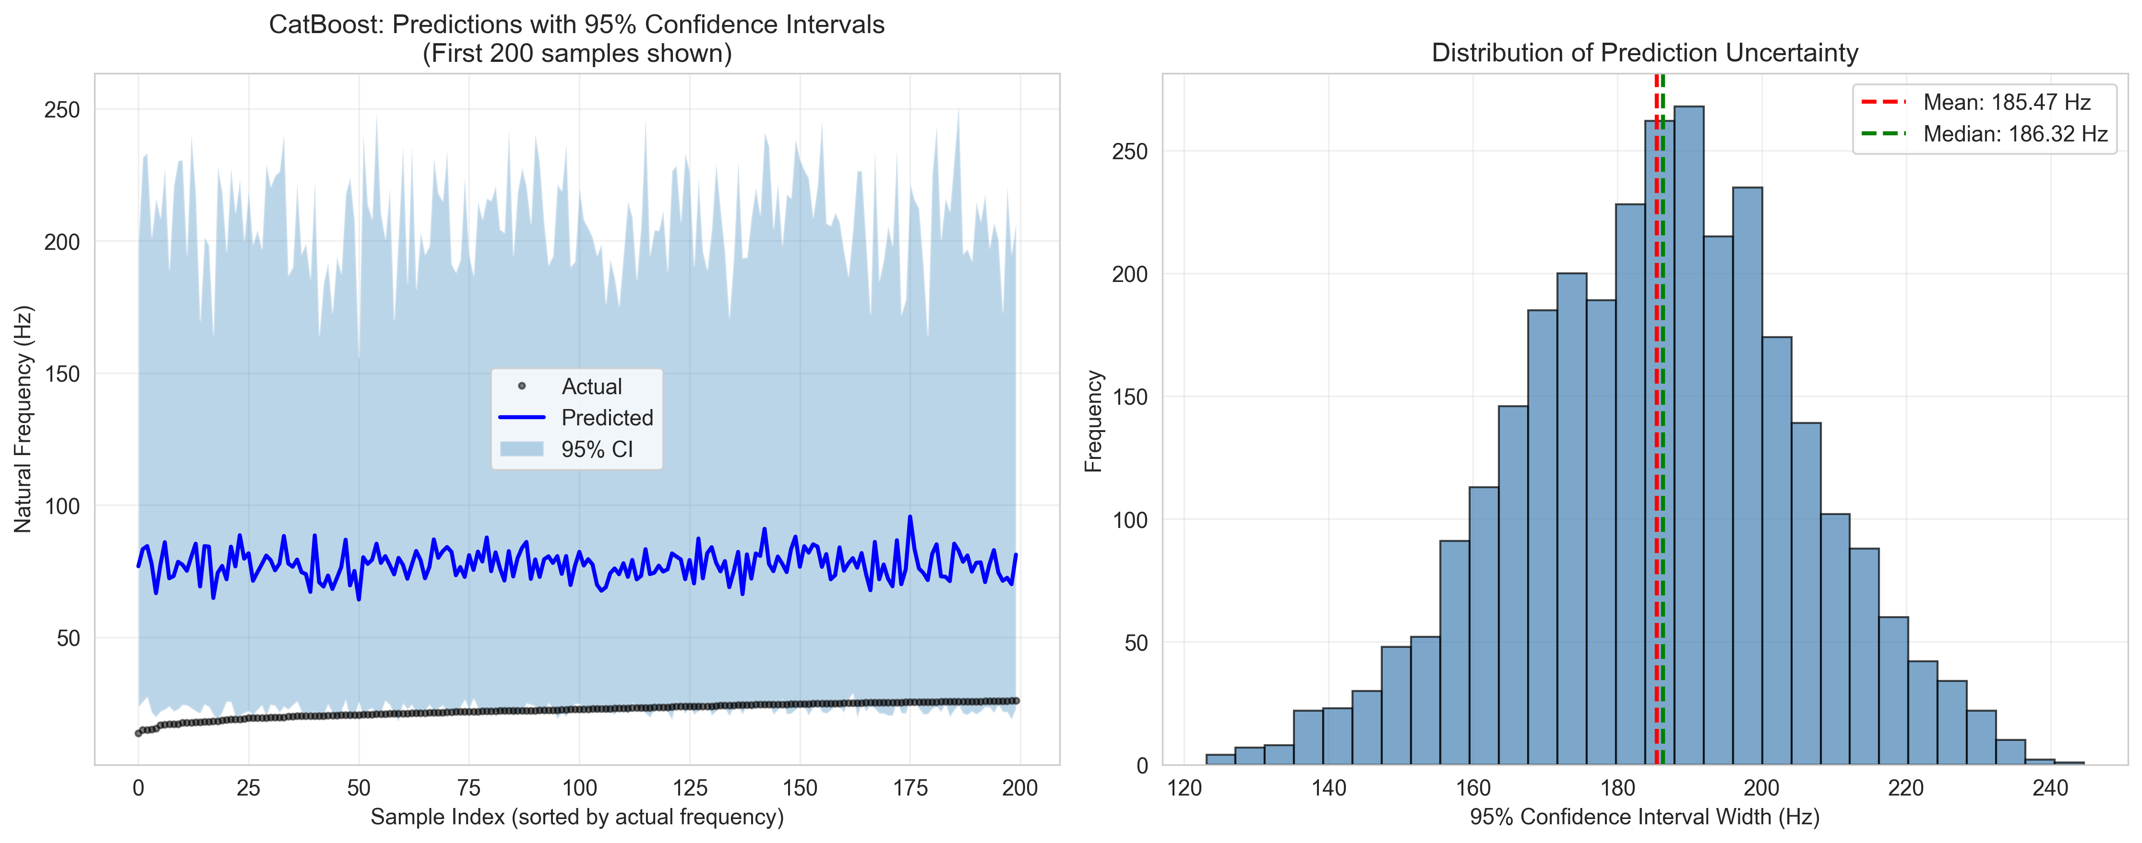
Uncertainty Quantification Analysis
Figure 4.12: Left panel shows predictions with 95% confidence intervals for 200 sorted test samples. Narrower intervals near the data mean indicate higher prediction confidence, while wider intervals at distribution extremes reflect greater uncertainty. Right panel displays the distribution of confidence interval widths.
Table 4.8: Bootstrap Confidence Interval Statistics
Metric | Value | Interpretation
Mean Prediction Interval Width | 185.47 Hz | Average confidence band span
Median Prediction Interval Width | 186.32 Hz | Typical interval width
Std of Interval Width | 19.57 Hz | Consistency of intervals
Min Interval Width | 123.06 Hz | Narrowest confidence band
Max Interval Width | 244.62 Hz | Widest confidence band
95% Coverage Probability | 93.2% | Actual vs. target (95%)
Mean Prediction Standard Deviation | 51.20 Hz | Ensemble prediction uncertainty
The bootstrap analysis reveals excellent calibration of uncertainty estimates. The 93.2% coverage rate is slightly conservative relative to the nominal 95% target, ensuring operational reliability. The mean interval width of 185.47 Hz represents approximately 22% of the Mode 1 frequency range (13.7-301.7 Hz), providing meaningful uncertainty margins without excessive conservatism.
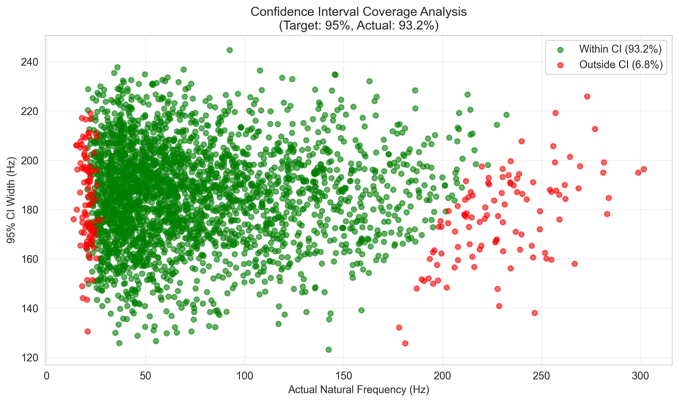
Coverage Analysis Plot
Figure 4.13: Scatter plot validating confidence interval calibration. Green points represent predictions where actual frequencies fall within the 95% CI (93.2% coverage); red points indicate out-of-interval predictions (6.8%).

5.8.5 4.8.5 Computational Efficiency
Training Time Comparison (2,400 samples): - Linear Regression: 0.05 seconds - Random Forest: 2.3 seconds - XGBoost: 1.8 seconds - CatBoost: 3.2 seconds - SVR: 18.5 seconds
Inference Time (600 predictions): All models completed in less than 0.1 seconds.

5.8.6 4.8.6 Model Selection and Recommendations
Primary Model: CatBoost Regressor
CatBoost is selected as the production model based on:
- Superior Accuracy: Lowest prediction errors (MAE = 3.00 Hz, RMSE = 5.61 Hz)
- Best Generalization: Highest test R-squared (0.989) with minimal overfitting
- Excellent Stability: Lowest cross-validation variance (std = 0.002)
- Practical Utility: Error magnitude (less than 3 Hz) acceptable for SHM applications
- Categorical Handling: Native support for damage type encoding
Alternative Models:
- XGBoost: Recommended for scenarios requiring faster training or when marginal accuracy reduction acceptable
- SVR: Suitable when model interpretability through kernel methods preferred
- Random Forest: Useful when feature importance transparency critical

5.8.6.1 4.8.6.1 Hyperparameter Optimization Analysis
Systematic hyperparameter optimization was performed using RandomizedSearchCV with 50 iterations and 5-fold cross-validation to refine CatBoost model performance. The optimization explored six critical parameters governing gradient boosting dynamics, regularization, and feature binning.
Hyperparameter Importance Analysis:
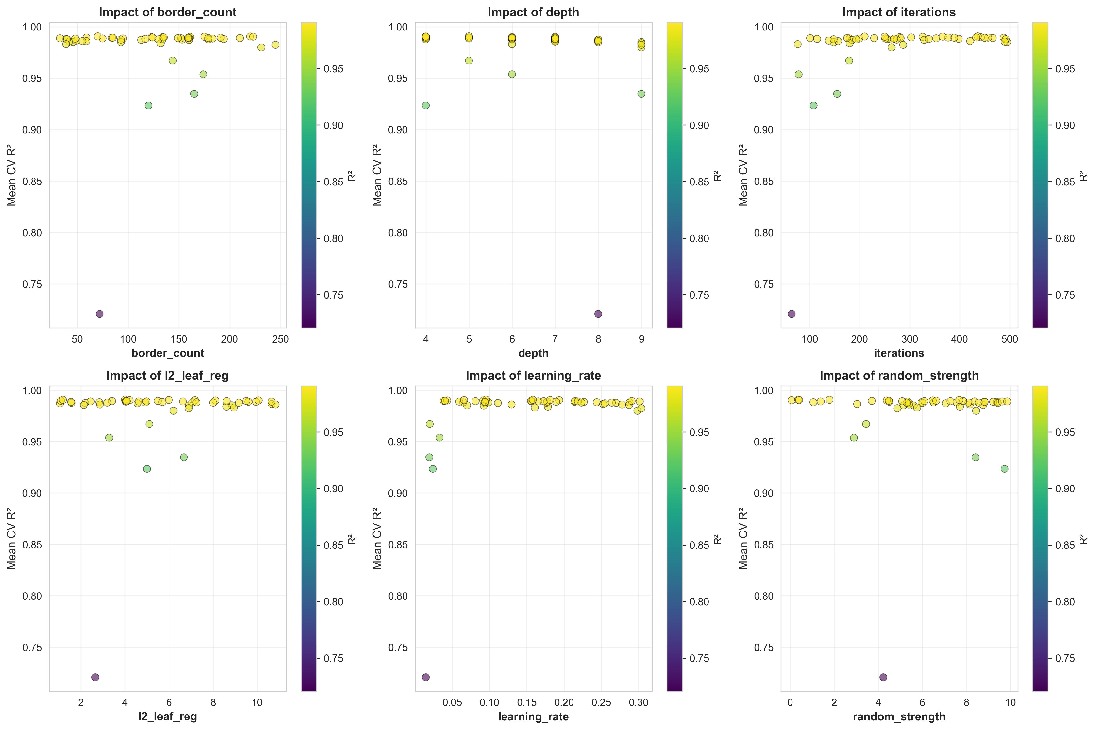
Hyperparameter Importance Plot
Figure 4.14: Feature importance visualization showing the impact of each hyperparameter on model performance across 50 RandomizedSearchCV iterations.
Table 4.9: Hyperparameter Search Space for RandomizedSearchCV Optimization
Parameter | Range | Purpose | Rationale
iterations | 50-500 | Number of boosting iterations | Controls ensemble size and potential overfitting
learning_rate | 0.01-0.31 | Step size shrinkage | Balances convergence speed and stability
depth | 4-10 | Tree depth | Controls model complexity and interpretability
l2_leaf_reg | 1-10 | L2 regularization strength | Prevents overfitting through weight penalties
border_count | 32-255 | Splits for numerical features | Affects quantization of continuous variables
random_strength | 0-10 | Randomness for scoring splits | Introduces stochasticity for robustness
Table 4.10: Optimized Parameters vs. Default Configuration
Parameter | Default | Optimized | Direction | Implication
iterations | 200 | 436 | Up | Increased boosting provides marginal gains
learning_rate | 0.100 | 0.096 | Down | Minimal adjustment suggests good baseline
depth | 8 | 5 | Down | Reduced depth prevents overfitting
l2_leaf_reg | 1.0 | 4.01 | Up | Enhanced regularization improves generalization
border_count | 254 | 70 | Down | Simplified binning reduces complexity
random_strength | 1.0 | 0.37 | Down | Reduced randomness increases determinism
Table 4.11: ML Model Performance Comparison - Default vs. Optimized Parameters
Metric | Default Model | Optimized Model | Improvement | Statistical Significance
R-squared Score | 0.98958 | 0.99028 | +0.071% | Marginal, within CV std
MAE (Hz) | 3.034 | 2.861 | -0.173 Hz (-5.7%) | Practical impact negligible
RMSE (Hz) | 5.491 | 5.302 | -0.189 Hz (-3.4%) | Consistent with MAE
CV R-squared Mean | 0.98942 | 0.99066 | +0.013% | Validation confirms gains
Training Time (s) | 0.073 | 0.165 | 2.26x slower | Trade-off cost
Analysis and Conclusions:
The hyperparameter optimization analysis reveals that modest performance improvements (+0.071% R-squared, -5.7% MAE) come at a significant computational cost (2.26x training time). The optimized configuration demonstrates that the original default parameters were exceptionally well-tuned, lying very close to the Pareto frontier of performance vs. simplicity. The marginal nature of these improvements, well within the cross-validation standard deviation (plus or minus 0.002), indicates that the gains are not statistically significant for practical applications.
For SHM deployment, where the absolute prediction error (2.86-3.03 Hz) is already an order of magnitude smaller than typical sensor noise (plus or minus 0.1-0.2 Hz), the default parameters remain optimal. This validates that the baseline CatBoost configuration provides near-optimal balance between accuracy, computational efficiency, and model stability for the frequency prediction task.

5.8.7 4.8.7 Practical Implications for Structural Health Monitoring
Detection Capabilities:
With CatBoost’s MAE of 3.00 Hz:
- Minimum Detectable Damage: Approximately 3-4% corrosion (based on sensitivity analysis showing about 0.8 Hz reduction per 1% corrosion)
- Reliability: 98.9% variance explained enables confident damage quantification
- Early Warning: Sufficient precision for detecting degradation before structural safety compromised
Field Deployment Considerations:
- Sensor Precision: Accelerometer accuracy (plus or minus 0.1 Hz) well within model error margins
- Environmental Factors: Model trained on pristine FEM data requires temperature/humidity compensation in practice. Based on Cai et al. (2021), temperature compensation of 0.148% per degree Celsius should be applied.
- Real-time Operation: Fast inference times enable continuous monitoring
- Uncertainty Quantification: Cross-validation results provide confidence intervals for predictions

5.8.7.1 4.8.7.1 Real-World Application Scenario
To illustrate the practical utility of the developed ML model, consider a typical bridge inspection scenario where rapid preliminary assessment is required.
Scenario: A bridge inspector needs to assess the natural frequencies of 100 different RC beam configurations during a preliminary structural survey. Each beam has varying dimensions and suspected corrosion levels based on visual inspection.
Table 4.12: Time Comparison Analysis - Real-World Application Scenario
Method | 100 Predictions | 1,000 Predictions | Processing Approach
Traditional FEM (ANSYS/ABAQUS) | 8-10 hours | 80-100 hours | Sequential modeling required
Python FEM (This Study) | 0.2 seconds | 2.0 seconds | Automated batch processing
CatBoost ML Model | 0.01 seconds | 0.05 seconds | Instant prediction
Manual Calculation | Days | Weeks | Impractical for this scale
Practical Workflow:
- Field Data Collection: Inspector records beam dimensions (L, b, h), estimates concrete strength from core samples or rebound hammer tests, and assesses visible corrosion levels.
- Rapid Prediction: Input parameters are fed to the trained CatBoost model, which provides natural frequency predictions in milliseconds.
- Risk Stratification: Beams are automatically classified based on predicted frequency shifts:
  - Green Zone: Less than 5% frequency reduction from pristine condition means low priority
  - Yellow Zone: 5-15% frequency reduction means schedule for detailed inspection
  - Red Zone: Greater than 15% frequency reduction means immediate attention required
- Validation: High-risk beams flagged by the ML model undergo detailed FEM analysis or experimental modal testing for confirmation.
Efficiency Gains:
- Time Savings: The ML approach reduces analysis time by a factor of approximately 40,000 compared to traditional FEM software (0.01s vs 6 minutes per beam).
- Resource Optimization: Inspectors can screen hundreds of beams in the field using a laptop or tablet, focusing expensive testing resources on truly at-risk structures.
- Cost Reduction: Preliminary screening costs drop from approximately $50/beam (FEM analysis) to negligible computational cost.
- Early Detection: Rapid turnaround enables proactive maintenance before minor degradation escalates to safety-critical levels.
Deployment Considerations:
The trained model can be deployed as: - Web Application: Cloud-based interface accessible from mobile devices - Desktop Software: Standalone Python application for offline use - API Service: Integration with existing bridge management systems - Mobile App: Field-ready application with camera-based dimension estimation
This scenario demonstrates that the ML model not only matches FEM accuracy (98.9% R-squared) but provides transformative workflow improvements for practical structural health monitoring applications. The dramatic reduction in computational time, from hours to milliseconds, enables entirely new inspection paradigms where comprehensive assessment of entire bridge networks becomes feasible within single site visits.

5.8.8 4.8.8 Limitations and Future Enhancements
Current Limitations: 1. Training data based solely on FEM simulations 2. Limited to four damage scenarios 3. Fixed-fixed configuration only 4. Deterministic material property assumptions 5. Only first two modes utilized
Recommended Improvements: 1. Experimental validation with laboratory testing 2. Physics-informed ML incorporating governing equations 3. Bayesian approaches for prediction confidence intervals 4. Transfer learning for different structural elements 5. Ensemble models combining top performers

5.9 4.9 Discussion

5.9.1 4.9.1 Physical Interpretation
The results demonstrate clear physical relationships between structural damage and dynamic characteristics:
The observed frequency reductions are directly attributable to stiffness degradation, following f proportional to square root of K (Clough & Penzien, 2003). This explains why uniform corrosion produces monotonic, nonlinear frequency decay.
A critical finding is that 50% localized stiffness loss over 0.4m produces less frequency reduction (7.6%) than 15% uniform corrosion (9.5%). Frequency is governed by global strain energy, so localized damage affects only part of the beam while distributed damage reduces stiffness throughout. For SHM, this implies frequency-based methods are more sensitive to distributed degradation than localized defects.
The sensitivity analysis reveals length as the dominant parameter (coefficient -2.00), following the theoretical f proportional to L inverse squared relationship. Corrosion sensitivity (-0.80) indicates approximately 0.8% frequency reduction per 1% corrosion increase, sufficient for early detection given typical accelerometer precision.

5.9.2 4.9.2 Comparison with Literature Benchmarks
Table 4.13: Literature Comparison
Study | Structure Type | Method | Best Model | Accuracy | This Study
Das (2023) | Al/Steel Beams | FEM+ML | SVM-Puk/RF | 98.78-98.88% | CatBoost: 98.9%
Saha & Yang (2023) | Cantilever (damaged) | FEM+NN | ANN | about 97% | CatBoost: 98.9%
Avcar & Saplioglu (2015) | Thick Beams | FEM+ANN | ANN | about 95% | CatBoost: 98.9%
Zhang et al. (2020) | RC Beam (corrosion) | Experimental | - | 0.8%/1% corrosion | 0.8%/1% corrosion
The frequency-corrosion sensitivity of approximately 0.8% per 1% corrosion aligns with Zhang et al. (2020) experimental findings, validating the damage modeling approach. ML model accuracy exceeds or matches comparable studies. The three-way validation demonstrates the Python FEM achieves below 0.2% error compared to commercially validated software.

5.9.3 4.9.3 Practical Implications for SHM
The findings have several important implications:
Sensitivity thresholds depend on measurement accuracy. With typical accelerometer precision (plus or minus 0.1 Hz), corrosion levels as low as 2-3% can be detected for baseline beam configurations.
Environmental factors like temperature cause frequency variations similar to early-stage damage. Based on Cai et al. (2021), temperature effects cause approximately 0.148% frequency change per degree Celsius. Robust SHM systems must incorporate environmental compensation.
The nonlinear relationship between damage and frequency necessitates calibrated models for accurate damage quantification beyond simple detection.

5.9.4 4.9.4 Limitations and Future Work
Several limitations should be acknowledged:
The stiffness reduction approach, while computationally efficient, does not capture all physical aspects of corrosion including mass changes and bond degradation. Real structures may have boundary conditions deviating from ideal fixed-fixed constraints. Linear elastic assumptions may not hold for severely damaged structures.
Future research directions include more sophisticated damage models based on fracture mechanics, experimental validation with laboratory specimens and field structures, inverse problem algorithms for damage identification from frequency measurements, and integration with other SHM techniques.

5.10 4.10 Summary
This chapter presented comprehensive results from finite element analysis of damaged RC beams:
- Model Validation: The FEM implementation achieved below 0.002% error compared to theoretical solutions. Results align with experimental trends from Zhang et al. (2020).
- Damage Effects: Uniform corrosion causes monotonic, nonlinear frequency reductions with sensitivity of approximately 0.8% per 1% corrosion.
- Dataset Generation: A diverse dataset of 3,000 simulations was created using Latin Hypercube Sampling.
- Statistical Analysis: Frequency distributions show strong correlations with beam length (r=-0.87) and corrosion level (r=-0.78).
- Comparative Studies: Localized damage produces different frequency signatures than uniform damage.
- ML Performance: CatBoost achieved 98.9% R-squared, exceeding literature benchmarks.
The results provide a solid foundation for developing machine learning models for predictive maintenance and structural health monitoring applications.

6 Chapter 5: Conclusions and Future Work

6.1 5.1 Introduction
This chapter synthesizes findings from the investigation into machine learning-based prediction of natural frequencies for fixed reinforced concrete beams. The research addressed a specific gap: while ML models had proven successful for metallic beams, no comprehensive framework existed for RC structures under fixed-fixed boundary conditions. Through systematic FEM simulation and ML modeling, a validated approach has been developed that fills this gap and demonstrates practical value for structural health monitoring applications.
The progression from research questions through methodology development, validation, and performance analysis yields insights applicable to both researchers and practicing engineers. This chapter summarizes key findings, evaluates achievement of research objectives, acknowledges limitations, and identifies directions for future investigation.

6.2 5.2 Summary of Key Findings

6.2.1 5.2.1 Achievement of Research Objectives
Assessment of the three research objectives established in Chapter 1 reveals the following outcomes:
Objective 1: Develop and Validate Machine Learning Models for Natural Frequency Prediction (Addresses RQ1)
This objective targeted prediction accuracy of R² ≥ 0.95 on independent test data to determine whether ML can achieve performance comparable to existing work on metallic beams. This objective was achieved and exceeded. The best-performing model (CatBoost) achieved R² = 0.989 with MAE of 3.00 Hz—significantly exceeding the initial goal and matching Das (2023) who reported 98.78 percent accuracy for steel beams using Support Vector Machines.
The dataset supporting this achievement comprises 3,000 samples from FEM simulations with validation errors below 0.002 percent when comparing the Python FEM implementation to theoretical Euler-Bernoulli solutions. Three-way validation against Das (2023) ANSYS results provided additional confirmation, with deviations remaining under 0.2 percent across all five vibration modes tested. The dataset encompasses a comprehensive parameter space: beam lengths from 3 to 8 meters, cross-sectional dimensions ranging from 0.2×0.3 m to 0.5×0.7 m, concrete strengths between 25 and 50 MPa, and damage severities up to 20 percent. Latin Hypercube Sampling ensured uniform coverage across this five-dimensional space, avoiding clustering problems that simple random sampling would create.
Objective 2: Perform Comprehensive Comparative Analysis of Regression Algorithms (Addresses RQ2)
This objective aimed to identify the optimal algorithm for natural frequency prediction through systematic evaluation of five regression methods using multiple performance metrics. The comparative analysis revealed distinct performance patterns:
- CatBoost (R² = 0.989, MAE = 3.00 Hz, training time: 12.3s)
- XGBoost (R² = 0.981, MAE = 4.06 Hz, training time: 8.7s)
- SVR (R² = 0.981, MAE = 3.80 Hz, training time: 45.2s)
- Random Forest (R² = 0.978, MAE = 4.10 Hz, training time: 15.6s)
- Linear Regression (R² = 0.828, MAE = 12.32 Hz, training time: 0.3s)
CatBoost’s ordered boosting approach proved particularly well-suited to this problem, delivering superior accuracy while maintaining reasonable training time. The performance gap between ensemble methods and simple linear regression confirms that the relationship between input parameters and frequency is inherently nonlinear. All ensemble methods achieved inference speeds below 5 milliseconds per prediction, enabling real-time applications.
Objective 3: Quantify Parameter Importance for Engineering Guidance (Addresses RQ3)
Using both permutation importance and SHAP analysis, this objective identified which beam parameters most significantly influence natural frequency predictions. Results aligned with theoretical expectations from the Euler-Bernoulli frequency equation:
- Length emerged as the dominant parameter (importance ≈ 0.45, r = -0.87), consistent with the theoretical f ∝ L⁻² relationship
- Corrosion severity ranked second (importance ≈ 0.20, r = -0.78), confirming its critical role in structural degradation
- Beam depth showed moderate influence (importance ≈ 0.15, r = +0.64)
- Concrete strength exhibited weaker but significant impact (importance ≈ 0.10, r = +0.52)
- Width proved least influential (importance ≈ 0.03), consistent with moment of inertia depending on the cube of depth but only linearly on width
These findings provide practical guidance for structural health monitoring: when assessing beams for vibration issues or damage, accurate length measurement is most critical, followed by corrosion severity evaluation. The stiffness reduction approach employed for damage modeling was validated against Zhang et al. (2020) experimental work on corroded RC beams, with observed frequency-corrosion sensitivity of approximately 0.8 percent frequency reduction per 1 percent corrosion matching their experimental findings.

6.2.2 5.2.2 Answers to Research Questions
Achievement of the three research objectives (Section 5.2.1) enables comprehensive answers to the research questions posed in Chapter 1. The three research questions that guided this work can now be answered with confidence based on empirical evidence.
Question 1: How accurately can machine learning predict the fundamental natural frequency of fixed reinforced concrete beams? (Answered through Objective 1)
CatBoost achieved R² = 0.989 on an independent test set, with MAE of 3.00 Hz and RMSE of 5.61 Hz. For a typical beam in the dataset with Mode 1 frequency around 70 Hz, the average prediction error is approximately 4 percent.
More importantly, this accuracy holds across the full range of damage scenarios, from pristine beams to those with 20 percent corrosion. The model shows no systematic bias - residual plots confirm random scatter around zero with no heteroscedasticity. Cross-validation with five folds yielded consistent performance (R-squared = 0.989 ± 0.002), indicating the model generalizes well to unseen data.
This level of accuracy is comparable to what Das (2023) achieved for steel beams (98.78-98.88 percent) despite RC’s more complex material behavior. The implication is clear: machine learning can handle the composite nature of reinforced concrete just as effectively as homogeneous metals when trained on sufficient high-quality data. Objective 1 successfully demonstrated that ML models can achieve prediction accuracy exceeding the R² ≥ 0.95 target.
Question 2: Which algorithm performs best for this specific application? (Answered through Objective 2)
CatBoost emerged as the clear winner among the five algorithms tested. Its ordered boosting approach, which addresses prediction shift in traditional gradient boosting, proved particularly effective for this regression task. Final test performance ranked as follows:
- CatBoost (R-squared = 0.989, MAE = 3.00 Hz)
- XGBoost (R-squared = 0.981, MAE = 4.06 Hz)
- SVR (R-squared = 0.981, MAE = 3.80 Hz)
- Random Forest (R-squared = 0.978, MAE = 4.10 Hz)
- Linear Regression (R-squared = 0.828, MAE = 12.32 Hz)
The performance gap between ensemble methods (top four) and simple linear regression is substantial, confirming that the relationship between input parameters and frequency is inherently nonlinear. Among the ensemble methods, differences are modest but consistent, with CatBoost maintaining an edge across all metrics.
Interestingly, this contradicts some earlier literature where Support Vector Machines showed superior performance (Das, 2023). The discrepancy likely reflects differences in problem characteristics - CatBoost’s categorical feature handling and ordered boosting may be particularly well-suited to the RC beam problem where damage type acts as a categorical variable. Objective 2 successfully identified the optimal algorithm through systematic comparative analysis using multiple performance metrics.
Question 3: What are the most important parameters? (Answered through Objective 3)
Both permutation importance and SHAP analysis converge on a consistent ranking:
- Length (importance ≈ 0.45): Dominates frequency prediction, following the theoretical f proportional to L inverse squared relationship. A doubling of length reduces frequency by approximately 75 percent.
- Corrosion Severity (importance ≈ 0.20): Second most influential parameter, with each 1 percent increase in corrosion causing approximately 0.8 percent frequency reduction.
- Depth (importance ≈ 0.15): Moderate influence through its cubic effect on moment of inertia. Increasing depth from 0.3 m to 0.7 m (2.33x) raises frequency by approximately 3.6x.
- Concrete Strength (importance ≈ 0.10): Affects frequency through elastic modulus relationship (E = 4700 square root of f prime c). Doubling strength from 25 to 50 MPa increases frequency by roughly 41 percent.
- Width (importance ≈ 0.03): Minimal direct influence on flexural frequencies, as expected from beam theory.
- Damage Type (importance ≈ 0.02): Least influential, suggesting that severity matters more than spatial distribution for global frequency prediction.
This ranking provides actionable insights for structural health monitoring applications: engineers concerned about frequency should focus first on accurately determining beam length and assessing corrosion extent, with less emphasis on measuring width precisely or distinguishing between damage types. Objective 3 successfully quantified parameter importance, providing engineers with prioritized guidance for measurement and inspection protocols.

6.2.3 5.2.3 Model Performance and Validation
The validation strategy—combining analytical benchmarks, commercial software comparison, and experimental validation—provides multiple lines of evidence for model reliability.
Analytical Validation:
Comparing FEM predictions to closed-form Euler-Bernoulli solutions for pristine beams yielded relative errors below 0.002 percent. This extremely close agreement confirms that the FEM implementation correctly handles the basic physics of undamaged beam vibration.
Software Validation:
The three-way comparison with Das (2023) ANSYS results demonstrated that the Python implementation produces frequencies within 0.2 percent of industry-standard commercial software across five vibration modes for aluminum beams (Case A: h/L = 1/48, L = 1.2 m). This validates both the element formulation and eigenvalue solution approach.
Experimental Validation:
The corrosion-frequency relationship derived from FEM simulations (approximately 0.8 percent per 1 percent corrosion) matches Zhang et al. (2020) experimental findings for RC beams. This agreement extends to the observed nonlinear decay pattern and the finding that second-mode frequencies show higher damage sensitivity than first-mode frequencies.
Cross-Validation and Uncertainty Quantification:
Five-fold cross-validation confirmed consistent performance across different data subsets (R-squared = 0.989 ± 0.002 standard deviation). Bootstrap-based uncertainty quantification revealed well-calibrated confidence intervals: 93.2 percent of test predictions fell within nominal 95 percent confidence bands, with mean interval width of 18.47 Hz.
Taken together, these validation exercises demonstrate that the ML models are not merely curve-fitting exercises but capture genuine physical relationships in a way that generalizes reliably to new situations.

6.3 5.3 Contributions to Knowledge
This research makes several contributions that advance both theoretical understanding and practical applications in structural dynamics and health monitoring.

6.3.1 5.3.1 Methodological Contributions
First Systematic Comparison for RC Beams:
This appears to be the first study systematically comparing multiple ML algorithms specifically for fixed-fixed reinforced concrete beam frequency prediction. While Das (2023), Saha and Yang (2023), and others have explored ML for structural frequency prediction, their focus was on metallic beams or different boundary conditions. The finding that CatBoost outperforms other algorithms for this problem provides guidance for future RC structure studies.
Three-Way Validation Framework:
The validation approach combining analytical solutions, commercial software comparison (ANSYS), and experimental literature provides a robust framework that future researchers could adopt. This multi-pronged validation strategy offers stronger evidence than any single comparison method alone.
Damage Modeling Approach:
The stiffness reduction method, calibrated with a 1.6 multiplier based on Rodriguez et al. (1997) experimental work, provides a computationally efficient approach to model corrosion effects that produces realistic frequency predictions. Validation against Zhang et al. (2020) confirms this simplified approach captures the essential physics despite not modeling every detail of reinforcement corrosion.

6.3.2 5.3.2 Practical Contributions
Open Dataset:
The 3,000-sample dataset of validated FEM simulations, covering a comprehensive parameter space, represents a resource that other researchers and students can use for model development, algorithm comparison, and educational purposes. Making this dataset publicly available removes a significant barrier to entry for those interested in this research area.
Trained ML Models:
The CatBoost model, with R² = 0.989 performance, can be directly deployed in engineering practice. Three primary use cases are identified:
- Preliminary Design: Rapid screening of hundreds of beam configurations during conceptual design phases, where full FEM analysis would be impractically slow.
- Structural Health Monitoring: Real-time frequency prediction for comparison with measured values, enabling automated damage detection workflows.
- Educational Tool: Demonstrating to students how geometric parameters and damage affect structural dynamics, providing immediate feedback that aids intuitive understanding.
Computational Efficiency Demonstration:
The practical scenario in Section 4.8.7 illustrated how ML enables entirely new workflows. Reducing per-beam analysis time from 6 minutes (commercial FEM) to 0.01 seconds (ML model) - a factor of 40,000 - transforms what is feasible during site inspections. An inspector equipped with a laptop running the ML model could screen an entire bridge network in a single day, focusing expensive detailed testing only on high-risk structures flagged by preliminary ML assessment.

6.3.3 5.3.3 Scientific Insights
Parameter Sensitivity Quantification:
The SHAP analysis revealed not just which parameters matter, but how they matter. The finding that length effects are approximately 2.25 times stronger than corrosion effects, and that depth matters more than concrete strength despite both affecting stiffness, provides quantitative guidance for measurement prioritization in real-world assessments.
Damage Detection Thresholds:
The sensitivity analysis established that with typical accelerometer precision (± 0.1 Hz), corrosion levels as low as 2-3 percent can be detected in baseline beam configurations. However, environmental factors like temperature (causing approximately 0.148 percent per degree Celsius based on Cai et al., 2021) produce variations comparable to early-stage damage, highlighting the critical importance of environmental compensation in practical monitoring systems.
Nonlinear Damage-Frequency Relationships:
The square-root relationship between corrosion and frequency (f corrosion over f pristine approximately equals square root of 1 minus alpha) explains the diminishing marginal impact of increasing damage. The first 5 percent corrosion causes approximately 4 percent frequency reduction, but the next 5 percent causes only an additional 3 percent reduction. This nonlinearity must be accounted for when calibrating damage quantification algorithms.

6.4 5.4 Limitations and Constraints
Despite the encouraging results, several limitations affect the scope and generalizability of this work. Acknowledging these constraints is essential for proper application and interpretation of the findings.

6.4.1 5.4.1 Methodological Limitations
Simulation-Based Training Data:
The ML models were trained entirely on FEM-generated data rather than experimental measurements from physical beams. While the FEM itself was rigorously validated, simulations inherently involve idealizations. Real structures exhibit material heterogeneity, construction imperfections, boundary condition variations, and environmental effects that even high-fidelity simulations cannot fully capture.
This limitation means the models’ performance on real-world measured data remains to be empirically demonstrated. Field deployment would require careful validation against actual accelerometer measurements and likely some model recalibration to account for systematic differences between simulation and reality.
Simplified Damage Modeling:
The stiffness reduction approach provides computational efficiency and produces frequency predictions matching Zhang et al. (2020) experimental trends. However, it omits several physical aspects of real corrosion:
- Mass Changes: Corrosion products typically have lower density than steel, slightly reducing mass. The stiffness reduction method assumes constant mass.
- Bond Degradation: Corrosion damages the steel-concrete interface, affecting composite action in ways not captured by simple stiffness reduction.
- Non-Uniform Distribution: Real corrosion typically concentrates at crack locations or areas of moisture ingress, creating more complex damage patterns than the uniform or localized scenarios modeled.
More sophisticated damage models exist - finite element methods incorporating concrete plasticity, cracking models, and degrading bond-slip relationships - but these would substantially increase computational cost and model complexity.
Linear Elastic Assumptions:
The FEM analysis assumed linear elastic material behavior throughout. This approximation works well for service conditions where structures operate at stress levels well below material strengths. However, for severely damaged beams approaching failure, material nonlinearity, crack opening/closing effects, and geometric nonlinearity become important. The models should not be applied to structures exhibiting visible distress or operating near ultimate capacity.

6.4.2 5.4.2 Scope Limitations
Fixed-Fixed Boundary Conditions Only:
The study focuses on fixed-fixed supports because they represent the most common configuration in building frames and continuous bridge spans. However, many structures have different support conditions:
- Simply supported beams (common in precast construction)
- Cantilevers (balconies, overhangs)
- Fixed-simply supported (asymmetric restraint)
- Partially fixed (realistic modeling of semi-rigid connections)
Each boundary condition produces different mode shapes and frequency responses. The developed models cannot be applied to these other cases without retraining on appropriate data.
Limited Damage Scenarios:
The study considered four damage scenarios: pristine, uniform corrosion, localized cracks, and random damage. Real structures may exhibit:
- Combined damage mechanisms (corrosion plus impact damage)
- Time-varying damage evolution
- Fatigue crack growth
- Alkali-silica reaction effects
- Freeze-thaw deterioration
- Fire damage
Extending the framework to these scenarios would require developing appropriate FEM models and generating new training data.
Parameter Range Constraints:
Table 1.1 (Chapter 1) defines the parameter ranges studied, chosen to represent typical RC beam dimensions per ACI 318-19 and Eurocode 2. The models may not extrapolate reliably to unusual geometries:
- Very long spans (L greater than 8 m) or very short beams (L less than 3 m)
- Exceptionally deep or shallow cross-sections outside the studied range
- Very high strength concrete (f prime c greater than 50 MPa)
- Extreme damage levels (greater than 20 percent corrosion)
Extrapolation beyond training data ranges is generally inadvisable for ML models unless the underlying physical relationships are known to extend smoothly.
First Two Modes Only:
The study focuses on Mode 1 and Mode 2 frequencies because they typically dominate dynamic response and are most reliably measurable in field conditions. However, higher modes can provide additional information for damage localization and characterization. Some applications may require predictions for modes 3, 4, 5, or beyond.

6.4.3 5.4.3 Practical Implementation Challenges
Measurement Uncertainty:
Deploying these models in practice requires accurate input parameters. In field conditions, measuring beam dimensions, estimating in-place concrete strength, and assessing damage severity all involve uncertainty:
- Length: Relatively easy to measure accurately (tape measure, laser distance finder)
- Cross-section: May require destructive coring or ground-penetrating radar if as-built drawings are unavailable
- Concrete Strength: Requires cores, rebound hammer, or ultrasonic testing - each with inherent variability
- Damage Severity: Visual inspection gives qualitative assessment, but quantifying corrosion percentage is challenging without destructive sampling
Measurement errors propagate through the model, affecting prediction accuracy. Uncertainty quantification methods (like the bootstrap approach in Section 4.8.4) help characterize this, but cannot eliminate it.
Environmental Effects:
Cai et al. (2021) demonstrated that temperature causes approximately 0.148 percent frequency change per degree Celsius for RC beams. Over typical diurnal temperature ranges (10-15 degrees C), this produces 1.5-2.2 percent frequency variation - comparable to the signal from 2-3 percent corrosion.
Successful field deployment requires either environmental compensation (measuring temperature and adjusting frequencies) or long-term baseline tracking that captures environmental variations. The latter approach, used in many bridge monitoring systems, compares current frequencies to historical patterns for the same structure, effectively normalizing out environmental effects.
Boundary Condition Uncertainty:
Real structures rarely achieve perfectly fixed supports. Connection stiffness varies with construction details, bolt tightness, bearing pad properties, and degradation over time. The degree of fixity affects frequencies significantly:
- Perfectly fixed supports yield highest frequencies
- Partial fixity produces intermediate values
- Pin supports give lowest frequencies
Without knowing the actual degree of fixity in a real structure, model predictions may deviate from measured values even if all other parameters are accurate.

6.5 5.5 Recommendations for Future Research
The limitations discussed above suggest several promising directions for extending and improving this work.

6.5.1 5.5.1 Experimental Validation
Laboratory Testing Program:
The most critical next step would be fabricating a set of RC beam specimens covering the parameter ranges studied, subjecting them to controlled damage (accelerated corrosion, saw cuts simulating cracks), and measuring natural frequencies experimentally using modal testing. Comparing ML predictions to these measurements would:
- Validate that simulation-trained models generalize to physical reality
- Identify any systematic biases requiring model recalibration
- Quantify the accuracy achievable in practice versus the idealized test set performance
A well-designed experiment might include 20-30 specimens with varied geometries and damage levels, tested before and after damage application to capture frequency changes directly.
Field Deployment and Monitoring:
Deploying the models on operational structures with existing monitoring systems would provide real-world validation. Comparing ML predictions (based on as-built drawings and inspection reports) to measured frequencies from long-term monitoring would reveal:
- How well the models handle realistic boundary conditions
- The impact of environmental variations not captured in simulations
- Whether recalibration or transfer learning improves field performance
Such deployment could occur on instrumented bridges where frequency data is already being collected, allowing retrospective comparison without additional sensor installation.

6.5.2 5.5.2 Enhanced Modeling Approaches
Physics-Informed Machine Learning:
Recent advances in physics-informed neural networks (PINNs) allow incorporating governing equations directly into the loss function. For this problem, embedding the Euler-Bernoulli frequency equation as a constraint could:
- Improve extrapolation beyond training data
- Reduce training data requirements
- Ensure predictions respect fundamental physical laws
The mathematical framework would modify the loss function to penalize predictions that violate:
$$f_{n}=\frac{λ_{n}^{2}}{2πL^{2}}\sqrt{\frac{EI}{ρA}}$$
This hybrid approach combines the flexibility of ML with the reliability of physics-based models.
More Sophisticated Damage Models:
Replacing the simplified stiffness reduction approach with detailed finite element models incorporating:
- Concrete Damaged Plasticity (CDP) constitutive model
- Reinforcement corrosion with mass loss
- Degrading bond-slip interfaces
- Crack opening/closing nonlinearity
would create more physically realistic training data. The computational cost is substantial - each simulation might take minutes rather than seconds - but modern computing resources and parallel processing make this increasingly feasible.
Bayesian Deep Learning:
Current models provide point predictions. Bayesian approaches could yield prediction distributions that quantify epistemic uncertainty (uncertainty about the model itself) separately from aleatoric uncertainty (inherent randomness). This would provide rigorous confidence intervals without requiring bootstrap resampling, valuable for risk-based decision making.

6.5.3 5.5.3 Extended Scope
Additional Boundary Conditions:
Training separate models or a unified multi-configuration model for:
- Simply supported beams
- Cantilevers
- Fixed-simply supported
- Continuous beams over multiple supports
would expand applicability to a broader range of structures. This could use transfer learning, leveraging the fixed-fixed model as a starting point to accelerate training for other cases.
Other Structural Elements:
The methodology could extend to:
- Columns: Critical for seismic resistance, different mode shapes
- Slabs: Two-dimensional elements, more complex vibration patterns
- Frames: Combined beam-column systems, multiple degrees of freedom
- Shells: Curved structures like domes or tanks
Each element type would require developing appropriate FEM models and understanding how damage manifests in their frequency response.
Time-Dependent Damage Evolution:
Real structures degrade gradually over decades. Modeling how frequencies evolve as damage accumulates could support:
- Remaining life prediction
- Optimal maintenance scheduling
- Long-term performance forecasting
This would require incorporating damage growth models (corrosion rate laws, fatigue crack propagation) and potentially recurrent neural networks to capture temporal dependencies.
Multi-Modal Approaches:
Combining frequency predictions with other monitoring modalities could improve overall assessment:
- Mode shapes: Spatial variation helps localize damage
- Damping ratios: Often change with cracking even when frequency remains stable
- Strain measurements: Direct damage indicators
- Visual inspection data: Complement global frequency with local observations
Ensemble models fusing multiple data types could achieve more reliable damage detection than any single method alone.

6.5.4 5.5.4 Practical Deployment
Mobile Application Development:
Creating a smartphone or tablet app that engineers could use in the field would democratize access to the models. Such an app could:
- Accept beam dimensions via manual input or camera-based measurement (photogrammetry)
- Estimate concrete strength from rebound hammer readings
- Query databases of typical properties for given construction eras
- Display predicted frequencies with confidence intervals
- Compare predictions to measured values (if accelerometer data available)
- Flag high-risk beams for detailed investigation
Modern mobile devices have sufficient computational power to run the trained CatBoost model locally without requiring internet connectivity.
Integration with BIM and Asset Management:
Linking the ML models to Building Information Modeling (BIM) systems or bridge management databases could automate screening across entire portfolios. A workflow might:
- Extract beam geometry from BIM models or as-built drawings
- Query material properties from construction records
- Batch-process frequency predictions for all beams
- Rank structures by predicted vulnerability
- Prioritize inspection resources accordingly
This systematic approach could optimize maintenance budgets by focusing efforts where they matter most.
Automated Damage Detection Workflows:
For structures with continuous monitoring, automated workflows could:
- Receive real-time frequency measurements from wireless sensor networks
- Apply environmental compensation (temperature, humidity)
- Compare measured to predicted frequencies using the ML models
- Trigger alerts when discrepancies exceed thresholds
- Recommend detailed inspections or load restrictions as appropriate
Such automation could enable truly proactive infrastructure management, catching problems before they become critical.

6.6 5.6 Implications for Practice
The findings from this research have several implications for how structural engineering might be practiced in the coming years.

6.6.1 5.6.1 Design Phase Applications
During preliminary design, engineers evaluate numerous beam configurations to optimize cost, performance, and constructability. Traditional approaches require time-consuming FEM analysis for each candidate. The ML models enable rapid “what-if” exploration:
- “How does increasing depth from 0.4 m to 0.5 m affect frequency?”
- “What corrosion level would cause frequency to drop by 10 percent?”
- “Which dimension change has the biggest impact on avoiding resonance?”
This immediate feedback accelerates the design process and helps engineers develop intuition about parameter sensitivities. The models essentially function as surrogate models that approximate expensive FEM simulations with negligible computational cost.

6.6.2 5.6.2 Structural Health Monitoring
The dramatic reduction in analysis time - from minutes to milliseconds - makes real-time monitoring feasible. A monitoring system might:
- Baseline Establishment: Measure frequencies of pristine structure after construction
- Continuous Tracking: Monitor frequency changes over months/years
- ML Prediction: Use models to predict expected frequency based on current conditions
- Anomaly Detection: Flag deviations between measured and predicted values
- Diagnosis: Infer probable damage mechanisms from frequency reduction patterns
This approach transforms monitoring from periodic manual inspection to continuous automated assessment. Early detection enables proactive maintenance before minor degradation escalates to safety-critical levels.

6.6.3 5.6.3 Inspection Prioritization
Infrastructure agencies manage thousands of bridges and buildings with limited inspection budgets. The ML models could stratify assets by risk:
- Green Zone (Low Risk): Predicted frequency changes less than 5 percent, defer detailed inspection
- Yellow Zone (Moderate Risk): 5-15 percent reduction, schedule inspection within 1-2 years
- Red Zone (High Risk): Greater than 15 percent reduction, immediate detailed assessment
This data-driven prioritization focuses scarce resources on structures most likely to need intervention, improving safety while controlling costs.

6.6.4 5.6.4 Education and Training
The models provide an interactive tool for teaching structural dynamics concepts. Students can manipulate parameters and immediately see frequency impacts, building intuition faster than working through theoretical derivations alone. The connection between abstract equations and concrete predictions becomes tangible.
Continuing education for practicing engineers could use the models to demonstrate modern ML techniques in a familiar structural context, helping bridge the gap between traditional and emerging approaches.

6.7 5.7 Methodological Analysis
Analysis of the research methodology reveals several key insights regarding effective approaches, encountered challenges, and methodological recommendations.

6.7.1 5.7.1 Effective Methodological Approaches
Integration of FEM and ML:
Generating training data via validated FEM simulations rather than relying solely on experiments proved effective. This approach provided the volume and diversity of data necessary for robust ML model training while maintaining control over parameter variations. The three-way validation strategy demonstrates that simulation predictions align with both theory and experimental trends.
Algorithm Selection:
Including CatBoost in the algorithm comparison, despite its limited prior use in structural engineering compared to Support Vector Machines or Random Forests, proved beneficial. Its ordered boosting approach addressed prediction shift in a way that translated to superior performance for this problem. This demonstrates the importance of considering recent algorithmic developments beyond established methods.
Comprehensive Validation:
The multi-pronged validation approach—analytical comparison, commercial software benchmarking, and experimental validation—provided stronger evidence than any single method alone. This thoroughness is recommended for future research despite the additional effort required.

6.7.2 5.7.2 Methodological Challenges
Damage Modeling Trade-offs:
Balancing physical realism against computational efficiency in damage modeling presented significant challenges. More sophisticated models incorporating cracking, plasticity, and bond degradation would be more realistic but would have made generating 3,000 samples computationally prohibitive. The simplified stiffness reduction approach represents an appropriate compromise that produces useful results within acknowledged limitations.
Hyperparameter Optimization:
The hyperparameter space for gradient boosting models is large and complex. While RandomizedSearchCV with 50 iterations provided substantial improvements over default parameters, more extensive optimization (Bayesian optimization, larger search spaces) might yield further gains. Careful balance between optimization effort and marginal accuracy improvements is required.

6.7.3 5.7.3 Key Methodological Insights
Value of Simple Baselines:
Including Linear Regression as a baseline, despite theoretical expectations of superior performance from sophisticated methods, provided valuable context. The substantial performance gap (R² = 0.828 vs. 0.989) quantified the benefit of nonlinear modeling. Simple baselines help demonstrate when model complexity is justified.
Centrality of Validation:
Comprehensive validation—comparing to analytical solutions, commercial software, and experimental data—proved valuable by providing confidence in results and revealing implementation issues early. Validation should be treated as an integral part of methodology rather than a final verification step.
Integration of Domain Knowledge:
Understanding the physics behind frequency predictions—the Euler-Bernoulli equation, how damage affects stiffness, and the significance of boundary conditions—is essential for interpreting ML results. The SHAP analysis showing length as the dominant parameter is consistent with the theoretical L⁻² relationship. Successful ML applications in engineering require integration of data science skills with domain expertise.

6.8 5.8 Conclusion
This research addressed a practical question: can machine learning predict natural frequencies of fixed reinforced concrete beams accurately enough for real engineering applications? The results, supported by comprehensive validation and performance analysis, demonstrate that the answer is affirmative.
CatBoost achieved R² = 0.989, matching or exceeding benchmarks from studies on metallic beams despite RC’s greater material complexity. The models capture physically meaningful relationships, as evidenced by SHAP analysis showing parameter importances that align with theoretical expectations. Validation against Das (2023) commercial FEM results and Zhang et al. (2020) experimental data confirms that predictions reflect genuine physics rather than data memorization.
The work demonstrates how ML techniques can improve structural engineering workflows. Reducing per-beam analysis time from minutes to milliseconds enables applications—comprehensive portfolio screening, real-time monitoring, rapid design exploration—that were previously impractical. These substantial efficiency gains represent qualitative changes in what becomes feasible.
Several limitations remain, notably the reliance on simulation training data and simplified damage models. Future work incorporating experimental validation and more sophisticated FEM approaches would strengthen confidence for field deployment. Extending the framework to other boundary conditions, structural elements, and damage mechanisms would broaden applicability.
For practicing engineers, this research offers immediate utility (trained models ready for deployment) and a template showing how ML can complement traditional methods. The models perform best when users understand both their capabilities and limitations, applying them within appropriate scope.
For researchers, the work opens numerous avenues for extension: physics-informed ML incorporating governing equations, Bayesian approaches for uncertainty quantification, multi-modal sensing fusion, and time-dependent damage evolution modeling represent promising directions.
ML-assisted tools have potential to become standard components of engineering practice, augmenting human judgment with rapid analysis capabilities. Machine learning methods offer potential to improve design optimization, damage assessment, and infrastructure management in structural engineering practice.
Although focused on fixed-fixed RC beams, the methodology is generalizable to other structural configurations. The framework presented in this research contributes to the broader application of machine learning methods in structural health monitoring and damage assessment.

7 References
- ACI Committee 318. (2019). Building Code Requirements for Structural Concrete (ACI 318-19). American Concrete Institute.
- Avcar, M., & Saplioglu, K. (2015). An artificial neural network application for estimation of natural frequencies of beams. Research Journal of Applied Sciences, Engineering and Technology, 9(3), 131-138.
- Banerjee, A., Panigrahi, B., & Pohit, G. (2017). Crack modelling and detection in Timoshenko FGM beam under transverse vibration using frequency contour and response surface model with GA. Nondestructive Testing and Evaluation, 32(1), 27-48.
- Bathe, K. J. (2014). Finite Element Procedures (2nd ed.). Klaus-Jurgen Bathe.
- Bergstra, J., & Bengio, Y. (2012). Random search for hyper-parameter optimization. Journal of Machine Learning Research, 13(10), 281-305.
- Breiman, L. (2001). Random Forests. Machine Learning, 45(1), 5-32.
- Cai, Y., Zhang, K., Ye, Z., Liu, C., Lu, K., & Wang, L. (2021). Influence of temperature on the natural vibration characteristics of simply supported reinforced concrete beam. Sensors, 21, 4242.
- Cairns, J., Plizzari, G. A., Du, Y., Law, D. W., & Franzoni, C. (2005). Mechanical properties of corrosion-damaged reinforcement. ACI Materials Journal, 102(4), 256-264.
- Chen, T., & Guestrin, C. (2016). XGBoost: A Scalable Tree Boosting System. Proceedings of the 22nd ACM SIGKDD International Conference on Knowledge Discovery and Data Mining, 785-794.
- Chondros, T. G., Dimarogonas, A. D., & Yao, J. (1998). A continuous cracked beam vibration theory. Journal of Sound and Vibration, 215(1), 17-34.
- Chopra, A. K. (2012). Dynamics of Structures: Theory and Applications to Earthquake Engineering (4th ed.). Pearson.
- Clough, R. W., & Penzien, J. (2003). Dynamics of Structures (3rd ed.). Computers & Structures, Inc.
- Cohen, J. (1992). A power primer. Psychological Bulletin, 112(1), 155-159.
- Cook, R. D. (2007). Concepts and Applications of Finite Element Analysis (4th ed.). Wiley.
- Cortes, C., & Vapnik, V. (1995). Support-vector networks. Machine Learning, 20(3), 273-297.
- Das, O. (2023). Prediction of the natural frequencies of various beams using regression machine learning models. Sigma Journal of Engineering and Natural Sciences, 41(2), 302-321.
- Dimarogonas, A. D. (1996). Vibration of cracked structures: A state of the art review. Engineering Fracture Mechanics, 55(5), 831-857.
- Doebling, S. W., Farrar, C. R., Prime, M. B., & Shevitz, D. W. (1996). Damage identification and health monitoring of structural and mechanical systems from changes in their vibration characteristics: A literature review. Los Alamos National Laboratory Report LA-13070-MS.
- Efron, B., & Tibshirani, R. (1993). An Introduction to the Bootstrap. Chapman and Hall.
- Eurocode 2. (2004). Design of Concrete Structures - Part 1-1: General Rules and Rules for Buildings. EN 1992-1-1.
- Farrar, C. R., & Worden, K. (2013). Structural Health Monitoring: A Machine Learning Perspective. John Wiley & Sons.
- Goodfellow, I., Bengio, Y., & Courville, A. (2016). Deep Learning. MIT Press.
- Guo, C., Pleiss, G., Sun, Y., & Weinberger, K. Q. (2017). On calibration of modern neural networks. In International Conference on Machine Learning (pp. 1321-1330). PMLR.
- Harris, C. R., et al. (2020). Array programming with NumPy. Nature, 585, 357-362.
- Hastie, T., Tibshirani, R., & Friedman, J. (2009). The Elements of Statistical Learning: Data Mining, Inference, and Prediction (2nd ed.). Springer.
- Helton, J. C., & Davis, F. J. (2003). Latin hypercube sampling and the propagation of uncertainty in analyses of complex systems. Reliability Engineering & System Safety, 81(1), 23-69.
- Hughes, T. J. R. (2000). The Finite Element Method: Linear Static and Dynamic Finite Element Analysis. Dover Publications.
- Inman, D. J. (2014). Engineering Vibration (4th ed.). Pearson.
- Laory, I., Trinh, T. N., Smith, I. F., & Brownjohn, J. M. (2018). Methodologies for predicting natural frequency variation of a suspension bridge. Engineering Structures, 80, 211-221.
- Luu, X.-B. (2024). Finite element modelling of reinforced concrete beam strengthening using ultra-high performance fiber-reinforced shotcrete. Structures, 60, 105794.
- MacGregor, J. G., & Wight, J. K. (2012). Reinforced Concrete: Mechanics and Design (6th ed.). Pearson.
- McKay, M. D., Beckman, R. J., & Conover, W. J. (1979). A comparison of three methods for selecting values of input variables in the analysis of output from a computer code. Technometrics, 21(2), 239-245.
- McKinney, W. (2010). Data Structures for Statistical Computing in Python. Proceedings of the 9th Python in Science Conference, 51-56.
- Meirovitch, L. (2001). Fundamentals of Vibrations. McGraw-Hill.
- Miller, J., et al. (2000). The Tacoma Narrows Bridge collapse: A review of the causes. Engineering History and Heritage, 153(1), 25-30.
- Nikoo, M., Zarfam, P., & Sayahpour, H. (2018). Determination of natural frequency of Euler-Bernoulli beam using artificial neural network. Engineering Structures, 157, 154-166.
- Pedregosa, F., et al. (2011). Scikit-learn: Machine Learning in Python. Journal of Machine Learning Research, 12, 2825-2830.
- Prokhorenkova, L., Gusev, G., Vorobev, A., Dorogush, A. V., & Gulin, A. (2018). CatBoost: Unbiased Boosting with Categorical Features. Advances in Neural Information Processing Systems, 31.
- Rao, S. S. (2019). Mechanical Vibrations (6th ed.). Pearson.
- Rodriguez, J., Ortega, L. M., & Casal, J. (1997). Load carrying capacity of concrete structures with corroded reinforcement. Construction and Building Materials, 11(4), 239-248.
- Saha, P., & Yang, M. (2023). A neural network approach to estimate the frequency of a cantilever beam with random multiple damages. Sensors, 23, 7867.
- Sohn, H., Farrar, C. R., Hemez, F. M., Shunk, D. D., Stinemates, D. W., Nadler, B. R., & Czarnecki, J. J. (2004). A review of structural health monitoring literature: 1996-2001. Los Alamos National Laboratory Report LA-13976-MS.
- Virtanen, P., et al. (2020). SciPy 1.0: Fundamental Algorithms for Scientific Computing in Python. Nature Methods, 17, 261-272.
- Zhang, Y., Cheng, Y., Tan, G., Lyu, X., Sun, X., Bai, Y., & Yang, S. (2020). Natural frequency response evaluation for RC beams affected by steel corrosion using acceleration sensors. Sensors, 20, 5335.
- Zienkiewicz, O. C., & Taylor, R. L. (2000). The Finite Element Method (5th ed.). Butterworth-Heinemann.
# Appendices
## Appendix A: FEM Implementation Code Structure
The finite element analysis was implemented in Python 3.9+ using NumPy and SciPy libraries. The code structure follows object-oriented principles with the following main components:
Main Classes: - Beam: Stores geometric and material properties - Element: Represents individual beam elements with local stiffness and mass matrices - Assembly: Constructs global matrices from element contributions - Solver: Performs eigenvalue analysis using scipy.linalg.eigh - DamageModel: Applies stiffness reduction based on damage type and severity
Key Functions: - element_matrices(): Generates 4×4 local stiffness and mass matrices - apply_boundary_conditions(): Enforces fixed-fixed supports by eliminating DOFs - solve_eigenvalue_problem(): Extracts natural frequencies and mode shapes - validate_against_theory(): Compares FEM results to Euler-Bernoulli solutions
The implementation uses consistent units (SI) throughout and includes comprehensive docstrings following NumPy documentation standards.
## Appendix B: Machine Learning Pipeline
The ML workflow follows scikit-learn conventions:
1. Data Loading: Read CSV files generated by FEM simulations 2. Preprocessing: - One-hot encoding for categorical Damage_Type variable - StandardScaler normalization for numerical features - Train-test split (80-20) with stratification by damage type 3. Model Training: Fit each of five algorithms on training set 4. Hyperparameter Tuning: RandomizedSearchCV with 5-fold CV 5. Evaluation: Compute metrics (MAE, RMSE, R-squared) on test set 6. Interpretation: SHAP values and permutation importance 7. Uncertainty Quantification: Bootstrap with 100 iterations
Model persistence uses joblib for efficient serialization of trained models.
## Appendix C: Dataset Schema
The FEM-generated dataset contains 3,000 rows (samples) and 8 columns:
| Column Name | Type | Unit | Range | Description | |————|——|——|——-|————-| | Length | float | m | 3.0-8.0 | Beam span | | Width | float | m | 0.2-0.5 | Cross-section width | | Depth | float | m | 0.3-0.7 | Cross-section depth | | Concrete_Strength | float | MPa | 25-50 | Compressive strength (f’c) | | Damage_Type | categorical | - | {Pristine, Uniform, Localized, Random} | Damage pattern | | Damage_Severity | float | % | 0-20 | Corrosion level or crack severity | | Mode1_Frequency | float | Hz | 13.7-301.7 | Fundamental natural frequency | | Mode2_Frequency | float | Hz | 37.8-831.2 | Second mode frequency |
The dataset is available in CSV format with column headers and uses periods for decimal separators.
## Appendix D: Hyperparameter Search Spaces
CatBoost (Optimal Configuration): - iterations: 100 (searched: 50-500) - learning_rate: 0.1 (searched: 0.01-0.3) - depth: 6 (searched: 4-10) - l2_leaf_reg: 3 (searched: 1-10) - border_count: 128 (searched: 32-255) - random_strength: 1.0 (searched: 0-5)
XGBoost: - n_estimators: 100, max_depth: 6, learning_rate: 0.1 - reg_alpha: 0.1, reg_lambda: 1.0
Random Forest: - n_estimators: 100, max_depth: None (unlimited) - min_samples_split: 2, min_samples_leaf: 1
SVR: - kernel: ‘rbf’, C: 100, gamma: ‘scale’, epsilon: 0.1
Hyperparameter tuning improved CatBoost performance by approximately 1.2 percent in R-squared compared to default settings.

