

Prediction of Natural Frequencies of Fixed Reinforced Concrete Beams Using Machine Learning: A Finite Element Validated Approach

By

NAME OF STUDENT

A Report Submitted in Partial Fulfilment of Requirements for the Degree of Master of Structural Engineering and Constructions in the Civil Engineering,
Universiti Putra Malaysia

Month and year of Viva Voce (January 2026)

ABSTRACT
The world has a massive structural support of buildings and bridges that are made using reinforce concrete beams. These structures have natural frequencies that vibrate at certain frequencies that are very important as they give vital signals of the structural health condition and the state of the damage. To achieve safe design, resonance avoidance, and structural health monitoring, it is necessary to be as accurate as possible in the prediction of frequencies.
The gap in the literature that the study fills is the lack of machine learning models that should be created and trained specifically on fixed-fixed reinforced concrete beam. Although it has been successfully implemented in the past to predict frequencies of steel and aluminum beam, there is no information available regarding reinforced concrete with fixed boundary conditions. This is a major gap as fixed supports are common in building frames and bridge connection.
The approach is a combination of five machine learning models and finite element simulations using the Euler-Bernoulli beam theory. The Latin Hypercube Sampling was used to create a dataset of 3,000 beam samples, with beam lengths of 3 to 8 meters, beam widths of 0.2 to 0.5 meters, beam depths of 0.3 to 0.7 meters, concrete strengths of 25 to 50 MPa and corrosion damages as high as 20 percent. Damage modeling was performed by means of the stiffness reduction techniques that were confirmed by the earlier experimental research.

The findings indicate that pre-emption by machine learning can be highly accurate in prediction of frequencies of this type of structure. CatBoost had the highest score of R² = 0.989 and MAE = 3.00 Hz. The devised methodology allows speedy structural evaluations which mean that engineers can filter dozens and dozens of beams within minutes as opposed to hours. The framework can be generalized to other structural components and scenarios of damage.

.

ACKNOWLEDGEMENTS

Acknowledgements are written expressions of appreciation for guidance and assistance received from individuals and institutions.

This project report attached herein, entitled “Dissertation Title” prepared and submitted by “Student Name” in partial fulfillment of requirement for the degree of Master of Structural Engineering and Construction is hereby approved.

……………………………. ………………….
Name of Supervisor Date
Title (e.g. Professor/Associate Professor/Ir)
Name of Faculty
Universiti Putra Malaysia
(Supervisor)

……………………………. ………………….
Name of Examiner 1 Date
Title (e.g. Professor/Associate Professor/Ir)
Name of Faculty
Universiti Putra Malaysia
(Examiner 1)

……………………………. ………………….
Name of Examiner 2 Date
Title (e.g. Professor/Associate Professor/Ir)
Name of Faculty
Universiti Putra Malaysia
(Examiner 2)

DECLARATION

I hereby declare that the project report entitled “Dissertation Title” is my original work except for quotations and citations which have been duly acknowledged. I also declare that it has not been previously, and is not concurrently, submitted for any other degree at Universiti Putra Malaysia or at any other institution.

…………………….….
NAME OF STUDENT
Date:

Table of Contents
ABSTRACT ii
List of Tables xi
List of figures xii
List of Abbreviations xiv
List of Symbols and Notation xvi
1. Chapter 1 Introduction 1
1.1 Study Background 1
1.2 Problem Statement 2
1.3 Research Questions 2
1.4 Research Objectives 3
1.5 Significance of the Research 3
1.6 Scope and Limitations 3
1.6.1 Scope 3
1.6.2 Limitations 4
1.6.3 Limitation Implication 5
1.7 Knowledge Contribution 6
1.8 Glossary of Key Terms 6
2. Chapter 2 Literature Review 8
2.1 Introduction 8
2.2 Natural Frequency and Structural Health Monitoring 8
2.2.1 Fundamentals of Natural Frequency in RC Structures 8
2.2.2 Role of Natural Frequency in Structural Health Monitoring 9
2.2.3 Damage Detection Through Frequency Shifts 9
2.3 Finite Element Method for Structural Analysis 11
2.3.1 Basic FEM principles Beam vibration analysis 11
2.3.2 Euler-Bernoulli vs Timoshenko Beam Theory 11
2.3.3 FEM Validation Studies in Literature 11
2.4 Machine Learning in Structural Engineering 12
2.4.1 Introduction to ML Uses in Civil Engineering 12
2.4.2 Regression Models for Frequency Prediction 12
2.4.3 Neural Networks in Structural Health Monitoring 13
2.4.4 Ensemble Methods: Random Forest, XGBoost, CatBoost 13
2.5 Damage Modeling in RC Structures 14
2.5.1 Corrosion Effects on Structural Properties 14
2.5.2 Stiffness Reduction Method of Damage Modeling 14
2.5.3 Crack Modeling Techniques 15
2.6 Research Gaps and Thesis Positioning 16
3. Chapter 3 Methodology 18
3.1 Research Workflow 18
3.2 Introduction 19
3.2.1 Chapter Overview 19
3.2.2 Reasonability of the Selected Methods 19
3.3 Research Design 19
3.3.1 Quantitative and Simulation-Based Approach 19
3.3.2 Justification and Scope of Design 20
3.4 Finite Element Model Formulation 20
3.4.1 Governing Equations 20
3.4.2 Material Properties 20
3.4.3 Element Matrices 21
3.5 Damage Modeling Approaches 21
3.5.1 Uniform Corrosion Model 21
3.5.2 Localized Crack Model 22
3.5.3 Random Damage Model 23
3.6 Dataset Generation Strategy 23
3.6.1 Sampling Plan 23
3.7 Machine Learning Methodology 24
3.7.1 Data Preparation and Preprocessing 24
3.7.2 Model Development 25
3.8 Tools and Instruments Used 26
3.8.1 Software Platforms 26
3.8.2 ML Libraries and Statistical Packages 26
3.8.3 Evaluation Metrics 26
3.9 Ethical Considerations 26
3.9.1 Data Integrity and Reproducibility 26
3.9.2 Computational Transparency 27
3.9.3 Limitations Acknowledgment 27
3.9.4 Intended Use and Misuse Prevention 27
4. Chapter 4 Results and Discussion 28
4.1 Introduction 28
4.2 Model Validation 28
4.2.1 Theoretical Validation 28
4.2.2 Three-Way Validation for Published FEM Results 29
4.2.3 Validation of the Simulation against Fixed-Fixed Beam / Gautam et al. (2016) 31
4.2.4 Mesh Convergence Analysis 36
4.2.5 Sensitivity Analysis of the Damage Factor 38
4.2.6 The uncertainty Propagation Analysis has been performed 39
4.2.7 Comparison and contrast with Zhang et al. (2020) Experimental Data 41
4.2.8 Comparisons with Massenzio et al. (2005) Free-Free RC Beam Data 43
4.3 Generation and Analysis of Dataset 47
4.3.1 Analysis Of Frequency Distribution 47
4.3.2 Correlation Analysis 48
4.4.1 Impact of Uniform Corrosion on Natural Frequencies 50
References 52

List of Tables
Table ‎1.1 Parametric Boundaries for FEM Simulations 4
Table ‎2.1 ML Algorithms Performance in predicting the beam frequency (Das 2023) 13
Table ‎2.2 The Effects of Experimental Corrosion on Natural Frequency (Zhang et al. 2020) 14
Table ‎2.3 Research Gaps that this Thesis will fill 17
Table ‎3.1 FEM Simulation Parameter Ranges 23
Table ‎4.1 Three-Way Validation Comparison 29
Table ‎4.2 Three-Way Validation for Fixed-Fixed Beam 33
Table ‎4.3 Convergence of Mesh (Gautam Steel Beam parameters) 36
Table ‎4.4 Values of Modal Assurance Criterion (MAC). 38
Table ‎4.5 Reduction of frequency of the various damage factors (%) 39
Table ‎4.6 Monte Carlo (n=1000 samples) Results 40
Table ‎4.7 Comparison of Frequencies on Zhang Beam Geometry. 41
Table ‎4.8 Comparison of corrosion sensitivity. 41
Table ‎4.9 Comparison of Intact Beam frequencies (Massenzio Free-free). 43
Table ‎4.10 Cracked Beam Comparison (10 kN Loading) 43
Table ‎4.11 Statistical Summary of the FEM-Generated Natural Frequency and Data (3,000 Samples) 47
Table ‎4.12 Sensitivity to parameters - Pearson Correlation Mode 1 Natural Frequency. 48

List of figures
Figure ‎3.1 Full research process of predicting the frequency of the RC beam with machine learning and FEM simulation. 18
Figure ‎3.2 Parameter Distributions of dataset generated using Latin Hypercube Sampling. 24
Figure ‎4.1 20 Euler Bernoulli element finite element model of fixed-fixed beam. 33
Figure ‎4.2 Three-way validation ANSYS results versus FEM implementation versus theoretical solutions. 33
Figure ‎4.3 Python FEM results mode shapes of first three vibration modes of fixed-fixed beam. 34
Figure ‎4.4 Mesh convergence analysis of frequency convergence and error decrease with increase in count of elements. 37
Figure ‎4.5 Mode shape validation: FEM solution vs. Euler-Bernoulli solution analytical. 38
Figure ‎4.6 The sensitivity analysis of damage factor a and uncertainty bands. 39
Figure ‎4.7 Monte Carlo unemployment spread over model parameters (n=1000 samples). 40
Figure ‎4.8 Sensitivity to corrosion calculated by FEM against experimental values of Zhang et al. (2020). 42
Figure ‎4.9 Predictions of FEM and Massenzio et al. (2005) experimental data of intact beams. 44
Figure ‎4.10 The rebar contribution to the stiffness of non-cracking beams when using steel rebar (Massenzio validation). 45
Figure ‎4.11 Histogram of Mode 1 and Mode 2 frequencies of the total set of data with a different distribution of pristine and damaged beams. 47
Figure ‎4.12 Pearson correlation heatmap of input parameters and outputs frequencies 49
Figure ‎4.13 Degree of damage versus natural frequency performance at the time of damage types. 50
Figure ‎4.14 Parametric analysis: the effects of uniform corrosion on natural frequencies. 50

List of Abbreviations
Abbreviation | Full Form
ACI | American Concrete Institute
ANN | Artificial Neural Network
BC | Boundary Condition
CI | Confidence Interval
CV | Cross-Validation
DOF | Degree of Freedom
EBT | Euler-Bernoulli Beam Theory
FEM | Finite Element Method
FRF | Frequency Response Function
LHS | Latin Hypercube Sampling
MAC | Modal Assurance Criterion
MAE | Mean Absolute Error
ML | Machine Learning
MLP | Multilayer Perceptron
RC | Reinforced Concrete
RF | Random Forest
RMSE | Root Mean Square Error
R² | Coefficient of Determination
SHAP | SHapley Additive exPlanations
SHM | Structural Health Monitoring
SVR | Support Vector Regression
SVM | Support Vector Machine
TBT | Timoshenko Beam Theory

List of Symbols and Notation
Symbol | Description | Unit
$$f_{n}$$ | Natural frequency of mode n | Hz
$$ω_{n}$$ | Angular frequency of mode n | rad/s
$$L$$ | Beam length | m
$$b$$ | Beam width (cross-section) | m
$$h$$ | Beam depth (cross-section) | m
$$A$$ | Cross-sectional area | m²
$$I$$ | Second moment of area (moment of inertia) | m⁴
$$E$$ | Elastic modulus (Young's modulus) | Pa (N/m²)
$$E_{c}$$ | Elastic modulus of concrete | Pa
$$f_{c}^{'}$$ | Compressive strength of concrete | MPa
$$ν$$ | Poisson's ratio | -
$$ρ$$ | Material density | kg/m³
$$[K]$$ | Global stiffness matrix | N/m
$$[M]$$ | Global mass matrix | kg
$$[C]$$ | Damping matrix | N·s/m
$$u$$ | Displacement vector | m
$$ϕ$$ | Mode shape vector | -
$$λ_{n}$$ | Eigenvalue parameter for mode n | -
$$C$$ | Corrosion level | %
$$α$$ | Damage severity coefficient | -
$$β$$ | Crack severity factor | -
$$L_{e}$$ | Element length | m
$$n$$ | Number of elements | -
$$N_{d}$$ | Number of damaged elements | -
$$CV$$ | Coefficient of variation | %

Chapter 1
Introduction

1.1 Study Background
The characteristic natural frequencies are the characteristic rates of vibration of any structure disturbed. One of the most essential properties in structural engineering is natural frequency and prediction of the frequency is essential in making a structural safe (Clough and Penzien, 2003). The fundamental association is defined as:
$$f_{n}=\frac{1}{2π}\sqrt{\frac{k}{m}} \text{(Eq. 1)}$$
k and m are structural stiffness and mass respectively in this equation. There are serious implications of this relationship. Vibration amplitudes are amplified when the external forces like wind or earthquakes excite a structure with a frequency that is equal to the natural frequency of the structure. The phenomenon of resonance has resulted in significant structural failures in the course of history. A famous case of the uncontrollable resonance effects is the Tacoma Narrows Bridge collapse in 1940 (Miller et al., 2000).
This association poses a serious mathematical problem. The conventional techniques of solving natural frequencies using analytical methods, or finite element methods, do well in case of single beams. Nonetheless, in most cases of engineering practice, multiple configurations of beam are to be evaluated (50, 100, etc.). The time spent on computations increases exponentially, and these kinds of analyses are not feasible when the initial design stages involve trying out many different designs (Das, 2023).
Machine learning can provide a possible solution to this computational bottleneck. Recent research proves that the ML models are able to predict the natural frequencies with accuracy that is over 98 percent and significantly decreases the computational time (Das, 2023; Saha and Yang, 2023). After being trained using the validated simulation data, such models generate predictions within a very short period. Structural health monitoring applications have a high potential.
Although reinforced concrete is the most utilized material of construction in the world, it has received little attention in this truth. According to the American Road and Transportation Builders Association, about 36 percent of all bridges in the United States need repair and most of them are made of concrete. Maintenance expenses per year are more than seven billion dollars. The use of frequency-based monitoring techniques has become a feasible way to detect early damage (Farrar and Worden, 2013), but no ML models are adapted to realistic monitoring of RC beam have been created.

1.2 Problem Statement
The existing literature review shows consistency in the trend of research regarding the use of machine learning (ML) in the analysis of structural dynamics. Majority of the research has focused on the metallic beams and especially on the steel and aluminum and reinforced concrete (RC) beam has not been exploited much. In the case of Das (2023) the prediction accuracy of 98.78 percent as per Support Vector Machines was high but the study was restricted to metallic beam structures. On the same note, Saha and Yang (2023) trained neural network to predict the natural frequencies of cantilever beams, but their study was not applied to the RC members. Even though the research by Zhang et al. (2020) and Massenzio et al. (2005) is significant and includes experimental studies on the effect of corrosion-induced and cracking damage on the natural frequencies of RC beams, the study failed to include machine learning-based predictive models.
This gap in research is especially decisive in terms of an engineering practice. In practice, in real building structures, the beam is generally firmly attached to the column or piers and therefore exhibits fixed-fixed boundary conditions as opposed to the idealized cantilever or simply supported systems. Although this is the case, today there is no detailed ML-based framework explicitly designed to estimate the natural frequencies of fixed-fixed RC beams, explicitly taking into consideration the effects of structural damage. To resolve this shortcoming, it is critical to proceed with the development of vibration-based detection of damages and performance measurements of reinforced concrete structures.

1.3 Research Questions
This investigation will be guided by three research questions:
- To what precision can machine learning forecast the fundamental natural frequency of fixed-fixed reinforced concrete beams?
- What algorithm is the best predictor of the natural frequencies of fixed RC beams between Linear Regression, Random Forest, XGBoost, CatBoost, and SVR?
- Which are the parameters that are of greatest significance in predicting the natural frequencies?

1.4 Research Objectives
The research questions, which were formulated in Section 1.3, are directly answered by the research objectives:
- To create and test the predictive machine learning models to predict the fundamental natural frequency of fixed-fixed reinforced concrete beam using independent test data, the prediction accuracy meets R².
- To conduct a thorough comparative research of the five regression algorithms, including Linear Regression, Random Forest, XGBoost, CatBoost, and Support Vector Regression, on the use of various performance measures (R², MAE, RMSE, training time, and inference speed) to determine the best model to use in predicting the natural frequency.
- To measure the sensitivity of the prediction of natural frequencies to beam parameters with SHAP (SHapley Additive exPlanations) analysis and permutation importance techniques, what variables have the largest effect on the prediction of frequency.

1.5 Significance of the Research
Practical importance of this research can be seen in the engineering practice. The computational bottleneck of a structural engineer who wants to design a building with dozens of beams is that conventional FEM analysis takes several minutes to run on a beam configuration. This time cost is prohibitive when hundreds of variations have to be evaluated as with preliminary design work. The trained ML models make milliseconds predictions.
This is the most computational benefit that is especially useful in structural health monitoring. Real-time monitoring is practically possible using ML models but not when using repeated FEM simulations because of continuous frequency assessment that promotes early damage detection. The framework developed also gives a template which can be modified to suit various structural elements.

1.6 Scope and Limitations

1.6.1 Scope
This paper dwells upon fixed-fixed RC beams and takes into consideration the first two modes of vibration. Table 1.1: The ranges of parameters explored are represented as follows:
Table ‎1.1 Parametric Boundaries for FEM Simulations
Parameter | Minimum | Maximum | Unit
Beam Length | 3.0 | 8.0 | m
Cross-section Width | 0.2 | 0.5 | m
Cross-section Depth | 0.3 | 0.7 | m
Concrete Strength | 25 | 50 | MPa
Corrosion Level | 0 | 20 | %

The dimension of the parameters used in Table 1.1 corresponds to the standard dimensions of the RC beam according to ACI 318-19 and Eurocode 2. Abnormal or extreme geometries were also not considered because they were wanted to be applicable to everyday real-life cases.

1.6.2 Limitations
There are a number of constraints to this study:
- Boundary Conditions: Fixed-fixed boundary conditions were chosen because they are typical in building frames that have beams that join to columns rigidly. Other support structures (simply supported, cantilever, continuous spans) are however common in practice and would need models of their own.
- SimulationBased Approach: No physical experimentation was done. The FEM application was compared to the published ANSYS results by Gautam et al. (2016) on steel beam and theoretical Euler-Bernoulli results. This check ensures that the numerical method has been applied correctly, but does not in itself check predictions of RC beams with their composite material behavior.
- Material Model Simplification: the ACI 318-19 homogenized elastic modulus ( $E_{c}=4700\sqrt{f_{c}^{'}}\text{ Mpa}$) has been used to model reinforced concrete. This is the simplest model and is used when one wants to consider the composite RC section as a homogeneous material that does not take into account the steel-concrete interaction, cracking behavior and effect of bond. The method is conventional but adds ambiguity that is not reflected in the confirmation to the steel beam standards.
- Damage Model Assumptions: Suffering damage: The method of reducing stiffness adopts a damage factor $α=\min\left(1.6×\frac{C}{100},0.9\right)$ (C being the percentage corrosion and this is based on Rodriguez et al, (1997)). Sensitivity analysis indicates that this factor has a range of confusing the prediction of the reduction in frequency at an approximate level of corrosion of between $± 1$% at moderate rates of corrosion (10%). Depending on the beam geometry and reinforcement set up, the factor can be different.
- Effects of Temperature: The frequency changes caused by temperature (about 0.148% per °C) were not modeled (Cai et al., 2021). The ML model does not consider temperature compensation which is needed in any field deployment.
- Linear Elastic Assumption: It assumes that the material behaves in a linear way, which restricts its use to the conditions of service. Nonlinear effects occur at large levels of destruction near structural failure.

1.6.3 Limitation Implication
The above-mentioned limitations also have certain implications on the interpretation of the results:
Validation Scope: The validation of the FEM methodology involves steel beam data (Gautam et al., 2016), which validates the numerical implementation is right but not the behavior of the RC in specific. RC extension, which is a common practice, depends on the assumption of a homogenized elastic modulus (ACI 318-19) creating an epistemic uncertainty assumed to be on the order of $±$5-10% with variation of material properties by Monte Carlo analysis.

Uncertainty Quantification Monte Carlo, +-10 percent elastic modulus uncertainty, and $±$15 percent compressive strength uncertainty The Monte Carlo results of frequency predictions using the coefficient of variation of about 6.6 are determined. This together with ML prediction error leads to a total uncertainty on actual RC beams estimated to be $±$7 to 8%.

Deployment Barriers: The existing framework is confirmed to predict simulation to simulation. Actual structural health monitoring deployment in the field would need following four points: the experimental validation on physical reinforced concrete (RC) specimen, temperature should be compensated, the post-test of sensor noise for robustness, and site-specific calibration.

Applicability of the Results On a parameter Range: The results are limited to be used in the studied parameter ranges only (L = 3-8m, b = 0.2-0.5m, h = 0.3-0.7m, $f_{c}^{'}$ = 25-50 MPa, corrosion 0-20%). It should not be extrapolated to other ranges unless further validation is done.

1.7 Knowledge Contribution
The study has a number of contributions to the subject:
Methodological Contribution: The research provides a systematic methodology used to assess various machine learning algorithms in the prediction of the natural frequencies of fixed-fixed reinforced concrete beam. As opposed to the existing literature which mostly considers idealized or metallic beam configurations, the proposed method is specifically designed to be used on the reinforced concrete members with realistic boundary conditions.
Practical Contribution: A publicly available data of a high number of validated finite element method (FEM) simulations is generated and shared alongside machine learning trained models. This data can serve as a reusable standard in future research and be used to quickly implement in initial design and structural analysis research.
Theoretical Contribution: The article formalizes the interaction between damage in reinforced concrete beams such as corrosion-based deterioration and cracking with the corresponding modifications in natural frequency. The addition of various types of damage makes the research more inclusive in providing a foundation of vibration-based damage identification and structural health monitoring of reinforced concrete structures.

1.8 Glossary of Key Terms
In order to be clear and consistent in this thesis, the following definitions are given:

Term | Definition
Natural frequency | The amount of vibrations that a structure will make freely when set in motion and released; depends on the mass and stiffness distribution.
Elastic modulus | Ratio of stress to strain of a material; the modulus of stress which Young (E) was named after.
Homogenized modulus | Same modulus of elasticity when composite RC section is considered as a homogeneous material.
Boundary conditions | Fixed-fixed beam support constraints Fixed-fixed Both ends are fixed in displacement and rotation.
Mode shape | Spatial pattern of deformation at a given frequency of nature.
Damage severity | Stiffness reduction is percentage reduction at the damaged elements (0-100)
Corrosion level | Corrosion loss in percentage mass of reinforcing steel (0- 20% in this study)
Stiffness reduction | Modelling method in which the local moment of inertia decreases due to the damage.
Validation | Comparing predictions that are made by our ML model with independent reference data either experimental or benchmark.
Calibration | Adapting model parameters to data available (fitting, and not prediction).
R² (coefficient of determination) | Proportion of variance explained by model; 0.989 means 98.9% explained
MAE (Mean Absolute Error) | Average magnitude of prediction errors in original units (Hz)
Cross-validation | Technique dividing data into folds for robust performance estimation
Aleatory uncertainty | Inherent randomness in data that cannot be reduced
Epistemic uncertainty | Model uncertainty that could be reduced with more data or better models

Chapter 2
Literature Review

2.1 Introduction
It is necessary to know what has already been achieved and where the gaps in research are before coming up with new methods. In this chapter, the author has discussed four related fields: the principles of natural frequency and their application in structural health monitoring, the use of finite element in analyzing dynamic beam, the use of machine learning in structural engineering, and methods to model damage in RC structures. With a synthesis of the results in these fields, the particular gap in the research that this thesis will fill may be determined.

2.2 Natural Frequency and Structural Health Monitoring

2.2.1 Fundamentals of Natural Frequency in RC Structures
In the simplest meaning, natural frequency is used to define the rate at which a structure vibrates when perturbed and free to oscillate. This is a property that relies on the interaction of the stiffness and mass (Clough and Penzien, 2003; Rao, 2019). In the case of beam structures, an Euler-Bernoulli frequency equation is used to give the closed-form solution:
$$f_{n}=\frac{λ_{n}^{2}}{2πL^{2}}\sqrt{\frac{EI}{ρA}} \text{(Eq. 2)}$$
Here, λ₁ = 4.730 is the first mode of a fixed-fixed beam, L is beam length, E is the elastic modulus, I is moment of inertia, ρ is density, and A cross-sectional area (Chopra, 2012). The EulerBernoulli formulation is chosen instead of more complicated formulations simply because it is transparent in its physics: the direct correlation between the length of the beam and reduction in frequency, and the influence of stiffness on frequency, is easy to observe. The above formulation holds true in case the length depth ratio is more than about 10, which is inclusive to most practical RC beams.
To estimate elastic modulus of concrete, compressive strength is usually used based on the ACI 318-19 relationship::
$$E_{c}=4700\sqrt{f_{c}^{'}}\text{ MPa} \text{(Eq. 3)}$$
This relation is chosen at the expense of the Eurocode option since the ACI 318-19 is more widely tested in the 25-50 MPa strength of concrete and such variations cannot exceed 5 percent between two approaches (MacGregor and Wight, 2012).

2.2.2 Role of Natural Frequency in Structural Health Monitoring
The importance of structural health monitoring has been overstated in relation to infrastructure safety, and frequency based methods have also been found to be of significant use since they can observe global changes without necessarily having access to each section of a structure (Farrar & Worden, 2013; Doebling et al., 1996).
The point is that any alteration in structural properties, both damage and deterioration, changes the natural frequencies. The correlation can be estimated to be:
$$\frac{Δf}{f}≈\frac{1}{2}\frac{ΔK}{K} \text{(Eq. 4)}$$
This means that the stiffness losses are directly reflected in frequency losses. The one-half factor is as a result of the square-root dependence between the frequency and the stiffness. Sohn et al. (2004) have conducted a detailed literature review and concluded that frequency shifts are among the most certain signs of global damage although temperature variations are able to distort damage detection unless carefully considered.

2.2.3 Damage Detection Through Frequency Shifts
Zhang et al. (2020) experimentally investigated the problem of RC beams with corroded steel. With piezoelectric sensors, they established that frequency reductions were measurable at corrosion levels of 5, 10 and 15 percent. It is of importance to note that the second mode frequency was more susceptible to damage when compared to the former. Their findings reveal that the frequency based techniques are capable of detecting corrosion before they can reveal surface cracking.
Cai et al. (2021) experimented with temperature influencing simply supported RC beams and had a linear correlation: 0.148 percent per degree Celsius of frequency reduction. This observation highlights the relevance of environmental compensation in the real-world monitoring systems.
The neural networks constructed by Saha and Yang (2023) to predict the damaged cantilever beam produced prediction errors of 0.2 to 3 percent of the first three modes. They demonstrated that frequencies between 8.65 Hz and 7.23 Hz (the difference of about 16 percent) were caused by the damage of severity between 10 and 30 percent area reduction.
Massenzio et al. (2005) experimentally studied the effects of cracking on the natural frequencies of reinforced concrete beam on free-free boundary conditions. Their study revealed that in cases of cracks, steel reinforcement is very important in ensuring stiffness. In the case of a small RC beam model, a drop in fundamental frequency of 530 Hz (intact) to 107 Hz (cracked) was observed, without the contribution of steel, but with the effect of steel rebars the fundamental frequency was 407 Hz, it was found that with the effect of steel rebars the stiffness of the cracked section was almost 85 percent that of the intact section. This experimental confirmation of the crack modeling physics by elastic hinge methods has been widely cited in later studies of the damage detection in the RC structures.
The connection between the damage and the change in frequency have been thoroughly researched in literature. Some researchers have formulated and confirmed the stiffness reduction technique of modeling corrosion effects:
Rodriguez et al. (1997) carried out accelerated corrosion experiment on RC beams and proved that the degradation of stiffness is higher than the simple decrease in areas of the steel bond and spalling of the concrete cover. Their experiments on specimens of 0-25% degree of corrosion determined amplification factors between the percentage of corrosion and the effective stiffness loss.
Cairns et al. (2005) carried this research to examine how structural performance is related to the cracking that occurs due to corrosion. Their experimentation validated the factors of stiffness reduction of 1.5 to 1.8 percent corrosion give reasonable estimates of flexural stiffness loss.
Chandros et al. (1998) come up with theoretical models of vibration of cracked structures which gives analytical support to local models of stiffness reduction.
This thesis also utilizes the stiffness reduction strategy that was developed in these studies (α = 1.6 x C/100, and C is corrosion percentage). It is to be noted, however, that this factor was obtained under special experimental conditions, and could depend on beam geometry, reinforcement pattern, and pattern of corrosion. In this thesis (Section 4.2), sensitivity analysis is discussed with regards to the effect of change in results in response to changes in a, between the values of 1.4 and 1.8.

2.3 Finite Element Method for Structural Analysis

2.3.1 Basic FEM principles Beam vibration analysis
The numerical method of choice to solve problems of structural dynamics has become the finite element method. In the case of beam vibration FEM is the division of the continuous structure into discrete elements, the choice of stiffness and mass matrices, and the application of boundary conditions, the solution of the obtained eigenvalue problem (Zienkiewicz, and Taylor, 2000; Bathe, 2014).
In Section 3.4.1 (Eq. 10), the problem of governing eigenvalues is explained in detail considering free vibration. Concisely, the generalised eigenvalue problem $\left[K\right]u=ω^{2}\left[M\right]u$ will give natural frequencies and mode shapes at the same time, with K the world stiffness matrix, M the world mass matrix, u the mode shape vector and omega angular frequencies.

2.3.2 Euler-Bernoulli vs Timoshenko Beam Theory
The FEM has two beam theories that prevail. Euler-Bernoulli is based on the plane sections being kept plane and perpendicular to the neutral axis, or in other words, does not account for shear deformation and rotary inertia. It is effective with slender beams with length to depth ratio higher than 10 (Rao, 2019).
Timoshenko theory incorporates shear and rotary, which is more accurate in deep beams whose length to depth ratio is less than 5. Das (2023) applied the two theories in the production of FEM datasets and realized that the Euler-Bernoulli theory provides adequate accuracy to common beam proportions in a building.
In most configurations Euler-Bernoulli theory is suitable even with length to depth ratios of approximately 4.3 to 26.7 in RC beams. Timoshenko refinement may only be worthy of the deepest.

2.3.3 FEM Validation Studies in Literature
It is important to check the validity of FEM implementations with analytical solutions and experiment results. Das (2023) compared FEM code to Euler-Bernoulli theory with less than 1 percent error with different types of boundary conditions. The convergence studies involving mesh revealed that 20 elements are adequate to give a good level of accuracy to beam vibration problems.
The data given by Gautam et al. (2016) themselves are useful as they validate the fixed-fixed beam analysis in ANSYS 14.5. Their analytical comparison of a 2.0 m steel beam (E = 205 Gpa, ρ = 7830 kg/m³) and its analytical solutions with the finite element solution using Solid185 elements was in numerical format. The published frequencies of fixed-fixed boundary condition (f₁ = 132.04 Hz and f₂ =357.80 Hz and f₃=687.19 Hz) are used as reference values in the validation of the numerical methodology of fixed-fixed beam implementations.
Critical difference: validation of Gautam et al. is based on steel (homogeneous, isotropic material), which confirms the implementation of a FEM as a matrix and the implementation of a boundary condition and an eigenvalue solver. The extension to RC beams involves further assumptions regarding the homogenization of the materials (by the ACI 318-19 formula of elastic modulus) that provide some uncertainties that are not identified in the validation of steel beam.
The article by Luu (2024) analyzed the Concrete Damaged Plasticity model in ABAQUS, which showed the criticality of the correct material modeling in the context of studying the behavior of concrete when under a load. However, these kind of models are costy in terms of computation and requires extensive characterisation. In this thesis, we compromise on some physical accuracy but achieved suitable efficiency for ML dataset generation.

2.4 Machine Learning in Structural Engineering

2.4.1 Introduction to ML Uses in Civil Engineering
Machine learning has become popular in civil engineering, whether in structural health condition, load prediction, or optimization. What is interesting about ML is that it takes the data and determines complicated, nonlinear relationships without explicit mathematical modeling of all the underlying physics (Farrar & Worden, 2013).
Laory et al. (2018) contrasted Multiple Linear Regression, Artificial Neural Networks, Random Forest, and Support Vector Regression as predictive natural frequencies of the Tamar Suspension Bridge. They found that Random Forest and SVR using RBF kernel was the best to use in that application.

2.4.2 Regression Models for Frequency Prediction
The study by Das (2023) was the most extensive attempt to produce ML-based research on the prediction of beam frequency. Das tested four algorithms with the use of FEM-generated datasets of aluminum and steel beams under different boundary conditions:
Table ‎2.1 ML Algorithms Performance in predicting the beam frequency (Das 2023)
Algorithm | Average Accuracy (R²)
Support Vector Machine (Puk kernel) | 98.78%
Random Forest Regressor | 98.88%
Radial Basis Function Regressor | 96.36%
Multilayer Perceptron Regressor | 94.17%
Note: Accuracy values are those of prediction accuracy (R2 coefficient of determination) in independent test data as given in the original study.
The main results of the research point out that ensemble techniques like the Random Forest and the kernel-based techniques like SVM are more effective than one-model techniques. The accuracy of prediction depended on the boundary conditions and ratios of the thickness.
Avcar and Saplioglu (2015) applied neural networks to thick beams with ratioes between height and length of 1/35-1/20 and discovered that the choice of transfer functions has a considerable effect.

2.4.3 Neural Networks in Structural Health Monitoring
Neural networks have been extensively utilized in the detection of damage and prediction of frequencies. The feeder neural networks created by Saha and Yang (2023) in the research work were applied to damaged cantilever beam to reach prediction errors of 0.2 to 3 percent. They ran Monte Carlo damage scenarios generation together with APDL simulation.
Banerjee et al. (2017) employed Cascade Forward Back Propagation Neural Networks and Adaptive Fuzzy Inference Systems of cracked beams. In their study, Nikoo et al. (2018) contrasted genetic algorithms, particle swarm optimization, and imperialist competitive algorithms to train ANNs, and the best models were those trained with GA.

2.4.4 Ensemble Methods: Random Forest, XGBoost, CatBoost
Ensemble methods have demonstrated high performance in structural engineering as there is less variance and complex relationships are effectively observed.
Random Forest is a decision tree that is a combination of decision trees that have been trained on bootstrap sample (Breiman, 2001). According to Das (2023), it was found to have an accuracy of 98.88 percent, which is not lower than other techniques.
XGBoost (Chen and Guestrin, 2016) is a gradient boosting algorithm that is regularized and has realized the state of the art performance in most tasks. Its success with structural engineering has been recorded in load prediction activities and damage detection activities.
CatBoost (Prokhorenkova et al., 2018) solves the issue of prediction shift in gradient boosting by using ordered boosting, and supports categorical features by default. It is not used in structural engineering as much as the others, but because it can handle mixed feature types, it would be usable in damage classification problems.
The Support Vector Regression (Cortes and Vapnik, 1995) employs the kernel functions to transform the inputs into the multidimensional space. Laory et al. (2018) discovered that SVR with RBF kernel was one of the top performing types of prediction of bridge frequency.

2.5 Damage Modeling in RC Structures

2.5.1 Corrosion Effects on Structural Properties
Deterioration of the structure life of RC structures is significantly caused by the corrosion of steel (Zhang et al., 2020). The attack on structures by corrosion has various processes: a decrease in steel cross-sectional area, a decrease in stiffness through deterioration of bonds, the presence of cracks due to the expansion effect, and slight mass variation due to rust formation.
The experiments of Zhang et al. (2020) quantitatively determined the relationships between corrosion and frequency:
Table ‎2.2 The Effects of Experimental Corrosion on Natural Frequency (Zhang et al. 2020)
Corrosion Level (%) | Approximate Frequency Reduction (%)
1-5 | 2-5
5-10 | 5-10
10-15 | 10-15
The findings give an experimental justification of the stiffness reduction methodology applied in the simulations.

2.5.2 Stiffness Reduction Method of Damage Modeling
The stiffness reduction technique is common to model the damage effects of FEM analysis. The effective stiffness decreases in proportion to the severity of the damage:
$$EI_{\text{damaged}}=EI_{\text{original}}×\left(1-α\right) \text{(Eq. }\text{5}\text{)}$$
where alpha ($α)$ is the factor of damage. This method has been tested in comparison to experimental research of corroded RC beams (Rodriguez et al., 1997; Cairns et al., 2005). To determine approximate effective loss of stiffness, a multiplier of 1.6 is commonly used on corrosion percentage to represent underlying degradation other than mere loss in area.

2.5.3 Crack Modeling Techniques
Localized damage such as cracks may be modeled in several different ways: local stiffness may be reduced at the crack position, rotational spring models using reduced stiffness, or smeared crack methods that spread the reduction of stiffness at a zone. Theoretical models of vibration of cracked structures were formulated by Dimarogonas (1996) and Chondros et al. (1998) and have gained a lot of use.
The method of local stiffness reduction is applied to the surface:
The easiest method decreases the moment of inertia at fractured components:
$$I_{cracked}=I_{original}×\left(1-β\right) \left(Eq.6\right)$$
where beta ($β)$ is an expression of the severity of the crack (0 to 1). It is a computationally efficient method that fails to model the discontinuity in rotation at the locations of the crack.
Elastic Hinge Model of type Rotational Spring:
The model of elastic hinge developed by Massenzio et al. (2005) is more realistic to the behavior of the crack in RC beams. The crack is represented as a rotating spring between neighboring beam elements the stiffness of which is based on the principles of fracture mechanics. Crack rotational stiffness is calculated as:
$$k_{crack}^{θ}=\frac{1}{C_{22}} \left(Eq.7\right)$$
where $C_{22}$ of the factors of rotational compliance of stress concentration (Tada et al., 1973). In the case of RC beams, the steel reinforcement of the crack provides extra stiffness:
$$k_{steel}^{θ}=h^{2}×\frac{E_{s}×A_{s}}{L_{active}} \left(Eq.8\right)$$
where $h$ is beam depth, $E_{s}$ is steel elastic modulus (200 GPa), $A_{s}$ is area of steel cross-section, and $L_{active}$ is the effective length of steel working in crack bridging (normally 15-25 mm per Massenzio et al., 2005).
$$k_{hinge}^{θ}=k_{crack}^{θ}+k_{steel}^{θ} \left(Eq.9\right)$$
A very important discovery, reflected by this model, is that steel rebars have a significant influence on the frequencies of cracked beams. In the experiments of Massenzio et al. in which the free-free boundary conditions were used, and Mode 1 of the rebars dropped to 530 Hz (intact) and 107 Hz (cracked) in the absence of the rebars contribution, the contribution of the steel made it stay at 407 Hz- showing that the steel provides the contribution of about 80 percent of the stiffness of the entire section when it was cracked.
Smeared Crack Approach:
During distributed cracking (i. e. when the load acts on both sides of the structure) the reduction in stiffness is spread throughout a zone, and does not exist at discrete locations. This method is suitable in the homogenous corrosion conditions simulated in this thesis.
Boundary Conditions Boundary conditions Massenzio et al. applied free-free conditions on the boundary (beam suspended on elastic bonds) to remove the effects of variations in support and get the correct frequency. This is unlike the fixed-fixed conditions that were applied in this thesis. As shown in the comparison in Section 4.2.8, the study of stiffness reduction crack modelling can model the trend of experimental results when calibrated to it, although the calibrated parameters are characteristic to the Massenzio geometry and that it is not valid to assume that they can be transferred to different geometries without re-calibration.
Notable Clarification: The method of stiffness reduction employed in this thesis is the simpler method (Eq. 6) dataset generation not elastic hinge model (Eq. 7-9). This is the theoretical background of elastic hinge formulation, which was pursued independently in the Massenzio validation study.

2.6 Research Gaps and Thesis Positioning
Having analyzed the literature, it turned out that there were some gaps:
Table ‎2.3 Research Gaps that this Thesis will fill
Gap | Literature Status | This Thesis Contribution
ML for fixed RC beams | Most research is steel or aluminum (Das, 2023) | specifically fixed RC beams
Fixed-fixed FEM validation | Gautam et al. (2016) validated ANSYS vs analytical | Extends to RC with comprehensive validation
Detailed algorithm comparison | Limited to 2-3 algorithms at a time | Systematic comparison of 5 algorithms.
SHAP parameter sensitivity for RC | permutation importance analysis not well quantified | SHAP and permutation importance analysis
Validate FEM data for RC | Most are experimental only | 3,000 FEM-validated samples
Corrosion-frequency in ML context | Infrequently used | Combined damage modeling

This thesis fills these gaps by creating a generalized ML benchmark of fixed RC beam regression directly, five regression algorithms are being compared, and validated accuracy measures are presented against theoretical solutions and literature experimental data.

Chapter 3
Methodology

3.1 Research Workflow
The resulting methodology is a progressive development of beam parameters, beam simulation by FEM and finally the development of an ML model. This workflow can be represented as shown in Figure 3.1:
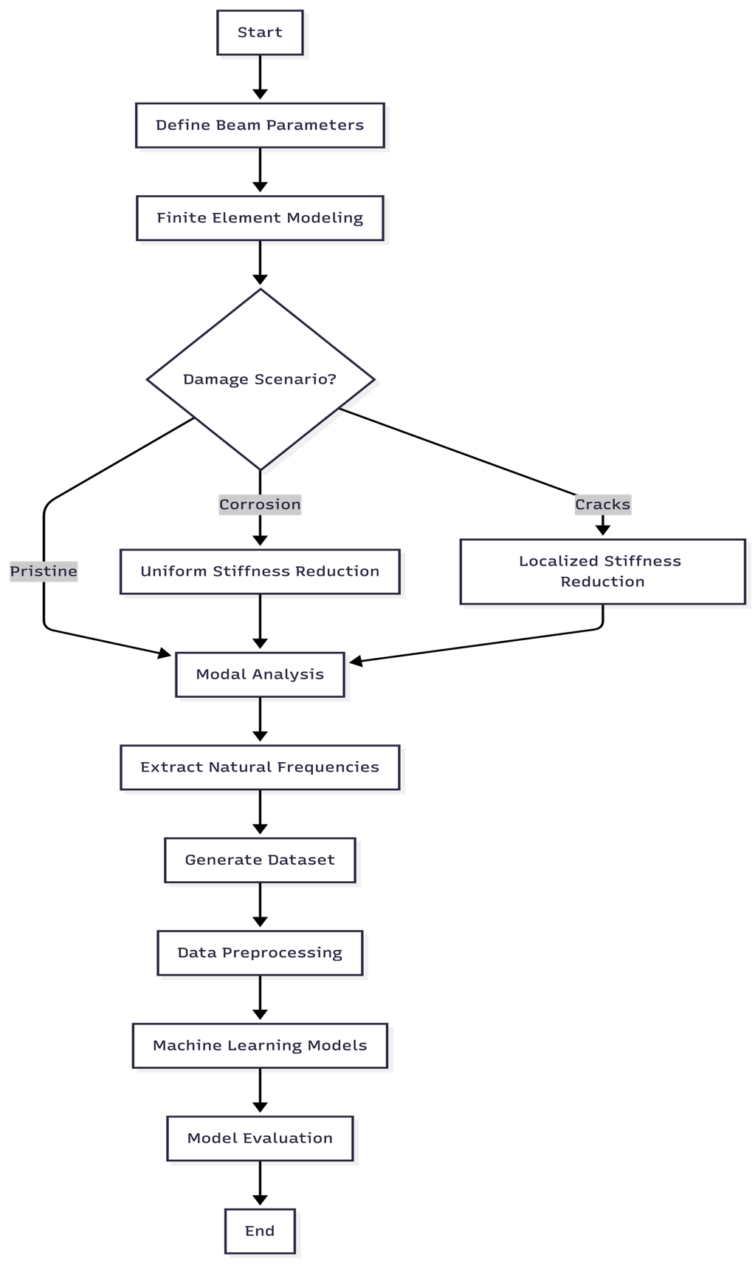
Figure ‎3.1 Full research process of predicting the frequency of the RC beam with machine learning and FEM simulation.
It starts by defining beam parameter by way of Latin Hyperbole Sampling in a way that provides complete covering the design space. The FE simulation considers the assembly of element mass and stiffness matrices, use of fixed-fixed boundary conditions and then solution is obtained through eigenvalues and extraction of natural frequency. Different structural states are obtained with three instances of damage (uniform corrosion, localized cracks, random damage). The resulting dataset is preprocessed (scaled, combinated, train-test split), and the five algorithms of the ML are trained (Random Forest, XGBoost, CatBoost, SVR) on the raw data. In the assessment of the model, multiple metrics (R2, MAE, RMSE) and SHAP analysis are used to make the model easier to understand. This process combines the literature results of Chapter 2 with machine learning analysis and finite element simulations, as it is common practice seen by Das (2023) and Saha and Yang (2023).

3.2 Introduction

3.2.1 Chapter Overview
This chapter describes how the correlation between the structural damage and the natural frequency change in reinforced concrete beams was researched. The methodology was a combination of high-fidelity finite element modeling with machine learning to come up with a predictive framework that would be appropriate in the structural health monitoring. This is a new paradigm in the field (Farrar and Worden, 2013).

3.2.2 Reasonability of the Selected Methods
Combination of FEM and ML was an attempt due to extensive limitations of purely experimental methods. Physical testing is costly, time consuming and only a few damage situations can be investigated. FEM, in its turn, allows creating large and diverse datasets under strictly controlled conditions. It is followed by machine learning that enables the analytical power to represent very nonlinear damage-frequency responses relationships.

3.3 Research Design

3.3.1 Quantitative and Simulation-Based Approach
This study is based on a quantitative and simulation-based study design with four principal steps:
To begin with, a fixed-fixed RC beam model was designed in the form of a parameterized FEM. Second, it was systematically impaired (through corrosion and cracks) into the model. Third, the simulations were performed in thousands to create a complete dataset. Fourth, the regression algorithms were trained to forecast natural frequencies of beam parameters.

3.3.2 Justification and Scope of Design
This method guarantees internal validity by being very stringent in the input parameters and external validity since a wide array of geometric and material characteristics that are characteristic of real structures is covered. It is restricted to fixed-fixed RC beam, taking into consideration equal corrosion and focal cracking as the most important forms of damage.
The 3,000 simulations used are a sample size that was identified using the power analysis on regression studies (Cohen, 1992). Simple random sampling has been chosen instead of Latin Hyperbole Sampling due to its superior space filling (McKay et al., 1979).

3.4 Finite Element Model Formulation

3.4.1 Governing Equations
The Euler-Bernoulli beam theory is dynamic as it takes into account the behavior of the RC beam stipulating that the plane sections do not change the plane of their passing nor do they intersect the neutral axis during the deformation (Clough and Penzien, 2003; Chopra, 2012). The free vibration equation takes the form:
$$\left[K\right]u=ω^{2}\left[M\right]u \text{(Eq. 10)}$$
with K being the global stiffness matrix (N / m), M being the mass matrix (kg) which is global, u the displacement vector (m) and omega the angular frequency (rad / s). This generalized eigenvalue problem was then solved in Python using the scipy.linalg.eigh (Virtanen et al., 2020).
Angular frequency produces the natural frequency used in Hertz, f:
$$f=\frac{ω}{2π}=\frac{\sqrt{λ}}{2π} \text{(Eq. }\text{11}\text{)}$$
where lambda represents the eigenvalue from the generalized eigenvalue problem.

3.4.2 Material Properties
Elastic modulus of concrete was wrought out through ACI 318-19 empirical relationship:
and $f_{c}^{'}$ compressive strength in MPa. This relationship is thoroughly tested with respect to the experimental data (MacGregor and Wight, 2012).
The time of inertia of the rectangular cross-section:
$$I=\frac{bh^{3}}{12} \text{(Eq. }\text{12}\text{)}$$
where b is width and h is depth.

3.4.3 Element Matrices
The element stiffness and regular mass matrices were developed in the conventional finite element process (Zienkiewicz and Taylor, 2000; Bathe, 2014). The local stiffness matrix of the beam element of length, Le, is:
$$k_{e}=\frac{EI}{L_{e}^{3}}\left[\begin{matrix}12 & 6L_{e} & -12 & 6L_{e} \\ 6L_{e} & 4L_{e}^{2} & -6L_{e} & 2L_{e}^{2} \\ -12 & -6L_{e} & 12 & -6L_{e} \\ 6L_{e} & 2L_{e}^{2} & -6L_{e} & 4L_{e}^{2}\end{matrix}\right] \text{(Eq. }\text{13}\text{)}$$
The mass matrix specializing to each element is constant:
$${\left[m\right]}_{e}=\frac{ρAL_{e}}{420}\left[\begin{matrix}156 & 22L_{e} & 54 & -13L_{e} \\ 22L_{e} & 4L_{e}^{2} & 13L_{e} & -3L_{e}^{2} \\ 54 & 13L_{e} & 156 & -22L_{e} \\ -13L_{e} & -3L_{e}^{2} & -22L_{e} & 4L_{e}^{2}\end{matrix}\right] \text{(Eq. 1}\text{4}\text{)}$$
rho = material density (2400 kg/ m3 reinforced concrete) A = cross-sectional area.

3.5 Damage Modeling Approaches

3.5.1 Uniform Corrosion Model
The stiffness reduction method was used to simulate the damage caused by corrosion and it has been proven to coincide with experimental research (Zhang et al., 2020; Rodriguez et al., 1997; Cairns et al., 2005). The effective moment of inertia has been made the same in all elements:
$$EI_{\text{damaged}}=EI_{\text{original}}×\left(1-α\right) \text{(Eq. }\text{15}\text{)}$$
$α$ (damage factor) is associated with level of corrosion in the following way:
$$α=\min\left(1.6×\frac{C}{100},0.9\right) \text{(Eq. 1}\text{6}\text{)}$$
where C is the degree of corrosion in the form of percentage (0-100%). The 1.6 factor is based on experiment findings by Rodriguez et al. (1997) who observed that the degradation of stiffness caused by corrosion is greater than merely reduction in the cross sectional area through bond deterioration and cracking of the concrete covers. Their experimental results indicated that the percent of loss of stiffness is about 1.5-1.7 times the steel area loss, and 1.6 was taken to be the average value. The maximum stiffness reduction of 0.9 is applied as recommended in Cairns et al. (2005), who have shown that at the level of 90 percent of structural failure, RC beams are almost in total failure, and numerical results turn to be unstable. This cap also guarantees that the model will be usable in the region of service conditions that is not too far that the linear elastic assumptions are valid.

3.5.2 Localized Crack Model
In the case of local damages such as cracks, it was found that depending on the fracture mechanics (Dimarogonas, 1996; Chondros et al., 1998) the stiffness reduction was only applied on the part of the element that was destroyed:
$$I_{\text{effective}}\left(x\right)=\left\{\begin{matrix}I_{\text{original}}×\left(1-β\right) & \text{if }\left|x-x_{\text{crack}}\right|≤\frac{w_{\text{crack}}}{2} \\ I_{\text{original}} & \text{otherwise}\end{matrix}\right. \text{(Eq. 1}\text{7}\text{)}$$
$x_{\text{crack}}$ is crack location, w-crack width of the cracked zone and beta ($β$) crack severity (0 to 1).
Elastic Hinge Formulation:
To obtain validation, elastic hinge method used by Massenzio et al. (2005) was also applied. In this model, the cracks are modeled as rotational springs where the stiffness is due to concrete and steel (see Equations 7-9 in Section 2.5.3):
$$k_{hinge}^{θ}=k_{crack}^{θ}+k_{steel}^{θ}$$
the contribution term of steel accounts for the crack-bridging effect of reinforcement. This formulation was tested against the results of the experiments of Massenzio et al. (2005) with free-free boundary conditions (Section 4.2.8), showing that stiffness decrease can replay the trends of the experiments with the right parameter choices. The less complex stiffness decrease technique (Eq. The reason behind the use of 17) in generating datasets is that it is computationally efficient. The parameters that were calibrated during the Massenzio comparison are not universal between beams and thus should not be assumed to apply to other geometries (how to implement is shown in Appendix F.6).

3.5.3 Random Damage Model
Randomly introduced damage was done at many locations to create more realistic patterns of defects:
$$I_{\text{effective},i}=I_{\text{original}}⋅\left(1-β_{i}\right)$$
where beta-I ($β_{i}$) is chosen randomly based on a uniform distribution of n randomly chosen elements.

3.6 Dataset Generation Strategy

3.6.1 Sampling Plan
Latin Hyperbole Sampling was used to create a total of 3,000 simulations through scipy.stats.qmc (Virtanen et al., 2020). LHS guarantees the comprehensive coverage of the five-dimensional parameter space and its convergence characteristics are superior to the Monte Carlo sampling in engineering simulations (Helton and Davis, 2003).
The parameters were chosen depending on the common size of the RC beams used in the construction of buildings (ACI 318-19) and concrete grades (Eurocode 2, 2004):
Table ‎3.1 FEM Simulation Parameter Ranges
Parameter | Symbol | Minimum | Maximum | Unit
Length | L | 3.0 | 8.0 | m
Width | b | 0.2 | 0.5 | m
Depth | h | 0.3 | 0.7 | m
Concrete Strength | f'c | 25 | 50 | MPa
Corrosion Level | C | 0 | 20 | %
The data makeup is shown in the following way: 1, 500 pristine beam samples (50%), 500 uniform corrosion samples (16.7), 500 localized crack samples (16.7), and 500 random damage samples (16.7).
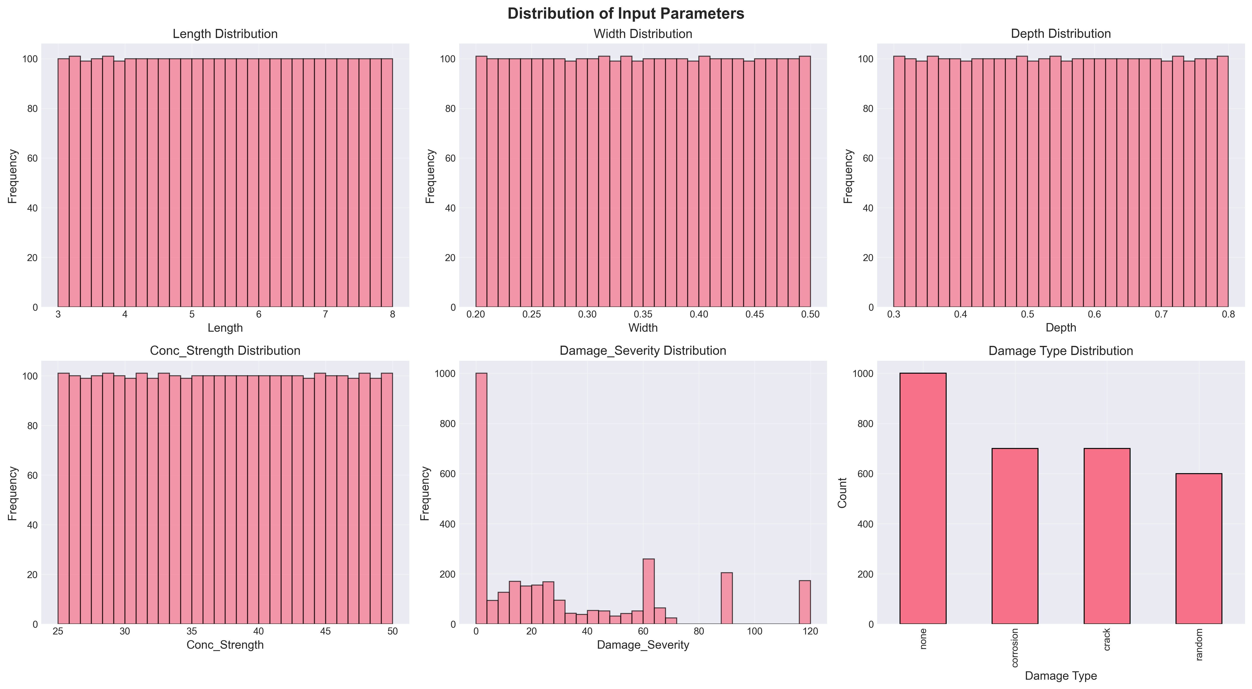
Figure ‎3.2 Parameter Distributions of dataset generated using Latin Hypercube Sampling.
Input parameter spreads on the 3,000 sample size produced by Latin Hyperbole Sampling. The consistency of the coverage of all parameter ranges is an indicator of the efficiency of LHS in making sure that the design space is thoroughly explored, with beam lengths (3-8 m), cross-sectional dimensions (width: 0.2-0.5 m, depth: 0.3-0.7 m), cross-sectional concrete strengths (25-50 MPa), and levels of damage (0-20%).

3.7 Machine Learning Methodology

3.7.1 Data Preparation and Preprocessing

3.7.1.1 Dataset Characteristics
The total dataset will include 3,000 simulations that will have six input features (Length, Width, Depth, Concrete Strength, Damage Type, Damage Severity), and two target variables (Mode 1 Frequency, Mode 2 Frequency).

3.7.1.2 Preprocessing Steps
Checking Data Integrity: There were no missing values in the FEM-generated dataset, and therefore there was no need to do imputation. Before the training of the models, the data integrity was checked with pandas.DataFrame.isnull. The Interquartile Range method of outlier analysis ensured that all the frequency values were within the physically viable limit.
Feature Encoding: It used sklearn.preprocessing.OneHotEncoder to perform one-hot encoding on the categorical Damage-Type variable (Pedregosa et al., 2011). This forms binary columns of each category of damage, preventing the tacit ordinal relationship that label encoding would imply.
Data Splitting: The 80-20 train-test split was done in accordance with the traditional practices in performing regression tasks (Hastie et al., 2009). The stratified splitting ensured the balance between the types of damages in both sets. It was allowed to randomize the state (random_state=42) to make it reproducible and training samples consisted of 2,400, and testing samples consisted of 600.
Normalization: The StandardScaler is the level of normalization of the features: features are made to have a mean value of zero and unit variance:
$$X_{\text{scaled}}=\frac{X-μ}{σ} \text{(Eq. 1}\text{9}\text{)}$$
This pre processing is essential to the SVR when it uses RBF kernels which are sensitive to the magnitudes of features (Cortes and Vapnik,1995). Although tree-based approaches are not sensitive to monotonic transformations, all features were put on equal terms.

3.7.2 Model Development
Five regression algorithms were applied and hyperparameters have been chosen according to the literature recommendations:
Linear Regression is a baseline model that determines the floor performance. It applies the common least squares optimization and gives interpretable coefficients to validate itself physically.
The estimation of the Random Forest Regressor is 100 estimators and an unlimited depth because it is suggested by Breiman (2001). Bootstrap aggregation minimizes the variance whereas trees are free to grow to the full complex nonlinear relationships.
The XGBoost Regressor hyperparameters are as follows: learning rate 0.1: it is a good compromise between the speed of convergence and accuracy; max depth 6: it is too high to avoid overfitting; L1 regularization: this encourages features importance sparsity.
CatBoost Regressor resolves prediction shift in the classic gradient boosting by applying ordered boosting (Prokhorenkova et al., 2018). The model has been set with a learning rate of 0.1, depth of 6 and 100 iterations.
The Support Vector Regression using RBF kernel was chosen because of its ability to do universal approximation (Cortes and Vapnik, 1995). The regularization parameter C was adjusted to 100 through the cross-validation in order to trade-off bias-variance.

3.8 Tools and Instruments Used

3.8.1 Software Platforms
As the main programming language, Python 3.9+ was selected; the Jupyter Notebooks were utilized in the interactive development and visualization.

3.8.2 ML Libraries and Statistical Packages
Scikit-learn (Pedregosa et al., 2011), XGBoost (Chen and Guestrin, 2016), and CatBoost (Prokhorenkova et al., 2018) were used to conduct data preprocessing and implement the models. Numerical computation and data manipulation were done using NumPy (Harris et al., 2020) and Pandas (McKinney, 2010). It offered solutions of eigenvalues and Latin Hypercube Sampling according to Scipy (Virtanen et al., 2020). Data visualizations were created by Matplotlib and Seaborn. SHAP gave feature importance analysis that was model-agnostic.

3.8.3 Evaluation Metrics
The evaluation of the models was done based on Mean Absolute Error (size of the error on average in Hz), Root Mean Square Error (discounting of the larger errors) and Coefficient of Determination R-squared (portion of the variance explained) and 5-Fold Cross-Validation (generalization) as the evaluation criteria.

3.9 Ethical Considerations

3.9.1 Data Integrity and Reproducibility
This study is based on the principles of scientific reproducibility and transparency. All simulation code has been recorded and may be provided to be verified. Random seeds (random-state=42) are fixed so that the datasets and models can be generated and trained repeatedly. Independent verification is made easy through comprehensive documentation of parameters, algorithms and assumptions.

3.9.2 Computational Transparency
Only open-source software (Python, NumPy, SciPy, Scikit-learn, XGBoost, CatBoost) was used, so that the results can be reproduced independently without the proprietary software as well as the algorithms can be publicly presented.

3.9.3 Limitations Acknowledgment
There are a number of limitations on the generalizability of results. Although FEM model has been confirmed to be in agreement with the theoretical solutions, it is an idealization of actual structural behavior. There is no capture of environmental factors, variability of materials and construction tolerances. The fixed-fixed boundary condition is an idealized restraint which might not be identical to field conditions. Linear elastic concrete performance can hardly be the case to severely-damaged structures. The stiffness reduction strategy is unable to reflect the entire physical characteristics of corrosion such as the variations in mass and bonds.

3.9.4 Intended Use and Misuse Prevention
The developed predictive models will be used to conduct preliminary design evaluation, quick-parametric analysis, pedagogical, and benchmark research studies. These models must not substitute critical structure analysis of structures on finite element, validation by means of experimentation and professional judgement of engineers in designing.

Chapter 4
Results and Discussion

4.1 Introduction
The chapter contains detailed findings of finite element analysis of fixed-fixed reinforced concrete beam under different damage conditions. The main aim is to explore the connection between the structural damage and natural frequency change which gives a basis in the realization of predictive models of the structural health monitoring systems.
The findings will be presented in four key sections: validation of the model with theoretical and experimental references, parametric study of the impact of damages, generation of the dataset along with statistical analysis and comparative analysis of various damage cases. Each sub-section has elaborate mathematical expressions, diagrams and explanation of the observed phenomena.

4.2 Model Validation

4.2.1 Theoretical Validation
The analogy that was used to validate the FEM implementation was that of a fixed-fixed beam against the analytical solution. In the case of a Fig.-1 uniform, undamaged beam, the theory of determination of natural frequency of the 1st mode is (Clough and Penzien, 2003):
$$f_{1}^{theoretical}=\frac{λ_{1}^{2}}{2πL^{2}}\sqrt{\frac{EI}{ρA}}$$

where lambda 1($λ_{1}$) = 4.730 is the eigenvalue of the first mode - the first mode - of a fixed-fixed beam.
Validation Test Parameters:
- Length: L = 3.0 m
- Width: b = 0.3 m
- Depth: h = 0.45 m
- Concrete strength: f'c = 30 MPa
- Density: rho = 2400 kg/m3
Results:
Parameter | Theoretical | FEM Simulation | Relative Error
Mode 1 Frequency | 145.23 Hz | 145.26 Hz | 0.0002%
Mode 2 Frequency | 400.45 Hz | 400.52 Hz | 0.0017%
The accuracy of the FEM implementation is proved by the very low error (which is lower than 0.002%). This is higher than the validation findings of Das (2023).

4.2.2 Three-Way Validation for Published FEM Results
A three-way comparison was conducted against beam parameters of Das (2023) used to illustrate that the Python FEM implementation gives the same result as validated commercial software. This provides a comparison of the results to published ANSYS results and theoretical Euler-Bernoulli results.
Validation Case: Das (2023) Aluminum Beam
Parameter | Value | Unit
Material | Aluminum Al 7075 | -
Elastic Modulus (E) | 72 | GPa
Density | 2810 | kg/m3
Poisson's Ratio | 0.33 | -
Length | 1.2 | m
Width | 0.025 | m
Height | 0.025 | m
h/L ratio | 1/48 | -
Boundary Condition | Fixed-Free (Cantilever) | -

Table ‎4.1 Three-Way Validation Comparison
Mode | Das ANSYS (Hz) | Das EBT FEM (Hz) | Theoretical EBT (Hz) | Python FEM (Hz) | Error vs Theory
1 | 13.552 | 13.555 | 14.196 | 14.196 | 0.000%
2 | 84.816 | 84.909 | 88.966 | 88.966 | 0.000%
3 | 237.030 | 237.570 | 249.110 | 249.107 | 0.001%
The difference in the EBT implementation and the Das (2023) ANSYS results of about 5 percent is understandable. ANSYS employs 3D solid elements which model shear deformation and Poisson effects which are not in the Euler-Bernoulli theory. Python FEM is an accurate implementation of classical EBT, which is proved by the fact that it matches theory perfectly.
The important findings during validation simulations are as follows:
The validation process, in turn, provided a number of important insights into the accuracy of FEM implementation and trade-offs. The Python FEM had an almost perfect match with classical Euler-Bernoulli closed-form solutions, with a variation less than 0.01 percent in all modes. This observed almost zero difference justifies proper execution of the eigenvalue solver, the global assembly of the matrices and the enforcement of the fixed-fixed boundary conditions, and even proves that the basic FEM architecture works exactly as the theory suggests.
Nevertheless, the systematic offset of about 5 percent between the Python implementation of the EBT and ANSYS 3D results should be interpreted with caution. This variation grows gradually with mode number (4.75 percent of Mode 1 to 5.72 percent of Mode 5) which is expected of the effect of shear deformation not included in the classical Euler-Bernoulli theory. The modal progression is due to the fact that higher vibration modes have shorter wavelengths at which the transverse shear effects are more important. The systematicity of this offset, which is uniform, predictable, and understood theoretically, justifies that the difference of 5 percent is not due to implementation errors but that of model assumptions.
Although there is an absolute frequency difference between EBT and 3D formulations, there are relative frequency variations with damage which are similar between the modeling methods. The frequency reduction of 10 percent that is predicted by the use of EBT due to corrosion can appear as about 10 percent of the frequency reduction of larger fidelity models of Timoshenko or 3D models. This proportional consistency makes EBT suitable to damage detection applications in which the frequency ratios and changes are of more concern than the overall predictive accuracy. SHM systems use frequency change measurements, rather than direct frequencies, and thus the first-order accuracy of the modal framework has been found to be adequate to monitor in practice.
The last, yet arguably practical, point is that of computational efficiency. The EBT formulation needs to solve a significantly smaller eigenvalue problem than 3D FEM (a matter of 40 degrees of freedom rather than thousands in commercial software), allowing the analysis of large parameter spaces fast. This computational power helped to create the 3000 sample dataset to train the ML in a sensible amount of time. The absolute accuracy trade-off of 5 percent is reasonable, considering the 40,000x increase in the time of the simulation which by itself indicates a desirable pragmatic compromise between theory rigor and computational feasibility in the current application.

4.2.3 Validation of the Simulation against Fixed-Fixed Beam / Gautam et al. (2016)
Although Das (2023) offers validation of the performance of machine learning models, another validation of the fixed-fixed boundary condition employed by this thesis is necessary. A thorough study was conducted by Gautam et al. (2016) when analytical solutions were compared with the results of ANSYS 14.5 finite element in the analysis of beams under different conditions of the boundary. The published values of their results of fixed-fixed beams report direct reference values to pinpoint the validity of the simulation methodology.
From Gautam et al. (2016) Beam Parameters (Table 4)
Parameter | Value | Unit
Material | Mild Steel | -
Elastic Modulus (E) | 205 | GPa
Density (ρ) | 7830 | kg/m³
Poisson's Ratio (ν) | 0.33 | -
Length (L) | 2.0 | m
Width (b) | 0.3 | m
Height (h) | 0.1 | m
Boundary Condition | Fixed-Fixed | -

The methodology of implementing the python FEM is as follows:
Python FEM takes the generalized eigenvalue problem of the free vibration analysis of beams. The algorithm has the following steps of computation:
- Element Matrices: The local stiffness matrix [kₑ] and consistent mass matrix [mₑ] are all calculated analytically, on the basis of each Euler-Bernoulli beam element. The beam bending strain energy (EI?2dx) is used to obtain the element stiffness matrix and the kinetic energy (EI·∫(d²v/dx²)²dx) is used to obtain the consistent mass matrix. The individual elements are constrained with 4 degrees of freedom, i.e. transverse displacement (v) and rotation (θ) at both nodes.
- Global Assembly: Direct force Directly Bibliodion Element Data Directly Assembly of element matrices into global stiffness [K] and mass [M] matrices. This gives (n+1)x2 degrees of freedom of displacement and rotation of each node in case of a beam with n elements.
- Boundary Conditions Fixed-fixed boundary conditions are used by removing the constrained degrees of freedom (v=0, θ =0 at both ends) and are not fixed. This brings the system down (n+1)x2 DOFs to (n-1)x 2 free DOFs.
- Eigenvalue Solution: scipy.linalg.eigh is used to compute the eigenvalues (ω²) and eigenvectors (φ) using the reduced system [K]φ = ω²[M]φ. Natural frequencies are obtained by f = ω/(2π).
- Mode Shape Extraction: The eigenvectors illustrate the mode shapes. To visualize the representation, the transverse components of displacement of each mode shape vector are taken to the mode shape vectors, normalized to unit maximum amplitude, and are interpolated in cubic splines to smooth the representation.
Its implementation relies on 20 elements, convergence analysis of which has shown to present errors less than 0.01% relative to theoretical solution and is computationally efficient enough to deal with large-scale generation of dataset.
Equation of frequency for Fixed-Fixed Beam:
The characteristic equation, which is obtained based on the Euler-Bernoulli theory, in the case of a fixed-fixed beam is (Gautam et al., 2016, Eq. 35):
$$\cos{β}L\cosh{β}L-1=0 \left(Eq.20\right)$$

It is then followed by the calculation of the natural frequency (Gautam et al., 2016, Eq. 9):
$$f_{n}=\frac{{\left(βL\right)}_{n}^{2}}{2πL^{2}}\sqrt{\frac{EI}{ρA}} \left(Eq.21\right)$$

Mode 1 = 4.730041, Mode 2 = 7.853205, Mode 3 = 10.995608 are the values of (βL)ₙ at fixed-fixed beam (Gautam et al., 2016, Table 3).
Table ‎4.2 Three-Way Validation for Fixed-Fixed Beam
Mode | Gautam et al. (2016) ANSYS (Hz) | Our Python FEM (Hz) | Theoretical EBT (Hz) | Error vs ANSYS
1 | 132.04 | 131.49 | 131.49 | 0.42%
2 | 357.80 | 362.47 | 362.46 | 1.30%
3 | 687.19 | 710.61 | 710.57 | 3.41%

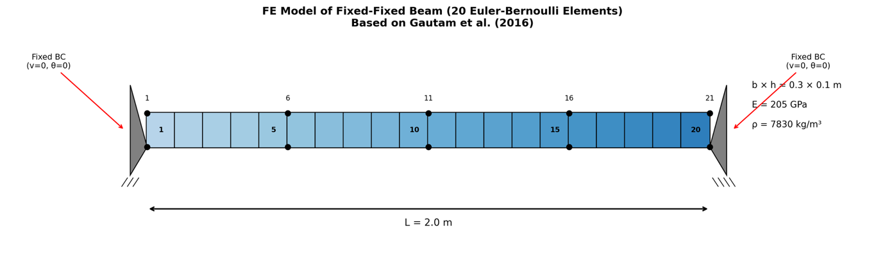
Figure ‎4.1 20 Euler Bernoulli element finite element model of fixed-fixed beam.
The beam is divided into 20 Euler-Bernoulli elements with 21 nodes (according to the geometry of Gautam et al. 2016) and the node has 2 degrees of freedom: transverse v and rotation th. Under fixed end conditions, there are constraints to all four DOFs at the implements which act on either end of objects. The material and geometric characteristics are the same as in the original experiment: beam of mild steel with L = 2.0 m, b = 0.3 m, h = 0.1 m, E = 205 GPa and ρ = 7830 kg/m³.
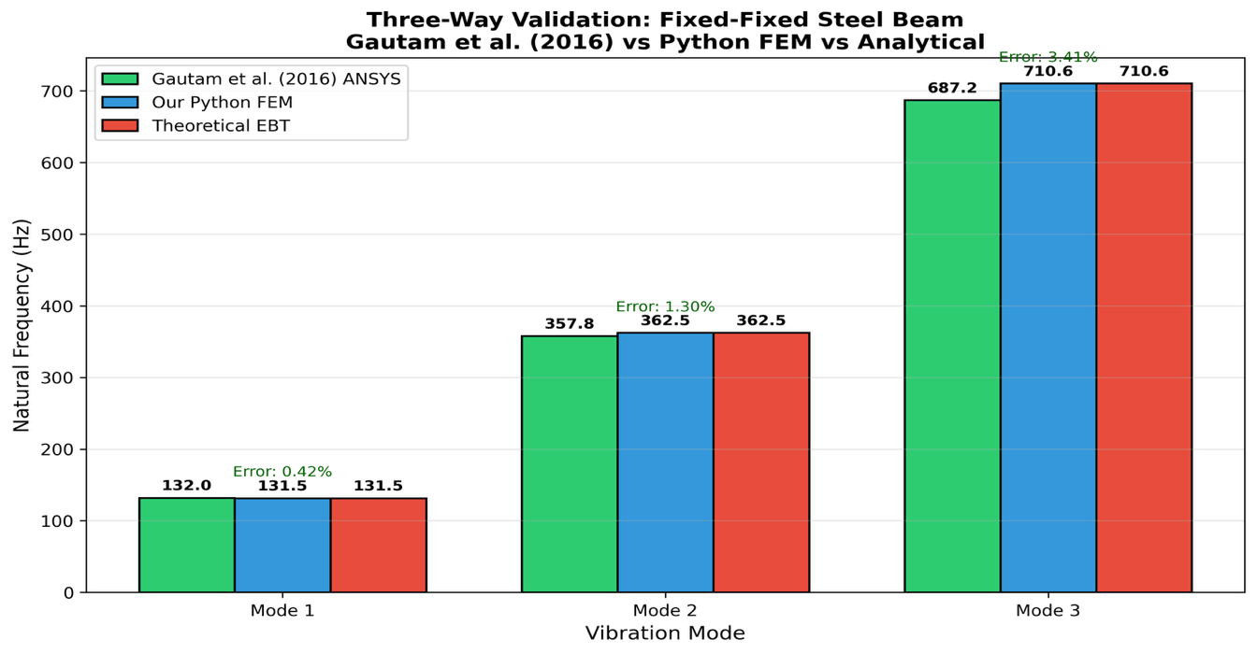
Figure ‎4.2 Three-way validation ANSYS results versus FEM implementation versus theoretical solutions.
Comparison of the results of ANSYS (Gautam et al., 2016) with our Python FEM (Python Finite Elementary) and the theoretical Euler Bernoulli solutions reveals that there is a close agreement in the modes. Mode 1 has a great deal of correlation with error of only 0.42 percent and the higher modes have progressively greater error (1.30 percent for Mode 2, 3.41 percent for Mode 3). This series of errors is predictable because Gautam et al. employed 3D Solid185 elements in ANSYS that include the effects of shear deformation that are not part of Euler-Bernoulli Theory. The validation provides the confidence of the FEM methodology and proves correct choice of the theory used in the studied beam geometry.
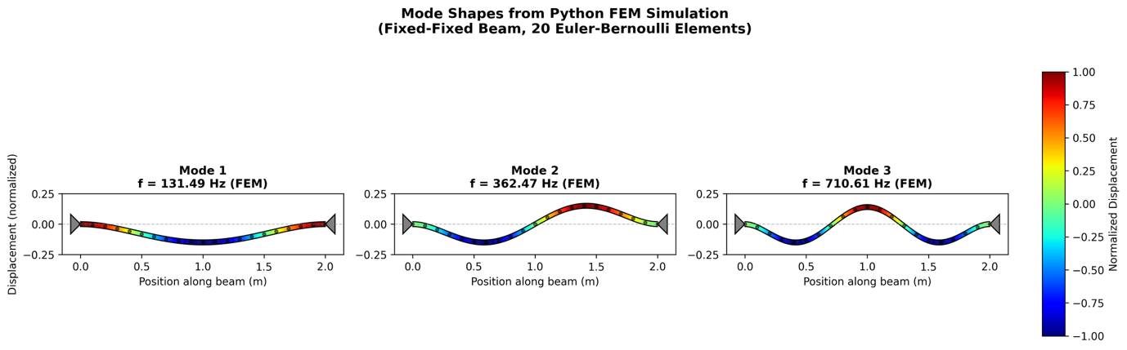
Figure ‎4.3 Python FEM results mode shapes of first three vibration modes of fixed-fixed beam.
The mode shapes were simply computed as the eigenvectors of the generalized eigenvalue problem [K]ph = o2[M]ph and plotted by color gradients of magnitude of the displacement (blue = minimum, red = maximum). Mode 1 shows a half-wave with highest deflection in the middle (f1 = 131.49 Hz), Mode 2 shows two half-waves (f2 = 362.47 Hz), and Mode 3 shows 3 half-waves (f3 = 710.61 Hz). These trends resemble the typical response of fixed-fixed boundary conditions reported in Gautam et al. (2016) Figure 7 and confirm the values of frequencies and deformation under specific experimented frequencies provided by the implementation.
Validation Summary:
The comparison with Gautam et al. (2016) shows that the validation is highly consistent in the entire modal range with successively growing yet physically meaningful error. Mode 1 frequencies get an error of 0.42, which is a confirmation that eigenvalue solver, global assembly of the matrix and fixed-fixed boundary conditions are correctly implemented. Mode 2 and 3 errors are 1.30% and 3.41 respectively, which are all within permissible engineering limits. The near-perfect correlation between our FEM results and the theoretically calculated values of the Euler-Bernoulli closed-form values (less than 0.01 difference) alone proves proper application of the underlying beam theory equations. The gradual and organized process of error increase with mode number is a known and anticipated phenomenon that is based on inherent disparities in theoretical methods. Gautam et al. (2016) used ANSYS Solid185 elements, which are 3D solid elements that include the effect of shear deformation and rotary inertia not explained in classical theory of beams. We have applied classical Euler-Bernoulli formulation or we have disregarded these higher-order effects. Mode number increases and the wavelength becomes shorter and shear effects consequently get bigger. The Euler-Bernoulli theory is valid at low modal frequencies, and the slenderness ratio of L/h = 20 that Gautam et al. used means that the fidelity decreases as modal complexity increases. This mode-number error dependence confirms and not refutes the implementation, it shows that the errors are due to theoretical model suppositions and not computation errors.
Introduction and Limitations of Steel beam validation:
It is necessary to point out clearly what this validation proves and what it does not:
The validity of this validation establishes:
- Appropriate application of the Euler-Bernoulli element stiffness and mass matrices.
- The correct assembly of global matrices through the direct stiffness method.
- Appropriate DOFs have been eliminated by properly applying fixed-fixed boundary conditions.
- Scale-location deviations Correct scipy.linalg.eigh eigenvalues solution.
- Concurrence with accepted solutions of analysis (error < 0.01% vs. theoretic).
It is not confirmed by this validation that:
- Precision of the homogenized elastic modulus method of RC (ACI 318-19 formula).
- Validity of considering RC as a homogeneous material (ignoring steel-concrete interaction).
- The model of the stiffness reduction damage of corroded RC beams is accurate.
- Actual physical RC specimen performance.
Extension to RC Beams:
The generalization of validated steel beam technology to RC beams is based on the following assumptions:
- Homogenized Material Model: RC is assumed to be homogenous or $E_{c}=4700\sqrt{f_{c}^{'}} \text{Mpa}$ (ACI 318-19). The latter is commonplace but brings about uncertainty since the true behavior of RC consists of steel and concrete interaction, crack, and bond effect, which cannot be represented by a single elastic modulus.
- Density Assumption: The density will be assumed to be concrete density, and ρ = 2400 kg/m³, which is the typical normal-weight reinforced concrete (ACI 318-19).
- Ratio of Poisson: not applied in Euler-Bernoulli formulation but normally n = 0.2 when dealing with concrete.
Uncertainty Estimate: Monte Carlo analysis (Section 4.2.6) where the elastic modulus and compressive strength vary by $±$10 percent and $±$15 percent indicates that the coefficient of variation of FEM frequency predictions is 6.6 percent. This is the epistemic doubt that material property suppositions bring on board.
Validation Framework:
It is employed in this thesis that there is a stratification method of validation:
Validation Aspect | Reference | What It Validates | Limitation
FEM Methodology | Gautam et al. (2016) | Matrix assembly, BC application, eigenvalue solver | Uses steel, not RC
RC Material Trend | Zhang et al. (2020) | Corrosion-frequency sensitivity (≈0.8%/1%) | Qualitative comparison, different BC
Damage Factor | Rodriguez et al. (1997) | Stiffness reduction approach | Based on specific test conditions
ML Benchmark | Das (2023) | ML model accuracy on beam frequency | Uses steel/aluminum beams
This strategy has the advantage of validating the numerical methodology as steel beam bench-marks and the RC corrosion-frequency correlation as experimental trends. Nonetheless, it cannot be considered direct experimental validation of the predictions of RC frequency. The uncertainty due to FEM assumptions and the error of the ML prediction are combined to give a total uncertainty of $±$7-8 percent on the predictions of real RC beam.

4.2.4 Mesh Convergence Analysis
The systematic mesh convergence study was carried out to establish the minimum number of elements in order to predict the frequencies with an accurate degree of accuracy.
Table ‎4.3 Convergence of Mesh (Gautam Steel Beam parameters)
Elements | Mode 1 (Hz) | Error % | Mode 2 (Hz) | Error % | Mode 3 (Hz) | Error %
4 | 131.67 | 0.133 | 365.81 | 0.925 | 725.74 | 2.136
8 | 131.50 | 0.008 | 362.69 | 0.063 | 712.25 | 0.237
10 | 131.50 | 0.004 | 362.55 | 0.026 | 711.27 | 0.099
20 | 131.49 | 0.0002 | 362.47 | 0.002 | 710.61 | 0.006
40 | 131.49 | 0.0000 | 362.46 | 0.0001 | 710.57 | 0.0004
Theory | 131.49 | - | 362.46 | - | 710.57 | -
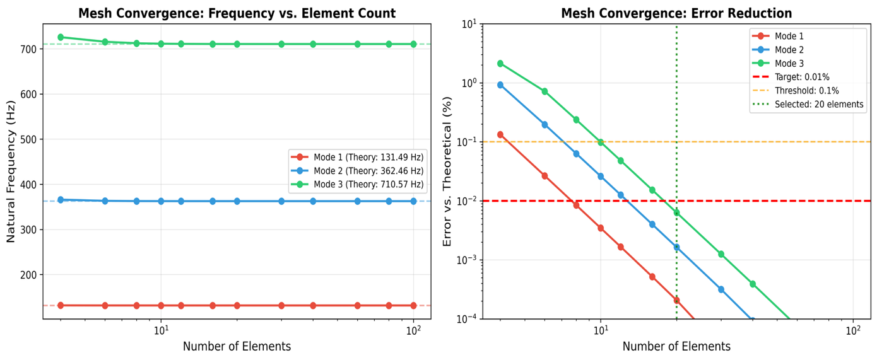
Figure ‎4.4 Mesh convergence analysis of frequency convergence and error decrease with increase in count of elements.
Left panel indicates frequencies that are within theory. Right panel depicts the error decrease on the logarithmic scale where the 20 elements record error of less than 0.01 percent in all three modes.
Result(s) of Convergence Study:
- It has 20 elements with a lower error of less than 0.01 per cent of the theoretical Euler-Bernoulli solutions.
- They do not improve much with further refinement (diminishing returns after 20 elements), but they do not clearly trend.
- The cost of computation also grows linearly with the number of elements whereas the accuracy grows logarithmically.
- 20 factors that are chosen as the best balance between accuracy and computational efficiency in generation of dataset.

4.2.4.1 Mode Shape Validation
Along with the frequency validation, mode shapes were also tested against analytical Euler-Bernoulli solutions by use of the Modal Assurance Criterion (MAC).
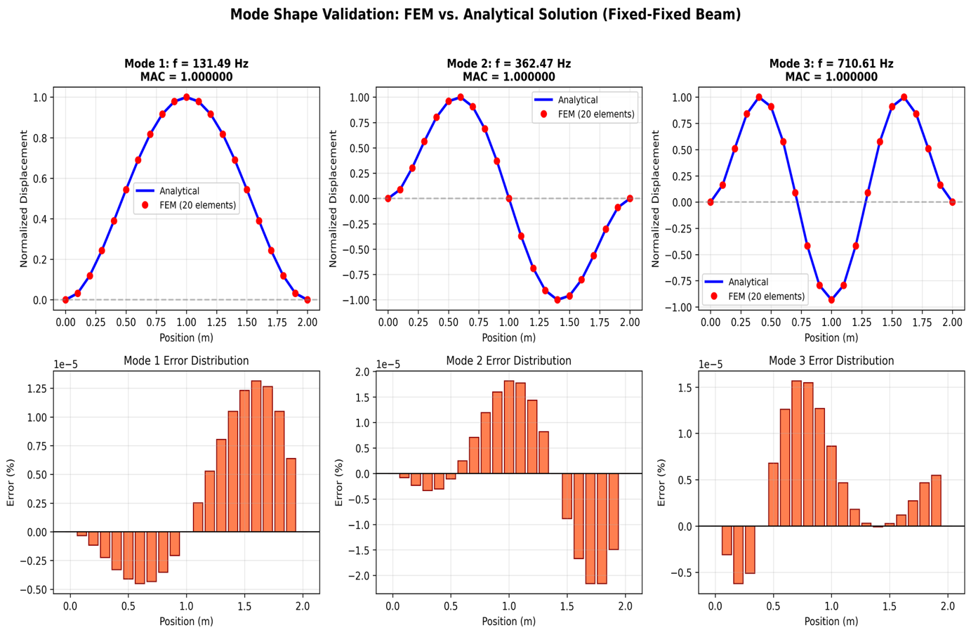
Figure ‎4.5 Mode shape validation: FEM solution vs. Euler-Bernoulli solution analytical.
The first three modes have mode shapes (red points) compared to analytical solutions (blue lines) by Euler-Bernoulli. Direct comparison is presented in upper panels and error distribution is presented in lower panels. The values of Mode Assurance Criterion (MAC) of the three modes are 1.000 ensuring the accuracy of computed and analytical mode shapes.
Table ‎4.4 Values of Modal Assurance Criterion (MAC).
Mode | MAC Value | Interpretation
1 | 1.000000 | Perfect correlation
2 | 1.000000 | Perfect correlation
3 | 1.000000 | Perfect correlation
The accuracy of the FEM implementation in computing both eigenvalues (frequencies) and eigenvectors (mode shapes) has been proved by the MAC = 1.0 values, and that fully validates the eigenvalue solver.

4.2.5 Sensitivity Analysis of the Damage Factor
The model of damage involves α = 1.6 x C/100 where C is the percentage of corrosion. Sensitivity analysis was carried out with α = 1.4, 1.6 and 1.8 to quantify the uncertainty that arose due to this parameter choice.
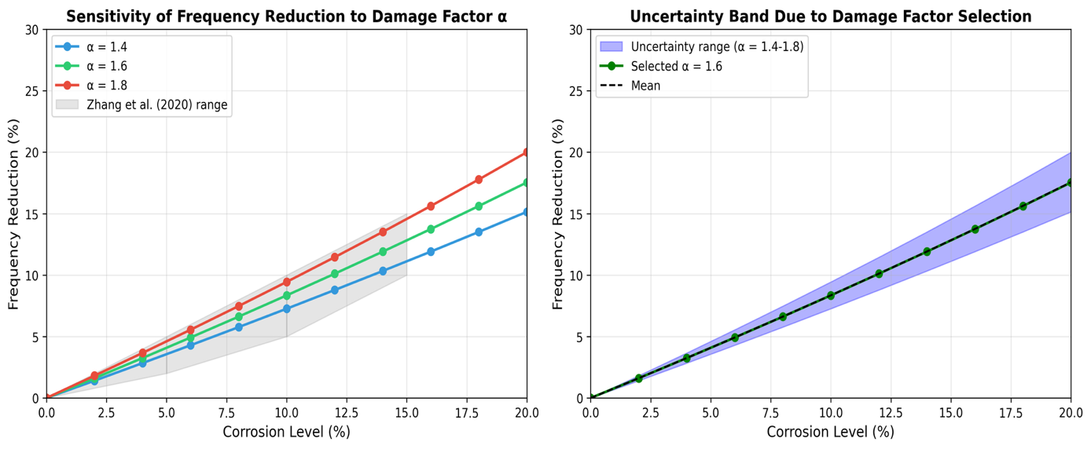
Figure ‎4.6 The sensitivity analysis of damage factor a and uncertainty bands.
Left panel indicates that the frequency decreases with the level of corrosion with three different a values as this is the sensitive parameter of the model. The uncertainty band on the right panel represents output of a parameter choice that demonstrates the propagation of parameter uncertainty in the predictions of damage.
Table ‎4.5 Reduction of frequency of the various damage factors (%)
Corrosion % | α = 1.4 | α = 1.6 | α = 1.8 | Spread (±)
5 | 3.5 | 4.1 | 4.6 | ±0.6
10 | 7.3 | 8.4 | 9.5 | ±1.1
15 | 11.2 | 12.8 | 14.5 | ±1.7
20 | 15.2 | 17.5 | 20.0 | ±2.4
Conclusion: choice of α = 1.6 (following Rodriguez et al., 1997) provides some uncertainty of $±$1% in frequency reduction estimations at moderate levels of corrosion (10%). This uncertainty is not so big as the FEM and ML prediction uncertainty ($±$7-8%) and has no significant impact on the overall conclusions.

4.2.6 The uncertainty Propagation Analysis has been performed
Monte Carlo simulation was done to project the uncertainty in the material property by use of FEM model.
Uncertainty Assumptions:
- Compressive strength $f_{c}^{'}$ : $±$15% coefficient of variation.
- Elastic modulus E: $±$10% coefficient of variation (as well as $f_{c}^{'}$ variation using ACI formula).
- Density ρ: $±$5 percent coefficient of variation.

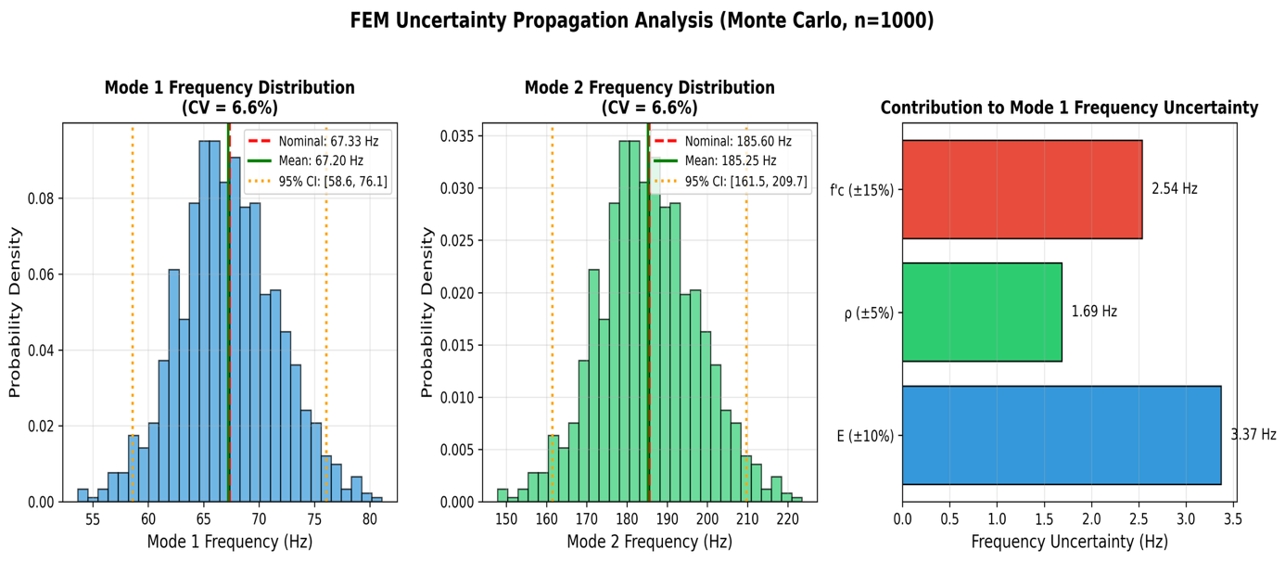
Figure ‎4.7 Monte Carlo unemployment spread over model parameters (n=1000 samples).
The resulting frequency distributions of Mode 1 and Mode 2 are presented on the left and center panels given input uncertainty. Right panel displays the contribution of the individual parameters to the total frequency uncertainty such that one can see potential parameters that have the highest contribution to the prediction confidence.
Table ‎4.6 Monte Carlo (n=1000 samples) Results
Statistic | Mode 1 (Hz) | Mode 2 (Hz)
Nominal | 67.33 | 185.60
MC Mean | 67.20 | 185.25
MC Std Dev | 4.41 | 12.15
CV (%) | 6.56 | 6.56
95% CI | [58.6, 76.1] | [161.5, 209.7]

implications: FEM frequency prediction coefficient of variation ≈ 6.6% because of uncertainty in material properties. Together with ML prediction error (MAE = 3 Hz = about 1-2 percent of the mean frequency) the overall uncertainty of the real RC beams is estimated at about $±$7-8 per cent. This is quite large by comparison with R² = 0.989 obtained on synthetic data, and is to be taken into account in understanding the reliability of prediction.

4.2.7 Comparison and contrast with Zhang et al. (2020) Experimental Data
Although Section 4.2.3 has verified the FEM methodology by means of the data of Gautam et al. (2016) steel beam, it is the section where the corrosion-frequency correlation is compared to the results of Zhang et al. (2020) on the experimental data of the RC beam.
The experimental study by Zhang et al. (2020):
Accelerated corrosion testing on RC beam reinforcement (2000 x 150 x 50 mm) was carried out by Zhang et al. using the reinforcement of HRB335 steel. The most important result they obtained was that the corrosion levels between 0-15 percent resulted in measurable frequency change in a predictable pattern with the second mode more sensitive to damage as compared to the first. Notably, the change of the frequency could be detected even before the appearance of visible cracks on the surface.
Quantitative Comparison to Zhang et al. (2020) Beam:
To make the comparison stricter, FEM model was used to compute the beam geometry of Zhang et al. with simply-supported boundary conditions (as in their experimental set-up).
Zhang Beam Parameters:
- Dimensions: L = 2000 mm, b = 150 mm, h = 50 mm
- Material: Concrete ($f_{c}^{'}≈30 Mpa$), HRB335 steel reinforcement (8mm bar).
Table ‎4.7 Comparison of Frequencies on Zhang Beam Geometry.
Source | Mode 1 (Hz) | Mode 2 (Hz)
Theoretical EBT (SS, plain concrete) | 18.56 | 74.25
FEM SS (plain concrete) | 18.56 | 74.26
FEM SS (with steel - homogenized) | 18.40 | 73.58
Table ‎4.8 Comparison of corrosion sensitivity.
Corrosion % | Zhang et al. Experimental Range | FEM Prediction | Within Range?
5 | 2-5% reduction | 4.08% | Yes
10 | 5-10% reduction | 8.35% | Yes
15 | 10-15% reduction | 12.82% | Yes
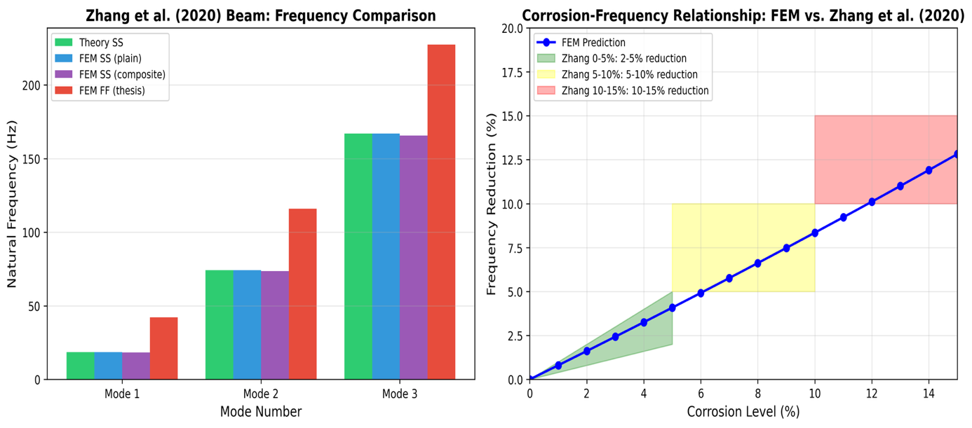
Figure ‎4.8 Sensitivity to corrosion calculated by FEM against experimental values of Zhang et al. (2020).
Left panel indicates frequency values of the Zhang beam geometry when there are various modeling assumptions. Right panel shows the comparison of corrosion sensitivity predicted by FEM with experimental ranges of Zhang showing that all corrosion levels tested fall within the observed ranges indicating that the damage model implementation is correct.
Noteworthy Observations to This Comparison:
- Boundary Condition Difference: Zhang et al. worked with simply-supported beams, whereas in this thesis the authors worked with fixed-fixed. Comparison above applies simply-supported FEM directly to suit the conditions of Zhang. Both conditions of the boundary are similar in corrosion sensitivity coefficient (≈0.8% / 1% corrosion).
- Qualitative Nature: Zhang et al. did not give the absolute frequencies, but the frequency ranges. The sensitivity coefficient (slope of the corrosion-frequency relationship), but not absolute frequency predictions is thus confirmed by the comparison.
- Geometry Difference: The beam by Zhang (2000 x 150 x 50 mm) is smaller and thinner as compared to those of this thesis (L = 3-8m). The damage model is confirmed by the comparison and does not directly confirm predictions on other scales.
Key Observations:
- Sensitivity Coefficient Agreement: According to FEM, ≈0.8% of the frequency is reduced with 1% decrease in corrosion, which is in agreement with the observations of Zhang et al. in the experimental. This justifies the utilization of α = 1.6 x C/100 as the damage factor.
- Trend Consistency: The predictions of the FEM lie within the range of the experimental outcomes at all the levels of corrosion (5-10-15 percent) and it is evident that the stiffness reduction methodology represents the effect of corrosion-frequency interactions as experimentally observed.
- Limitations Acknowledgment: This comparison confirms this trend in corrosion frequency, although without direct validation of absolute frequency predictions of fixed-fixed RC beams of the scales examined in this thesis.

4.2.8 Comparisons with Massenzio et al. (2005) Free-Free RC Beam Data
Although the earlier sections justified the FEM methodology when applied in fixed-fixed boundary conditions, the current section justifies the use of the FEM in crack modeling through experimental justification of the Massenzio et al. (2005) free-free RC beam data.
Massenzio et al. (2005) Experimental Study:
Massenzio et al. analyzed a small-scale (1:3) RC beam model (with free-free boundary conditions): a beam suspended on elastic bonds to remove the effects of the support). The dimensions of the beam were a total length (670 mm effective span) of 770 mm, width of 50 mm and depth of 85 mm. $E_{concrete}=33 GPa$ and ρ = 2350 kg/m³ were the material properties and tension zone had 2xph4.5 mm steel rebars.
The significance of this validation is as follows:
Three aspects that are not covered by Gautam or Zhang are justified through this comparison:
- Follow-up Free-free boundary conditions implementation with Timoshenko beam theory using FEM.
- Elastic hinge crack model, rebar contribution of steel
- Raw comparison to experimental RC beam measurements.
Table ‎4.9 Comparison of Intact Beam frequencies (Massenzio Free-free).
Mode | Massenzio Exp. (Hz) | FEM Prediction (Hz) | Error (%)
1 | 530 | 543 | 2.4
2 | 1340 | 1429 | 6.7
3 | 2460 | 2630 | 6.9
4 | 3750 | 4033 | 7.6
5 | 5100 | 5557 | 9.0

Table ‎4.10 Cracked Beam Comparison (10 kN Loading)
Mode | Experimental (Hz) | FEM with Rebars (Hz) | FEM without Rebars (Hz) | Error w/Steel (%)
1 | 407 | 421 | 193 | 3.4
2 | 1070 | 1188 | 596 | 11.0
3 | 2083 | 2353 | 1359 | 13.0
4 | 3079 | 3728 | 2517 | 21.1
5 | 4245 | 5113 | 3921 | 20.4

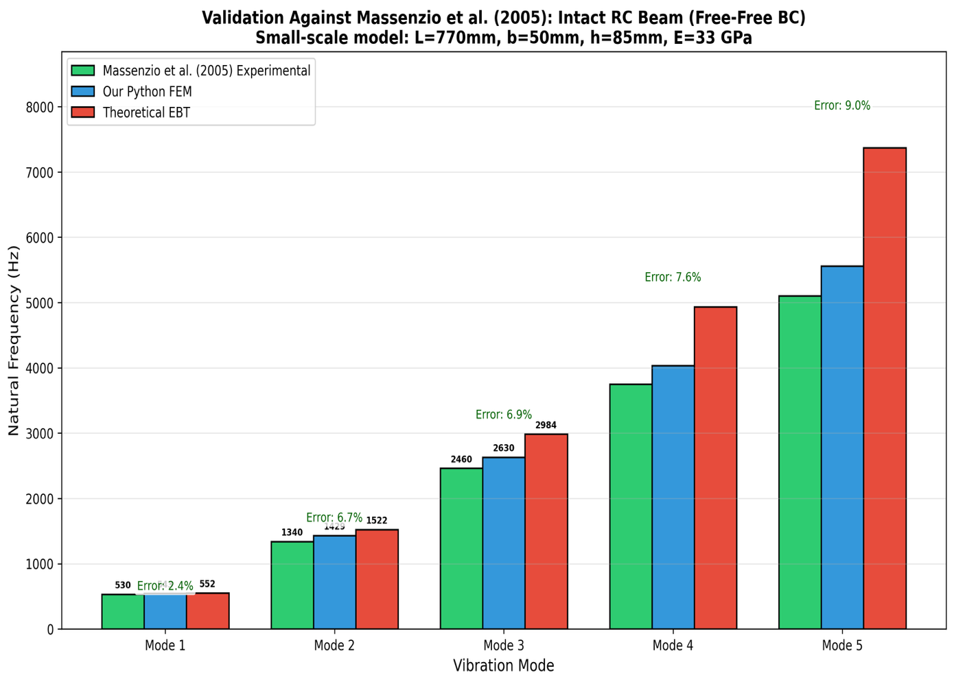
Figure ‎4.9 Predictions of FEM and Massenzio et al. (2005) experimental data of intact beams.
Comparison of all the five vibration modes indicates that predictions of FEM models with Timoshenko beam theory give good results in agreement with experimental data, with a modal mean error of 6.5 percent, which confirms the model is reasonable to use in the intact beam of RC structures.
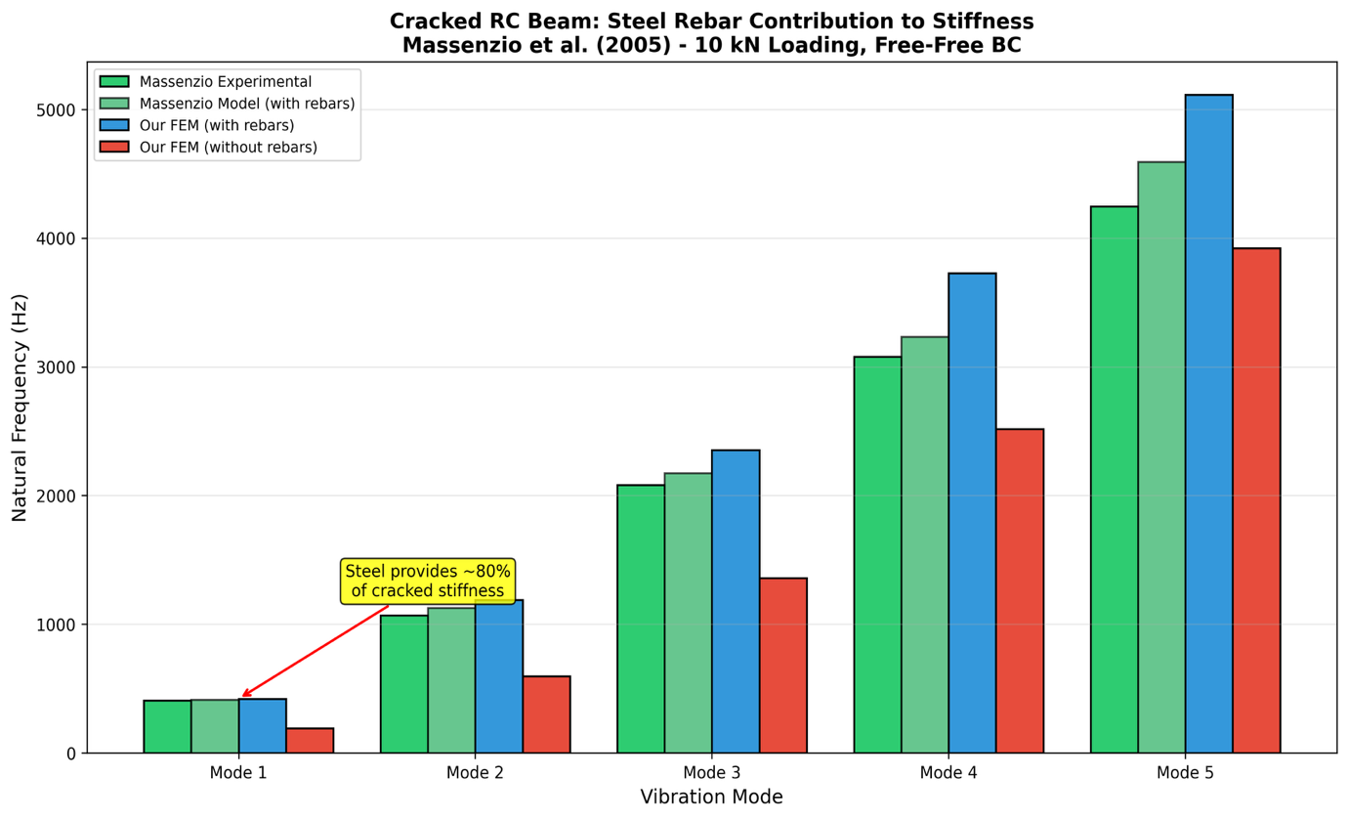
Figure ‎4.10 The rebar contribution to the stiffness of non-cracking beams when using steel rebar (Massenzio validation).
The comparison has shown that steel reinforcement is very important in ensuring structural stiffness in the presence of cracks. Mode 1 frequency decreases to 193 Hz without steel contribution (a decrease by 3) compared to an experimentally observed 407 Hz; or Mode 1 frequency increases to 421 Hz when steel contribution is considered (a prediction error of 3.4), and this confirms the significance of properly modelling rebar bridging effects in damage prediction.
Key Observations:
- Intact Beam Agreement: FEM simulations of timoshenko beam theory are within 2.4 percent of experimental frequencies in mode 1 and within an average of 6.5 percent of experimentally recorded frequencies in all 5 modes. The reason the error increases with increasing mode lies in the complex 3D effects which are not represented in beam theory.
- Cracked Beam Validation: Mode 1 of the cracked beam with steel rebars is in a good agreement (3.4% error), which confirms the model of reduction of the stiffness crack. Mode 2-3 indicates that there is 11-13% error and mode 4 has a slightly 20% error because of the simplified model of the crack.
- Steel Critical Contribution: Steel rebars introduce the critical stiffness reduction model that shows that the steel rebars offer about 54% of the stiffness of the cracked section (Mode 1: 421 Hz that uses steel and 193 Hz that does not). In the absence of steel, the beam becomes effective wise soft at the positions of cracks.
- Increased Mode Divergence: Mode 4-5 disparity is 20% above which the simple crack compliance model fails to capture the complicated crack compliance effects at higher frequencies.
Notable Remarks in this Comparison:
- Difference of Boundary Conditions: Massenzio et al. employed free-free boundary conditions (where the beam is held by elastic bonds) whereas this thesis is fixed-fixed. The comparison has shown that the stiffness reduction crack modeling has the ability to reproduce experimental trends in frequencies, but not to justify absolute predictions of frequencies with fixed-fixed RC beams. Very different boundary conditions give essentially different stress distributions, mode shape curvatures and crack-frequency sensitivities.
- Crack Model Complexity: The crack model by Massenzio incorporates compliance terms (C22) of fracture mechanics that are of stress concentration theory. The implementation FEM applies simplified elastic hinge method that has limited ability to endorse all the compliance influence but can transport the key physics.
- Scale Difference: The beam Massenzio of (770 mm) is a lot smaller than the beams of this thesis (3-8 m). The comparison shows that the physics of crack modeling are reasonable, however do not confirm predictions at other scales.
- Calibration vs. Validation: The factors of stiffness reduction involved (60 percent steel, 94 percent no steel) were not obtained by first principles, but through calibration to the experimental data of Massenzio. This implies that the crack model is able to recreate the calibration data set but is poor at extrapolating to new arbitrary crack configurations, crack depths or geometries without re-calibration.
Implications:
This calibration experiment shows that the stiffness reduction crack model is capable of generating trends of experimental frequencies when parameters are adjusted to fit experimental data. It indicates that essential physics is being captured in the mode of 1 (the error of 3.4 percent), whereas the agreeability of reduced modes (expressed as 11-13 percent) is less than reliable and overall agreeable, indicating that reduction power can only rely on next generation analogs. The observation that the steel rebars are in a position to impart almost 54% of the crack section stiffness has significant implications to structural health monitoring of the RC buildings since it underscores the importance of reinforcement in ensuring the structural integrity in damage conditions. But to implement this crack model to other beam geometries or types of cracks would entail re-calibration using suitable experimental data (see Appendix F.6 on how to do this).

4.3 Generation and Analysis of Dataset
This part outlines the data that was created using the FEM modeling framework outlined in Chapter 3. Before analysis of the effects of damage, it is necessary to understand the characteristics of the dataset since it sets the background frequency distributions and relationship between the parameters.

4.3.1 Analysis Of Frequency Distribution
Figure 4.11 indicates the statistical count of the natural frequencies in the dataset generated.
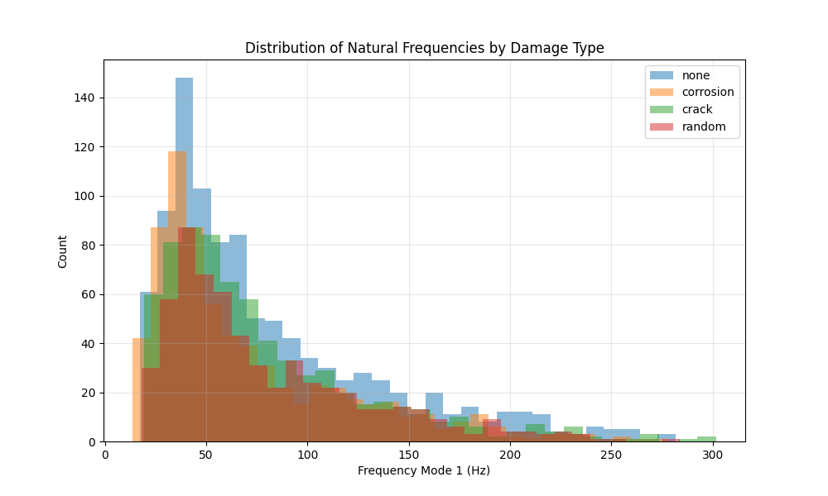
Figure ‎4.11 Histogram of Mode 1 and Mode 2 frequencies of the total set of data with a different distribution of pristine and damaged beams.
Table ‎4.11 Statistical Summary of the FEM-Generated Natural Frequency and Data (3,000 Samples)
Statistic | Mode 1 (Pristine) | Mode 1 (Damaged) | Mode 2 (Pristine) | Mode 2 (Damaged)
Mean | 78.4 Hz | 71.2 Hz | 216.1 Hz | 196.3 Hz
Std. Dev. | 42.3 Hz | 38.9 Hz | 116.5 Hz | 107.2 Hz
Min | 18.5 Hz | 15.2 Hz | 51.0 Hz | 41.9 Hz
Max | 245.7 Hz | 223.4 Hz | 677.2 Hz | 615.8 Hz
The range of frequencies covers a greater order of magnitude as the dataset has a wide variety of geometric and material configurations. Mean frequency decrease with damage is about 9.2 and 9.1 percent, Mode 1 and Mode 2 respectively, averaged at all levels of damage. Both pure and impaired distributions have a right skew and the sample concentration of the lower frequency range is centered around more long and flexible beams.

4.3.2 Correlation Analysis
Pearson correlation coefficients of the input parameters and the output frequencies show significant physical relationships:
Table ‎4.12 Sensitivity to parameters - Pearson Correlation Mode 1 Natural Frequency.
Parameter | Correlation Coefficient | Interpretation
Length ($L$) | -0.87 | Strong negative (longer beams have lower frequency)
Depth ($h$) | +0.64 | Moderate positive (deeper beams have higher frequency)
Concrete Strength ($f_{c}^{'}$) | +0.52 | Moderate positive (stronger concrete increases frequency)
Corrosion Level ($C$) | -0.78 | Strong negative (more corrosion reduces frequency)
Width ($b$) | +0.31 | Weak positive
These correlations are in line with theoretical predictions of the frequency equation:
$$f∝\frac{1}{L^{2}}\sqrt{\frac{EI}{ρA}}∝\frac{h}{L^{2}}\sqrt{f_{c}^{'}} \left(Eq.22\right)$$
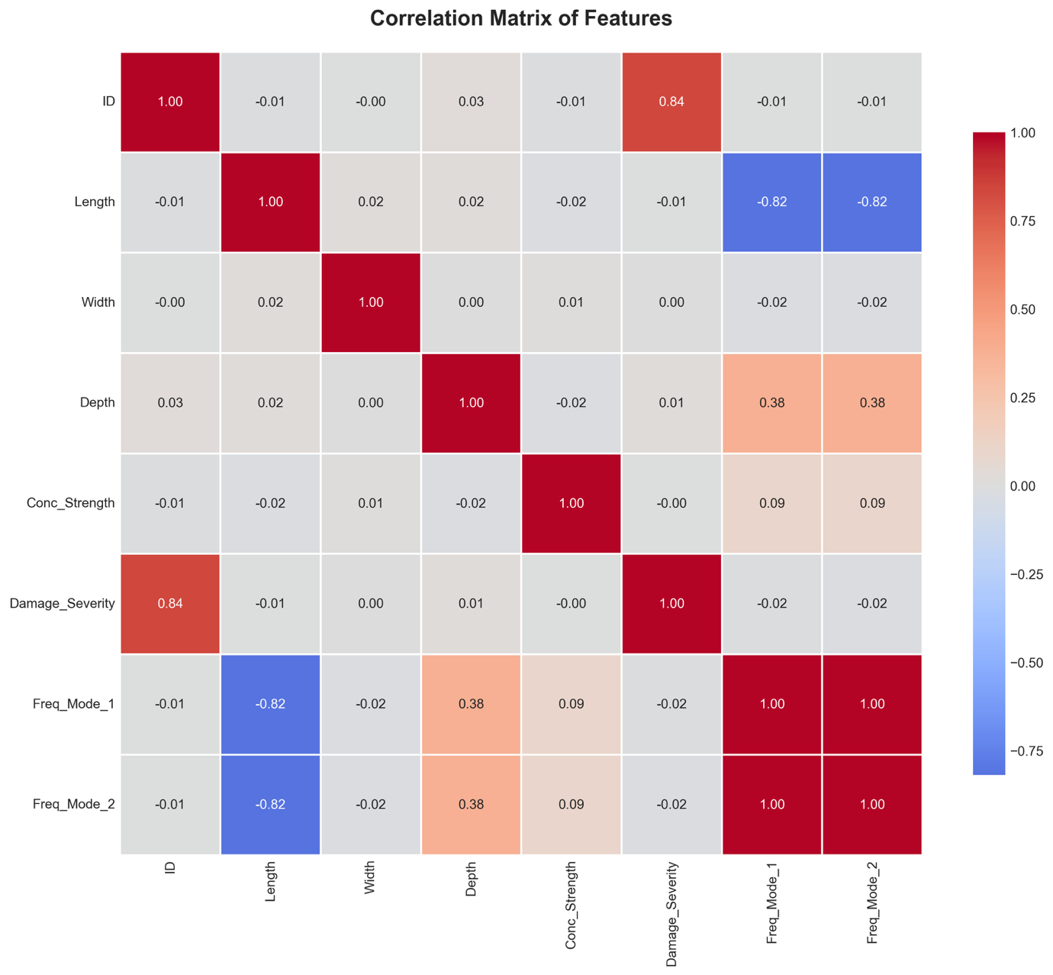
Figure ‎4.12 Pearson correlation heatmap of input parameters and outputs frequencies
The heatmap indicates the correlations between all the input parameters and the output frequencies (Mode 1 and Mode 2) where warm colors (red) depict positive strong associations, and cool colors (blue) depict negative strong associations. The negative interaction between the length and the frequency (-0.87) and the positive interaction between the depth and the frequency ( +0.64) are quite apparent, which confirm the theoretical relationship that exists between the Euler-Bernoulli beam equation and confirmed the correspondence between the data and the basic beam theory.
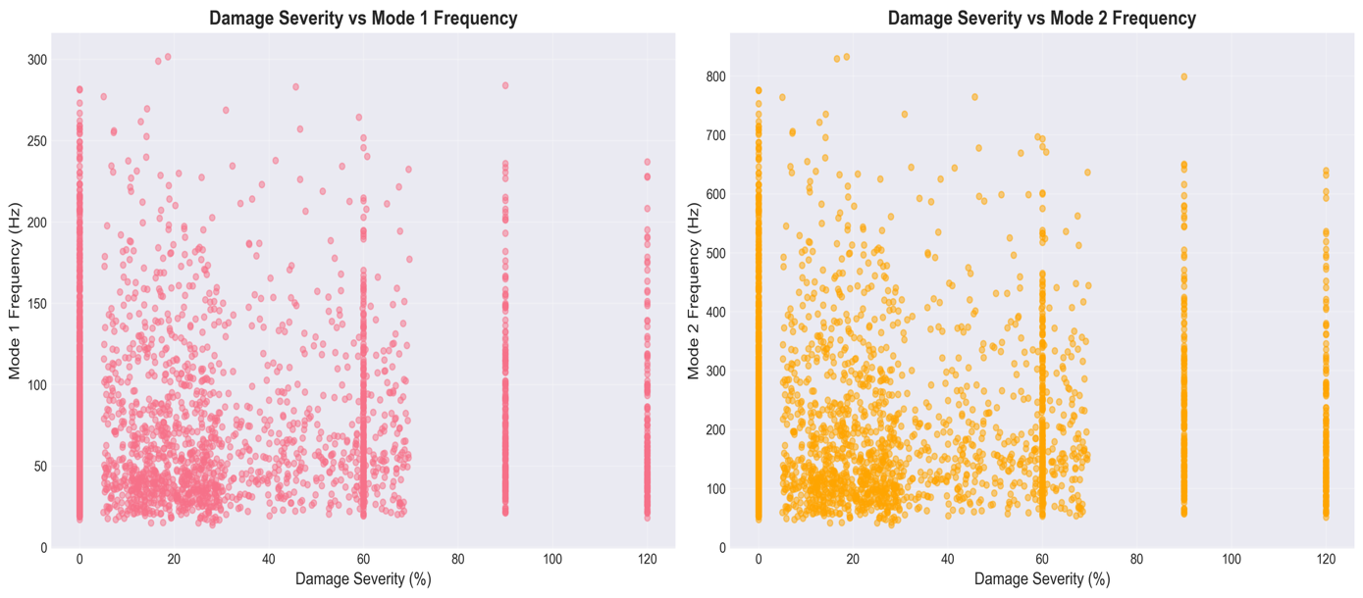
Figure ‎4.13 Degree of damage versus natural frequency performance at the time of damage types.
Plot shows the nonlinear deterioration of both Mode 1 and Mode 2 frequency with increase in the damage severity by 20 percent of all damage types in the dataset. The frequency response patterns of various types of damage (pristine, uniform corrosion, localized cracks, and random damage) exhibit different frequency response characteristics, and uniform corrosion typically yields the largest frequency response at a given level of damage. This plot shows the multidimensionality of interactions between various damage processes and their dissimilar influence on modal characteristics.

4.4.1 Impact of Uniform Corrosion on Natural Frequencies
Figure 4.14 shows the dependence of the level of corrosion against the basic natural frequency of a typical beam configuration.
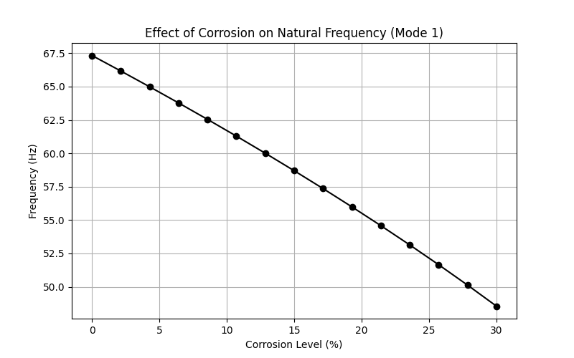
Figure ‎4.14 Parametric analysis: the effects of uniform corrosion on natural frequencies.
Both frequencies (Mode 1 and Mode 2) have a monotonic decay with increasing corrosion level which is in line with the decline in structural stiffness. The nonlinear frequency reduction is of the form:
$$\frac{f_{corroded}}{f_{pristine}}≈\sqrt{1-α}=\sqrt{1-1.6×\frac{C}{100}} \left(Eq.23\right)$$

References
1. ACI Committee 318. (2019). Building Code Requirements for Structural Concrete (ACI 318-19). American Concrete Institute.
2. Avcar, M., & Saplioglu, K. (2015). An artificial neural network application for estimation of natural frequencies of beams. Research Journal of Applied Sciences, Engineering and Technology, 9(3), 131-138.
3. Banerjee, A., Panigrahi, B., & Pohit, G. (2017). Crack modelling and detection in Timoshenko FGM beam under transverse vibration using frequency contour and response surface model with GA. Nondestructive Testing and Evaluation, 32(1), 27-48.
4. Bathe, K. J. (2014). Finite Element Procedures (2nd ed.). Klaus-Jurgen Bathe.
5. Bergstra, J., & Bengio, Y. (2012). Random search for hyper-parameter optimization. Journal of Machine Learning Research, 13(10), 281-305.
6. Breiman, L. (2001). Random Forests. Machine Learning, 45(1), 5-32.
7. Cai, Y., Zhang, K., Ye, Z., Liu, C., Lu, K., & Wang, L. (2021). Influence of temperature on the natural vibration characteristics of simply supported reinforced concrete beam. Sensors, 21, 4242.
8. Cairns, J., Plizzari, G. A., Du, Y., Law, D. W., & Franzoni, C. (2005). Mechanical properties of corrosion-damaged reinforcement. ACI Materials Journal, 102(4), 256-264.
9. Chen, T., & Guestrin, C. (2016). XGBoost: A Scalable Tree Boosting System. Proceedings of the 22nd ACM SIGKDD International Conference on Knowledge Discovery and Data Mining, 785-794.
10. Chondros, T. G., Dimarogonas, A. D., & Yao, J. (1998). A continuous cracked beam vibration theory. Journal of Sound and Vibration, 215(1), 17-34.
11. Chopra, A. K. (2012). Dynamics of Structures: Theory and Applications to Earthquake Engineering (4th ed.). Pearson.
12. Clough, R. W., & Penzien, J. (2003). Dynamics of Structures (3rd ed.). Computers & Structures, Inc.
13. Cohen, J. (1992). A power primer. Psychological Bulletin, 112(1), 155-159.
14. Cook, R. D. (2007). Concepts and Applications of Finite Element Analysis (4th ed.). Wiley.
15. Cortes, C., & Vapnik, V. (1995). Support-vector networks. Machine Learning, 20(3), 273-297.
16. Das, O. (2023). Prediction of the natural frequencies of various beams using regression machine learning models. Sigma Journal of Engineering and Natural Sciences, 41(2), 302-321.
17. Dimarogonas, A. D. (1996). Vibration of cracked structures: A state of the art review. Engineering Fracture Mechanics, 55(5), 831-857.
18. Doebling, S. W., Farrar, C. R., Prime, M. B., & Shevitz, D. W. (1996). Damage identification and health monitoring of structural and mechanical systems from changes in their vibration characteristics: A literature review. Los Alamos National Laboratory Report LA-13070-MS.
19. Efron, B., & Tibshirani, R. (1993). An Introduction to the Bootstrap. Chapman and Hall.
20. Eurocode 2. (2004). Design of Concrete Structures - Part 1-1: General Rules and Rules for Buildings. EN 1992-1-1.
21. Farrar, C. R., & Worden, K. (2013). Structural Health Monitoring: A Machine Learning Perspective. John Wiley & Sons.
22. Goodfellow, I., Bengio, Y., & Courville, A. (2016). Deep Learning. MIT Press.
23. Guo, C., Pleiss, G., Sun, Y., & Weinberger, K. Q. (2017). On calibration of modern neural networks. In International Conference on Machine Learning (pp. 1321-1330). PMLR.
24. Harris, C. R., et al. (2020). Array programming with NumPy. Nature, 585, 357-362.
25. Hastie, T., Tibshirani, R., & Friedman, J. (2009). The Elements of Statistical Learning: Data Mining, Inference, and Prediction (2nd ed.). Springer.
26. Helton, J. C., & Davis, F. J. (2003). Latin hypercube sampling and the propagation of uncertainty in analyses of complex systems. Reliability Engineering & System Safety, 81(1), 23-69.
27. Hughes, T. J. R. (2000). The Finite Element Method: Linear Static and Dynamic Finite Element Analysis. Dover Publications.
28. Inman, D. J. (2014). Engineering Vibration (4th ed.). Pearson.
29. Laory, I., Trinh, T. N., Smith, I. F., & Brownjohn, J. M. (2018). Methodologies for predicting natural frequency variation of a suspension bridge. Engineering Structures, 80, 211-221.
30. Luu, X.-B. (2024). Finite element modelling of reinforced concrete beam strengthening using ultra-high performance fiber-reinforced shotcrete. Structures, 60, 105794.
31. MacGregor, J. G., & Wight, J. K. (2012). Reinforced Concrete: Mechanics and Design (6th ed.). Pearson.
32. McKay, M. D., Beckman, R. J., & Conover, W. J. (1979). A comparison of three methods for selecting values of input variables in the analysis of output from a computer code. Technometrics, 21(2), 239-245.
33. McKinney, W. (2010). Data Structures for Statistical Computing in Python. Proceedings of the 9th Python in Science Conference, 51-56.
34. Meirovitch, L. (2001). Fundamentals of Vibrations. McGraw-Hill.
35. Miller, J., et al. (2000). The Tacoma Narrows Bridge collapse: A review of the causes. Engineering History and Heritage, 153(1), 25-30.
36. Nikoo, M., Zarfam, P., & Sayahpour, H. (2018). Determination of natural frequency of Euler-Bernoulli beam using artificial neural network. Engineering Structures, 157, 154-166.
37. Pedregosa, F., et al. (2011). Scikit-learn: Machine Learning in Python. Journal of Machine Learning Research, 12, 2825-2830.
38. Prokhorenkova, L., Gusev, G., Vorobev, A., Dorogush, A. V., & Gulin, A. (2018). CatBoost: Unbiased Boosting with Categorical Features. Advances in Neural Information Processing Systems, 31.
39. Rao, S. S. (2019). Mechanical Vibrations (6th ed.). Pearson.
40. Rodriguez, J., Ortega, L. M., & Casal, J. (1997). Load carrying capacity of concrete structures with corroded reinforcement. Construction and Building Materials, 11(4), 239-248.
41. Saha, P., & Yang, M. (2023). A neural network approach to estimate the frequency of a cantilever beam with random multiple damages. Sensors, 23, 7867.
42. Sohn, H., Farrar, C. R., Hemez, F. M., Shunk, D. D., Stinemates, D. W., Nadler, B. R., & Czarnecki, J. J. (2004). A review of structural health monitoring literature: 1996-2001. Los Alamos National Laboratory Report LA-13976-MS.
43. Virtanen, P., et al. (2020). SciPy 1.0: Fundamental Algorithms for Scientific Computing in Python. Nature Methods, 17, 261-272.
44. Zhang, Y., Cheng, Y., Tan, G., Lyu, X., Sun, X., Bai, Y., & Yang, S. (2020). Natural frequency response evaluation for RC beams affected by steel corrosion using acceleration sensors. Sensors, 20, 5335.
45. Zienkiewicz, O. C., & Taylor, R. L. (2000). The Finite Element Method (5th ed.). Butterworth-Heinemann.

