**VIRTUAL CAMPUS GUIDE AND ASSISTANT**

**ALMASRADI OMAR BATI F**

**COLLEGE OF COMPUTING AND INFORMATICS**

**UNIVERSITI TENAGA NASIONAL**

**2023**

**VIRTUAL CAMPUS GUIDE AND ASSISTANT.**

By

ALMASRADI OMAR BATI F

Project Supervisor:

AHMED MUBARAK AHMED AL-HAIQI, DR.

A REPORT SUBMITTED IN PARTIAL FULFILLMENT OF THE REQUIREMENTS FOR THE BACHELOR OF INFORMATION TECHNOLOGY,

COLLEGE OF INFORMATION TECHNOLOGY

UNIVERSITI TENAGA NASIONAL

2023

**DECLARATION**

I hereby declare that this report, submitted to University Tenaga Nasional as a partial fulfilment of the requirements for the Bachelor of Information Technology has not been submitted as an exercise for a degree at any other university. I also certify that the work described here is entirely my own except for excerpts and summaries whose sources are appropriately cited in the references.

This report may be made available within the university library and may be photocopied or loaned to other libraries for the purposes of consultation.

DEC, 2024 SW0108026

**APPROVAL SHEET**

This thesis entitled:

“**VIRTUAL CAMPUS GUIDE AND ASSISTANT.**”

Submitted by:

ALMASRADI OMAR BATI F (SW0108026)

In requirement for the degree of Bachelor of Information Technology, College of Information Technology, University Tenaga Nasional has been accepted.

Supervisor: AHMED MUBARAK AHMED AL-HAIQI, DR.

Signature:

.........................

Date: ___________________

**ABSTRACT**

Many new students face challenges navigating a complex college campus, locating important facilities, and staying informed about campus events and resources. The purpose of this project is to create an extensive "Virtual Campus Guide and Assistant" mobile application in order to solve these issues and improve the overall school experience. The purpose of this program is to offer a simple and easy-to-use platform that is customized for our university and allows for effective navigation, quick access to important campus resources, real-time updates, and a reliable feedback system.

The goal of the "Virtual Campus Guide and Assistant" app is to provide a centralized solution that easily combines a number of features, such as an interactive campus map, a library of crucial school data, real-time alerts, and a user feedback system. The app should be made with the goal of improving student involvement and the entire campus experience, which will help new students adjust more easily and become more productive in the long run.

**TABLE OF CONTENT**

CHAPTER 1 1

1 1.0. INTRODUCTION 1

■ 1.1 Background 1

■ 1.2 Problem Statement 1

■ 1.3. Objectives 2

■ 1.4 Project Scope 3

CHAPTER 2 5

1 LITERATURE REVIEW 5

■ 2.1 Introduction 5

■ 2.2 Similar Systems 5

■ 2.3 Terminology and Key Concepts 7

■ 2.4 Related Works 9

CHAPTER 3 11

1 ANALYSIS 11

■ 3.1 Introduction 11

■ 3.2 Stakeholder Identification 11

■ 3.3 Requirements Gathering 12

3.4 Analyzing Functional and Non-Functional Aspects 13

Chapter 4 15

4.0 DESIGN 15

4.1 Use case Diagram 16

4.2 User Class Diagram 16

4.3 ER Diagram 17

4.4 Sequence Diagram/Interaction Diagram 17

4.5 Package Diagram 18

4.6 Deployment Diagram 19

4.7 Activity Diagram 19

4.8 User Interface 21

4.8.1 Login 21

4.8.2 Home 22

4.8.3 Events 23

4.8.4 Others 24

CHAPTER 5 25

5.0 Conclusion 25

Contributions and impact: 25

The Path forward: 26

References 27

**Table of Table**

**Table 2.1.** Summary of similar systems and application to the proposed project…………7

# CHAPTER 1

## INTRODUCTION

### 1.1 Background

In the fast-paced and dynamic environment of modern educational institutions, navigating the campus, accessing resources, and staying informed about various campus activities can often pose significant challenges for students, faculty, and visitors. To address these challenges and enhance the overall campus experience, this project proposes the development of a comprehensive "Virtual Campus Guide and Assistant" mobile application. This application aims to provide an intuitive and user-friendly platform that facilitates efficient navigation, access to essential campus resources, real-time updates, and a robust feedback mechanism, tailored specifically for our institution.

The "Virtual Campus Guide and Assistant" app is designed to offer a centralized solution that seamlessly integrates various functionalities, including an interactive campus map, a repository of essential campus information, real-time notifications, and a user feedback system. By leveraging the latest advancements in mobile technology and user-centric design principles, this application seeks to streamline the process of navigating the campus, accessing important resources, and staying connected with the latest campus updates and events.

### 1.2 Problem Statement

Many new students face challenges navigating a complex college campus, locating important facilities, and staying informed about campus events and resources. Existing methods of physical maps and information boards are often insufficient, leading to confusion and inefficiency. This results in students spending valuable time searching for classrooms, offices, and other key locations, and missing out on important campus events and resources. There is a clear need for a user-friendly mobile application that provides an interactive virtual map, facilitates access to campus resources, and keeps students informed about campus events and emergency procedures. The app should be designed to enhance the overall campus experience and improve student engagement, ultimately contributing to a smoother transition and improved productivity for new students.

### 1.3. Objectives

The main objective of developing a virtual campus guide and assistant app can be broken down into the following set of objectives:

1. To develop an intuitive and interactive mobile application that provides a comprehensive virtual map of the campus, enabling new students to easily locate essential facilities and navigate the campus without confusion.
2. To create a centralized platform within the app for students to access important campus resources, including study materials, event notifications, and emergency services information.
3. To implement a user feedback system to gather valuable insights from students about their experience on campus, thereby enabling the management to make data-driven decisions for enhancing campus facilities, courses, and student satisfaction.

### 1.4 Project Scope

The scope of the project encompasses various aspects that contribute to the successful development and implementation of the app. The following points outline the key areas that fall within the project's scope:

1. ***User Interface Design*:** Design an intuitive and visually appealing user interface for the mobile application, ensuring ease of navigation and accessibility for all users, including new students, faculty, and campus visitors.
2. ***Virtual Campus Map Development*:** Create a comprehensive virtual map of the campus, integrating key locations and landmarks, and implementing interactive features to enable users to locate specific buildings, classrooms, and facilities easily.
3. ***Information Repository Integration*:** Incorporate a centralized information repository within the app, providing access to essential campus resources, including study materials, event schedules, emergency procedures, and contact information for various campus departments.
4. ***Real-Time Updates and Notifications*:** Implement a notification system that delivers real-time updates about campus events, schedule changes, and emergency alerts to keep users informed and engaged.
5. ***Feedback Mechanism Implementation*:** Develop a user feedback mechanism that allows students to provide valuable insights and suggestions, fostering continuous improvement and enhancing the overall user experience of the app.
6. ***Testing and Bug Fixes*:** Conduct comprehensive testing to identify and address any potential bugs or issues within the app, ensuring a smooth user experience.
7. ***Documentation and User Guidelines*:** Create comprehensive documentation outlining the app's features, functionalities, and usage guidelines, facilitating ease of use and providing support for users and administrators.

Figure 1.1 depicts the elements of scope discussed above.

*User Interface Design*

*Virtual Campus Map Development*

*Information Repository Integration*

*Real-Time Updates and Notifications*

*Feedback Mechanism Implementation*

*Testing and Bug Fixes*

*Documentation and User Guidelines*

Figure 1.1: Project scope

# CHAPTER 2

## LITERATURE REVIEW

### 2.1 Introduction

The rapid advancements in technology have revolutionized the way educational institutions manage their campus operations and enhance the overall student experience. Several studies have emphasized the significance of integrating mobile applications and digital platforms to streamline campus navigation, facilitate access to resources, and improve communication within the academic community. This chapter focuses on previous research and existing solutions related to campus navigation systems, mobile applications for educational institutions, and feedback mechanisms for enhancing the campus experience.

### 2.2 Similar Systems

There are several similar systems and applications in the market that provide functionalities similar to the proposed "Virtual Campus Guide and Assistant” app. Some of these systems are listed below.

### 2.2.1 Campus maps and navigation apps

Various universities and colleges have their own campus maps and navigation apps that help students and faculty find their way around the campus, locate buildings, classrooms, and other facilities. These apps often include features such as real-time location tracking, points of interest, and directions to specific destinations within the campus.

### 2.2.2 Educational institution mobile apps

Many educational institutions have their own mobile apps that provide students with access to various campus resources, including course information, academic calendars, library catalogs, and campus news and events. Some of these apps also offer functionalities for communication with faculty, staff, and other students.

### 2.2.3 Event management and communication platforms

Certain platforms are designed to facilitate event management and communication within educational institutions. These platforms often include features for organizing and promoting campus events, sending out notifications and updates to students, and collecting feedback and responses from attendees.

### 2.2.4 Feedback and survey tools

Several software solutions enable educational institutions to gather feedback and conduct surveys among students and faculty. These tools help in collecting valuable insights and opinions about various aspects of campus life, including facilities, courses, and overall student experience.

While these existing systems provide certain functionalities similar to the proposed app, the current project aims to integrate all these features into a single, user-friendly platform, specifically tailored to the unique needs of the particular college or university. The emphasis is on providing a comprehensive solution that combines campus navigation, information access, real-time updates, and user feedback within a single, intuitive interface. Table 2.1 lists some of the specific systems and applications that are commonly used in educational institutions for similar purposes.

Table 2.1. Summary of similar systems and application to the proposed project

|  |  |
| --- | --- |
| **Application** | **Description** |
| Google Maps for Universities | Google Maps offers customized mapping solutions for universities and colleges, enabling institutions to create interactive campus maps that help students and visitors navigate the campus efficiently. |
| Blackboard Mobile App | Blackboard provides a mobile app that allows students and faculty to access course materials, check grades, participate in discussions, and receive notifications about important events and deadlines. |
| Labster | Labster is an educational platform that offers virtual lab simulations for science courses, allowing students to conduct experiments and learn scientific concepts in a virtual environment. |
| Canvas | Canvas is a learning management system (LMS) used by many educational institutions to manage course materials, assignments, quizzes, and grades. It also offers communication tools for students and instructors. |
| Eventbrite for Universities | Eventbrite offers event management solutions that many universities use to organize and promote campus events, workshops, and seminars, enabling students to register for and attend various activities. |
| Qualtrics | Qualtrics is a widely used survey and feedback platform that allows educational institutions to gather feedback from students and faculty on various aspects of campus life, academic programs, and facilities. |
| ESRI ArcGIS for Higher Education | ESRI ArcGIS provides geographic information system (GIS) software that some universities use to create custom campus maps, conduct spatial analysis, and manage location-based data. |

These systems and applications serve different purposes within the educational environment, but collectively they contribute to enhancing the overall campus experience for students and faculty. The proposed app aims to integrate key functionalities from these systems into a unified platform tailored specifically for the needs of UNITEN.

### 2.3 Terminology and Key Concepts

Below are definitions of key concepts and terminology used in the description of the proposed project.

1. ***User Interface Design****.* User interface design refers to the process of creating interfaces in software or computerized devices with a focus on maximizing usability and the user experience. It involves designing the look and feel, layout, and interaction of the elements within the interface to ensure ease of use and efficiency.
2. ***Virtual Campus Map*.** A virtual campus map is a digital representation of a college or university campus that provides an interactive view of various buildings, landmarks, and facilities. It typically allows users to navigate through the campus virtually and locate specific points of interest.
3. ***Information Repository***. An information repository is a centralized storage location that houses various types of information or data. In the context of the project, it refers to a digital database or collection of resources, including study materials, event schedules, emergency procedures, and contact information for different departments within the campus.
4. ***Real-Time Updates and Notifications*.** Real-time updates and notifications refer to the immediate delivery of information and alerts to users as events or changes occur. In the context of the project, this feature ensures that users receive timely updates about campus events, schedule changes, and emergency alerts.
5. ***Feedback Mechanism*.** A feedback mechanism is a system or process that allows users to provide their opinions, suggestions, and experiences regarding a particular product or service. In this project, the feedback mechanism enables students to share their insights about various aspects of campus life, which can be used to make improvements and enhance the overall user experience of the app.
6. ***Mobile Application*.** A mobile application, also known as a mobile app, is a software application designed to run on mobile devices such as smartphones and tablets. It provides specific functionalities and services that cater to the needs of the users, allowing them to access information and perform tasks efficiently while on the go.
7. ***Interactive Features*.** Interactive features refer to the components within a system or application that enable users to engage and interact with the content or functionality provided. In the context of the project, interactive features may include touch-based navigation, clickable elements, and dynamic content that respond to user input.

### 2.4 Related Works

Table 2.2 shows a summary of the most relevant works from the literature to the purpose of the proposed app. Each work is labeled with the purpose that is the main focus of the work, as no work encompass all the functionalities of the proposed application entirely.

Table 2.2. A summary of a selected set of relevant works from the literature

|  |  |  |
| --- | --- | --- |
| **Ref** | **Focus** | **Summary** |
| [1] | Campus Navigation Systems | This study explores the application of augmented reality technology for campus navigation and ecological information retrieval. By integrating augmented reality and location-based services, the research establishes an environmentally friendly navigation system within the campus environment. The study focuses on rendering 3D animation models, video playback, and image recognition of flora and fauna, providing users with guidance and information when encountering specific ecological elements. |
| [2] | Campus Navigation Systems | This paper presents algorithmic, interface, and technological solutions for an information system aimed at enhancing navigation within a university campus. Analyzing the limitations of existing navigation systems, the paper outlines the requirements and architecture of the proposed system, detailing the design and development stages. The implemented system effectively addresses previous limitations, as evidenced by positive user feedback during its use in a national university. The paper concludes by outlining future prospects for this navigation system. |
| [3] | Mobile Applications for Educational Institutions | This paper presents a recent study on the use of smart devices in school education, focusing on students' interest in multimedia mobile devices for educational purposes. It addresses the opportunities, obstacles, and challenges associated with the effective use of mobile applications in learning activities, aiming to identify the key factors essential for the successful integration of smart devices in the educational setting. |
| [4] | Mobile Applications for Educational Institutions | These abstract highlights the emergence of mobile learning (m-learning) in the educational field, particularly in Malaysia, and emphasizes the need to explore its current usage and impact. It suggests that while the use of m-learning has gained interest, it is still in its early stages in many countries, including Malaysia. The study utilizes a qualitative approach to analyze past research on m-learning and underscores the necessity for integrating m-learning applications in educational institutions in Malaysia. |
| [5] | Feedback Mechanisms for Campus Improvement | This project aims to address the limitations of the existing feedback system at University Tunku Abdul Rahman (UTAR) by developing a mobile feedback application. The app allows students and academic staff to report facility defects, track the progress of their feedback, and provide ratings on staff performance. Additionally, the application offers filtering functions for staff to manage and assign feedback, enabling administrators to monitor monthly feedback and staff performance effectively. |
| [6] | Feedback Mechanisms for Campus Improvement | This mixed-methods study explores online feedback processes in online education, focusing on the perspectives of instructors and students. Analyzing data from forums and interviews, the study finds that the feedback provided aligns with best practices in terms of timeliness, accessibility, and depth. However, students' perceptions reveal a broader understanding of effective feedback, emphasizing its pedagogical, contextual, and relational dimensions. The study underscores the importance of considering these diverse perspectives for instructors seeking to enhance online teaching and advocates for a comprehensive framework to understand the impact of online feedback on student learning. |

# CHAPTER 3

## ANALYSIS

### 3.1 Introduction

The Analysis phase plays a pivotal role in laying the foundation for the "Virtual Campus Guide and Assistant" project. This phase is dedicated to gaining a profound understanding of the project's intricacies, encompassing its requirements, constraints, and overarching objectives. It serves as the bedrock upon which the entire application will be developed. This chapter not only outlines the key functional and non-functional requirements but also provides insights into the rationale behind each element, ensuring a thorough comprehension of the application's scope and purpose.

### 3.2 Stakeholder Identification

Identifying stakeholders is a nuanced and meticulous process crucial for aligning the application's functionalities with the diverse needs of its users. In the context of the "Virtual Campus Guide and Assistant," primary stakeholders include students, faculty, administrators, and visitors. Each stakeholder group brings a unique perspective and set of expectations to the table.

* **Students:** As the primary users, students require intuitive navigation, quick access to relevant resources, and real-time updates on campus events. Their needs range from efficient classroom location services to timely notifications about extracurricular activities.
* **Faculty:** Faculty members seek seamless communication channels, easy access to academic resources, and a platform to disseminate information effectively. The application must cater to their requirements for streamlined course management and communication with students.
* **Administrators:** Administrative stakeholders are concerned with the overall efficiency of campus operations. They need tools for gathering feedback, monitoring app usage, and ensuring that the application aligns with broader institutional goals.
* **Visitors:** Visitors, including prospective students and guests, require user-friendly interfaces to explore the campus, access information about facilities, and stay informed about ongoing events.

Understanding the distinct needs and expectations of each stakeholder group is paramount in tailoring the application to be inclusive and user-centric.

### 3.3 Requirements Gathering

The requirements gathering process involved a comprehensive approach to capture the essence of stakeholders' expectations. This multifaceted strategy included:

* **Interviews:** Direct engagement with stakeholders through one-on-one interviews provided qualitative insights into their expectations, concerns, and desired functionalities.
* **Surveys:** Distributed surveys allowed for a broader data collection approach, enabling stakeholders to express their preferences and priorities anonymously.
* **Workshops:** Collaborative workshops facilitated dynamic discussions, encouraging stakeholders to articulate their needs and engage in dialogue with one another, fostering a collective understanding of priorities.

The culmination of these methods resulted in a rich pool of information, which was meticulously categorized into functional and non-functional aspects. This approach ensures that the application not only meets the immediate needs of stakeholders but also aligns with the broader goals of enhancing the overall campus experience. The iterative nature of requirements gathering allowed for ongoing refinement and validation, ensuring that the documented requirements accurately reflect the stakeholders' expectations and challenges.

### 3.4 Analyzing Functional and Non-Functional Aspects

The analysis phase delved into the intricate details of functional and non-functional aspects, ensuring a comprehensive understanding of the "Virtual Campus Guide and Assistant" project's scope and purpose.

### 3.4.1 Functional Requirements Identification

Functional requirements are the cornerstone of the application's capabilities, defining specific functionalities that cater to users' immediate needs. These were meticulously identified through a multifaceted approach involving stakeholder engagements, interviews, surveys, and workshops.

The functional requirements encompassed critical elements such as user authentication, interactive campus mapping, event management, and a feedback mechanism. Each requirement was meticulously articulated, considering the distinct needs of stakeholders. For instance, the user authentication feature ensures a secure environment, while the interactive campus map offers real-time navigation services to aid students and visitors in seamless exploration of the campus.

### 3.4.2 Non-Functional Requirements Consideration

In parallel, the non-functional requirements formed an integral part of the analysis, focusing on performance, security, and usability aspects crucial for a robust and user-centric application. These requirements were devised to ensure the application's efficiency, reliability, and ease of use.

Performance requirements, stipulating response times and system efficiency, aimed to provide users with a seamless experience, ensuring quick access to information and navigation services. Security requirements emphasized data encryption and compliance with industry standards to safeguard user information and maintain privacy. Additionally, usability requirements focused on an intuitive interface, aligning with industry best practices to enhance user satisfaction and engagement.

### 3.4.3 Iterative Refinement and Validation

Throughout the analysis phase, an iterative approach was adopted, allowing for continuous refinement and validation of the documented requirements. This iterative process ensured that evolving stakeholder expectations and challenges were consistently incorporated, guaranteeing that the articulated requirements were accurate and aligned with the overarching goals of enhancing the campus experience.

In essence, the analysis phase served as the cornerstone, laying the groundwork for the subsequent design phase by comprehensively identifying, categorizing, and prioritizing functional and non-functional requirements essential for the successful development of the "Virtual Campus Guide and Assistant" application.

# CHAPTER 4

## DESIGN

The design phase of the "Virtual Campus Guide and Assistant" project marks a critical juncture in the development lifecycle, where the foundational architecture and structure of the application begin to take shape. This chapter delves into the intricacies of the system's design, elucidating the structural organization, interaction patterns, and the underlying framework that empowers the functionalities envisioned in the preceding analysis phase.

The comprehensive analysis conducted in prior chapters has provided a profound understanding of stakeholder requirements, system functionalities, and essential constraints. This understanding forms the bedrock upon which the design principles are articulated, ensuring that the resultant design aligns meticulously with the articulated needs and expectations of stakeholders, while also addressing the broader objectives of enhancing the campus experience.

This chapter not only outlines the design rationale but also elucidates the architectural decisions, class structures, interaction diagrams, and the systematic arrangement of modules encapsulated within packages. It aims to offer a clear and coherent view of the system's architecture, illustrating how various components, modules, and functionalities interact to deliver a cohesive and user-centric experience.

The design of the "Virtual Campus Guide and Assistant" application is orchestrated to encompass user authentication, campus navigation, event management, feedback systems, and other crucial functionalities within a coherent and scalable framework. Through meticulous design decisions, the aim is to ensure the system's flexibility, extensibility, and adaptability to meet evolving user needs and technological advancements.

This chapter navigates through the delineation of class diagrams, entity-relationship models, sequence diagrams, package diagrams, and other design artifacts, each contributing to the holistic blueprint of the application's architecture. Each design artifact serves as a vital piece in the puzzle, contributing to the comprehensive understanding of the system's structure and behaviour.

The culmination of the design phase not only represents an architectural plan but also serves as a guiding map for the development team, empowering them to translate the envisioned system into a tangible and functional reality. Additionally, the design phase remains open to refinement, iteration, and enhancement based on ongoing feedback, technological advancements, and evolving project dynamics.

In essence, this chapter serves as a gateway to the inner workings of the "Virtual Campus Guide and Assistant," offering insights into its design philosophy, structural composition, and the orchestrated ensemble of functionalities aimed at enhancing the campus experience.

### 4.1 Use case Diagram

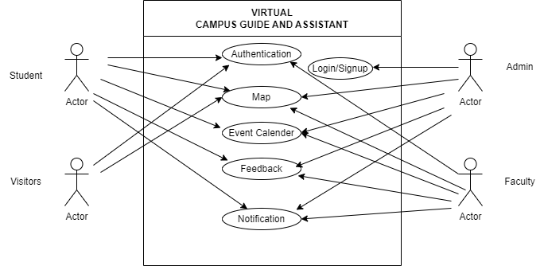

### 4.2 User Class Diagram

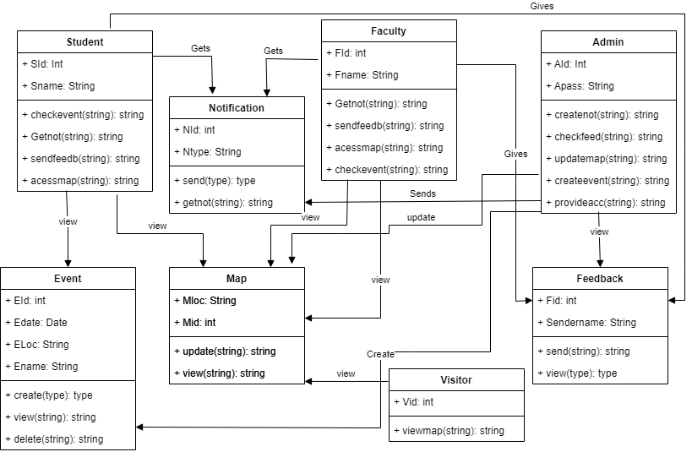

### 4.3 ER Diagram

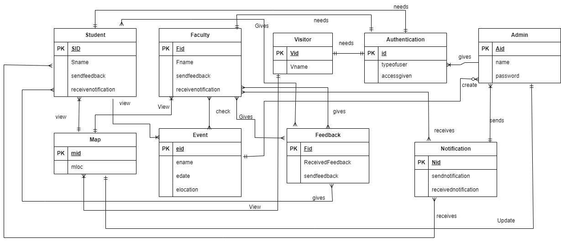

### 4.4 Sequence Diagram/Interaction Diagram

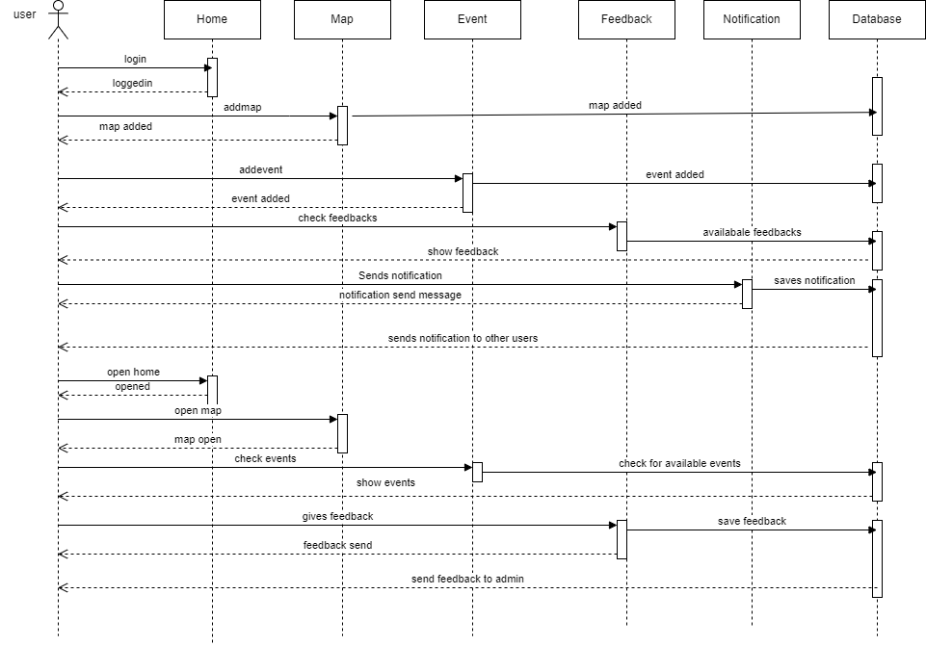

### 4.5 Package Diagram

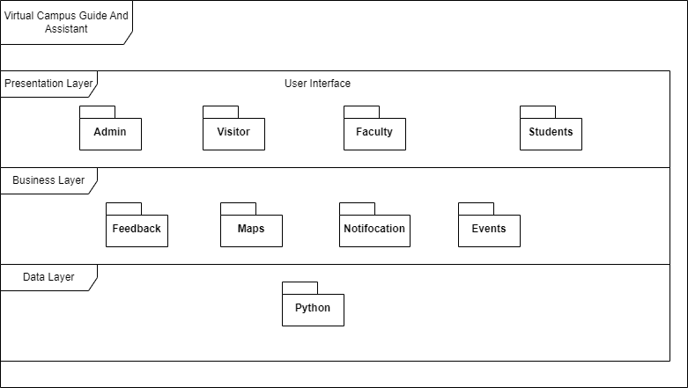

### 4.6 Deployment Diagram

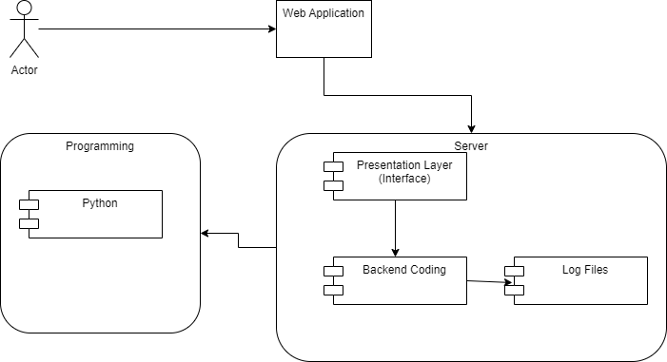

### 4.7 Activity Diagram

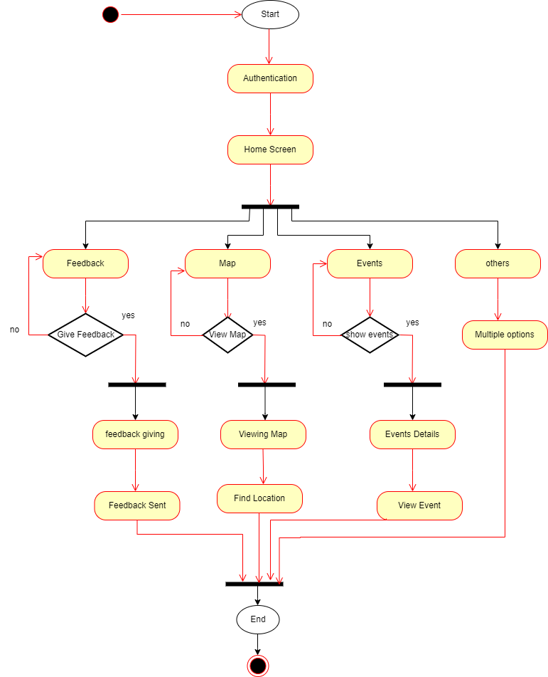

### 4.8 User Interface

#### 4.8.1 Login

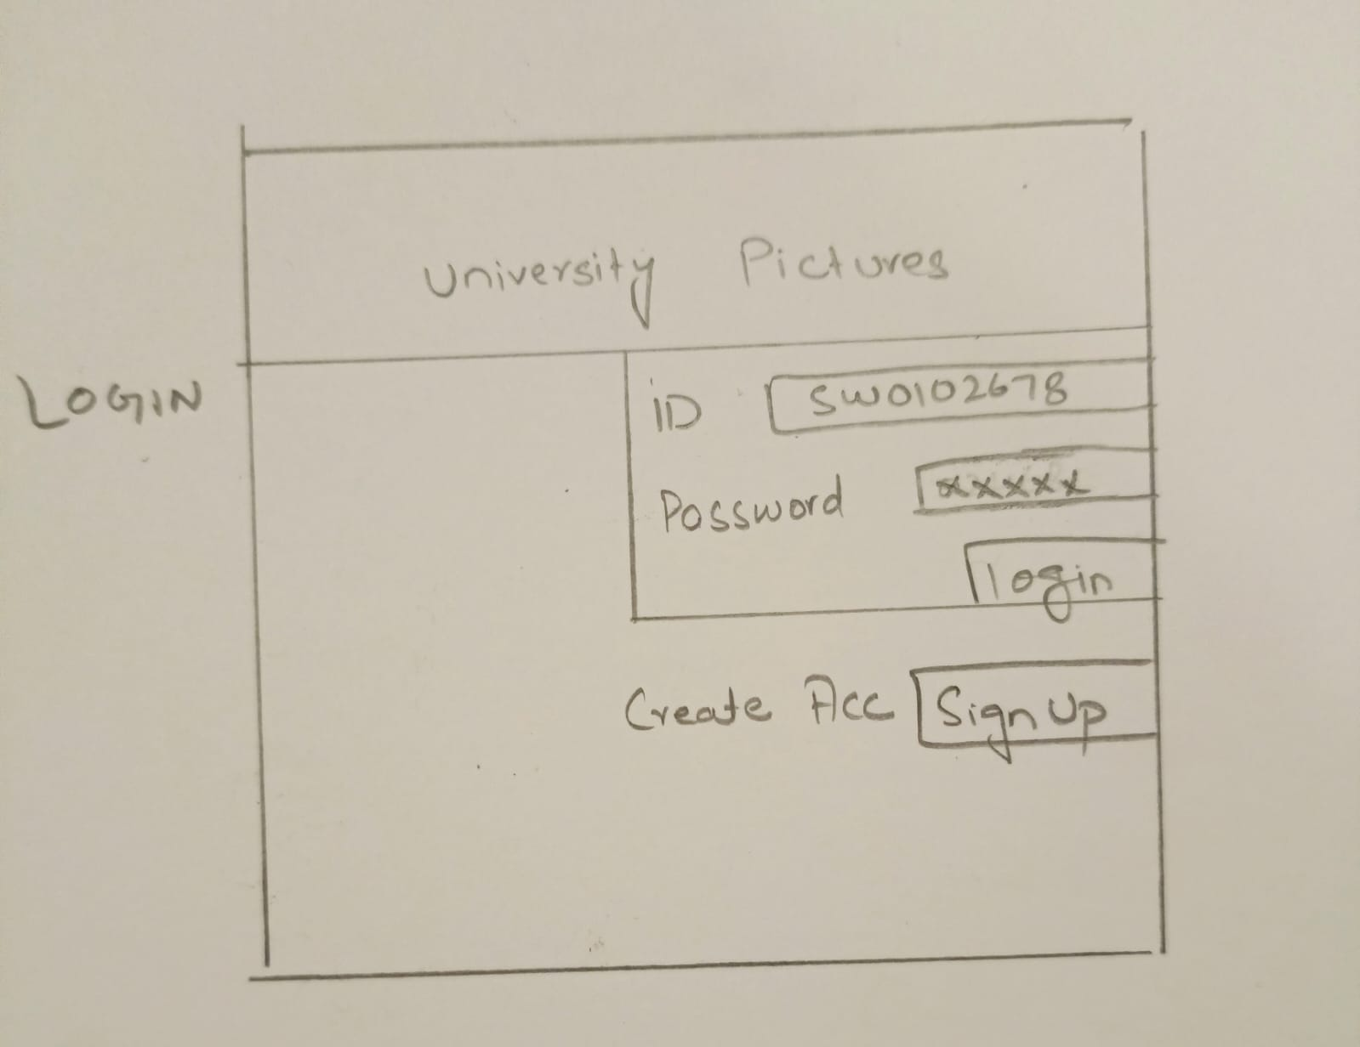

#### 4.8.2 Home

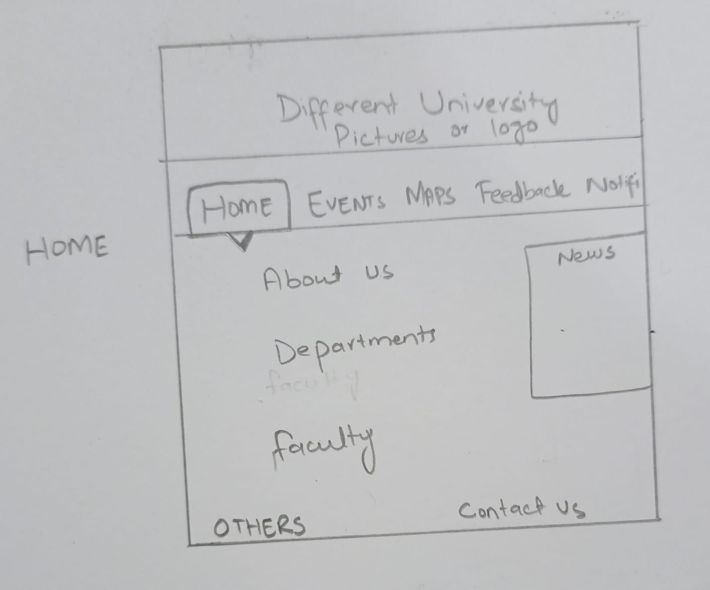

#### 4.8.3 Events

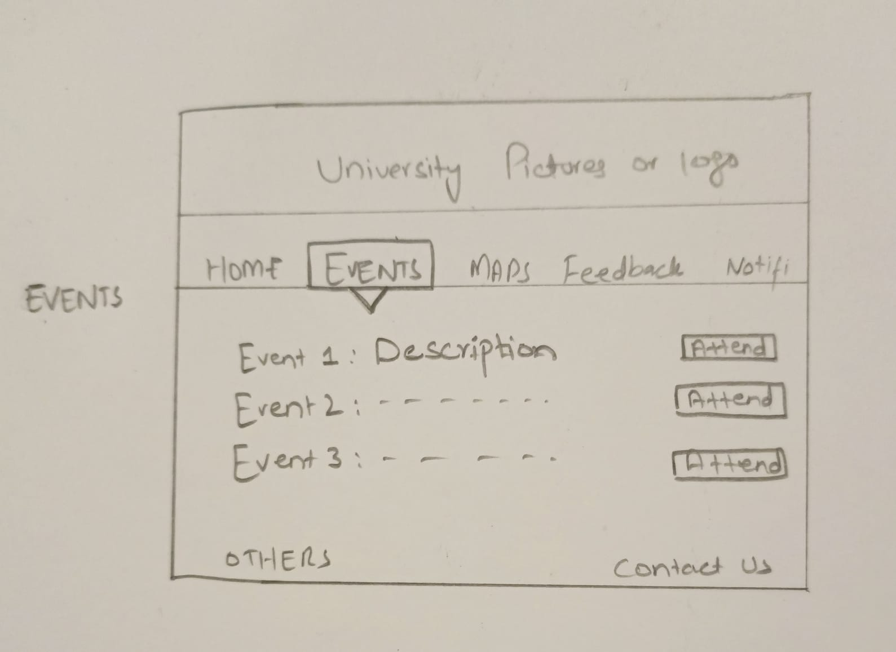

#### 4.8.4 Others

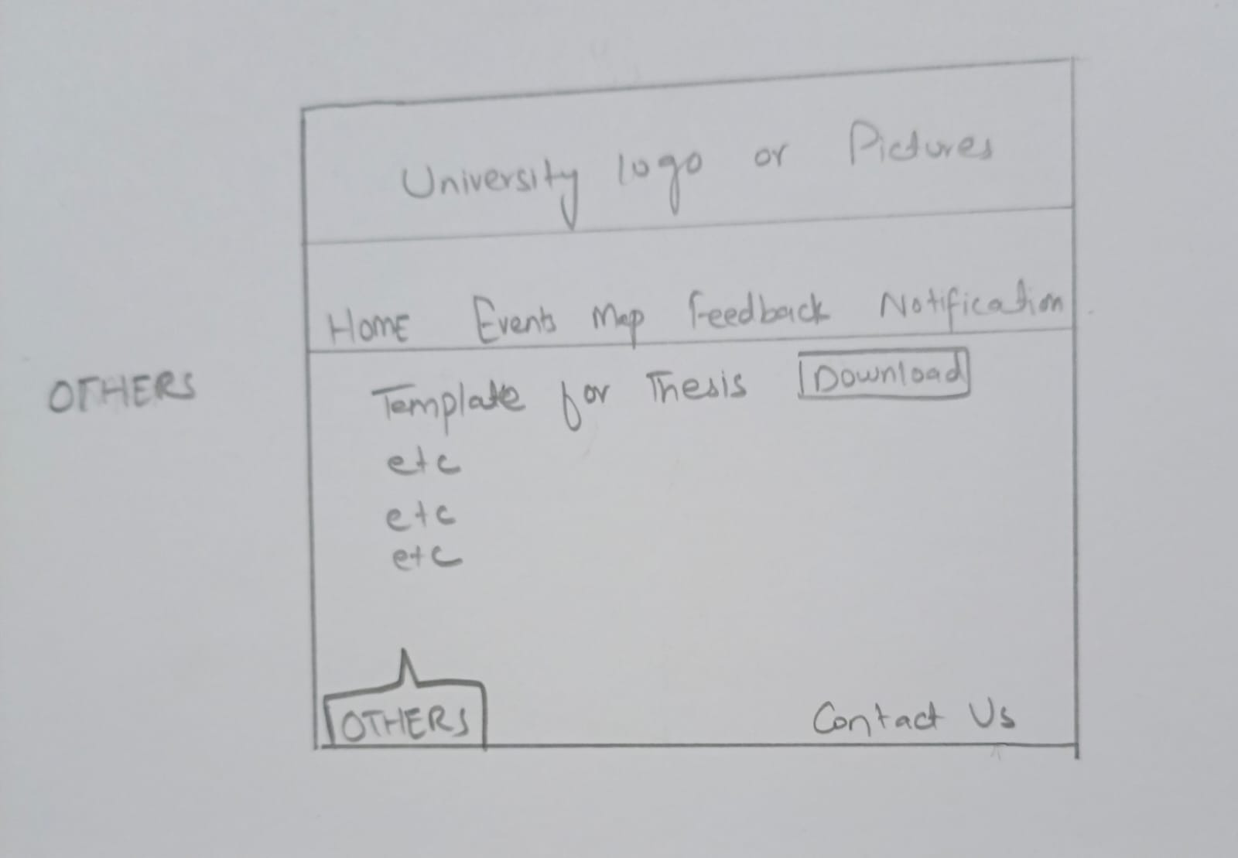

# CHAPTER 5

## CONCLUSION

The journey from conceptualization through design and analysis to the culmination of the "Virtual Campus Guide and Assistant" project was an enlightening expedition aimed at expanding the university experience for students, faculty, administrators and visitors alike. This chapter summarizes the key findings, achievements and future directions planned for the project.

The inception of the project revolved around addressing the growing need for a sophisticated yet user-friendly mobile application to navigate campus, access key resources, and support an environment of interaction and engagement. The due diligence phase clarified the various needs of stakeholders and laid the foundation for a comprehensive understanding of functional and non-functional requirements.

The subsequent design phase carefully created an architectural blueprint that clarified the system's structural design, interaction patterns, and seamless orchestration of the various modules encapsulated in the packages. From class diagrams to entity relationship models and sequence diagrams, each design artifact contributed to creating a cohesive and scalable framework for the application.

#### 5.1 Contributions and Impact

The "Virtual Campus Guide and Assistant" project seeks to transform the campus experience by providing an intuitive platform that brings together essential functions. It promises seamless campus navigation, real-time event updates, robust user authentication and a platform for valuable feedback, thereby fostering an inclusive and engaging campus ecosystem.

The impact of the project goes beyond mere technological implementation. It embodies a user-centric approach, increases user engagement and satisfaction, facilitates smoother campus integration for new entrants, and enhances administrative efficiency through data-driven decision-making.

#### 5.2 The Path Forward

As the project ends its current phase, the roadmap ahead is full of opportunities for growth and refinement. Moving from the design phase to the development phase means realizing the envisioned architecture into a tangible application, followed by rigorous testing, deployment, and iterative improvements based on user feedback and technological advances.

The future beckons with the prospect of continuous development, feature expansion, feature expansion, and the introduction of new technologies that will enhance the application's ability to meet the dynamic needs of a vibrant campus community.

# References

[1] Yu, Kun-Ming, et al. "A mobile application for an ecological campus navigation system using augmented reality." 2015 8th International Conference on Ubi-Media Computing (UMEDIA). IEEE, 2015.

[2] Gryzun, Liudmyla E., Oleksandr V. Shcherbakov, and Bogdan O. Bida. "Development of the information system for navigation in modern university campus." CTE Workshop Proceedings. Vol. 10. 2023.

[3] Damyanov, Ivo, and Nikolay Tsankov. "Mobile apps in daily learning activities." iJIM 12.6 (2018).

[4] Masrom, Maslin, et al. "Mobile learning in Malaysia education institutions." Issues in Information Systems 17.4 (2016): 152-157.

[5] Chong, Zi Ming. Mobile Feedback System For Improving Facilities In Utar Campus. Diss. UTAR, 2020.

[6] Savvidou, Christine. "Exploring the pedagogy of online feedback in supporting distance learners." Advanced Learning and Teaching Environments: Innovation, Contents and Methods (2018): 103-122.