Test ID | 1
Test Description | Initial setup
Steps | Run the flask_game_engine.py file and head to http://127.0.0.1:5000
Expected Result | Loads the board. 8x8 board. Two dark and two light pieces in the center diagonally opposite to the counter of their colour.
Actual Result | 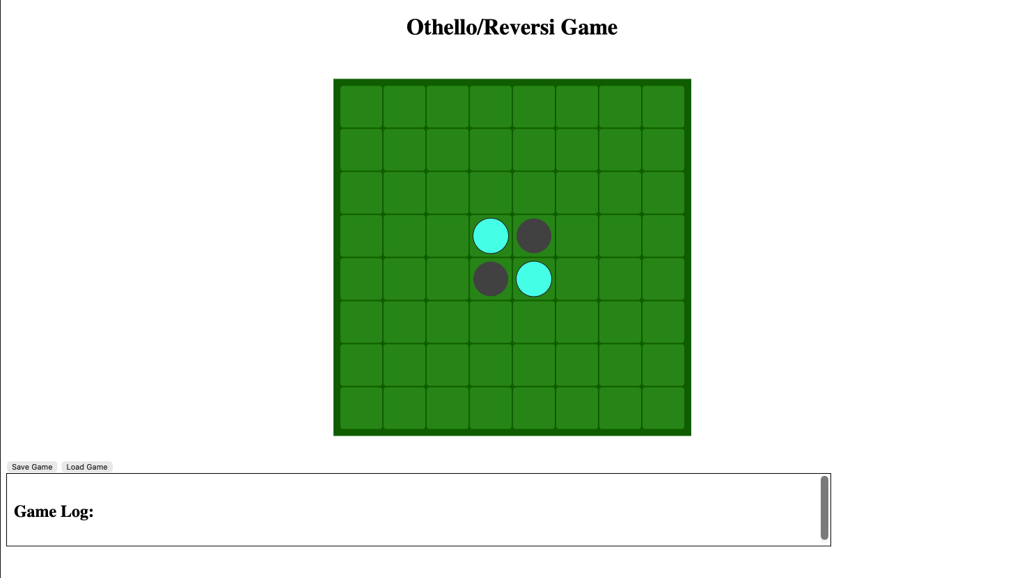

Test ID | 2
Test Description | Valid move and AI response
Steps | Click valid square that outflanks light piece(3, 4)
Expected Result | The outflanked piece flips colour and then the AI takes its turn. Log outputs that move was accepted at the coordinate 3,4 and then says its darks turn
Actual Result | 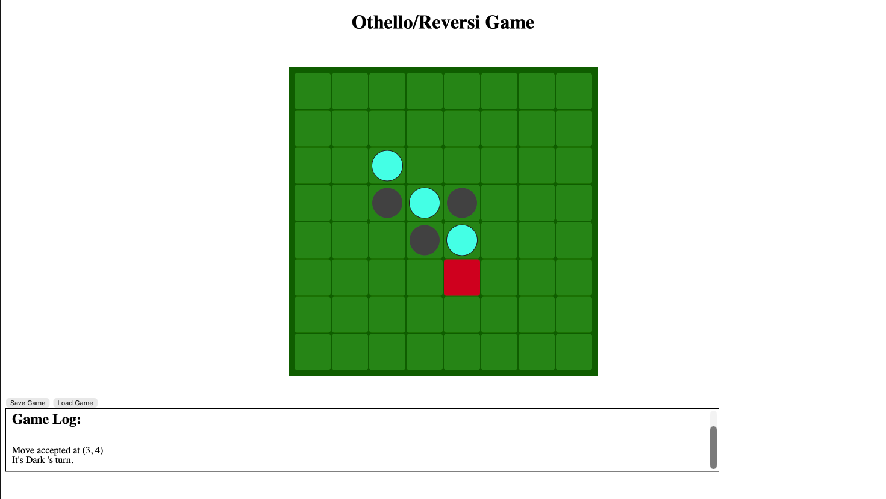

Test ID | 3
Test Description | Invalid move where tile is not free
Steps | Click a tile where there is already a counter
Expected Result | It says invalid move at the coordinates selected
Actual Result | 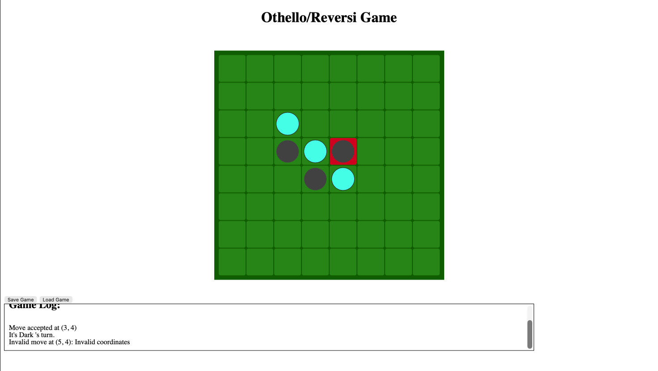

Test ID | 4
Test Description | Invalid move where no pieces are outflanked
Steps | Select a tile where no pieces are outflanked
Expected Result | It says invalid move at the coordinates selected
Actual Result | 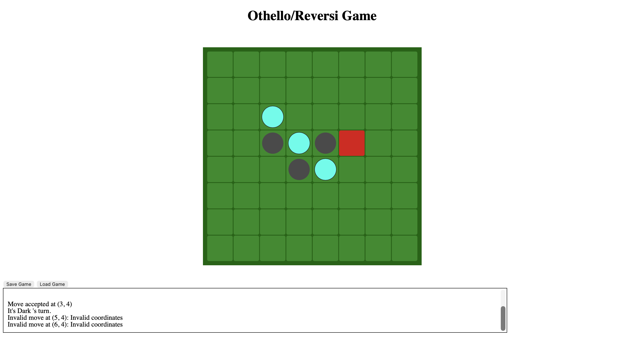

Test ID | 5
Test Description | Save game
Steps | Click save game and check if save file was there
Expected Result | Popup shows up saying game was saved and file is created/updated in game folder. Game is saved correctly with correct turn and move counter and board state
Actual Result | 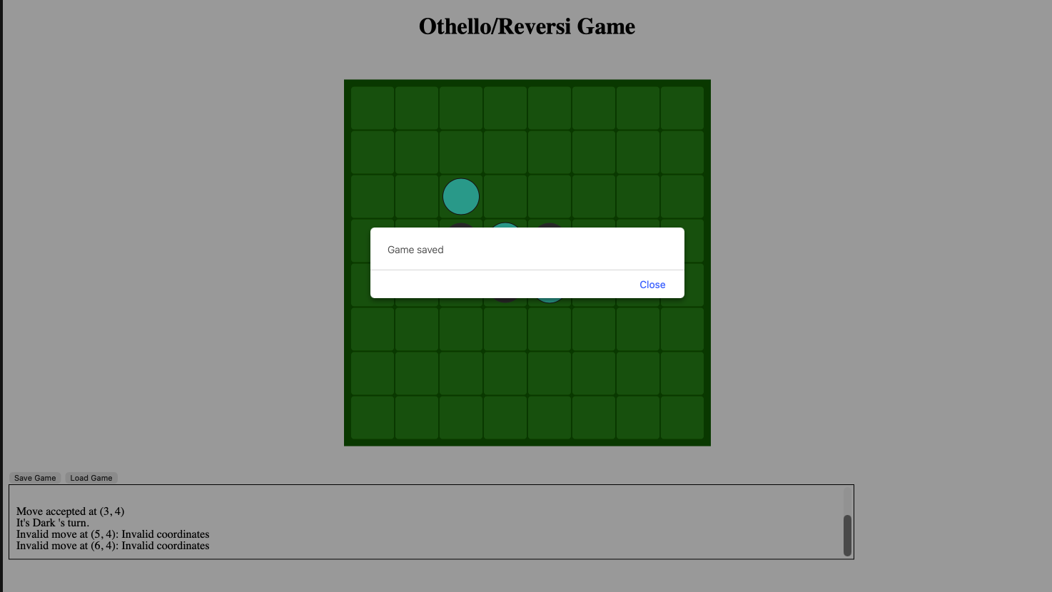  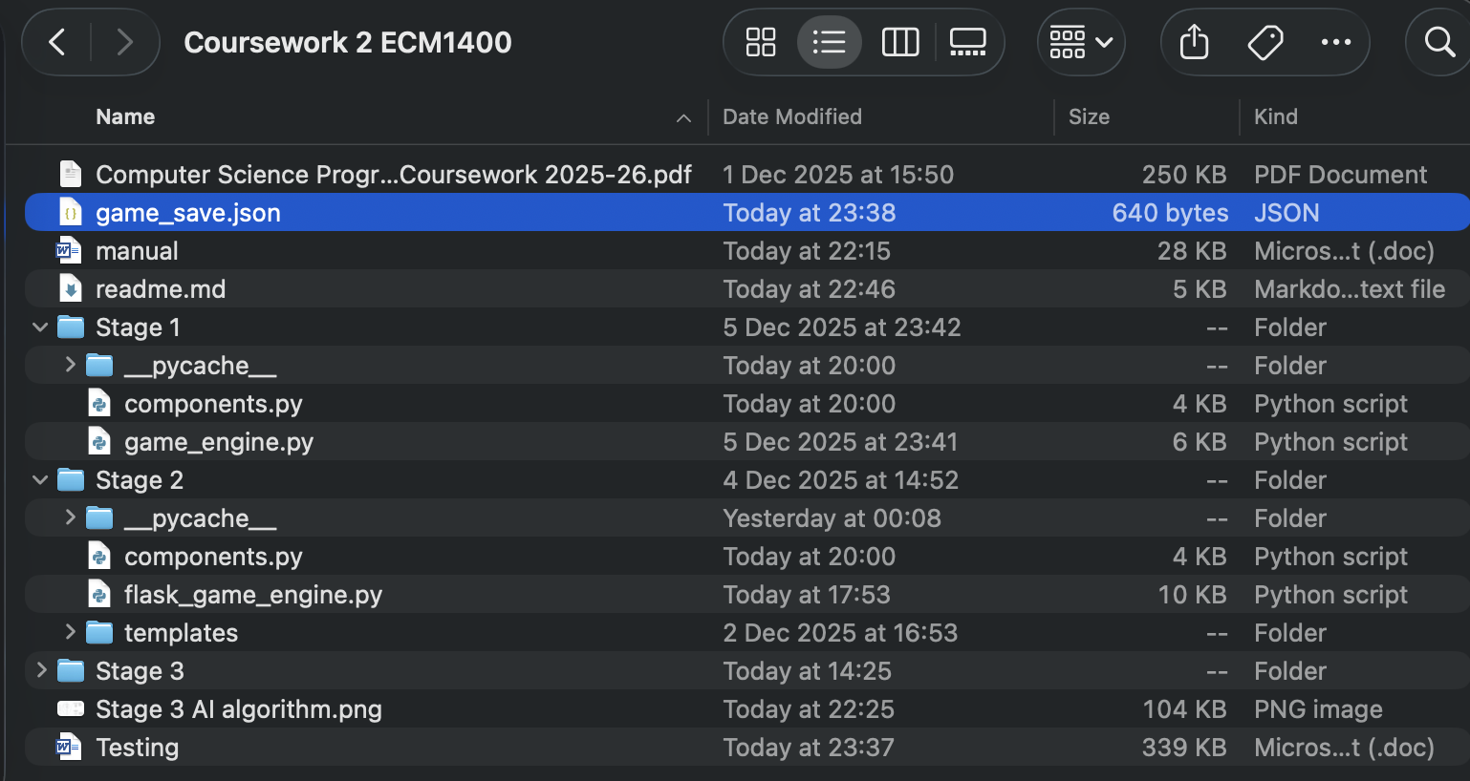

Test ID | 6
Test Description | Load game
Steps | Reload page. Click load game
Expected Result | Game log updates with message saying game was loaded and board updates. It also outputs whose turn it is in the game log
Actual Result | 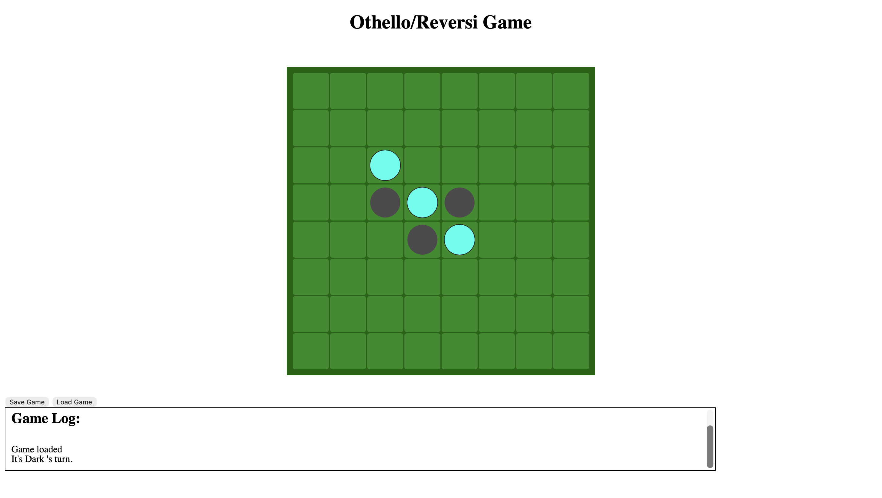

Test ID | 9
Test Description | Game over
Steps | Play the game until the board is full
Expected Result | Outputs who won using popup window and also clears log and updates it by outputting winner. Board updates once popup window is closed.
Actual Result | 