Overview

Software decomposition

Eventify is decomposed into the following package structure. Each line indicates a dependency. The goal has been to maintain a clean code while facilitating debugging and further development. There is a minor circular dependency between the eventutil and activity package since the class NotificationUtil in eventutil references DetailAcitivty in the activity package in order to open a detail view based on the notification clicked.

* **Activity,** contains all the activity classes
* **Manager,** contains all the classes close to the Android system
* **Model,** contains all the model classes
* **Helper,** contains smaller classes used to help others
* **Eventutil,** contains classes that provide functionality regarding events
* **Util,** contains classes that provides functionality. E.g. location services
* **View,** contains all the UI classes
* **Adapter,** contains all the adapter classes

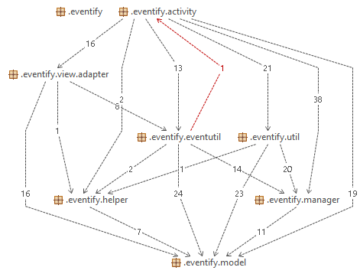

Figure 1. Package structure.

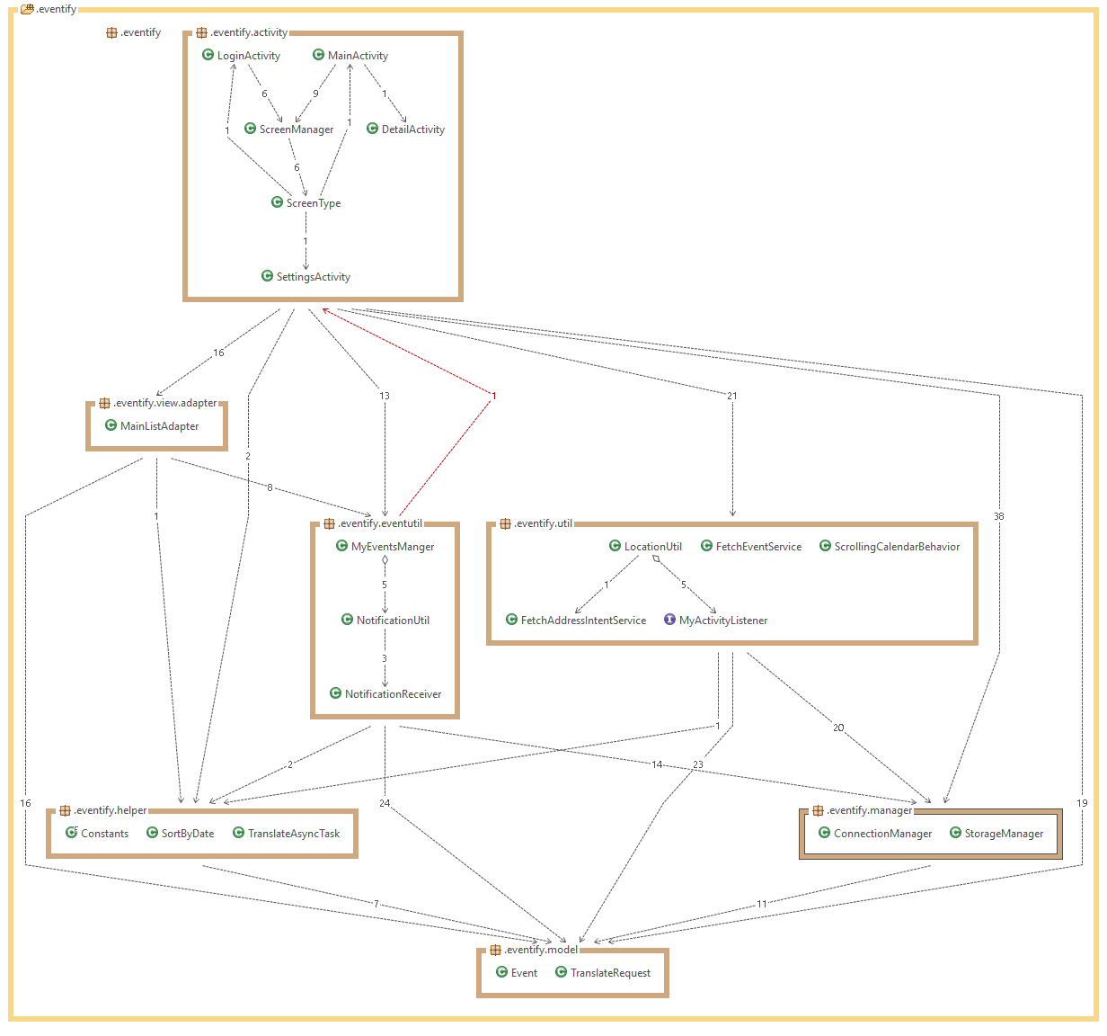

Figure 2. Detailed view of package structure.