S-CCPCH performance
BLER, multipath: PB 3km/h;
reference:
[1] S-CCPCH performance, 3GPP, (4.3.1.5 Pedestrian B (3km/hr) Figure 4.3.10 – 64kbps, 1%BLER, PB3, 80ms TTI ) site distance = 2.8 km
%Tx=10^(Ec_Ior_dB)/10); therefore, Ptfach_lin = 20*%Tx = 20* 10^(Ec_Ior/10)
[2] Multi-resolution MBMS.., fig 6 – S-CCPCH average coverage vs Tx. Power for 1 RL, site distance =1000m, 3 sector

Coverage |  |  | 64kbps; power;  TTL=80ms[1]  Figure 4.3.4 , PA3  Site distance = 2.8km |  |  | 128 kbps |  |  | 256 kbps
(km) | (%) | G factor  macro cell | (dB) | (W) | (W) | power (%)[2] | (dB) | (W) | Power (%) [2] | Power (W)
[0, 0.05] | 10 |  | -15 | 0.632456 |  | 12.5 | 2.5 |  | 30 | 6
(0.05,0.075] | 15 |  | -14.8 | 0.662262 |  | 14 | 2.8 |  | 32 | 6.4
(0.075, 0.1] | 20 |  | -14.4 | 0.726156 |  | 15.5 | 3.1 |  | 33 | 6.6
(0.1, 0.125] | 25 |  | -13.3 | 0.93547 |  | 17 | 3.4 |  | 36 | 7.2
(0.125, 0.15] | 30 |  | -12.8 | 1.049615 | 0.64 | 18 | 3.6 |  | 40 | 8
(0.15, 0.175] | 35 |  | -12 | 1.261915 | 0.74 | 19.2 | 3.84 |  | 44 | 8.8
(0.175, 0.2] | 40 |  | -11 | 1.588656 | 0.8 | 22 | 4.4 |  | 48 | 9.6
(0.2, 0.225] | 45 |  | -10.5 | 1.782502 | 0.9 | 24.8 | 4.96 |  | 53 | 10.6
(0.225, 0.25] | 50 |  | -9.8 | 2.094257 | 1 | 26 | 5.2 |  | 58 | 11.6
(0.25, 0.275] | 55 |  | -9 | 2.517851 | 1.18 | 28 | 5.6 |  | 64 | 12.8
(0.275, 0.3] | 60 | 0 dB | -8.2 | 3.027122 | 1.32 | 32 | 6.4 |  | 70 | 14
(0.3, 0.325] | 65 |  | -7.5 | 3.556559 | 1.52 | 35 | 7 |  | 76 | 15.2
(0.325, 0.35] | 70 |  | -6.9 | 4.083476 | 1.64 | 39 | 7.8 |  | 87 | 17.4
(0.35, 0.375] | 75 |  | -6 | 5.023773 | 2 | 44 | 8.8 |  | 95 | 19
(0.375, 0.4] | 80 | -3 dB | -5.1 | 6.180591 | 2.48 | 49 | 9.8
(0.4, 0.425] | 85 |  | -4.2 | 7.603788 | 2.82 | 55 | 11
(0.425, 0.45] | 90 |  | -3.2 | 9.572602 | 3.84 | 65 | 13
(0.45, 0.475] | 95 |  | -1 | 15.88656 | 4.48 | 80 | 16
(0.475, 0.5] | 100 |  | -0.5 | 17.82502 | 10.2 | 100 | 20

[3] chapter 9 - Radio Resource Management for E-MBMS Transmission towards LTE, A.A. 2009 , cell radius = 577 m , site distance = 1000m
No soft combing, no MDC(Macro Diversity Combining)

Coverage |  |  | 32kbps power(W)  TTL=80ms[3] | 64kbps; power;(W)  TTL=80ms[3] | 128 kbps (W)  TTL=80ms[3] | 256 kbps [2]
(%) | (km) | (km) |  |  |  | Power (W)
0,10 | [0, 0.058] | [0, 0.058] | 0.95 | 1.4 | 2.6 | 6
10,15 | (0.058,0.0866] | (0.058,0.087] | 0.98 | 1.5 | 2.8 | 6.4
15,20 | (0.08655, 0.1154] | (0.087, 0.12] | 1 | 1.6 | 3 | 6.6
20,25 | (0.1154, 0.14425] | (0.12, 0.14] | 1.05 | 1.8 | 3.3 | 7.2
25,30 | (0.14425, 0.1731] | (0.14, 0.17] | 1.1 | 1.85 | 3.6 | 8
30,35 | (0.1731 , 0.20195] | (0.17, 0.202] | 1.2 | 1.95 | 3.85 | 8.8
35,40 | (0.20195, 0.2308] | (0.202, 0.230] | 1.4 | 2 | 4.2 | 9.6
40,45 | (0.2308, 0.25965] | (0.230, 0.26] | 1.5 | 2.3 | 4.6 | 10.6
45,50 | (0.25965, 0.2885] | (0.26, 0.289] | 1.7 | 2.5 | 5 | 11.6
50,55 | (0.2885,0.31735] | (0.289,0.317] | 1.8 | 2.8 | 5.6 | 12.8
55,60 | ( 0.31735 ,0.3462] | ( 0.317 ,0.346] | 1.95 | 3 | 6.2 | 14
60,65 | (0.3462 ,0.37505] | (0.346 ,0.375] | 2.15 | 2.1 | 7 | 15.2
65,70 | (0.37505, 0.4039] | (0.375, 0.404] | 2.4 | 3.6 | 7.8 | 17.4
70,75 | (0.4039, 0.43275] | (0.404, 0.433] | 2.5 | 4.2 | 9 | 19
75,80 | (0.43275, 0.4616] | (0.433, 0.462] | 2.6 | 4.8 | 9.8[2]
80,85 | (0.46,0.49] | (0.462,0.49] | 2.8 | 5.5 | 11[2]
85,90 | (0.49,0.52] | (0.49,0.52] | 3.15 | 6.4 | 13[2]
90,95 | (0.52, 0.55 ] | (0.52, 0.55 ] | 3.9 | 7.6 | 16[2]
95, 100 | (0.55, 0577] | (0.55, 0577] | 5.3 | 10.2[1] | 19[2]

==== SCCPCH slot format(s-ccpch performance):
Service bit rate | SF = power(2, sf) | slot format
16kbps | 128 = 2^7 | 6
32kbps | 64 = 2^6 | 8
64kbps | 32 = 2^5 | 10
128kbps | 16 = 2^ 4 | 12
128kbps | 32 = 2^5 | 11 VA30
256kbps | 8 = 2^3 | 15
512kbps | 4=2^2

==UL DPDCH ½ rate coding slot format ===
reference : <UMTS Capacity and Throughput Maximization for Different Spreading Factors> JOURNAL OF NETWORKS, VOL. 1, NO. 3, JULY 2006

Service /User data Rate  1/2 rate coding | Spreading Factor | DPDCH bit rate
7.5 Kbps | 256= 2^8 | 15 Kbps
15 Kbps | 128= 2^7 | 30 Kbps
30 Kbps | 64= 2^6 | 60 Kbps
60 Kbps | 32= 2^5 | 120 Kbps
120 Kbps | 16= 2^4 | 240 Kbps
240 Kbps | 8= 2^3 | 480 Kbps
480 Kbps | 4 = 2^ 2 | 960 Kbps
2.8 Mbps | 4, with 6 parallel codes 5740 Kbps 2.8 Mbps

=== Cell::Pdch 计算的数据来源 ===

Eb/No - requried target Ec/No for achieving a certain Bir Error Rate as to satisfy the required QoS
* = 10^(EbNodB/10)
* A typical 128 kbps Bearer requires and Eb/No of about 2dB
* ref: <Multiaccess, mobility and teletraffic for wireless communications By Xavier Lagrange, Bijan Jabbari> P68,Table 1
* data service ; Eb/No target
* 32 kbps, 3.0 dB
* 64 kbps, 2.5 dB
* 128 kbps,2.0 dB
* 256 kbps,2.0 dB / 1.5
【http://books.google.com/books?id=mGkgAqClJAEC&pg=PA68&lpg=PA68&dq=target+Eb/No,+32+kbps,&source=bl&ots=jm13nTYXAh&sig=vA_-ixX1PP6V6KgsRPHIafauPZk&hl=en&ei=Uwq0TtPDPIOl8QP-2M2oBQ&sa=X&oi=book_result&ct=result&resnum=1&ved=0CBkQ6AEwAA#v=onepage&q=target%20Eb%2FNo%2C%2032%20kbps%2C&f=false】

target Eb/No Eb/No reference:
target vs. service bitrate: http://wirelessexam.com/wlexamutms-link-budget-question-answer/
[]<Evolved cellular network planning and optimization for UMTS and LTE, By Lingyang Song, Jia Shen> tabel 4.7, generic downlink service link budgets , 5.0;4.7;4.8 (64,128,384) page 141

CC's paper: outdoor pedestrian: 5km/h
Site-to-Site distance : 1000 m
bbones project:
multi-resolution(SCCPCH performance): P-B, 3km/h, V-A, 3km/h

<RRSM in UMTS> section 4.4.4
PT being the base station transmitted power,
PTi being the power devoted to the ith user,
Lp,i being the path loss,
Rb,i the ith user transmission rate,
W the bandwidth ?
Pp the power devoted to common control channels
PN the background noise.
《WCDMA 参数设置指导书》 ： -112~ -50dBm ,步长为0.1dBm ， 缺省值为 71，对应-105dBm
ρ is the orthogonality factor (see page 32) since orthogonal codes are used in the downlink but some orthogonality is lost due to multi-path. ρ is between 0 and 1,
multi-cell & single cell, s

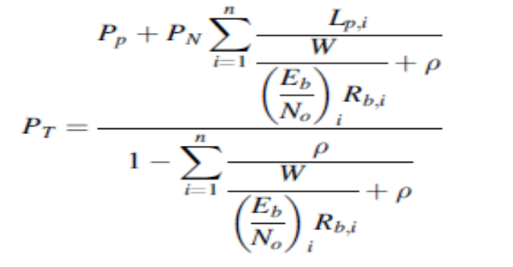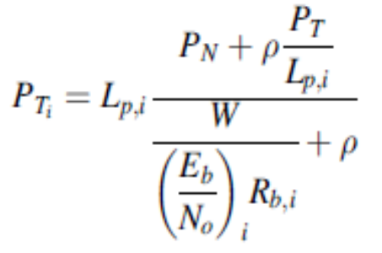

Figure 4.12 present the probability density function of the sum of path losses for 500 m
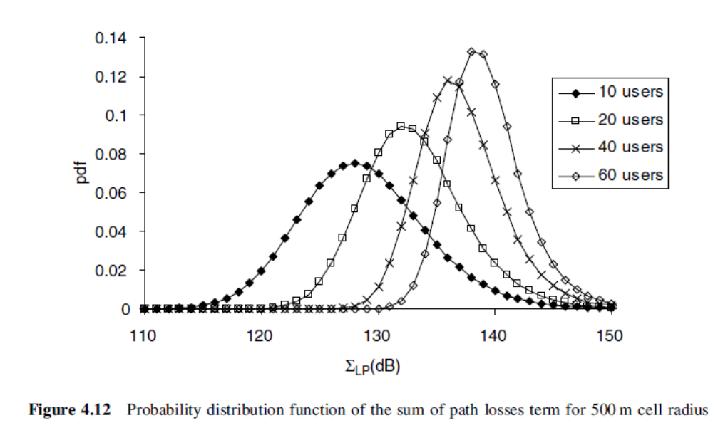
One example of figure 4.14:
Figure 4.14 shows the node B transmitted power probability distribution when all users require a target of Eb/No = 3 dB and a transmission rate of Rb =64 kb/s, the background noise level at the terminals is PN= -100 dBm and the common control channels power is Pp = 30 dBm. The cell radius in this case is 500 m.

<RRMS in UMTS > values :
ρ = 0.5
Eb/No = 3 dB => 2
Pn = -100dBm = 10^(-13) w
Pp = 30dBm = 1w
W – bandwidth, UMTS 5MHz

< Power counting for optimized capacity in MBMS enhanced UTRAN -C.C>
W-chip rate, 3.84 Mcps

<S-CCPCH performance>: simulations parameters
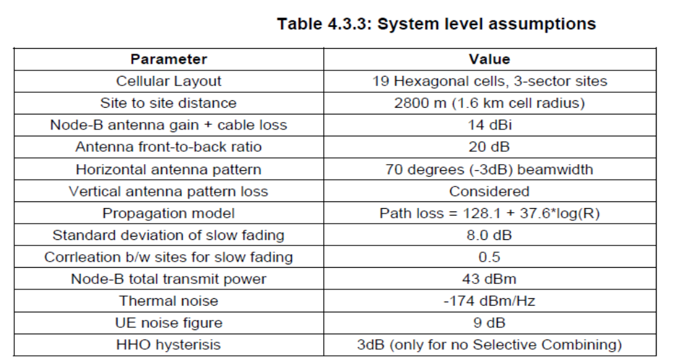

scenario example:

256 = 128 + 1*64 + 2* 32

===== IUT pathloss environment: =====
Case 1, 3 kmh [3]
Case 2, 3kmh [3]
Pedestrian A, 3 km/h [4]
Pedestrian B, 3 km/h [4]
Vehicular-A. 3 kmh [4]
Vehicular-A, 30 kmh [4]

[3] 3GPP TS 21.101: “UE Radio transmission and reception (FDD)”
[4] 3GPP TR 30.03U: “Selection procedures for the choice of radio transmission technologies of the UMTS”

Matlab scripts in EURANE

Chan_generator.m:
P_out=PTx-10*log10((10^(Iintra/10))+(10.^((Iinter+Ploss)/10)));
% The received power, P_out, is based on:
% 1.transmission power, PTx (scalar constant; in dBm)
% 2. intra-cell interference (scalar constant; in dBm)
% 3. inter-cell interference (scalar constant; in dBm) --- 1-3 fixed in parameters
% power loss, Ploss (varying over time; in dB) --- Ploss(t), only value that varying

Ploss = -P_ff + shadowing(numTTI,shadow_std,alpha,beta)+distloss-GT;
% We compute the total path loss, containing the
% fast fading, slow (=shadow) fading, distance loss and base station antenna gain (GT, in dBi) GT= 17 in original version , 14dBi in 3GPP…
% The shadowing is changing over time时间变量. The other three contributions are constant.

In which:
P_ff = 10*log10(sum(omega_2,2)); % Find resulting power in Rake receiver (in dB) 常量

distloss=Linit+10*distlossexp*log10(distanceUEBS/1000); % This is a scalar constant It remains constant in time
% It may be different for each UE attenuation (path loss)
% 每个UE（接受HS-DSCH的UEs）恒定，但是各个UE不一样
% distlossexp=3.52 % See Holma e.a. WCDMA for UMTS, section 8.2, p 160

SINR value for different CQI @ different BLER
Ref: master thesis & SINR based…

CQI mapping ref: 3GPP TS 25.214 V7.17.0

 | CQI= | 1 | 2 | 3 | 4 | 5 | 6 | 7 | 8 | 9 | 10 | 11 | 12 | 13 | 14 | 15 | 16 | 17 | 18 | 19 | 20
BLER = 5% | SINR
BLER = 10%

Note:
所有输入的长度单位固定为 meter

