Project name: Squad-up!

Technical Design Document

Version 1.0

10/07/2019

Table of Contents

**Overview**

High Level: An application that populates the most convenient public food/beverage locations to meet-up between two people.

Demographic: People who are looking for convenient public meet-up places for casual and/or business purposes.

Technical: Android Studios 3.5.1, JRE 1.8, API Level 20 or higher, GitHub as repository, GitHub Desktop as our GIT client

Features

* One database with two tables
  + User table consists of:
    - Primary key: ID
    - Google PlayStore ID (way to check if the person is in database)
    - Screen Name
  + Sender table
    - Sender
    - Receiver
    - GPS 1 (null after accepted)
    - GPS 2 (null after accepted)
    - Accepted/Declined
    - Location (Calculated after acceptance)
    - Date
* Send invite – once accepted takes GPS1 & GPS2 locations, return one location recommendation to meet up

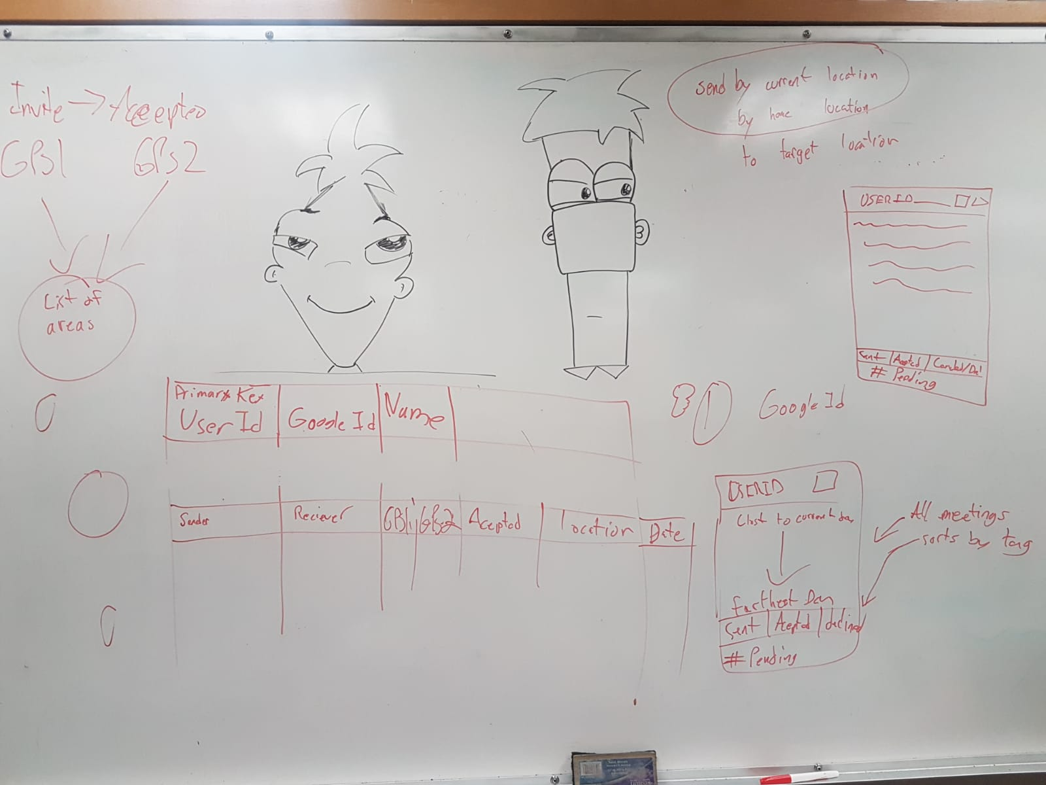

Main: Find locations within two target origins that march search criteria

Search criteria can fall under different categories of preferences:

* Price Range: Looking at low, mid, and high price points as according to google price standards
* Food/Activities: Can differentiate between cafes, restaurants, entertainment locations, etc.
* Reviews: Minimum stars accepted by user (1-5)
* Distance: From midpoint between the two origins, select x km radius

Design

Purple: #5D5390

Orange: #F3A760, #FEB157

Flow

* Calendar -> map
* Map -> Calendar
* Settings is accessible on every page

Screens

* **Calendar**
  + Make calendar (Current date)
  + Populate with user Google calendar info
    - Permissions
    - Get events & store in app calendar
    - Update google calendar with change
  + Add own meetings/events to calendar
  + General Notes widget
    - Get next 3 upcoming events
    - Add/delete/store notes
  + Calendar expansion
    - Hide notes
    - More calendar detail
  + Notes expansion
    - Squish calendar to week view

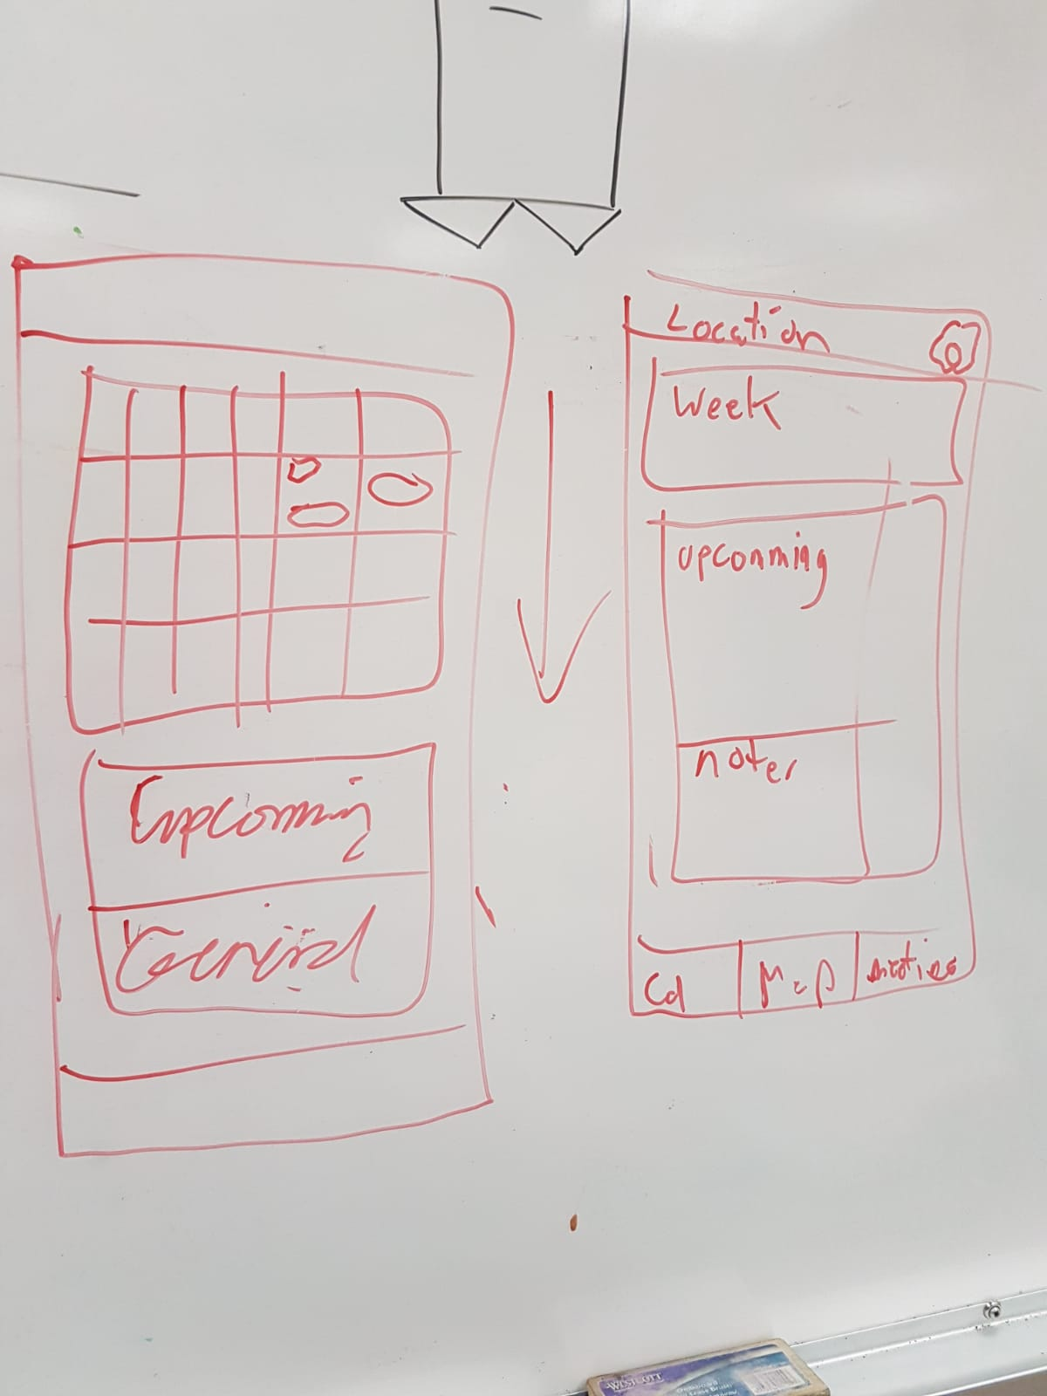

* **Map**
  + Draw map
  + GPS Location
  + Change Location (Find two spots on map)
  + Find midpoint
  + Filter or find location/restaurant within range
    - Meters/radius
    - Captions
    - Categories
    - ratings
  + Accept & save location/time of accepting
  + Add meeting to calendar (depend on calendar)
  + Send meeting to other person (function database)

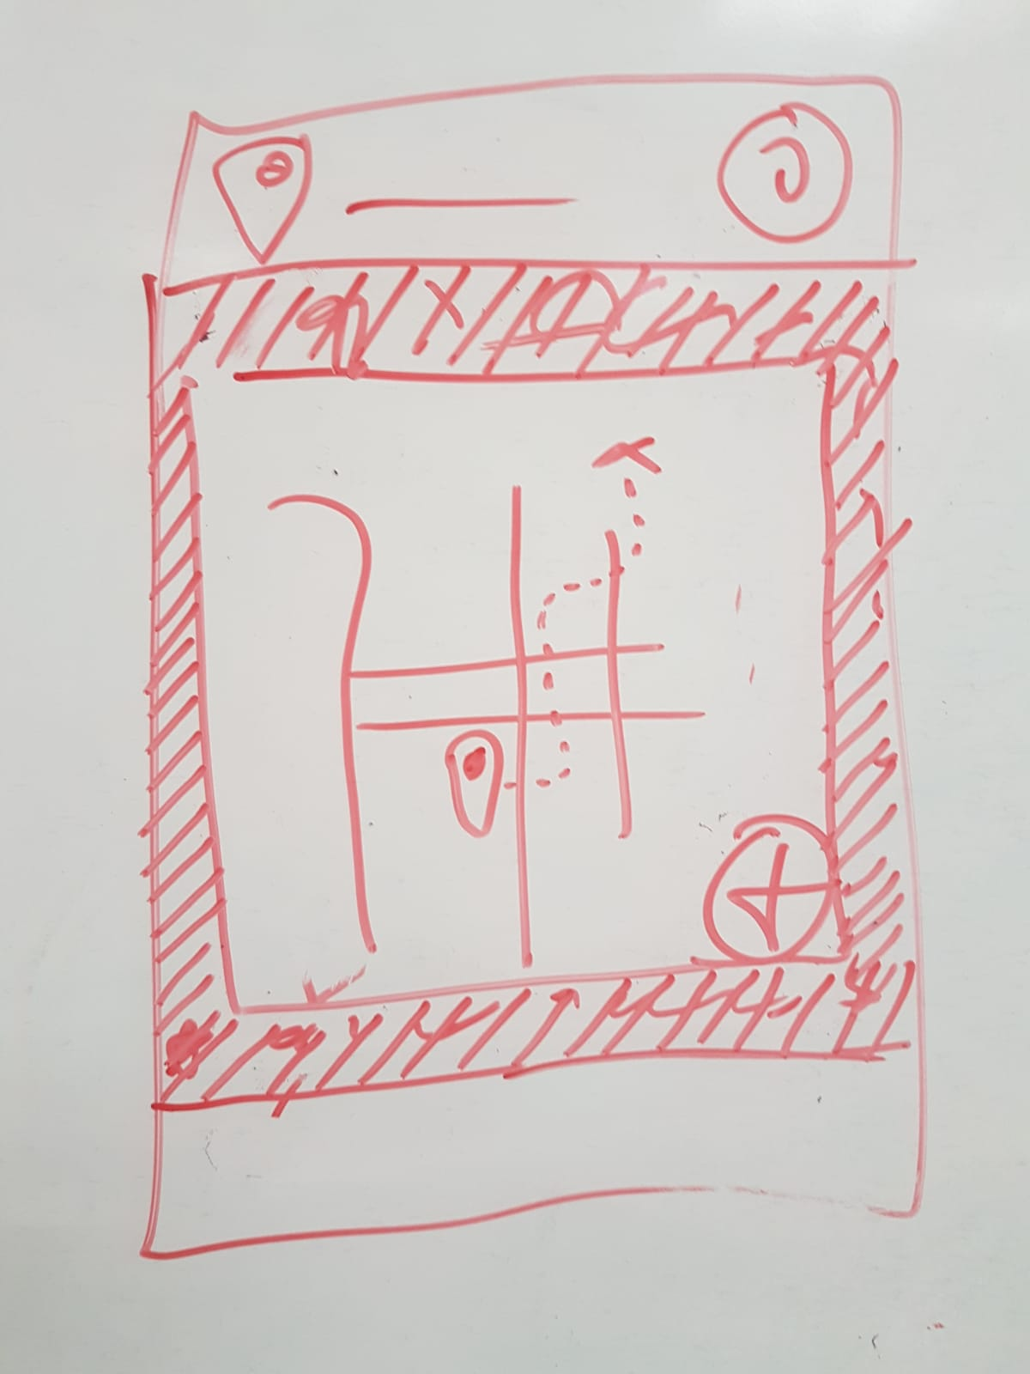

* Meetup screen
  + SQL gets setup
    - 2 tables
    - User/meeting tables
  + Grab data from tables
    - Create class for meetings (created Class meeting in Maps – Steven as lead)
      * Location
      * Status (accepted, declined, etc)
      * Person -> ½
      * Date
    - Store all data into meeting list



Future Plans

Means of travel

Calendar Plans

Permissions

* Location
* Google play ID
* Calendar
* Return Lists of recommendations based on two points
* Travel by different modes of transportation
* Guest user – for offline meetings