**copy files**

#vi playbooks/pb1.yml

---

- hosts: all

remote_user: root

become: yes

tasks:

- name: copy files

copy:

src: /root/sample.txt

dest: /tmp/sample.txt

- name: msg display

debug:

msg: files are copied!

------------------------------------------------------------------------------------------------------------------------------------------

**Install apache and tomcat packages for Ubuntu**

#vi playbooks/pb2.yml

---

- hosts: webserver

remote_user: root

gather_facts: false

tasks:

- name: To Update Repo.

raw: apt-get update -y

- name: Install Apache

apt: name=apache2 state=latest

- name: Install Tomcat

apt: name=tomcat8 state=latest

- hosts: appserver

gather_facts: false

tasks:

- name: To Update Repo.

raw: yum update -y

- name: Install httpd

yum: name=httpd state=latest

------------------------------------------------------------------------------------------------------------------------------------------

**Handlers:**

#vi playbooks/pb3.yml

---

- hosts: ubuntu

tasks:

- name: Install apache

apt: name=apache2 state=latest

notify:

- start apache

- name: Install Tomcat

apt: name=tomcat8 state=latest

notify:

- start tomcat8

handlers:

- name: start apache

service: name=apache2 state=started

- name: start tomcat8

service: name=tomcat8 state=started

------------------------------------------------------------------------------------------------------------------------------------------

#vi playbooks/pb4.yml

---

- hosts: all

become: true

tasks:

- name: to update packages

raw: apt-get update

when: ansible_distribution == "Ubuntu"

- name: install mysql

apt: name=mysql-server* state=latest

when: ansible_distribution == "Ubuntu"

notify:

start mysql

- name: to update packages

raw: yum update -y

when: ansible_distribution == "RedHat"

- name: to install mariadb

yum: name=mariadb-server state=latest

when: ansible_distribution == "RedHat"

notify:

start mariadb

handlers:

- name: start mysql

service: name=mysql state=started

- name: start mariadb

service: name=mariadb state=started

------------------------------------------------------------------------------------------------------------------------------------------

#vi playbooks/pb4.yml

- hosts: ubuntu

remote_user: root

vars_prompt:

- name: pack_name

prompt: Give Package Name

private: no

tasks:

- name: Install Package {{pack_name}}

apt: name="{{pack_name}}" state=latest

------------------------------------------------------------------------------------------------------------------------------------------

#vi playbooks/pb5.yml

- hosts: all

become: true

vars_prompt:

- name: pack_name1

prompt: Enter package-1

private: yes

- name: pack_name2

prompt: Enter package-2

private: no

tasks:

- name: Install {{pack_name1}}

apt: name="{{pack_name1}}" state=latest

when: ansible_distribution == "Ubuntu"

- name: INstall {{pack_name2}}

yum: name="{{pack_name2}}" state=latest

when: ansible_distribution == "RedHat"

------------------------------------------------------------------------------------------------------------------------------------------

#vi playbooks/pb6.yml

- hosts: all

remote_user: root

tasks:

- name: copy {{items}}

copy:

src: /root/files/{{item}}

dest: /tmp/{{item}}

with_items:

- abc1.txt

- abc2.txt

- abc3.txt

------------------------------------------------------------------------------------------------------------------------------------------

#vi playbooks/pb6.yml

- hosts: all

become: true

tasks:

- name: add group

group: name=sales state=present

- name: add users to group

user: name={{item}} groups=sales state=present

with_items:

- user1

- user2

- user3

------------------------------------------------------------------------------------------------------------------------------------------

#vi playbooks/pb7.yml

- hosts: ubuntu

become: true

vars:

- username: abhinay

- file_path: /var/www/html

tasks:

- name: Copy Site Files

template:

src=/root/templates/file.j2

dest={{file_path}}/index.html mode=0777

------------------------------------------------------------------------------------------------------------------------------------------#vi playbooks/pb8.yml

---

- hosts: ubuntu

gather_facts: false

become: true

vars:

- myport: 9090

- file_path: /etc/tomcat8/

tasks:

- name: To change tomcat port

template:

src=/root/templates/demo.j2

dest={{file_path}}/server.xml

notify:

restart tomcat

handlers:

- name: restart tomcat

service: name=tomcat8 state=restarted

------------------------------------------------------------------------------------------------------------------------------------------

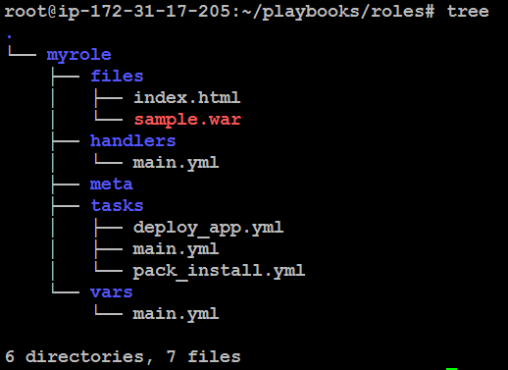

**To install java & tomcat package on redhat and start service and deploy sample.war**

---

- hosts: redhat

become: true

gather_facts: false

tasks:

- name: update repo

raw: yum -y update

- name: install java

yum: name=java state=latest

- name: install tomcat

package: name=tomcat state=latest

notify:

- start tomcat

- name: to deploy war

copy:

src: /root/files/sample.war

dest: /var/lib/tomcat/webapps/sample.war

handlers:

- name: start tomcat

service: name=tomcat state=started