《计算机组成原理》实验报告

一、实验目的
（1）理解流水线(Pipeline)设计原理；
（2）了解算术逻辑单元ALU的原理；
（3）熟悉并运用Verilog语言设计ALU；
（4）熟悉并运用Verilog语言设计流水线全加器。
二、实验项目内容

1,根据功能图实现ALU模块
2,实现4级流水线32bit加法器，每一级处理8bit，带有按级暂停（阻塞），清除功能
三、实验过程或算法（源程序）
ALU功能图
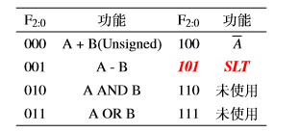
ALU代码
1，顶层模块
- module topModel(
- input wire [7:0] ins,
- input wire [2:0] op,
- input wire clk,reset,
- input wire [31:0]s,
- output wire [6:0]seg,
- output [7:0] ans
- );

- reg [31:0] num2 = 32'h01;
- wire [31:0] num1 = {24'b0,ins[7:0]};
- wire [31:0] result;
- Myalu myalu(num1,num2,op,result);
- display mydis(clk,reset,result,seg,ans);
- endmodule
2，ALU模块
- module Myalu(
- input [31:0] A,
- input [31:0] B,
- input [2:0] op,
- output [31:0] C
- );
- reg [31:0] x;
- always @(*) begin
- case(op)
- 3'b000:x<=A+B;
- 3'b001:x<=A-B;
- 3'b010:x<=A&B;
- 3'b011:x<=A|B;
- 3'b100:x<=~A;
- 3'b101:x<=(A<B?32'b00000000000000000000000000000001:32'b00000000000000000000000000000000);
- 3'b110:;
- 3'b111:;
- default:;
- endcase
- end
- assign C = x;

- endmodule
3，7段管显示模块
- module display(
- input wire clk,
- input wire reset,
- input wire [31:0]s,
- output wire [6:0]seg,
- output reg [7:0]ans
- );
- reg [20:0]count;
- reg [4:0]digit;
- always@(posedge clk,posedge reset)
- if(reset)
- count = 0;
- else
- count = count + 1;

- always @(posedge clk)
- case(count[20:18])
- 0:begin
- ans = 8'b11111110;
- digit = s[3:0];
- end

- 1:begin
- ans = 8'b11111101;
- digit = s[7:4];
- end

- 2:begin
- ans = 8'b11111011;
- digit =s[11:8];
- end

- 3:begin
- ans = 8'b11110111;
- digit = s[15:12];
- end

- 4:begin
- ans = 8'b11101111;
- digit = s[19:16];
- end

- 5:begin
- ans = 8'b11011111;
- digit = s[23:20];
- end

- 6:begin
- ans = 8'b10111111;
- digit =s[27:24];
- end

- 7:begin
- ans = 8'b01111111;
- digit = s[31:28];
- end
- endcase

- seg7 U4(.din(digit),.dout(seg));
- endmodule
- module seg7(
- input wire [3:0]din,
- output reg [6:0]dout
- );

- always@(*)
- case(din)
- 5'h0:dout = 7'b000_0001;
- 5'h1:dout = 7'b100_1111;
- 5'h2:dout = 7'b001_0010;
- 5'h3:dout = 7'b000_0110;
- 5'h4:dout = 7'b100_1100;
- 5'h5:dout = 7'b010_0100;
- 5'h6:dout = 7'b010_0000;
- 5'h7:dout = 7'b000_1111;
- 5'h8:dout = 7'b000_0000;
- 5'h9:dout = 7'b000_0100;
- 5'ha:dout = 7'b000_1000;
- 5'hb:dout = 7'b110_0000;
- 5'hc:dout = 7'b011_0001;
- 5'hd:dout = 7'b100_0010;
- 5'he:dout = 7'b011_0000;
- 5'hf:dout = 7'b011_1000;
- default:dout = 7'b111_1111;
- endcase

- endmodule

32bit流水线全加器代码
- module plusWaterw(
- input [31:0] plusA,
- input [31:0] plusB,
- input clk,
- input [3:0] reset,
- input [3:0] stop,
- output [31:0] out,
- output c
- );
- reg c1;
- reg c2;
- reg c3;
- reg c4;
- reg [7:0] plus1;
- reg [15:0] plus2;
- reg [23:0] plus3;
- reg [31:0] plus4;

- reg [31:0] plusA2;
- reg [31:0] plusA3;
- reg [31:0] plusA4;
- reg [31:0] plusB2;
- reg [31:0] plusB3;
- reg [31:0] plusB4;

- always@(posedge clk)begin
- if(stop!=4'b0001 && stop!=4'b0010 && stop!= 4'b0100 && stop!=4'b1000)begin
- if(reset==4'b0001)begin
- plus1<=8'b00000000;
- c1<=1'b0;
- end else begin
- {c1,plus1}<={1'b0,plusA[7:0]} + {1'b0,plusB[7:0]};
- plusA2<=plusA;
- plusB2<=plusB;
- end
- end else begin
- plus1<=plus1;
- c1<=c1;
- end
- end

- always@(posedge clk)begin
- if(stop!=4'b0010 && stop!= 4'b0100 && stop!=4'b1000)begin
- if(reset==4'b0010)begin
- plus2<=8'b00000000;
- c2<=1'b0;
- plusA2<=32'h00;
- plusB2<=32'h00;
- end else begin
- {c2,plus2}<={{1'b0,plusA2[15:8]} + {1'b0,plusB2[15:8]} + c1 , plus1};
- plusA3<=plusA2;
- plusB3<=plusB2;
- end
- end else begin
- plus2<=plus2;
- c2<=c2;
- end
- end

- always@(posedge clk)begin
- if(stop!= 4'b0100 && stop!=4'b1000)begin
- if(reset==4'b0100)begin
- plus3<=8'b00000000;
- c3<=1'b0;
- plusA3<=32'h00;
- plusB3<=32'h00;
- end else begin
- {c3,plus3}<= {{1'b0,plusA3[23:16]} + {1'b0,plusB3[23:16]} + c2, plus2};
- plusA4<=plusA3;
- plusB4<=plusB3;
- end
- end else begin
- plus3<=plus3;
- c3<=c3;
- end
- end

- always@(posedge clk)begin
- if(stop!=4'b1000)begin
- if(reset==4'b1000)begin
- plus4<=8'b00000000;
- c4<=1'b0;
- plusA4<=32'h00;
- plusB4<=32'h00;
- end else begin
- {c4,plus4}<= {{1'b0,plusA4[31:24]} + {1'b0,plusB4[31:24]} + c3, plus3};
- end
- end else begin
- plus4<=plus4;
- c4<=c4;
- end
- end

- assign out = plus4;
- assign c = c4;

- endmodule

四、实验结果及分析和（或）源程序调试过程
4.1 ALU验证实验结果
操作 | Num1 | Result
A + B(Unsigned) | 8’b00000010 | 32’h00000003
A - B | 8’b11111111 | 32’h000000FE
A AND B | 8’b11111110 | 32’h00000000
A OR B | 8’b10101010 | 32’h000000AB
A | 8’b11110000 | 32’Hffffff0f
SLT | 8’b10000001 | 32’h00000000
ALU test_becnch
- module fangzhen(

- );
- reg clk;
- reg [31:0] a;
- reg [31:0] b;
- wire [31:0] c;
- reg [2:0] op;

- Myalu myalu(a,b,op,c);

- initial begin
- clk=1'b0;
- a=32'b00000000000000000000000000001000;
- b=32'b00000000000000000000000000001111;
- op=3'b000;
- #5 clk=~clk;
- #5 clk=~clk;

- a=32'b00000000000000000000000000000110;
- b=32'b00000000000000000000000000000111;
- op=3'b001;
- #5 clk=~clk;
- #5 clk=~clk;

- a=32'b00000000000000000000000000001110;
- b=32'b00000000000000000111111111111111;
- op=3'b010;
- #5 clk=~clk;
- #5 clk=~clk;

- a=32'b00000000000000000000000000001110;
- b=32'b00000000000000000111111111111111;
- op=3'b010;
- #5 clk=~clk;
- #5 clk=~clk;

- a=32'b00000000000000000000000000001110;
- b=32'b00000000000000000000000000010001;
- op=3'b011;
- #5 clk=~clk;
- #5 clk=~clk;

- a=32'b00000000000000000000000000001111;
- op=3'b100;
- #5 clk=~clk;
- #5 clk=~clk;

- a=32'b00000000000000000000000000011111;
- b=32'b00000000000000000000000000010001;
- op=3'b101;
- #5 clk=~clk;
- #5 clk=~clk;

- a=32'b00000000000000000000000000001111;
- b=32'b00000000000000000000000000010001;
- op=3'b101;
- #5 clk=~clk;
- #5 clk=~clk;

- end

- endmodule
ALU仿真图
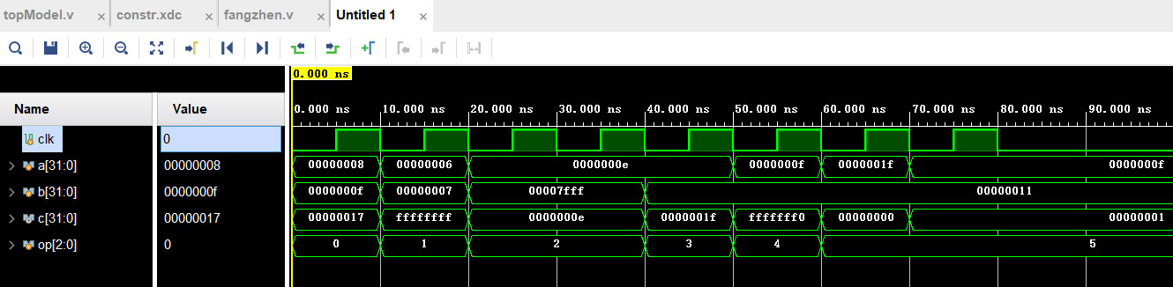

流水线阻塞（暂停）仿真图
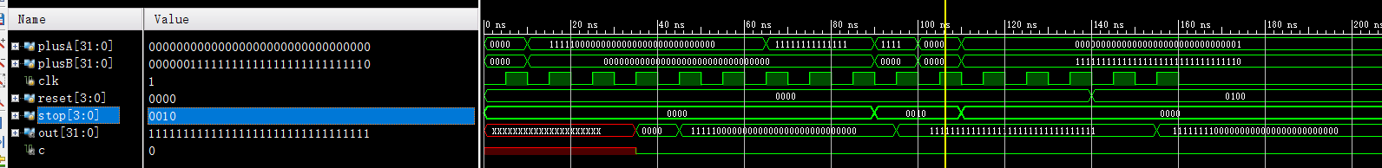
流水线test_bench
- module fangzhen();
- reg [31:0] plusA;
- reg [31:0] plusB;
- reg clk;
- reg [3:0] reset;
- reg [3:0] stop;
- wire [31:0] out;
- wire c;
- plusWaterw myplus(plusA,plusB,clk,reset,stop,out,c);
- initial begin
- plusA = 32'b00000000000000000000000000001111;
- plusB = 32'b00000000000000000000000000001110;
- clk = 1'b0;
- reset = 4'b0000;
- stop = 4'b0000;
- #5 clk=~clk;
- #5 clk=~clk;
- plusA = 32'b11111000000000000000000000000000;
- plusB = 32'b00000000000000000000000000000000;
- #5 clk=~clk;
- #5 clk=~clk;
- #5 clk=~clk;
- #5 clk=~clk;
- #5 clk=~clk;
- #5 clk=~clk;
- #5 clk=~clk;
- #5 clk=~clk;
- #5 clk=~clk;
- #5 clk=~clk;
- #5 clk=~clk;
- plusA = 32'b11111111111111111111111111111111;
- plusB = 32'b00000000000000000000000000000000;
- #5 clk=~clk;
- #5 clk=~clk;
- #5 clk=~clk;
- #5 clk=~clk;
- #5 clk=~clk;
- //第10周期，中断第2级
- plusA = 32'b11111111111111111111111111111100;
- plusB = 32'b00000000000000000000000000000010;
- stop=4'b0010;
- #5 clk=~clk;
- #5 clk=~clk;
- plusA = 32'b00000000000000000000000000000000;
- plusB = 32'b00000011111111111111111111111110;
- #5 clk=~clk;
- #5 clk=~clk;
- stop = 4'b0000;
- plusA = 32'b00000000000000000000000000000001;
- plusB = 32'b11111111111111111111111111111110;
- #5 clk=~clk;
- #5 clk=~clk;
- #5 clk=~clk;
- #5 clk=~clk;
- #5 clk=~clk;
- #5 clk=~clk;
- //15周期清空第三级
- reset = 4'b0100;
- #5 clk=~clk;
- #5 clk=~clk;
- #5 clk=~clk;
- #5 clk=~clk;
- end
- endmodule

备注：

