《计算机组成原理》实验报告

一、实验目的
（1）掌握单周期CPU控制器的工作原理及其设计方法。
（2）掌握单周期CPU各个控制信号的作用和生成过程。
（3）掌握单周期CPU执行指令的过程。
（4）掌握取指、译码阶段数据通路执行过程
二、实验项目内容
1，根据原理图完成模块的实现
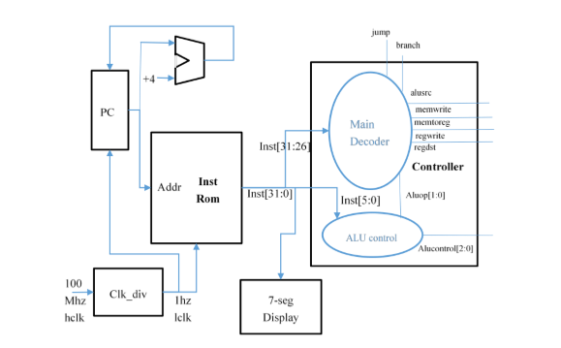
三、实验过程或算法（源程序）
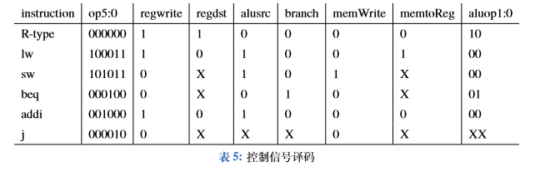
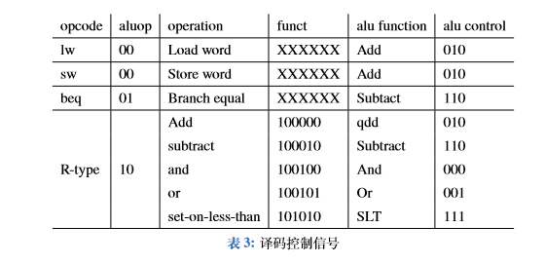
1，项目目录
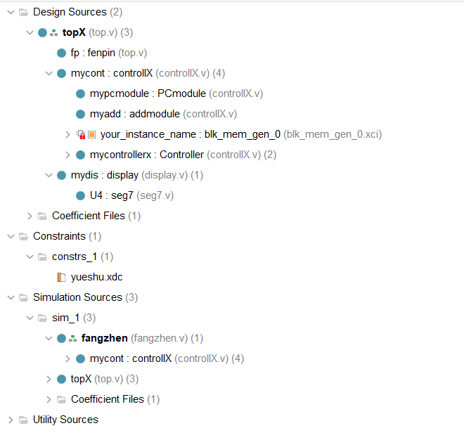
2，PC模块
- module PCmodule(
- input clk,
- input rst,
- input [31:0] pcin,
- output [31:0] pc,
- output inst_ce
- );
- reg [31:0] pc;
- reg inst_ce;
- always @(posedge clk)begin
- if(rst)begin
- pc<=32'b00000000000000000000000000000000;
- inst_ce<=1'b0;
- end else begin
- pc<=pcin;
- inst_ce<=1'b1;
- end
- end
- endmodule

3，controller模块
- module Controller(
- input [5:0] op,
- input [5:0] funct,
- output regwrite,
- output regdst,
- output alusrc,
- output branch,
- output memWrite,
- output memtoReg,
- output [2:0] alucontroll
- );
- wire [1:0] aluop;
- MainDecoder mydecoder(op,regwrite,regdst,alusrc,branch,memWrite,memtoReg,aluop);
- aluController myalucontroller(aluop,funct,alucontroll);
- endmodule

4，maindec模块
- module MainDecoder(
- input [5:0] op,
- output reg regwrite,
- output reg regdst,
- output reg alusrc,
- output reg branch,
- output reg memWrite,
- output reg memtoReg,
- output reg [1:0] aluop
- );
- always @(*)begin
- casex(op)
- 6'b000000:begin
- regwrite<=1'b1;
- regdst<=1'b1;
- alusrc<=1'b0;
- branch<=1'b0;
- memWrite<=1'b0;
- memtoReg<=1'b0;
- aluop<=2'b10;
- end
- 6'b100011:begin
- regwrite<=1'b1;
- regdst<=1'b0;
- alusrc<=1'b1;
- branch<=1'b0;
- memWrite<=1'b0;
- memtoReg<=1'b1;
- aluop<=2'b00;
- end
- 6'b101011:begin
- regwrite<=1'b0;
- regdst<=1'b0;
- alusrc<=1'b1;
- branch<=1'b0;
- memWrite<=1'b1;
- memtoReg<=1'b0;
- aluop<=2'b00;
- end
- 6'b000100:begin
- regwrite<=1'b0;
- regdst<=1'b0;
- alusrc<=1'b0;
- branch<=1'b1;
- memWrite<=1'b0;
- memtoReg<=1'b0;
- aluop<=2'b01;
- end
- 6'b001000:begin
- regwrite<=1'b1;
- regdst<=1'b0;
- alusrc<=1'b1;
- branch<=1'b0;
- memWrite<=1'b0;
- memtoReg<=1'b0;
- aluop<=2'b00;
- end
- 6'b000010:begin
- regwrite<=1'b0;
- regdst<=1'b0;
- alusrc<=1'b0;
- branch<=1'b0;
- memWrite<=1'b0;
- memtoReg<=1'b0;
- aluop<=2'b00;
- end
- default:;
- endcase
- end
- endmodule

5，aludec模块
- module aluController(
- input [1:0] aluop,
- input [5:0] op,
- output reg [2:0] alucontroll
- );
- always @(*)begin
- casex({aluop,op})
- 8'b10100000: alucontroll<=3'b010;
- 8'b10100010:alucontroll<=3'b110;
- 8'b10100100:alucontroll<=3'b000;
- 8'b10100101:alucontroll<=3'b001;
- 8'b10101010:alucontroll<=3'b111;
- 8'b00xxxxxx:alucontroll<=3'b010;
- 8'b01xxxxxx:alucontroll<=3'b110;
- endcase;
- end
- endmodule

6，controller模块
- module Controller(
- input [5:0] op,
- input [5:0] funct,
- output regwrite,
- output regdst,
- output alusrc,
- output branch,
- output memWrite,
- output memtoReg,
- output [2:0] alucontroll
- );
- wire [1:0] aluop;
- MainDecoder mydecoder(op,regwrite,regdst,alusrc,branch,memWrite,memtoReg,aluop);
- aluController myalucontroller(aluop,funct,alucontroll);
- endmodule

7，controllX模块（连接controller，PC和inst memory）
- module controllX(
- input reset,
- input clk,
- output regwrite,
- output regdst,
- output alusrc,
- output branch,
- output memWrite,
- output memtoReg,
- output [2:0] alucontroll,
- output [31:0] opInct
- );
- //

- wire [31:0] pcin;
- wire [31:0] pc;
- wire inst_ce;
- //PC计数器
- PCmodule mypcmodule(clk,reset,pcin,pc,inst_ce);

- //计数器加法
- addmodule myadd(pc,32'h4,pcin);

- //指令ROM
- blk_mem_gen_0 your_instance_name (
- .clka(clk), // input wire clka
- .ena(inst_ce), // input wire ena
- .addra(pc[9:2]), // input wire [7 : 0] addra
- .douta(opInct) // output wire [31 : 0] douta
- );
- //控制器
- Controller mycontrollerx(opInct[31:26],opInct[5:0],regwrite,regdst,alusrc,branch,memWrite,memtoReg,alucontroll);

- endmodule

- module addmodule(
- input [31:0] pcin,
- input [31:0] jumpnum,
- output [31:0] pcout
- );
- assign pcout = pcin + jumpnum;
- endmodule

8，top模块，连接controllX和七段管显示模块
- module fenpin(
- input clk,
- output newclk
- );
- reg oldclk = 1'b1;
- reg [31:0] jishu = 32'b0;
- always @(posedge clk)begin
- if(jishu == 100000000)begin
- oldclk <= ~oldclk;
- jishu <= 32'b0;
- end else begin
- jishu = jishu + 1;
- end
- end
- assign newclk = oldclk;
- endmodule

- module topX(
- input reset,
- input clk,
- output [6:0]seg,
- output [7:0]ans,
- output [8:0]con
- );
- wire regwrite;
- wire regdst;
- wire alusrc;
- wire branch;
- wire memWrite;
- wire memtoReg;
- wire [2:0] alucontroll;
- wire [31:0] opInct;
- wire newclk;

- fenpin fp(clk,newclk);

- controllX mycont(reset,newclk,regwrite,regdst,alusrc,branch,memWrite,memtoReg,alucontroll,opInct);

- assign con = {regwrite,regdst,alusrc,branch,memWrite,memtoReg,alucontroll};

- display mydis(clk,reset,opInct,seg,ans);

- endmodule

四、实验结果及分析和（或）源程序调试过程
Testbench文件
- module fangzhen(

- );
- reg rst;
- reg clk;
- wire [7:0] ans;
- wire [6:0] seg;
- wire [8:0] led;
- initial
- begin
- clk = 1'b0;
- rst = 1'b1;
- #500;
- rst = 1'b0;
- end
- always #10 clk = ~clk;
- topX top(
- .clk(clk),
- .reset(rst),
- .seg(seg),
- .ans(ans),
- .con(led)
- );
- endmodule

Testbench仿真结果
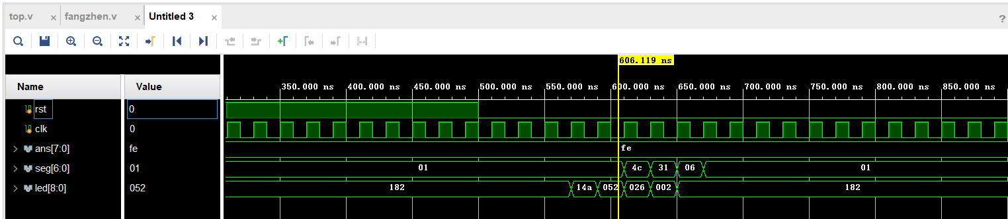

备注：

