《计算机组成原理》实验报告

一、实验目的
（1）掌握不同类型指令在数据通路中的执行路径。
（2）掌握Vivado仿真方式。
二、实验项目内容
1，根据单周期CPU图编写模块
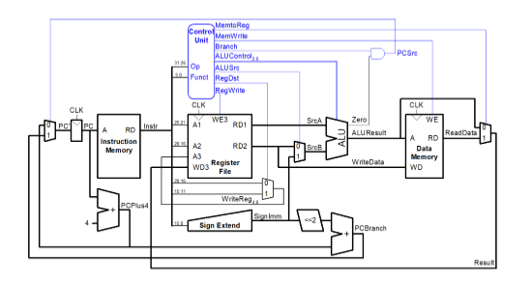
2，完成datapath模块
3，编写top模块连接controller模块，data_memory模块，init_memory模块，datapath模块
三、实验过程或算法（源程序）
1，项目结构
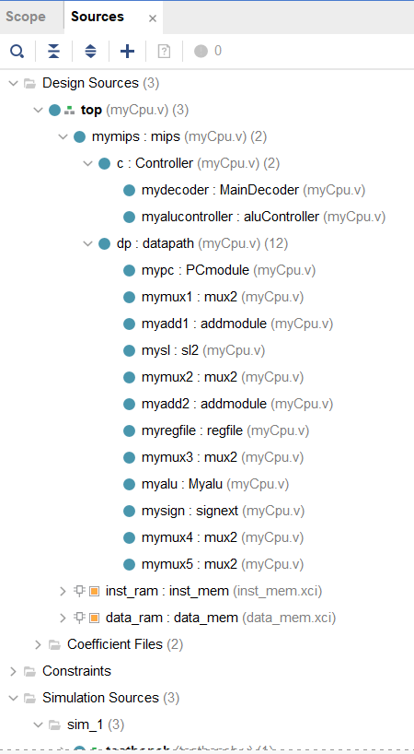

2，控制器Controller模块
- module MainDecoder(
- input [31:0] instr,
- output reg regwrite,
- output reg regdst,
- output reg alusrc,
- output reg branch,
- output reg memWrite,
- output reg memtoReg,
- output reg [1:0] aluop,
- output reg jump
- );
- wire [5:0] op;
- assign op = instr[31:26];
- always @(*)begin

- case(op)
- 6'b000000:begin
- regwrite<=1'b1;
- regdst<=1'b1;
- alusrc<=1'b0;
- branch<=1'b0;
- memWrite<=1'b0;
- memtoReg<=1'b0;
- aluop<=2'b10;
- jump<=1'b0;
- end
- 6'b100011:begin
- regwrite<=1'b1;
- regdst<=1'b0;
- alusrc<=1'b1;
- branch<=1'b0;
- memWrite<=1'b0;
- memtoReg<=1'b1;
- aluop<=2'b00;
- jump<=1'b0;
- end
- 6'b101011:begin
- regwrite<=1'b0;
- regdst<=1'b0;
- alusrc<=1'b1;
- branch<=1'b0;
- memWrite<=1'b1;
- memtoReg<=1'b0;
- aluop<=2'b00;
- jump<=1'b0;
- end
- 6'b000100:begin
- regwrite<=1'b0;
- regdst<=1'b0;
- alusrc<=1'b0;
- branch<=1'b1;
- memWrite<=1'b0;
- memtoReg<=1'b0;
- aluop<=2'b01;
- jump<=1'b0;
- end
- 6'b001000:begin
- regwrite<=1'b1;
- regdst<=1'b0;
- alusrc<=1'b1;
- branch<=1'b0;
- memWrite<=1'b0;
- memtoReg<=1'b0;
- aluop<=2'b00;
- jump<=1'b0;
- end
- 6'b000010:begin
- regwrite<=1'b0;
- regdst<=1'b0;
- alusrc<=1'b0;
- branch<=1'b0;
- memWrite<=1'b0;
- memtoReg<=1'b0;
- aluop<=2'b00;
- jump<=1'b1;
- end
- default:begin
- regwrite<=1'b0;
- regdst<=1'b0;
- alusrc<=1'b0;
- branch<=1'b0;
- memWrite<=1'b0;
- memtoReg<=1'b0;
- aluop<=2'b00;
- jump<=1'b0;
- end
- endcase

- end
- endmodule

- module aluController(
- input [1:0] aluop,
- input [5:0] op,
- output reg [2:0] alucontroll
- );
- always @(*)begin
- casex({aluop,op})
- 8'b10100000: alucontroll<=3'b010;
- 8'b10100010:alucontroll<=3'b110;
- 8'b10100100:alucontroll<=3'b000;
- 8'b10100101:alucontroll<=3'b001;
- 8'b10101010:alucontroll<=3'b111;
- 8'b00xxxxxx:alucontroll<=3'b010;
- 8'b01xxxxxx:alucontroll<=3'b110;
- endcase;
- end
- endmodule

- //控制器核心
- module Controller(
- input [31:0] instr,
- input zero,
- output memtoReg,
- output memWrite,
- output pcsrc,
- output alusrc,
- output regdst,
- output regwrite,
- output jump,
- output [2:0] alucontroll
- );
- wire [1:0] aluop;
- wire branch;
- MainDecoder mydecoder(instr,regwrite,regdst,alusrc,branch,memWrite,memtoReg,aluop,jump);
- aluController myalucontroller(aluop,instr[5:0],alucontroll);
- assign pcsrc = branch & zero;
- endmodule

3，datapath模块
- module datapath(
- input wire clk,rst,
- input wire memtoreg,pcsrc,
- input wire alusrc,regdst,
- input wire regwrite,jump,
- input wire[2:0] alucontrol,
- output wire zero,
- output wire[31:0] pc,
- input wire[31:0] instr,
- output wire[31:0] aluout,writedata,
- input wire[31:0] readdata
- );

- /*
- module PCmodule
- input clk,
- input rst,
- input en,
- input [31:0] pcin,
- output reg [31:0] pc
- */
- wire [31:0] pcpie;
- wire [31:0] pcnextpie;
- //PC计数器
- PCmodule mypc(clk,rst,1'b1,pcpie,pc);

- wire [31:0] pcplus4,pcbranch;
- wire [31:0] signimm,signimm2;

- mux2 #(32) mymux1(pcnextpie,{pcplus4[31:28],instr[25:0],2'b00},jump,pcpie);

- addmodule myadd1(pc,32'b100,pcplus4);

- sl2 mysl(signimm,signimm2);

- mux2 #(32) mymux2(pcplus4,pcbranch,pcsrc,pcnextpie);

- addmodule myadd2(pcplus4,signimm2,pcbranch);

- //寄存器堆
- wire [31:0] ra,rb;
- wire [4:0] writereg;
- wire [31:0] aluresult;
- regfile myregfile(clk,regwrite,instr[25:21],instr[20:16],writereg,aluresult,ra,writedata);
- //ALU模块
- mux2 #(32) mymux3(writedata,signimm,alusrc,rb);
- /*
- Myalu
- input [31:0] A,
- input [31:0] B,
- input [2:0] op,
- output [31:0] C
- */
- Myalu myalu(ra,rb,alucontrol,aluout);

- assign zero = (ra==rb)?1'b1:1'b0;

- signext mysign(instr[15:0],signimm);

- mux2 #(5) mymux4(instr[20:16],instr[15:11],regdst,writereg);

- mux2 #(32) mymux5(aluout,readdata,memtoreg,aluresult);
- endmodule

4，mips模块
- module mips(
- input wire clk,rst,
- output wire[31:0] pc,
- input wire[31:0] instr,
- output wire memwrite,
- output wire[31:0] aluout,writedata,
- input wire[31:0] readdata
- );
- wire memtoreg,alusrc,regdst,regwrite,jump,pcsrc,zero;
- wire[2:0] alucontrol;
- /*
- input [31:0] instr,
- input zero,
- output memtoReg,
- output memWrite,
- output pcsrc,
- output alusrc,
- output regdst,
- output regwrite,
- output jump,
- output [2:0] alucontroll
- */
- Controller c(instr,zero,memtoreg,
- memwrite,pcsrc,alusrc,regdst,regwrite,jump,alucontrol);
- datapath dp(clk,rst,memtoreg,pcsrc,alusrc,
- regdst,regwrite,jump,alucontrol,zero,pc,instr,aluout,writedata,readdata);
- endmodule

5，top模块
- module top(
- input wire clk,rst,
- output wire[31:0] writedata,dataadr,
- output wire memwrite
- );
- wire[31:0] pc,instr,readdata;
- mips mymips(clk,rst,pc,instr,memwrite,dataadr,writedata,readdata);
- inst_mem inst_ram (
- .clka(~clk), // input wire clka
- .ena(1'b1), // input wire ena
- .wea(4'b0000), // input wire [3 : 0] wea
- .addra(pc[9:2]), // input wire [7 : 0] addra
- .dina(32'b0), // input wire [31 : 0] dina
- .douta(instr) // output wire [31 : 0] douta
- );

- data_mem data_ram (
- .clka(~clk), // input wire clka
- .ena(1'b1), // input wire ena
- .wea({4{memwrite}}), // input wire [3 : 0] wea
- .addra(dataadr[9:0]), // input wire [9 : 0] addra
- .dina(writedata), // input wire [31 : 0] dina
- .douta(readdata) // output wire [31 : 0] douta
- );
- endmodule

6，其他模块
- module PCmodule(
- input clk,
- input rst,
- input en,
- input [31:0] pcin,
- output reg [31:0] pc
- );
- always @(posedge clk,posedge rst)begin
- if(rst)begin
- pc<=32'b00000000000000000000000000000000;
- end else if(en) begin
- pc<=pcin;
- end
- end
- endmodule

- //加法器
- module addmodule(
- input [31:0] pcin,
- input [31:0] jumpnum,
- output [31:0] pcout
- );
- assign pcout = pcin + jumpnum;
- endmodule

- //ALU模块
- module Myalu(
- input [31:0] A,
- input [31:0] B,
- input [2:0] op,
- output [31:0] C
- );
- reg [31:0] x;
- always @(*) begin
- case(op)
- 3'b000:x<=A&B;
- 3'b001:x<=A|B;
- 3'b010:x<=A+B;
- 3'b011:;
- 3'b100:x<=~A;
- 3'b101:;
- 3'b110:x<=A-B;
- 3'b111:x<=(A<B?32'b00000000000000000000000000000001:32'b00000000000000000000000000000000);
- default:;
- endcase
- end
- assign C = x;
- endmodule

- //有符号扩展16-32
- module signext(
- input wire[15:0] a,
- output wire[31:0] y
- );
- assign y = {{16{a[15]}},a};
- endmodule

- //左移位模块
- module sl2(
- input wire[31:0] a,
- output wire[31:0] y
- );
- assign y = {a[29:0],2'b00};
- endmodule

- //寄存器堆
- module regfile(
- input wire clk,
- input wire we3,
- input wire[4:0] ra1,ra2,wa3,
- input wire[31:0] wd3,
- output wire[31:0] rd1,rd2
- );
- reg [31:0] rf[31:0];
- always @(posedge clk) begin
- if(we3) begin
- rf[wa3] <= wd3;
- end
- end
- assign rd1 = (ra1 != 0) ? rf[ra1] : 0;
- assign rd2 = (ra2 != 0) ? rf[ra2] : 0;
- endmodule

- //二选一选择器
- module mux2 #(parameter WIDTH = 8)(
- input wire[WIDTH-1:0] x1,x2,
- input wire a,
- output wire[WIDTH-1:0] y
- );
- assign y = a ? x2 : x1;
- endmodule

7，testbench
- module testbench(

- );
- reg clk;
- reg rst;

- wire[31:0] writedata,dataadr;
- wire memwrite;

- top dut(clk,rst,writedata,dataadr,memwrite);

- initial begin
- rst <= 1;
- #200;
- rst <= 0;
- clk <= 1;
- end

- always begin
- clk <= 1;
- #10;
- clk <= 0;
- #10;

- end

- always @(negedge clk) begin
- if(memwrite) begin
- /* code */
- if(dataadr === 84 & writedata === 7) begin
- /* code */
- $display("Simulation succeeded");
- $stop;
- end else if(dataadr !== 80) begin
- /* code */
- $display("Simulation Failed");
- $stop;
- end
- end
- end
- endmodule

四、实验结果及分析和（或）源程序调试过程
仿真结果
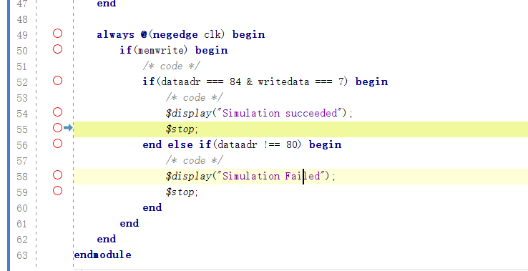
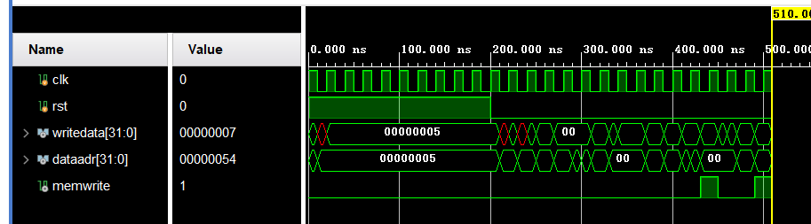

备注：

