《计算机组成原理》实验报告

一、实验目的
（1）掌握流水线(Pipelined)处理器的思想。
（2）掌握单周期处理中执行阶段的划分。
（3）了解流水线处理器遇到的冒险。
（4）掌握数据前推、流水线暂停等冒险解决方式。
二、实验项目内容
1，根据5级流水CPU图编写模块
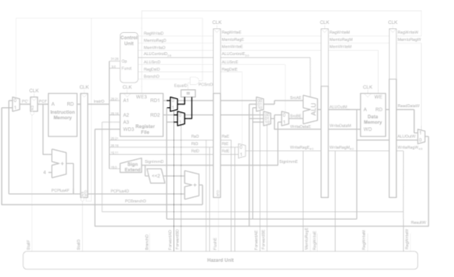
2，完成datapath模块
3，编写top模块连接controller模块，data_memory模块，init_memory模块，datapath模块，harzard模块

三、实验过程或算法（源程序）
1，项目结构
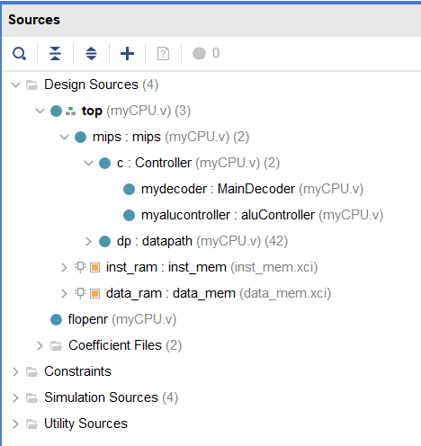
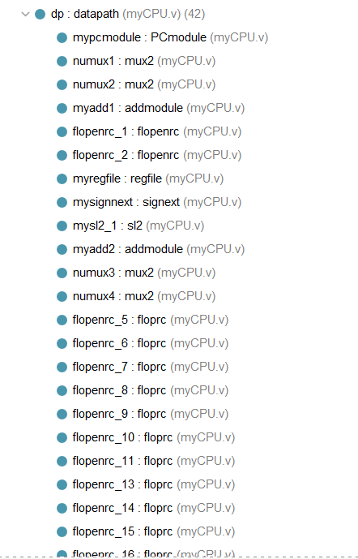
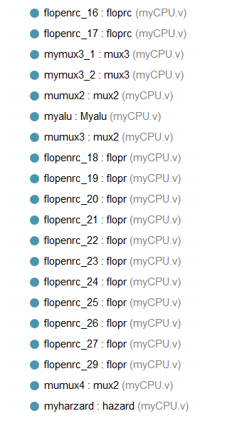
2，top模块
- //顶层
- module top(
- input wire clk,rst,
- output wire[31:0] writedata,dataadr,
- output wire memwrite,
- output [31:0] instr
- );
- wire[31:0] pc,readdata;
- //CPU核心
- mips mips(clk,rst,pc,instr,memwrite,dataadr,writedata,readdata);
- //存储层
- inst_mem inst_ram (
- .clka(~clk), // input wire clka
- .ena(1'b1), // input wire ena
- .wea(4'b0000), // input wire [3 : 0] wea
- .addra(pc[9:2]), // input wire [7 : 0] addra
- .dina(32'b0), // input wire [31 : 0] dina
- .douta(instr) // output wire [31 : 0] douta
- );

- data_mem data_ram (
- .clka(~clk), // input wire clka
- .ena(1'b1), // input wire ena
- .wea({4{memwrite}}), // input wire [3 : 0] wea
- .addra(dataadr[9:0]), // input wire [9 : 0] addra
- .dina(writedata), // input wire [31 : 0] dina
- .douta(readdata) // output wire [31 : 0] douta
- );
- endmodule

3，MIPS模块
- module mips(
- input wire clk,rst,
- output wire[31:0] pcF,
- input wire[31:0] instrF,
- output wire memwriteM,
- output wire[31:0] aluout,writedata,
- input wire[31:0] readdata
- );

- wire memtoregD,alusrcD,regdstD,regwriteD,pcsrcD,zeroD,memwriteD;
- wire[2:0] alucontrolD;
- wire [31:0] instrD;
- wire jumpD;
- wire branchD;
- //控制器

- Controller c(instrD,zeroD,memtoregD,
- memwriteD,pcsrcD,alusrcD,regdstD,regwriteD,jumpD,alucontrolD,branchD);
- //数据链路
- datapath dp(
- .clk(clk),
- .rst(rst),
- .instrF(instrF),
- .instrD(instrD),
- .jumpD(jumpD),
- .regwriteD(regwriteD),
- .memtoregD(memtoregD),
- .memwriteD(memwriteD),
- .alucontrollD(alucontrolD),
- .alusrcD(alusrcD),
- .regdstD(regdstD),
- .pcsrcD(pcsrcD),
- .zero(zeroD),
- .pcF(pcF),
- .aluoutM(aluout),
- .writedataM(writedata),
- .readdataM(readdata),
- .branchD(branchD),
- .memwriteM(memwriteM)
- );
- endmodule

4，controller模块
- module MainDecoder(
- input [31:0] instr,
- output reg regwrite,
- output reg regdst,
- output reg alusrc,
- output reg branch,
- output reg memWrite,
- output reg memtoReg,
- output reg [1:0] aluop,
- output reg jump
- );
- wire [5:0] op;
- assign op = instr[31:26];
- always @(*)begin

- case(op)
- 6'b000000:begin
- regwrite<=1'b1;
- regdst<=1'b1;
- alusrc<=1'b0;
- branch<=1'b0;
- memWrite<=1'b0;
- memtoReg<=1'b0;
- aluop<=2'b10;
- jump<=1'b0;
- end
- 6'b100011:begin
- regwrite<=1'b1;
- regdst<=1'b0;
- alusrc<=1'b1;
- branch<=1'b0;
- memWrite<=1'b0;
- memtoReg<=1'b1;
- aluop<=2'b00;
- jump<=1'b0;
- end
- 6'b101011:begin
- regwrite<=1'b0;
- regdst<=1'b0;
- alusrc<=1'b1;
- branch<=1'b0;
- memWrite<=1'b1;
- memtoReg<=1'b0;
- aluop<=2'b00;
- jump<=1'b0;
- end
- 6'b000100:begin
- regwrite<=1'b0;
- regdst<=1'b0;
- alusrc<=1'b0;
- branch<=1'b1;
- memWrite<=1'b0;
- memtoReg<=1'b0;
- aluop<=2'b01;
- jump<=1'b0;
- end
- 6'b001000:begin
- regwrite<=1'b1;
- regdst<=1'b0;
- alusrc<=1'b1;
- branch<=1'b0;
- memWrite<=1'b0;
- memtoReg<=1'b0;
- aluop<=2'b00;
- jump<=1'b0;
- end
- 6'b000010:begin
- regwrite<=1'b0;
- regdst<=1'b0;
- alusrc<=1'b0;
- branch<=1'b0;
- memWrite<=1'b0;
- memtoReg<=1'b0;
- aluop<=2'b00;
- jump<=1'b1;
- end
- default:begin
- regwrite<=1'b0;
- regdst<=1'b0;
- alusrc<=1'b0;
- branch<=1'b0;
- memWrite<=1'b0;
- memtoReg<=1'b0;
- aluop<=2'b00;
- jump<=1'b0;
- end
- endcase

- end
- endmodule

- module aluController(
- input [1:0] aluop,
- input [5:0] op,
- output reg [2:0] alucontroll
- );
- always @(*)begin
- casex({aluop,op})
- 8'b10100000: alucontroll<=3'b010;
- 8'b10100010:alucontroll<=3'b110;
- 8'b10100100:alucontroll<=3'b000;
- 8'b10100101:alucontroll<=3'b001;
- 8'b10101010:alucontroll<=3'b111;
- 8'b00xxxxxx:alucontroll<=3'b010;
- 8'b01xxxxxx:alucontroll<=3'b110;
- endcase;
- end
- endmodule

- //控制器核心
- module Controller(
- input [31:0] instr,
- input zero,
- output memtoReg,
- output memWrite,
- output pcsrc,
- output alusrc,
- output regdst,
- output regwrite,
- output jump,
- output [2:0] alucontroll,
- output branch
- );
- wire [1:0] aluop;

- MainDecoder mydecoder(instr,regwrite,regdst,alusrc,branch,memWrite,memtoReg,aluop,jump);
- aluController myalucontroller(aluop,instr[5:0],alucontroll);
- assign pcsrc = branch & zero;

- endmodule

5，datapath模块
- //数据链路
- module datapath(
- input wire clk,rst,
- input wire [31:0] instrF,
- output wire [31:0] instrD,
- input wire jumpD,
- input wire regwriteD,memtoregD,memwriteD,
- input wire [2:0] alucontrollD,
- input wire alusrcD,regdstD,
- input wire branchD,
- input wire pcsrcD,
- output wire zero,
- output wire[31:0] pcF,
- output wire [31:0] aluoutM,writedataM,
- input wire [31:0] readdataM,
- output wire memwriteM
- );
- //第一级
- wire [31:0] pcpie;
- wire startIF; //链接冒险模块
- wire [31:0] pcplus4F;
- wire [31:0] pcbranchD;
- wire startID;//链接冒险模块
- wire [31:0] pcplus4D;
- wire [31:0] resultW;
- wire regwriteW;//第五级
- wire [4:0] writeregW;//第五级
- wire [31:0] rd1D;
- wire [31:0] rd2D;
- wire [31:0] newrd1D,newrd2D;
- wire [31:0] signlmmD;
- wire [31:0] signlmmD2;
- wire startIE;
- wire [4:0] rsE,rtE,rdE;
- wire regwriteE,memtoregE,memwriteE,alusrcE,regdstE;
- wire [2:0] alucontrollE;
- wire [31:0] rd1E;
- wire [31:0] rd2E;
- wire [31:0] signlmmE;
- wire [31:0] srcAE;
- wire [1:0] forwardAE;
- wire [1:0] forwardBE;
- wire [31:0] writedataE;
- wire regwriteM,memtoregM;
- wire [4:0] writeregE,writeregM;
- wire [31:0] aluoutE;
- wire [31:0] srcBE;
- wire [31:0] readdataW,aluoutW;
- wire forwardAD,forwardBD;
- wire memtoregW;
- wire [31:0] pcnextbrFD;

- PCmodule mypcmodule(.clk(clk),.rst(rst),.en(~startIF),.pcin(pcpie),.pc(pcF));

- mux2 #(32) numux1(.x1(pcplus4F),.x2(pcbranchD),.a(pcsrcD),.y(pcnextbrFD));

- mux2 #(32) numux2(pcnextbrFD,{pcplus4D[31:28],instrD[25:0],2'b00},jumpD,pcpie);

- addmodule myadd1(.pcin(pcF),.jumpnum(32'h4),.pcout(pcplus4F));
- //第一级门

- flopenrc #(32) flopenrc_1(clk,rst,~startID,pcsrcD,pcplus4F,pcplus4D);
- flopenrc #(32) flopenrc_2(clk,rst,~startID,pcsrcD,instrF,instrD);

- regfile myregfile(.clk(clk),.we3(regwriteW),.ra1(instrD[25:21]),.ra2(instrD[20:16]),.wa3(writeregW),.wd3(resultW),.rd1(rd1D),.rd2(rd2D));

- signext mysignnext(.a(instrD[15:0]),.y(signlmmD));

- sl2 mysl2_1(.a(signlmmD),.y(signlmmD2));

- addmodule myadd2(.pcin(signlmmD2),.jumpnum(pcplus4D),.pcout(pcbranchD));

- mux2 #(32) numux3(rd1D,aluoutM,forwardAD,newrd1D);

- mux2 #(32) numux4(rd2D,aluoutM,forwardBD,newrd2D);

- assign zero = (newrd1D==newrd2D)?1'b1:1'b0;

- //第二级门
- floprc #(1) flopenrc_5(clk,rst,startIE,regwriteD,regwriteE);
- floprc #(1) flopenrc_6(clk,rst,startIE,memtoregD,memtoregE);
- floprc #(1) flopenrc_7(clk,rst,startIE,memwriteD,memwriteE);
- floprc #(3) flopenrc_8(clk,rst,startIE,alucontrollD,alucontrollE);
- floprc #(1) flopenrc_9(clk,rst,startIE,alusrcD,alusrcE);
- floprc #(1) flopenrc_10(clk,rst,startIE,regdstD,regdstE);
- floprc #(32) flopenrc_11(clk,rst,startIE,rd1D,rd1E);
- floprc #(32) flopenrc_13(clk,rst,startIE,rd2D,rd2E);
- floprc #(5) flopenrc_14(clk,rst,startIE,instrD[25:21],rsE);
- floprc #(5) flopenrc_15(clk,rst,startIE,instrD[20:16],rtE);
- floprc #(5) flopenrc_16(clk,rst,startIE,instrD[15:11],rdE);
- floprc #(32) flopenrc_17(clk,rst,startIE,signlmmD,signlmmE);

- //第三级
- mux3 #(32) mymux3_1(.x1(rd1E),.x2(resultW),.x3(aluoutM),.a(forwardAE),.y(srcAE));

- mux3 #(32) mymux3_2(.x1(rd2E),.x2(resultW),.x3(aluoutM),.a(forwardBE),.y(writedataE));

- mux2 #(32) mumux2(.x1(writedataE),.x2(signlmmE),.a(alusrcE),.y(srcBE));

- Myalu myalu(.A(srcAE),.B(srcBE),.op(alucontrollE),.C(aluoutE));

- mux2 #(5) mumux3(.x1(rtE),.x2(rdE),.a(regdstE),.y(writeregE));

- //第三级门
- flopr #(1) flopenrc_18(clk,rst,regwriteE,regwriteM);
- flopr #(1) flopenrc_19(clk,rst,memtoregE,memtoregM);
- flopr #(1) flopenrc_20(clk,rst,memwriteE,memwriteM);
- flopr #(32) flopenrc_21(clk,rst,aluoutE,aluoutM);
- flopr #(32) flopenrc_22(clk,rst,writedataE,writedataM);
- flopr #(5) flopenrc_23(clk,rst,writeregE,writeregM);

- //第四级门
- flopr #(1) flopenrc_24(clk,rst,regwriteM,regwriteW);
- flopr #(1) flopenrc_25(clk,rst,memtoregM,memtoregW);
- flopr #(32) flopenrc_26(clk,rst,readdataM,readdataW);
- flopr #(32) flopenrc_27(clk,rst,aluoutM,aluoutW);
- flopr #(5) flopenrc_29(clk,rst,writeregM,writeregW);

- //第五级
- mux2 #(32) mumux4(.x1(aluoutW),.x2(readdataW),.a(memtoregW),.y(resultW));

- //冒险模块
- hazard myharzard(
- .stallF(startIF),
- .rsD(instrD[25:21]),
- .rtD(instrD[20:16]),
- .branchD(branchD),
- .forwardaD(forwardAD),
- .forwardbD(forwardBD),
- .stallD(startID),
- .rsE(rsE),
- .rtE(rtE),
- .writeregE(writeregE),
- .regwriteE(regwriteE),
- .memtoregE(memtoregE),
- .forwardaE(forwardAE),
- .forwardbE(forwardBE),
- .flushE(startIE),
- .writeregM(writeregM),
- .regwriteM(regwriteM),
- .memtoregM(memtoregM),
- .writeregW(writeregW),
- .regwriteW(regwriteW)

- );

- endmodule

6，其余模块
- module PCmodule(
- input clk,
- input rst,
- input en,
- input [31:0] pcin,
- output reg [31:0] pc
- );
- always @(posedge clk,posedge rst)begin
- if(rst)begin
- pc<=32'b00000000000000000000000000000000;
- end else if(en) begin
- pc<=pcin;
- end
- end
- endmodule

- //加法器
- module addmodule(
- input [31:0] pcin,
- input [31:0] jumpnum,
- output [31:0] pcout
- );
- assign pcout = pcin + jumpnum;
- endmodule

- //ALU模块
- module Myalu(
- input [31:0] A,
- input [31:0] B,
- input [2:0] op,
- output [31:0] C
- );
- reg [31:0] x;
- always @(*) begin
- case(op)
- 3'b000:x<=A&B;
- 3'b001:x<=A|B;
- 3'b010:x<=A+B;
- 3'b011:;
- 3'b100:x<=~A;
- 3'b101:;
- 3'b110:x<=A-B;
- 3'b111:x<=(A<B?32'b00000000000000000000000000000001:32'b00000000000000000000000000000000);
- default:;
- endcase
- end
- assign C = x;
- endmodule

- //有符号扩展16-32
- module signext(
- input wire[15:0] a,
- output wire[31:0] y
- );
- assign y = {{16{a[15]}},a};
- endmodule

- //左移位模块
- module sl2(
- input wire[31:0] a,
- output wire[31:0] y
- );
- assign y = {a[29:0],2'b00};
- endmodule

- //寄存器堆
- module regfile(
- input wire clk,
- input wire we3,
- input wire[4:0] ra1,ra2,wa3,
- input wire[31:0] wd3,
- output wire[31:0] rd1,rd2
- );
- reg [31:0] rf[31:0];
- always @(negedge clk) begin
- if(we3) begin
- rf[wa3] <= wd3;
- end
- end
- assign rd1 = (ra1 != 0) ? rf[ra1] : 0;
- assign rd2 = (ra2 != 0) ? rf[ra2] : 0;
- endmodule

- //二选一选择器
- module mux2 #(parameter WIDTH = 8)(
- input wire[WIDTH-1:0] x1,x2,
- input wire a,
- output wire[WIDTH-1:0] y
- );
- assign y = a ? x2 : x1;
- endmodule

- //三选一选择器
- module mux3 #(parameter WIDTH = 8)(
- input wire[WIDTH-1:0] x1,x2,x3,
- input wire [1:0] a,
- output reg [WIDTH-1:0] y
- );
- always @(*) begin
- case(a)
- 2'b00:y<=x1;
- 2'b01:y<=x2;
- 2'b10:y<=x3;
- endcase
- end
- endmodule

- //寄存器
- module flopr #(parameter WIDTH = 8)(
- input wire clk,rst,
- input wire [WIDTH-1:0] in,
- output reg [WIDTH-1:0] out
- );
- always @(posedge clk,posedge rst) begin
- if(rst)begin
- out<=0;
- end else begin
- out<=in;
- end
- end
- endmodule

- module floprc #(parameter WIDTH = 8)(
- input wire clk,rst,clear,
- input wire [WIDTH-1:0] in,
- output reg [WIDTH-1:0] out
- );
- always @(posedge clk,posedge rst) begin
- if(rst)begin
- out<=0;
- end else if(clear) begin
- out<=0;
- end else begin
- out<=in;
- end
- end
- endmodule

- module flopenrc #(parameter WIDTH = 8)(
- input wire clk,rst,en,clear,
- input wire [WIDTH-1:0] in,
- output reg [WIDTH-1:0] out
- );
- always @(posedge clk,posedge rst) begin
- if(rst)begin
- out<=0;
- end else if(clear) begin
- out<=0;
- end else if(en) begin
- out<=in;
- end
- end
- endmodule

- module flopenr #(parameter WIDTH = 8)(
- input wire clk,rst,en,
- input wire [WIDTH-1:0] in,
- output reg [WIDTH-1:0] out
- );
- always @(posedge clk,posedge rst) begin
- if(rst)begin
- out<=0;
- end else if(en) begin
- out<=in;
- end
- end
- endmodule

7，冒险模块
- module hazard(
- output wire stallF,
- input wire[4:0] rsD,rtD,
- input wire branchD,
- output wire forwardaD,forwardbD,
- output wire stallD,
- input wire[4:0] rsE,rtE,
- input wire[4:0] writeregE,
- input wire regwriteE,
- input wire memtoregE,
- output reg[1:0] forwardaE,forwardbE,
- output wire flushE,
- input wire[4:0] writeregM,
- input wire regwriteM,
- input wire memtoregM,
- input wire[4:0] writeregW,
- input wire regwriteW
- );
- wire lwstallD,branchstallD;
- assign forwardaD = (rsD != 0 & rsD == writeregM & regwriteM);
- assign forwardbD = (rtD != 0 & rtD == writeregM & regwriteM);
- always @(*) begin
- forwardaE = 2'b00;
- forwardbE = 2'b00;
- if(rsE != 0) begin
- if(rsE == writeregM & regwriteM) begin
- forwardaE = 2'b10;
- end else if(rsE == writeregW & regwriteW) begin
- forwardaE = 2'b01;
- end
- end
- if(rtE != 0) begin
- if(rtE == writeregM & regwriteM) begin
- forwardbE = 2'b10;
- end else if(rtE == writeregW & regwriteW) begin
- forwardbE = 2'b01;
- end
- end
- end
- assign #2 lwstallD = memtoregE & (rtE == rsD | rtE == rtD);
- assign #2 branchstallD = branchD &
- (regwriteE &
- (writeregE == rsD | writeregE == rtD) |
- memtoregM &
- (writeregM == rsD | writeregM == rtD));
- assign #2 stallD = lwstallD | branchstallD;
- assign #2 stallF = stallD;
- assign #2 flushE = stallD;
- endmodule

8，test_bench模块
- module fangzhen();
- reg clk;
- reg rst;

- wire[31:0] writedata,dataadr;
- wire memwrite;
- wire[31:0] op;

- top dut(clk,rst,writedata,dataadr,memwrite,op);

- initial begin
- rst <= 1;
- #200;
- rst <= 0;
- end

- always begin
- clk <= 1;
- #10;
- clk <= 0;
- #10;

- end

- always @(negedge clk) begin
- if(memwrite) begin
- /* code */
- if(dataadr === 84 & writedata === 7) begin
- /* code */
- $display("Simulation succeeded");
- $stop;
- end else if(dataadr !== 80) begin
- /* code */
- $display("Simulation Failed");
- $stop;
- end
- end
- end
- endmodule

四、实验结果及分析和（或）源程序调试过程
Test_bench仿真图
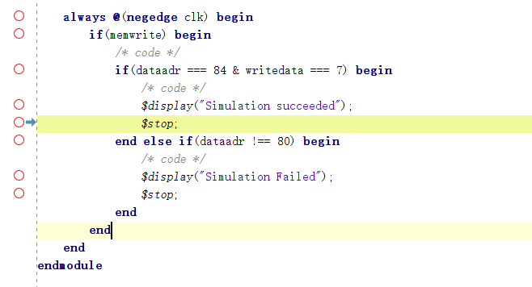
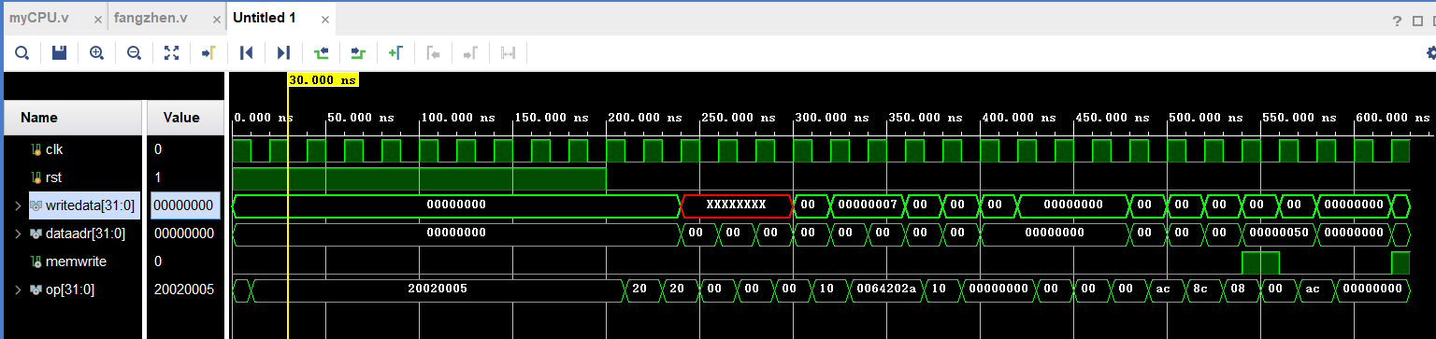

备注：

