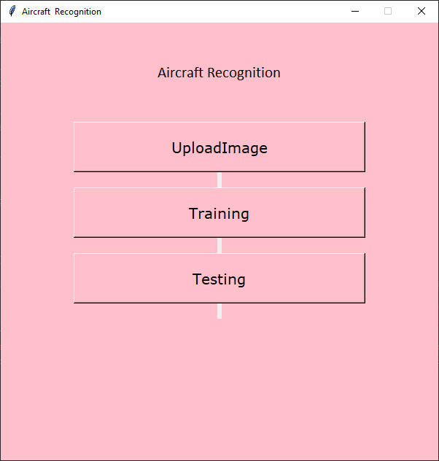

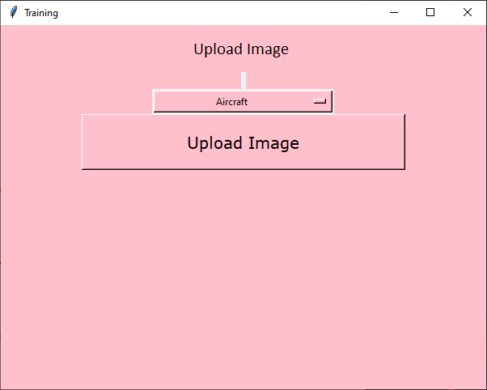
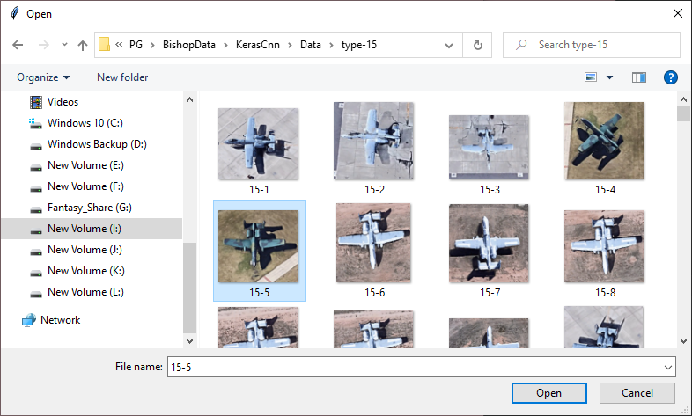
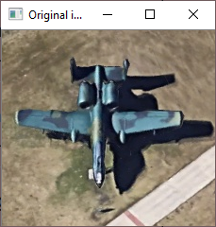
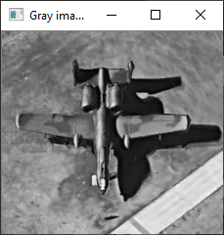
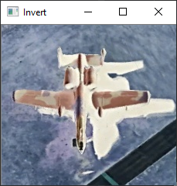
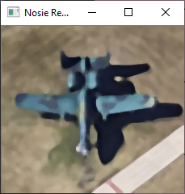
I:\NewProject2022\PG\BishopData\KerasCnn\venv\Scripts\python.exe I:/NewProject2022/PG/BishopData/KerasCnn/Main.py
2022-05-10 09:28:08.059313: W tensorflow/stream_executor/platform/default/dso_loader.cc:64] Could not load dynamic library 'cudart64_110.dll'; dlerror: cudart64_110.dll not found
2022-05-10 09:28:08.059569: I tensorflow/stream_executor/cuda/cudart_stub.cc:29] Ignore above cudart dlerror if you do not have a GPU set up on your machine.
type-15
After saving image:
I:/NewProject2022/PG/BishopData/KerasCnn/Data/type-15/15-11.jpg
15-11.jpg
Found 1505 images belonging to 9 classes.
2022-05-10 09:30:48.658363: W tensorflow/stream_executor/platform/default/dso_loader.cc:64] Could not load dynamic library 'nvcuda.dll'; dlerror: nvcuda.dll not found
2022-05-10 09:30:48.659060: W tensorflow/stream_executor/cuda/cuda_driver.cc:269] failed call to cuInit: UNKNOWN ERROR (303)
2022-05-10 09:30:48.685063: I tensorflow/stream_executor/cuda/cuda_diagnostics.cc:169] retrieving CUDA diagnostic information for host: DESKTOP-9BF8NUN
2022-05-10 09:30:48.685919: I tensorflow/stream_executor/cuda/cuda_diagnostics.cc:176] hostname: DESKTOP-9BF8NUN
2022-05-10 09:30:48.736807: I tensorflow/core/platform/cpu_feature_guard.cc:151] This TensorFlow binary is optimized with oneAPI Deep Neural Network Library (oneDNN) to use the following CPU instructions in performance-critical operations: AVX AVX2
To enable them in other operations, rebuild TensorFlow with the appropriate compiler flags.
Model: "sequential"
_________________________________________________________________
Layer (type) Output Shape Param #
=================================================================
conv2d (Conv2D) (None, 198, 198, 16) 448

max_pooling2d (MaxPooling2D (None, 99, 99, 16) 0
)

conv2d_1 (Conv2D) (None, 97, 97, 32) 4640

max_pooling2d_1 (MaxPooling (None, 48, 48, 32) 0
2D)

conv2d_2 (Conv2D) (None, 46, 46, 64) 18496

max_pooling2d_2 (MaxPooling (None, 23, 23, 64) 0
2D)

conv2d_3 (Conv2D) (None, 21, 21, 64) 36928

max_pooling2d_3 (MaxPooling (None, 10, 10, 64) 0
2D)

conv2d_4 (Conv2D) (None, 8, 8, 64) 36928

max_pooling2d_4 (MaxPooling (None, 4, 4, 64) 0
2D)

flatten (Flatten) (None, 1024) 0

dense (Dense) (None, 128) 131200

dense_1 (Dense) (None, 9) 1161

=================================================================
Total params: 229,801
Trainable params: 229,801
Non-trainable params: 0
_________________________________________________________________
Epoch 1/25
WARNING:tensorflow:AutoGraph could not transform <function Model.make_train_function.<locals>.train_function at 0x0000025ACDF9FF78> and will run it as-is.
Please report this to the TensorFlow team. When filing the bug, set the verbosity to 10 (on Linux, `export AUTOGRAPH_VERBOSITY=10`) and attach the full output.
Cause: 'arguments' object has no attribute 'posonlyargs'
To silence this warning, decorate the function with @tf.autograph.experimental.do_not_convert
2022-05-10 09:30:52.775250: W tensorflow/core/framework/cpu_allocator_impl.cc:82] Allocation of 80289792 exceeds 10% of free system memory.
2022-05-10 09:30:54.013025: W tensorflow/core/framework/cpu_allocator_impl.cc:82] Allocation of 80289792 exceeds 10% of free system memory.
1/47 [..............................] - ETA: 2:25 - loss: 2.1536 - accuracy: 0.25002022-05-10 09:30:54.200828: W tensorflow/core/framework/cpu_allocator_impl.cc:82] Allocation of 80289792 exceeds 10% of free system memory.
2022-05-10 09:30:54.719541: W tensorflow/core/framework/cpu_allocator_impl.cc:82] Allocation of 80289792 exceeds 10% of free system memory.
2022-05-10 09:30:54.936892: W tensorflow/core/framework/cpu_allocator_impl.cc:82] Allocation of 80289792 exceeds 10% of free system memory.
47/47 [==============================] - 32s 622ms/step - loss: 2.0977 - accuracy: 0.2492
Epoch 2/25
47/47 [==============================] - 25s 540ms/step - loss: 1.9535 - accuracy: 0.2865
Epoch 3/25
47/47 [==============================] - 26s 544ms/step - loss: 1.4938 - accuracy: 0.4807
Epoch 4/25
47/47 [==============================] - 26s 547ms/step - loss: 1.0026 - accuracy: 0.6544
Epoch 5/25
47/47 [==============================] - 26s 549ms/step - loss: 0.5988 - accuracy: 0.8086
Epoch 6/25
47/47 [==============================] - 28s 599ms/step - loss: 0.3459 - accuracy: 0.8859
Epoch 7/25
47/47 [==============================] - 28s 598ms/step - loss: 0.2855 - accuracy: 0.9117
Epoch 8/25
47/47 [==============================] - 28s 597ms/step - loss: 0.1721 - accuracy: 0.9498
Epoch 9/25
47/47 [==============================] - 26s 551ms/step - loss: 0.1332 - accuracy: 0.9620
Epoch 10/25
47/47 [==============================] - 26s 543ms/step - loss: 0.0638 - accuracy: 0.9817
Epoch 11/25
47/47 [==============================] - 26s 549ms/step - loss: 0.1346 - accuracy: 0.9783
Epoch 12/25
47/47 [==============================] - 26s 545ms/step - loss: 0.0768 - accuracy: 0.9762
Epoch 13/25
47/47 [==============================] - 26s 543ms/step - loss: 0.0657 - accuracy: 0.9830
Epoch 14/25
47/47 [==============================] - 26s 545ms/step - loss: 0.0580 - accuracy: 0.9885
Epoch 15/25
47/47 [==============================] - 26s 542ms/step - loss: 0.0557 - accuracy: 0.9919
Epoch 16/25
47/47 [==============================] - 26s 544ms/step - loss: 0.0511 - accuracy: 0.9885
Epoch 17/25
47/47 [==============================] - 26s 542ms/step - loss: 0.0934 - accuracy: 0.9857
Epoch 18/25
47/47 [==============================] - 26s 543ms/step - loss: 0.0042 - accuracy: 0.9993
Epoch 19/25
47/47 [==============================] - 26s 553ms/step - loss: 0.0615 - accuracy: 0.9885
Epoch 20/25
47/47 [==============================] - 26s 543ms/step - loss: 0.0638 - accuracy: 0.9837
Epoch 21/25
47/47 [==============================] - 25s 542ms/step - loss: 4.5464e-04 - accuracy: 1.0000
Epoch 22/25
47/47 [==============================] - 26s 543ms/step - loss: 2.8777e-05 - accuracy: 1.0000
Epoch 23/25
47/47 [==============================] - 26s 546ms/step - loss: 0.1502 - accuracy: 0.9837
Epoch 24/25
47/47 [==============================] - 26s 552ms/step - loss: 0.0011 - accuracy: 1.0000
Epoch 25/25
47/47 [==============================] - 26s 543ms/step - loss: 2.8834e-05 - accuracy: 1.0000
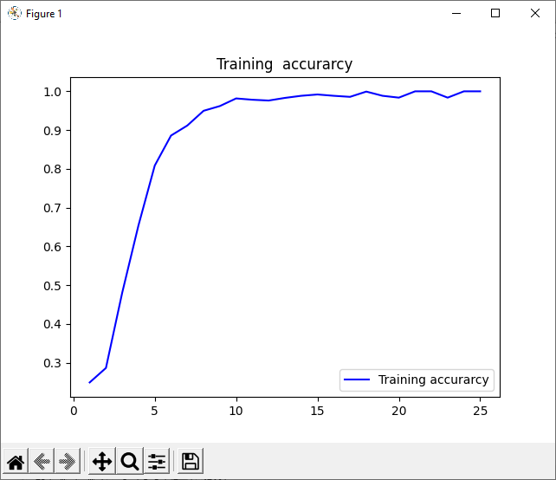
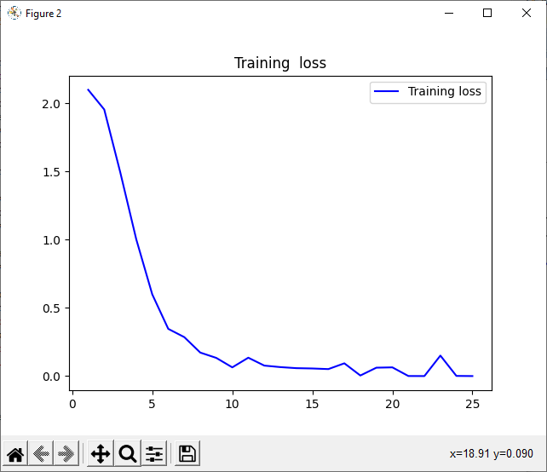
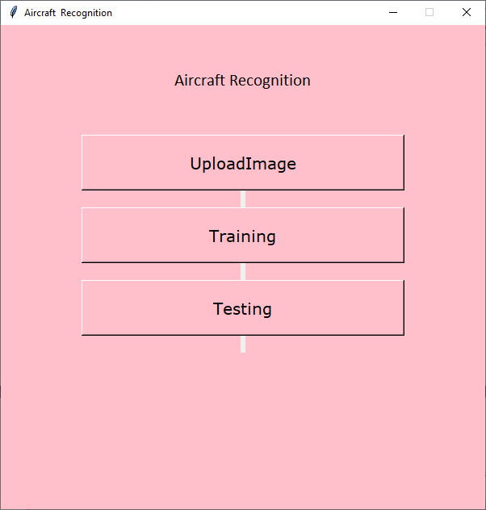

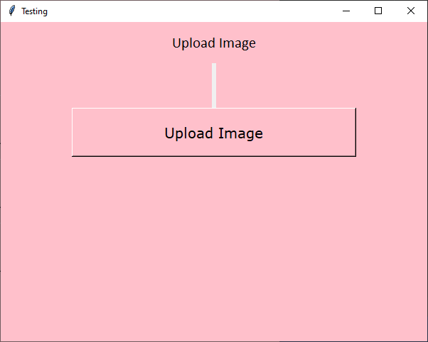
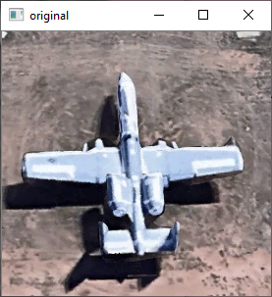
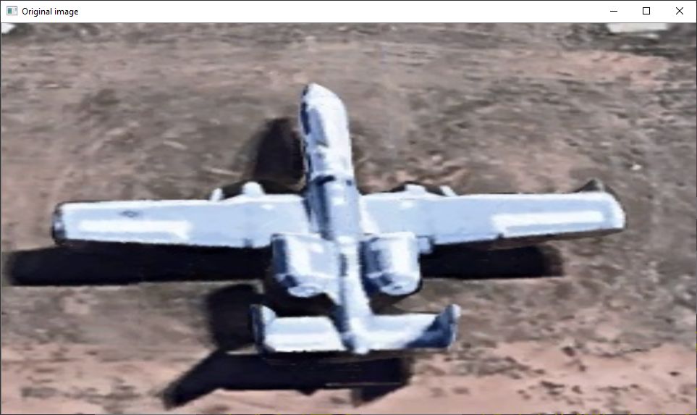
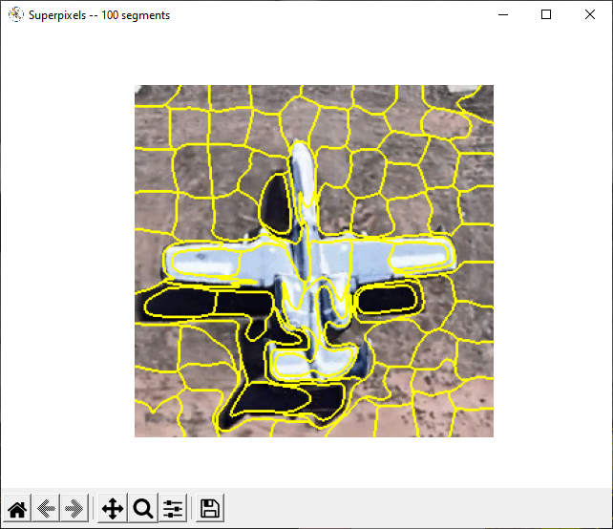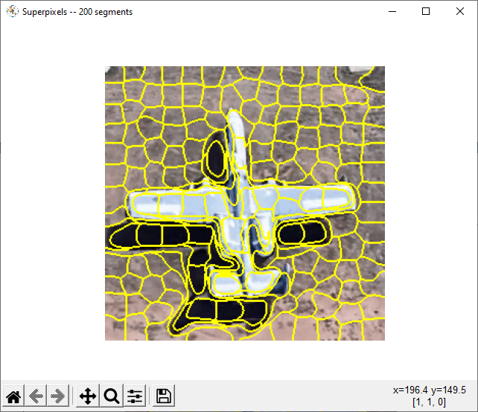
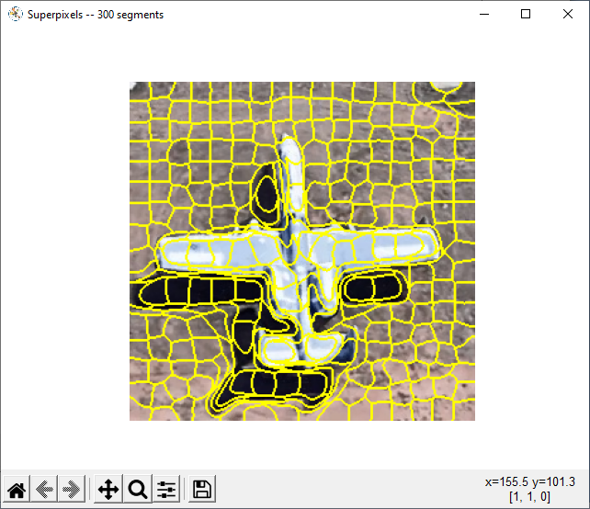
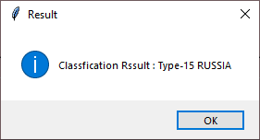
import tensorflow as tf
import numpy as np
from tkinter import *
import os
from tkinter import filedialog
import cv2
import time
from matplotlib import pyplot as plt
from tkinter import messagebox
import smtplib
def endprogram():
print ("\nProgram terminated!")
sys.exit()
def file_sucess():
global file_success_screen
file_success_screen = Toplevel(training_screen)
file_success_screen.title("File Upload Success")
file_success_screen.geometry("150x100")
file_success_screen.configure(bg='pink')
Label(file_success_screen, text="File Upload Success").pack()
Button(file_success_screen, text='''ok''', font=(
'Verdana', 15), height="2", width="30", bg='pink').pack()
global ttype
def training():
global training_screen
global clicked
training_screen = Toplevel(main_screen)
training_screen.title("Training")
# login_screen.geometry("400x300")
training_screen.geometry("600x450+650+150")
training_screen.minsize(120, 1)
training_screen.maxsize(1604, 881)
training_screen.resizable(1, 1)
training_screen.configure(bg='pink')
# login_screen.title("New Toplevel")
Label(training_screen, text='''Upload Image ''', background="#d9d9d9", disabledforeground="#a3a3a3",
foreground="#000000", width="300", height="2",bg='pink', font=("Calibri", 16)).pack()
Label(training_screen, text="").pack()
options = [
"type-12",
"type-13",
"type-14",
"type-15",
"type-16",
"type-17",
"type-18",
"type-19",
"type-20"
]
# datatype of menu text
clicked = StringVar()
# initial menu text
clicked.set("Aircraft")
# Create Dropdown menu
drop = OptionMenu(training_screen, clicked, *options )
drop.config(width="30",bg='pink')
drop.pack()
ttype=clicked.get()
Button(training_screen, text='''Upload Image''', font=(
'Verdana', 15), height="2", width="30",bg='pink', command=imgtraining).pack()
def imgtraining():
name1 = clicked.get()
print(name1)
import_file_path = filedialog.askopenfilename()
import os
s = import_file_path
os.path.split(s)
os.path.split(s)[1]
splname = os.path.split(s)[1]
image = cv2.imread(import_file_path)
#filename = 'Test.jpg'
filename = 'Data/'+name1+'/'+splname
cv2.imwrite(filename, image)
print("After saving image:")
gray = cv2.cvtColor(image, cv2.COLOR_BGR2GRAY)
cv2.imshow('Original image', image)
cv2.imshow('Gray image', gray)
# import_file_path = filedialog.askopenfilename()
print(import_file_path)
fnm = os.path.basename(import_file_path)
print(os.path.basename(import_file_path))
from PIL import Image, ImageOps
im = Image.open(import_file_path)
im_invert = ImageOps.invert(im)
im_invert.save('lena_invert.jpg', quality=95)
im = Image.open(import_file_path).convert('RGB')
im_invert = ImageOps.invert(im)
im_invert.save('tt.png')
image2 = cv2.imread('tt.png')
cv2.imshow("Invert", image2)
""""-----------------------------------------------"""
img = image
gray = cv2.cvtColor(img, cv2.COLOR_BGR2GRAY)
cv2.imshow('Original image', img)
#cv2.imshow('Gray image', gray)
#dst = cv2.fastNlMeansDenoisingColored(img, None, 10, 10, 7, 21)
dst = cv2.medianBlur(img, 7)
cv2.imshow("Nosie Removal", dst)
def fulltraining():
import model as mm
def testing():
global testing_screen
testing_screen = Toplevel(main_screen)
testing_screen.title("Testing")
# login_screen.geometry("400x300")
testing_screen.geometry("600x450+650+150")
testing_screen.minsize(120, 1)
testing_screen.maxsize(1604, 881)
testing_screen.resizable(1, 1)
testing_screen.configure(bg='pink')
# login_screen.title("New Toplevel")
Label(testing_screen, text='''Upload Image''', disabledforeground="#a3a3a3",
foreground="#000000", width="300", height="2",bg='pink', font=("Calibri", 16)).pack()
Label(testing_screen, text="").pack()
Label(testing_screen, text="").pack()
Label(testing_screen, text="").pack()
Button(testing_screen, text='''Upload Image''', font=(
'Verdana', 15), height="2", width="30",bg='pink', command=imgtest).pack()
global affect
def imgtest():
import_file_path = filedialog.askopenfilename()
image = cv2.imread(import_file_path)
print(import_file_path)
filename = 'Output/Out/Test.jpg'
cv2.imwrite(filename, image)
print("After saving image:")
#result()
#import_file_path = filedialog.askopenfilename()
print(import_file_path)
fnm = os.path.basename(import_file_path)
print(os.path.basename(import_file_path))
# file_sucess()
print("\n*********************\nImage : " + fnm + "\n*********************")
img = cv2.imread(import_file_path)
if img is None:
print('no data')
img1 = cv2.imread(import_file_path)
print(img.shape)
img = cv2.resize(img, ((int)(img.shape[1] / 5), (int)(img.shape[0] / 5)))
original = img.copy()
neworiginal = img.copy()
cv2.imshow('original', img1)
gray = cv2.cvtColor(img1, cv2.COLOR_BGR2GRAY)
img1S = cv2.resize(img1, (960, 540))
cv2.imshow('Original image', img1S)
grayS = cv2.resize(gray, (960, 540))
cv2.imshow('Gray image', grayS)
dst = cv2.medianBlur(img1,7)
cv2.imshow("Nosie Removal", dst)
super()
result()
def super():
from skimage.segmentation import slic
from skimage.segmentation import mark_boundaries
from skimage.util import img_as_float
from skimage import io
import matplotlib.pyplot as plt
filename = 'Output/Out/Test.jpg'
image = img_as_float(io.imread(filename))
# loop over the number of segments
for numSegments in (100, 200, 300):
# apply SLIC and extract (approximately) the supplied number
# of segments
segments = slic(image, n_segments=numSegments, sigma=5)
# show the output of SLIC
fig = plt.figure("Superpixels -- %d segments" % (numSegments))
ax = fig.add_subplot(1, 1, 1)
ax.imshow(mark_boundaries(image, segments))
plt.axis("off")
plt.savefig(str(numSegments)+".jpg")
# show the plots
plt.show()
def result():
import warnings
warnings.filterwarnings('ignore')
import tensorflow as tf
classifierLoad = tf.keras.models.load_model("airmodel.h5")
import numpy as np
from keras.preprocessing import image
global mmmsg
#filename1 = "100.jpg"
#filename2 = "200.jpg"
#filename3 = "300.jpg"
#cv2.imshow('100 Superpixels', filename1)
# cv2.imshow("200 Superpixels", filename2)
# cv2.imshow("300 Superpixels", filename3)
test_image = image.load_img('Output/Out/Test.jpg', target_size=(200, 200))
img1 = cv2.imread('Output/Out/Test.jpg')
# test_image = image.img_to_array(test_image)
test_image = np.expand_dims(test_image, axis=0)
result = classifierLoad.predict(test_image)
out = ''
pre=''
if result[0][0] == 1:
out = "Type-12 India"
elif result[0][1] == 1:
out = "Type-13 USA"
elif result[0][2] == 1:
out = "Type-14 UAE"
elif result[0][3] == 1:
out = "Type-15 RUSSIA"
elif result[0][4] == 1:
out = "Type-16 CHINA"
elif result[0][5] == 1:
out = "Type-17 INDONESIA"
elif result[0][6] == 1:
out = "Type-18 PARIS"
elif result[0][7] == 1:
out = "Type-19 INDIA"
elif result[0][8] == 1:
out = "Type-20 INDIA"
messagebox.showinfo("Result", "Classfication Rssult : "+str(out))
#s = smtplib.SMTP('smtp.gmail.com', 587)
#s.starttls()
#s.login("sampletest685@gmail.com", "mailtest4")
#message = out
#s.sendmail("sampletest685@gmail.com", "shabanabana944@gmail.com", message)
#s.quit()
mmmsg = out;
import smtplib
from email.mime.multipart import MIMEMultipart
from email.mime.text import MIMEText
from email.mime.base import MIMEBase
from email import encoders
fromaddr = "sampletest685@gmail.com"
toaddr = "shabanabana944@gmail.com"
# instance of MIMEMultipart
msg = MIMEMultipart()
# storing the senders email address
msg['From'] = fromaddr
# storing the receivers email address
msg['To'] = toaddr
# storing the subject
msg['Subject'] = "Alert"
# string to store the body of the mail
body = mmmsg
# attach the body with the msg instance
msg.attach(MIMEText(body, 'plain'))
# creates SMTP session
s = smtplib.SMTP('smtp.gmail.com', 587)
# start TLS for security
s.starttls()
# Authentication
s.login(fromaddr, "mailtest4")
# Converts the Multipart msg into a string
text = msg.as_string()
# sending the mail
s.sendmail(fromaddr, toaddr, text)
# terminating the session
s.quit()
sendmsg("9597900586",out)
def sendmsg(targetno,message):
import requests
requests.post("http://smsserver9.creativepoint.in/api.php?username=fantasy&password=596692&to=" + targetno + "&from=FSSMSS&message=Dear user your msg is " + message + " Sent By FSMSG FSSMSS&PEID=1501563800000030506&templateid=1507162882948811640")
def main_account_screen():
global main_screen
main_screen = Tk()
width = 600
height = 600
screen_width = main_screen.winfo_screenwidth()
screen_height = main_screen.winfo_screenheight()
x = (screen_width / 2) - (width / 2)
y = (screen_height / 2) - (height / 2)
main_screen.geometry("%dx%d+%d+%d" % (width, height, x, y))
main_screen.resizable(0, 0)
# main_screen.geometry("300x250")
main_screen.configure(bg='pink')
main_screen.title("Aircraft Recognition")
Label(text="Aircraft Recognition", width="300", height="5", bg='pink', font=("Calibri", 16)).pack()
Button(text="UploadImage", font=(
'Verdana', 15), height="2", width="30", command=training, highlightcolor="black",bg='pink').pack(side=TOP)
Label(text="").pack()
Button(text="Training", font=(
'Verdana', 15), height="2", width="30", command=fulltraining, highlightcolor="black",bg='pink').pack(side=TOP)
Label(text="").pack()
Button(text="Testing", font=(
'Verdana', 15), height="2", width="30", bg='pink', command=testing).pack(side=TOP)
Label(text="").pack()
main_screen.mainloop()
main_account_screen()

# Part 1 - Building the CNN
# Importing the Keras libraries and packages
from keras.models import Sequential
from keras.layers import Convolution2D
from keras.layers import MaxPooling2D
from keras.layers import Flatten
from keras.layers import Dense
from keras.models import model_from_json
import matplotlib.pyplot as plt
import warnings
warnings.filterwarnings('ignore')
batch_size = 32
from tensorflow.keras.preprocessing.image import ImageDataGenerator
# All images will be rescaled by 1./255
train_datagen = ImageDataGenerator(rescale=1/255)
# Flow training images in batches of 128 using train_datagen generator
train_generator = train_datagen.flow_from_directory(
'Data', # This is the source directory for training images
target_size=(200, 200), # All images will be resized to 200 x 200
batch_size=batch_size,
# Specify the classes explicitly
classes = ['type-12','type-13','type-14','type-15','type-16','type-17','type-18','type-19','type-20'],
# Since we use categorical_crossentropy loss, we need categorical labels
class_mode='categorical')
import tensorflow as tf
model = tf.keras.models.Sequential([
# Note the input shape is the desired size of the image 200x 200 with 3 bytes color
# The first convolution
tf.keras.layers.Conv2D(16, (3,3), activation='relu', input_shape=(200, 200, 3)),
tf.keras.layers.MaxPooling2D(2, 2),
# The second convolution
tf.keras.layers.Conv2D(32, (3,3), activation='relu'),
tf.keras.layers.MaxPooling2D(2,2),
# The third convolution
tf.keras.layers.Conv2D(64, (3,3), activation='relu'),
tf.keras.layers.MaxPooling2D(2,2),
# The fourth convolution
tf.keras.layers.Conv2D(64, (3,3), activation='relu'),
tf.keras.layers.MaxPooling2D(2,2),
# The fifth convolution
tf.keras.layers.Conv2D(64, (3,3), activation='relu'),
tf.keras.layers.MaxPooling2D(2,2),
# Flatten the results to feed into a dense layer
tf.keras.layers.Flatten(),
# 128 neuron in the fully-connected layer
tf.keras.layers.Dense(128, activation='relu'),
# 5 output neurons for 5 classes with the softmax activation
tf.keras.layers.Dense(9, activation='softmax')
])
model.summary()
from tensorflow.keras.optimizers import RMSprop
early = tf.keras.callbacks.EarlyStopping(monitor='val_loss',patience=5)
model.compile(loss='categorical_crossentropy',
optimizer=RMSprop(lr=0.001),
metrics=['accuracy'])
total_sample=train_generator.n
n_epochs = 25
history = model.fit_generator(
train_generator,
steps_per_epoch=int(total_sample/batch_size),
epochs=n_epochs,
verbose=1)
model.save('airmodel.h5')
acc = history.history['accuracy']
loss = history.history['loss']
epochs = range(1, len(acc) + 1)
# Train and validation accuracy
plt.plot(epochs, acc, 'b', label='Training accurarcy')
plt.title('Training accurarcy')
plt.legend()
plt.figure()
# Train and validation loss
plt.plot(epochs, loss, 'b', label='Training loss')
plt.title('Training loss')
plt.legend()
plt.show()

