Author Biographies
 | Bo Ma received the Ph.D. degree from Auckland University of Technology, Auckland, New Zealand. He is currently engaged in research at Auckland University of Technology. His research interests include machine vision, deep learning, and the quantization of deep learning models.
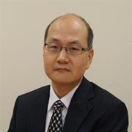 | Weiqi Yan (Wei Qi Yan) is an Associate Professor in Computer and Information Sciences at Auckland University of Technology, Auckland, New Zealand, which he joined in 2010 from the UK, and Honorary Director and Chief Scientist of its Centre for Robotics and Vision. His expertise covers intelligent robotics, vision intelligence, deep learning, intelligent surveillance and multimedia computing. He is an Associate Editor of IEEE Transactions on Circuits and Systems for Video Technology and of ACM Transactions on Multimedia Computing, Communications and Applications, a Senior Area Editor of IEEE Signal Processing Letters, and a Section Editor of Discover Artificial Intelligence. He worked as an exchange computer scientist between the Royal Society Te Aparangi and the Chinese Academy of Sciences, and is listed among the World's Top 2% Scientists for career-long impact in Artificial Intelligence and Image Processing by Stanford University.
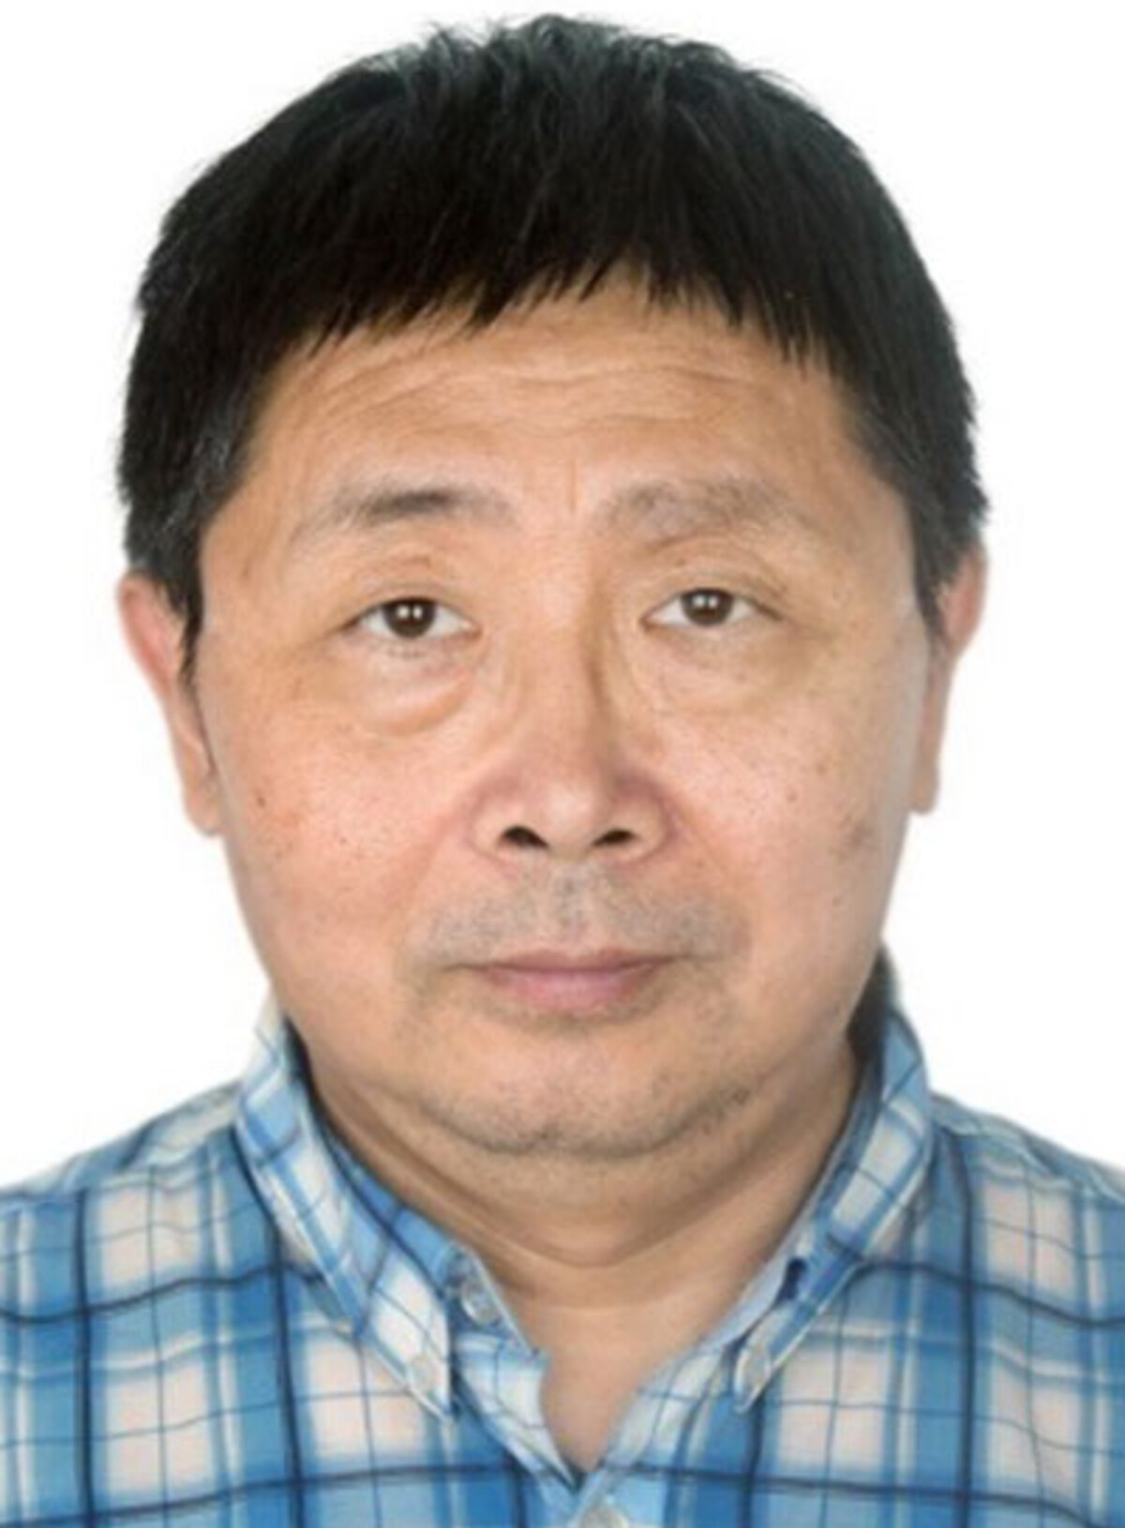 | Jinsong Wu (Senior Member, IEEE) is a Professor at Guilin University of Electronic Technology, Guilin, China. He received the Ph.D. degree from Queen's University at Kingston, Canada, was an Associate Professor at the University of Chile, and spent five years as a research scientist at Bell Laboratories, Alcatel-Lucent. He is the founder and founding chair of the IEEE Technical Committee on Green Communications and Computing (2011-2017) and a co-founder and founding vice chair of the IEEE Technical Committee on Big Data. His research interests include big data, machine learning, green information and communication technology, the Internet of Things, cloud, fog and edge computing, communication networks, and signal processing.

