Temporal Domains Without a Global Clock
Partial Gluing, Holonomy, and Gauge-Invariant Transport in Finite Relational Event Networks
Mariano Boj Viudes
Independent Researcher, Villanueva del Pardillo, Spain
mabojviu@gmail.com | ORCID: 0009-0003-5544-0273
Abstract. Many descriptions of collective dynamics introduce a scalar time coordinate before asking which temporal relations are actually available to subsystems. We study a finite relational alternative in which local precedence (ORD), affine clock calibration (CAL), and correlation witnesses (CORR) are distinct typed relations and no global scalar clock is primitive. Bounded-radius relational coherence can remain stable while the conditioning of a single scalar coordinate worsens over the tested system sizes. We formalize temporal coordination domains and show that inter-domain interaction can yield no common temporal relation, partial precedence, nonredundant affine gluing, redundantly testable scalarization, or holonomy obstruction according to relation type and consistency. In the positive CAL scale sector, the additive connection gamma_ij = log a_{j<-i} transforms as gamma -> gamma + D0 q under independent local clock rescalings. Registered compositional 2-cells give a gauge-invariant curl, while discrete Hodge decomposition separates exact, coexact, and harmonic sectors; a harmonic period can obstruct global scalarization even when local curl vanishes. We prove that the naive divergence -D0^T gamma is gauge-dependent. Projecting away exact gauge directions instead yields invariant nonintegrable content and a local density. When event provenance selects a transport current J, an exact gauge-invariant balance law Delta rho + div_T J = S distinguishes redistribution from net production or removal of nonintegrable calibration structure. For closed source-free patches, this balance gives conservation of Q_T = sum_i rho_i = ||eta||^2, without assuming a Noetherian origin. The results are finite and do not assume spatial geometry, a continuum, Lorentzian structure, or gravity.
Keywords: relational time; temporal domains; affine clock calibration; holonomy; discrete Hodge theory; gauge-invariant transport
Article Highlights
- Identical network skeletons acquire different temporal meaning under ORD, CAL, and CORR links.
- CAL holonomy and Hodge sectors diagnose when local calibration cannot be globally scalarized.
- A provenance-selected gauge-invariant current yields an exact continuity equation and source-free conservation law.

1. Introduction
A global scalar parameter is often introduced before a theory asks which temporal relations are actually available to its subsystems. In distributed systems this assumption is known to be stronger than event order: causal or logical precedence is naturally partial, and a total clock ordering is an additional construction [1]. In foundational physics, relational approaches have likewise explored descriptions in which temporal information is recovered from correlations or internal degrees of freedom rather than assumed as an external universal parameter [2,3]. Our aim here is narrower and more operational. We ask what finite temporal structure can be defined, compared, glued, obstructed, transported, and tested when a globally scalar clock is not primitive.
The starting point is a strict typing discipline. Local precedence relations, affine clock calibrations, and correlation witnesses are different objects. A precedence relation can order events without calibrating clocks; a calibration can compare clock scales without adding event precedence; a correlation can support inference without doing either. This distinction is not cosmetic. In an unseen matched-connectivity holdout reported below, identical inter-domain graph skeletons acquire different temporal semantics solely because their links are typed differently.
The second organizing principle is that global scalarization is treated as an optional integrable reduction. If local affine calibrations can be glued consistently, one may introduce a common scalar clock. If they cannot, temporal structure does not disappear: partial precedence, local calibration, cycle holonomy, or harmonic periods can remain meaningful. This shifts the question from 'what is the global time?' to 'which temporal relations are jointly available, and what obstructs their integration?'
The third principle is gauge consistency. A local choice of clock scale must not manufacture a physical field. The positive scale sector of the calibration atlas naturally defines an additive edge cochain gamma. Its registered-cell curl is gauge-invariant, but its naive graph divergence is not. This asymmetry forces a typed differential vocabulary: the temporal gradient acts on scalar potentials, the temporal curl acts on the calibration connection, and a physically admissible temporal divergence acts on a gauge-invariant transport current selected by event provenance, not on the gauge-dependent connection itself.
The paper makes five contributions. First, it separates finite relational coherence from the conditioning of a single global scalar coordinate. Second, it gives an exact theory of partial temporal gluing between finite domains. Third, it introduces a gauge-covariant temporal scale connection and an exact/coexact/harmonic Hodge decomposition. Fourth, it proves a no-go theorem for raw temporal divergence and constructs gauge-invariant field-content observables. Fifth, it defines a provenance-aware transport current for which an exact continuity equation distinguishes redistribution from net production or removal of nonintegrable temporal-calibration structure and yields an integrated conservation law on closed source-free patches.
The present study addresses a different question from scalar-serialization obstruction analyses. Rather than asking whether a supplied event dynamics can be represented by one scalar time parameter, we classify the temporal structure that remains when no global scalar is assumed: typed temporal domains, partial gluing, affine holonomy, exact/coexact/harmonic calibration sectors, and provenance-selected transport. No conditioned-hazard law or quantum-jump kernel is used in the constructions below.
Mathematically, the construction draws on finite cochain complexes and Hodge theory [4-7], and its synchronization aspect is adjacent to group- and connection-synchronization problems [8,9]. The physical interpretation, however, is deliberately restricted: the relational complex is not assumed to be a spatial discretization, registered 2-cells are compositional calibration cells rather than geometric faces, and no Lorentzian metric, continuum manifold, or gravitational dynamics is introduced.

2. Finite temporal atlas and typed relations

2.1 Events, domains, and clocks
Let E be a finite set of events distributed among local lines or charts. Each chart i may carry an order-preserving local clock coordinate tau_i on the events it can represent. The numerical values of tau_i are not primitive observables; only the relations they encode are retained. A temporal coordination domain D_alpha is an analyst-level active patch whose internal temporal relations satisfy the relevant finite coherence certificates. A domain is not assumed to be spatially localized, maximal, or ontologically fundamental.
No spatial geometry is assigned to these objects. Vertices carry no primitive coordinates, distances, angles, dimensional labels, embedding, or metric, and no Euclidean, spherical, hyperbolic, Lorentzian, or other geometry is weighted in advance. The unit-weight cochain inner product introduced later is a permutation-invariant auxiliary combinatorial measure on cochains, not a physical metric or a prior over spatial geometries. Weighted variants would require independent relational motivation.
Three relation types are admitted. ORD links encode directed event precedence. CAL links encode orientation-preserving affine clock maps, and CORR links encode correlation witnesses without temporal force. The types are intentionally noninterchangeable:
- ORD: e -> f contributes precedence and therefore enters the collective partial order.
- CAL: g_{j<-i}(x) = a_{j<-i} x + b_{j<-i}, with a_{j<-i} > 0, compares local clock representations but does not itself create event precedence.
- CORR: records a witness or correlation only; it creates neither precedence nor calibration.
gⱼ←ᵢ(x) = aⱼ←ᵢ x + bⱼ←ᵢ, aⱼ←ᵢ > 0 | (1)
A full affine atlas is scalarizable when local chart gauges can be chosen so that all active CAL transitions are induced by a common scalar coordinate. On a connected CAL graph, a tree never provides redundant consistency information: arbitrary affine transitions on a tree can be integrated recursively. Cycles are therefore where falsifiable consistency first appears. The ordered product of affine transitions around a cycle is its holonomy; identity holonomy is required for full affine scalarization.
Proposition 1 (typed partial gluing). For internally coherent finite temporal domains, inter-domain temporal structure is not binary. With no active ORD/CAL link, relative affine gauge remains unidentified and there is no cross-domain precedence. An ORD bridge may create only partial event comparability without calibrating clocks. A single CAL bridge can identify a relative affine gauge nonredundantly. Redundant CAL links are jointly scalarizable exactly when their induced cycle holonomies are compatible. CORR-only links create neither precedence nor calibration.
Proof sketch. The statements follow directly from relation typing and from composition of orientation-preserving affine maps. A single cross-domain ORD edge contributes reachability only through its forward transitive closure. A tree of affine maps admits recursive gauge assignment. Additional CAL links close cycles and therefore impose independent composition constraints. CORR is excluded from both closure operations by definition.

2.2 Active coordination, history, split, and reglue
The framework distinguishes historical precedence/provenance from active coordination. Removing all active cross-domain ORD/CAL links splits the active temporal atlas even though past cross-domain relations remain in the record. Historical memory alone cannot create new future comparisons. A later temporal reglue requires a fresh active typed relation. This non-resurrection rule is essential: without it, a past interaction would behave as a permanent hidden synchronization channel.
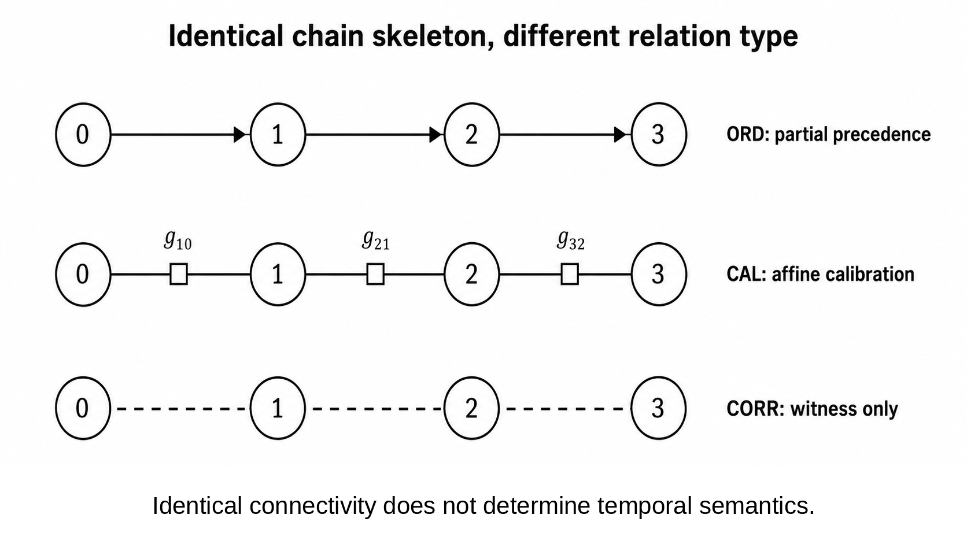
Figure 1. The same chain skeleton can carry ORD, CAL, or CORR links. The chain connectivity is identical, but temporal semantics differ by relation type.

3. Relational coherence without a well-conditioned global scalar clock
Before introducing temporal domains, we tested whether finite local relational coherence necessarily tracks the conditioning of a single global scalar coordinate. It does not in the tested family. On chain-plus-span-2 calibration graphs, local triangle consistency remained stable under fixed mismatch thresholds while endpoint effective resistance, used as a scalar-synchronization susceptibility, grew approximately linearly with system size.
N | Local prediction p90 | Endpoint scalar susceptibility R_eff
24 | 0.0099491 | 4.9577709
48 | -- | 9.7577709
96 | -- | 19.3577709
192 | 0.0098429 | 38.5577709
Table 1. Finite scale-deconditioning result. Local prediction error is essentially unchanged from N=24 to N=192, while endpoint scalar susceptibility increases strongly. The log-log slope of R_eff versus N is 0.986606.
Across N = 24, 48, 96, 192, all 48 unseen local-mismatch cases passed the preregistered relational-coherence criterion. The median local prediction p90 changed from 0.0099491 at N=24 to 0.0098429 at N=192, whereas endpoint R_eff rose from 4.9578 to 38.5578, with log-log slope 0.986606. Strong local loss plus noise, dense gaps, sparse gaps, and severe redundancy collapse behaved as negative controls. These finite results do not imply an asymptotic continuum statement; they establish only that bounded-radius relational coherence and global scalar conditioning can decouple over the tested range.

4. Matched-connectivity test of temporal-domain semantics
The central domain-interaction test used 200 unseen cases over D = 3, 4, 5, 6 temporal domains. The strongest control held the inter-domain graph skeleton fixed while changing only relation type. ORD_MULTI, CAL_TREE, and CORR_ONLY all used the same chain 0-1-...-(D-1) with D-1 links in every matched cell.
Relation on identical chain | Observed temporal semantics
ORD_MULTI | Partial cross-domain precedence; no affine calibration
CAL_TREE | Connected common relative affine gauge; scalarizable but nonredundant
CORR_ONLY | No cross-domain precedence; relative affine gauge unidentified
Table 2. Matched-connectivity holdout. Relation typing, not graph connectivity alone, determines the admitted temporal structure.
All frozen holdout gates passed. Redundant consistent CAL cycles were classified as scalarizable; a single inconsistent redundant CAL link produced a holonomy obstruction. All split/no-resurrection cases passed (16/16), all fresh-reglue cases passed (16/16), and all CORR-only null cases remained temporally null (16/16). The frozen replay reproduced records, gates, summaries, and verdict exactly across platforms.
This is the first point at which the informal phrase 'temporal islands' becomes mathematically useful, provided it remains an analogy rather than an ontological conclusion. A pair of domains can be temporally unrelated, partially ordered, affinely glued, redundantly scalarizable, or holonomy-obstructed while each remains internally coherent. A single global time is therefore one possible state of a temporal atlas, not its definition.

5. Temporal scale connection and local clock gauge

5.1 From affine calibration to an additive scale connection
The full CAL map is affine and contains both scale and translation. The present field construction isolates the positive scale sector because its multiplicative group is abelian and becomes additive under the logarithm. Translation holonomy remains part of the full affine gluing problem but is not included in the linear Hodge decomposition below.
γᵢⱼ = log aⱼ←ᵢ | (2)
If chart i is locally rescaled by a positive factor c_i and q_i = log c_i, then the relative scale transforms as a'_{j<-i} = c_j a_{j<-i} c_i^{-1}. Hence the edge variable transforms by a coboundary:
γ → γ + D₀q | (3)
Here D0 is the vertex-to-edge coboundary matrix for a chosen orientation of active CAL edges. Equation (3) is the relevant gauge law. Any proposed physical observable in the scale sector must therefore either be invariant under addition of D0 q or be explicitly interpreted as gauge-dependent.

5.2 Registered compositional 2-cells and curl
A graph alone does not specify a local curl. To define one, the atlas must register compositional CAL 2-cells: finite loops whose composition is meaningful as a local consistency relation. These cells are relational certificates, not spatial faces. Let D1 be the edge-to-2-cell coboundary. The boundary-of-boundary identity gives
D₁D₀ = 0. | (4)
The registered-cell temporal curl is then
F = curlₜ γ := D₁γ. | (5)
By (4), F is gauge-invariant. On a bare graph with no registered 2-cells, one may still discuss integrated cycle periods or affine holonomy, but it would be incorrect to infer a local face-curl observable from graph topology alone.

6. Exact, circulatory, and harmonic temporal sectors
On a finite registered relational 2-complex with the unit-weight cochain inner product, the scale connection admits the discrete Hodge decomposition familiar from finite cochain theory [5-7]. The inner product is used only to select orthogonal representatives in cochain space; it does not define a spatial metric or privilege an embedding.
γ = D₀s + D₁ᵀψ + h, | (6)
h ∈ ker(D₀ᵀ) ∩ ker(D₁). | (7)
The three terms are orthogonal. The exact/gradient component is the sector that can be absorbed into a scalarization. The coexact component lies in im(D₁ᵀ), is divergence-free in the cochain sense, and carries registered local circulation. The harmonic component is both closed and coclosed; it is invisible to local curl tests yet can retain a nonzero global period.
This decomposition is a statement about the finite relational calibration complex, not about a pre-existing spatial manifold. Its value here is diagnostic: it separates failure of scalarization into a local circulatory part and a global cohomological part.
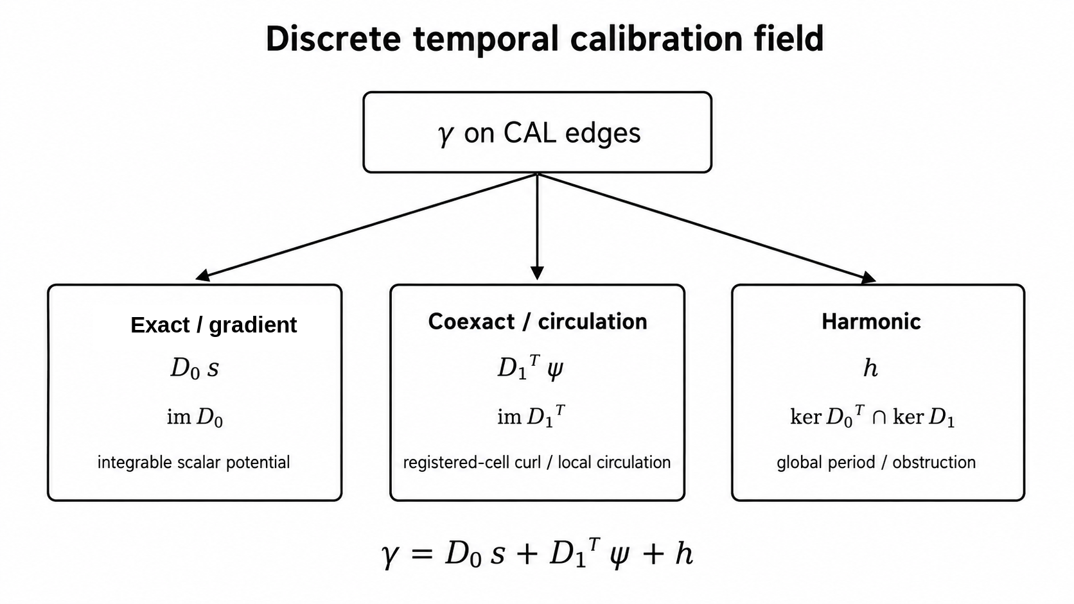
Figure 2. Typed Hodge decomposition of the temporal scale connection. The exact/gradient sector is integrable; the coexact sector carries registered local circulation; the harmonic sector carries global non-exact periods.
Theorem 2 (scale scalarization criterion). On a connected fixed CAL complex, a common global log-scale potential exists exactly when gamma lies in im(D0). Equivalently, the coexact and harmonic components in (6) both vanish.
Proof sketch. If gamma = D0 s, the chart rescalings encoded by s integrate all relative scales. Conversely, any globally integrated scale assignment produces edge differences and therefore lies in im(D0). Orthogonality of the Hodge decomposition makes the criterion equivalent to vanishing coexact and harmonic components.
A key consequence is that curl-free does not imply globally scalarizable. If H^1 is nontrivial, an edge field can satisfy D1 gamma = 0 and D0^T gamma = 0 while still carrying a nonzero cycle period. In the exact tests, an unfilled four-cycle supports precisely such a harmonic mode. Local integrability and global integrability are therefore distinct.
D₁γ = 0 ⇏ γ = D₀s when H¹ ≠ 0. | (8)

7. Why the naive temporal divergence fails
The most tempting analogy is to define div gamma = -D0^T gamma and interpret positive or negative values as temporal sources or sinks. This fails the gauge test. More generally, consider a positive diagonal edge-weight matrix W and the weighted incidence divergence A = -D0^T W. Under (3),
A(γ + D₀q) = Aγ − D₀ᵀWD₀q. | (9)
Theorem 3 (static divergence no-go). On a connected nontrivial CAL graph with positive edge weights, no nonzero weighted incidence divergence -D0^T W gamma is gauge-invariant under independent local scale gauges.
Proof sketch. Gauge invariance would require D0^T W D0 q = 0 for every q. But L_W = D0^T W D0 is the positive weighted graph Laplacian. Its quadratic form is strictly positive on every nonconstant gauge mode of a connected graph. Hence the required annihilation fails except on the trivial constant gauge.
Registered CAL curl does not rescue a static vertex source. F = D1 gamma is gauge-invariant, and the coexact current J_curv = D1^T F is also gauge-invariant, but
D₀ᵀJ_curv = D₀ᵀD₁ᵀF = (D₁D₀)ᵀF = 0. | (10)
Thus static CAL circulation cannot by itself furnish a nonzero vertex source density.

7.1 Gauge-invariant nonintegrable content
To remove exact gauge directions, let P_perp be the orthogonal projector onto the complement of im(D0), and define
η = P⊥γ, P⊥D₀ = 0. | (11)
The field eta is invariant under (3) and vanishes exactly for a globally scalarizable scale connection on a connected fixed complex. We use it as an analyst-level diagnostic of nonintegrable calibration content; the framework does not assume that the microdynamics computes P_perp globally.
E_inv = ‖η‖², ρᵢ = ½ ∑_{e∋i} ηₑ². | (12)
The local shares rho_i are gauge-invariant and sum exactly to E_inv. On a fixed complex the invariant content separates further into coexact and harmonic energies. Across two updates, sigma_i = rho_i^+ - rho_i^- and Delta E_inv = sum_i sigma_i remain gauge-invariant even if the clock gauges chosen before and after the event are independent.

8. Provenance-aware temporal transport and divergence

8.1 Why a transport law is needed
Gauge-invariant density change alone does not distinguish production from redistribution. A continuity equation requires a current J. On a graph with cycles, solving a prescribed divergence equation does not determine J uniquely because any divergence-free cycle current can be added. This ambiguity is not a clock gauge; it is a transport ambiguity. We therefore require the micro-event law to supply local provenance that selects a routing structure. The resulting balance theorem is conditional on that provenance input; it is not a derivation of the routing law from kinematics alone.

8.2 Rooted event-provenance tree
For one micro-event e, let T_e be a finite rooted provenance tree on its event patch, with root r_e equal to the write-anchor. Let Delta rho_v denote the invariant density change assigned to the vertices of that patch. For each oriented provenance edge p -> c, define
Jₑ(p → c) = ∑_{v∈subtree(c)} Δρᵥ. | (13)
Define div_T J at a vertex as outgoing provenance current minus incoming provenance current. Then
Δρ + divₜ J = S. | (14)
Theorem 4 (provenance-tree balance theorem). Conditional on a finite rooted event-provenance tree and write-anchor supplied by the micro-event law, the current (13) satisfies equation (14) exactly. Every non-root vertex has S_v = 0, while the write-anchor satisfies S_r = sum_v Delta rho_v. The tree current is unique under the root-source convention. This theorem does not derive the provenance tree; it proves the unique gauge-invariant transport/source decomposition induced by that declared local provenance.
Proof sketch. For a non-root vertex v, the current entering v is the sum of Delta rho over the subtree rooted at v; the outgoing currents are the corresponding sums over child subtrees. Their difference is -Delta rho_v, yielding S_v = 0. At the root there is no incoming edge, so the residual is the total density change. Uniqueness follows because the reduced tree incidence matrix is square and full rank. On a cyclic graph, the incidence divergence has a nontrivial cycle kernel.
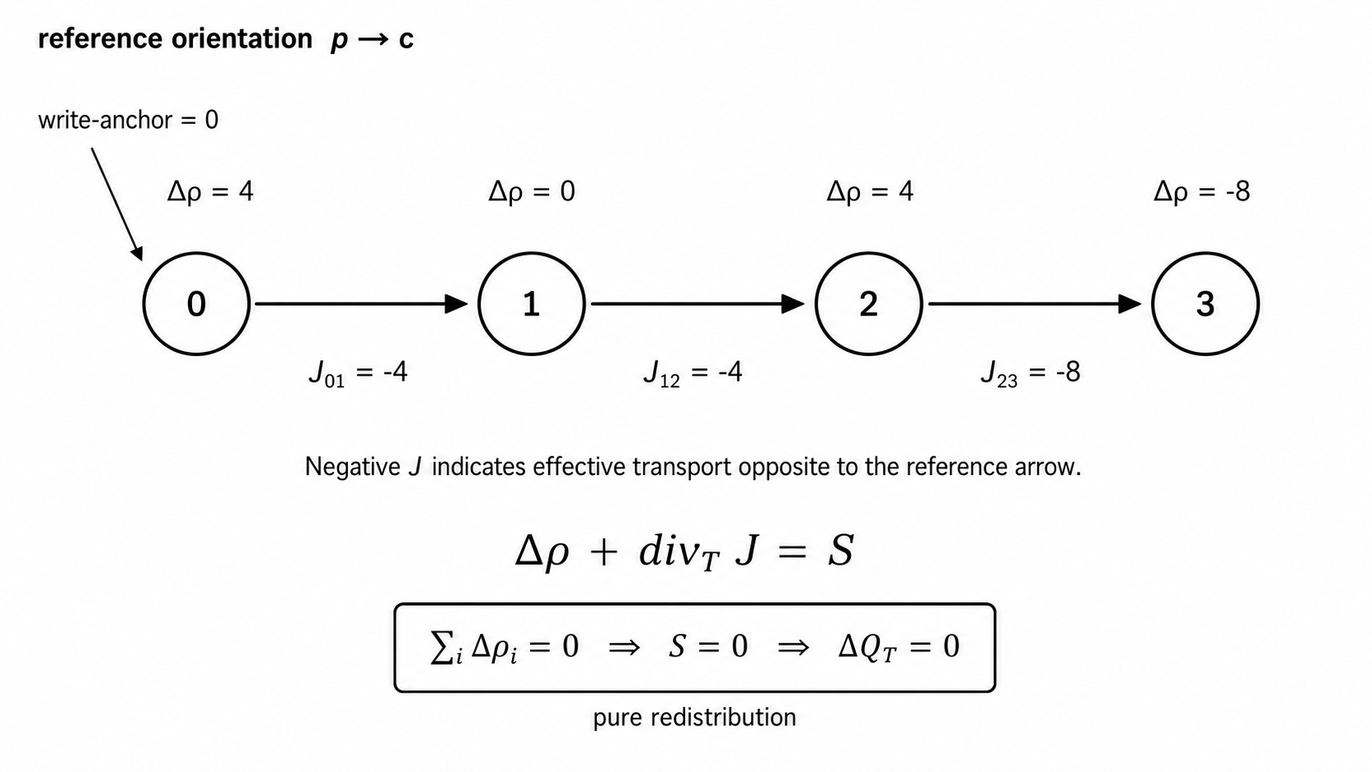
Figure 3. Exact redistribution example on a provenance chain. Arrows set the reference orientation; negative J denotes effective transport in the opposite direction. The invariant density changes sum to zero, the source residual vanishes, and ΔQ_T = 0.
Equation (14) gives the first gauge-consistent temporal divergence in the present framework. Importantly, it is div_T J, not div gamma. The current J is gauge-invariant because it is constructed from gauge-invariant Delta rho and event provenance. Its divergence therefore survives independent local clock rescalings before and after the update. The nontrivial content is the typing, gauge invariance, local tree uniqueness, and explicit separation of transport from the net residual once the provenance law is specified.
The source residual S has a restricted interpretation. If sum Delta rho = 0, then S = 0 and the event is pure redistribution of invariant temporal-calibration content. If the sum is positive, the event produces nonintegrable calibration content relative to its provenance law; if negative, it removes such content. We do not identify S with creation or destruction of physical time.

8.3 Integrated balance, conditional conservation, and Noether outlook
Summing the exact balance law (14) over a closed event-provenance patch removes internal transport because every provenance current contributes once as outgoing and once as incoming. Define the total gauge-invariant nonintegrable calibration content by
Q_T := sum_i rho_i = E_inv = ||eta||^2. | (15)
The integrated continuity law is therefore
Delta Q_T = sum_i S_i. | (16)
Corollary 5 (conditional conservation of nonintegrable temporal-calibration content). For a closed event-provenance patch with no net source or removal, sum_i S_i = 0, the total gauge-invariant content Q_T is conserved exactly: Delta Q_T = 0. In particular, pure redistribution preserves Q_T. This conservation result follows from the exact balance law and is not asserted here to be a Noether charge.
The local clock-scale symmetry gamma -> gamma + D0 q makes a variational reformulation a natural next question, but no action principle is assumed in the present work. Accordingly, the conservation law above should not be attributed to Noether's theorem. A future formulation with a gauge-invariant action would naturally invite a Noether-second-theorem analysis of the local gauge symmetry, while a genuine conserved Noether charge would require an appropriate continuous global symmetry of the microdynamics [12].
Operation | Acts on | Gauge status | Interpretation
Gradient D0 s | scalar potential s | gauge/exact sector | integrable relative clock-scale structure
Curl D1 gamma | CAL scale connection gamma | gauge-invariant | registered local circulation / CAL holonomy density
Cycle period | gamma on closed loop | gauge-invariant | global holonomy / harmonic obstruction
Divergence div_T J | provenance-selected current J | gauge-invariant | transport balance of invariant temporal content
Source S | continuity residual | gauge-invariant | production/removal of nonintegrable calibration content
Total content Q_T = sum_i rho_i | gauge-invariant density rho | gauge-invariant | conserved on closed source-free patches
Table 3. Differential vocabulary with explicit typing. Gradient, curl, and divergence do not act indiscriminately on the same primitive object.

9. Exact finite verification and unseen holdout
The mathematical claims above were checked in exact finite arithmetic before being assembled into the manuscript. The discrete Hodge foundations were tested on a filled triangle, an unfilled four-cycle, a two-triangle disk, and a tetrahedral boundary. The tests verified D1 D0 = 0, exact reconstruction, expected harmonic dimensions, gauge invariance of curl and cycle periods, and the failure of raw divergence under gauge transformation.
For the 200-case typed-domain holdout, the generator, evaluator, adjudicator, family counts, relation-type controls, and gates were frozen before a fresh external nonce materialized the case set. The evaluator received typed raw relations and affine maps; family labels were used only for aggregation. The one-shot return was then independently replayed against the frozen code and CASE_SET hash. These computational checks provide reproducibility and adversarial regression evidence; they do not replace the algebraic proofs of the exact statements.
The gauge-invariant observable block verified that P_perp annihilates exact gauge directions, eta and its coexact/harmonic projections are invariant, local rho partitions E_inv exactly, and the weighted raw-divergence no-go holds. The transport block then verified exact continuity, pure redistribution, positive production, negative removal, independent endpoint gauge invariance, relabel covariance, spectator independence of the routing rule, uniqueness on rooted trees, and nonuniqueness without provenance.
Block | Verification result | Main content
Relational coherence / scalar deconditioning | H0-H10 all pass on 216-case holdout | stable local coherence while scalar susceptibility worsens
Typed domain interaction | H0-H13 all pass on 200 unseen cases | matched skeleton distinguishes ORD, CAL, CORR
Hodge foundations | 16/16 exact tests | gradient, curl, harmonic obstruction
Gauge-invariant observables | 18/18 exact tests | raw-divergence no-go; eta, rho, sector energies
Provenance transport/divergence | 18/18 exact tests | Delta rho + div_T J = S; redistribution vs production/removal; source-free conservation of Q_T
Table 4. Validation ladder used in the present manuscript. The field-theory blocks are exact finite foundations; the domain-interaction result additionally uses an unseen frozen holdout.
The matched-connectivity domain holdout is particularly important because it attacks a simple confound: a model could otherwise mistake generic connectedness for common temporal structure. The control eliminates that explanation by keeping the skeleton and link count fixed while changing only relation type. Exact cross-platform replay reproduced all 200 records, all gates, the summary, and the final verdict.

10. Interpretation: a temporal atlas rather than a universal scalar
The results support a precise but limited reformulation of collective time in the finite setting studied here. Temporal organization can be layered. Local ORD provides precedence. CAL provides relative clock calibration. Compatible CAL can integrate to a scalar clock, but the scalar is a derived reduction rather than a primitive. Nontrivial curl or harmonic periods record failure of that reduction without erasing all temporal structure. Provenance-aware currents then describe how gauge-invariant nonintegrable calibration content is redistributed or produced by events.
This vocabulary allows the phrase 'temporal gradient' to be used literally in the scale sector: D0 s is the exact part of the calibration field. 'Temporal curl' is likewise precise on registered compositional 2-cells: D1 gamma is gauge-invariant. 'Temporal divergence' becomes precise only after a current has been defined: div_T J is a balance operator on a gauge-invariant, provenance-selected transport current. The distinction is the opposite of a loose analogy; it is enforced by the gauge algebra. The integrated balance adds a distinct conservation statement: on a closed patch with zero net source, the total invariant content Q_T = sum_i rho_i is exactly preserved even while its local distribution is transported by J.
The harmonic sector is conceptually distinctive. A domain network may be locally curl-free while retaining a global nonzero period. In that situation every registered local composition test can pass, yet no single global scale potential exists. Such a state is naturally described as locally integrable but globally non-scalarizable. This is the strongest mathematical sense in which a multi-domain temporal atlas can possess coherent local time without one global clock.
The theory also separates historical memory from active temporal coordination. A split domain may retain records of past precedence and calibration while lacking present active glue. This prevents historical relation from acting as an unacknowledged global background clock and makes temporal reconnection an event that must be generated anew.

11. Scope, limitations, and falsifiable extensions
Several boundaries are essential to the claim. First, all constructions are finite. No N -> infinity, continuum, differentiable-manifold, or hydrodynamic limit is established. Second, the relational graph and registered 2-cells carry no assumed spatial geometry: there are no primitive coordinates, distances, dimensions, embeddings, or metric tensors, and no geometric class is favored a priori. The unit-weight cochain inner product is an auxiliary permutation-invariant diagnostic choice, not an emergent spacetime metric. The terms gradient, curl, harmonic, and divergence refer to typed cochain operators on a relational complex. Third, no Lorentz symmetry, causal cone, spacetime metric, gravitational field, stress-energy tensor, or Einstein equation is derived.
Fourth, the Hodge projector P_perp and the density rho are presently diagnostic observables on a fixed active complex. The microdynamics is not assumed to compute a global projector. TC9C localizes the transport routing once Delta rho is supplied, but a fully microscopic local estimator of invariant density remains a separate problem. Fifth, the continuity theorem is established for a fixed event patch between the compared field states. Merge, split, and reglue with changing Hodge dimension require explicit pushforward/pullback rules between complexes.
These limitations define direct falsification targets rather than rhetorical caveats. A next-stage campaign should test topology-changing transport, noisy CAL estimates, alternative local provenance trees, and adversarial current ambiguities. A separate variational program should ask whether an action can be constructed whose continuous symmetries generate identities or charges related to the present continuity law; that Noetherian question is deliberately left open here. Failure of gauge invariance, relation-type specificity, or continuity under those extensions would delimit the framework without invalidating the exact finite statements proved here.

12. Conclusion
We have constructed a finite relational account of temporal coordination in which a globally scalar clock is optional rather than primitive. Typed ORD, CAL, and CORR relations support different temporal operations; matched-connectivity tests show that their semantics cannot be reduced to bare graph connectivity alone. The positive CAL scale sector defines a gauge-covariant edge connection gamma, whose registered-cell curl and cycle periods are gauge-invariant. Discrete Hodge decomposition separates globally integrable, locally circulatory, and harmonic global-obstruction sectors.
A naive divergence of gamma fails because it changes under local clock rescaling. The gauge-invariant quotient field eta = P_perp gamma instead provides a nonintegrable-content density rho. When a micro-event supplies a finite rooted provenance tree, that density change determines a unique local transport current J and an exact continuity equation Delta rho + div_T J = S. The source residual distinguishes redistribution from production or removal of nonintegrable temporal-calibration structure, without being identified with creation or destruction of physical time. On a closed source-free patch, the same balance law gives the exact conservation result Delta Q_T = 0 for Q_T = sum_i rho_i = ||eta||^2. No variational principle is assumed, so this conditional conservation is not identified here as a Noether charge.
Within this finite framework, the natural primitive is therefore not a universal time value but a typed atlas of temporal relations. A single scalar time appears when that atlas is integrable. When it is not, partial order, calibration, circulation, and harmonic structure can remain well defined. This provides a concrete mathematical route for studying collective temporal organization without assuming in advance the global clock whose emergence is at issue.

Author declarations
Conflict of Interest: The author has no conflicts to disclose.
Ethics Approval: Not applicable; this study involves no human participants, animals, or identifiable personal data.
Author Contributions: Conceptualization, formal analysis, investigation, methodology, software, validation, visualization, writing - original draft, and writing - review and editing.

Data Availability Statement
The data and code that support the findings of this study, including the finite frozen validation packages identified by SHA-256 hashes in Appendix B, are available from the corresponding author upon reasonable request.

Appendix A. Algebraic identities and proof details

A.1 Gauge law for the scale sector
Let τᵢ′ = cᵢτᵢ with cᵢ > 0. If τⱼ = aⱼ←ᵢ τᵢ + bⱼ←ᵢ, then the transformed scale coefficient is aⱼ←ᵢ′ = cⱼ aⱼ←ᵢ cᵢ⁻¹. With qᵢ = log cᵢ and γᵢⱼ = log aⱼ←ᵢ, taking logarithms gives the local gauge law
γ′ = γ + D₀ q.

A.2 Hodge decomposition and the harmonic obstruction
For a finite cochain complex C⁰ —D₀→ C¹ —D₁→ C² with D₁D₀ = 0 and the unit-weight cochain inner product, the one-cochain space decomposes orthogonally as
C¹ = im(D₀) ⊕ im(D₁ᵀ) ⊕ [ker(D₀ᵀ) ∩ ker(D₁)].
The last factor represents H¹ by its harmonic representative. Hence a closed field can fail to be exact precisely when its harmonic class is nonzero.

A.3 Positive-weight divergence no-go
For A = −D₀ᵀW with W positive diagonal, gauge invariance would require AD₀ = 0. But −AD₀ = D₀ᵀWD₀. For any nonconstant q on a connected graph,
qᵀD₀ᵀWD₀q = ‖W¹ᐟ²D₀q‖² > 0.
Therefore AD₀ cannot vanish on all gauge modes.

A.4 Provenance-tree continuity
Let T be rooted at r. For each non-root vertex v with parent p(v), define the provenance current by the invariant-density change over the subtree rooted at v:
Jₚ₍ᵥ₎→ᵥ = Σᵤ∈subtree(v) Δρᵤ.
At v, the incoming current is that subtree sum and the outgoing currents are the child-subtree sums. Since the subtree of v is the disjoint union of {v} and its child subtrees, outgoing minus incoming equals −Δρᵥ. Hence Sᵥ = Δρᵥ + divₜJᵥ = 0 for every non-root vertex, while at the root
Sᵣ = Σᵥ Δρᵥ.
The reduced incidence matrix of a tree has full rank, which proves uniqueness of J under the root-source convention.

A.5 Integrated conservation and the open Noether question
Summing Eq. (14) over all vertices of a closed provenance patch gives sum_i Delta rho_i + sum_i (div_T J)_i = sum_i S_i. Every internal tree current appears once with positive sign and once with negative sign, hence sum_i (div_T J)_i = 0. Therefore
Delta Q_T = sum_i S_i, Q_T = sum_i rho_i = ||eta||^2. | (A1)
If the patch is source-free, sum_i S_i = 0, then Q_T is conserved exactly. This is an algebraic corollary of the provenance-tree continuity law. Deriving the same or a related conservation law from a variational symmetry would require an action and therefore lies beyond the present construction. The local gauge freedom suggests that Noether's second theorem, rather than a direct Noether-first-theorem charge assignment, is the appropriate starting point for such an extension [12].

Appendix B. Frozen finite validation identifiers
The following SHA-256 identifiers bind the finite validation artifacts used to assemble the present manuscript. They are included as reproducibility anchors rather than as substitutes for peer review or external replication.
Artifact | SHA-256
Relational coherence / CERT-016 | fed6181cff06b2efabafcb8276edb866551b197cad2cbaff9c9e1ba106f5fdb8
Typed temporal-domain interaction / CERT-017 | ba3363cf5bc0063a71ba42ae38a44ace31e9a7cebad74e8a89902efe956adfe5
Temporal Hodge foundations / TC9A | 78a8cbad034d03e928d3cd64bad442c440f3323641e475dddab16540d37bde5b
Gauge-invariant observables / TC9B | 9b41fb0101ac7bc37525f37dd39481ed03681c83fe654c95a0275e10578a2c92
Provenance transport and divergence / TC9C | 9771ae79e4463c71b1eb54006cf4bf49601446e9baa599501d539cd1471069a5

References
[1] Lamport, L. Time, clocks, and the ordering of events in a distributed system. Communications of the ACM 21(7), 558-565 (1978). doi:10.1145/359545.359563.
[2] Page, D. N. & Wootters, W. K. Evolution without evolution: Dynamics described by stationary observables. Physical Review D 27, 2885-2892 (1983). doi:10.1103/PhysRevD.27.2885.
[3] Rovelli, C. Time in quantum gravity: An hypothesis. Physical Review D 43, 442-456 (1991). doi:10.1103/PhysRevD.43.442.
[4] Whitney, H. Geometric Integration Theory. Princeton University Press (1957).
[5] Desbrun, M., Hirani, A. N., Leok, M. & Marsden, J. E. Discrete Exterior Calculus. arXiv:math/0508341 (2005).
[6] Jiang, X., Lim, L.-H., Yao, Y. & Ye, Y. Statistical ranking and combinatorial Hodge theory. Mathematical Programming 127, 203-244 (2011). doi:10.1007/s10107-010-0419-x.
[7] Lim, L.-H. Hodge Laplacians on graphs. SIAM Review 62(3), 685-715 (2020). doi:10.1137/18M1223101.
[8] Singer, A. Angular synchronization by eigenvectors and semidefinite programming. Applied and Computational Harmonic Analysis 30(1), 20-36 (2011).
[9] Bandeira, A. S., Singer, A. & Spielman, D. A. A Cheeger inequality for the graph connection Laplacian. SIAM Journal on Matrix Analysis and Applications 34(4), 1611-1630 (2013). doi:10.1137/120875338.
[10] Eckmann, B. Harmonische Funktionen und Randwertaufgaben in einem Komplex. Commentarii Mathematici Helvetici 17, 240-255 (1944).
[11] Hodge, W. V. D. The Theory and Applications of Harmonic Integrals. Cambridge University Press (1941).
[12] Noether, E. Invariante Variationsprobleme. Nachrichten von der Gesellschaft der Wissenschaften zu Gottingen, Mathematisch-Physikalische Klasse, 235-257 (1918).

