Document NO

《Software Engineering》

Class : CST 2022

Student No: 马博文

Full Name: md mahadi hasan

Experiment No |  | 2 | Experiment Name | Start developing a software system
Device |  |  | PC, Visio |  | Date
Experimental purpose and requirements

1、Learn Visio 2016；；
2、Using software engineering methods for software design;
3、How to Plan Software System Development;
4、How to design database;

二、Experimental content and process
- If you are a project manager, what software system do you plan to develop,S
Please write down the name of this software system.
Can you explain why you chose to develop this system:

If I am a project manager, I will develop a Student Management System.
I plan to develop a Student Management System to streamline and automate administrative tasks, making it easier to manage student information, attendance, grades, and communication within an educational institution.

1. Project Name: Student Management System (SMS)

2. Purpose:
• The student management system will help educational institutions manage student data efficiently, including enrollment, academic records, attendance, and communication.
3.Reasons for Developing This System:
- Centralized Data: Easy access and accurate records.
- Efficiency: Streamlines operations, saving time.
- Communication: Enhances updates with students and parents.
- Customizable: Versatile for all educational institutions.

- Is the software system you have chosen to develop feasible? Please try to conduct an analysis :

To determine the feasibility of developing the Student Management System, I can analyze it from several perspectives:
1. Technical Feasibility:
• Tools & Skills: Use accessible tech like HTML/CSS, JavaScript for front-end, and Python, Java, or PHP for the back-end. Databases like MySQL work well.
• Hosting: Cloud or local servers are viable.
• Integration: Can connect with existing systems like Learning Management Systems (LMS).

2. Economic Feasibility:

• Development Costs: Initial investment in software, hosting, and licensing.
• Operational Costs: Ongoing maintenance and support, but manageable.
• Cost-Benefit: Saves time, reduces paperwork, and potentially generates revenue if sold to multiple institutions.

3. Operational Feasibility:

• User-Friendly: Simple interface for easy adoption.
• Acceptance: Likely to be well-received by institutions for its efficiency.
• Efficiency: Frees up time for administrators and educators.

4. Schedule Feasibility:

• Timeline: Core functions developed first, with additional features phased in.
• Project Management: Agile approach ensures timely progress.

5. Legal Feasibility:

• Data Privacy: Follow data protection laws like GDPR, FERPA, and best practices.
• User Consent: Clear consent and terms of service for all users.
• Data Security: Implement encryption and secure access to protect user data.
• Licensing Compliance: Verify legal use of third-party resources.
Conclusion: The SMS is feasible in all areas—technical, economic, operational, schedule, and legal.

3,If this system is feasible, how many people, how much time, and approximately how much money do you need for development? Why?

If the Student Management System is feasible, here’s an estimate of the team size, time, and budget needed for development:

1. Team Size:
• People Needed: 10-12
• 1 Project Manager: Manages planning, resource allocation, and team coordination.
• 4 Developers:
• 2 Front-End Developers: Focus on creating a responsive and interactive user interface.
• 2 Back-End Developers: Handle the server, database integration, and core functionalities.
• 1 Database Administrator (DBA): Designs, implements, and optimizes the database, ensuring data security and efficiency.
• 2 QA Testers: Perform testing at multiple stages (unit, integration, and system testing) to maintain system reliability and performance.
• 1 UI/UX Designer: Crafts user flows and an intuitive interface to improve user experience.
• 1 Technical Writer: Develops documentation for both users and administrators, such as user guides and system manuals.
• 1 DevOps Engineer: Manages deployment, continuous integration (CI), and infrastructure for smooth development and post-launch scalability.
2. Time Required:

• Duration: 3 months
• Phase 1 (Planning and Design): 2 weeks – Define requirements, scope, and system architecture.
• Phase 2 (Development): 6 weeks – Develop and integrate core functionalities, with regular QA testing.
• Phase 3 (Testing and Refinement): 2-3 weeks – Conduct full system testing, address bugs, and refine based on feedback.
• Phase 4 (Deployment and Documentation): 1 week – Prepare for deployment, finalize documentation, and ensure team alignment on system use.
3. Estimated Cost:

• Budget: Approximately ¥300,000 - ¥400,000 RMB
• Personnel: Main cost, given the larger, specialized team required for quick, high-quality delivery.
• Infrastructure and Tools: Cost for hosting, cloud storage, development tools, and testing environments.
• Licenses and Subscriptions: Tools for UI/UX design, testing suites, and cloud deployment tools.
• Miscellaneous: Budget for office resources, meetings, and any unexpected project needs.
4,If you were a project manager, how would you arrange these personnel? Please use Visio to draw the organizational chart of the software project (including name, position, contact information, and main job responsibilities):

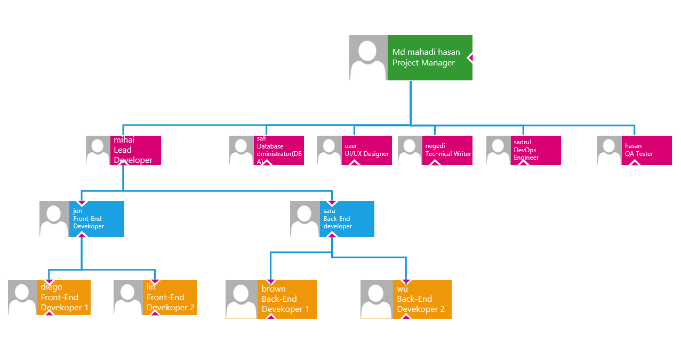
Step 1: Define Roles and Responsibilities

• Roles: Project Manager, Software Engineers (Frontend, Backend), QA Engineers, UX/UI Designers, Product Owner, Business Analysts, Technical Support.
• Responsibilities:
• Project Manager: Manages project, timelines, and team coordination.
• QA Engineer: Tests software, finds bugs, ensures quality.
• UX/UI Designer: Designs interfaces and improves user experience.

Step 2: Collect Role Information

• Name: Use placeholder names like “John Doe.”
• Contact Info: Add an email or phone number.
• Job Responsibilities: Briefly describe core tasks for each role.

Step 3: Design the Chart in Visio

1. Template: Open the Organization Chart template in Visio.
2. Hierarchy:
• Place Project Manager at the top.
• Add leads under the Project Manager (Development Lead, Design Lead).
• Group teams under respective leads (Frontend Engineers under Development Lead).

Step 4: Customize Each Shape
1. Add Text: Name, position, contact info, and responsibilities.
2. Formatting:
• Use different colors for each team (blue for Development, green for QA).
• Adjust text size for readability.
3. Connections: Solid lines for direct reports, dashed lines for collaboration.

Step 5: Refine and Review

1. Align Shapes: Use alignment tools to keep it organized.
2. Spacing: Ensure enough space for readability.
3. Title: Label as “Software Project Organizational Chart.”

Step 6: Finalize and Export

1. Save and Export: Save and export as a PDF for easy sharing.
2. Review: Check with the team for clarity and accuracy.

- Please list the types of personnel and their responsibilities that may be involved in this software system.
1. Project Manager

• Responsibilities:
• Plan, coordinate, and oversee the project.
• Manage resources, timeline, and team communication.
• Report project progress and resolve any issues.

2. Front-End Developers

• Responsibilities:
• Design and build the user interface for students, staff, and administrators.
• Ensure the interface is responsive and user-friendly.
• Integrate with back-end APIs to display dynamic data.

3. Back-End Developers

• Responsibilities:
• Develop server-side code, including data processing and business logic.
• Set up and manage database connections and data transactions.
• Ensure security and efficiency of data storage and retrieval.

4. Database Administrator (DBA)

• Responsibilities:
• Design and optimize the database for managing student records.
• Ensure data integrity, security, and efficient data handling.
• Regularly back up data and monitor performance.

5. UI/UX Designer

• Responsibilities:
• Design intuitive user flows and layouts for a positive user experience.
• Conduct usability testing to make improvements.
• Work with front-end developers to implement design elements.

6. QA Testers

• Responsibilities:
• Perform testing to identify bugs and issues.
• Conduct unit tests, integration tests, and system tests.
• Provide feedback to developers to improve software quality.

7. Technical Writer

• Responsibilities:
• Create documentation such as user guides, setup instructions, and technical manuals.
• Maintain clear and accessible documentation for end-users and administrators.
• Update documents as new features are added.

8. DevOps Engineer

• Responsibilities:
• Set up and maintain deployment pipelines and CI/CD processes.
• Manage server infrastructure for smooth operation and scaling.
• Monitor system performance and ensure continuous availability.

9. Support Specialist (Optional)

• Responsibilities:
• Assist end-users with technical issues post-launch.
• Respond to inquiries and troubleshoot software issues.
• Collect user feedback to suggest future improvements.

- Please list the functions of this software and draw a functional module diagram.

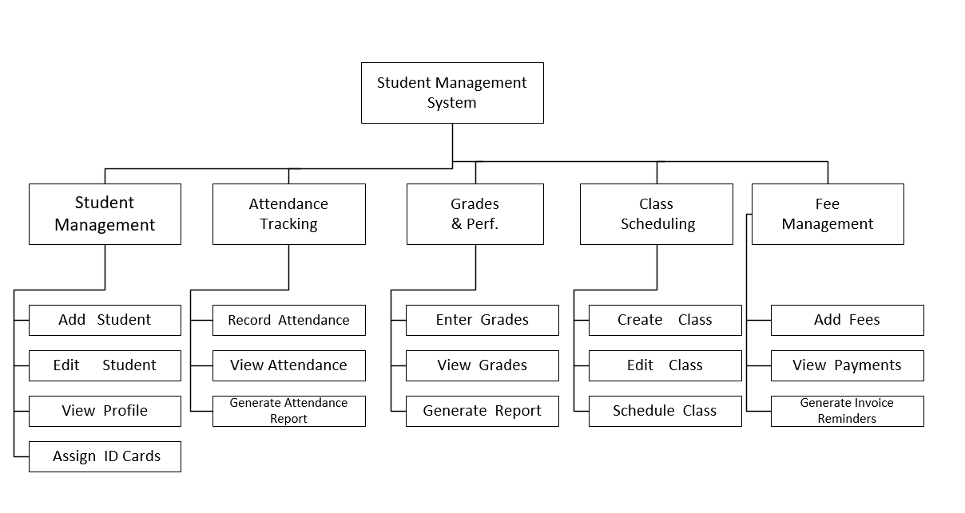
Explanation of the Structure
• Top Level: Student Management System is the main system at the very top, representing the overall application.
• Primary Modules: Below the main system, each primary module is represented in its own box:
• Student Management
• Attendance Tracking
• Grades & Performance
• Class Scheduling
• Fee Management
• Sub-Functions for Each Module:
• Each main module has its own sub-functions listed below, with separate boxes connected in a downward hierarchy.
• Student Management: Add Student, Edit Student, View Profile.
• Attendance Tracking: Record Attendance, Generate Report.
• Grades & Performance: Enter Grades, Generate Report.
• Class Scheduling: Create Class, Edit Class.
• Fee Management: Add Fees, Generate Invoice.

7、If you are a project manager, how do you allocate time? Please use Visio to draw a time allocation diagram for each stage of development.

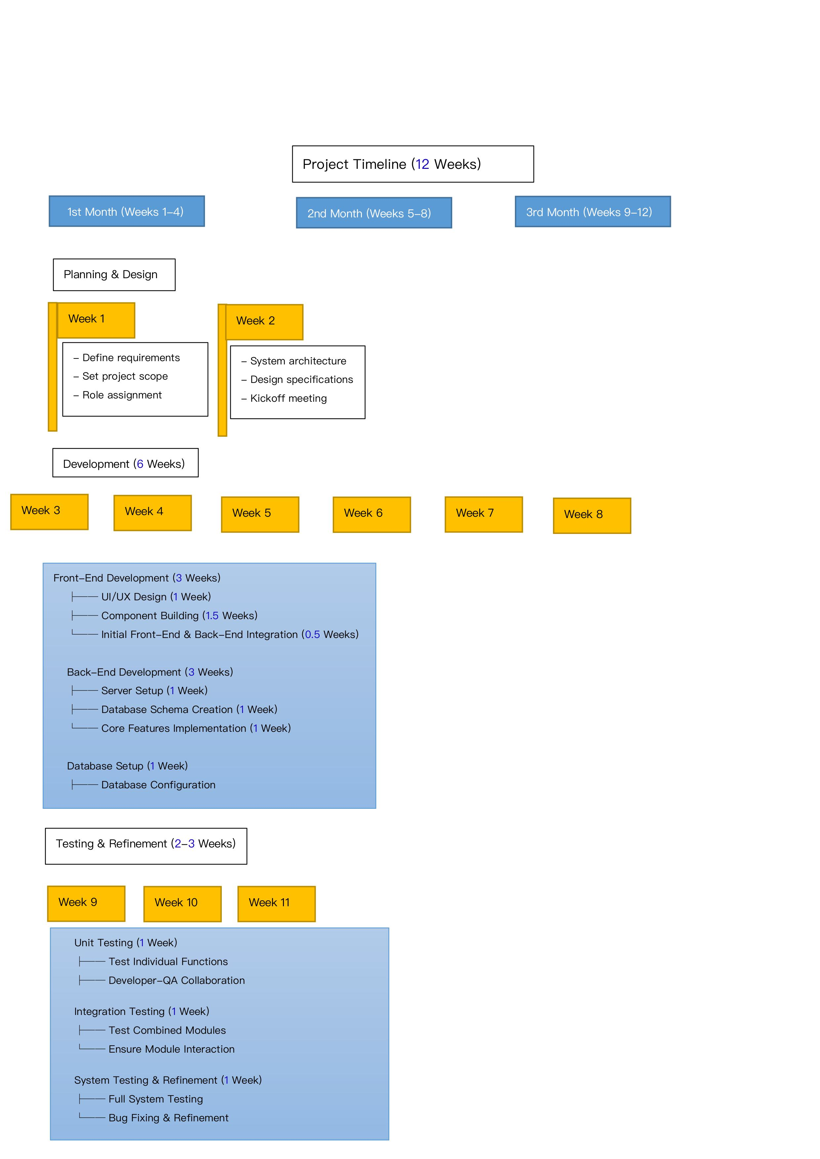
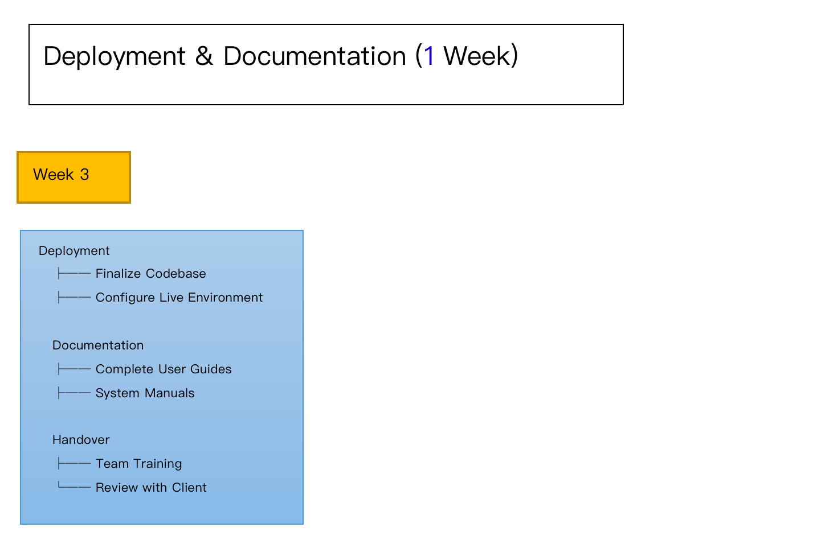
Explanation

1. Planning & Design (2 Weeks): Initial stage for setting up the project’s foundation. Activities focus on defining requirements, determining scope, system architecture, and assigning roles.
2. Development (6 Weeks): Core development activities split into front-end and back-end work, with overlapping tasks. The Database Setup runs in parallel for quick progress.
• Front-End Development: Focuses on UI/UX design, building interface components, and initial integration.
• Back-End Development: Covers server setup, database schema, and core functionality.
• Database Setup: Involves configuration and optimization.
3. Testing & Refinement (2-3 Weeks): Ensures quality by unit, integration, and system testing. Any bugs or refinements are addressed before deployment.
4. Deployment & Documentation (1 Week): Final stage where the system is deployed, documentation is completed, and handover to the client takes place with training.

8、What type of development model would you choose for this system and why?

For a Student Management System, a suitable development model would be the Agile Development Model. Here’s why Agile is a good fit for this type of project:

Reasons for Choosing the Agile Model

1. Flexibility and Adaptability:
• In software like a Student Management System, requirements may evolve as the project progresses. Stakeholders might realize they need additional features or adjustments after seeing initial versions.
• Agile allows for continuous iteration and improvement, making it easier to adapt to changing requirements without disrupting the entire project.
2. Incremental Development:
• Agile breaks the project into smaller, manageable increments (sprints), allowing the team to develop, test, and deliver parts of the system in phases.
• By delivering features incrementally, the team can quickly gather feedback on each module (such as student registration, attendance tracking, or grade management) and make necessary adjustments early.
3. Continuous Testing and Quality Assurance:
• Agile emphasizes regular testing at the end of each sprint, ensuring that bugs and issues are identified and resolved immediately.
• This continuous QA approach helps maintain system stability and improves overall reliability, which is crucial for a system handling sensitive student data.
4. Enhanced Stakeholder Involvement:
• Agile encourages regular communication with stakeholders, allowing them to see the system develop gradually and provide feedback.
• For a Student Management System, involving administrators, teachers, and other stakeholders ensures the system meets real-world needs and expectations.
5. Focus on User-Centric Design:
• Agile promotes a user-focused approach. By prioritizing feedback from educators, students, and administrators, the system can be tailored to enhance the user experience.
• Features like a clean, intuitive interface and role-based access control can be refined iteratively to ensure ease of use for different types of users.
6. Risk Mitigation:
• Agile minimizes risk by delivering a working product after each sprint. This way, if the project encounters challenges, there will already be a functional system with essential features.
• It reduces the likelihood of project failure, as the team can address and mitigate risks early in the development process.

Agile Implementation for This Project

1. Sprints: Define 2-3 week sprints focused on specific functionalities (e.g., Sprint 1 for student registration, Sprint 2 for attendance management).
2. Feedback Loops: After each sprint, review the deliverables with stakeholders to gather feedback and make necessary adjustments.
3. Daily Stand-ups: Regular short meetings to discuss progress and identify blockers, keeping the team aligned.
4. Iteration and Refinement: Based on feedback from testing and stakeholders, refine and improve each module as development progresses.

- What type of system architecture(For example :c/s or b/s) would you choose for the development of this system, and why?

For the development of this Student Management System, I would choose the Browser-Server (B/S) architecture. Here’s why:
1. Wide Accessibility: A B/S system allows users to access the system through any device with a web browser and internet connection, without the need to install additional software. This flexibility is essential for students, teachers, and administrators who may access the system from various locations and devices, such as computers, tablets, or mobile phones.
2. Centralized Management: In the B/S model, all core functions, data storage, and system logic are managed on a central server. This setup simplifies maintenance and updates, as any changes can be implemented on the server side without needing individual client installations. This reduces the workload on IT staff and ensures consistent functionality for all users.
3. Enhanced Data Security: Since student data like grades, attendance, and personal information are stored on a central server, data security measures—such as encryption, access control, and regular backups—can be more effectively managed. This approach ensures data is protected and reduces the risk of unauthorized access.
4. Scalability: B/S architecture is easily scalable, meaning it can handle a growing number of users without major changes to the system. This is beneficial if the school expands or if more students and staff need access. Server resources can simply be increased as needed.
5. Cross-Platform Support: Because a B/S system only requires a web browser, it offers seamless compatibility across different platforms, such as Windows, Mac, Linux, and mobile devices. This cross-platform support is essential for a diverse user base with varied device preferences.

- If the system includes a database, please draw an E-R diagram and list the names of each table and the attributes contained in each table.

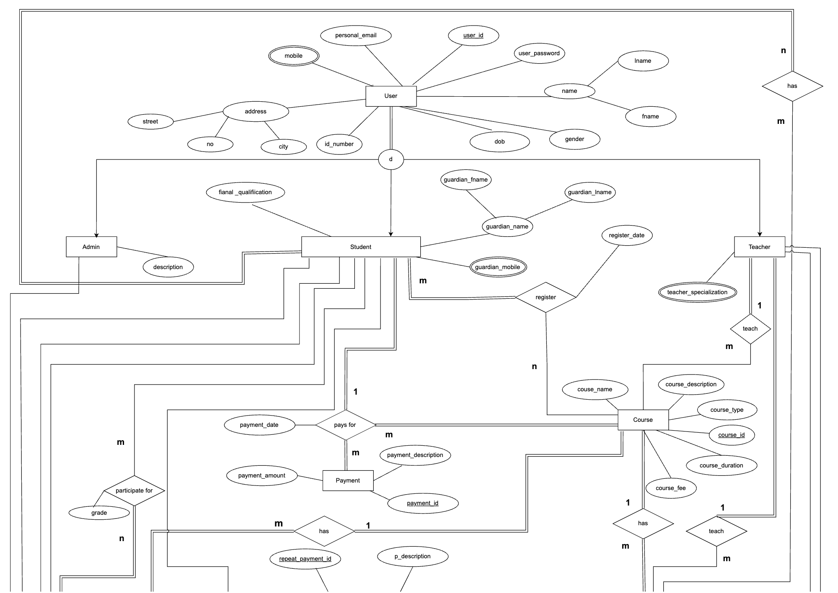
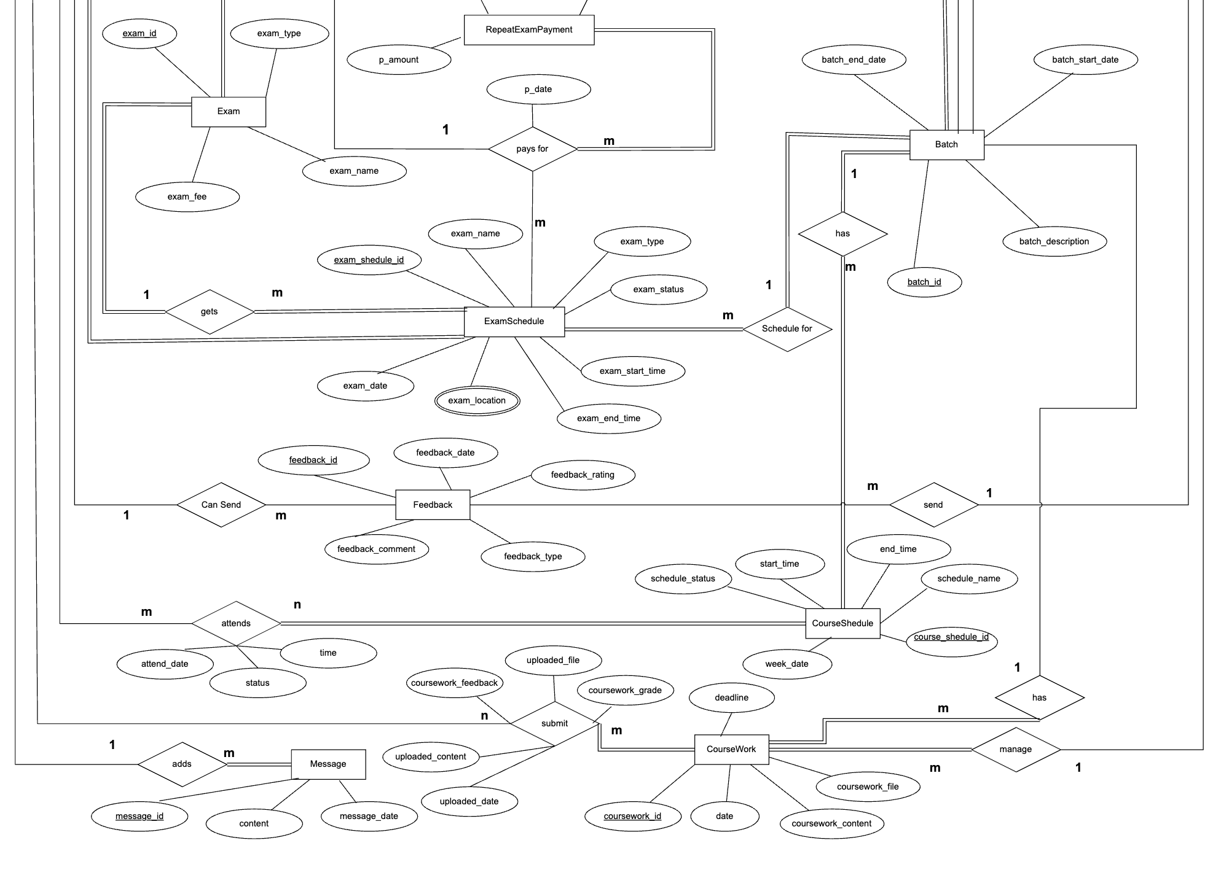

Student Management System Database Schema
Table Name | Attributes
Student | student_id (PK), fname, lname, id_number, dob, address, cityno, street, guardian_name, guardian_fname, guardian_lname, guardian_mobile, mobile, personal_email, gender
User | user_id (PK), user_password, final_qualification, name
Admin | admin_id (PK), admin_name, email, role
Teacher | teacher_id (PK), teacher_specialization, personal_email, gender
Course | course_id (PK), course_name, course_description, course_duration, course_fee, course_type
Payment | payment_id (PK), payment_date, payment_amount, p_description
Attendance | attend_date, status
Exam | exam_id (PK), exam_name, exam_date, exam_start_time, exam_end_time, exam_type, exam_location
CourseSchedule | course_schedule_id (PK), week_date, start_time, end_time
ExamSchedule | exam_schedule_id (PK), schedule_name, exam_location
Batch | batch_id (PK), batch_description, batch_start_date, batch_end_date
CourseWork | coursework_id (PK), coursework_content, deadline, coursework_feedback, coursework_grade
Feedback | feedback_id (PK), feedback_date, feedback_rating, feedback_comment, feedback_type
Message | message_id (PK), message_date, content

- Experimental Summary

In this experiment, I focused on understanding the key stages in developing a software system using software engineering principles. I learned to utilize Visio 2016 for designing project documentation and creating visual models, such as organizational charts and functional module diagrams.

The main project for this experiment was a Student Management System (SMS), designed to streamline educational processes like enrollment, attendance, grades, and fee management. Through the experiment, I gained insights into the feasibility analysis, team structure, timeline planning, and the Agile methodology to ensure adaptability and continuous improvement during development.

The experimental summary highlighted the importance of organized planning, role distribution, and user-centric design, all of which contribute to creating a functional, efficient, and scalable software solution.

实writing workshops | Teacher's Signature：

Sample

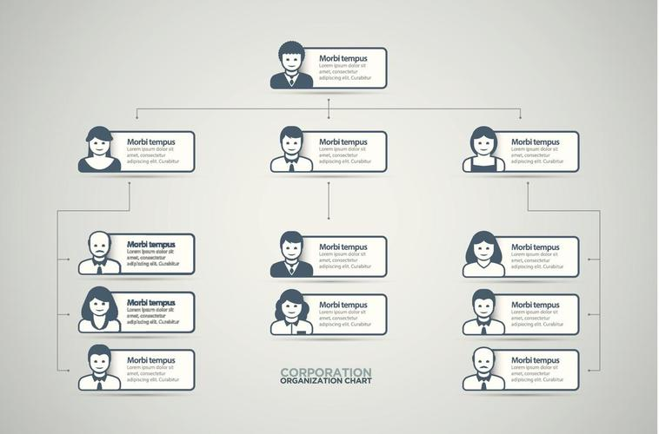
organizational chart

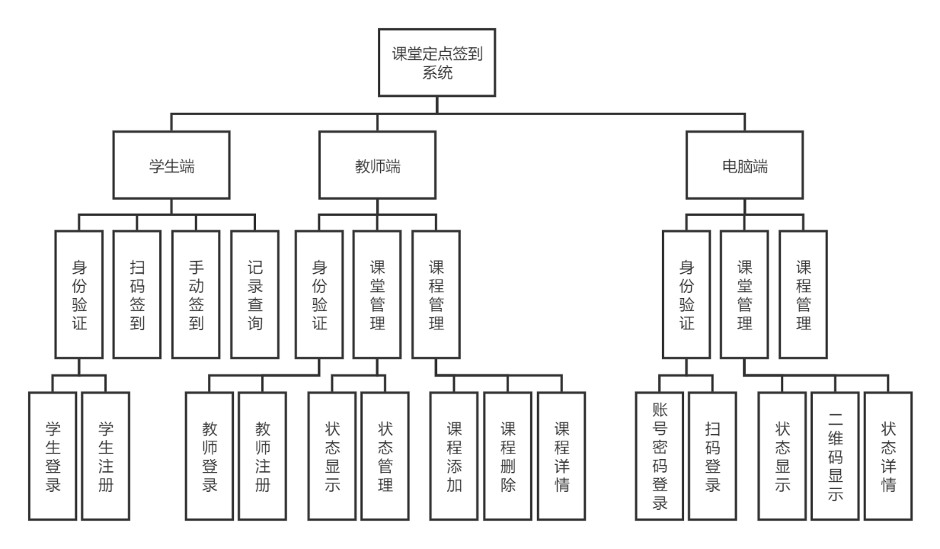
functional module diagram.

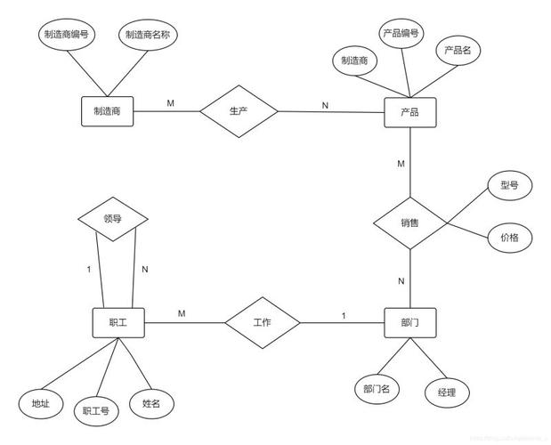
E-R diagram

