

User Manual

Version 0.1 Afrobob
Charly in Madagascar
User Manual
manual version: 0.1
game version: 0.1
(some figures might show older versions with a slightly different look)

Copyright (C) 2014 Markus Brenneis, Jan Ecknigk, Simon Franz, Kevin Gnyp, Jessica Petrasch

Charly in Madagascar is released under the following license:
This program is free software: you can redistribute it and/or modify it under the terms of the GNU General Public License as published by the Free Software Foundation, either version 3 of the License, or (at your option) any later version.
This program is distributed in the hope that it will be useful, but WITHOUT ANY WARRANTY; without even the implied warranty of MERCHANTABILITY or FITNESS FOR A PARTICULAR PURPOSE. See the GNU General Public License for more details.
You should have received a copy of the GNU General Public License along with this program. If not, see <http://www.gnu.org/licenses/>.

The Vorbis SPI package <http://www.javazoom.net> is free software; you can redistribute it and/or modify it under the terms of the GNU Library General Public License as published by the Free Software Foundation; either version 2 of the License, or (at your option) any later version.

The json-simple package <https://code.google.com/p/json-simple/> is licensed under the Apache License, Version 2.0 (the “License”); you may not use this file except in compliance with the License. You may obtain a copy of the License at http://www.apache.org/licenses/LICENSE-2.0.

Some files of the game distribution might have more restrictive licenses, especially the contained background music. See the relevant COPYING file for details.

We’d like to express thanks to all the persons who tested our software; special thanks go to Maximilian Bauer and Timo Bornfleth, who have conducted thorough tests with the pre-release versions of Charly in Madagascar. Special thanks also go to the Band Storm Seeker <https://fb.com/Stormseekerband>, which provided the background music contained in the standard distribution.
Charly in Madagascar was originally started as a project for the lecture Programmierpraktikum at Heinrich-Heine-Universität. We also thank our tutor Tobi.
Table of Contents
I Getting Started 5
1 Principle of the Game 5
2 Installation 5
2.1 System Requirements 5
2.2 Starting the Game 5
3 Playing a Quick Game 6
II Customizing 9
1 Customize 9
1.1 Team Creator 9
1.2 Game Style Creator 9
1.3 Level Editor 10
2 Settings 11
III Playing Online 12
1 The Host 12
1.1 Hosting a Game 12
1.2 Lobby 12
2 Other Players and Spectators 13
2.1 Connecting with a Network Game 13
2.2 Lobby 14
3 Chat 14
3.1 Writing Messages 14
3.2 Chat Commands 15
4 Special Use Cases 15
4.1 Connecting via LAN 15
IV Reference 16
1 Shortcuts 16
2 Items 16
2.1 Selecting an Item 16
2.2 Using a Tool and Shooting a Weapon 17
2.3 Available Items 17
3 Crates 18
4 Conditions 18
4.1 Poisoning 18
4.2 Digitation 18
5 Sudden Death 19
5.1 Boss 19
5.2 Flood 19
6 Frequently Asked Questions 19
6.1 The game does not start, there are strange error messages. 19
6.2 After clicking on “Start!”, I see the main menu again. 20
6.3 After clicking on “Start!”, nothing happens. 20
6.4 My firewall shows a warning. 20
6.5 The main menu looks strange: There are no images, no levels … 20
6.6 Xy is misspelled. 20
6.7 I have found a problem and have wishes. Where can I report them? 20
7 Final Notes 20

Getting Started

Principle of the Game
Charly in Madagascar is a round based tactic shooter. The goal is to kill all enemies while surviving with at least one character. You have an arsenal of weapons and tools to deal damage, destroy terrain, heal and many more.

Installation

System Requirements
Please make sure that the computer you want to run Charly in Madagascar on meets the following requirements:
- at least 10 MiB free hard disk space
- at least 512 MiB free main memoryf
- Java Runtime Environment version 8 or later; use the software manager of your operating system or visit http://java.com to get the latest version.
  - You can check if the right version of Java is installed by executing java -version in a terminal application. You should see a line reading something like java version 1.8.0.
  - On Ubuntu-based system with an older version of Java, you can execute the following command to get the latest version of Java:
sudo add-apt-repository ppa:webupd8team/java && sudo apt-get update && sudo apt-get install oracle-java8-installer
You have to say yes/agree to all steps of the installation process.
Charly in Madagascar has been successfully testes on the following systems:
- Ubuntu 14.04 (64 bit) [it’s free, give it a try]
- Windows 7 (32 bit)
If your system is not listed here, it does not mean that the game won’t work for you, but we cannot guarantee that it does, either.

Starting the Game
After downloading Charly in Madagascar, you have to extract the archive file to a place of your choice (usually by right-clicking on it and clicking on something like Extract to folder). Then open the new folder Charly_in_Madagascar and (double) click on Launch.sh (Linux) or Launch.bat (Windows).
If you have trouble starting the game, have a look at the Frequently Asked Questions.

Playing a Quick Game
To quickly start a new game, click on Start local game.
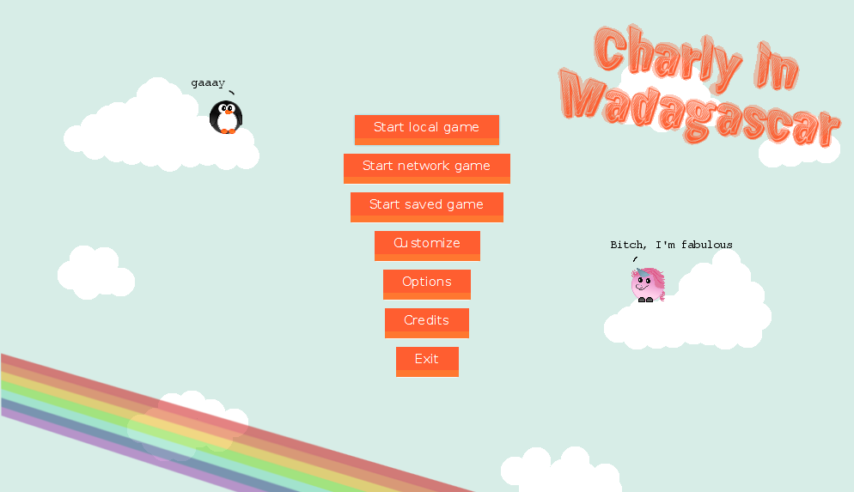Figure 1: The start screen
After clicking on Start local game, you will get to the Game settings screen.
You can choose the teams here, how many teams will play, and which style will be played. Each style shows its properties right under its name. When everything is as you want, click on Start!.
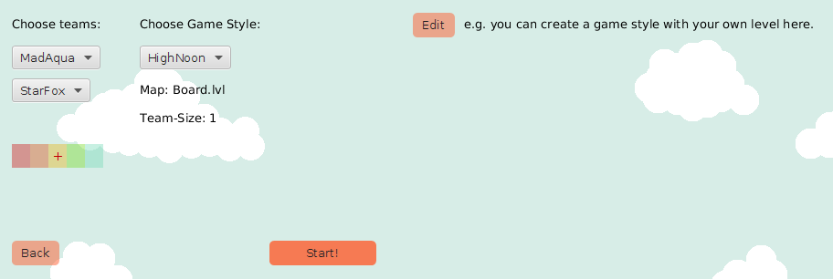Figure 2: In the game settings, you can choose up to 4 teams to play with.
Now you see the game board on which the game takes place. You can change the displayed part of the level by panning it with the mouse. Each team is distinguished by name and color. There are also two different styles: Penguins and Unicorns.
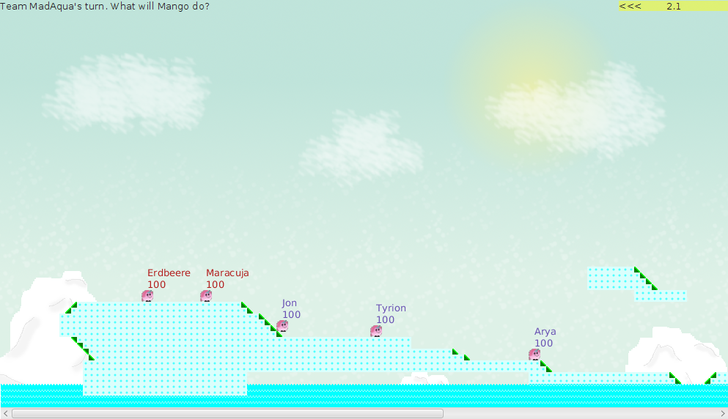Figure 3: The level where the figures will have a nice time.
To move around, use the arrow keys on the keyboard.
Now let's see how to deal damage.
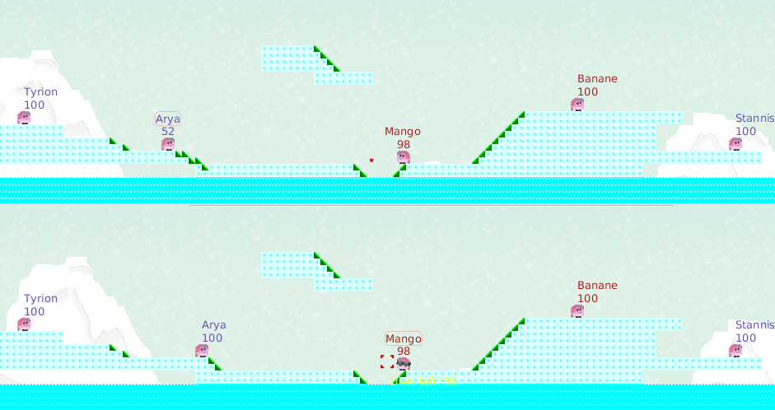Figure 4: Mango is trying to hit Arya.
At first, you have to choose a weapon or tool by pressing a number from 1 to 9, and aim with the now appearing cross hair.
In figure 4, you see a red dot. That’s a projectile shot by Arya, whose name is framed because it’s her turn, at Mango. After being hit by it, Mango gets some damage, which depends on the weapon Arya has chosen, and (if you destroy the terrain under him) by falling on the ground or maybe by touching water. (Remember: Water and lava is very bad to you, so avoid it!) Also note that the wind influences every movement. The current wind force and direction is indicated in the top right corner.
So this is your goal: Shoot your enemies, stay alive.
Either you hit or you miss, maybe hit your own but after your projectile hits something, your turn is over and the next team’s turn starts.

Customizing
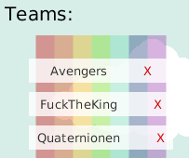Figure 5: Clicking X will remove a team, by clicking on the name you can edit it.

Customize
When you want to play a game you have to choose a game style and a team for each player. In the Customize section you can create your own teams and styles and even draw own levels. All creations and default teams etc. are listed and can be edited or removed.

Team Creator
To create your own team click Create new team in the upper menu. You can now choose several settings:
- Team name: Enter the name you want for the team. This name will be shown in the lists later on, so choose a remarkable one.
- Figure names: Every figure of your team can have a name that will be shown above it during the game.
- Team color: In-game the information about your figures will be shown in this color.
- Figure: Your figures can either be penguins or unicorns. See Digitation for more information about their differences.
As soon as you are satisfied with all settings, you can click Save. The new team will appear in the list and can be chosen for every game now.

Game Style Creator
A game style contains basic settings that affect every team and the game itself. So for one game you can only choose one game style, but you can create as many as you want under Create new game style. You can choose:
- Style name: Same as for the team name, will be shown in the lists later on.
- Team size: The number of figures per team.
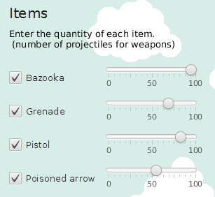Figure 6: With the slider next to each item-name you can set the quantity of this particular item.
- Level: The level you want to play.
- When clicking Change items, a list of items that the game contains will appear. You can now set how many of an item each team should have. Unselecting an item will set the number to 0.
Clicking Save will save the game style.

Level Editor
As described before, you can choose a level when creating a game style. Along with this game you get a few default levels, but you can also draw your own ones with the level editor by clicking Create new level under Customize.
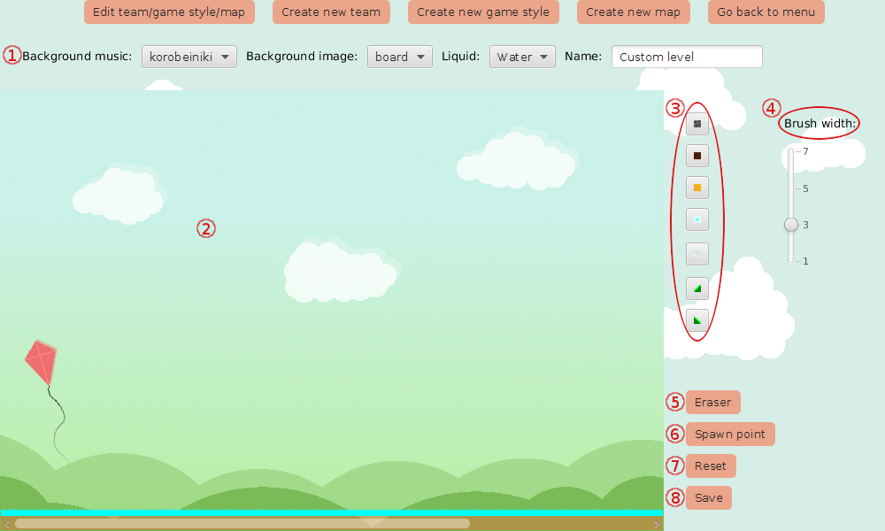Figure 7: The level editor

External settings
Before drawing the level you can take care of the settings ① at the top. You can choose the background music that will be played while playing the level, as well as the background image. Choosing another one will also change it in the editor. On the right, you can enter a name for your level by which you can identify it afterwards. Choosing lava as liquid will place lava in the bottom of the level, otherwise there will be water.

Drawing a level
Now to the important part: The drawing of the level itself. The area to draw ② in is the field on the left displaying the currently chosen background image. Clicking or dragging the mouse in here will place one or more new terrain blocks. You can change the terrain you want to place by clicking one of the buttons ③ on the right containing the image of the block that will be placed. When you move over one of these buttons with the mouse, the name of the terrain will be shown underneath. You can also change the width of the brush ④ so that drawing a whole level is faster.
In case you want to remove parts of the level again, you can choose the eraser ⑤ and use it just as the normal terrain brush.
To make your level playable, you have to add spawn points ⑥. These are the positions that the figures will start at in the game, which means that you need one spawn point per figure. The maximum of figures per game is limited to 24, so to make the level playable at all conditions you should add 24 spawn points (if you try to play with a level which does not have enough spawn points, the game will silently return to the main menu). You should not put them in the middle or directly on top of the terrain (leave one block free under and next to a spawn point), because a figure spawning surrounded by blocks will not be able to move. You also should not place them too far up in the air as they will fall down to the ground in the beginning of the game and might get fall damage.
Clicking the Reset button ⑦ will set the level back to the point where you started. If you are creating an all new level, the drawing area will be empty again; if you edit an existing level, it will be set back to the last saved status.
When you are finished you can click the Save button ⑧ and your level will be saved. Create new game style or edit an existing one to play the new level.

Settings
There are also some settings or options which you can set independent of the game style. To change these you have to choose Options in the main menu. You can make the following adjustments:
- Volume of the sound, where there’s a distinction between background music and context-sensitive sound effects like weapon sounds.
- Rounds till sudden death: Here you can enter the number of rounds to be played before sudden death happens. You can set it to any positive number and even 0 if you want to play a really short game and die early.
- Wind force: You can choose between four wind forces: Off, Easy, Normal and Hard. Off means no wind at all, hard means hurricane which makes it more difficult to aim. The default value is normal.
When clicking Close, these settings will be saved and applied.

Playing Online
Playing Charly in Madagascar is even more fun when playing with your friends over the Internet. In order to do so, one of you must host a game. The host of the game will choose the game settings like game style and wind force, can change any team’s settings, remove teams, and disconnect users. The other players must join the hosted game.

The Host

Hosting a Game
- On the start screen, click on Start network game.
- Enter your name in the first text field.
- Click on Host a game.
- Now you see the lobby, where you can change the game settings, remove team, and chat with the other players.
- When all players have indicated that they are ready, you can click on Start in the top right corner.
The players which want to connect need your IP address. The IP address is used to identify and find your computer in the Internet. The Start network game dialog displays your IP address(es) in the local network, which you can use e.g. when playing with friends at home. You might find your public IP address, which you need when playing over the Internet, in the network manager of your operating system, the settings of your router, or by visiting websites like http://myipaddress.com.
If the client are not able to connect with you, a firewall might be blocking the connections. Make sure that connections on port 61421 or not blocked by your operating system or router; it might be necessary to enable port-forwarding in the settings of your router. Please refer to the manual of your operating system or router.

Lobby
The lobby is the place where all players can see who is connected with the network game, which game style and level will be played, and which teams are chosen by the players. As the host, you can edit all settings.
In the section General Settings ①, you can choose one from the available game styles and levels, set how many figures there are in each team (overwriting the style’s default), and how many teams there are at maximum, thereby limiting the number of players who can connect. In the top right corner ②, there is the list of connected spectators and players, along with the information in which team they are.
The Teams section ③ shows which team style has been chosen for the teams, and whether the player clicked on their Ready button. When all players are ready, the game can be started by clicking on Start ④. Note that a game cannot be started two teams have chosen the same team; the host then has to change the team style. You can also remove a team by clicking on the red x next to it.
The chat ⑤ is explained below.
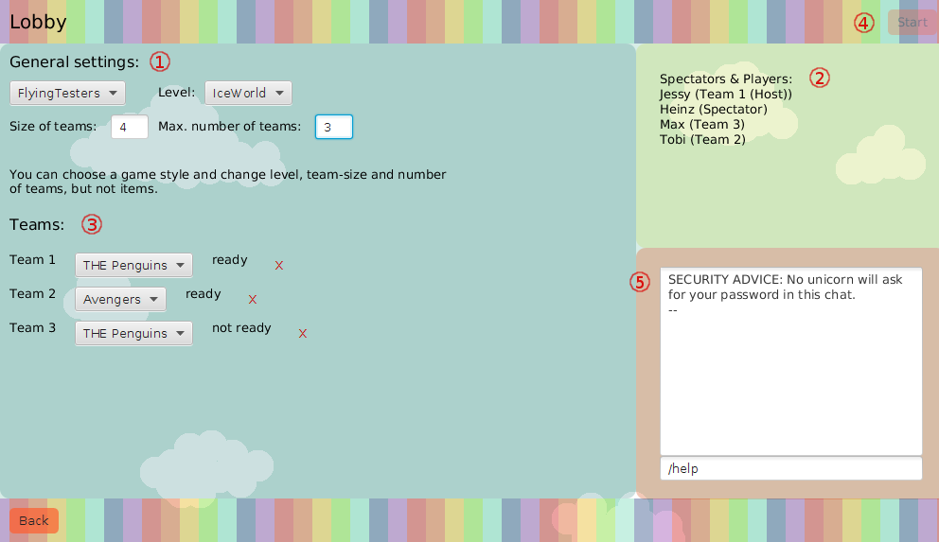Figure 8: The lobby from the host’s point of view. All settings can be changed.

Other Players and Spectators

Connecting with a Network Game
- Click on Start network game.
- Enter your name in the first text field.
- Enter the IP address the host told you in the other field.
- Click on Join a game.
- Depending on the current state of the game, you see the lobby or the running game.
You are now in the spectator mode and will be able to watch the game the other players will play. To join the game with a new team, continue with these steps:
- If you are in the lobby, you can uncheck Spectator in the top right corner. (If the maximum number of teams set by the host is reached, you will become a spectator again.)
- When you are ready with choosing your team’s settings, click on Read in the top right corner.

Lobby
The lobby is the place where all players can see who is connected with the network game, which game style and level will be played, and which teams are chosen by the players.
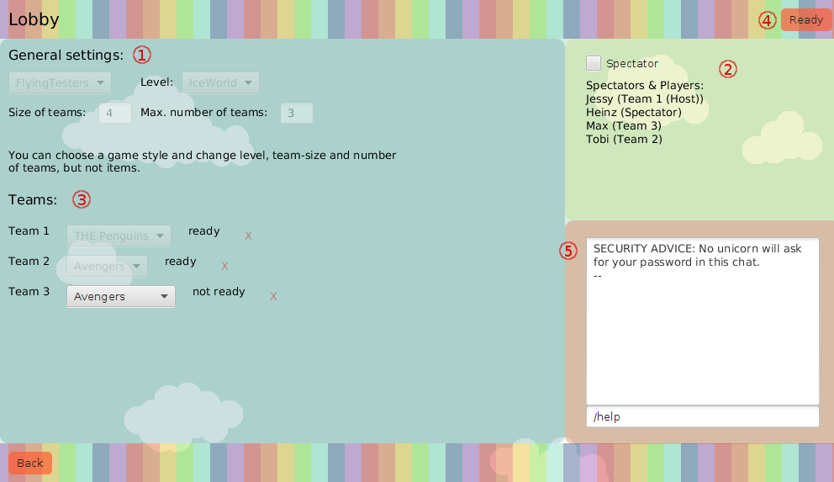Figure 9: The Lobby from a player’s point of view. Spectators and players can only edit their own settings.
After joining a game, the only thing that can be done is using the chat ⑤ and unchecking Spectator ②. When doing so, a new team will be created for you, unless the maximum number of teams set by the host is reached.
When you have a team, you can change its settings in the Teams section ③. When you have finished choosing your team style, click on Ready ④ to indicate this to all other players; only when all players clicked on Ready, the game can be started by the host. All other settings in the lobby can only be changed by the host; note that the host can also change the settings of your team.

Chat
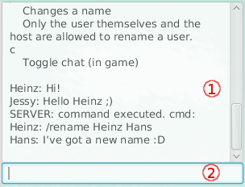Figure 10: In-game chat after showing help, exchanging some messages, and renaming Heinz to Hans.
During a network game and in the lobby, you can exchange messages with the other players and spectators. In the lobby, the chat window is situated in the bottom right corner; during the game, you can open the chat by pressing C, end close it by entering c end pressing ENTER.

Writing Messages
The chat window consists of two parts: The upper, bigger part ① shows the sent and received messages; the smaller text field ② is used to enter messages, which are sent by pressing ENTER. If you see your message in the upper part, delivery was successful.

Chat Commands
The chat can be used to execute a number of commands, like removing teams and players (can only be done by the hist), or renaming a player. Enter /help end press ENTER in the chat to see the list of available commands and their explanation.

Special Use Cases

Connecting via LAN
If you’re sitting right next to your friend, you can connect your computers directly using a patch cable. (NB: In the past, it was necessary to use a so called crossover cable; modern computers do not have this requirement.)
When connecting two computers directly, they usually do not get an IP address automatically, but you have to set it up manually. Here’s a rough description of this process, which differs from operating system to operating system; please refer to your operating system’s manual for details.
- Open the tool of your operating system for creating new network connections (connection editor or the like).
- Create a new cable connection.
- Set cloned mac address to the hardware address of your network card (you might get this information from commands like ifconfig, in the section ethX, where X is number).
- Set IPv4 Method to Manual.
- Add address 10.0.0.x (x must be unique for each player), network mask 255.255.255.0.
- Give the connection a sensible name, e.g. Network Game.
- Connect with the newly created connection.

Reference

Shortcuts
Here a list of all shortcuts you can (or must) use during a game:
- ← (or A): go to the left
- → (or D): go to the right
- ↑ (or W): jump, press twice to jump higher; if a weapon is selected, the cross hair is moved up instead
- ↓ (or S): aim downwards (if weapon is selected)
- 0–9: (de)select weapon or tool, see below
- Space: use active weapon (i.e. shoot) or item
- C: open the char (to close it again, enter c and press ENTER)
- Z: disable or enable the automatic centering of the currently moving figure or projectile
- P, ESC, or F1: pause the game and show short shortcuts reference; here you can also save the game, to load it later from the main menu (note that the game is automatically saved when closing the window)

Items
Items are making up the main part of the game. They are divided into tools and weapons. Each turn you are allowed to use as many of your tools as you want and have, while shooting a weapon is only allowed once, and will make your turn end as soon as the projectile hits something.

Selecting an Item
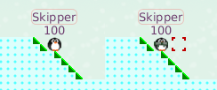Figure 11: Skipper without and with a weapon
- selects the Bazooka
- selects the Grenade
- selects the Shotgun
- selects the Rifle
- selects the Bow along with poisoned Arrows
- selects the Banana-Bomb
- selects the Digiwise
Figure 12: There are 50 grenades left to be thrown.
- selects the Medikit
Pressing 0 will deselect your item, but not use it.
Selecting an Item will also show a comment indicating the munition left or its lack.

Using a Tool and Shooting a Weapon
Tools and weapons are used or shot by pressing SPACE as long as they are selected. Shooting will cause a projectile to be spawned in the middle of the cross hair, flying into the aimed direction. By pressing UP or DOWN you can change the angle it is shot. This and the direction you face affects the projectile's direction.
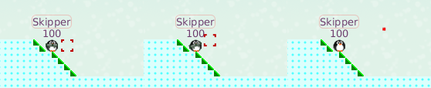Figure 13: 1. Select weapon. 2. Aim. 3. Shoot.

Available Items

Bazooka
A powerful weapon on short and high distances causing 50 damage in a direct hit plus additional falling damage caused by its enormous shockwave. While aiming take into account that its projectiles are slightly affected by wind and gravity.

Grenade
A weapon for short and average distances causing 40 damage in a direct hit, which is affected by gravity and wind.

Shotgun
With 30 damage on a direct hit, this is one of the weaker weapons, but nonetheless of strategic importance.

Rifle
Highly accurate weapon, which is completely unimpressed by distances, gravity and wind. Instead of the traditional crosshair, a red line indicates the flight path of the projectile. This weapon deals impressive 40 damage by a direct hit.

Poisoned Arrow
Highly accurate weapon, which is slightly affected by wind and gravity. It deals 30 damage on a direct hit and sets the poisoned condition to all figures nearby.

Banana
The most powerful and least accurate weapon in the game. Dealing 40 damage on a direct hit and bursting into 5 shards on impact, which again cause the same damage and destruction as the original projectile.

Digiwise
Forces the figure using it into the digitated condition.

Medipack
Heals the user by adding 50 health points and removes negative conditions like poisoning.

Crates
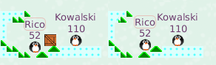Figure 14: Rico picking up a new item.
Crates drop from the sky somewhere onto the map randomly. They can be picked up by walking into them and will give a randomly selected item to the team and increase the munition by one.

Conditions
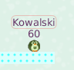Figure 15: Kowalski is poisoned.

Poisoning
A poisoned Figure loses 10 health points each round (when all living teams made a turn). Poisoning cannot kill a Figure, it will simply reduce its health to 1.
Poisoning can be healed using a Medikit.
Poisoned Figures are easily distinguished by their more greenly look.

Digitation
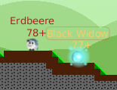Figure 16: Erdbeere is digitated. Black Widow is using her Digiwise to force Digitation.
The figures get special abilities when the following conditions are met:
- 2 × number of teams × size of teams turns have been played
- the figure has at least 65 health points
- the figure caused at least 30 health points damage by hitting other figures
The process of getting the special ability is called “Digitation”. Digitated figures have a different look and a + next to their hp label. Depending on the chosen figure type, the special abilities differ:
- Penguins lose some weight, and are therefore able to fly (keep pressing ↑ and ← or →), and get 10 % damage resistance.
- Unicorns get 50 % damage resistance, and a slightly increased maximum jump height.
- All digitated figures get less damage when standing on a liquid.
- When a digitated figure has less than 25 hp, it degitates, i.e. loses its special ability.
You can use the Digiwise to force the digitation of a figure. Use it wisely!

Sudden Death
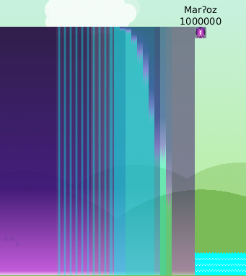Figure 17: The boss Marʔoz and its lethal light beams and fog.
The sudden death is a feature which will slowly end a game which has been running for a configurable number of turns. When sudden death starts, only a finite number of turns can be played before all figures are dead, meaning that an infinite game is not possible. There are two different kinds of sudden death; which one will happen is determined by chance.

Boss
The boss is an immortal figure which appears at the left or right side of the map. Albeit a small and ugly figure, the light beams he discharges behind him can destroy everything and everybody. The toxic violet fog cannot be entered by any figure (it’s for their own safety).

Flood
After a flood warning, the level of the liquid (water or lava) will increase after each turn. Remember that figures do not survive very long when they are standing in a liquid.

Frequently Asked Questions

The game does not start, there are strange error messages.
When the game does not start, open the file Afrobob.log in a text editor. You might see one of these messages:
Exception in thread "main" java.lang.UnsupportedClassVersionError: de/hhu/propra/team61/Afrobob : Unsupported major.minor version 52.0
Your version of Java you are using is outdated. See System Requirements for more information.
The file 'Charly_in_Madagascar.jar' is not marked as executable. If this was downloaded or copied from an untrusted source, it may be dangerous to run. For more details, read about the executable bit.
You tried to start the game by clicking on the jar file. Use the launcher scripts instead, see Starting the Game for more information. If you really want to start the jar file, make sure to have checked the file property executable; the manual of your operating system can help you.
If there is no file Afrobob.log, make sure that the launch file is marked executable in the file properties; you usually find it in the Permissions section.
If this didn’t help, see reporting problems.

After clicking on “Start!”, I see the main menu again.
The level you have chosen does not have enough starting points for all teams. Use the level editor to add more spawn points.

After clicking on “Start!”, nothing happens.
Another instance of the game might still be running. Use the system monitor application of your operating system to kill all java processes executing Charly_in_Madagascar.jar.

My firewall shows a warning.
Charly in Madagascar has some online features, which are also active when not playing a network game. You should not block the connection.

The main menu looks strange: There are no images, no levels …
You probably started the game by clicking on the jar file. Use the launcher scripts instead, see Starting the Game for more information. If you really want to start the jar file, make sure that your current working directory is the one containing the jar file.

Xy is misspelled.
See report problems and final notes.

I have found a problem and have wishes. Where can I report them?
Please send a detailed description to the guy who has given you this manual. If you are reporting a problem, please attach the file Afrobob.log.

Final Notes
All similarities of game contents to something you already know are entirely coincidental.
________________________________________________________________________________________________________________________________________________________________________________________________________________________________________________________________________________________________________________________________________________________________________________________________________________________________________________________________________________________________________________________________________________________________________________________________________________________________________________________________________________________________________________________________________________________________________________________________________________________________________________________________________________________________________________________________________________________________________________________________________________________________________________________________________________________________________________________________________________________________________________________________________________________________________________________________________________
✍

