**DSA MINI PROJECT**

“LIBRARY MANAGEMENT SYSTEM”



ARMY INSTITUTE OF TECHNOLOGY

(DEPARTMENT OF COMPUTER ENGINEERING)

(SE COMPUTERS SEM-I 2018-19)

Submitted by:

Asha Chauhan (3226)

Menka Yadav (3253)

**ABSTRACT**

Library management system is based on the concept of issuing and returning books. Here the system contains no login system, the user can easily issue, return a book, search for available book and view his /her status report and many more. This mini project contains fewer features but the essential ones.

Taking about the features of the library management system, while a data about the user has to provide first, last name, person ID, phone no. , address and select menu preferences. Then the system displays the student’s profile. Similarly when the user wants to change information about his contact details he/she has to provide the unique UID NUMBER and then change his information. Cancelling a book is easy through the system, the user just has to just provide the UID number. Likewise, when a user has to search for books records, he/she can simply find out in books available section. Other features include viewing the record of the book issued and status report which displays each and every detail of the student.

This simple library management system is developed using C++ programming language and different variables, strings have been used for the development of it.

**HARDWARE AND SOFTWARE REQUIREMENT**

HARDWARE SPECIFICATION:

* Processor: Intel(R)Core(TM)i5
* RAM: 4GB

SOFTWARE REQUIREMENT:

* IDE: Code blocks
* Operating System: Windows

**INTRODUCTION**

This is the library management system which is used to store various information about the student’s and the books available. It performs the following operation.

* Students details
* Issue Book
* Return Book
* Search for book
* Update your info
* Student Status

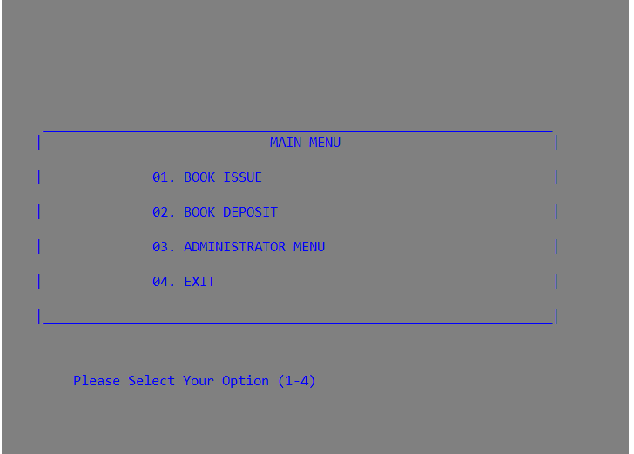

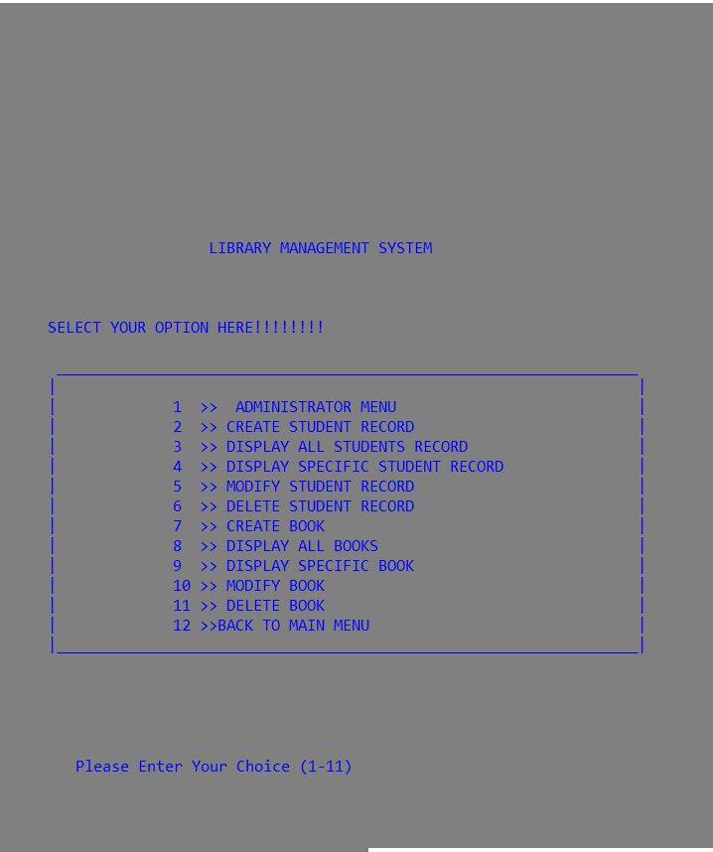

* **Book issued:** It issues the book to the student on unique UID number of the student for a particular time of 15 days.

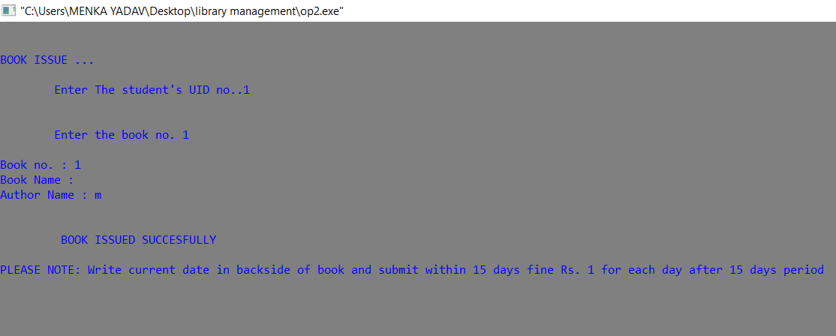

* **Return book**: It return the already issued book of the student in case they want to return the book they issued. To return the book you just need to enter the UID number. 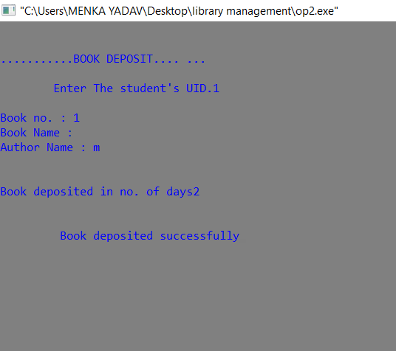
* **Search for Book**: It helps to search the details of the book available in the library. You can simply check the book available in the book available by simply entering his/her UID number.
* **Change students info**: It helps to change the already entered details of the student. This can be done by providing UID number and then changing the details.
* **View Student details**: This feature prints the list in tabular form which includes first, last name, Person’s ID, phone number, seat, book issued number and menu preferences.
* **Status report**: This feature displays the total number of book issued by student.

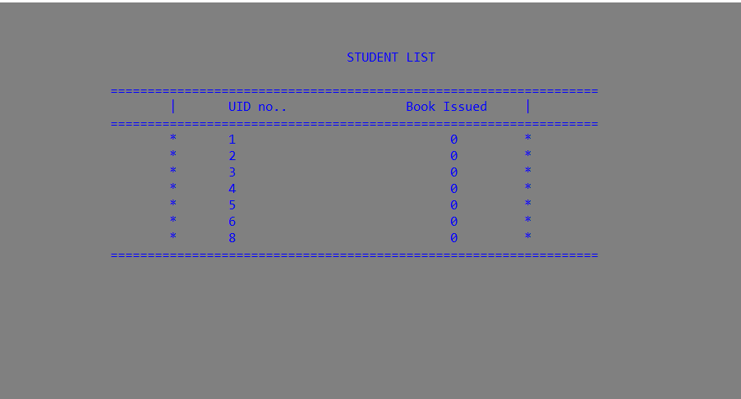

**ALGORITHMS AND DATA STRUCTURE USED**

* **Linked list**

1. **Insertion in linked list**: In any single linked list, the individual element is called as “node”. Every “node” contains two fields, data and next. The data field is used to store actual value of that node and next fields is used to store address of the next node in the sequence.

Algorithm is as follows:

In order to insert a new node at the end of the list we have to follows the below steps:

**(1)** First we have to check weather free node is available in the **Availability Stack** or not. If free node is available then we can allocate memory to new node. 

**(2)** After creating new node we have to check weather linked list is empty or not. We have two possibilities: 

**(A) Linked List is empty (FIRST=NULL)**. In this case the newly created node becomes the first node of linked list. 

**(B) Linked List is not empty (FIRST ≠ NULL)**. In this case we have to traverse from first node to last node in the list and insert new node at the end of linked list.

1. **Deletion in linked list**

Algorithm is as follows:

a. If list is empty, just return.

**b.** If position equal to 0 to be deleted, we need to delete head node.

**1.** Change head reference to head->next

**2.**Delete the old head. (free(head))

**c.**Create a temp node (auxiliary node to store reference of node to be deleted).

**d.**Find previous node of node to be deleted. (temp)

**e.**Traverse in node based on the value of position-1 by running a loop.

**f.**We need to delete temp → next, free it and unlink the deleted node.

**g.**If position is more than number of nodes, just return.

**FUTURE SCOPE**

1. Existing system does not have any facility of teachers login or student login whereas proposed system will have a facility of student login as well as teacher’s login
2. Existing system does not have a facility of online reservation of books whereas proposed system has a facility of online reservation of books
3. Existing system does not have any facility of online notice board where description of workshops happening in our college as well as nearby colleges is being provided.
4. Existing system does not has any option of lectures notes uploaded by teachers whereas proposed system will have this facility
5. Existing system does not have any facility to generate student reports as well book issue reports whereas proposed system provides librarian with a tool to generate reports
6. Existing system does not has any facility for book request and suggestions where as in proposed system after logging in to their accounts student can request books as well as provide suggestions to improve library

**CONCLUSION**

* This software deals with the problem of writing and storing huge databases which requires both time and storage of piles of files.
* In various library management counters this software can be used for the systematic storing records.
* This software can be used at different counters of library management system to provide instant access of :

1. Records of student.
2. Records of books.
3. Records of book returned.
4. Status report.

* This software ensures the complete freedom for student where user can issue the book with just logging in.
* This system allows user to issue the book, return the book, change students details, view the status report and search for the books available in the library.