Muhammad Abubakar Ali
22i-2693
SE-A
Lab Task 03

Github Repo Link:
https://github.com/mabubakarali/22i2693_Web_LabTasks2026.git
Index Page:
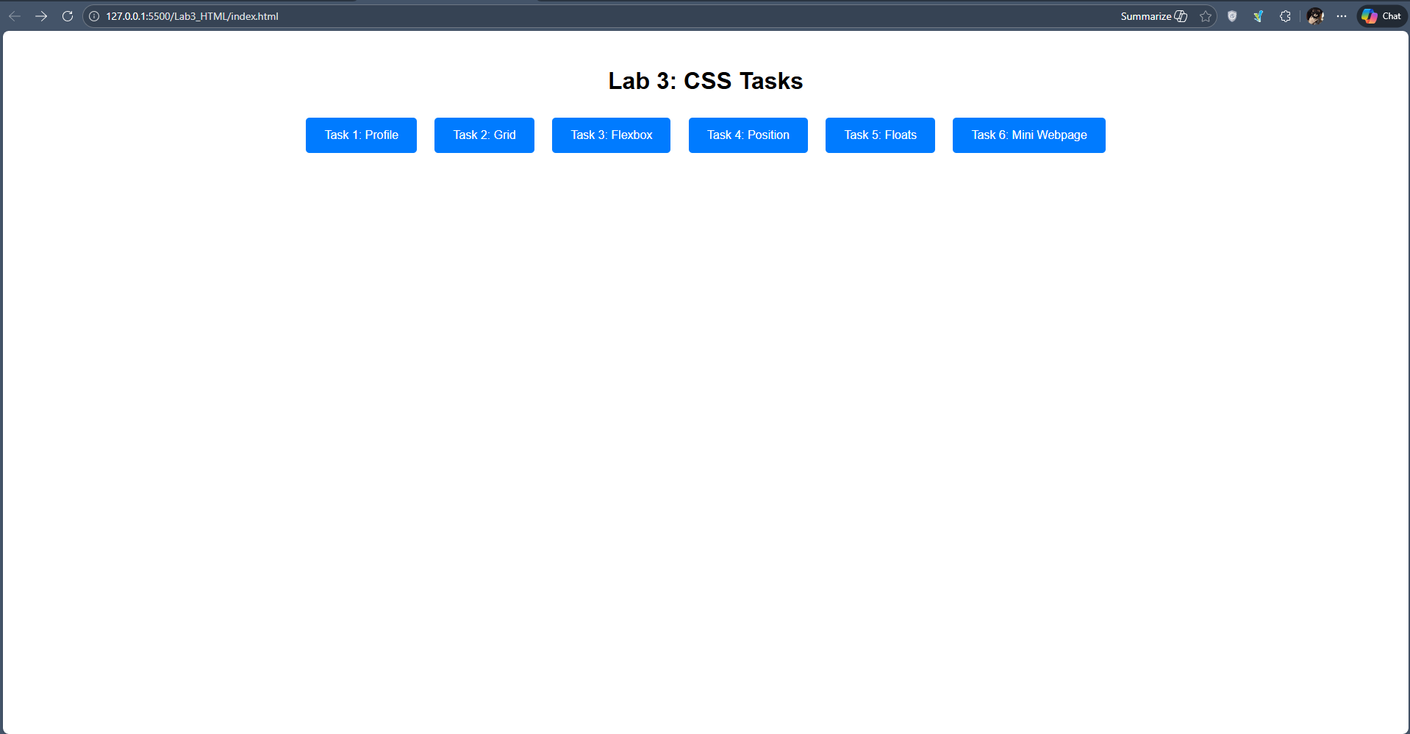

Task 1:
- Margin and Padding
- Background Color
- Text Color
- Border Radius
- Box Shadow
- Hover Effect
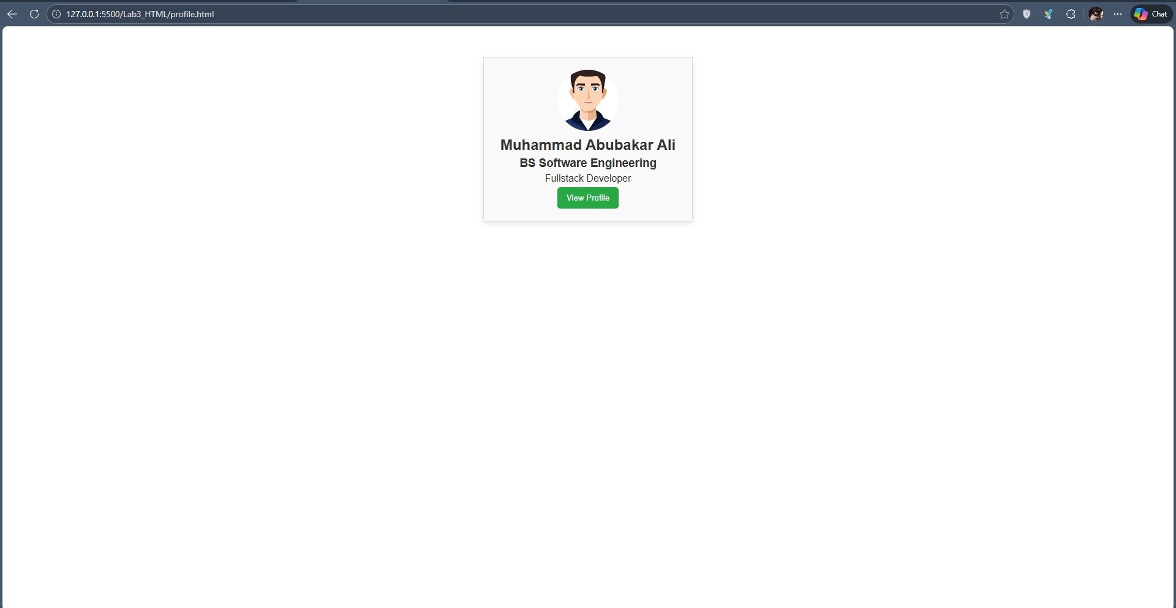
Task 2:
- display: grid
- grid-template-columns
- grid-template-rows
- Grid spanning
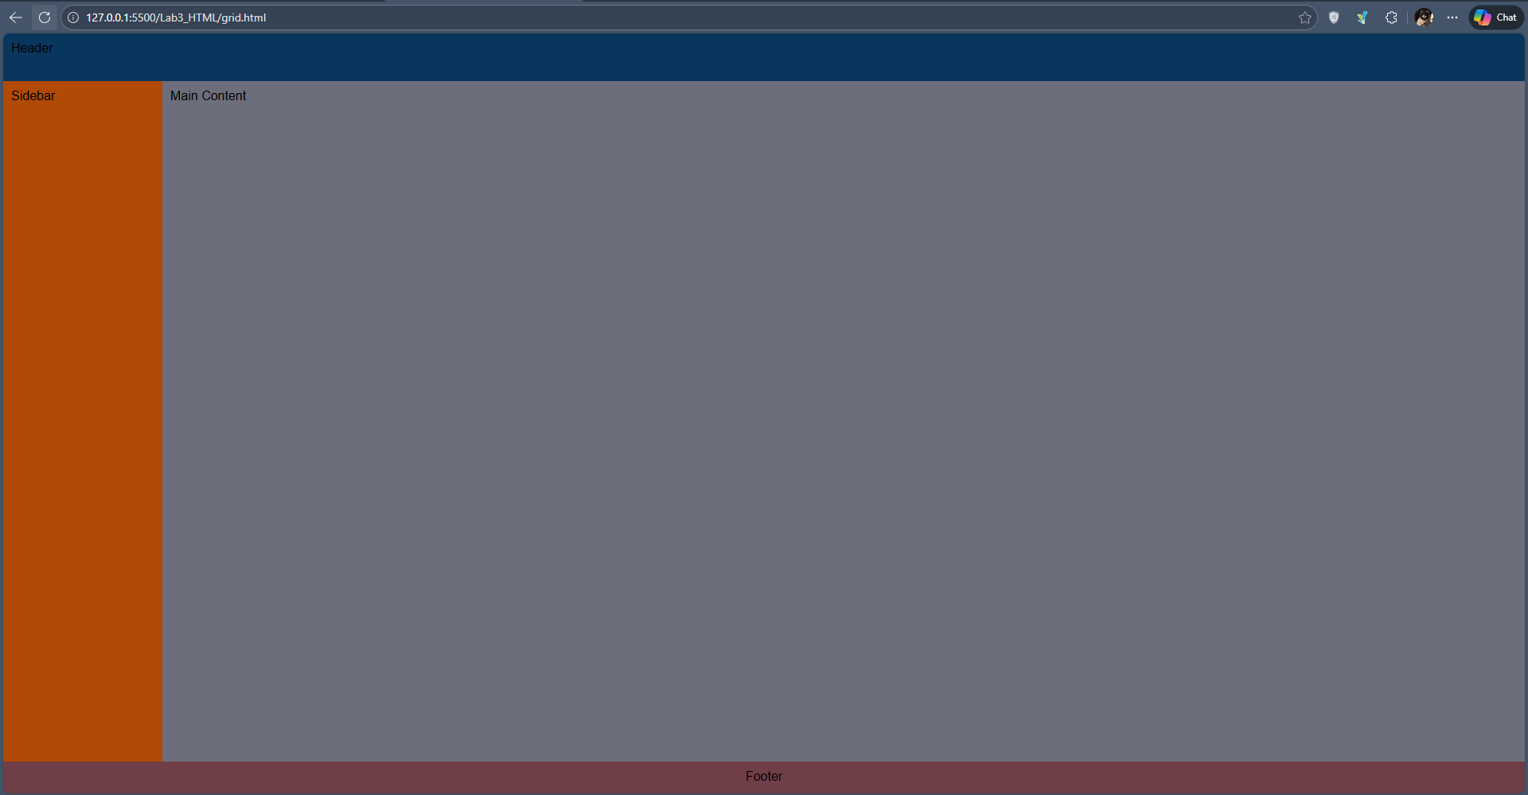

Task 3:
- display: flex
- justify-content
- align-items
- gap
- Hover Effect

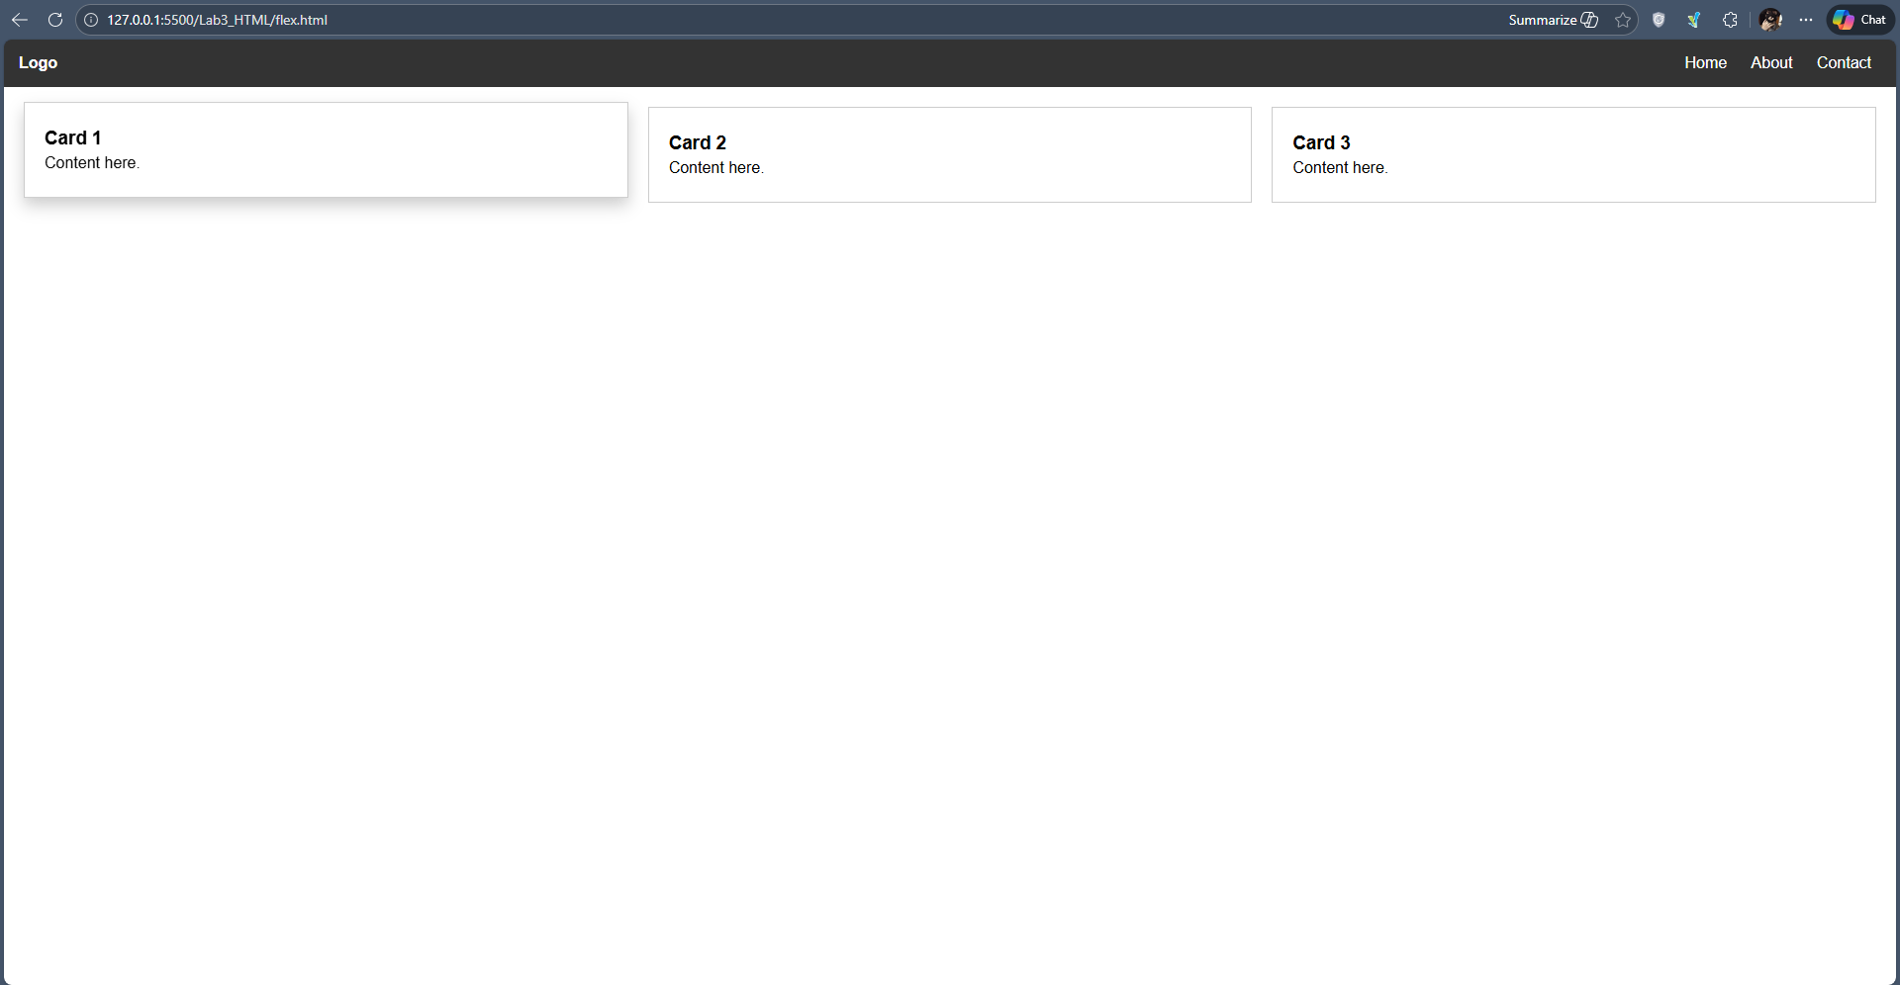
Task 4:
- position: sticky
- position: relative
- position: absolute
- position: fixed
- top, left, right, bottom

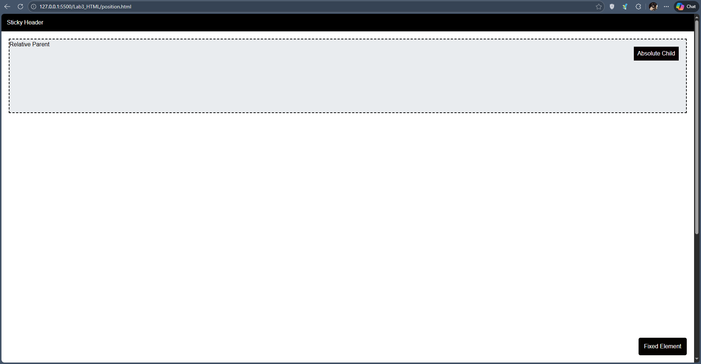

Task 5:
- float left and right
- width percentages
- margin and padding
- clear property

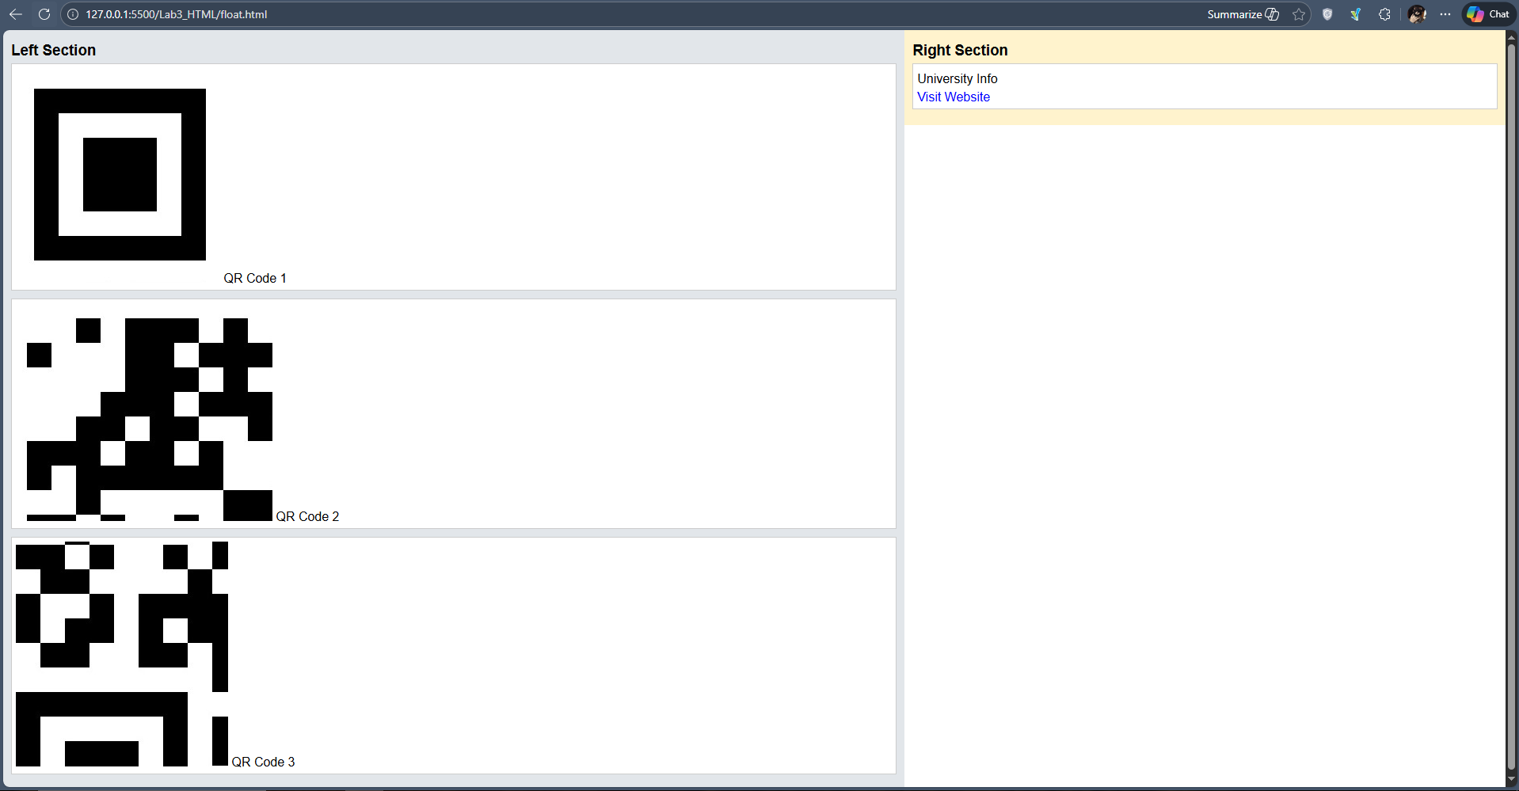
Task 6:
- CSS Grid for structure
- Flexbox inside sections
- Positioning for badge
- Hover effects
- Consistent colors and spacing
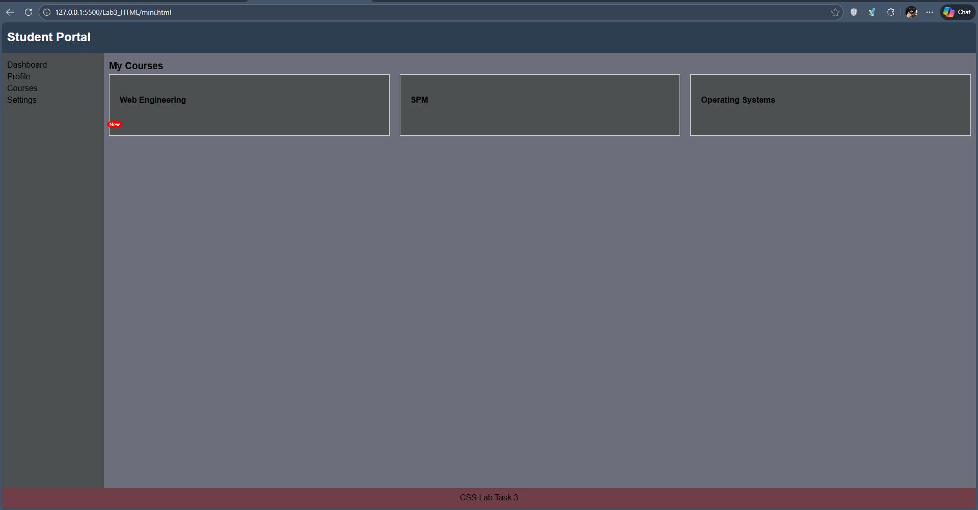

Github:
