Muhammad Abubakar Ali
22i-2693
SE-A
Lab Task 06

Github Repo Link:
https://github.com/mabubakarali/22i2693_Web_LabTasks2026
Index Page:
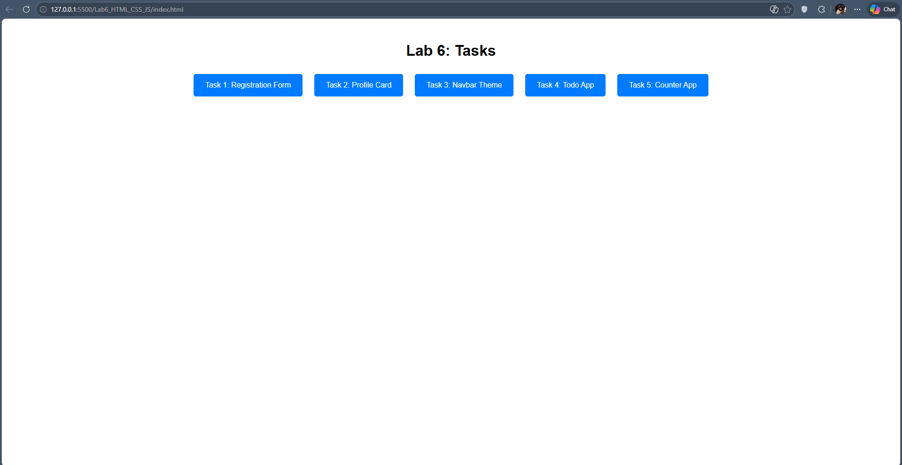

Task 1:
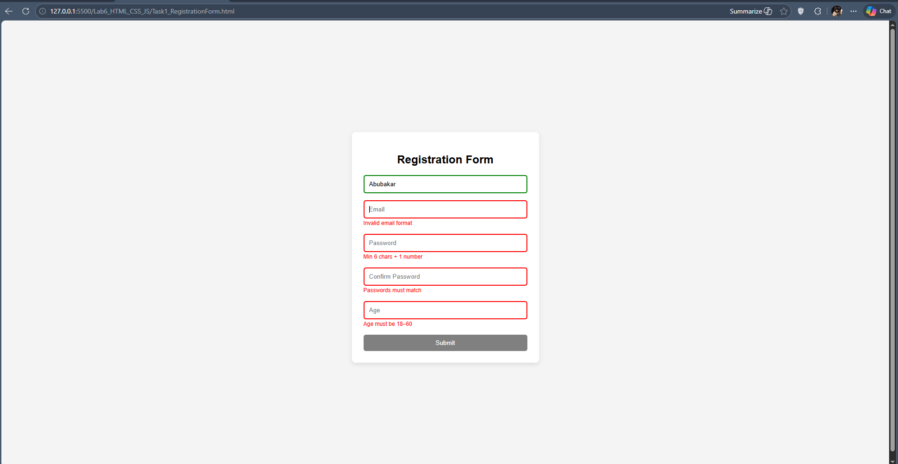
Task 2:
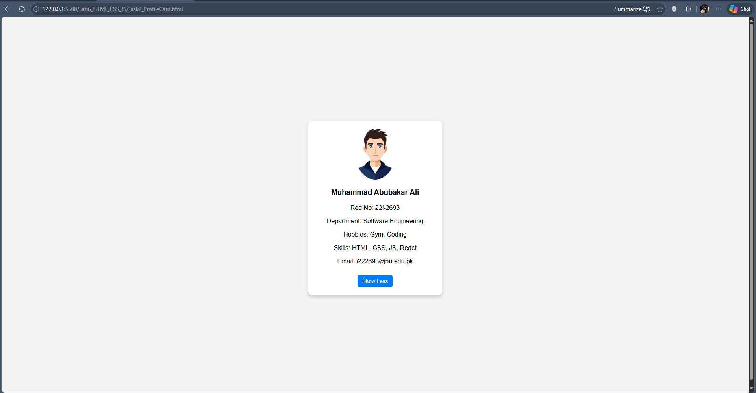
Task 3:
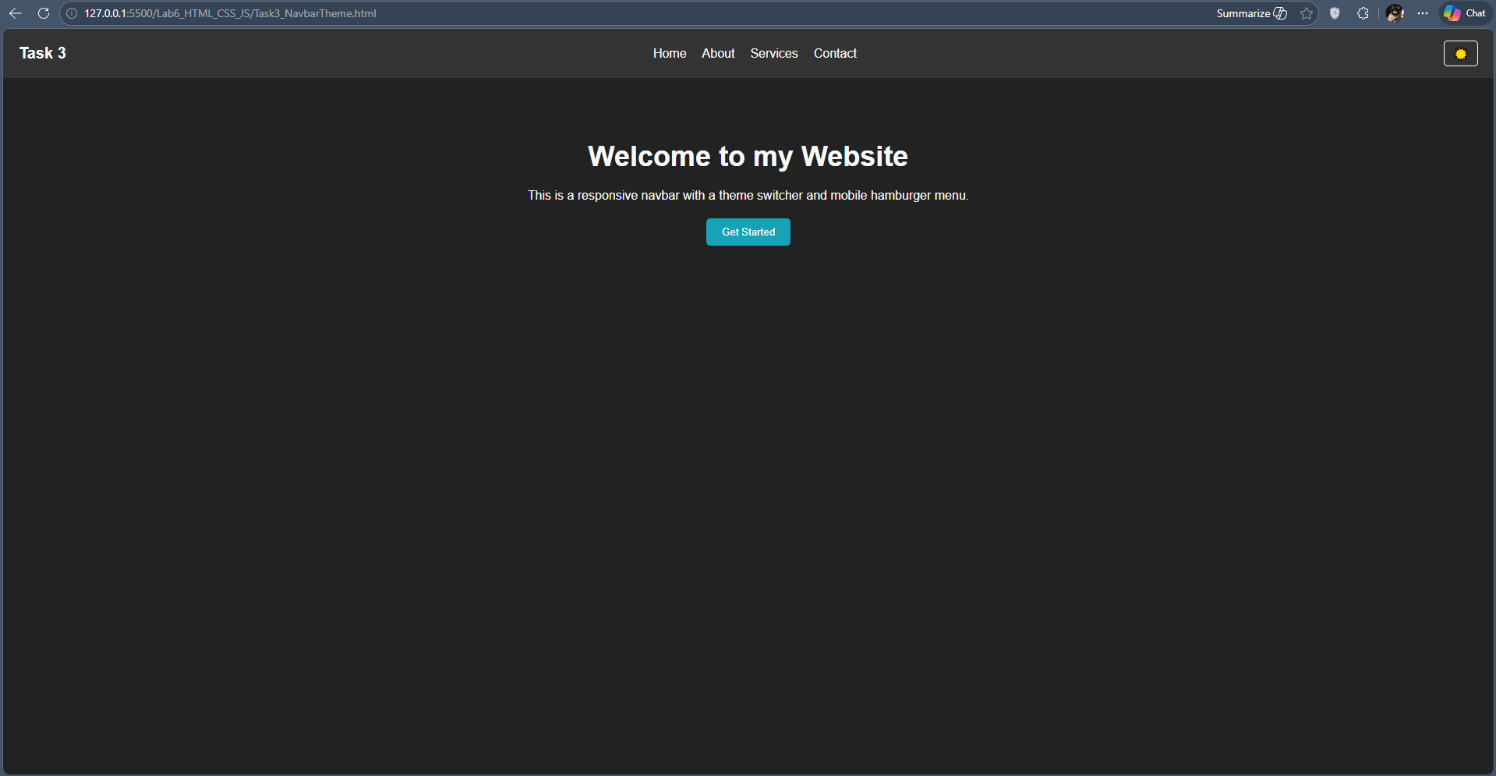
Task 4:
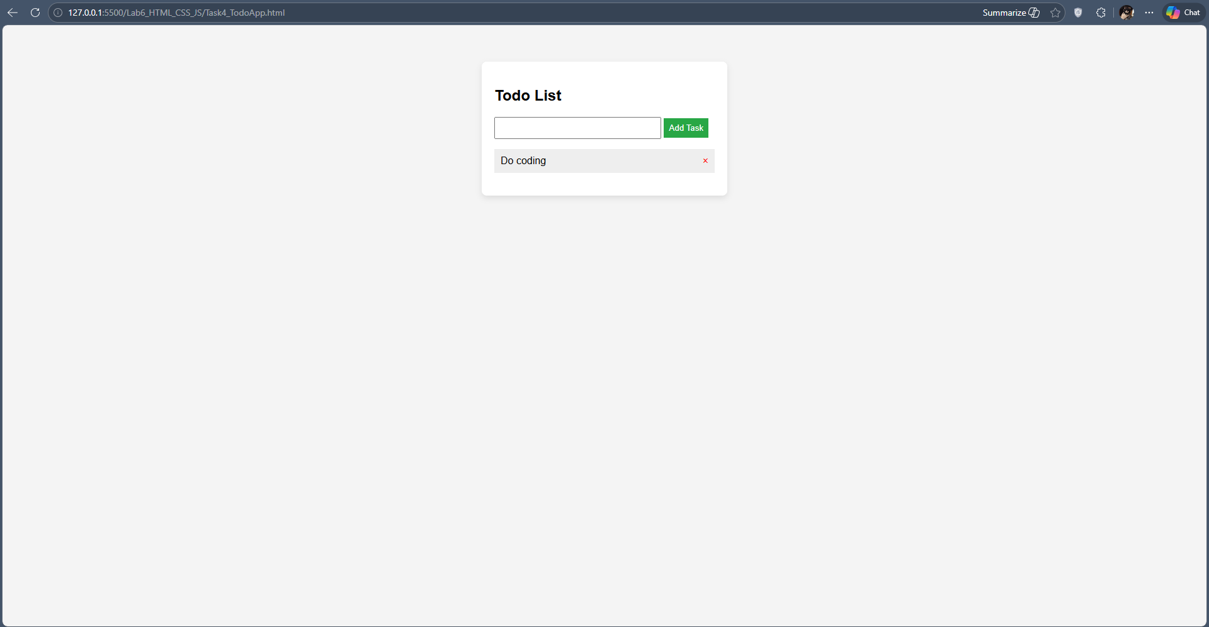
Task 5:
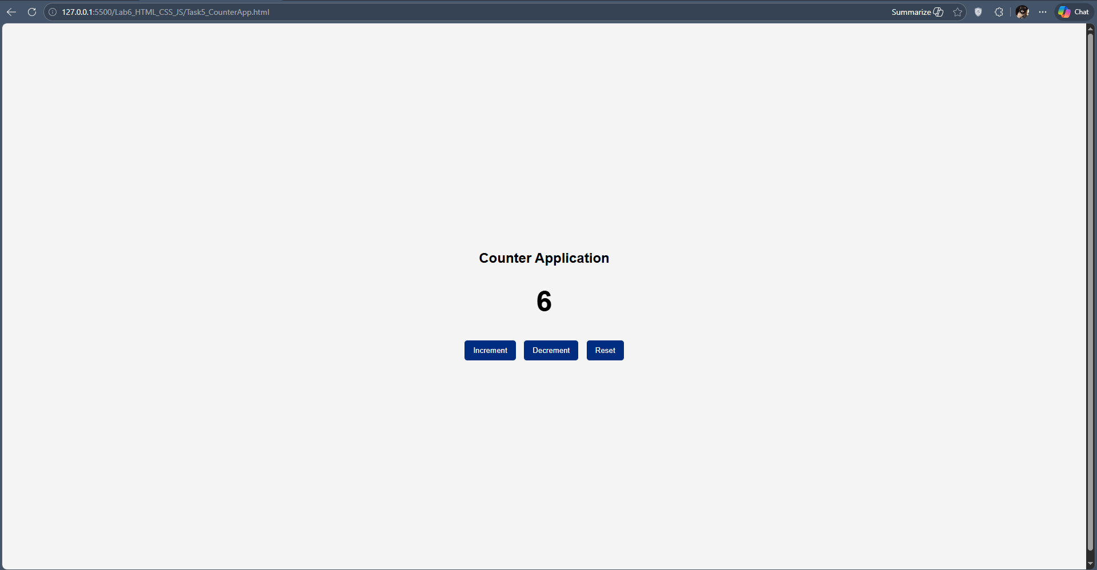
Github:
