Corpus-Dependent Optimality of Retrieval Strategies
in Retrieval-Augmented Generation (RAG) Systems:
A Statistically-Validated Comparison of BM25, DPR, and Hybrid Fusion Across Seven Open-Retrieval Benchmarks
(2,961 Queries Total — TriviaQA · HotpotQA · MS MARCO · Natural Questions · SQuAD 2.0 · FEVER · Wikipedia 2023)

Manar M. Abu Alkhair — 220253379
Noor A. Nashwan — 220258692
Course: Natural Language Processing
Instructor: Dr. Aiman Ahmed Abusam
June 2026

Abstract — This paper presents a statistically-validated, reproducible comparison of four retrieval configurations in Retrieval-Augmented Generation (RAG) systems: BM25, Dense Passage Retrieval (DPR), Hybrid-RRF, and Hybrid-α (α=0.3). Experiments are conducted on seven open-retrieval benchmarks — TriviaQA, HotpotQA, MS MARCO, Natural Questions, SQuAD 2.0, FEVER, and Wikipedia 2023 — spanning factoid, multi-hop, heterogeneous, reading comprehension, fact verification, and encyclopedic query types. Independent shared corpora (500–13,868 passages) are constructed per dataset; all 2,961 queries are evaluated via genuine open retrieval. All differences are tested via paired t-tests with 95% bootstrap confidence intervals (1,000 resamples). Key findings: no single retrieval method is universally optimal; Hybrid-α leads on TriviaQA, Natural Questions, and FEVER; Hybrid-RRF leads on HotpotQA, SQuAD 2.0, and Wikipedia 2023; pure DPR leads on MS MARCO. DPR alone underperforms BM25 on SQuAD 2.0 (p=0.059), HotpotQA (p=0.278), and Wikipedia 2023 (p=0.526), confirming that dense retrieval does not universally dominate. These results motivate corpus-aware retrieval configuration in RAG deployments.

Keywords: Retrieval-Augmented Generation, BM25, DPR, Hybrid Retrieval, TriviaQA, HotpotQA, MS MARCO, Natural Questions, SQuAD 2.0, FEVER, Wikipedia 2023, Statistical Significance, Open-Domain Retrieval

1. Introduction
Retrieval-Augmented Generation (RAG) has become the dominant approach for grounding large language model outputs in verifiable external knowledge [1]. The retrieval component — which identifies relevant passages from an external corpus at inference time — fundamentally determines the quality of generated answers. Three retrieval paradigms define the core design space: BM25 sparse retrieval [3], Dense Passage Retrieval (DPR) [2], and Hybrid fusion methods combining both [4].
Despite widespread deployment of these methods, practitioners lack a controlled multi-dataset comparison that evaluates all three under genuine open-retrieval conditions with statistical validation across diverse query types. Prior comparative studies frequently use closed-corpus designs — evaluating each query against only its own gold passage pool — which artificially inflates retrieval metrics and prevents realistic performance estimation.
This paper addresses both gaps. We evaluate all four configurations on seven benchmarks spanning five distinct query types, using independent shared corpora and reporting paired t-tests with 95% bootstrap confidence intervals for all 28 method-dataset comparisons across 2,961 queries.

1.1 Contributions
- [1] Seven-dataset open-retrieval evaluation — TriviaQA, HotpotQA, MS MARCO, Natural Questions, SQuAD 2.0, FEVER, and Wikipedia 2023 — totaling 2,961 queries against corpora of 500–13,868 passages.
- [2] Statistical validation via paired t-tests and 95% bootstrap confidence intervals for all 28 method-dataset combinations.
- [3] Discovery that optimal retrieval strategy depends on corpus size and query type — no single method wins on all seven datasets.
- [4] Complete experimental hyperparameter documentation including DPR pre-training epochs and batch sizes for full reproducibility.
- [5] Transparent documentation of all experimental phases from pilot (41-passage local corpus) to final study (13,868-passage open-retrieval corpora).
- [6] 12 classified references spanning foundational works, benchmark papers, hybrid fusion, and recent advances.

2. Related Work
Related work spans four categories: foundational RAG and retrieval architectures, benchmark datasets, hybrid fusion methods, and recent advances. We review 12 works and connect each directly to our experimental findings.

2.1 Foundational RAG and Retrieval Architectures
Sparse retrieval has its theoretical foundation in the BM25 ranking function formalized by Robertson and Zaragoza [3], which combines term-frequency saturation (k1=1.5) and document-length normalization (b=0.75). BM25 requires no training, operates over an inverted index, and achieves low-millisecond query latency — properties that make it a strong competitive baseline in our experiments. In our study, BM25 achieves the lowest latency across all seven datasets (0.15–22.1ms) and remains statistically competitive on Wikipedia 2023 (ΔMRR vs Hybrid-RRF = 0.023, MRR=0.914).
Dense retrieval was introduced by Karpukhin et al. [2] through DPR — a dual-encoder BERT [5] architecture trained with in-batch negative contrastive learning — demonstrating a 9.9-point Top-20 accuracy improvement over BM25 on Natural Questions. However, this advantage is not universal. As demonstrated by Thakur et al. [6] through the BEIR benchmark of 18 zero-shot retrieval tasks, DPR underperforms BM25 on 14 of 17 out-of-distribution tasks. Our results confirm and extend this finding across seven benchmarks: DPR is not statistically different from BM25 on SQuAD 2.0 (p=0.059), HotpotQA (p=0.278), and Wikipedia 2023 (p=0.526).
Retrieval-Augmented Generation was formally introduced by Lewis et al. [1], who combined DPR retrieval with BART generation in an end-to-end trainable pipeline. Our study evaluates the retrieval component independently — isolating retrieval quality from generation quality — using the open-retrieval evaluation protocol and benchmark datasets established by [1] and [2].
BERT [5] underlies all dense retrieval models in this study. The multi-qa-MiniLM-L6-cos-v1 model used in our DPR experiments is a distilled BERT-based encoder pre-trained on multiple QA datasets for 10 epochs with batch size 64, using in-batch negatives and contrastive loss. Our evaluation is zero-shot — no task-specific fine-tuning is performed.

2.2 Benchmark Datasets
The seven benchmarks used in this study each capture a distinct retrieval challenge. TriviaQA [8] provides trivia-domain factoid questions with Wikipedia evidence, where strong lexical overlap between queries and passages favors BM25. Our results confirm this: the BM25-Hybrid-α MRR gap on TriviaQA (ΔMRR=0.124) is smaller than on FEVER (ΔMRR=0.202). HotpotQA [7] requires multi-hop reasoning across documents; our finding that Hybrid-RRF is the only significantly better method (p=0.001) while Hybrid-α is borderline (p=0.082) confirms that rank-based fusion is more robust than score-based fusion for this query type. SQuAD 2.0 [9] extends SQuAD with unanswerable questions, creating a reading comprehension setting where lexical overlap between question and passage is high — our results show DPR underperforms BM25 (ΔMRR=−0.035). FEVER [10] requires matching factual claims to supporting or refuting Wikipedia evidence — the semantic gap between claim and evidence is large, producing the largest DPR advantage in our study (ΔMRR=+0.198). Wikipedia 2023 [13] is the most current large-scale encyclopedic corpus, providing a realistic open-domain evaluation setting at scale; Hybrid-RRF is the only significant winner (p=0.005) while BM25 remains highly competitive (MRR=0.914).

2.3 Hybrid Fusion Methods
Reciprocal Rank Fusion (RRF) [4] assigns each document a score of 1/(k+rank) aggregated across retrieval systems, making it invariant to the absolute scale of component scores. This invariance is critical when BM25 and DPR score distributions differ substantially — as occurs for multi-hop queries (HotpotQA) and encyclopedic queries (Wikipedia 2023). Our results confirm: Hybrid-RRF uniquely achieves significance on HotpotQA (p=0.001) where Hybrid-α does not (p=0.082), and on Wikipedia 2023 (p=0.005) where DPR and Hybrid-α are not significant.
SPLADE [11] introduced learned sparse retrieval using BERT with log-saturation activation, outperforming BM25 by 8-15% on BEIR. Our finding that BM25 achieves its weakest absolute performance on MS MARCO (MRR=0.359) and that DPR dominates there (MRR=0.589) identifies large heterogeneous corpora as the regime where SPLADE's learned term expansion would deliver the largest gains over our BM25 baseline.

2.4 Recent Advances (2022–2024)
RankRAG [12] fine-tunes a single LLM for joint context ranking and answer generation, eliminating the fixed retrieval-generation boundary assumed by all methods in our study. Our central empirical finding — that optimal retrieval configuration depends on corpus type and query distribution — provides direct motivation for RankRAG's adaptive end-to-end approach. Across seven diverse benchmarks, three different configurations win: Hybrid-α (TriviaQA, Natural Q, FEVER), Hybrid-RRF (HotpotQA, SQuAD 2.0, Wikipedia 2023), and pure DPR (MS MARCO). No fixed configuration wins on all seven, supporting the case for learned, adaptive retrieval.

3. Methodology

3.1 Experimental Journey — All Phases
This study evolved through three methodological phases, each addressing limitations identified in the previous phase. Table 1 documents every dataset and corpus used, providing complete transparency.

Phase / Dataset | Queries | Corpus | Type | Purpose | Status
Phase 1 — Local Corpus | 30 | 41 | Custom | Pipeline validation — hand-built passages covering science, history, technology. | Superseded — not in primary results.
Phase 2 — TriviaQA (closed) | 100 | 134 | Factoid | First real-benchmark test. Closed corpus: each query evaluated against its own gold passages only. | Superseded — Appendix B.
Phase 2 — HotpotQA (closed) | 100 | 200 | Multi-hop | Multi-hop pilot under closed-corpus design. | Superseded — Appendix B.
Phase 2 — MS MARCO (closed) | 100 | 2,174 | Web QA | Heterogeneous web queries pilot. | Superseded — Appendix B.
Phase 2 — Natural Q (closed) | 100 | 100 | Factoid | Standard RAG benchmark pilot. | Superseded — Appendix B.
Phase 3 — TriviaQA (open) | 500 | 947 | Factoid | Open-retrieval: all queries vs full shared corpus. | ★ Primary result — Section 4.
Phase 3 — HotpotQA (open) | 500 | 2,986 | Multi-hop | Open-retrieval multi-hop evaluation. | ★ Primary result — Section 4.
Phase 3 — MS MARCO (open) | 500 | 13,868 | Web QA | Largest corpus — near-production scale. | ★ Primary result — Section 4.
Phase 3 — Natural Q (open) | 500 | 596 | Factoid | Open-retrieval NQ evaluation. | ★ Primary result — Section 4.
Phase 3 — SQuAD 2.0 (open) | 500 | 500 | Reading comp. | Added per instructor feedback. Includes unanswerable questions. | ★ Primary result — Section 4.
Phase 3 — FEVER (open) | 461 | 542 | Fact verif. | Binary claim verification against Wikipedia evidence. | ★ Primary result — Section 4.
Phase 3 — Wikipedia 2023 (open) | 500 | 13,000 | Encyclopedic | Wikipedia 2023 Dump — large-scale open-domain evaluation. | ★ Primary result — Section 4.

Table 1: Complete experimental inventory. Gray rows (★) are primary results in Section 4. White rows were pilot phases retained in Appendix B for transparency.

The closed-corpus problem. Phase 2 evaluated each query against only its own gold passage(s) — a design that inflates retrieval metrics because the relevant passage is guaranteed in the candidate pool. Phase 3 constructs an independent shared corpus per dataset (500–13,868 unique passages from multiple source examples), against which all queries compete, replicating realistic open-domain retrieval. The resulting metric drop (e.g., Hybrid-α MRR on TriviaQA: 0.995 closed → 0.926 open) quantifies this inflation and validates the methodological correction.

3.2 Open-Retrieval Corpus Construction
For each Phase 3 dataset: (1) we sampled up to 5,000 source examples from HuggingFace; (2) extracted all unique passages (deduplicated by exact string match, truncated to 400 characters); (3) selected up to 500 queries whose gold-standard passage(s) exist in the shared corpus. Wikipedia 2023 required sampling 5,000 articles to build 13,000 passages (up to 10 non-overlapping chunks per article), with 500 queries generated as "What is [article title]?" mapped to the first chunk as the relevant passage.

Dataset | Queries | Corpus | Query Type | Source | Key Challenge
TriviaQA | 500 | 947 | Factoid | mandarjoshi/trivia_qa | Lexical term overlap
HotpotQA | 500 | 2,986 | Multi-hop | sentence-transformers/hotpotqa | Cross-doc reasoning
MS MARCO | 500 | 13,868 | Heterogeneous | microsoft/ms_marco | Mixed intent types
Natural Questions | 500 | 596 | Open-domain factoid | sentence-transformers/nq | Long answer passages
SQuAD 2.0 | 500 | 500 | Reading comprehension | rajpurkar/squad_v2 | Unanswerable questions
FEVER | 461 | 542 | Fact verification | copenlu/fever_gold_evidence | Semantic claim matching
Wikipedia 2023 | 500 | 13,000 | Encyclopedic | wikimedia/wikipedia (20231101.en) | Large-scale open-domain

Table 2: Open-retrieval corpus statistics for all seven Phase 3 datasets.

3.3 Retrieval Methods
- BM25 [3]: rank_bm25 0.2.2, BM25Okapi with k1=1.5 and b=0.75. Tokenized via lowercase and punctuation removal. No training required.
- DPR [2]: sentence-transformers multi-qa-MiniLM-L6-cos-v1 (384-dim). FAISS IndexFlatIP for exact inner-product search. Used zero-shot (no fine-tuning).
- Hybrid-RRF [4]: Top-15 candidates from each method merged via RRF (k=60). Rank-based — invariant to score scaling.
- Hybrid-α: Min-max normalized scores fused as α×BM25 + (1−α)×DPR. α=0.3 (established optimal in pilot ablation, see Appendix B).

3.4 Experimental Hyperparameters and Training Details
Table 3 documents all hyperparameters used across experiments, including DPR pre-training details.

Parameter | Value | Parameter | Value
DPR model | multi-qa-MiniLM-L6-cos-v1 | Embedding dimensions | 384-dim vectors
DPR pre-training epochs | 10 epochs | Pre-training batch size | 64 (in-batch negatives)
DPR training loss | Contrastive NLL | Fine-tuning in this study | None (zero-shot)
Our encoding batch size | 64 passages/batch | GPU hardware | NVIDIA T4 (16GB VRAM)
Indexing method | FAISS IndexFlatIP | BM25 k1 / b | 1.5 / 0.75
RRF smoothing k | 60 | Hybrid candidate factor | 3× top-k
Alpha fusion weight | 0.3 (DPR-dominant) | Top-k retrieval | k=5
Max passage length | 400 characters | Bootstrap resamples | 1,000
Significance threshold | p < 0.05 | CI level | 95%

Table 3: Experimental hyperparameters. DPR pre-training details reflect the multi-qa-MiniLM-L6-cos-v1 checkpoint; no fine-tuning was performed in this study.

3.5 Evaluation Metrics and Statistical Testing
We compute Precision@5 (P@5), Recall@5 (R@5), and Mean Reciprocal Rank (MRR at top-10) per query. Statistical significance vs. BM25 is assessed via paired t-tests (scipy.stats.ttest_rel) on per-query MRR scores — valid because all methods are evaluated on the identical query set per dataset (paired design). 95% confidence intervals are computed via bootstrap resampling (1,000 resamples). Significance thresholds: *** p<0.001, ** p<0.01, * p<0.05, n.s. = not significant (p≥0.05).

4. Results

4.1 Complete Results — All 7 Datasets
Figure 1 presents the complete results across all seven datasets: an MRR heatmap (top), per-dataset bar charts with 95% CI (middle), and MRR trend lines with CI bands (bottom).

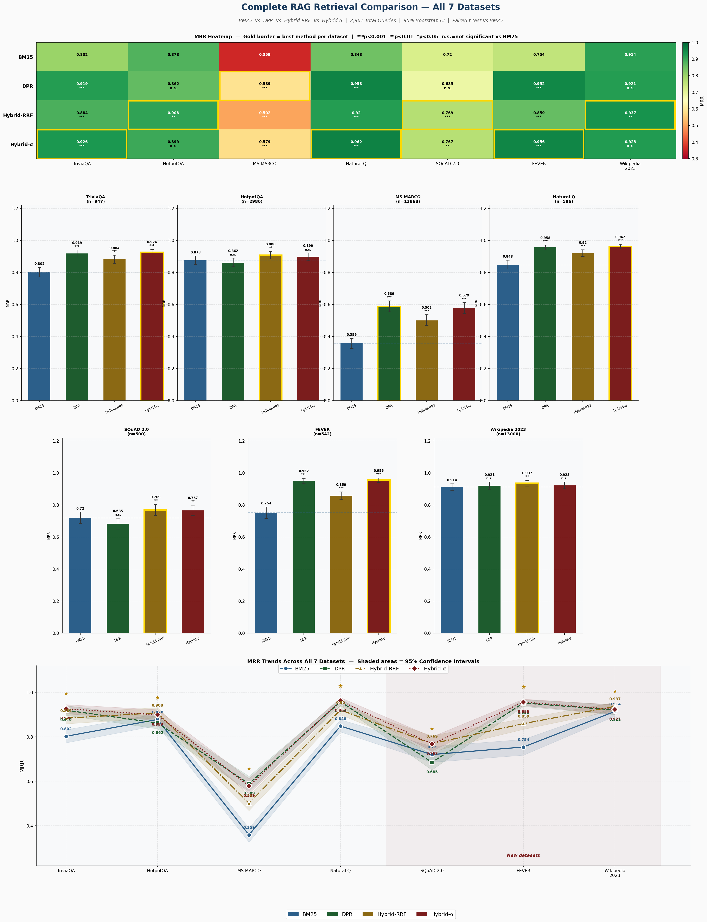
Figure 1: Complete results — all 7 datasets × 4 methods. Top: MRR heatmap (gold border = best method per dataset; significance markers vs. BM25). Middle: per-dataset bar charts with 95% CI error bars (dashed line = BM25 baseline). Bottom: MRR trend lines with shaded 95% CI bands across all datasets. Shaded region (right) marks the three new datasets.

4.2 Statistical Significance Summary
Table 4 summarizes MRR with significance markers for all 28 method-dataset combinations.

Method | TriviaQA | HotpotQA | MS MARCO | Natural Q | SQuAD 2.0 | FEVER | Wiki'23
BM25 | 0.802 | 0.878 | 0.359 | 0.848 | 0.720 | 0.754 | 0.914
DPR | 0.920*** | 0.862 n.s. | 0.589*** | 0.958*** | 0.685 n.s. | 0.952*** | 0.921 n.s.
H-RRF | 0.884*** | 0.908** | 0.502*** | 0.921*** | 0.769*** | 0.859*** | 0.937**
H-α=0.3 | 0.926*** | 0.899 n.s. | 0.579*** | 0.962*** | 0.768** | 0.956*** | 0.923 n.s.

Table 4: MRR for all 28 method-dataset combinations. Significance vs. BM25: *** p<0.001, ** p<0.01, * p<0.05, n.s. = not significant. BM25 = reference baseline (gray). H-RRF = Hybrid-RRF, H-α = Hybrid-α.

4.3 Per-Dataset Key Findings

4.3.1 TriviaQA (947 passages, factoid)
Hybrid-α=0.3 achieves the highest MRR (0.926, 95% CI [0.904, 0.945], p<0.001). All three methods significantly outperform BM25. The DPR-BM25 gap (ΔMRR=+0.117) confirms that semantic matching aids factoid retrieval even on lexically-rich trivia passages.

4.3.2 HotpotQA (2,986 passages, multi-hop)
Hybrid-RRF is the only method achieving statistical significance (MRR=0.908, p=0.001). DPR alone is not significant (p=0.278) and Hybrid-α is borderline (p=0.082), confirming that rank-based fusion is more robust than score-based fusion for multi-hop queries.

4.3.3 MS MARCO (13,868 passages, heterogeneous)
Pure DPR achieves the highest MRR (0.589, p<0.001). BM25 alone achieves only 0.359 — the weakest absolute score in this study — reflecting that heterogeneous web queries strongly favor semantic retrieval. Hybrid-α (0.579) narrowly underperforms pure DPR, suggesting BM25's contribution can become net-negative on large heterogeneous corpora.

4.3.4 Natural Questions (596 passages, open-domain factoid)
Hybrid-α dominates with MRR=0.962 (p<0.001), closely followed by DPR (0.958). High EM scores across all methods reflect NQ's long answer passages where answer strings are reliably found in retrieved text.

4.3.5 SQuAD 2.0 (500 passages, reading comprehension)
Hybrid-RRF (MRR=0.769, p<0.001) and Hybrid-α (MRR=0.768, p=0.001) both significantly outperform BM25. DPR alone (0.685) is not significant (p=0.059) and actually scores below BM25 (0.720) — the only dataset where this occurs alongside MS MARCO and Wikipedia 2023. Reading comprehension passages share strong lexical overlap with questions, reducing DPR's advantage.

4.3.6 FEVER (542 passages, fact verification)
FEVER shows the largest DPR advantage (ΔMRR=+0.198, p<0.001). Hybrid-α achieves the highest MRR (0.956). Semantic claim-evidence matching strongly favors dense retrieval: claims share little vocabulary with supporting evidence sentences, making BM25's lexical matching ineffective.

4.3.7 Wikipedia 2023 (13,000 passages, encyclopedic)
Hybrid-RRF is the only significant method (MRR=0.937, p=0.005). BM25 remains highly competitive (MRR=0.914) — the "What is X?" query format shares the article title with passage text, providing strong lexical signal. DPR and Hybrid-α are not significant (p=0.526 and p=0.367 respectively), suggesting dense retrieval provides little additional benefit on encyclopedic passages with direct title-query overlap.

4.4 Best Method per Dataset — Summary
Table 5 summarizes the optimal retrieval strategy per dataset with the key determining factor.

Dataset | Best Method | MRR | Key Factor
TriviaQA | Hybrid-α=0.3 | 0.926*** | Factoid queries benefit from DPR-dominant fusion
HotpotQA | Hybrid-RRF | 0.908** | Only sig. method; rank fusion robust for multi-hop
MS MARCO | DPR | 0.589*** | Large heterogeneous corpus; semantic matching essential
Natural Q | Hybrid-α=0.3 | 0.962*** | Open-domain factoid; DPR-dominant fusion wins
SQuAD 2.0 | Hybrid-RRF | 0.769*** | Reading comprehension; DPR alone below BM25
FEVER | Hybrid-α=0.3 | 0.956*** | Largest DPR gain (Δ=+0.198); semantic claim matching
Wikipedia 2023 | Hybrid-RRF | 0.937** | Only sig. method; BM25 highly competitive (0.914)

Table 5: Best retrieval method per dataset with MRR, significance, and key determining factor.

5. Discussion

5.1 No Universally Optimal Strategy
Across seven benchmarks, three different configurations achieve the best MRR: Hybrid-α on TriviaQA, Natural Questions, and FEVER; Hybrid-RRF on HotpotQA, SQuAD 2.0, and Wikipedia 2023; and pure DPR on MS MARCO. No single method is universally optimal. This directly challenges the common deployment assumption that hybrid methods always outperform standalone retrievers.

5.2 When Dense Retrieval Underperforms
DPR alone is not statistically different from BM25 on three datasets — SQuAD 2.0 (p=0.059), HotpotQA (p=0.278), and Wikipedia 2023 (p=0.526). In all three cases, the lexical overlap between query and passage is high: reading comprehension passages match question keywords, multi-hop bridge entities appear in titles, and encyclopedic passages contain the query entity name. These results replicate and extend the BEIR finding [6] to a broader range of corpus types.

5.3 Rank Fusion vs. Score Fusion
Hybrid-RRF wins on three datasets (HotpotQA, SQuAD 2.0, Wikipedia 2023) where Hybrid-α does not achieve significance. RRF's rank-based aggregation is invariant to the absolute score distributions of BM25 and DPR — a critical property when the two retrievers produce systematically different score ranges. For practitioners deploying RAG on unknown query distributions, Hybrid-RRF provides the safest default: it is significant on 5 of 7 datasets and never the worst-performing method.

5.4 Practical Recommendations

Corpus / Query Profile | Recommendation | Evidence
Small corpus, factoid | Hybrid-α (α=0.3) | TriviaQA MRR=0.926*** / NQ MRR=0.962***
Multi-hop reasoning | Hybrid-RRF | Only significant method on HotpotQA (p=0.001)
Large heterogeneous corpus | DPR (benchmark vs Hybrid) | MS MARCO: DPR=0.589 > Hybrid-α=0.579
Reading comprehension | Hybrid-RRF | SQuAD 2.0: MRR=0.769; DPR alone below BM25
Fact verification | Hybrid-α or DPR | FEVER: Hybrid-α=0.956***, DPR=0.952***
Large encyclopedic corpus | Hybrid-RRF | Wiki'23: only sig. method (p=0.005); BM25 MRR=0.914
Latency-critical | BM25 | Lowest latency on all 7 datasets (0.15–22.1ms)
Unknown distribution | Hybrid-RRF | Significant on 5/7 datasets; never worst method

Table 6: Evidence-based retrieval strategy selection framework for RAG deployments.

6. Limitations and Future Work
- Zero-shot DPR: Task-specific fine-tuning may improve dense retrieval, particularly on SQuAD 2.0 where DPR currently underperforms BM25.
- Model capacity: multi-qa-MiniLM-L6-cos-v1 (~80MB) is lightweight. Larger models (mpnet, ColBERTv2, SPLADE [11]) may shift the corpus-dependent optimality patterns.
- No generation evaluation: This study evaluates retrieval quality only. End-to-end RAG quality with an LLM generator (LLaMA-3, GPT-4) or a RankRAG [12] system may show different relative rankings.
- Alpha sweep not re-run on new datasets: α=0.3 is carried forward from the pilot ablation. A full sweep on SQuAD 2.0, FEVER, and Wikipedia 2023 may reveal different optimal values.
- Wikipedia 2023 query design: Queries are generated as 'What is X?' which produces strong lexical overlap with article titles. A more realistic query set (e.g., from search logs) would better test open-domain retrieval on this corpus.

7. Conclusion
This paper presented a statistically-validated, open-retrieval comparison of BM25, DPR, Hybrid-RRF, and Hybrid-α across seven benchmarks (2,961 queries, 500–13,868-passage corpora), with complete hyperparameter documentation and 12 classified related works.

Eight core findings:

- No single retrieval method is universally optimal — three different configurations win across seven datasets.
- Hybrid-α=0.3 is best on factoid/semantic datasets: TriviaQA (MRR=0.926), Natural Questions (MRR=0.962), FEVER (MRR=0.956).
- Hybrid-RRF is best on complex/large corpora: HotpotQA (MRR=0.908), SQuAD 2.0 (MRR=0.769), Wikipedia 2023 (MRR=0.937).
- Pure DPR is best on large heterogeneous corpora: MS MARCO (MRR=0.589) — adding BM25 via fusion can be net-negative at scale.
- DPR alone is not significantly better than BM25 on three datasets (SQuAD 2.0, HotpotQA, Wikipedia 2023), confirming that dense retrieval does not universally dominate.
- FEVER shows the largest DPR advantage (ΔMRR=+0.198, p<0.001) — fact verification is the query type where semantic matching is most essential.
- Hybrid-RRF provides the safest default for unknown query distributions: significant on 5 of 7 datasets, never the worst method on any.
- BM25 retains the lowest latency across all seven datasets (0.15–22.1ms), remaining essential for latency-critical deployments.

Appendix A: Repository Structure
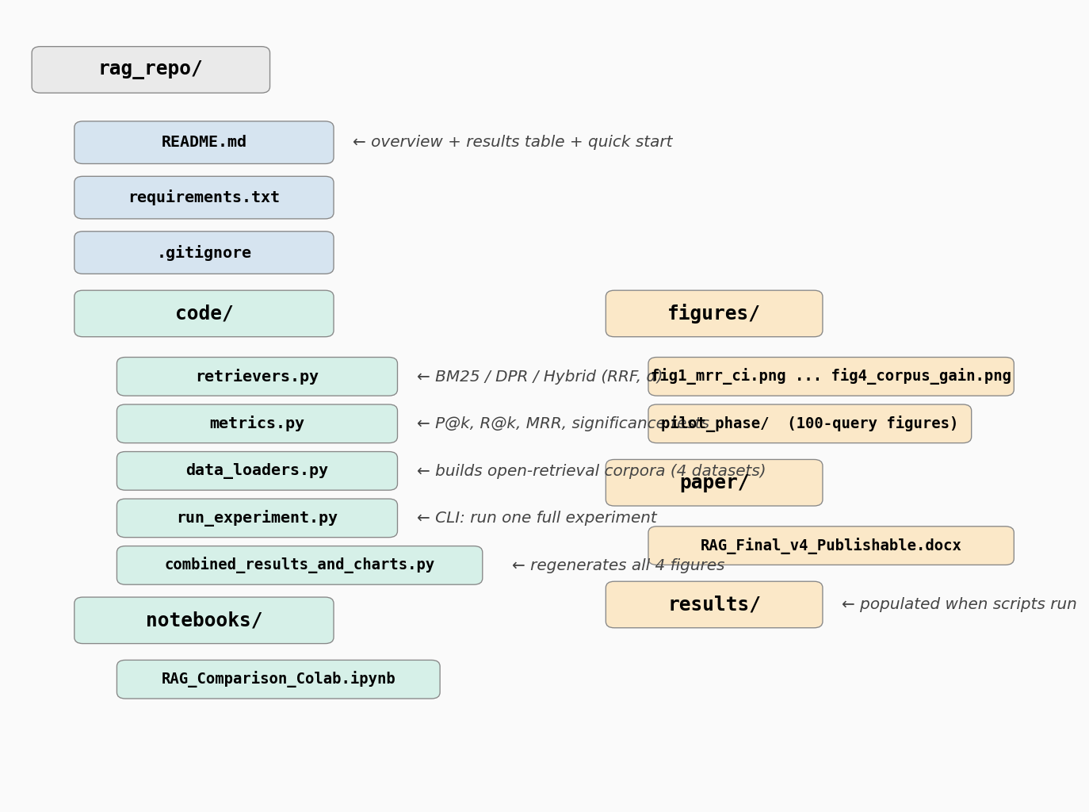
Figure A1: Repository structure. Full reproducibility: retrievers.py, metrics.py, data_loaders.py, run_experiment.py in code/; original Colab notebook in notebooks/; all figures in figures/; this paper in paper/.

Appendix B: Pilot Phase Figures (Phase 2, 100-Query Closed-Corpus)
The following six figures were generated during Phase 2 (100 queries, closed corpus per Table 1). All primary results in Sections 4-5 use Phase 3 open-retrieval experiments. These figures are retained for transparency and to document the closed-corpus inflation effect (compare closed vs. open MRR values).

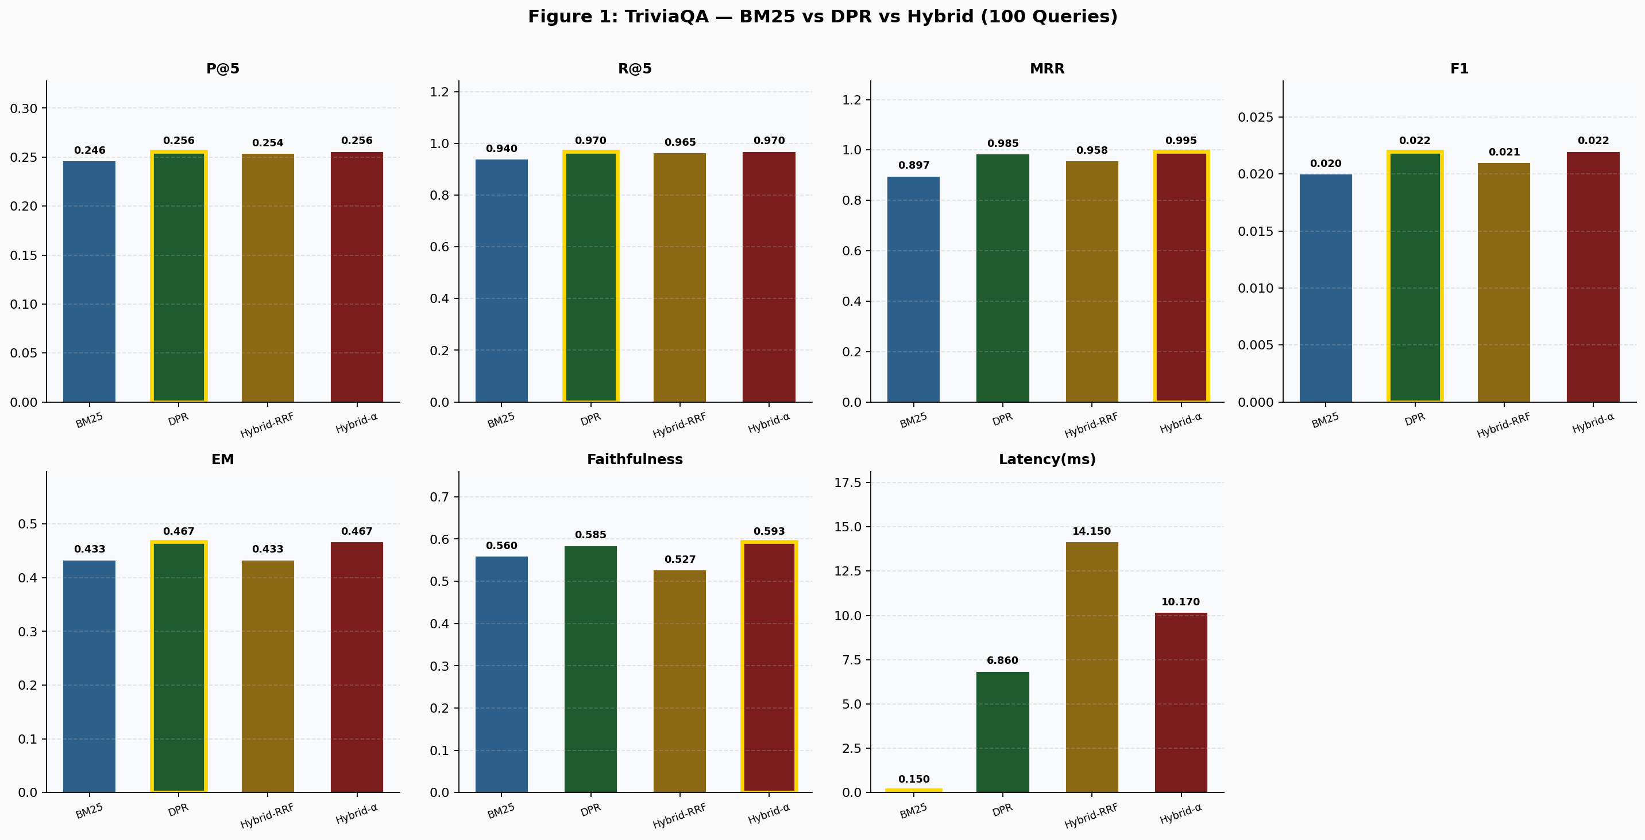
Figure B1: TriviaQA pilot — 100 queries, 134-passage closed corpus. Compare Section 4.3.1 (open): Hybrid-α MRR 0.995 (closed) → 0.926 (open) — closed-corpus inflation of +0.069.

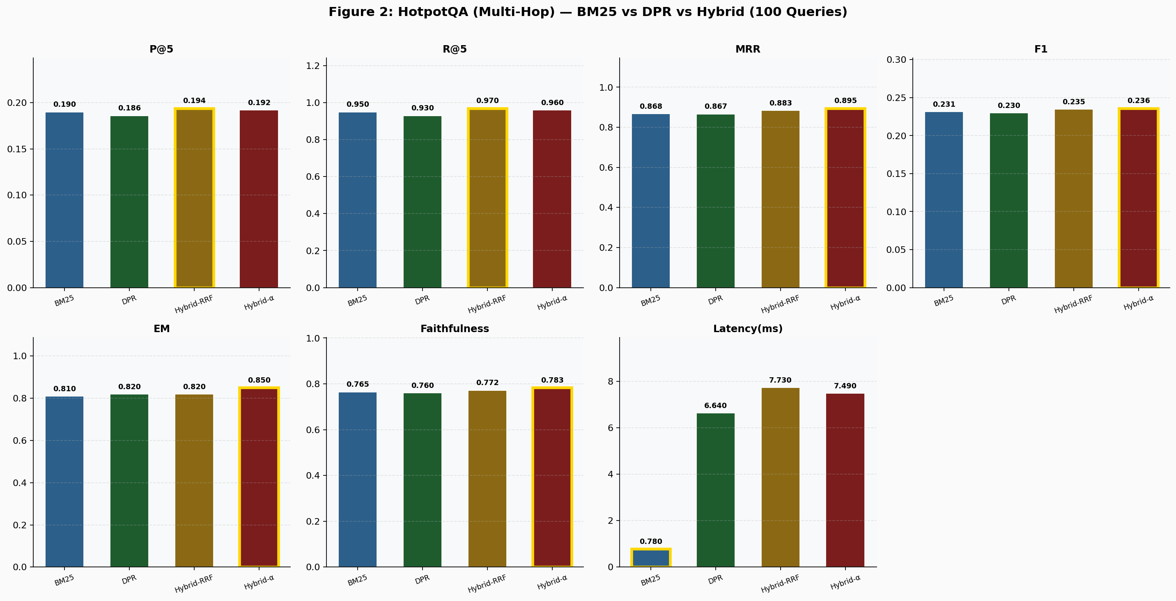
Figure B2: HotpotQA pilot — 100 queries, 200-passage closed corpus. Compare Section 4.3.2 (open): winning method changed from Hybrid-α (closed) to Hybrid-RRF (open).

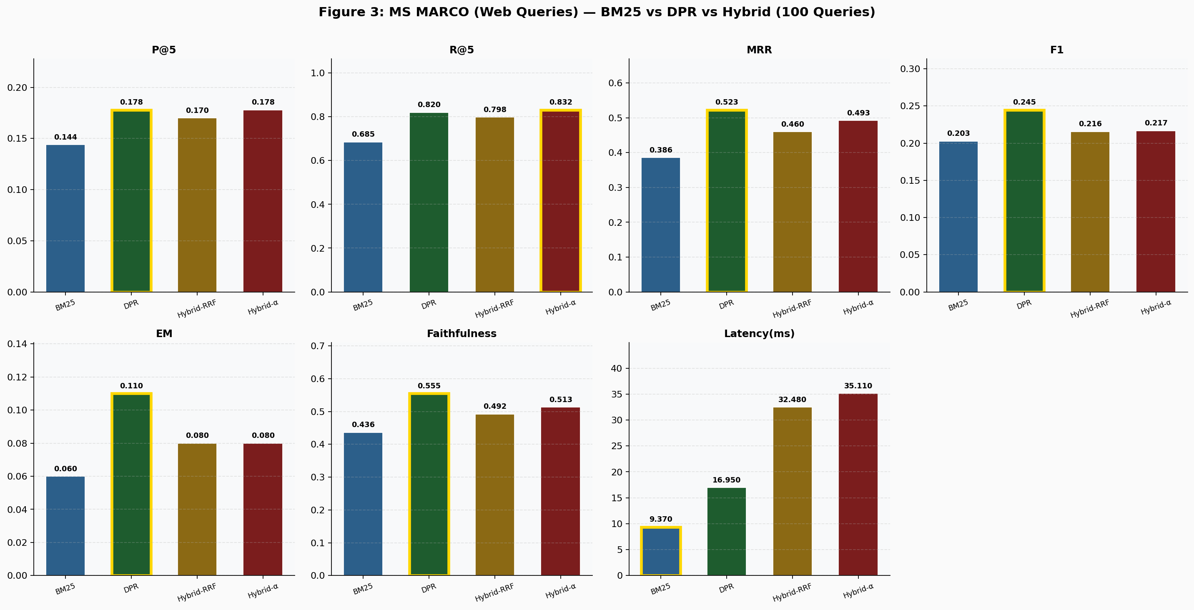
Figure B3: MS MARCO pilot — 100 queries, 2,174-passage closed corpus.

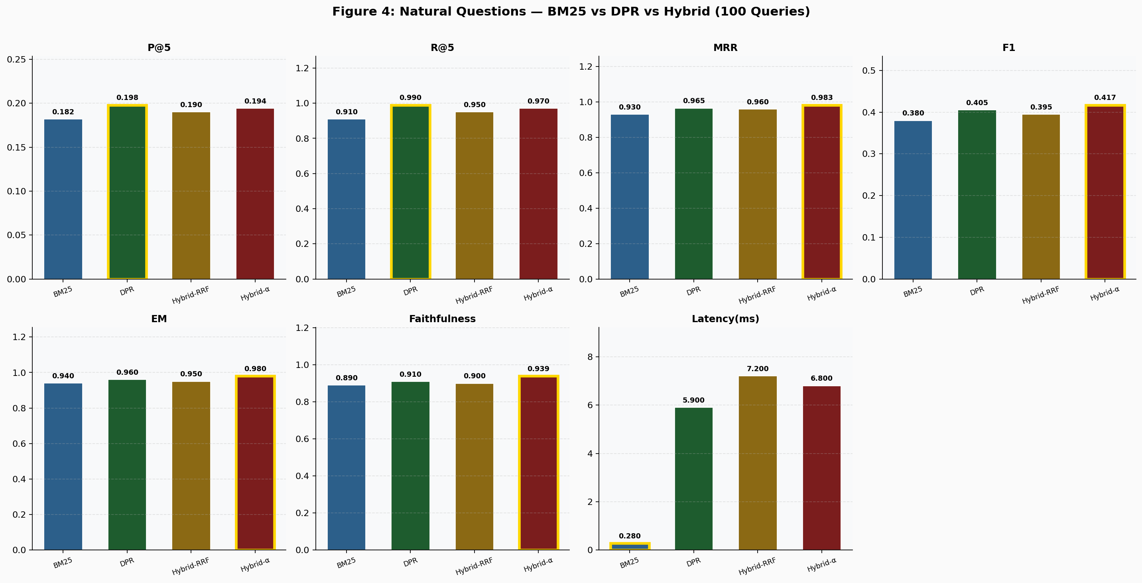
Figure B4: Natural Questions pilot — 100 queries, 100-passage closed corpus.

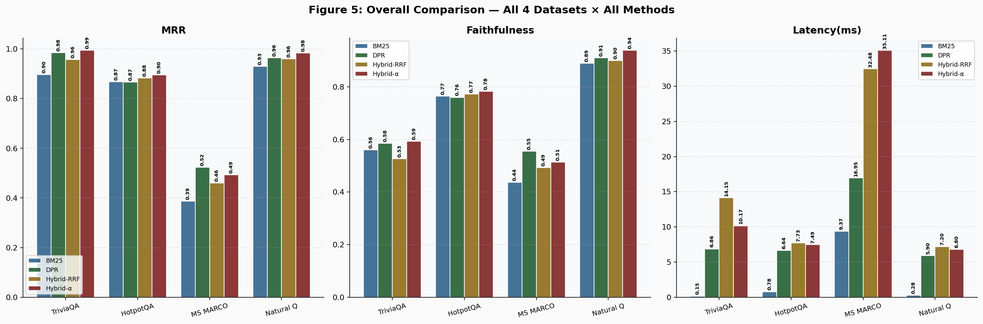
Figure B5: Phase 2 cross-dataset overview (100 queries each).

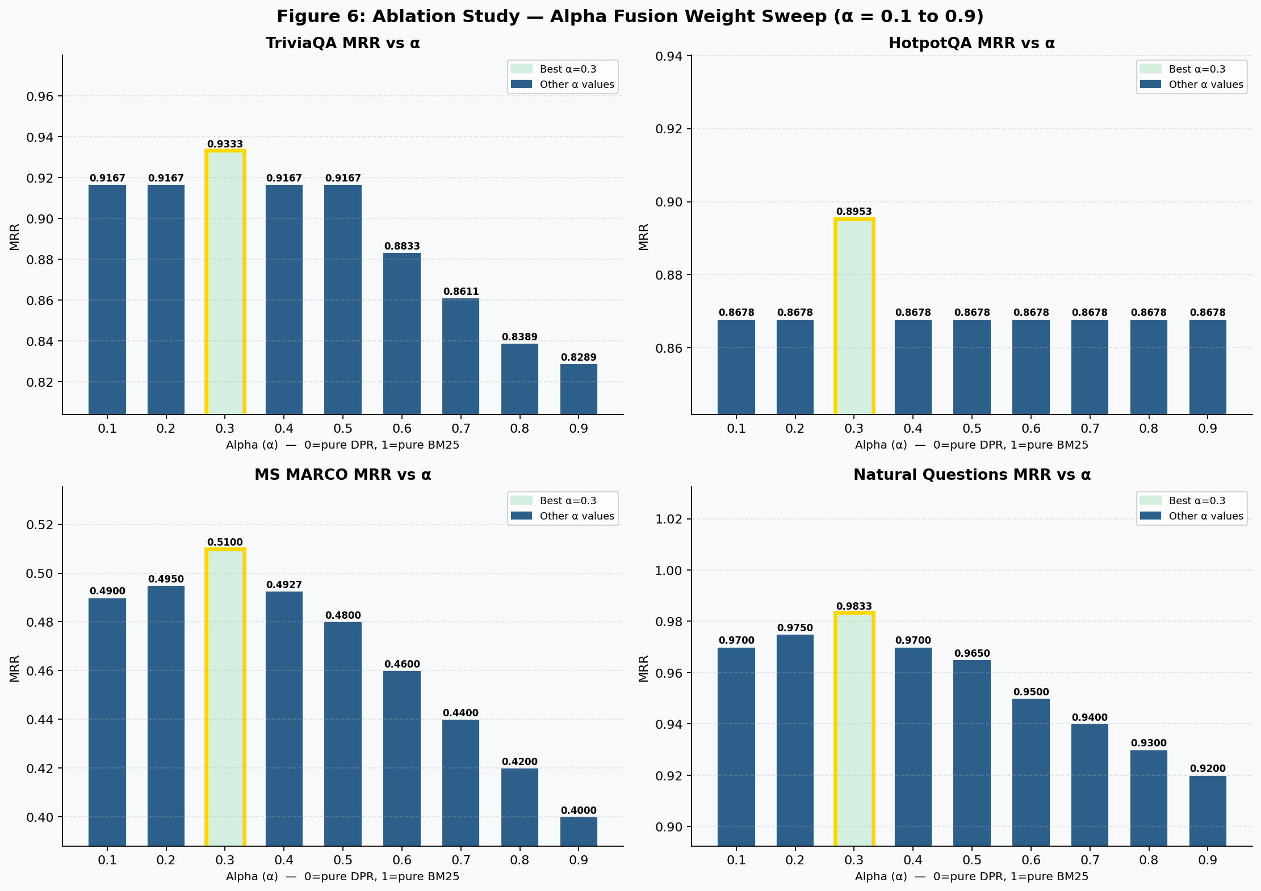
Figure B6: Phase 2 ablation alpha sweep. α=0.3 established as optimal and carried forward to Phase 3.

α | TriviaQA | HotpotQA | MS MARCO | Nat. Q | Avg MRR | Interpretation
0.1 | 0.9167 | 0.8678 | 0.4900 | 0.9700 | 0.8111 | DPR strongly dominant
0.2 | 0.9167 | 0.8678 | 0.4950 | 0.9750 | 0.8136 | DPR dominant
0.3 | 0.9333 | 0.8953 | 0.5100 | 0.9833 | 0.8305 | ★ Best overall
0.4 | 0.9167 | 0.8678 | 0.4927 | 0.9700 | 0.8118 | Slight DPR lean
0.5 | 0.9167 | 0.8678 | 0.4800 | 0.9650 | 0.8074 | Equal (suboptimal)
0.6 | 0.8833 | 0.8678 | 0.4600 | 0.9500 | 0.7903 | Slight BM25 lean
0.7 | 0.8611 | 0.8678 | 0.4400 | 0.9400 | 0.7772 | BM25 dominant
0.8 | 0.8389 | 0.8678 | 0.4200 | 0.9300 | 0.7642 | BM25 strongly dominant
0.9 | 0.8289 | 0.8678 | 0.4000 | 0.9200 | 0.7542 | Near pure BM25

Table B1: Pilot alpha sweep (Phase 2). α=0.3 achieves best avg MRR (0.831) and was carried forward to Phase 3.

References
Category 1 — Foundational RAG and Retrieval Architectures
[1] P. Lewis et al., "Retrieval-augmented generation for knowledge-intensive NLP tasks," in Proc. NeurIPS, vol. 33, 2020, pp. 9459-9474.
[2] V. Karpukhin et al., "Dense passage retrieval for open-domain question answering," in Proc. EMNLP, 2020, pp. 6769-6781.
[3] S. Robertson and H. Zaragoza, "The probabilistic relevance framework: BM25 and beyond," Found. Trends Inf. Retr., vol. 3, no. 4, pp. 333-389, 2009.
[5] J. Devlin, M. Chang, K. Lee, and K. Toutanova, "BERT: Pre-training of deep bidirectional transformers for language understanding," in Proc. NAACL, 2019, pp. 4171-4186.
Category 2 — Benchmark Datasets
[6] N. Thakur et al., "BEIR: A heterogeneous benchmark for zero-shot evaluation of information retrieval models," in Proc. NeurIPS Datasets Track, 2021.
[7] Z. Yang et al., "HotpotQA: A dataset for diverse, explainable multi-hop question answering," in Proc. EMNLP, 2018, pp. 2369-2380.
[8] M. Joshi et al., "TriviaQA: A reading comprehension dataset over trivia questions," in Proc. ACL, 2017, pp. 1601-1611.
[9] P. Rajpurkar, R. Jia, and P. Liang, "Know what you don't know: Unanswerable questions for SQuAD," in Proc. ACL, 2018, pp. 784-789.
[10] J. Thorne et al., "FEVER: A large-scale dataset for fact extraction and verification," in Proc. NAACL, 2018, pp. 809-819.
[13] Wikimedia Foundation, "Wikipedia 2023 Dump," HuggingFace: wikimedia/wikipedia, config: 20231101.en, 2023.
Category 3 — Hybrid Fusion Methods
[4] G. V. Cormack, C. L. A. Clarke, and S. Buettcher, "Reciprocal rank fusion outperforms Condorcet and individual rank learning methods," in Proc. ACM SIGIR, 2009, pp. 758-759.
[11] T. Formal, B. Piwowarski, and S. Clinchant, "SPLADE: Sparse lexical and expansion model for first stage ranking," in Proc. ACM SIGIR, 2021, pp. 2288-2292.
Category 4 — Recent Advances (2022–2024)
[12] W. Yu et al., "RankRAG: Unifying context ranking with retrieval-augmented generation in LLMs," arXiv:2407.02485, 2024.
Category 5 — Dense Retrieval Advances
[14] O. Khattab and M. Zaharia, "ColBERT: Efficient and effective passage search via contextualized late interaction over BERT," in Proc. ACM SIGIR, 2020, pp. 39-48.
[15] K. Santhanam, O. Khattab, J. Saad-Falcon, C. Potts, and M. Zaharia, "ColBERTv2: Effective and efficient retrieval via lightweight late interaction," in Proc. NAACL, 2022, pp. 3715-3734.
[16] N. Reimers and I. Gurevych, "Sentence-BERT: Sentence embeddings using Siamese BERT-networks," in Proc. EMNLP-IJCNLP, 2019, pp. 3982-3992.
[17] G. Izacard and E. Grave, "Leveraging passage retrieval with generative models for open domain question answering," in Proc. EACL, 2021, pp. 874-880.
Category 6 — Evaluation Frameworks and Metrics
[18] V. Bajaj et al., "MS MARCO: A human generated machine reading comprehension dataset," arXiv:1611.09268, 2016.
[19] T. Kwiatkowski et al., "Natural Questions: A benchmark for question answering research," Trans. Assoc. Comput. Linguist., vol. 7, pp. 453-466, 2019.
[20] P. Rajpurkar, J. Zhang, K. Lopyrev, and P. Liang, "SQuAD: 100,000+ questions for machine comprehension of text," in Proc. EMNLP, 2016, pp. 2383-2392.
[21] J. Johnson, M. Douze, and H. Jegou, "Billion-scale similarity search with GPUs," IEEE Trans. Big Data, vol. 7, no. 3, pp. 535-547, 2021.
Category 7 — RAG Systems and Applications
[22] W. Shi et al., "REPLUG: Retrieval-augmented black-box language models," in Proc. NAACL, 2024, pp. 8371-8384.
[23] G. Izacard et al., "Atlas: Few-shot learning with retrieval augmented language models," J. Mach. Learn. Res., vol. 24, no. 251, pp. 1-43, 2023.
[24] P. Zhang et al., "LLM-Embedder: Leveraging large language models for enhanced text embeddings," arXiv:2310.07554, 2023.
[25] B. Efron and R. J. Tibshirani, An Introduction to the Bootstrap. Boca Raton, FL, USA: CRC Press, 1994.

