Chapter 7 – Selection (if / Boolean logic)
how a program can choose between different actions.
- The computer asks yes/no questions, such as “is the score ≥ 90?”
- Each question has an answer that is either True or False.
- Questions can be combined with logical operators and, or, and not.
- if, elif, and else specify which block of code should run depending on the outcome of these questions.
Example – turning a score into a letter grade:
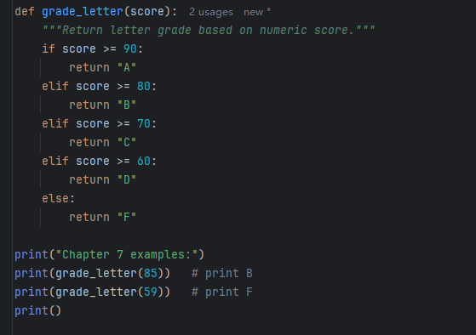
Chapter 8 – More About Iteration (loops)
repetition in programs.
- A loop allows a computer to repeat actions automatically.
- A for loop repeats a known number of times (for example, 10 times).
- A while loop repeats until a condition is no longer true, such as “keep going until the number becomes 1.”
- Classic examples include the 3n + 1 (Collatz) sequence and Newton’s method for square roots.
- Common patterns include keeping a running total and repeating until valid input is given.
Example – counting steps in the 3n+1 sequence:
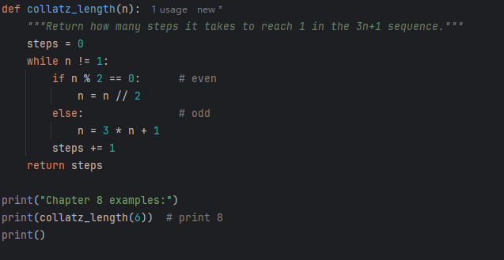
Chapter 9 – Strings (text)
text (strings) are data that a program can manipulate.
- A string is text in quotes, such as "hello" or "abc123".
- Individual characters can be accessed by position, and pieces of text can be sliced out.
- Typical operations include:
  - Concatenation ("hi" + "!" → "hi!")
  - Repetition ("ha" * 3 → "hahaha")
  - Membership tests ("h" in "hello").
- Common methods include .upper(), .lower(), .strip(), .split(), .join(), .format().
- Strings are immutable; once created, they are not changed in place. Instead, new strings are built from old ones.
Example – removing vowels from text:
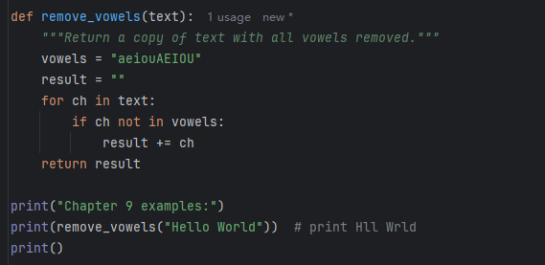
Chapter 10 – Lists (collections of items)
ordered collections of items.
- A list can store numbers, strings, or other objects, for example [10, 20, 30] or ["apple", "banana"].
- Elements are accessed by index, modified, and removed.
- Lists are mutable, meaning their contents can be changed after creation.
- The chapter also covers:
  - How two variables can refer to the same underlying list (aliasing).
  - How to create copies when independent lists are needed.
  - List comprehensions, a concise way to build new lists.
  - Tuples, which are similar to lists but cannot be changed.
Example – list of squares and its minimum/maximum:
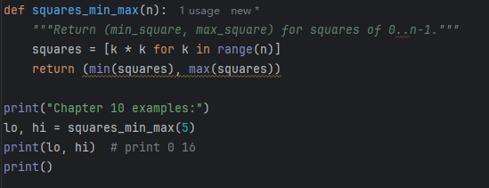
Chapter 11 – Files (reading and writing data)
how a program can read from and write to files.
- Files allow data to be stored permanently and reused later.
- A file can be opened with open("data.txt"), processed line by line, and then closed.
- A with statement is recommended so the file is closed automatically.
- Programs can read data from files, process it, and write results back to new files.
Example – summing numbers stored in a file:
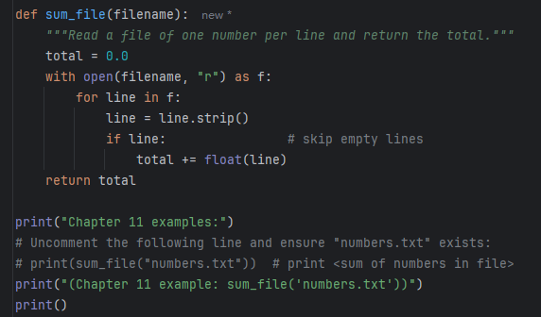
Chapter 12 – Dictionaries (key–value lookups)
dictionaries store information as key–value pairs.
- A dictionary may represent relationships such as name → phone number:
  - {"Alice": "555-1234", "Bob": "555-9999"}
- A value is retrieved by its key, for example phone["Alice"].
- Dictionaries support adding and updating entries, checking whether a key exists, and iterating over keys and values.
- A common use is counting how often items appear in some data.
Example – word frequency counter:
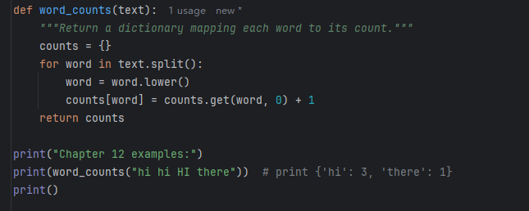
Chapter 17 – Classes and Objects: Basics
programs are built around objects that combine data and behavior.
- A class is a blueprint for creating objects.
- An object created from a class has attributes (data) and methods (functions that operate on that data).
- The special method __init__ (the constructor) sets up the object’s initial state.
- Another special method, __str__, defines how the object is displayed as text.
Example – a Point class representing a point in 2D space:
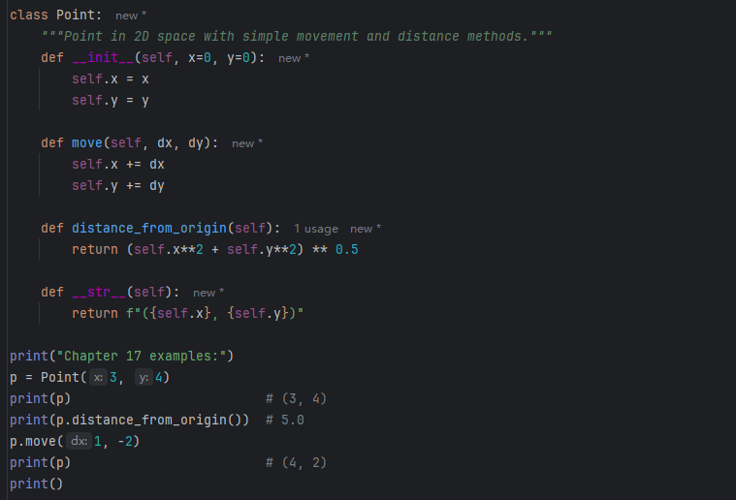
Chapter 18 – Classes and Objects: Deeper (Fractions)
- A Fraction object stores a numerator and denominator, representing rational numbers like 1/2 or 3/4.
- The class can enforce rules such as “the denominator cannot be zero” and “fractions stay in simplified form.”
- Special methods for arithmetic (such as __add__) define how operations like + behave for objects of this class.
- The distinction between value equality (==) and object identity (is) is also explored.
Example – Fraction class that supports addition:
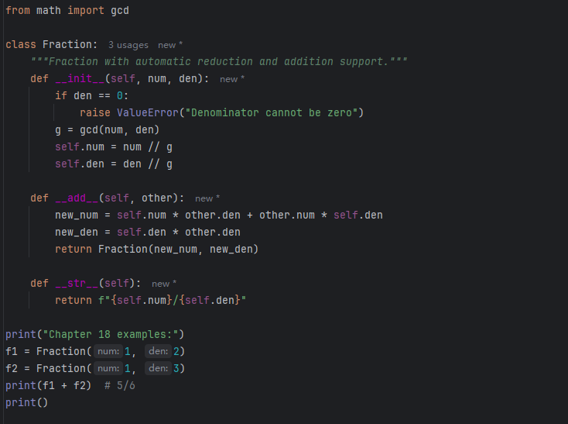
Chapter 20 – Unit Testing (automatic code checking)
testing code automatically.
- A unit test is a small test that checks whether a single function or component behaves correctly.
- The keyword assert is used to state conditions that must always be true; if a condition fails, an error is raised.
- A collection of tests can be run to quickly check for bugs after changes to the code.
- The chapter also introduces the testing framework pytest, which helps organize and run tests.
Example – function with simple unit tests:
