lab04_01_16_2026.R
matthewchan
2026-01-16
x <- seq(1,50, by=0.1)
plot(x)
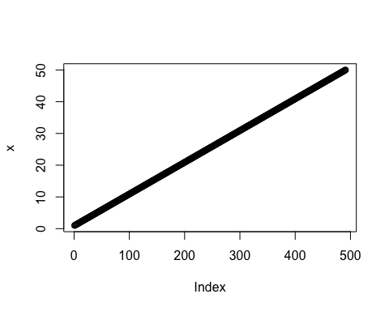
plot(x, sin(x), typ="l", col="blue", lwd=3, xlab="Is it lunch time yet?")
