**Homework 1 Report**

Ram Muthukumar – rm48763

Mark Carter –

URL: Guestbook-mcarter.appspot.com

Info:

Our blog is a site where people can view and share information from and to others around the web.

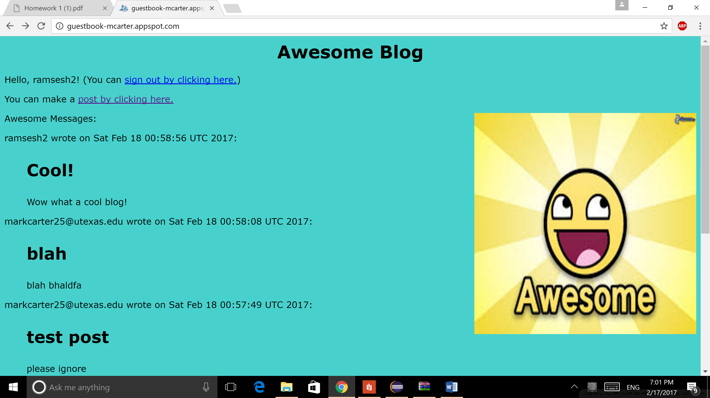

The landing page displays the 5 latest posts, while there is a button at the bottom of the page to view every post. As seen on the screenshot above, while signed in, I have the option to post a message with a title. If I had not signed in, as seen in the following screenshot, I would not have this option.

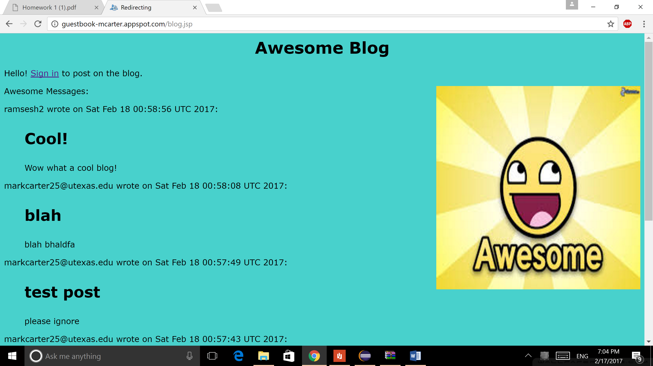

At the bottom of the page, there is a button to view all the posts, as well as a button to subscribe to this blog.

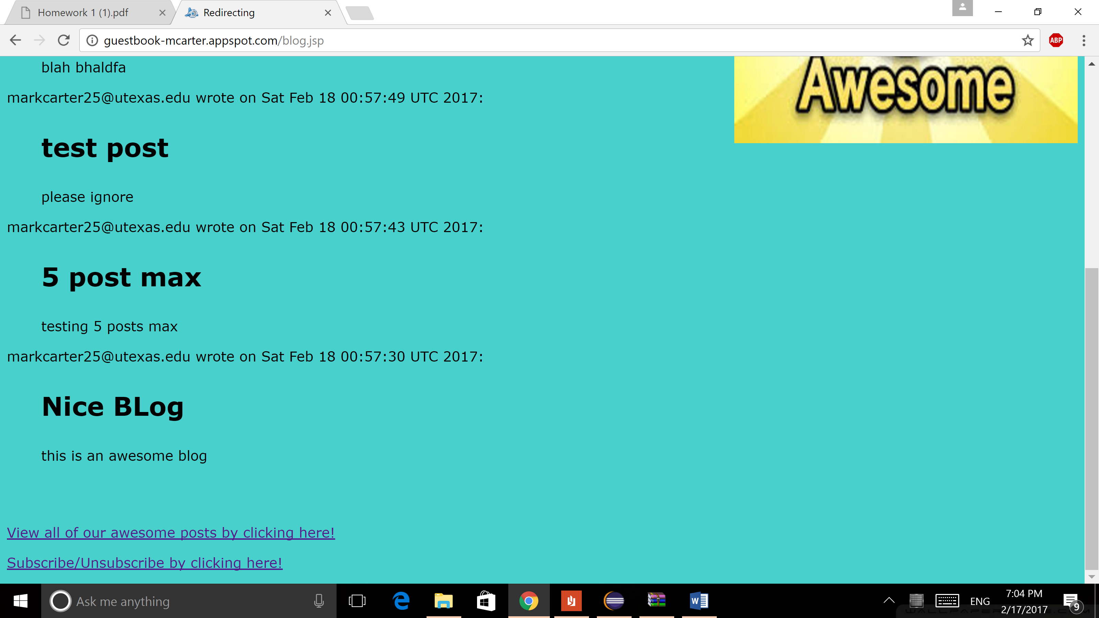

The subscribe/unsubscribe page allows you to input your email to either the subscribe option or to the unsubscribe option. The former subscribes the email, while the latter unsubscribes it.

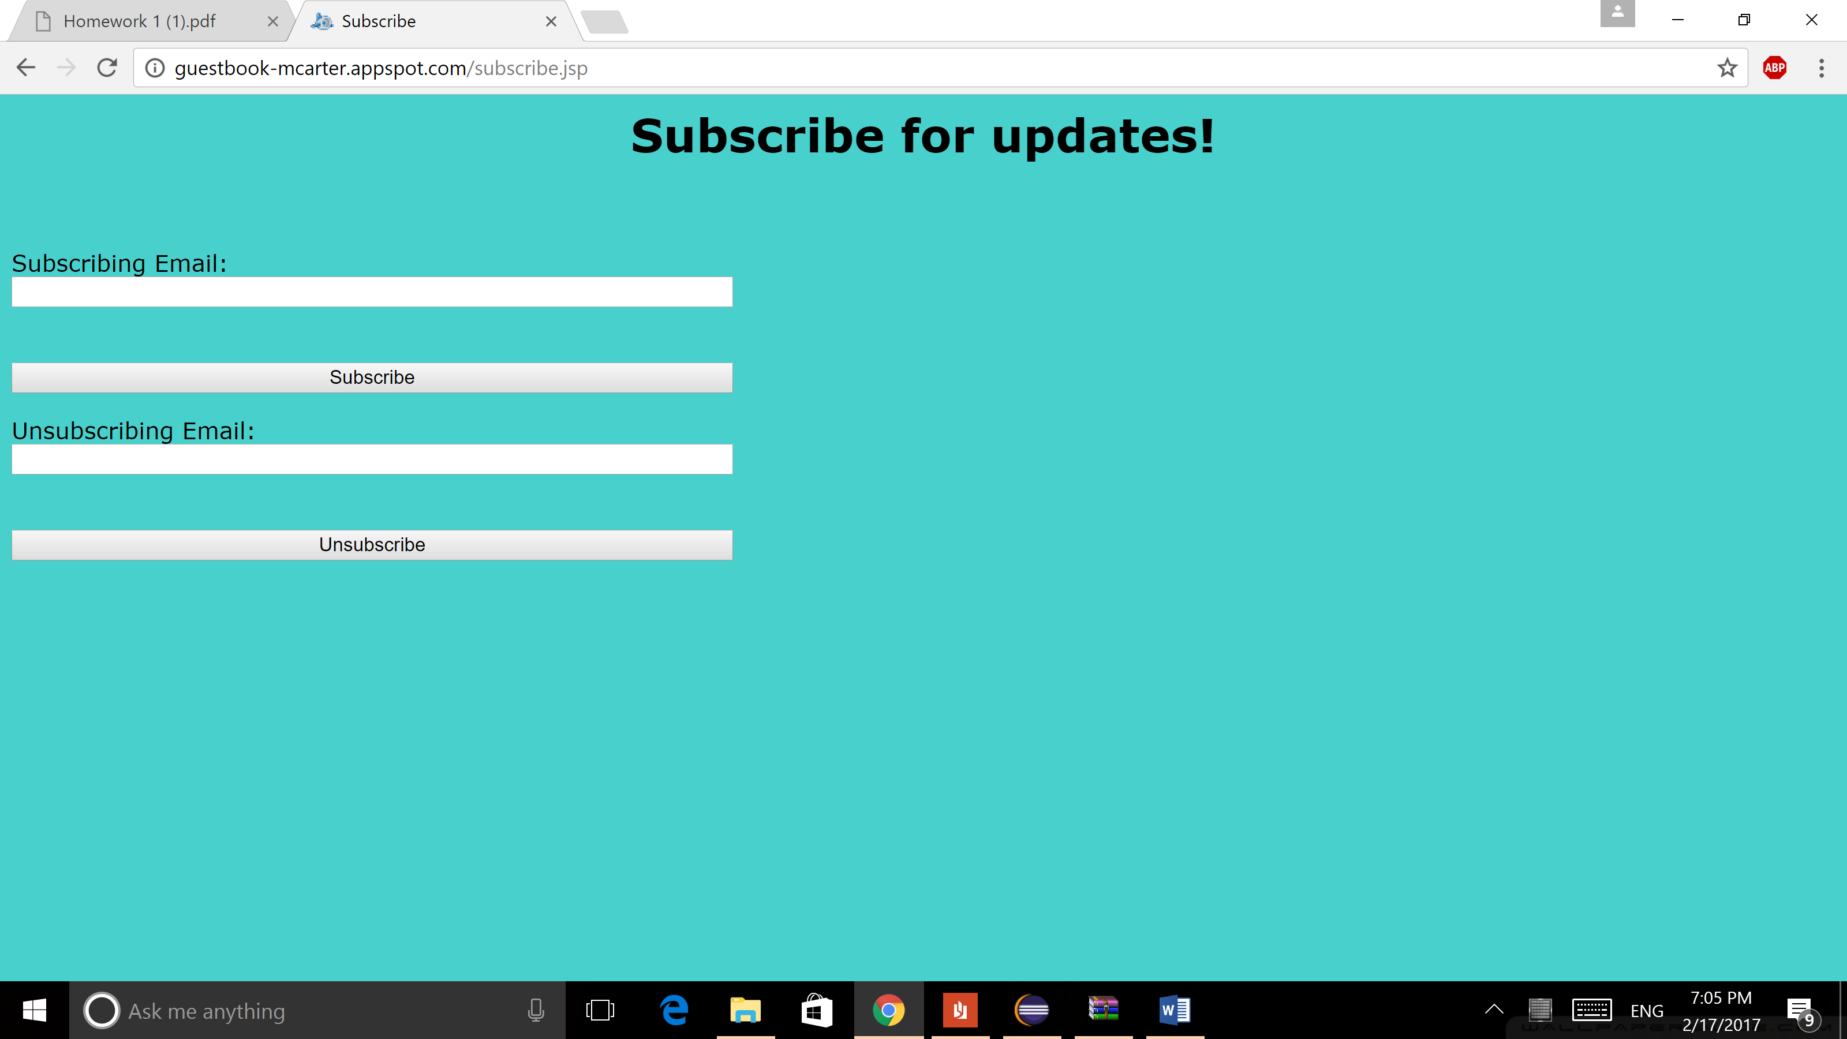

Teamwork:

Ram wrote SubscribeServlet.java and Unsubscribe.java, while Mark wrote PostServlet.java and DailyUpdate.java. We individually added these servlets to web.xml. Mark did the jsp files for the message and landing pages, while Ram made jsp files for the subscribe and all posts pages. Mark handles all of the graphical design, so Ram is going to be weak on that side of the design process.