

LLM RAG Agent

Development Environment



Ver 1.4

Table of Contents
1. Overview 3
2. Sign up for an account 3
3. Subscribe to the service 4
4. Colab settings 4
5. Development tools installation 5
6. Appendix 9
7. Reference 9

Overview
Prepare your work environment in advance for a smooth hands-on experience.
All materials can be downloaded from the following links.
- AI_foundation_tutorial : https://github.com/mac999/AI_foundation_tutorial/tree/main

Sign up for an account
Visit the following website and sign up for an account.
- Colab Pro sign - up ( paid ) : https://colab.research.google.com/signup
- ChatGPT subscription (paid)
- ChatGPT API Pay as you go sign up (paid. (Setting a limit of $ 8 ) https://platform.openai.com/settings/organization/billing/overview
- Claude ( free ) : https://claude.ai/
- Sign up for Github ( free ) : https://github.com/
- Sign up for Github Copilot ( paid, $ 10 /month ) : https://github.com/features/copilot/plans
- Sign up for Huggingface ( free ) : https://huggingface.co
- Generate Huggingface API Token ( free ) : https://huggingface.co/settings/tokens
- Stable diffusion - Kling subscription (paid. $6.99 per month ) : https://app.klingai.com/global/membership/membership-plan
- Sign up for Figma ( optional) : https://www.figma.com
If it is a paid service, simply The experience costs about $20 per service . It is recommended to subscribe within the limit. For example, for Kling , Monthly subscription ( standard ) We recommend that you set a usage limit for the Pay as you go service (check the separate menu) .
each In your account ID, PWD are Separate Record it Let go , next Development tools installation city Use it.
For reference, A Huggingface account is required to use LLM, Transformer , and Stable Diffusion-based models.

Subscribe to the service
We recommend subscribing to the following AI services for project development .
- gemini-api : https://aistudio.google.com/app/apikey for using gemini google ai key
- serp-api: https://serpapi.com/manage-api-key google search
- travily : https://app.tavily.com/home Web search
- wandb: https://docs.wandb.ai/quickstart/ Model learning and Fine tuning Monitoring log equipment
- langsmith: https://docs.smith.langchain.com/administration/how_to_guides/organization_management/create_account_api_key ( https://smith.langchain.com/o/2c462eb1-5b83-41c8-96c5-e008809d5655/settings ) l angchain log & debug tool
- visily ai: https://app.visily.ai planning AI tools

Colab settings
Open colab-env.ipynb from the following link in C oLab .
https://github.com/mac999/LLM-RAG-Agent-Tutorial/tree/main/1-1.prepare
You can do things like connect to your Google drive so that practice files can be saved .
Set the API key, etc. created above, in the key menu of your account's Colab as follows .
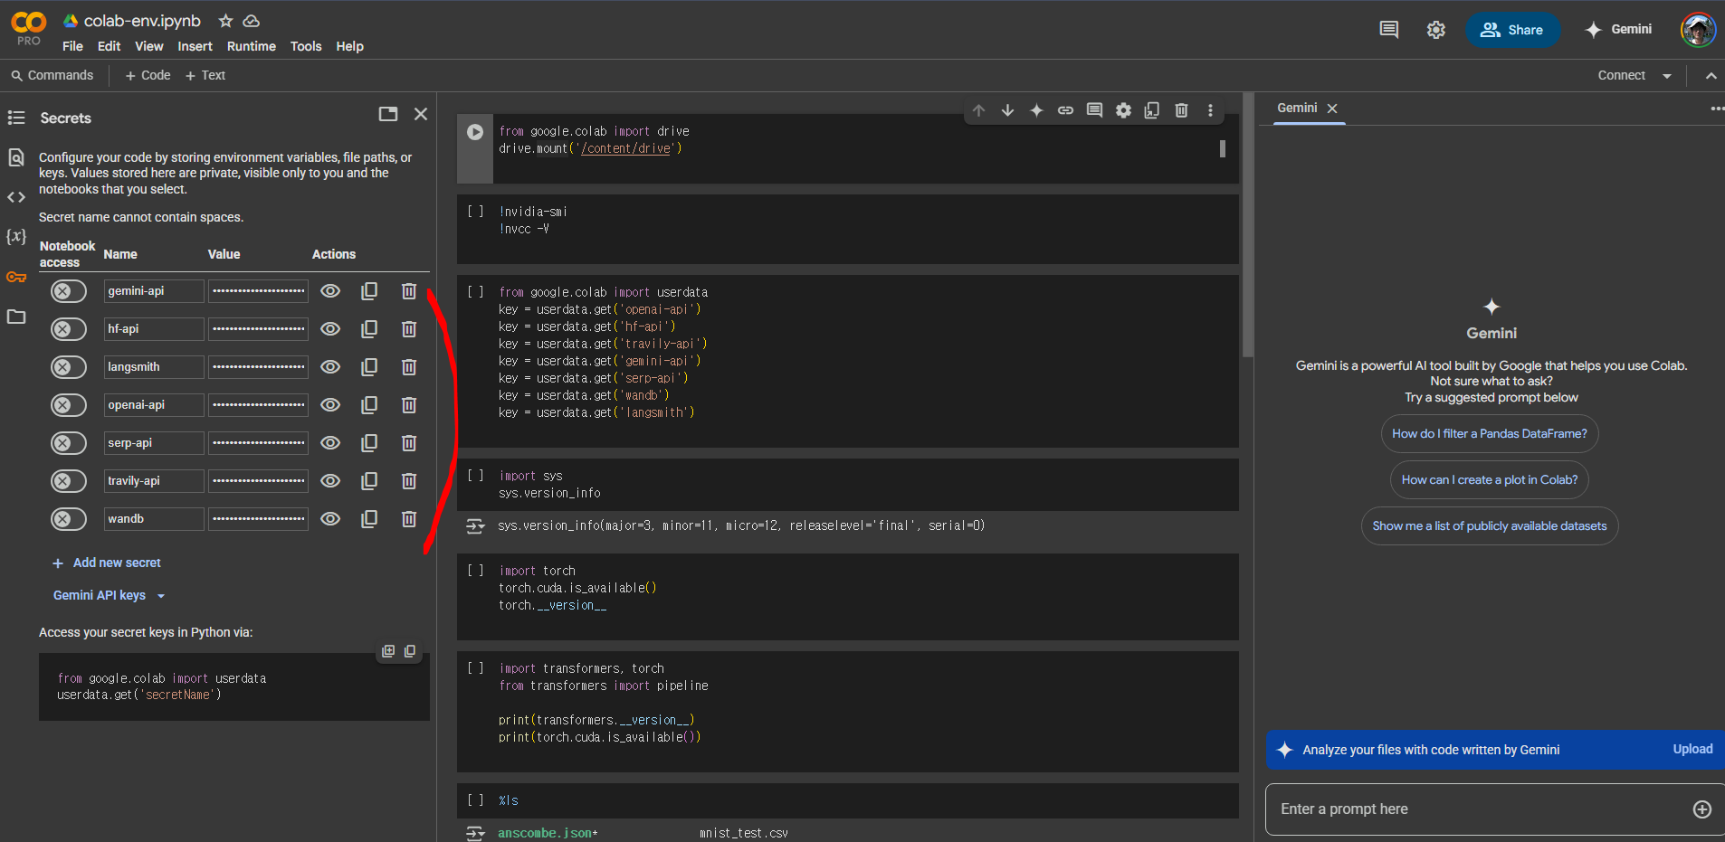

Development tools installation
The development tools will be explained during the hands-on session and then installed during the installation session. but, If you know in advance, Installing it before the practice saves time.
Python, Anaconda and other latest versions are often still under development, so errors may occur when installing packages, etc., so please install a stable version .
run cmd as follows in Windows .
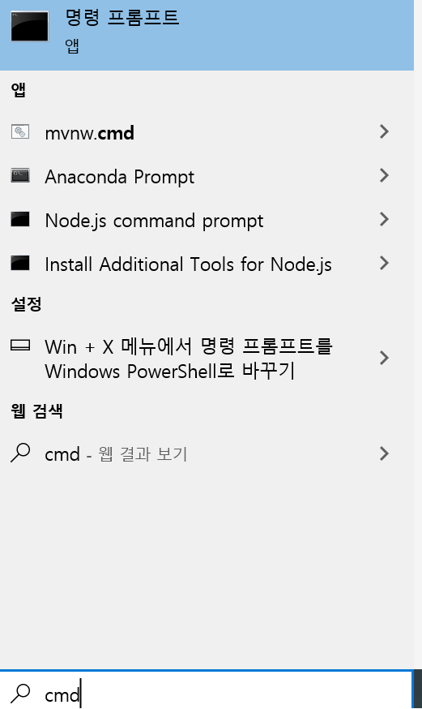

Python , Anaconda​ If there is an option to add PATH when installing Github , etc., Please check carefully. In the terminal, executable files such as python must be searchable in the path.
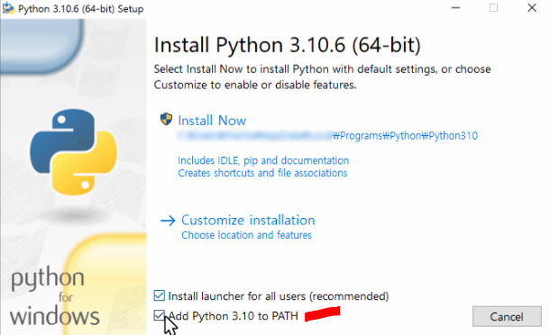

your laptop does not have an NVIDIA GPU , skip the GPU -related parts of the installation instructions below .

Python ( version 3.12 recommended for library compatibility . As of 2025.7 )
- Download Python
- Mac Users: Guide to Installing Python on Mac
- After installation, run python --version in terminal Properly felled ji Something to check out
NVIDIA Driver ( when using N VIDIA GPU)
- Download NVIDIA drivers
- After installation, check with nvidia-smi in the terminal.
CUDA Toolkit ( when using NVIDIA GPU )
- Download CUDA Toolkit
- Check GPU and driver compatibility during installation
- Add CUDA path to environment variables
Install Github tools
- Install the tool from the following link.
- https://docs.github.com/ko/desktop/installing-and-authenticating-to-github-desktop/installing-github-desktop
Anaconda (version 24.0 or later recommended)
- next From the link equipment Installed .
- Download Anaconda
Installing the PyTorch library
- After visiting the following link, install it from the terminal according to your CPU version or GPU driver version.
- https://pytorch.org/get-started/locally/
- C PU 's case , Next together At the terminal command Enter and install .
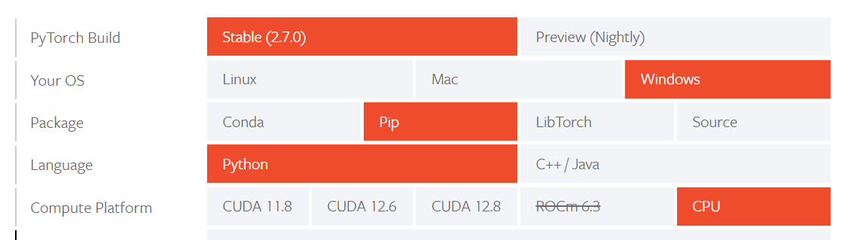
- For G PU , the following together nvcc -V If the C UDA version is displayed, Install that version from the terminal,
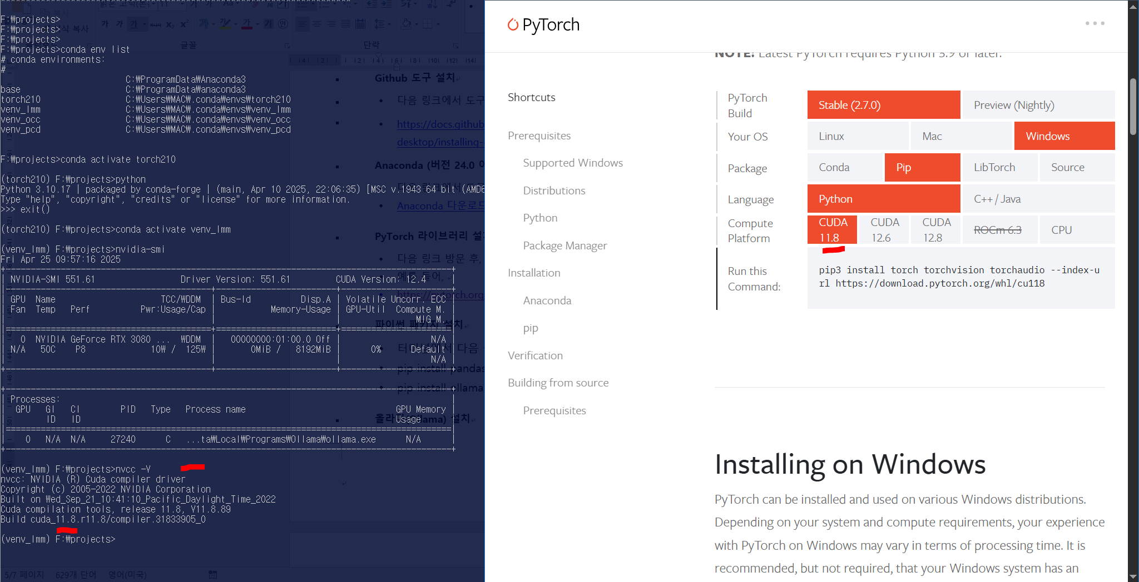
Installing Python Packages
- Create a virtual environment in the terminal With the name venv_lmm made after Install the package
- conda create --name venv_lmm python=3.11
- conda activate venv_lmm
- pip install pandas numpy
- pip install ollama openai transformers huggingface_hub langchain
Docker (optional )
Installation is required for virtual image-based operations .
- https://www.docker.com/get-started/ Visit installation
Install Ollama​
Ollama installation is required to use the local LLM AI tool.
- https://www.ollama.com/ Visit and install

Installing a code editor and IDE
- https://www.sublimetext.com/ installation
- https://code.visualstudio.com/download installation. Detailed installation instructions: https://www.youtube.com/watch?v=vesxpfOAOCw reference wind. You need to install Python extension tools, etc. ( see video)
- v scode installation after next video Please note Install github copilot and github coplot chat .
- https://www.youtube.com/watch?v=X_Aet9ndh_Y
- https://www.youtube.com/watch?v=dMbOh114Vd4
Installing Claude Desktop
- https://claude.ai/download installation

Appendix
If you have time, You just need to install it.
Install Blender for 3D modeling
LLM-based graphical modeling using Blender.
- https://www.blender.org/download/ Installation after visit

Install DaVinci for Gen AI video editor
- Install DaVinci Resolve 20 Public Beta ( optional) : https://www.blackmagicdesign.com/products/davinciresolve

Reference
- Huggingface: https://huggingface.co
- Blender LLM Addin Blog: https://medium.com
- NVIDIA Drivers: https://www.nvidia.com/Download/index.aspx
- CUDA Toolkit: https://developer.nvidia.com/cuda-toolkit
- Python: https://www.python.org
- Python Installation Guide for Mac: https://www.youtube.com
- Anaconda: https://docs.anaconda.com/anaconda/install/
- OpenAI: https://platform.openai.com
- PyTorch: https://pytorch.org

